Grace Lutheran Church
493 Forest Avenue, Glen Ellyn IL 630.469.1555
www.graceglenellyn.org

Second Sunday of Christmas January 3, 2021

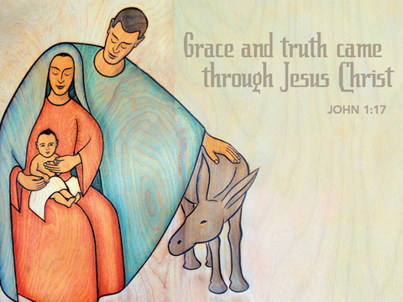

+ Proclaim Christ + Build Community +
+ Serve Our Neighbors +
Introduction
Within the gospel reading’s profound words lies the simple message that God is revealed in a human person. Though we may try to understand how the Word existed with God from the beginning of time, the wonder we celebrate at Christmas is that the Word continues to dwell among us. Christ comes among us in the gathered assembly, the scriptures, the waters of new birth, and the bread and the wine. Through these ordinary gifts we receive the fullness of God’s grace and truth.

Helpful Reminders for House Church:
- For House Church via computer, set your screen to Speaker View.
- Mute your mic during hymns.
- You may unmute for all group responses. Remember that your host can mute you but cannot unmute you; you must unmute your mic yourself.
- If you are joining by phone, move the mouthpiece away from your mouth unless you are speaking, to avoid broadcasting your breathing.
- Avoid background conversations when your mic is unmuted.
- THANK YOU FOR WORSHIPPING WITH US!

Gathering
The Holy Spirit calls us together as the people of God.

Prelude

Confession and Forgiveness
All may make the sign of the cross, the sign marked at baptism,
as the worship leader begins.
Blessed be the holy Trinity, ☩ one God, who was in the beginning,
who makes a dwelling among us, who covers us with justice and mercy.
Amen.

Let us confess our sin in the presence of God and of one another.
Silence is kept for reflection.

God of goodness and lovingkindness,
we confess that we have sinned against you
and our neighbors.
We have turned away from your invitation to new life.
We have turned away from the lowly and downtrodden.
In your abundant mercy, forgive us our sins,
those we know and those known only to you,
for the sake of the one who came to live among us,
Jesus Christ, our Savior. Amen.

Hear the good news of peace and salvation! God forgives us all our sins,
not through our own work, but through ☩ Jesus Christ, made known to all people.
With all who come to the manger, rejoice in this amazing gift of grace. Amen.

Opening Hymn (Please mute your mic) ELW#295 Of the Father’s Love Begotten; sts. 1, 4, 5
(You may unmute your mic)
Greeting
The grace of our Lord Jesus Christ, the love of God, and the communion of the Holy Spirit be with you all. And also with you.

Prayer of the Day
Almighty God, you have filled all the earth with the light of your incarnate Word. By your grace empower us to reflect your light in all that we do, through Jesus Christ, our Savior and Lord, who lives and reigns with you and the Holy Spirit, one God, now and forever. Amen.

Word
God speaks to us in scripture reading, preaching, and song.

First Lesson Jeremiah 31:7-14
God promises to bring Israel back to its land from the most remote parts of exile. In Zion Israel will rejoice over God’s gifts of food and livestock. Young women will express their joy in dancing; God will give gladness instead of sorrow.

⁷Thus says the Lord: Sing aloud with gladness for Jacob, and raise shouts for the chief of the nations; proclaim, give praise, and say, “Save, O Lord, your people, the remnant of Israel.” ⁸See, I am going to bring them from the land of the north, and gather them from the farthest parts of the earth, among them the blind and the lame, those with child and those in labor, together; a great company, they shall return here. ⁹With weeping they shall come, and with consolations I will lead them back, I will let them walk by brooks of water, in a straight path in which they shall not stumble; for I have become a father to Israel, and Ephraim is my firstborn.
¹⁰Hear the word of the Lord, O nations, and declare it in the coastlands far away; say, “He who scattered Israel will gather him,
and will keep him as a shepherd a flock.” ¹¹For the Lord has ransomed Jacob, and has redeemed him from hands too strong for him. ¹²They shall come and sing aloud on the height of Zion, and they shall be radiant over the goodness of the Lord, over the grain, the wine, and the oil, and over the young of the flock and the herd; their life shall become like a watered garden, and they shall never languish again. ¹³Then shall the young women rejoice in the dance, and the young men and the old shall be merry. I will turn their mourning into joy, I will comfort them, and give them gladness for sorrow. ¹⁴I will give the priests their fill of fatness, and my people shall be satisfied with my bounty, says the Lord.

Word of God, Word of Life. Thanks be to God.

The Psalm Read responsively by verse Psalm 147:12-20

¹²Worship the Lord, O Jerusalem; praise your God, O Zion,
¹³who has strengthened the bars of your gates and has blessed your children within you.
¹⁴God has established peace on your borders and satisfies you with the finest wheat.
¹⁵God sends out a command to the earth, a word that runs very swiftly.
¹⁶God gives snow like wool, scattering frost like ashes.
¹⁷God scatters hail like bread crumbs. Who can stand against God’s cold?
¹⁸The Lord sends forth the word and melts them; the wind blows, and the waters flow.
¹⁹God declares the word to Jacob, statutes and judgments to Israel.
²⁰The Lord has not done so to any other nation; they do not know God’s judgments. Hallelujah!

Second Lesson Ephesians 1:3-14
In Jesus, all of God’s plans and purposes have been made know as heaven and earth are united in Christ. Through Jesus, we have been chosen as God’s children and have been promised eternal salvation.

³Blessed be the God and Father of our Lord Jesus Christ, who has blessed us in Christ with every spiritual blessing in the heavenly places, ⁴just as he chose us in Christ before the foundation of the world to be holy and blameless before him in love. ⁵He destined us for adoption as his children through Jesus Christ, according to the good pleasure of his will, ⁶to the praise of his glorious grace that he freely bestowed on us in the Beloved. ⁷In him we have redemption through his blood, the forgiveness of our trespasses, according to the riches of his grace ⁸that he lavished on us. With all wisdom and insight ⁹he has made known to us the mystery of his will, according to his good pleasure that he set forth in Christ, ¹⁰as a plan for the fullness of time, to gather up all things in him, things in heaven and things on earth. ¹¹In Christ we have also obtained an inheritance, having been destined according to the purpose of him who accomplishes all things according to his counsel and will, ¹²so that we, who were the first to set our hope on Christ, might live for the praise of his glory. ¹³In him you also, when you had heard the word of truth, the gospel of your salvation, and had believed in him, were marked with the seal of the promised Holy Spirit; ¹⁴this is the pledge of our inheritance toward redemption as God’s own people, to the praise of his glory.

Word of God, Word of Life. Thanks be to God.

Gospel Acclamation
Alleluia. Let the peace of Christ rule in your hearts, and let the word of Christ dwell in you richly. Alleluia.

The holy Gospel according to John. Glory to you, O Lord.

Gospel John 1:1-18
John begins his gospel with this prologue: a hymn to the Word through whom all things were created. This Word became flesh and brought grace and truth to the world.

¹In the beginning was the Word, and the Word was with God, and the Word was God. ²He was in the beginning with God. ³All things came into being through him, and without him not one thing came into being. What has come into being ⁴in him was life, and the life was the light of all people. ⁵The light shines in the darkness, and the darkness did not overcome it.
⁶There was a man sent from God, whose name was John. ⁷He came as a witness to testify to the light, so that all might believe through him. ⁸He himself was not the light, but he came to testify to the light. ⁹The true light, which enlightens everyone, was coming into the world.
¹⁰He was in the world, and the world came into being through him; yet the world did not know him. ¹¹He came to what was his own, and his own people did not accept him. ¹²But to all who received him, who believed in his name, he gave power to become children of God, ¹³who were born, not of blood or of the will of the flesh or of the will of man, but of God.
¹⁴And the Word became flesh and lived among us, and we have seen his glory, the glory as of a father’s only son, full of grace and truth. ¹⁵(John testified to him and cried out, “This was he of whom I said, ‘He who comes after me ranks ahead of me because he was before me.’ ”) ¹⁶From his fullness we have all received, grace upon grace. ¹⁷The law indeed was given through Moses; grace and truth came through Jesus Christ. ¹⁸No one has ever seen God. It is God the only Son, who is close to the Father’s heart, who has made him known.

The Gospel of the Lord. Praise to you, O Christ.

(Please mute your mic)
Sermon The Rev. Melody Eastman

(You may unmute your mic)

Apostles’ Creed

With the whole church, let us confess our faith.
I believe in God, the Father almighty, creator of heaven and earth. I believe in Jesus Christ, God's only Son, our Lord, who was conceived by the Holy Spirit, born of the virgin Mary, suffered under Pontius Pilate, was crucified, died, and was buried; he descended to the dead. On the third day he rose again; he ascended into heaven, he is seated at the right hand of the Father, and he will come to judge the living and the dead. I believe in the Holy Spirit, the holy catholic church, the communion of saints, the forgiveness of sins, the resurrection of the body, and the life everlasting. Amen.

Prayers of Intercession
Joining our voices with the song of the angels, let us pray for the church, the world, and all who are in need.
A brief silence.

Redeeming God, you gather together your people from the farthest parts of the earth. Protect your church from stumbling. Let it not be overcome by sorrow, division, or despair. Make us radiant with goodness, that we might live always to the praise of your glory. Hear us, O God.
Your mercy is great.

You bring together heaven and earth. All creation testifies to your splendor. Hold the ecosystems of this earth in delicate balance, from coastlands to farmlands, forests to wetlands, deserts to rainforests. Show us new ways to live in harmony with the world around us. Hear us, O God.
Your mercy is great.

You overflow with grace upon grace. Expand the imaginations of those who serve in positions of authority. Open their hearts to the needs of their nations and communities. Protect all those in harm’s way and those risking danger for the sake of others. Hear us, O God.
Your mercy is great.

You bring consolation to those who weep. Embrace those who feel far-off, excluded, or defeated. Accompany those living with chronic and invisible illness. Sustain the weak and weary. Refresh those who labor under the weight of pain or sickness especially Dorothy, Helen, Sigrid, Chris, Anita, Evelyn, Norma, Carol, Dorothy, and those we name before you now. . . Hear us, O God. Your mercy is great.

You come to us in the beauty of darkness and of light. Bring justice and reconciliation to communities divided by oppressions and misuse of power. Guide us to speak holy words of advocacy and truth. Help us to honor your image in one another. Hear us, O God. Your mercy is great.
Here other intercessions may be offered.

You turn our mourning into joy. We give thanks for those who have died in faith. With all the saints, give us our inheritance in Christ. In the fullness of time, gather us all together in your mercy. Hear us, O God. Your mercy is great.

God of mercy, come quickly to us with grace upon grace as we lift these and all our prayers to you, in the name of Jesus. Amen.
(If your House Church is celebrating Communion, refer to that liturgy here.)

The Lord’s Prayer Ecumenical Version
Gathered into one by the Holy Spirit, let us pray as Jesus taught us.
Our Father in heaven, hallowed be your name, your kingdom come, your will be done, on earth as in heaven. Give us today our daily bread. Forgive us our sins as we forgive those who sin against us. Save us from the time of trial and deliver us from evil. For the kingdom, the power and the glory are yours, now and forever. Amen.

Sending
God blesses us and sends us in mission to the world.
Blessing
Almighty God, who sent the Holy Spirit to Mary, proclaimed joy through the angels, sent the shepherds with good news, and led the magi by a star, bless us this day ☩ through the Word made flesh. Amen.

Sending Hymn (Please mute your mic) ELW #269 Once in Royal David’s City
sts. 1, 2, 4
(You may unmute your mic)

Sent to the World
Go in peace. Share the gift of Jesus. Thanks be to God.

From Sundays and Seasons v.20190109.1233 Copyright © 2020 Augsburg Fortress. All rights reserved.
Reprinted by permission under Augsburg Fortress Liturgies Annual License #30867.
Reprinted under OneLicense.net #A-718333.

Current Prayer Requests
Name Relation to Grace Prayers For
Helen Sladek Member Healing & Strength
Chris Danly Son of Mark & Pat Danly Healing & Strength
Sigrid Elliott Friend of Grace Healing & Strength
Dorothy Tracy Member Healing & Strength
Prayers for our homebound Members
Anita Blakemore, Evelyn Elson, Carol Petersen, Norma Petersen, Dorothy Stein

Weekly Announcements
We will have our annual Congregational Meeting on Sunday, January 31. During this meeting we will elect new board members and vote on the 2021 budget. Due to the current pandemic situation, we will hold this meeting via Zoom. We will also have a “virtual” Coffee with Council via Zoom on a Sunday in January to review and discuss the 2021 budget. We will send out Zoom information and additional details in January. If you would like to join either of these sessions but are not comfortable with Zoom or have questions/comments, please contact Jon Milleville for help via email at jmilleville@comcast.net. Zoom does not require a computer as you can join by dialing in on a telephone.

We are in need of one new Council Member for a term starting in February of 2021. If you would be interested or have questions, please contact Jon Milleville.

House Church Worship via phone or internet every Sunday morning at 9:30am! We currently have five “House Churches” of worshipping members (each House Church consisting of 6-8 members/families meeting via Zoom or calling in by phone.) If you are unsure how to sign on, go ahead and register and let us know you need some help; we’ll walk you through it! We would be so blessed to have you join us. Register online for a House Church at graceglenellyn.org (on the main page Announcements).

Contributions to Grace: You may continue to mail your contributions to the church office; have your bank mail your contribution to the church office; or contribute on-line through Grace’s website. Please know, pandemic or no, our mission continues! Thank you for your continued support of our ministries at Grace Lutheran.

A contribution was made to the Angel Fund around October 11 but the envelope it came in has gone missing. Please contact the church office if you made this contribution so we can add it to your contribution statement. Thank you.

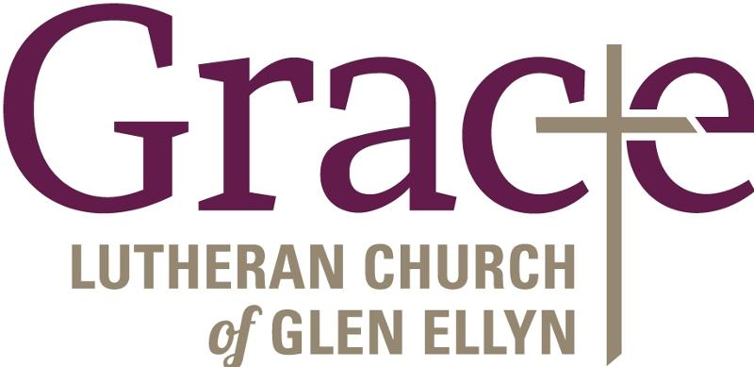
Every Member a Minister and Missionary!

Phone: 630-469-1555 Emergency Pastoral Contact: 630-674-2887
info@graceglenellyn.org www.graceglenellyn.org

Pastor
Rev. Melody Eastman office ext. 14
meastman@graceglenellyn.org

Minister of Music
Bradford Thompson 219-718-8879
bradfordmthompson@gmail.com

Ministry Associate
Becky Ficarella office ext. 17
bficarella@graceglenellyn.org

Office Manager
Barbara Sudds office ext. 10
bsudds@graceglenellyn.org

Parish Counselor
Carole LoGalbo M.S., LCPC 630-668-4594
carolelogalbo@yahoo.com

