Grace Lutheran Church

493 Forest Avenue, Glen Ellyn IL 630.469.1555
www.graceglenellyn.org

2nd Sunday after Epiphany January 15, 2023

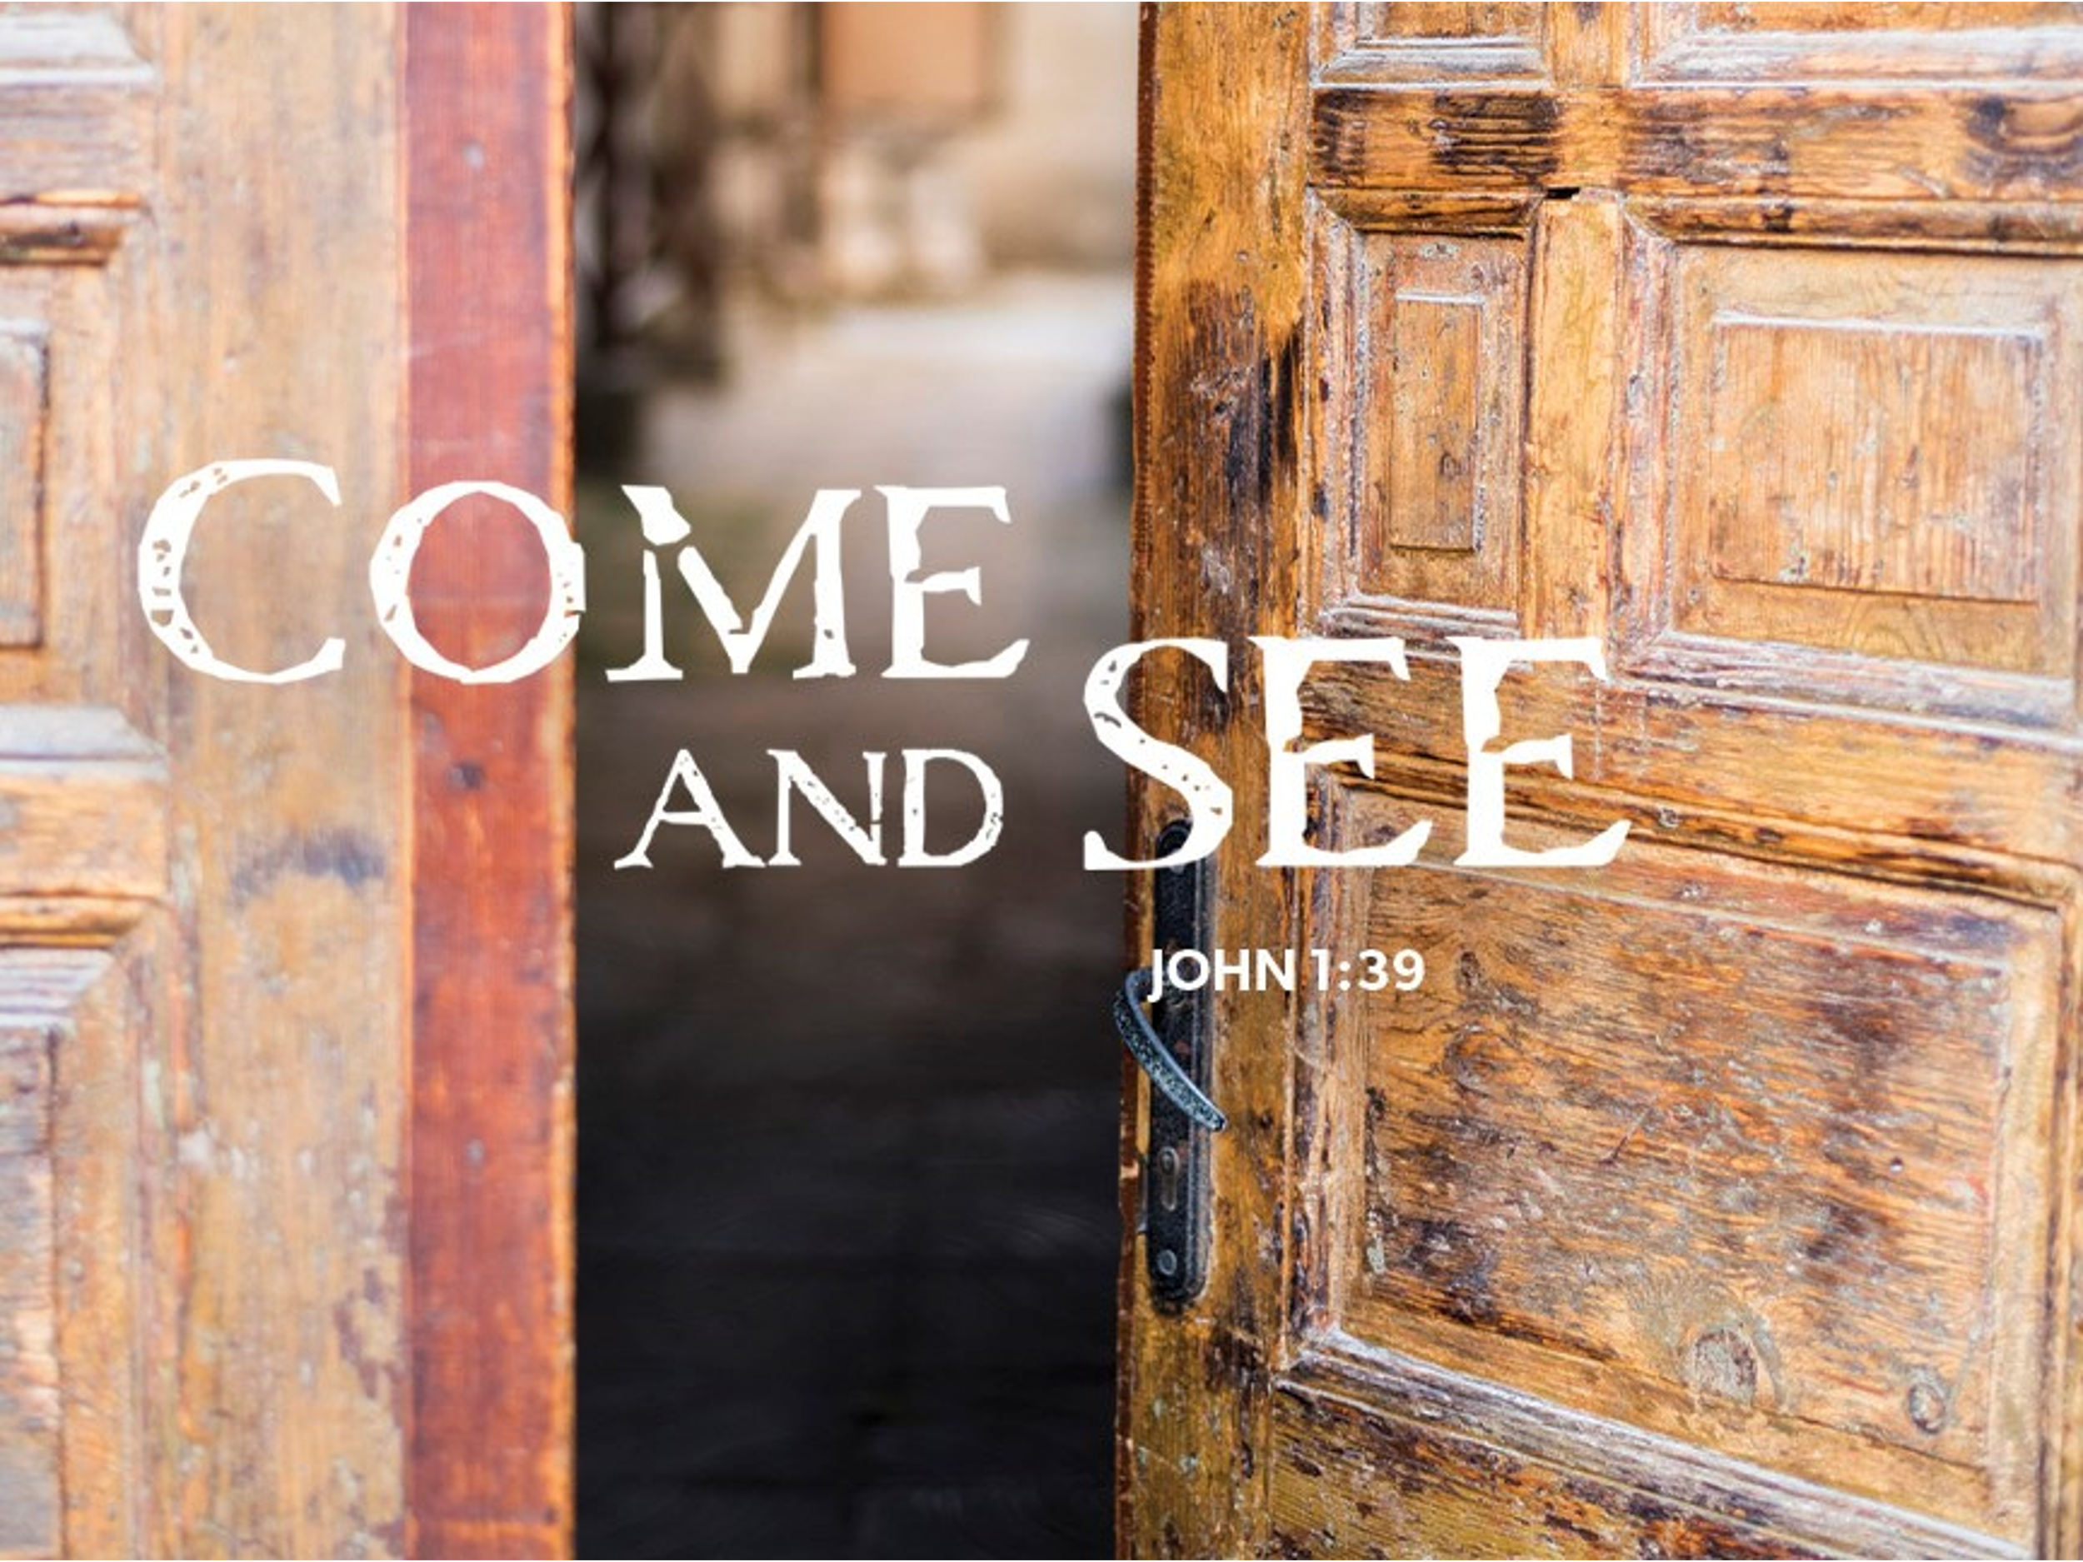

+ Proclaim Christ + Build Community +
+ Serve Our Neighbors +
Especially For Our Guests

Welcome to Grace!
If you are a guest, we’re thankful you’re here today. We hope you will feel welcomed and spiritually nourished. If you would like to speak to the pastor about the congregation, please let her know directly or call the church office. To enhance your worship experience, you may want to know the following:

· Please sign the attendance book at the end of the pew.

· You are invited to join us after service for some great refreshments and Christian Fellowship.

· Parts of the liturgy (worship service) not printed in this bulletin are in the red hymnal (ELW). Page numbers in the hymnal are at the bottom of the page; hymn numbers are the large numbers at the top in the back half of the book.

· All baptized people are welcome at communion. If you would like to come forward for a blessing without taking communion, you can do that too. If you have difficulty walking, feel free to let the usher know and we’ll bring communion to you.

· If you find yourself confused about where we are, ask a neighbor!

· Young children are welcome in worship! Parents, you can bring your little ones up front to the PrayGround, a space with tables, chairs, and quiet activities to keep our younger members engaged during services. Please sit near your little ones and help them use the space quietly as well as participate with you in worship. If you prefer, there is also a nursery space for you to use with infants or younger toddlers in the overflow room at the rear of the sanctuary. (But we really do like having children up front, if possible!)

· Please take your bulletin home with you. It contains the weekly calendar of events at Grace plus upcoming announcements.

Introduction
Today’s gospel opens with further reflection on Jesus’ baptism. He is the Lamb of God who takes away the sin of the world and the one anointed by the Spirit. In the liturgy we come and see Christ revealed among us in word and meal. We go forth to invite others to come and worship the Holy One and to receive the gifts of grace and peace made known among us.

An asterisk (*) indicates that you should stand for that portion of the service. If standing is difficult, please remain seated. Congregation responses are in bold print.
Gathering
The Holy Spirit calls us together as the people of God.
Welcome/Announcements

Prelude

*Entrance Hymn ELW #308 O Morning Star, How Fair and Bright!
sts. 1-3
(continued on next page)

*Greeting
The grace of our Lord Jesus Christ, the love of God, and the communion of the Holy Spirit be with you all. And also with you.

*Hymn of Praise p159
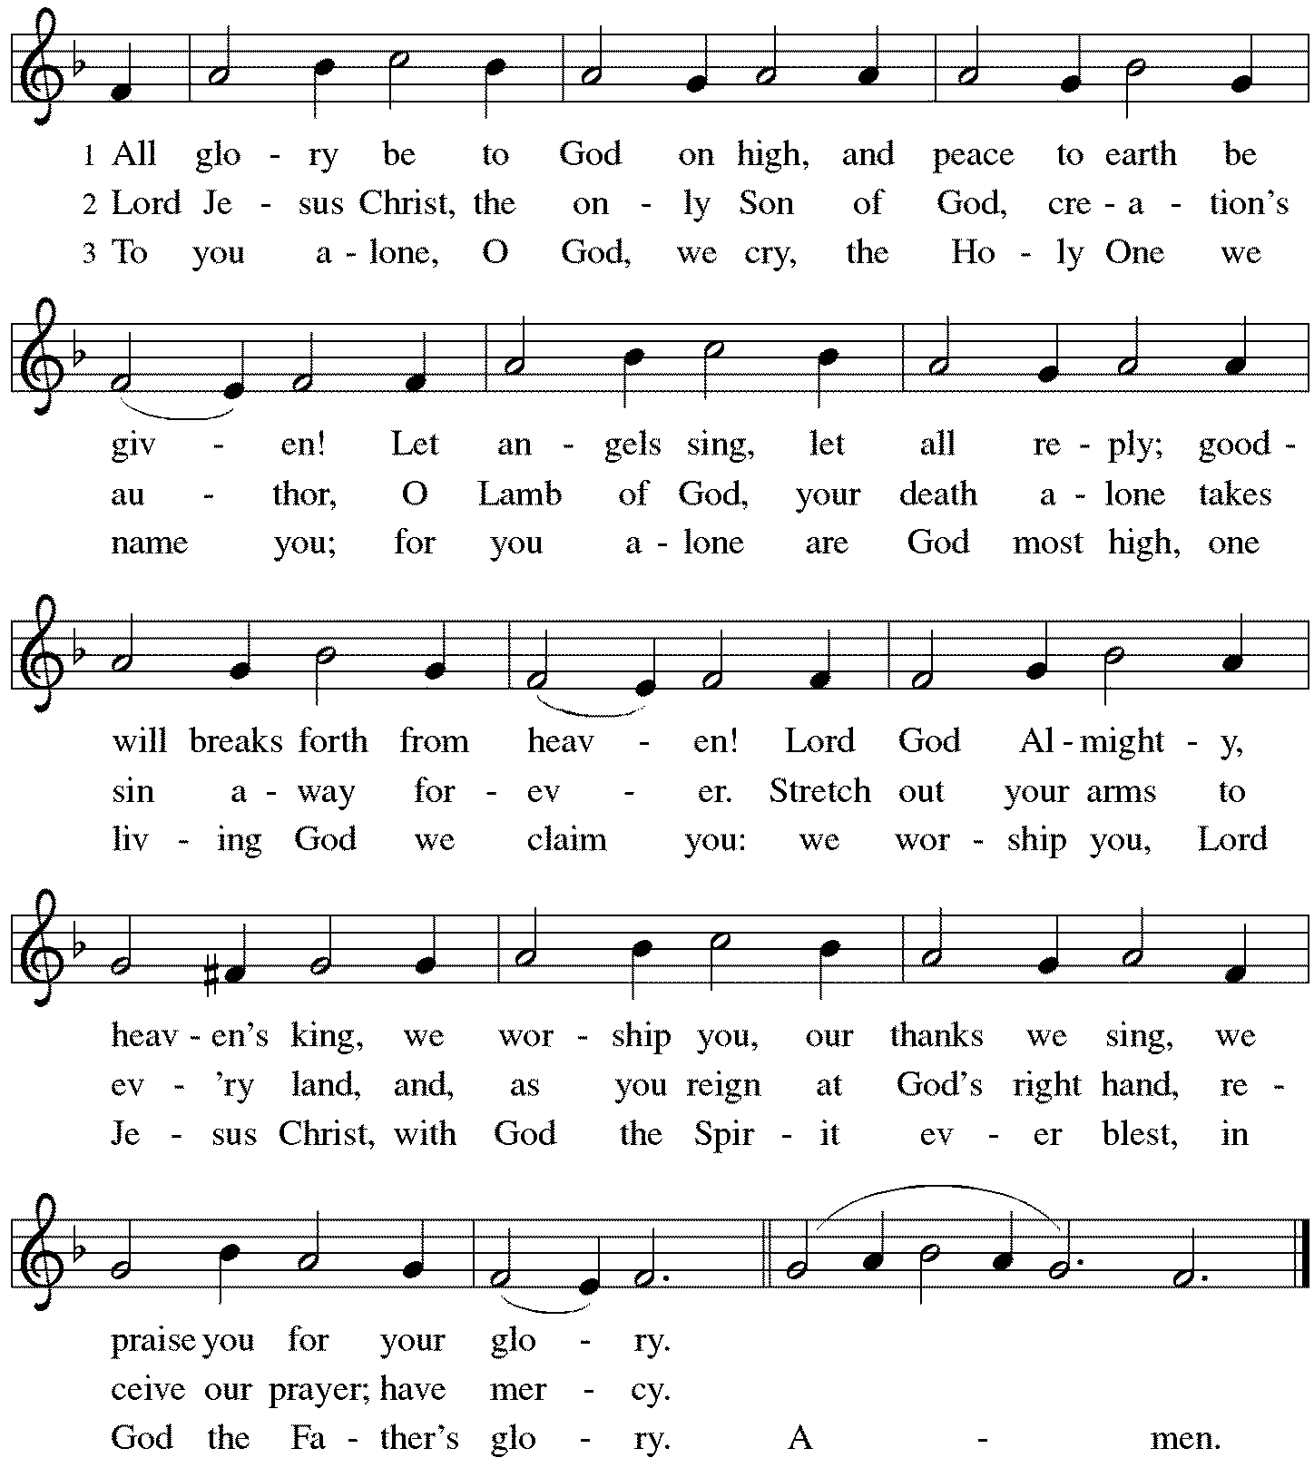

*Prayer of the Day
O God our Father, at the baptism of Jesus you proclaimed him your beloved Son and anointed him with the Holy Spirit. Make all who are baptized into Christ faithful to their calling to be your daughters and sons, and empower us all with your Spirit, through Jesus Christ, our Savior and Lord, who lives and reigns with you and the Holy Spirit, one God, now and forever. Amen. Be seated.

Word
God speaks to us in scripture reading.
First Lesson Isaiah 49:1-7
Here the servant, identified as Israel, speaks for herself and describes her honored mission. Called before her birth like Jeremiah and John the Baptist, the servant is not only to restore Israel. The servant’s ultimate assignment is to bring news of God’s victory to the ends of the earth. God in faithfulness has chosen Israel for this task.

¹Listen to me, O coastlands, pay attention, you peoples from far away! The Lord called me before I was born, while I was in my mother’s womb he named me. ²He made my mouth like a sharp sword, in the shadow of his hand he hid me; he made me a polished arrow, in his quiver he hid me away. ³And he said to me, “You are my servant, Israel, in whom I will be glorified.” ⁴But I said, “I have labored in vain, I have spent my strength for nothing and vanity; yet surely my cause is with the Lord, and my reward with my God.”
⁵And now the Lord says, who formed me in the womb to be his servant, to bring Jacob back to him, and that Israel might be gathered to him, for I am honored in the sight of the Lord, and my God has become my strength— ⁶he says, “It is too light a thing that you should be my servant to raise up the tribes of Jacob and to restore the survivors of Israel; I will give you as a light to the nations, that my salvation may reach to the end of the earth.”
⁷Thus says the Lord, the Redeemer of Israel and his Holy One, to one deeply despised, abhorred by the nations, the slave of rulers, “Kings shall see and stand up, princes, and they shall prostrate themselves, because of the Lord, who is faithful, the Holy One of Israel, who has chosen you.”

Word of God, Word of Life. Thanks be to God.

Second Lesson 1 Corinthians 1:1-9
Though God’s church in Corinth is a fractious congregation beset with many conflicts, Paul opens this letter by spotlighting the multiple ways God has enriched and sustained its life as part of the divine call into the fellowship of our Lord Jesus Christ.

¹Paul, called to be an apostle of Christ Jesus by the will of God, and our brother Sosthenes, ²To the church of God that is in Corinth, to those who are sanctified in Christ Jesus, called to be saints, together with all those who in every place call on the name of our Lord Jesus Christ, both their Lord and ours:
³Grace to you and peace from God our Father and the Lord Jesus Christ.
⁴I give thanks to my God always for you because of the grace of God that has been given you in Christ Jesus, ⁵for in every way you have been enriched in him, in speech and knowledge of every kind—⁶just as the testimony of Christ has been strengthened among you—⁷so that you are not lacking in any spiritual gift as you wait for the revealing of our Lord Jesus Christ. ⁸He will also strengthen you to the end, so that you may be blameless on the day of our Lord Jesus Christ. ⁹God is faithful; by him you were called into the fellowship of his Son, Jesus Christ our Lord.

Word of God, Word of Life. Thanks be to God.

*Please stand as you are able.
Gospel Acclamation
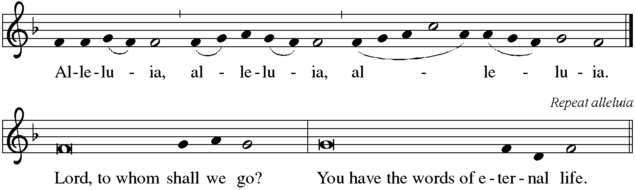

The holy Gospel according to John. Glory to you, O Lord.

*Gospel John 1:29-42
John the Baptist’s witness to Jesus initiates a chain of testimony as his disciples begin to share with others what they have found.

²⁹[John the Baptist] saw Jesus coming toward him and declared, “Here is the Lamb of God who takes away the sin of the world!³⁰This is he of whom I said, ‘After me comes a man who ranks ahead of me because he was before me.’ ³¹I myself did not know him; but I came baptizing with water for this reason, that he might be revealed to Israel.” ³²And John testified, “I saw the Spirit descending from heaven like a dove, and it remained on him. ³³I myself did not know him, but the one who sent me to baptize with water said to me, ‘He on whom you see the Spirit descend and remain is the one who baptizes with the Holy Spirit.’ ³⁴And I myself have seen and have testified that this is the Son of God.”
³⁵The next day John again was standing with two of his disciples, ³⁶and as he watched Jesus walk by, he exclaimed, “Look, here is the Lamb of God!” ³⁷The two disciples heard him say this, and they followed Jesus. ³⁸When Jesus turned and saw them following, he said to them, “What are you looking for?” They said to him, “Rabbi” (which translated means Teacher), “where are you staying?” ³⁹He said to them, “Come and see.” They came and saw where he was staying, and they remained with him that day. It was about four o’clock in the afternoon. ⁴⁰One of the two who heard John speak and followed him was Andrew, Simon Peter’s brother. ⁴¹He first found his brother Simon and said to him, “We have found the Messiah” (which is translated Anointed). ⁴²He brought Simon to Jesus, who looked at him and said, “You are Simon son of John. You are to be called Cephas” (which is translated Peter).

The Gospel of the Lord. Praise to you, O Christ. Be seated.

Sermon Pr. Melody Eastman

*Please stand as you are able.
*Hymn of the Day ELW #341 Now Behold the Lamb
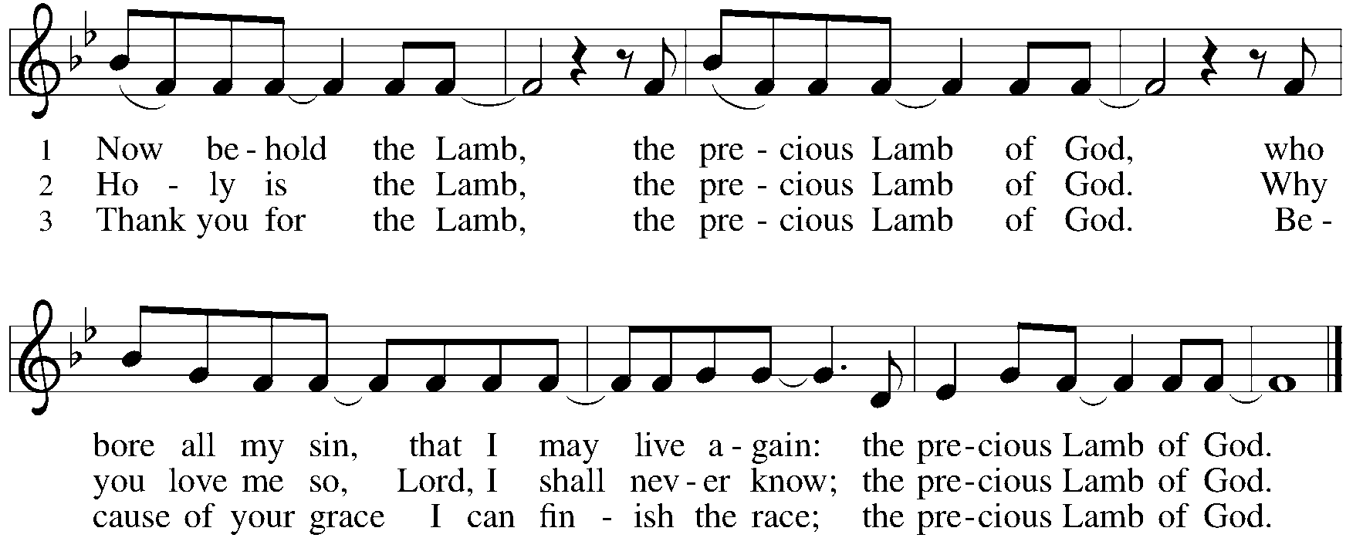

*Prayers of Intercession
Called together to follow Jesus, we pray for the church, the world, and all in need.
A brief silence.

Put a new song in the mouth of your church. Inspire the baptized to tell of your faithfulness, sharing the good news of your salvation throughout the earth. Bless the witness of missionaries. Merciful God, receive our prayer.

The waters of baptism call us into life in the Spirit. Preserve the world’s waters: protect them from pollution, support plants and animals who depend on them, and bring rain in places of drought. Guide us in protecting local waterways and in responding to devastating floods. Merciful God, receive our prayer.

In Jesus you are the Lamb of God who takes away the sin of the world. Show your mercy to all nations. Direct leaders to do your will; fill governing bodies with righteousness; equip judges with discernment and compassion. Merciful God, receive our prayer.

You incline your ear to all who cry to you. Draw near to individuals and communities suffering violence, injustice, illness, or poverty. Hide them in the shadow of your hand and make us signs of your faithfulness to all in need. We pray especially for Dorothy, Thom, Brittany, Carol, Norma, and those we name before your now. . . Merciful God, receive our prayer.

You are glorified in the servants you have called. With Martin Luther King Jr., give us bold trust in you. Even when it feels like a sharp sword or polished arrow, give us courage to receive your call to repentance and racial justice. Merciful God, receive our prayer.
Here other intercessions may be offered.

In every place and time, you have sanctified your people. We praise you for the testimony of those who have died in the faith. Strengthen us as we wait for the day of our Lord Jesus Christ. Merciful God, receive our prayer.

We bring to you our needs and hopes, O God, trusting your wisdom and power revealed in Christ crucified. Amen.

*Peace
The peace of Christ be with you always. And also with you.
Please share the peace with others in your household, or by making a sign of peace to those on Zoom. You may then be seated as the table is prepared.

Meal
God feeds us with the presence of Jesus Christ.
Gathering of Gifts
We gather gifts for those in need and for the church’s mission.

Music During Offering

*Please stand as you are able. The gifts are brought forward while the congregation sings:
*Offertory Response ELW #312 Jesus, Come! For We Invite You
sts. 1,2
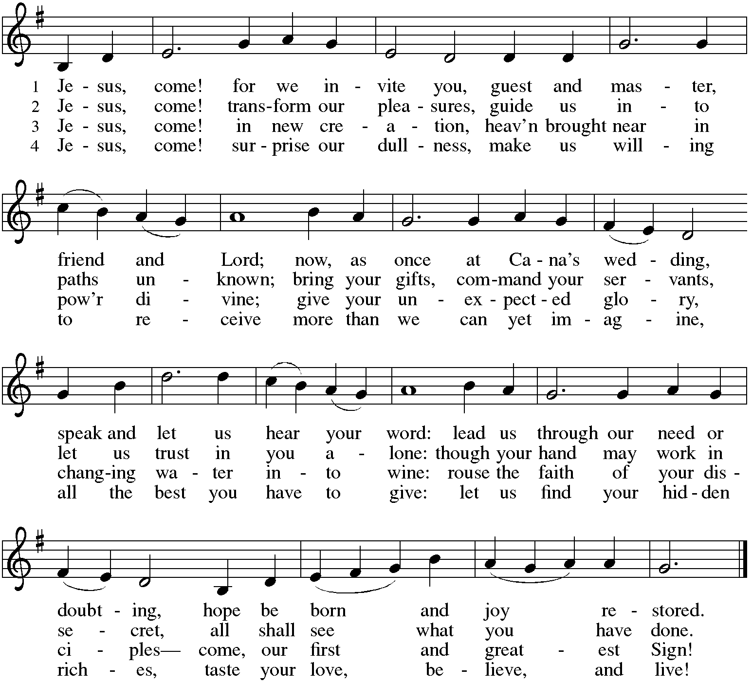

*Offering Prayer
Liberating God, you break the bonds of injustice
and let the oppressed go free.
Receive these offerings in thanksgiving for all your works of merciful power,
and shape us as people of your justice and freedom.
You we magnify and adore, through Jesus our Savior,
Amen.

*Great Thanksgiving p161

*Preface
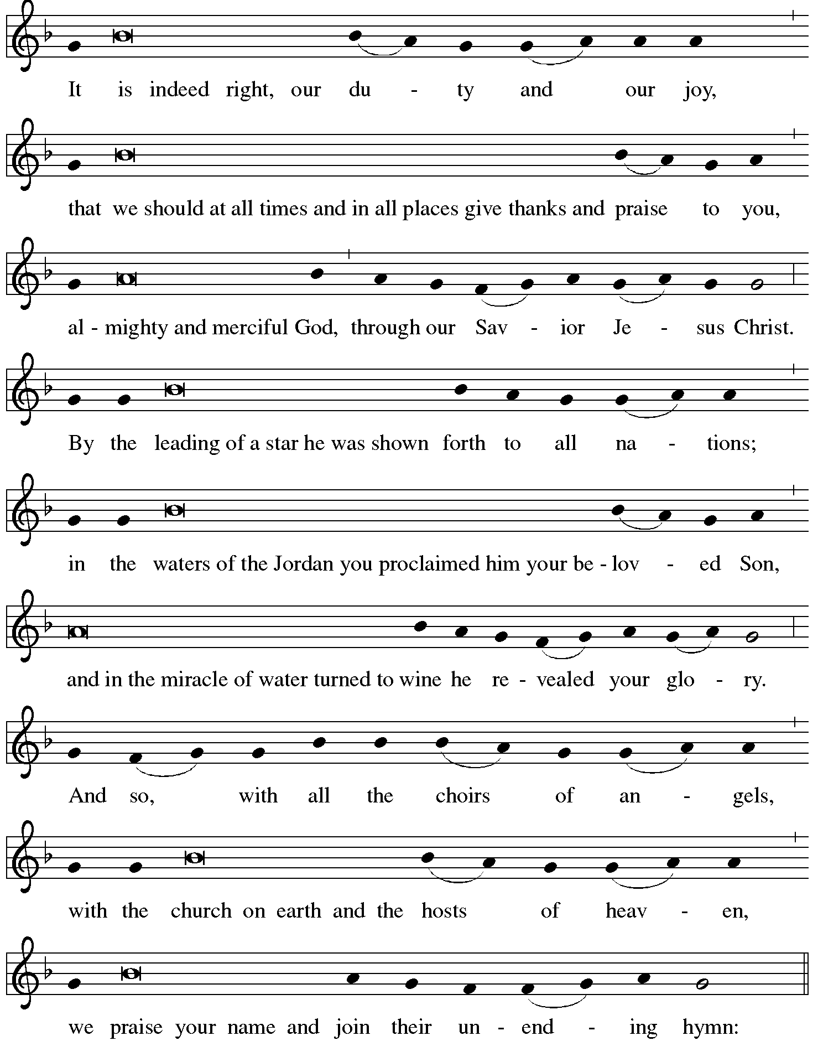

*Sanctus p162
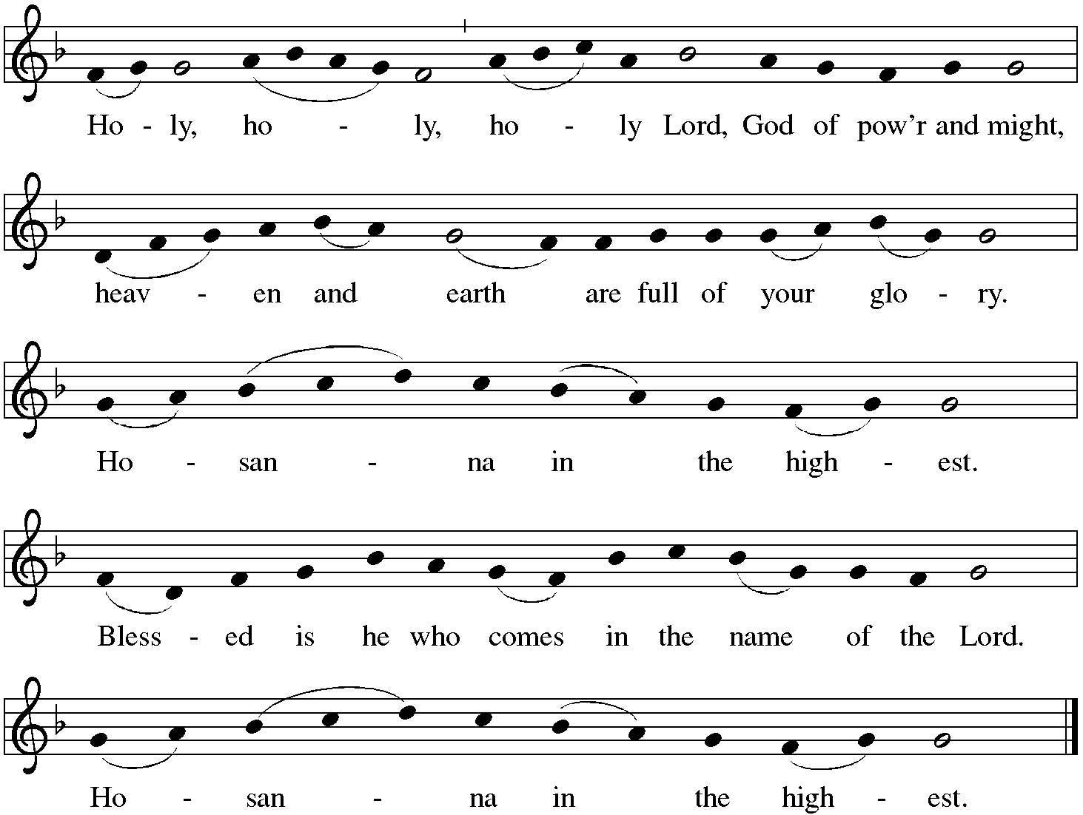

*Thanksgiving at the Table
Holy One, the beginning and the end, the giver of life:
Blessed are you for the birth of creation.
Blessed are you in the darkness and in the light.
Blessed are you for your promise to your people.
Blessed are you in the prophets' hopes and dreams.
Blessed are you for Mary's openness to your will.
Blessed are you for your Son Jesus, the Word made flesh.

In the night in which he was betrayed,
our Lord Jesus took bread, and gave thanks;
broke it, and gave it to his disciples, saying:
Take and eat; this is my body, given for you.
Do this for the remembrance of me.

Again, after supper, he took the cup, gave thanks,
and gave it for all to drink, saying:
This cup is the new covenant in my blood,
shed for you and for all people for the forgiveness of sin.
Do this for the remembrance of me.

Let us proclaim the mystery of faith:
Christ has died. Christ is risen. Christ will come again.

With this bread and cup we remember your Word
dwelling among us, full of grace and truth.
We remember our new birth in his death and resurrection.
We look with hope for his coming. Come, Lord Jesus.

Holy God, we long for your Spirit. Come among us.
Bless this meal. May your Word take flesh in us.
Awaken your people. Fill us with your light.
Bring the gift of peace on earth. Come, Holy Spirit.

All praise and glory are yours,
Holy One of Israel,
Word of God incarnate,
Power of the Most High,
one God, now and forever.
Amen.

*The Lord’s Prayer
Gathered into one by the Holy Spirit, let us pray as Jesus taught us.
Our Father, who art in heaven, hallowed be thy name, thy kingdom come, thy will be done on earth as it is in heaven. Give us this day our daily bread; and forgive us our trespasses, as we forgive those who trespass against us; and lead us not into temptation, but deliver us from evil. For thine is the kingdom, and the power, and the glory, forever and ever. Amen.

*Invitation to Communion
Come and taste the joy of God! Be seated.

Communion
For those receiving communion from home:
This is the body of Christ, given for you. Amen (Eat the bread.)
This is the blood of Christ, shed for you. Amen (Drink the juice.)
Those who wish to come forward for communion or a blessing may do so at the ushers’ direction. You may return to your seat by the side aisles after you have received the bread and wine.

Agnus Dei p164 Lamb of God
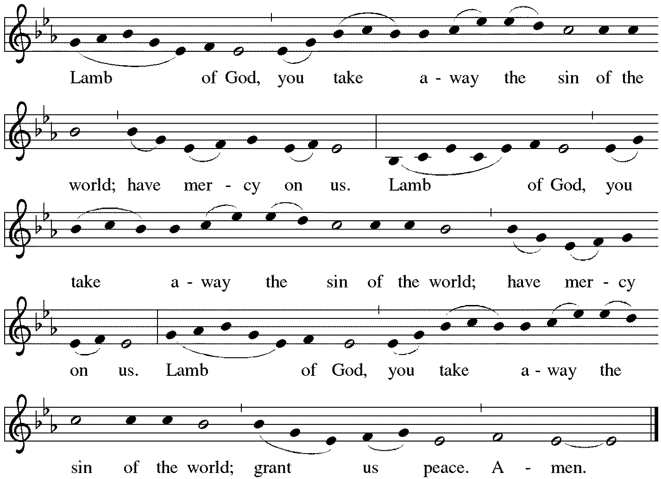

Communion Hymn ACS #962 In This Feast of Love
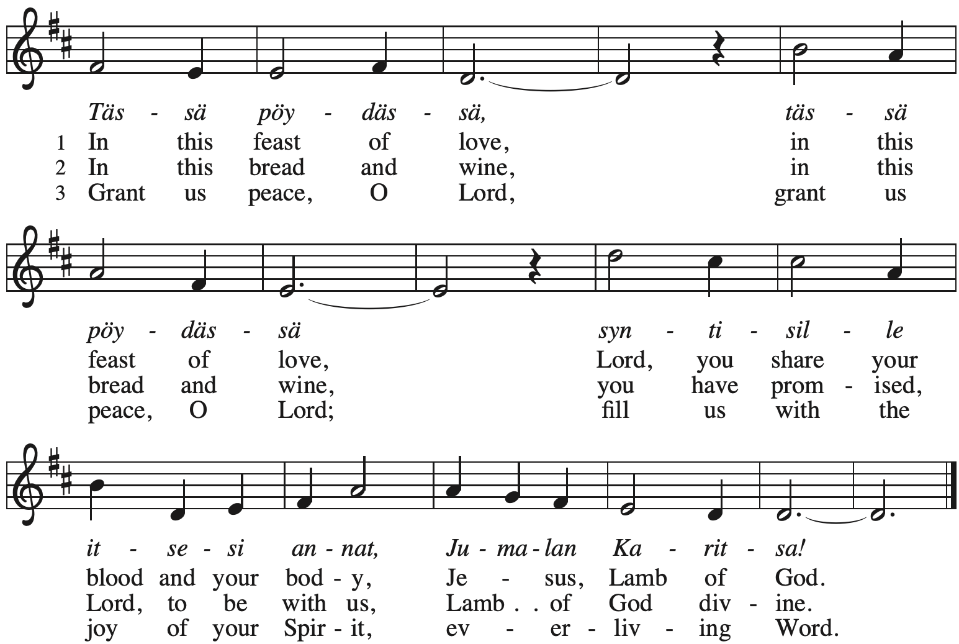
*Please stand as you are able.
*Post Communion Blessing
May the body and blood of our Lord Jesus Christ
strengthen you and keep you in his grace. Amen.

*Post Communion Prayer
Holy One,
we thank you for the healing
that springs forth abundantly from this table.
Renew our strength to do justice,
love kindness,
and journey humbly with you.
Amen.

Sending
God blesses us and sends us in mission to the world.
*Blessing
The God who faithfully brings forth justice
and breaks the oppressor’s rod
☩ bless, strengthen, and uphold you,
today and always. Amen.

*Sending Hymn ELW #808 Lord Jesus, You Shall Be My Song
sts. 1, 3,4
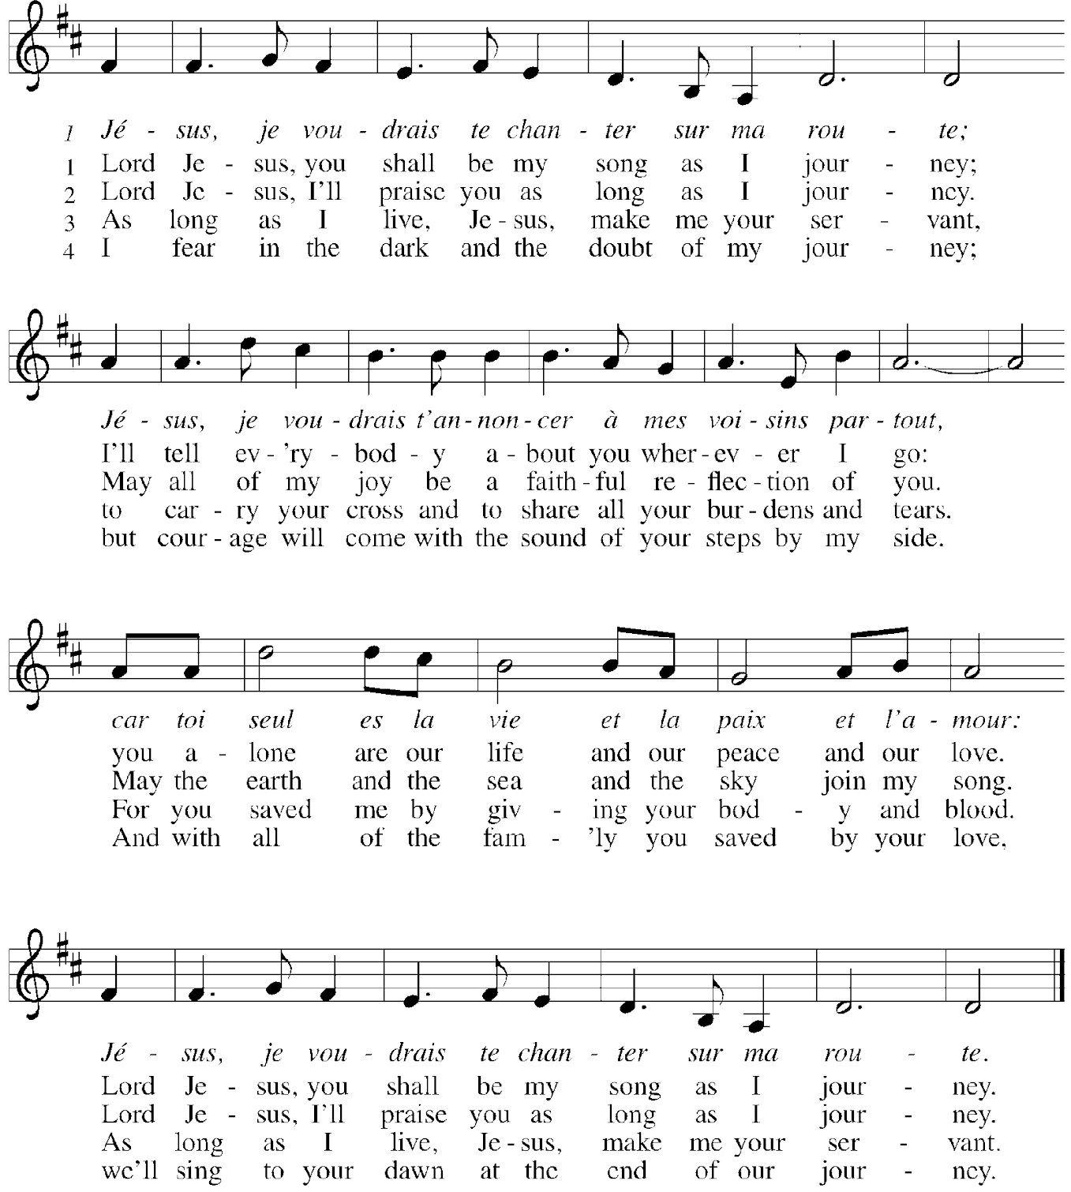

*Sent to the World
Go in peace. Follow the way of Jesus. Thanks be to God.

Postlude

From Sundays and Seasons v.20190109.1233 Copyright © 2022 Augsburg Fortress. All rights reserved.
Reprinted by permission under Augsburg Fortress Liturgies Annual License #30867.
All rights reserved. Reprinted under OneLicense.net #A-718333.

Assisting in Worship Today
Pastor Rev. Melody Eastman
Minister of Music Bradford Thompson
Altar Care Cathy Milleville
Crucifer
Lector Jeff Nelson
Ushers Mark Drager, John Jokela
Zoom Mark Hamilton, Jon & Cathy Milleville
Fellowship Hour Jean Jeske
Altar Flowers
Current Prayer Requests
Name Relationship Prayer For
Thom Griffin Friend of Ginny Stein Healing & Strength
Rich Davison Member Healing & Strength
Brittany Huizenga Cousin of Cheryl Huizenga Healing & Strength
Dorothy Tracy Member Healing & Strength
Prayers for our homebound Members
Carol Petersen, Norma Petersen

Weekly Announcements
Congregational Meeting: Mark your calendars for Sunday, January 29th at 11:15am. Grace will have its annual congregational meeting following our Sunday worship service. Your attendance is needed to reach our 50-member quorum requirement. The meeting will be conducted in the Sanctuary and on Zoom. We will be voting to approve the 2023 budget and electing new Church Council members. We will also share with the congregation our vision and plans for a new and exciting ministry partnership that will carry Grace into the future. Come and be a part of this exciting time at Grace.

Financial Forum: The Finance Committee will host a meeting in the Fellowship Hall on January 22 at 9am to present the 2022 financial overview and the 2023 proposed church budget. Following the presentation there will be a question-and-answer session. Please plan on attending.

Contribution Envelopes: Boxes for 2023 are in the Narthex. Please take your box home with you.

Monday Evening Bible Study: The Monday evening Bible study group, starting on Monday, January 30 (note new date) at 7:00pm, will study the Gospel of Matthew. This is the primary Gospel we are hearing in church in the current church year which began in late November.

Although evidence suggests that Mark was the first Gospel written, as both Matthew and Luke draw from it for their basic structure, Matthew is placed first in the New Testament because it serves as a bridge to the Hebrew Bible. In the first four chapters, Matthew quotes extensively from the Hebrew prophets to show that the life of Jesus fulfills the Scriptures. Matthew was addressed to a mixed community which included many Jewish converts to Christianity. The author wanted each part of the community to accept the other and to put their new life in Christ ahead of all that might divide them. The Gospel is filled with compassion, concentrating on the key teachings of Jesus to “Love God and love your neighbor.” There is a stress on the emerging church as an assembly of those called out to serve in the Kingdom of Heaven, right here in this world.

We will use Kerygma Bible study materials. The writer of the Resource Book for Matthew is Robert Bryant, Chair of the Department of Religion and Philosophy at Presbyterian College in Clinton, SC. He also wrote the Resource Book for First Corinthians which we studied some years ago. The sessions include a video presentation by the author. Participation will be possible in person in the Great Room and via Zoom link.

The Monday night group has become cohesive over the years, sharing conversation as well as our Bible study. Still, there is always room for more, and we will make you feel welcome. Kindly contact Mark Hamilton or Vince Hardt if you have not participated before so that we may order course materials for you and add you to our Email list.

Zoom Worship
We will offer a Zoom link for our 10am Sunday worship service for those who are continuing to participate from home. If you need a bulletin, remember you can view (on another device) or download/print a bulletin from Grace's website. Just click on Quick Link to Worship.
Zoom link: https://us02web.zoom.us/j/89031586315
Dial In: 1-312-626-6799 Meeting ID: 890 3158 6315

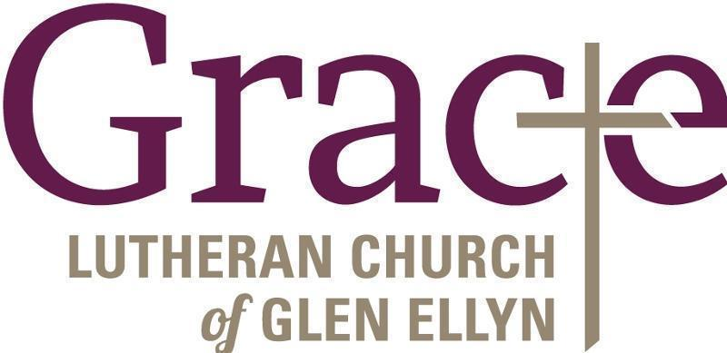

Every Member a Minister and Missionary!

Phone: 630-469-1555 Emergency Pastoral Contact: 630-674-2887
info@graceglenellyn.org www.graceglenellyn.org

Pastor
Rev. Melody Eastman office ext. 14
meastman@graceglenellyn.org

Minister of Music
Bradford Thompson 219-718-8879
bradfordmthompson@gmail.com

Office Manager
Barbara Sudds office ext. 10
bsudds@graceglenellyn.org

Parish Counselor
Carole LoGalbo M.S., LCPC 630-668-4594
carolelogalbo@yahoo.com

