Grace Lutheran Church

493 Forest Avenue, Glen Ellyn IL 630.469.1555
www.graceglenellyn.org

3rd Sunday after Epiphany January 22, 2023

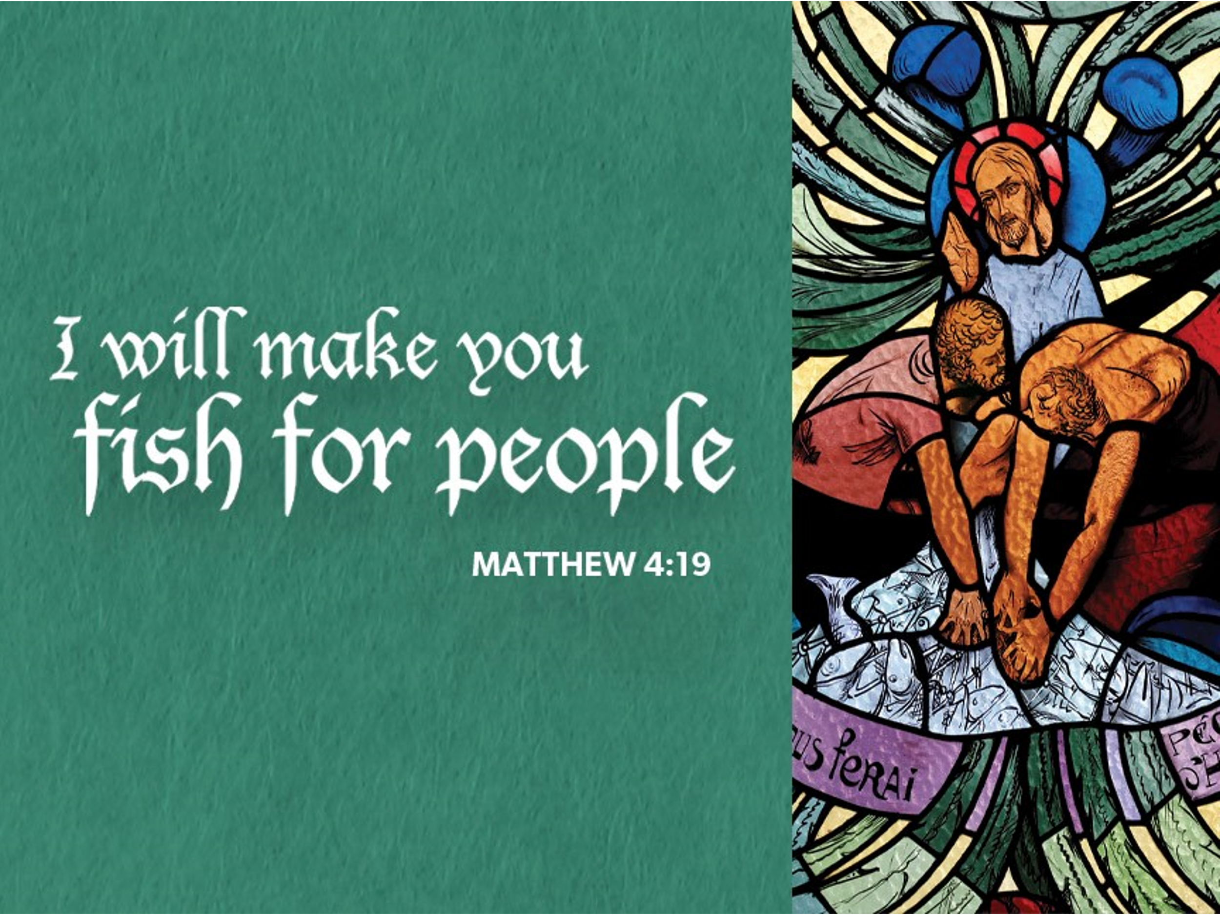

+ Proclaim Christ + Build Community +
+ Serve Our Neighbors +
Introduction
Jesus begins his public ministry by calling fishers to leave their nets and follow him. In Jesus the kingdom of God has come near. We who have walked in darkness have seen a great light. We see this light most profoundly in the cross—as God suffers with us and all who are oppressed by sickness, sin, or evil. Light dawns for us as we gather around the word, the font, and the holy table. We are then sent to share the good news that others may be “caught” in the net of God’s grace and mercy.

An asterisk (*) indicates that you should stand for that portion of the service. If standing is difficult, please remain seated. Congregation responses are in bold print.

Gathering
The Holy Spirit calls us together as the people of God.
Welcome/Announcements
Prelude

*Please stand as you are able.

*Confession and Forgiveness
All may make the sign of the cross, the sign that is marked at baptism, as the presiding minister begins.
Blessed be the holy Trinity, ☩ one God, who makes all things new, whose mercy endures forever. Amen.

Trusting in God’s mercy, let us confess our sin.
Silence is kept for reflection.
Holy One, source of our renewal, we confess that we are wrapped up in sin, and cannot free ourselves.
We have not practiced your righteousness. Our hearts have turned away from you. For the sake of the world you so love, forgive us, that we may be reconciled to one another for the glory of your holy name.
Amen.

Thus says our God: “The former things have come to pass and new things I now declare.” God’s mercy makes us new. We are forgiven in the name of ☩ Christ our Savior. Amen.

*Entrance Hymn ELW #511 Thy Strong Word, sts. 1, 3, 6
Alleluia and Stanza 6 on next page.

*Greeting
The grace of our Lord Jesus Christ, the love of God, and the communion of the Holy Spirit be with you all. And also with you.

*Hymn of Praise p159
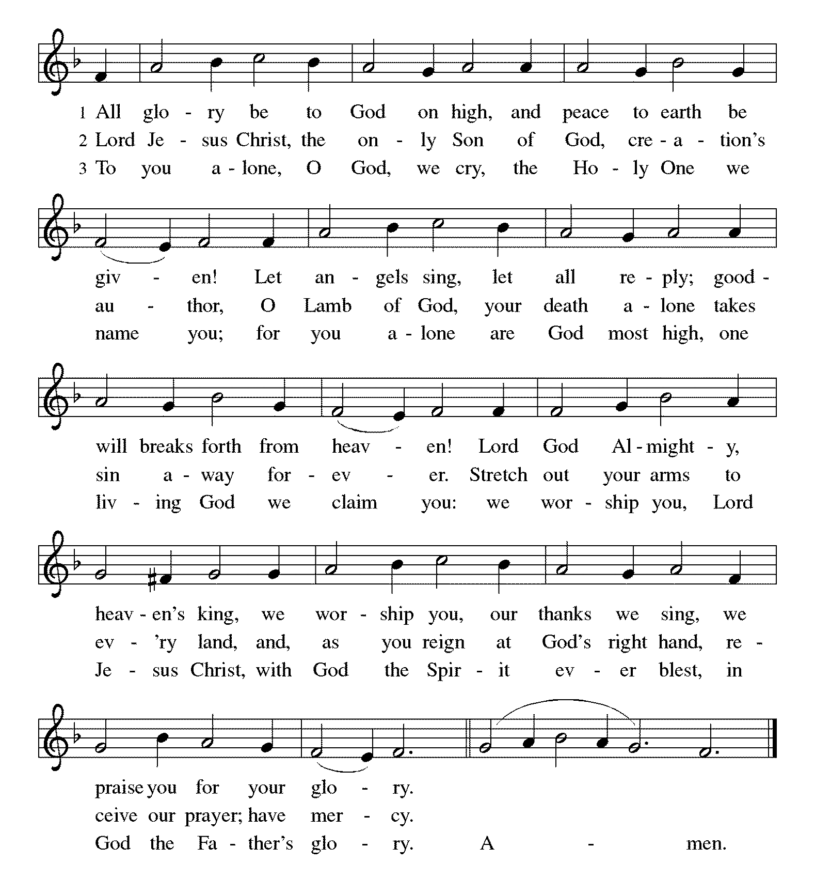
*Prayer of the Day
Lord God, your lovingkindness always goes before us and follows after us. Summon us into your light, and direct our steps in the ways of goodness that come through the cross of your Son, Jesus Christ, our Savior and Lord. Amen. Be seated.

Word
God speaks to us in scripture reading.
First Lesson Isaiah 9:1-4
The northern tribes of Zebulun and Naphtali experienced the gloom of defeat by Assyrian military forces, but they are assured that their condition will be reversed when God makes a light-filled appearance. The joy they will experience will resemble celebrations of great harvests, because God will deliver them from everything that diminishes or oppresses them.

¹There will be no gloom for those who were in anguish. In the former time [the Lord] brought into contempt the land of Zebulun and the land of Naphtali, but in the latter time he will make glorious the way of the sea, the land beyond the Jordan, Galilee of the nations.
²The people who walked in darkness have seen a great light; those who lived in a land of deep darkness— on them light has shined. ³You have multiplied the nation, you have increased its joy; they rejoice before you as with joy at the harvest, as people exult when dividing plunder. ⁴For the yoke of their burden, and the bar across their shoulders, the rod of their oppressor, you have broken as on the day of Midian.

Word of God, Word of Life. Thanks be to God.

Second Lesson 1 Corinthians 1:10-18
Paul calls on the Corinthians to end their dissensions and share the unified outlook of the gospel. Discord arises when we forget that we belong not to human leaders or institutions but to Christ. Indeed, the unifying word of the cross of Christ is the center of the gospel and the power of God’s salvation.

¹⁰Now I appeal to you, brothers and sisters, by the name of our Lord Jesus Christ, that all of you be in agreement and that there be no divisions among you, but that you be united in the same mind and the same purpose. ¹¹For it has been reported to me by Chloe’s people that there are quarrels among you, my brothers and sisters. ¹²What I mean is that each of you says, “I belong to Paul,” or “I belong to Apollos,” or “I belong to Cephas,” or “I belong to Christ.” ¹³Has Christ been divided? Was Paul crucified for you? Or were you baptized in the name of Paul? ¹⁴I thank God that I baptized none of you except Crispus and Gaius, ¹⁵so that no one can say that you were baptized in my name. ¹⁶(I did baptize also the household of Stephanas; beyond that, I do not know whether I baptized anyone else.) ¹⁷For Christ did not send me to baptize but to proclaim the gospel, and not with eloquent wisdom, so that the cross of Christ might not be emptied of its power.
¹⁸For the message about the cross is foolishness to those who are perishing, but to us who are being saved it is the power of God.
Word of God, Word of Life. Thanks be to God.

*Please stand as you are able.
*Gospel Acclamation
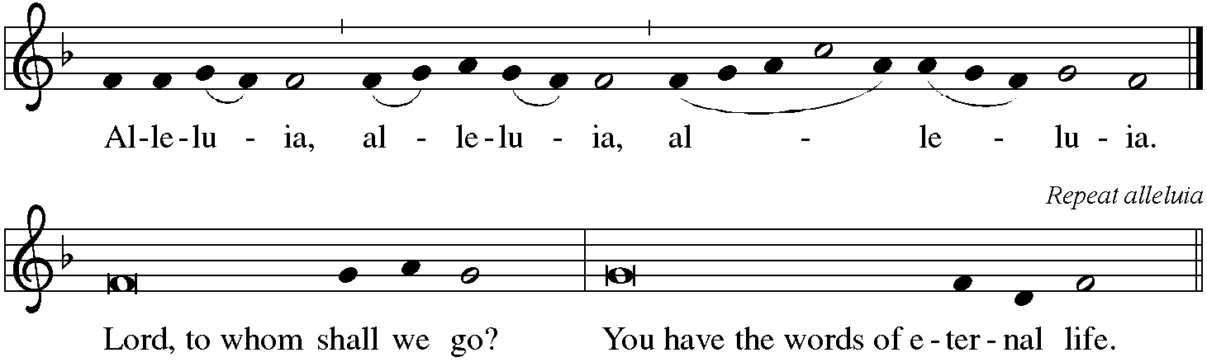

The holy Gospel according to Matthew. Glory to you, O Lord.
*Gospel Matthew 4:12-23
Jesus begins his public ministry shortly after John the Baptist is imprisoned by Herod. He proclaims the nearness of God’s reign and calls four fishermen to be his first disciples.

¹²Now when Jesus heard that John had been arrested, he withdrew to Galilee. ¹³He left Nazareth and made his home in Capernaum by the sea, in the territory of Zebulun and Naphtali, ¹⁴so that what had been spoken through the prophet Isaiah might be fulfilled: ¹⁵“Land of Zebulun, land of Naphtali, on the road by the sea, across the Jordan, Galilee of the Gentiles— ¹⁶the people who sat in darkness have seen a great light, and for those who sat in the region and shadow of death light has dawned.”
¹⁷From that time Jesus began to proclaim, “Repent, for the kingdom of heaven has come near.”
¹⁸As he walked by the Sea of Galilee, he saw two brothers, Simon, who is called Peter, and Andrew his brother, casting a net into the sea—for they were fishermen. ¹⁹And he said to them, “Follow me, and I will make you fish for people.” ²⁰Immediately they left their nets and followed him. ²¹As he went from there, he saw two other brothers, James son of Zebedee and his brother John, in the boat with their father Zebedee, mending their nets, and he called them. ²²Immediately they left the boat and their father, and followed him.

The Gospel of the Lord. Praise to you, O Christ. Be seated.

Sermon Pr. Melody Eastman

*Please stand as you are able.
*Hymn of the Day ELW #661 I Love to Tell the Story
sts. 1, 3
*Prayers of Intercession
Merciful God, receive our prayer.
We bring to you our needs and hopes, O God, trusting your wisdom and power revealed in Christ crucified. Amen.

*Peace
The peace of Christ be with you always. And also with you.

Meal
God feeds us with the presence of Jesus Christ.
Gathering of Gifts
We gather gifts for those in need and for the church’s mission.

Music During Offering

*Please stand as you are able. The gifts are brought forward while the congregation sings:
*Offertory Response ELW #312 Jesus, Come! For We Invite You
sts. 1,2
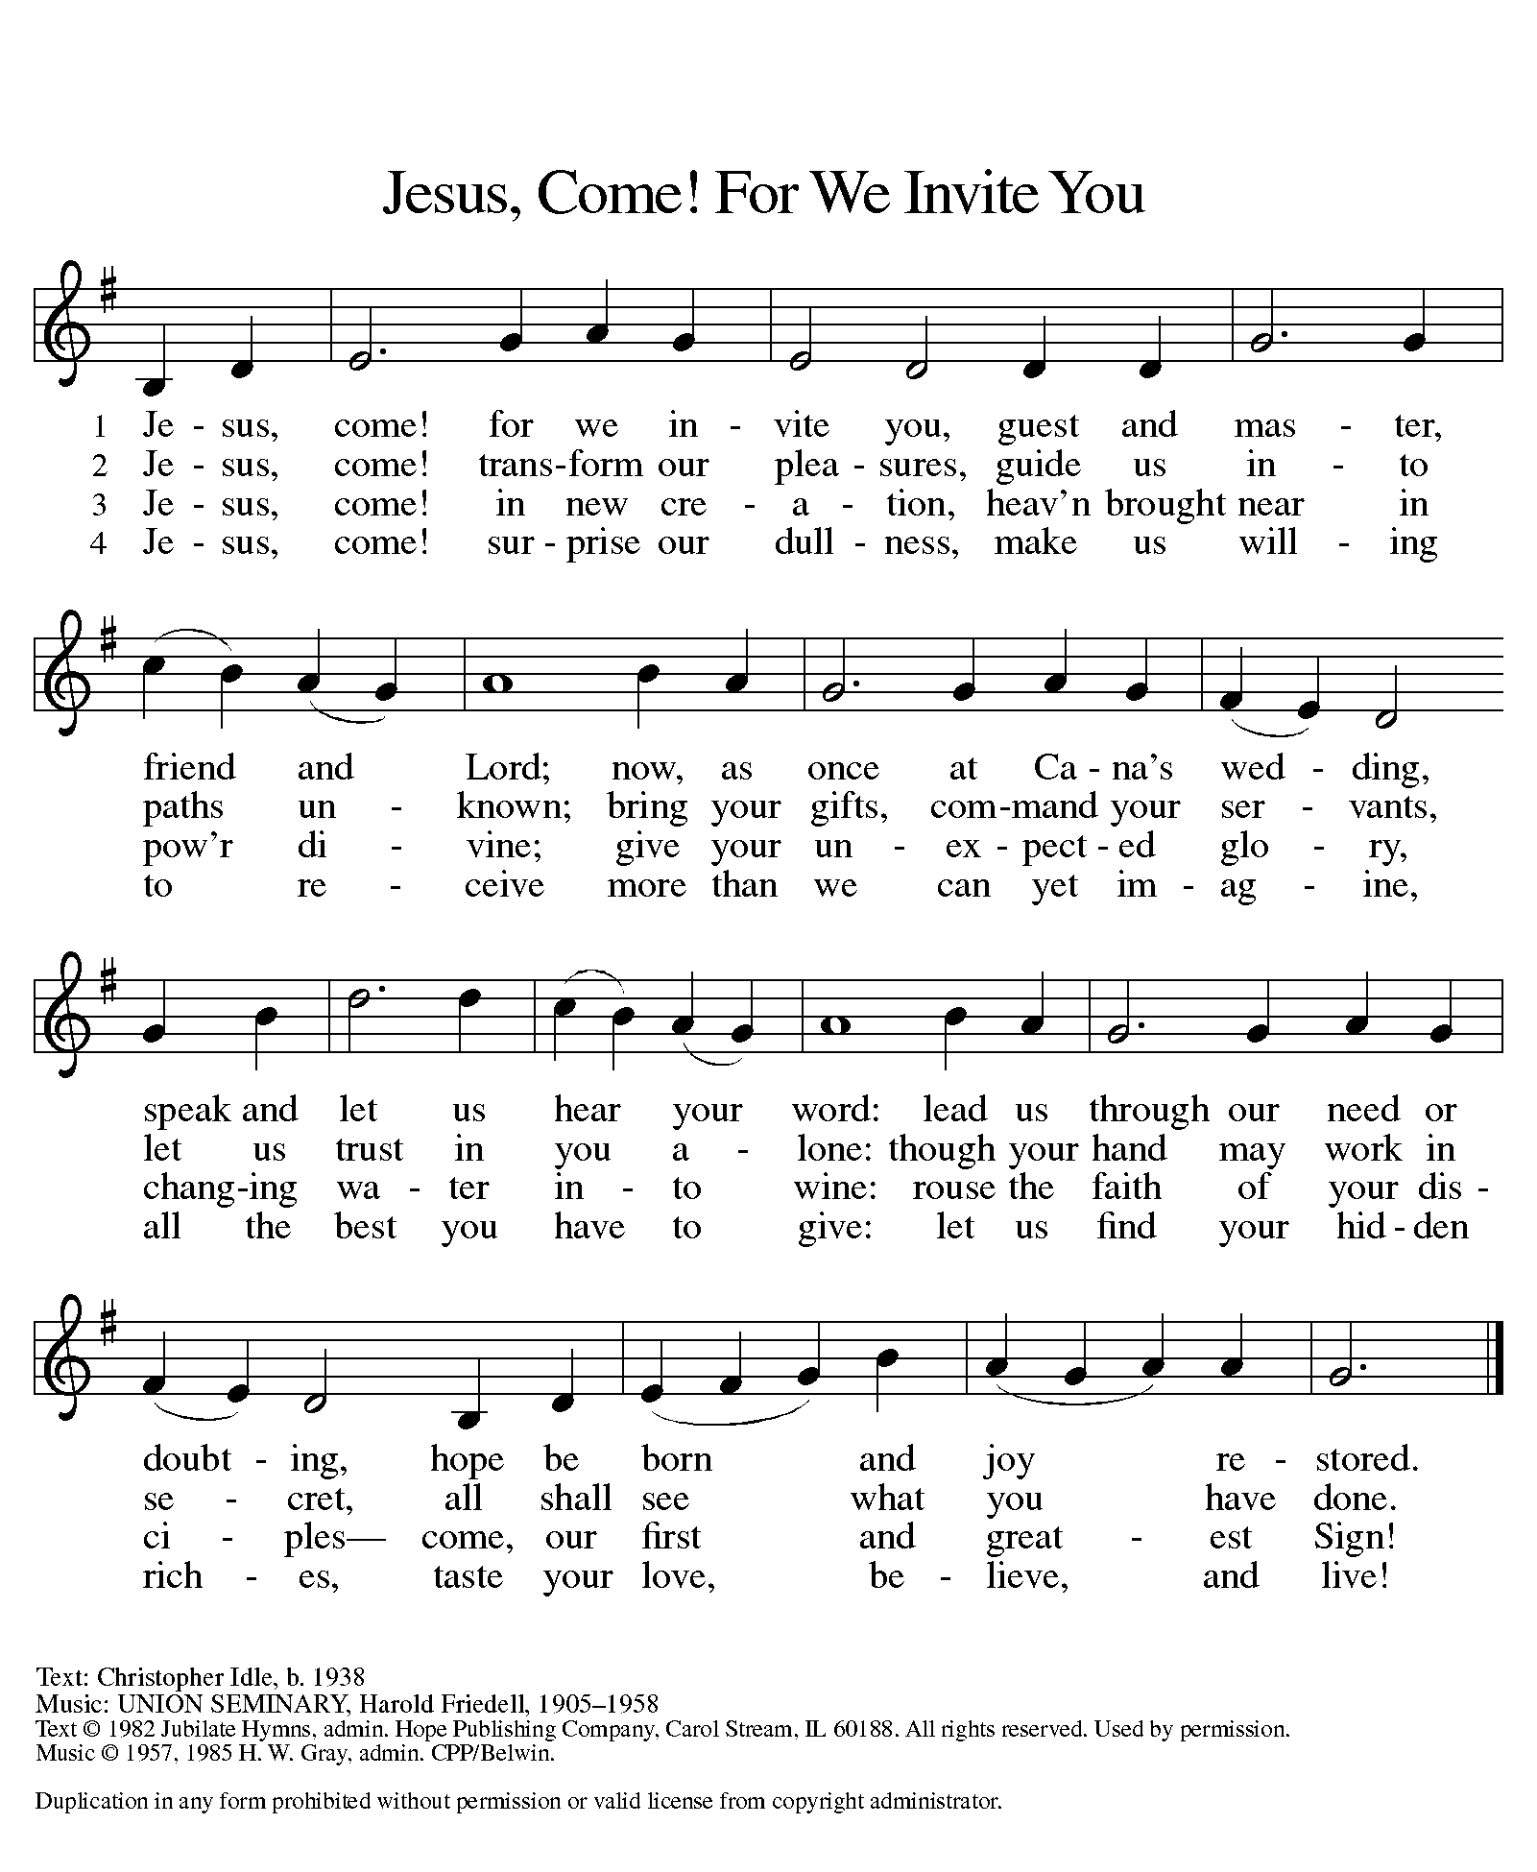
*Offering Prayer
Liberating God, you break the bonds of injustice and let the oppressed go free. Receive these offerings in thanksgiving for all your works of merciful power, and shape us as people of your justice and freedom. You we magnify and adore, through Jesus our Savior, Amen.

*Great Thanksgiving p161

*Preface
*Sanctus p162
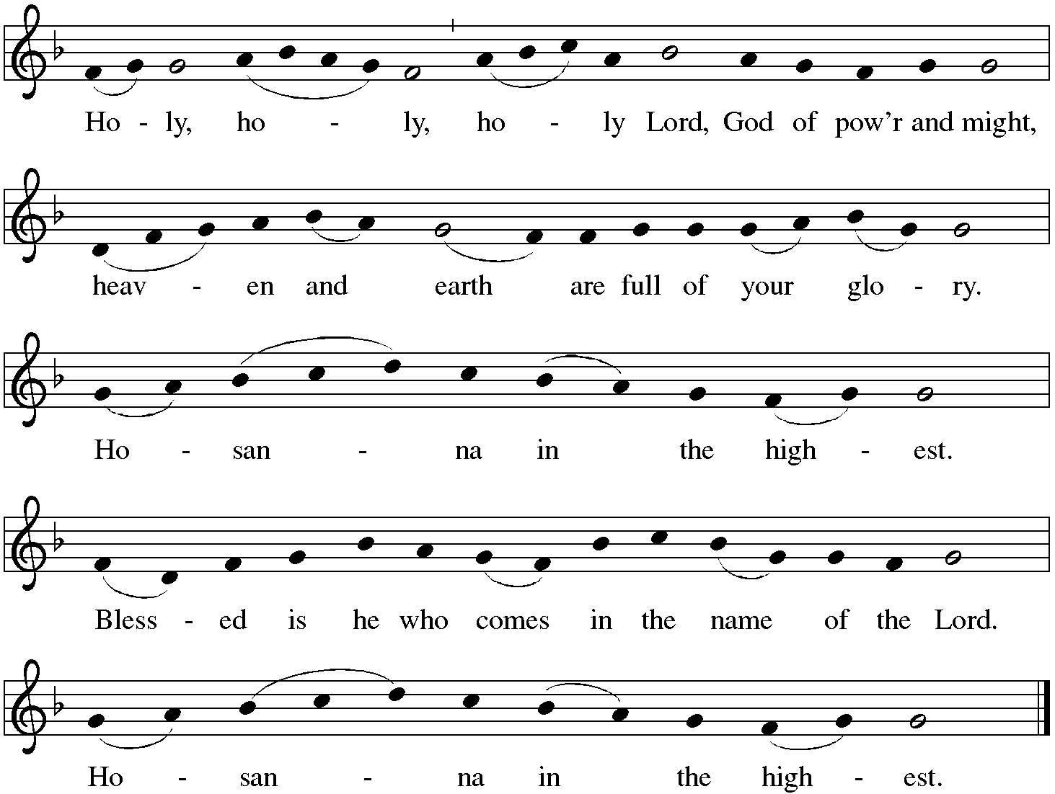
*Thanksgiving at the Table
. . . This cup is the new covenant in my blood, shed for you and for all people for the forgiveness of sin.
Do this for the remembrance of me. Let us proclaim the mystery of faith: Christ has died. Christ is risen. Christ will come again.

With this bread and cup we remember your Word dwelling among us, full of grace and truth. We remember our new birth in his death and resurrection. We look with hope for his coming. Come, Lord Jesus.

Holy God, we long for your Spirit. Come among us. Bless this meal. May your Word take flesh in us. Awaken your people. Fill us with your light. Bring the gift of peace on earth. Come, Holy Spirit.

All praise and glory are yours, Holy One of Israel, Word of God incarnate, Power of the Most High, one God, now and forever. Amen.

*The Lord’s Prayer
Gathered into one by the Holy Spirit, let us pray as Jesus taught us.
Our Father, who art in heaven, hallowed be thy name, thy kingdom come, thy will be done on earth as it is in heaven. Give us this day our daily bread; and forgive us our trespasses, as we forgive those who trespass against us; and lead us not into temptation, but deliver us from evil. For thine is the kingdom, and the power, and the glory, forever and ever. Amen.

*Invitation to Communion
Come and taste the joy of God! Be seated.

Communion
For those receiving communion from home:
This is the body of Christ, given for you. Amen (Eat the bread.)
This is the blood of Christ, shed for you. Amen (Drink the juice.)
Those who wish to come forward for communion or a blessing may do so at the ushers’ direction. You may return to your seat after you have received the bread and wine.

Agnus Dei p164 Lamb of God
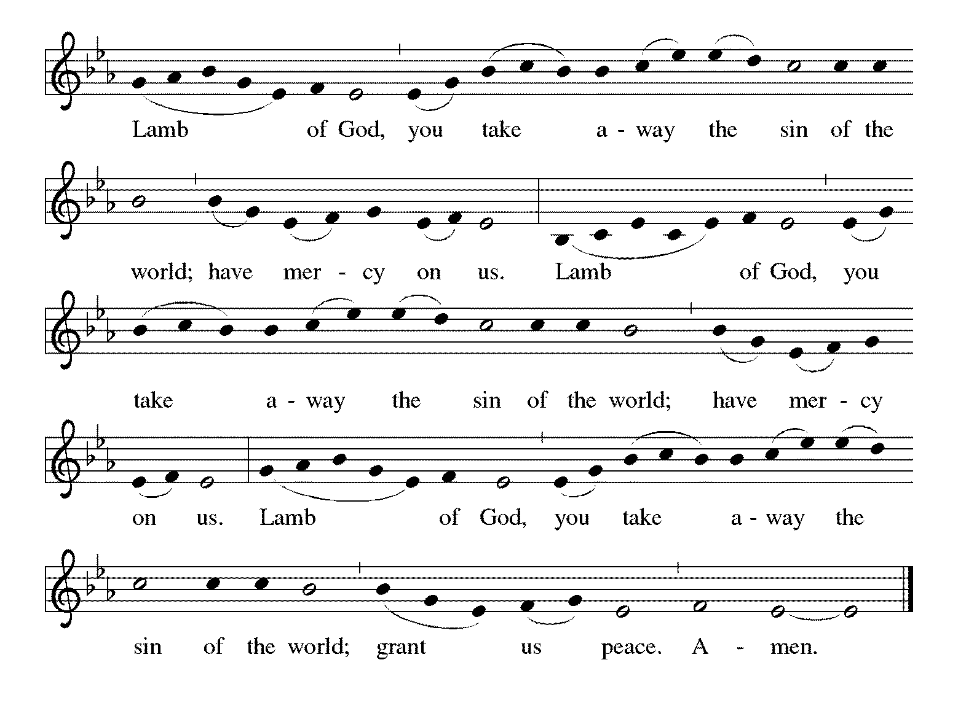

Communion Hymn ELW #574 Here I Am, Lord
Refrain on next page

*Please stand as you are able.
*Post Communion Blessing
May the body and blood of our Lord Jesus Christ strengthen you and keep you in his grace. Amen.

*Post Communion Prayer
Holy One, we thank you for the healing that springs forth abundantly from this table. Renew our strength to do justice, love kindness, and journey humbly with you. Amen.

Sending
God blesses us and sends us in mission to the world.
*Blessing
The God who faithfully brings forth justice and breaks the oppressor’s rod ☩ bless, strengthen, and uphold you, today and always. Amen.

*Sending Hymn ELW #866 We Are Marching in the Light of God
*Sent to the World
Go in peace. Follow the way of Jesus. Thanks be to God.

Postlude

From Sundays and Seasons v.20190109.1233 Copyright © 2022 Augsburg Fortress. All rights reserved.
Reprinted by permission under Augsburg Fortress Liturgies Annual License #30867.
All rights reserved. Reprinted under OneLicense.net #A-718333.

Assisting in Worship Today
Pastor Rev. Melody Eastman
Minister of Music Bradford Thompson
Altar Care Cathy Milleville
Crucifer
Lector Karen Kregor
Ushers Mark Drager, John Jokela
Zoom Mark Hamilton, Jon & Cathy Milleville
Fellowship Hour Sue Davison

Current Prayer Requests
Name Relationship Prayer For
Lenore Dean Member Birthday 1/22 (93)
Luke Pajowski Relative of the Roete’s Healing & Strength
Thom Griffin Friend of Ginny Stein Healing & Strength
Lori Garabrandt Niece of Lois Pertle Healing & Strength
Rich Davison Member Healing & Strength
Brittany Huizenga Cousin of Cheryl Huizenga Healing & Strength
Dorothy Tracy Member Healing & Strength
Prayers for our homebound Members
Carol Petersen, Norma Petersen

Weekly Announcements
Congregational Meeting: Mark your calendars for Sunday, January 29th at 11:15am. Grace will have its annual congregational meeting following our Sunday worship service. Your attendance is needed to reach our 50-member quorum requirement. The meeting will be conducted in the Sanctuary and on Zoom. We will be voting to approve the 2023 budget and electing new Church Council members. We will also share with the congregation our vision and plans for a new and exciting ministry partnership that will carry Grace into the future. Come and be a part of this exciting time at Grace. If you plan to attend the meeting via zoom, contact Barbara Sudds and she can either email or snail-mail the handouts to you.

Contribution statements for 2022 are in the narthex. Any statements not picked up will be mailed on January 30.

Contribution Envelopes: Boxes for 2023 are in the Narthex. Please take your box home with you.

Monday Evening Bible Study: The Monday evening Bible study group, starting on Monday, January 30 at 7:00pm, will study the Gospel of Matthew. This is the primary Gospel we are hearing in church in the current church year which began in late November.

Although evidence suggests that Mark was the first Gospel written, as both Matthew and Luke draw from it for their basic structure, Matthew is placed first in the New Testament because it serves as a bridge to the Hebrew Bible. In the first four chapters, Matthew quotes extensively from the Hebrew prophets to show that the life of Jesus fulfills the Scriptures. Matthew was addressed to a mixed community which included many Jewish converts to Christianity. The author wanted each part of the community to accept the other and to put their new life in Christ ahead of all that might divide them. The Gospel is filled with compassion, concentrating on the key teachings of Jesus to “Love God and love your neighbor.” There is a stress on the emerging church as an assembly of those called out to serve in the Kingdom of Heaven, right here in this world.

We will use Kerygma Bible study materials. The writer of the Resource Book for Matthew is Robert Bryant, Chair of the Department of Religion and Philosophy at Presbyterian College in Clinton, SC. He also wrote the Resource Book for First Corinthians which we studied some years ago. The sessions include a video presentation by the author. Participation will be possible in person in the Great Room and via Zoom link.

The Monday night group has become cohesive over the years, sharing conversation as well as our Bible study. Still, there is always room for more, and we will make you feel welcome. Kindly contact Mark Hamilton or Vince Hardt if you have not participated before so that we may order course materials for you and add you to our Email list.

Zoom Worship
We will offer a Zoom link for our 10am Sunday worship service for those who are continuing to participate from home. If you need a bulletin, remember you can view (on another device) or download/print a bulletin from Grace's website. Just click on Quick Link to Worship.
Zoom link: https://us02web.zoom.us/j/89031586315
Dial In: 1-312-626-6799 Meeting ID: 890 3158 6315

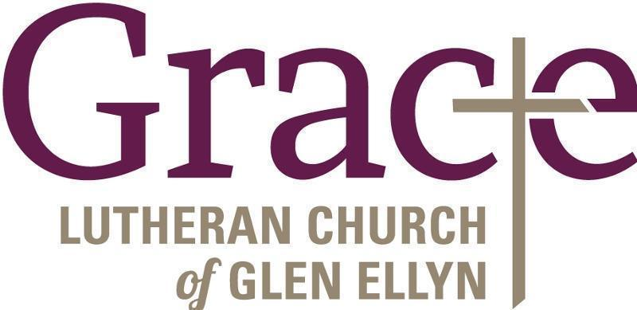

Every Member a Minister and Missionary!

Phone: 630-469-1555 Emergency Pastoral Contact: 630-674-2887
info@graceglenellyn.org www.graceglenellyn.org

Pastor
Rev. Melody Eastman office ext. 14
meastman@graceglenellyn.org

Minister of Music
Bradford Thompson 219-718-8879
bradfordmthompson@gmail.com

Office Manager
Barbara Sudds office ext. 10
bsudds@graceglenellyn.org

Parish Counselor
Carole LoGalbo M.S., LCPC 630-668-4594
carolelogalbo@yahoo.com

