Grace Lutheran Church

493 Forest Avenue, Glen Ellyn IL 630.469.1555
www.graceglenellyn.org

4th Sunday after Epiphany January 29, 2023

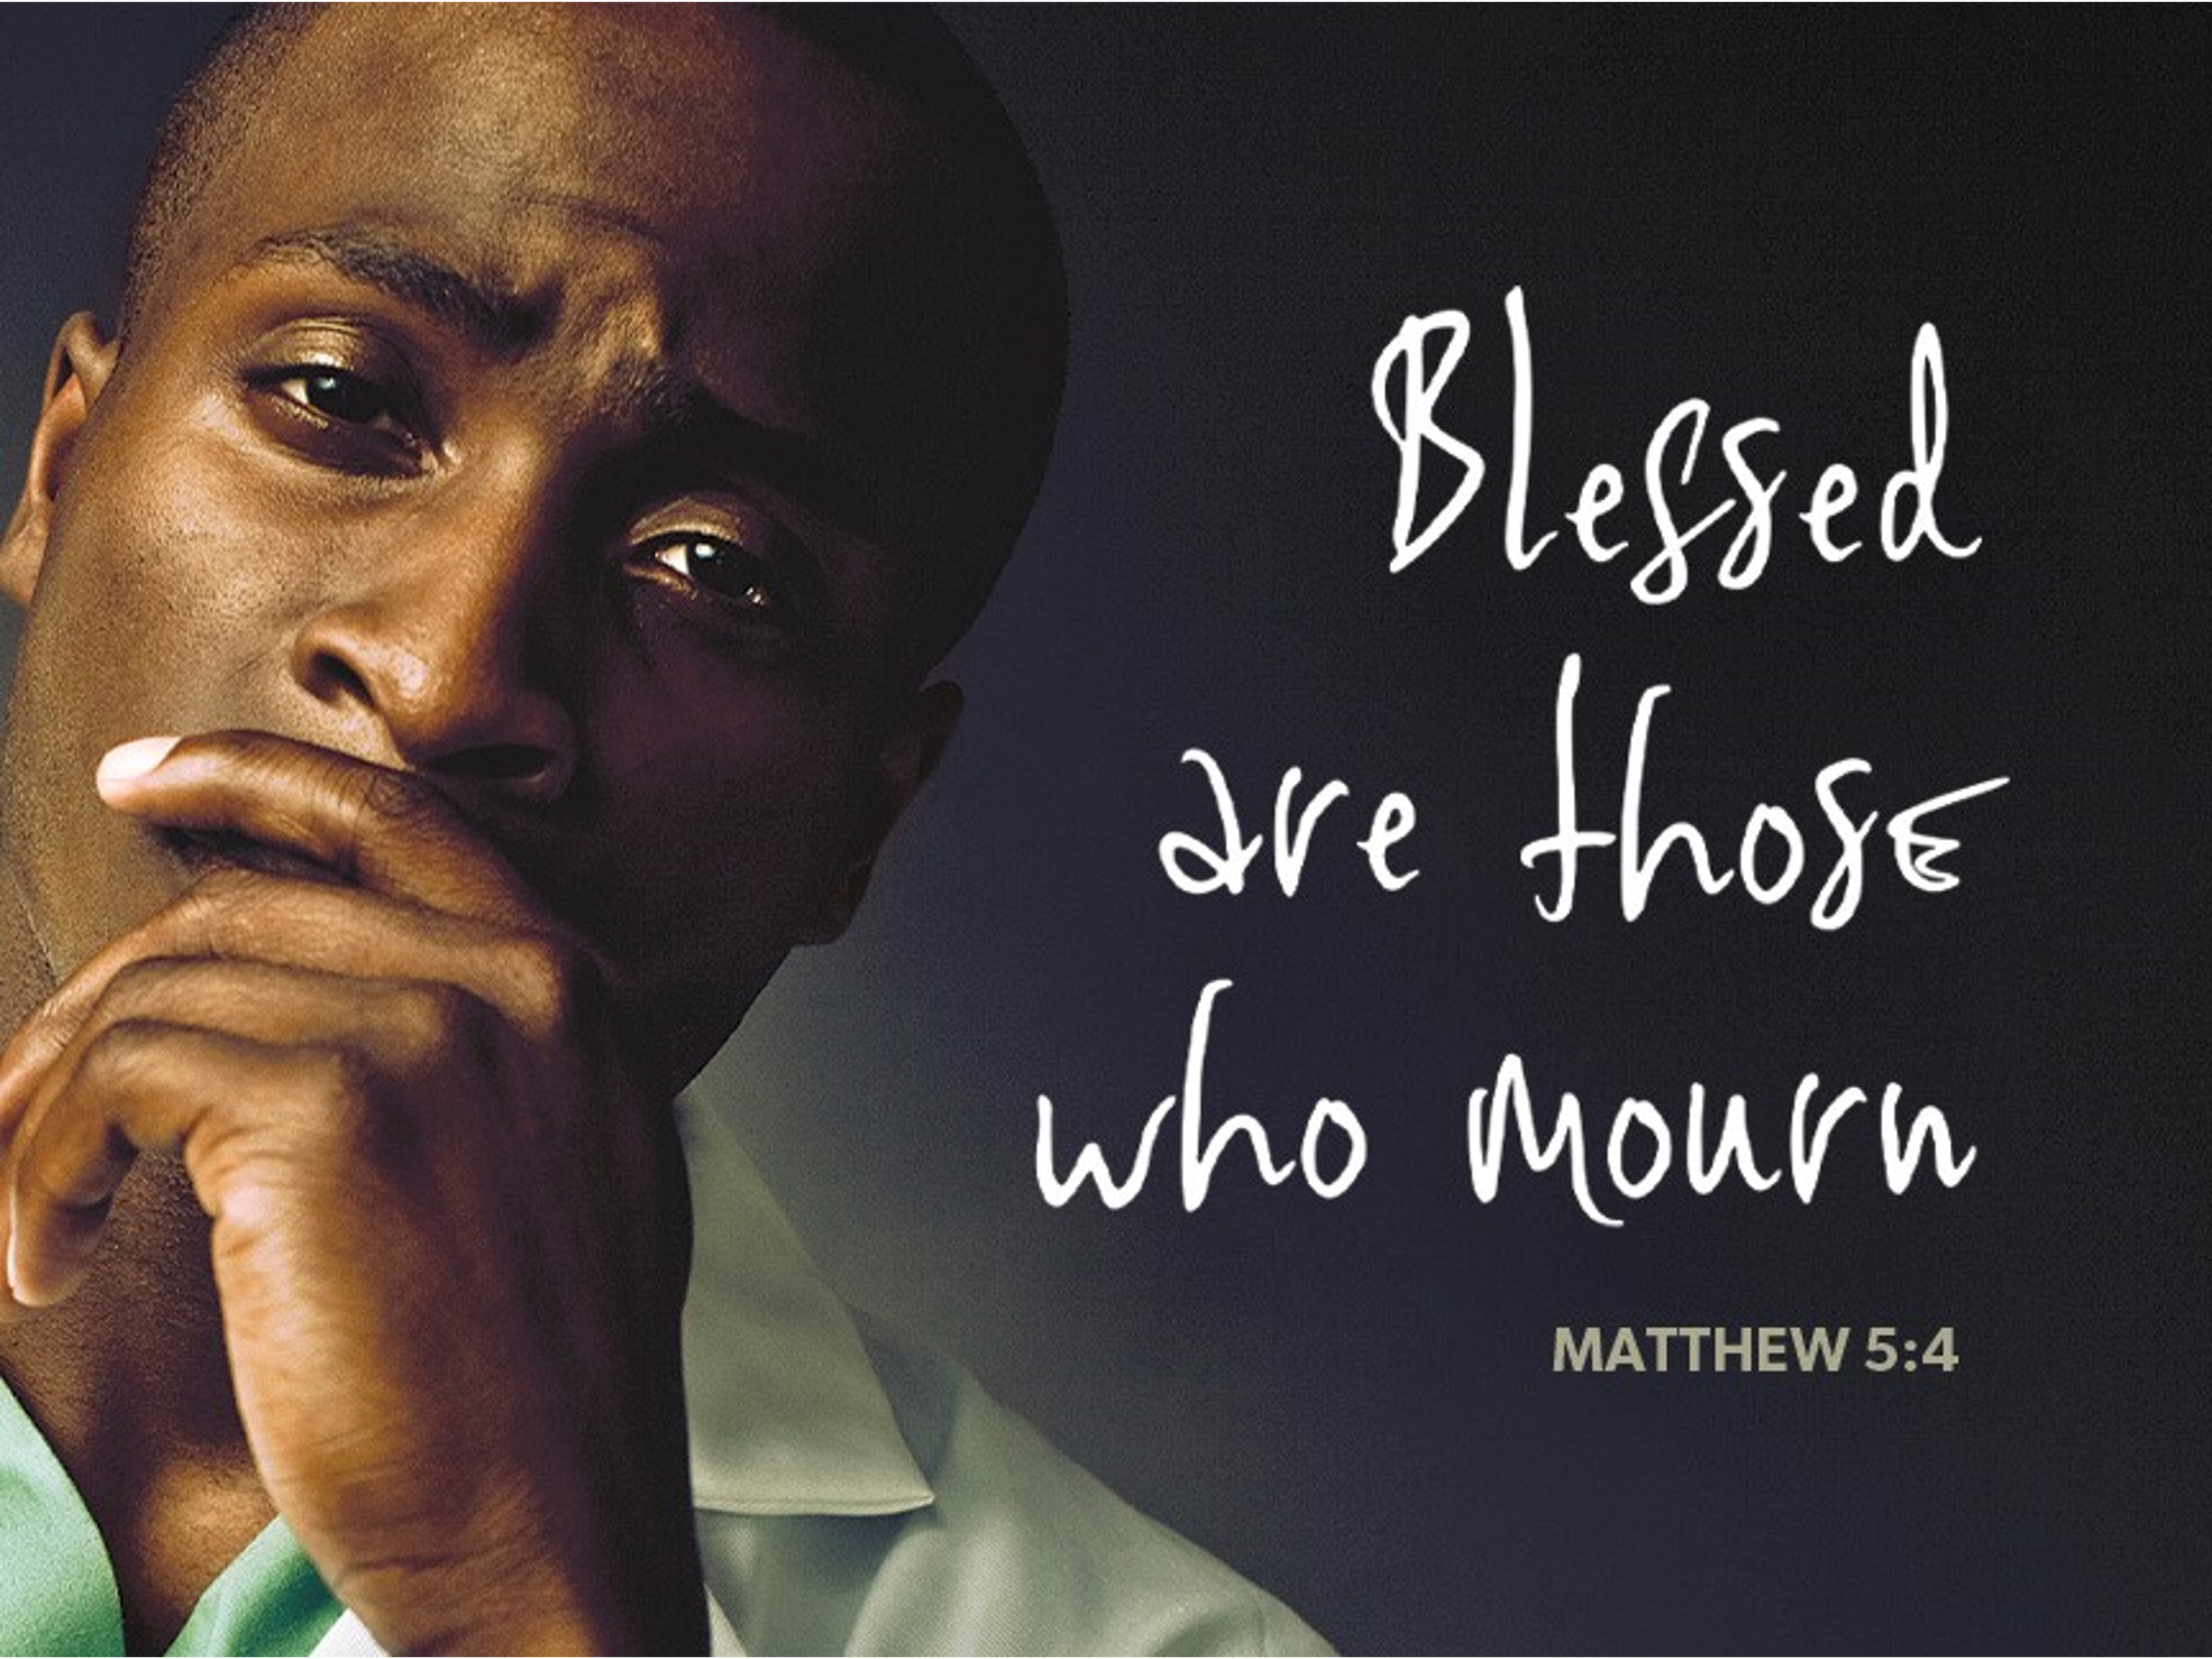

+ Proclaim Christ + Build Community +
+ Serve Our Neighbors +
Especially For Our Guests

Welcome to Grace!
If you are a guest, we’re thankful you’re here today. We hope you will feel welcomed and spiritually nourished. If you would like to speak to the pastor about the congregation, please let her know directly or call the church office. To enhance your worship experience, you may want to know the following:
· Please sign and pass the Worship Register located at the end of the pew near the center aisle. Visitors, please include your address, email, and phone number if you would like to be included on our mailing list or would like to be contact by the Pastor.
· You are invited to join us after service for some great refreshments and Christian fellowship.
· Parts of the liturgy (worship service) not printed in this bulletin are in the red hymnal (ELW). Page numbers in the hymnal are at the bottom of the page; hymn numbers are the large numbers at the top in the back half of the book.
· All baptized people are welcome at communion. If you would like to come forward for a blessing without taking communion, you can do that too. If you have difficulty walking, feel free to let the usher know and we’ll bring communion to you.
· If you find yourself confused about where we are, ask a neighbor!
· Young children are welcome in worship! Parents, you can bring your little ones up front to the PrayGround, a space with tables, chairs, and quiet activities to keep our younger members engaged during services. Please sit near your little ones and help them use the space quietly as well as participate with you in worship. If you prefer, there is also a nursery space for you to use with infants or younger toddlers in the overflow room at the rear of the sanctuary. (But we really do like having children up front, if possible!)
· Please take your bulletin home with you. It contains information of events at Grace plus upcoming announcements.

Introduction
Who are the blessed ones of God? For Micah, they are those who do justice, love kindness, and walk humbly with God. For Paul, they are the ones who find wisdom in the weakness of the cross. For Jesus, they are the poor, the meek, the merciful, the pure in heart, the peacemakers, those who mourn, and those who hunger for righteousness. In baptism we find our blessed identity and calling in this countercultural way of living and serving.

An asterisk (*) indicates that you should stand for that portion of the service. If standing is difficult, please remain seated. Congregation responses are in bold print.
Gathering
The Holy Spirit calls us together as the people of God.
Welcome/Announcements

Prelude

*Please stand as you are able.

*Confession and Forgiveness
All may make the sign of the cross, the sign that is marked at baptism, as the presiding minister begins.
Blessed be the holy Trinity, ☩ one God,
who makes all things new,
whose mercy endures forever.
Amen.

Trusting in God’s mercy, let us confess our sin.
Silence is kept for reflection.
Holy One, source of our renewal,
we confess that we are wrapped up in sin,
and cannot free ourselves.
We have not practiced your righteousness.
Our hearts have turned away from you.
For the sake of the world you so love,
forgive us,
that we may be reconciled to one another
for the glory of your holy name.
Amen.

Thus says our God:
“The former things have come to pass
and new things I now declare.”
God’s mercy makes us new.
We are forgiven in the name of ☩ Christ our Savior. Amen.

*Entrance Hymn ELW #873 Rejoice, Ye Pure in Heart!
sts. 1-3

*Greeting
The grace of our Lord Jesus Christ, the love of God, and the communion of the Holy Spirit be with you all. And also with you.

*Hymn of Praise ELW #164 Glory to God, Glory in the Highest
*Prayer of the Day
Holy God, you confound the world’s wisdom in giving your kingdom to the lowly and the pure in heart. Give us such a hunger and thirst for justice, and perseverance in striving for peace, that in our words and deeds the world may see the life of your Son, Jesus Christ, our Savior and Lord. Amen. Be seated.

Word
God speaks to us in scripture reading.
First Lesson Micah 6:1-8
With the mountains and the foundations of the earth as the jury, God brings a lawsuit against Israel. God has “wearied” Israel with a long history of saving acts. God does not want or expect lavish sacrifices to attempt to earn divine favor. Rather God empowers the people to do justice, to love loyalty to God, and to walk shrewdly in God’s service.

¹Hear what the Lord says: Rise, plead your case before the mountains, and let the hills hear your voice. ²Hear, you mountains, the controversy of the Lord, and you enduring foundations of the earth; for the Lord has a controversy with his people, and he will contend with Israel.
³“O my people, what have I done to you? In what have I wearied you? Answer me! ⁴For I brought you up from the land of Egypt, and redeemed you from the house of slavery; and I sent before you Moses, Aaron, and Miriam. ⁵O my people, remember now what King Balak of Moab devised, what Balaam son of Beor answered him, and what happened from Shittim to Gilgal, that you may know the saving acts of the Lord.”
⁶“With what shall I come before the Lord, and bow myself before God on high? Shall I come before him with burnt offerings, with calves a year old? ⁷Will the Lord be pleased with thousands of rams, with ten thousands of rivers of oil? Shall I give my firstborn for my transgression, the fruit of my body for the sin of my soul?” ⁸He has told you, O mortal, what is good; and what does the Lord require of you but to do justice, and to love kindness, and to walk humbly with your God?

Word of God, Word of Life. Thanks be to God.

Second Lesson 1 Corinthians 1:18-31
According to the world’s standards of power and might, the message of the cross seems stupid and offensive. Yet this word reveals the paradoxical way God has chosen to work power and salvation through weakness, rejection, and suffering. Hence the message of the cross becomes true wisdom and power for believers.

¹⁸The message about the cross is foolishness to those who are perishing, but to us who are being saved it is the power of God. ¹⁹For it is written, “I will destroy the wisdom of the wise, and the discernment of the discerning I will thwart.” ²⁰Where is the one who is wise? Where is the scribe? Where is the debater of this age? Has not God made foolish the wisdom of the world? ²¹For since, in the wisdom of God, the world did not know God through wisdom, God decided, through the foolishness of our proclamation, to save those who believe. ²²For Jews demand signs and Greeks desire wisdom, ²³but we proclaim Christ crucified, a stumbling block to Jews and foolishness to Gentiles, ²⁴but to those who are the called, both Jews and Greeks, Christ the power of God and the wisdom of God. ²⁵For God’s foolishness is wiser than human wisdom, and God’s weakness is stronger than human strength.
²⁶Consider your own call, brothers and sisters: not many of you were wise by human standards, not many were powerful, not many were of noble birth. ²⁷But God chose what is foolish in the world to shame the wise; God chose what is weak in the world to shame the strong; ²⁸God chose what is low and despised in the world, things that are not, to reduce to nothing things that are, ²⁹so that no one might boast in the presence of God. ³⁰He is the source of your life in Christ Jesus, who became for us wisdom from God, and righteousness and sanctification and redemption, ³¹in order that, as it is written, “Let the one who boasts, boast in the Lord.”

Word of God, Word of Life. Thanks be to God.

*Please stand as you are able.
*Gospel Acclamation ELW #170

The holy Gospel according to Matthew. Glory to you, O Lord.
*Gospel Matthew 5:1-12
Jesus opens the Sermon on the Mount by naming those who are blessed in the reign of God.

¹When Jesus saw the crowds, he went up the mountain; and after he sat down, his disciples came to him. ²Then he began to speak, and taught them, saying:
³“Blessed are the poor in spirit, for theirs is the kingdom of heaven.
⁴“Blessed are those who mourn, for they will be comforted.
⁵“Blessed are the meek, for they will inherit the earth.
⁶“Blessed are those who hunger and thirst for righteousness, for they will be filled.
⁷“Blessed are the merciful, for they will receive mercy.
⁸“Blessed are the pure in heart, for they will see God.
⁹“Blessed are the peacemakers, for they will be called children of God.
¹⁰“Blessed are those who are persecuted for righteousness’ sake, for theirs is the kingdom of heaven.
¹¹“Blessed are you when people revile you and persecute you and utter all kinds of evil against you falsely on my account. ¹²Rejoice and be glad, for your reward is great in heaven, for in the same way they persecuted the prophets who were before you.”

The Gospel of the Lord. Praise to you, O Christ. Be seated.

Sermon Pr. Melody Eastman

*Please stand as you are able.
*Hymn of the Day ELW #710 Let Streams of Living Justice

*Prayers of Intercession
Called together to follow Jesus, we pray for the church, the world, and all in need.
A brief silence.

Cultivate humility in your church. In gatherings of every size, teach us to boast only in the cross. Shape your church to be people of kindness, generosity, and justice. Merciful God, receive our prayer.

The foundations of the earth bear witness to your faithfulness; the mountains and hills echo with your holiness. When we mistreat your creation, show us the error of our ways. Inspire us with reverent awe to honor all you have made. Merciful God, receive our prayer.

You make foolish the wisdom of the world. Raise up honorable leaders who seek justice, love mercy, and pursue peace. Frustrate plans that are corrupt, wicked, and self-seeking. Prosper the work of peacemakers. Merciful God, receive our prayer.

Bless all whom the world rejects. Accompany those who are regarded as foolish, weak, low, and despised; reveal your power and presence at work where it is least expected. Give your life, strength, and wisdom to all in need especially Luke, Lori, Brittany, Norma, Carol, Dorothy, and those we name before you now . . . Merciful God, receive our prayer.

As with your people Israel, remind this congregation of your saving acts. Remind us how your faithfulness brought us through difficulties and sustained us despite our weaknesses. Establish the cross as the center of our life together. Merciful God, receive our prayer.
Here other intercessions may be offered.

Praise to you for your blessed saints in every time and place. Trusting you accompanied them in poverty, persecution, and in every trial, we trust you abide with your people always. Merciful God, receive our prayer.

We bring to you our needs and hopes, O God, trusting your wisdom and power revealed in Christ crucified. Amen.

*Peace
The peace of Christ be with you always. And also with you.
Please share the peace with others in your household, or by making a sign of peace to those on Zoom. You may then be seated as the table is prepared.

Meal
God feeds us with the presence of Jesus Christ.
Gathering of Gifts
We gather gifts for those in need and for the church’s mission.

Music During Offering

*Please stand as you are able. The gifts are brought forward while the congregation sings:
*Offertory Response ELW #185 Create in Me a Clean Heart

*Offering Prayer
Liberating God, you break the bonds of injustice and let the oppressed go free.
Receive these offerings in thanksgiving for all your works of merciful power,
and shape us as people of your justice and freedom. You we magnify and adore, through Jesus our Savior, Amen.

*Great Thanksgiving p161

*Preface
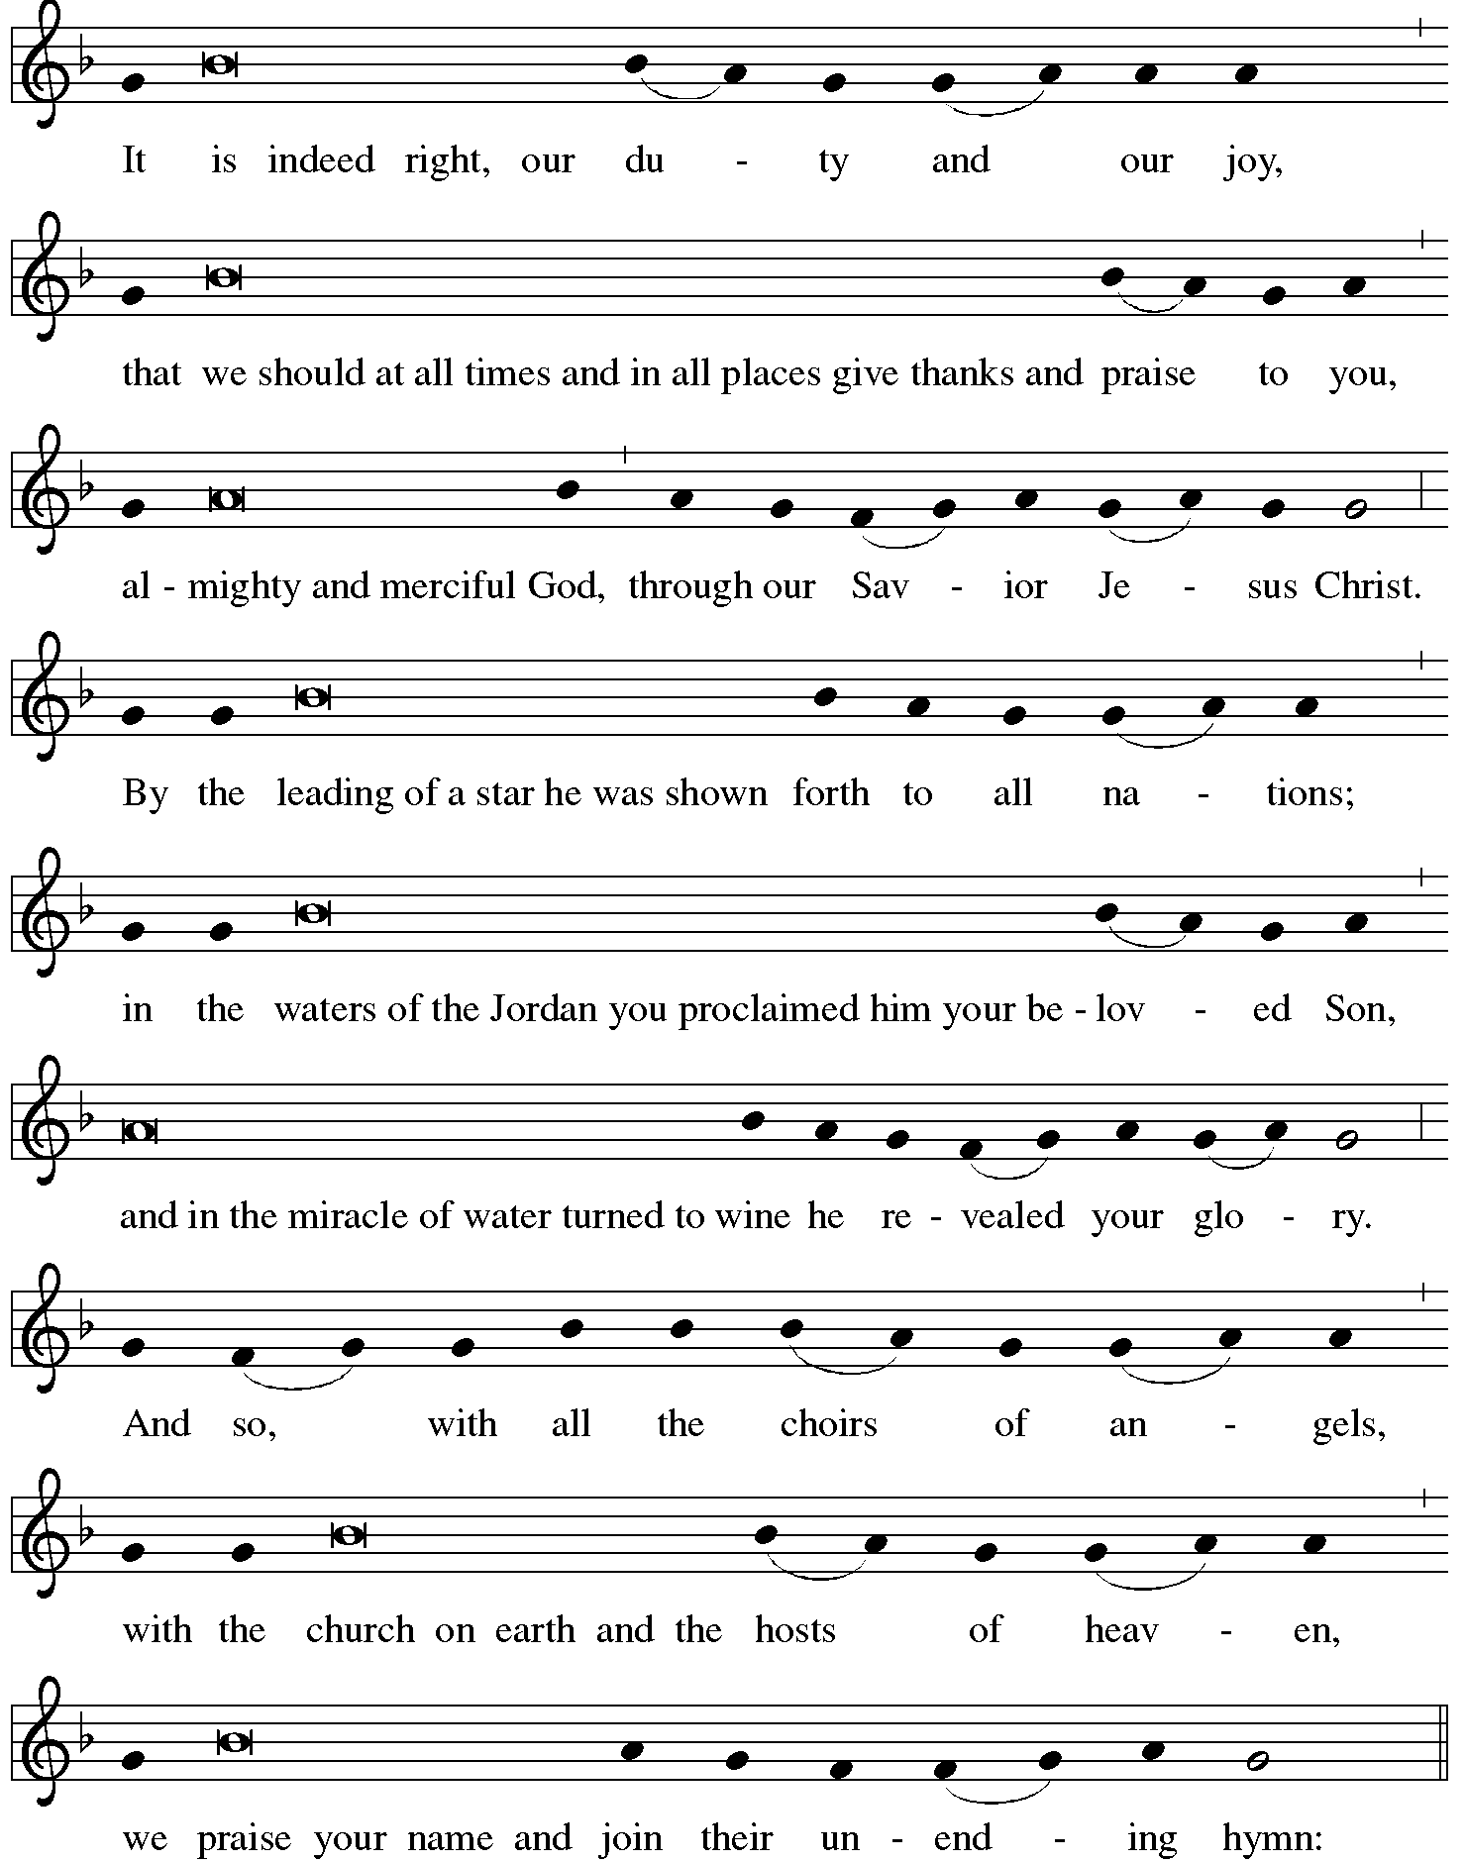

*Sanctus ELW #191 Holy, Holy, Holy

*Thanksgiving at the Table
Holy One, the beginning and the end, the giver of life:
Blessed are you for the birth of creation.
Blessed are you in the darkness and in the light.
Blessed are you for your promise to your people.
Blessed are you in the prophets' hopes and dreams.
Blessed are you for Mary's openness to your will.
Blessed are you for your Son Jesus, the Word made flesh.

In the night in which he was betrayed,
our Lord Jesus took bread, and gave thanks;
broke it, and gave it to his disciples, saying:
Take and eat; this is my body, given for you.
Do this for the remembrance of me.

Again, after supper, he took the cup, gave thanks,
and gave it for all to drink, saying:
This cup is the new covenant in my blood,
shed for you and for all people for the forgiveness of sin.
Do this for the remembrance of me.

Let us proclaim the mystery of faith:
Christ has died. Christ is risen. Christ will come again.

With this bread and cup we remember your Word
dwelling among us, full of grace and truth.
We remember our new birth in his death and resurrection.
We look with hope for his coming. Come, Lord Jesus.

Holy God, we long for your Spirit. Come among us.
Bless this meal. May your Word take flesh in us.
Awaken your people. Fill us with your light.
Bring the gift of peace on earth. Come, Holy Spirit.

All praise and glory are yours,
Holy One of Israel,
Word of God incarnate,
Power of the Most High,
one God, now and forever.
Amen.

*The Lord’s Prayer Ecumenical Version
Gathered into one by the Holy Spirit, let us pray as Jesus taught us.
Our Father in heaven, hallowed be your name, your kingdom come, your will be done, on earth as in heaven. Give us today our daily bread. Forgive us our sins as we forgive those who sin against us. Save us from the time of trial and deliver us from evil. For the kingdom, the power and the glory are yours, now and forever. Amen.

*Invitation to Communion
Come and taste the joy of God! Be seated.

Communion
For those receiving communion from home:
This is the body of Christ, given for you. Amen (Eat the bread.)
This is the blood of Christ, shed for you. Amen (Drink the juice.)
Those who wish to come forward for communion or a blessing may do so at the ushers’ direction. You may return to your seat after you have received the bread and wine.

Agnus Dei ELW #194 Lamb of God

Communion Hymn ELW #642 Ubi caritas et amor

Communion Hymn ELW #644 Although I Speak with Angel’s Tongue

*Please stand as you are able.
*Post Communion Blessing
May the body and blood of our Lord Jesus Christ
strengthen you and keep you in his grace. Amen.

*Post Communion Prayer
Holy One,
we thank you for the healing
that springs forth abundantly from this table.
Renew our strength to do justice,
love kindness,
and journey humbly with you.
Amen.

Sending
God blesses us and sends us in mission to the world.
*Blessing
The God who faithfully brings forth justice
and breaks the oppressor’s rod
☩ bless, strengthen, and uphold you,
today and always. Amen.

*Sending Hymn ELW #546 To Be Your Presence

*Sent to the World
Go in peace. Follow the way of Jesus. Thanks be to God.

Postlude

From Sundays and Seasons v.20190109.1233 Copyright © 2022 Augsburg Fortress. All rights reserved.
Reprinted by permission under Augsburg Fortress Liturgies Annual License #30867.
All rights reserved. Reprinted under OneLicense.net #A-718333.

Assisting in Worship Today
Pastor Rev. Melody Eastman
Minister of Music Bradford Thompson
Altar Care Cathy Milleville
Crucifer Evelyn Dieter
Lector Elizabeth Dieter
Ushers Mark Drager, John Jokela
Zoom Mark Hamilton, Jon & Cathy Milleville
Fellowship Hour Andy Swiston

Current Prayer Requests
Name Relationship Prayer For
Luke Pajowski Relative of the Roetes Healing & Strength
Lori Garabrandt Niece of Lois Pertle Healing & Strength
Brittany Huizenga Cousin of Cheryl Huizenga Healing & Strength
Dorothy Tracy Member Healing & Strength
Prayers for our homebound Members
Norma Petersen

Weekly Announcements
Congregational Meeting TODAY: Grace will have its annual congregational meeting following today’s worship service. Your attendance is needed to reach our 50-member quorum requirement. The meeting will be conducted in the Sanctuary and on Zoom. We will be voting to approve the 2023 budget and electing new Church Council members. We will also share with the congregation our vision and plans for a new and exciting ministry partnership that will carry Grace into the future. Come and be a part of this exciting time at Grace.

Contribution statements for 2022 are in the narthex. Any statements not picked up will be mailed on January 30.

Contribution Envelopes: Boxes for 2023 are in the Narthex. Please take your box home with you.

Monday Evening Bible Study: The Monday evening Bible study group, starting on Monday, January 30 at 7:00pm, will study the Gospel of Matthew. This is the primary Gospel we are hearing in church in the current church year which began in late November.

Although evidence suggests that Mark was the first Gospel written, as both Matthew and Luke draw from it for their basic structure, Matthew is placed first in the New Testament because it serves as a bridge to the Hebrew Bible. In the first four chapters, Matthew quotes extensively from the Hebrew prophets to show that the life of Jesus fulfills the Scriptures. Matthew was addressed to a mixed community which included many Jewish converts to Christianity. The author wanted each part of the community to accept the other and to put their new life in Christ ahead of all that might divide them. The Gospel is filled with compassion, concentrating on the key teachings of Jesus to “Love God and love your neighbor.” There is a stress on the emerging church as an assembly of those called out to serve in the Kingdom of Heaven, right here in this world.

We will use Kerygma Bible study materials. The writer of the Resource Book for Matthew is Robert Bryant, Chair of the Department of Religion and Philosophy at Presbyterian College in Clinton, SC. He also wrote the Resource Book for First Corinthians which we studied some years ago. The sessions include a video presentation by the author. Participation will be possible in person in the Great Room and via Zoom link.

The Monday night group has become cohesive over the years, sharing conversation as well as our Bible study. Still, there is always room for more, and we will make you feel welcome. Kindly contact Mark Hamilton or Vince Hardt if you have not participated before so that we may order course materials for you and add you to our Email list.

Zoom Worship
We will offer a Zoom link for our 10am Sunday worship service for those who are continuing to participate from home. If you need a bulletin, remember you can view (on another device) or download/print a bulletin from Grace's website. Just click on Quick Link to Worship.
Zoom link: https://us02web.zoom.us/j/89031586315
Dial In: 1-312-626-6799 Meeting ID: 890 3158 6315

Every Member a Minister and Missionary!

Phone: 630-469-1555 Emergency Pastoral Contact: 630-674-2887
info@graceglenellyn.org www.graceglenellyn.org

Pastor
Rev. Melody Eastman office ext. 14
meastman@graceglenellyn.org

Minister of Music
Bradford Thompson 219-718-8879
bradfordmthompson@gmail.com

Office Manager
Barbara Sudds office ext. 10
bsudds@graceglenellyn.org

Parish Counselor
Carole LoGalbo M.S., LCPC 630-668-4594
carolelogalbo@yahoo.com

