Grace Lutheran Church
493 Forest Avenue, Glen Ellyn IL 630.469.1555
www.graceglenellyn.org

Fifth Sunday after Epiphany February 7, 2021

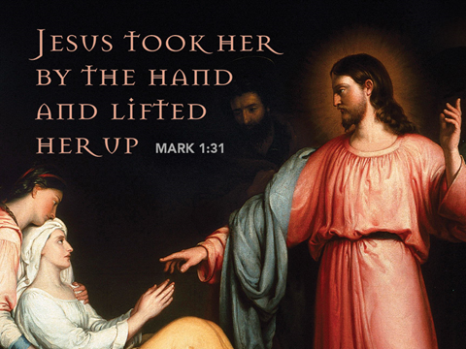

+ Proclaim Christ + Build Community +
+ Serve Our Neighbors +
Introduction
In Isaiah the one God who sits above the earth and numbers the stars also strengthens the powerless. So in Jesus’ healing work we see the hand of the creator God, lifting up the sick woman to health and service (diakonia). Like Simon’s mother-in-law, we are lifted up and healed to serve. Following Jesus, we strengthen the powerless; like Jesus, we seek to renew our own strength in quiet times of prayer.

Helpful Reminders for House Church:
- Mute your mic during hymns.
- You may unmute for all group responses. Remember that your host can mute you but cannot unmute you; you must unmute your mic yourself.
- If you are joining by phone, move the mouthpiece away from your mouth unless you are speaking, to avoid broadcasting your breathing.
- Avoid background conversations when your mic is unmuted.
- THANK YOU FOR WORSHIPPING WITH US!

Gathering
The Holy Spirit calls us together as the people of God.
Prelude (Please mute your mic)

Confession and Forgiveness (You may unmute your mic)
All may make the sign of the cross, the sign marked at baptism,
as the worship leader begins.
Blessed be the holy Trinity, ☩ one God, whose voice is upon the waters, whose mercy is poured out upon all people, whose goodness cascades over all creation. Amen.

Let us confess our sin, trusting in the abundant grace of God.
Silence is kept for reflection.
Holy God, you search us and know us. You are acquainted with all our ways. We confess that our hearts are burdened by sin—our own sins and the broken systems that bind us. We turn inward, failing to follow your outward way of love. We distrust those who are not like us.
We exploit the earth and its resources and fail to consider generations to come. Forgive us, gracious God, for all we have done and left undone. Even before the words are on our tongues, you know them; receive them in your divine mercy. Amen.

How vast is God’s grace! Through the power and promise of ☩ Christ Jesus, our sins are washed away and we are claimed as God’s own beloved. Indeed, we are forgiven. In the wake of God’s forgiveness, we are called to be the beloved community living out Christ’s justice
and the Spirit’s reconciling peace. Amen.

Opening Hymn (Please mute your mic) ELW #532 Gather Us In; sts. 1, 2, 4
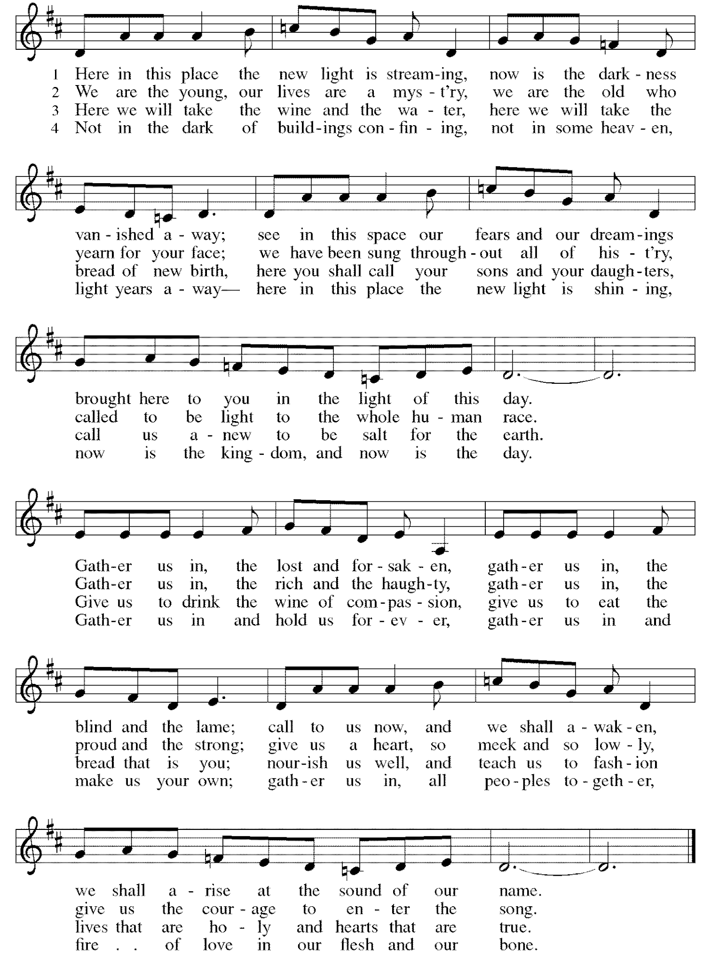
(You may unmute your mic)
Greeting
The grace of our Lord Jesus Christ, the love of God, and the communion of the Holy Spirit be with you all. And also with you.

Prayer of the Day
Everlasting God, you give strength to the weak and power to the faint. Make us agents of your healing and wholeness, that your good news may be made known to the ends of your creation, through Jesus Christ, our Savior and Lord. Amen.

Word
God speaks to us in scripture reading, preaching, and song.
First Lesson Isaiah 40:21-31
The Judeans in exile have a good reason to be hopeful: the one who will bring them to freedom is the God who created the world, the God who subdues the rulers of the earth and gives strength to those who are weary.

²¹Have you not known? Have you not heard? Has it not been told you from the beginning? Have you not understood from the foundations of the earth? ²²It is he who sits above the circle of the earth, and its inhabitants are like grasshoppers; who stretches out the heavens like a curtain, and spreads them like a tent to live in; ²³who brings princes to naught, and makes the rulers of the earth as nothing.
²⁴Scarcely are they planted, scarcely sown, scarcely has their stem taken root in the earth, when he blows upon them, and they wither, and the tempest carries them off like stubble.
²⁵To whom then will you compare me, or who is my equal? says the Holy One. ²⁶Lift up your eyes on high and see: Who created these? He who brings out their host and numbers them, calling them all by name; because he is great in strength, mighty in power, not one is missing.
²⁷Why do you say, O Jacob, and speak, O Israel, “My way is hidden from the Lord, and my right is disregarded by my God”? ²⁸Have you not known? Have you not heard? The Lord is the everlasting God, the Creator of the ends of the earth. He does not faint or grow weary; his understanding is unsearchable. ²⁹He gives power to the faint, and strengthens the powerless. ³⁰Even youths will faint and be weary, and the young will fall exhausted; ³¹but those who wait for the Lord shall renew their strength, they shall mount up with wings like eagles, they shall run and not be weary, they shall walk and not faint.

Word of God, Word of Life. Thanks be to God.

The Psalm Read responsively by verse Psalm 147:1-11, 20c
¹Hallelujah! How good it is to sing praises to our God!
How pleasant it is to honor God with praise!
²The Lord rebuilds Jerusalem,
and gathers the exiles of Israel.
³The Lord heals the brokenhearted
and binds up their wounds.
⁴The Lord counts the number of the stars
and calls them all by their names.
⁵Great is our Lord and mighty in power;
there is no limit to God’s wisdom.
⁶The Lord lifts up the lowly,
but casts the wicked to the ground.
⁷Sing to the Lord with thanksgiving;
make music upon the harp to our God,
⁸who covers the heavens with clouds
and prepares rain for the earth, making grass to grow upon the mountains.
⁹God provides food for the cattle
and for the young ravens when they cry.
¹⁰God is not impressed by the might of a horse,
and has no pleasure in the speed of a runner,
¹¹but finds pleasure in those who fear the Lord,
in those who await God’s steadfast love. ^{20c}Hallelujah!

Second Lesson 1 Corinthians 9:16-23
God entrusted Paul with the responsibility of bringing the gospel to diverse people. Hence the focus of Paul’s ministry is not his own rights or privileges as an apostle but the privilege of serving God by freely sharing the good news of Christ with others.

¹⁶If I proclaim the gospel, this gives me no ground for boasting, for an obligation is laid on me, and woe to me if I do not proclaim the gospel! ¹⁷For if I do this of my own will, I have a reward; but if not of my own will, I am entrusted with a commission. ¹⁸What then is my reward? Just this: that in my proclamation I may make the gospel free of charge, so as not to make full use of my rights in the gospel.
¹⁹For though I am free with respect to all, I have made myself a slave to all, so that I might win more of them. ²⁰To the Jews I became as a Jew, in order to win Jews. To those under the law I became as one under the law (though I myself am not under the law) so that I might win those under the law. ²¹To those outside the law I became as one outside the law (though I am not free from God’s law but am under Christ’s law) so that I might win those outside the law. ²²To the weak I became weak, so that I might win the weak. I have become all things to all people, that I might by all means save some. ²³I do it all for the sake of the gospel, so that I may share in its blessings.

Word of God, Word of Life. Thanks be to God.

Gospel Acclamation
Alleluia. The servant of God took our infirmities and bore our diseases. Alleluia.

(Please mute your mic)

The holy Gospel according to Mark. Glory to you, O Lord.
Gospel Mark 1:29-39
Everywhere Jesus goes, many people expect him to set them free from oppression. Everywhere he goes, he heals people and sets them free. Disease, devils, and death are running for their lives. The forces that diminish human life are rendered powerless by Jesus.

²⁹As soon as [Jesus and the disciples] left the synagogue, they entered the house of Simon and Andrew, with James and John. ³⁰Now Simon’s mother-in-law was in bed with a fever, and they told him about her at once. ³¹He came and took her by the hand and lifted her up. Then the fever left her, and she began to serve them.
³²That evening, at sunset, they brought to him all who were sick or possessed with demons. ³³And the whole city was gathered around the door. ³⁴And he cured many who were sick with various diseases, and cast out many demons; and he would not permit the demons to speak, because they knew him.
³⁵In the morning, while it was still very dark, he got up and went out to a deserted place, and there he prayed. ³⁶And Simon and his companions hunted for him. ³⁷When they found him, they said to him, “Everyone is searching for you.” ³⁸He answered, “Let us go on to the neighboring towns, so that I may proclaim the message there also; for that is what I came out to do.” ³⁹And he went throughout Galilee, proclaiming the message in their synagogues and casting out demons.

The Gospel of the Lord. Praise to you, O Christ.

Sermon The Rev. Melody Eastman

(You may unmute your mic)

Apostles’ Creed
With the whole church, let us confess our faith.
I believe in God, the Father almighty, creator of heaven and earth. I believe in Jesus Christ, God's only Son, our Lord, who was conceived by the Holy Spirit, born of the virgin Mary, suffered under Pontius Pilate, was crucified, died, and was buried; he descended to the dead. On the third day he rose again; he ascended into heaven, he is seated at the right hand of the Father, and he will come to judge the living and the dead. I believe in the Holy Spirit, the holy catholic church, the communion of saints, the forgiveness of sins, the resurrection of the body, and the life everlasting. Amen.

Prayers of Intercession
Guided by Christ made known to the nations, let us offer our prayers for the church, the world, and all people in need.
A brief silence.

For the church: for ministries of healing and wholeness, for hospital, hospice, and military chaplains, for those serving in prison ministry, for all who proclaim freedom and release in the name of Christ, let us pray. Have mercy, O God.

For creation: for insects in the grass, clouds on the mountaintops, for cattle and the rainwater they drink, for the humility to take our place among all creatures of the earth, let us pray. Have mercy, O God.

For the nations: for all who lead in cities and towns, states and countries; for community organizers, school officials, and CEOs; for international health organizations, that in times of trial, fear, or hopelessness, they find freedom in service to those most in need, let us pray. Have mercy, O God.

For all wearied by life’s burdens: for those who are poor, for those lacking supportive relationships, for those crushed by debt, for those struggling with chronic pain or other sickness, for those exhausted from overwork or stress, and for all who cry out to you, especially Helen, Dorothy, Sigrid, Anita, Evelyn, Dolores, Carol, Norma, Dorothy, and those we name before you now . . ., let us pray. Have mercy, O God.

For this congregation: for outreach and social ministries centered here; for parish nurses and visitors; for ministries of companionship and support, for the young people in this place who open us to new understandings, let us pray. Have mercy, O God.
Here other intercessions may be offered.

In thanksgiving for the faithful departed, who were called by name and now rest from their labors, that their lives serve as witnesses to the goodness of God, let us pray. Have mercy, O God.

Merciful God, hear the prayers of your people, spoken or silent, for the sake of the one who dwells among us, your Son, Jesus Christ our Savior. Amen.

The Peace
The peace of the Lord be with you always.
And also with you. If there are others in your household you may share the peace with them.

If your House Church is celebrating Communion, refer to that liturgy here.

The Lord’s Prayer
Gathered into one by the Holy Spirit, let us pray as Jesus taught us.
Our Father in heaven, hallowed be your name, your kingdom come, your will be done, on earth as in heaven. Give us today our daily bread. Forgive us our sins as we forgive those who sin against us. Save us from the time of trial and deliver us from evil. For the kingdom, the power and the glory are yours, now and forever. Amen.

Sending
God blesses us and sends us in mission to the world.
Blessing
God the creator strengthen you; Jesus the beloved fill you; and the Holy Spirit the
comforter ☩ keep you in peace. Amen.
Sending Hymn (Please mute your mic) ELW #661 I Love to Tell the Story; sts. 1, 3
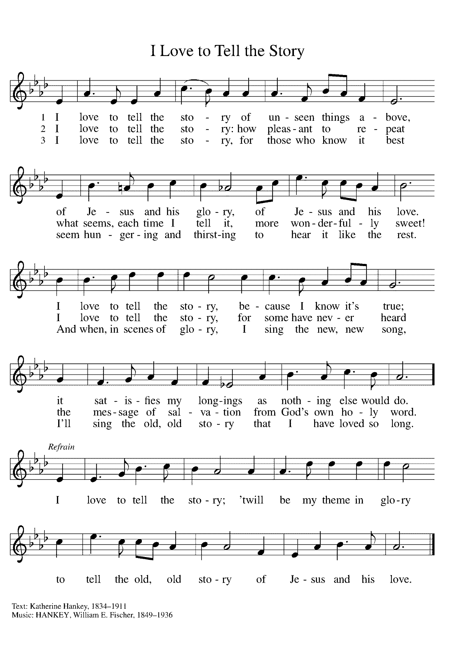

(You may unmute your mic)
Sent to the World
Go in peace. Be the light of Christ. Thanks be to God.

From Sundays and Seasons v .20210119.1257 Copyright © 2021 Augsburg Fortress. All rights reserved.
Reprinted by permission under Augsburg Fortress Liturgies Annual License #30867.
Reprinted under OneLicense.net #A-718333.

Current Prayer Requests
Name Relation to Grace Prayers For
Dorothy Derrico Member (missed being listed) 95th Birthday 1/2
Lucy Stephan Daughter of Pete and Michelle Stephan
Granddaughter of Tim and Donna Stephan New Life 1/16
Helen Sladek Member Healing & Strength
Rich Davison Member Healing & Strength
Sigrid Elliott Member Healing & Strength
Dorothy Tracy Member Healing & Strength
Sally and Eberhard Slenczka Parents of Karin Slenczka Healing & Strength
Family of Carol Jensen (Broker) Former Member Comfort in Grief
Family of Michael Benefied Brother of Farrel Benefield Comfort in Grief
Chris Danly Son of Mark & Pat Danly Healing & Strength
Prayers for our homebound Members
Anita Blakemore, Evelyn Elson, Dolores Nosal, Carol Petersen, Norma Petersen, Dorothy Stein

Weekly Announcements
Ash Wednesday is February 17! We will mark the beginning of Lent with an All-Church Zoom Service at 7:00 p.m. This service will include the Imposition of Ashes and Communion. You may pick up ashes and/or communion kits from the office during the following hours: Mondays, Wednesdays and Fridays from 9 a.m. to 3:30 p.m., and Tuesdays and Thursdays from 1:00 to 3:30 p.m. If you need ashes or communion kits delivered to you, contact the office by Monday, Feb. 15. You will find the link for the Zoom service in News From Grace, or you can get the link from the church office.

Midweek Lent Worship via Zoom, featuring excerpts from Holden Evening Prayer, Wednesdays at 7:00: Join Pastor Melody and Bradford for a time of prayer and centering, along with reflections on Community as Spiritual Practice: Living Out Faith in Democracy. Pastor Melody will explore many of the questions about whether, when and how collective faith impacts our society. We will look at scriptural foundations, the experience and teachings of Luther, boundaries established in our Constitution, and the praxis of the ELCA. (And yes, it is a spiritual discipline!)

House Church Worship via phone or internet every Sunday morning at 9:30am! We currently have five “House Churches” of worshipping members (each House Church consisting of 6-8 members/families meeting via Zoom or calling in by phone.) If you are unsure how to sign on, go ahead and register and let us know you need some help; we’ll walk you through it! We would be so blessed to have you join us. Register online for a House Church at graceglenellyn.org (on the main page Announcements).

Contributions to Grace: You may continue to mail your contributions to the church office; have your bank mail your contribution to the church office; or contribute on-line through Grace’s website. Please know, pandemic or no, our mission continues! Thank you for your continued support of our ministries at Grace Lutheran.

Contributions to Grace’s Mortgage Reduction Fund are always welcome! Indicate on the contribution that it is for the Mortgage Reduction Fund. Our goal is to make one additional $100,000 payment when our loan comes up for renewal in October! We eliminated the comma; now let’s see if we can reduce the first digit from a 9 to an 8!

Thrivent Choice Program Members: Be sure to check your account to see if you have any funds to distribute!

El Famous Burrito Bowls Over the Glen Ellyn Food Pantry: The upcoming professional football event isn’t the only game in town! In fact, the biggest competition going will pit the El Famous Burrito Lombard restaurant against the El Famous Burrito Glendale Heights restaurant in a
battle to collect the most food for the Glen Ellyn Food Pantry! From February 1 – 7, customers who donate at least one can of food on your curbside, carry-out or dine-in order will score one free taco valued at up to $2.75.
If you forget your can, just round-up your check by $2 and receive a taco coupon. The standings (cans and cash) will be posted on the Pantry Facebook page and the winning restaurant will be announced on February 12. Check out www.GlenEllynFoodPantry.org for most needed food items. Go teams!

Food Pantry Needs: Tomato Sauce/Paste; Cookies; Ketchup; Pet Food; Shampoo; Salad Dressing; Olives/Pickles; Salt/Pepper; Taco Shells; Canned Cannellini Beans.

Every Member a Minister and Missionary!

Phone: 630-469-1555 Emergency Pastoral Contact: 630-674-2887
info@graceglenellyn.org www.graceglenellyn.org

Pastor
Rev. Melody Eastman office ext. 14
meastman@graceglenellyn.org

Minister of Music
Bradford Thompson 219-718-8879
bradfordmthompson@gmail.com

Ministry Associate
Becky Ficarella office ext. 17
bficarella@graceglenellyn.org

Office Manager
Barbara Sudds office ext. 10
bsudds@graceglenellyn.org

Parish Counselor
Carole LoGalbo M.S., LCPC 630-668-4594
carolelogalbo@yahoo.com

