Grace Lutheran Church
493 Forest Avenue, Glen Ellyn IL 630.469.1555
www.graceglenellyn.org

Ash Wednesday February 17, 2021

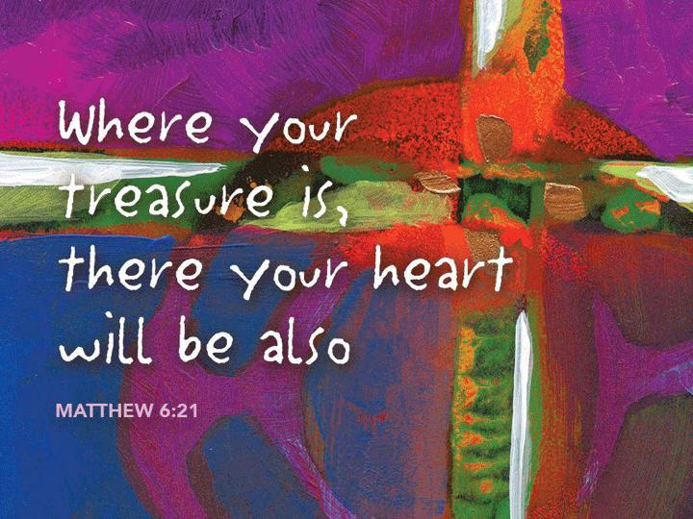

+ Proclaim Christ + Build Community +
+ Serve Our Neighbors +

Introduction
Lent begins with a solemn call to fasting and repentance as we begin our journey to the baptismal waters of Easter. As we hear in today’s readings, now is the acceptable time to return to the Lord. During Lent the people of God will reflect on the meaning of their baptism into Christ’s death and resurrection. The sign of ashes suggests our human mortality and frailty. What seems like an ending is really an invitation to make each day a new beginning, in which we are washed in God’s mercy and forgiveness. With the cross on our brow, we long for the spiritual renewal that flows from the springtime Easter feast to come.

Gathering
The Holy Spirit calls us together as the people of God.
We begin in silence.
Opening Litany Now Is the Time of Grace
Cantor introduces the refrain, congregation repeats, then sings the refrain between stanzas as indicated.
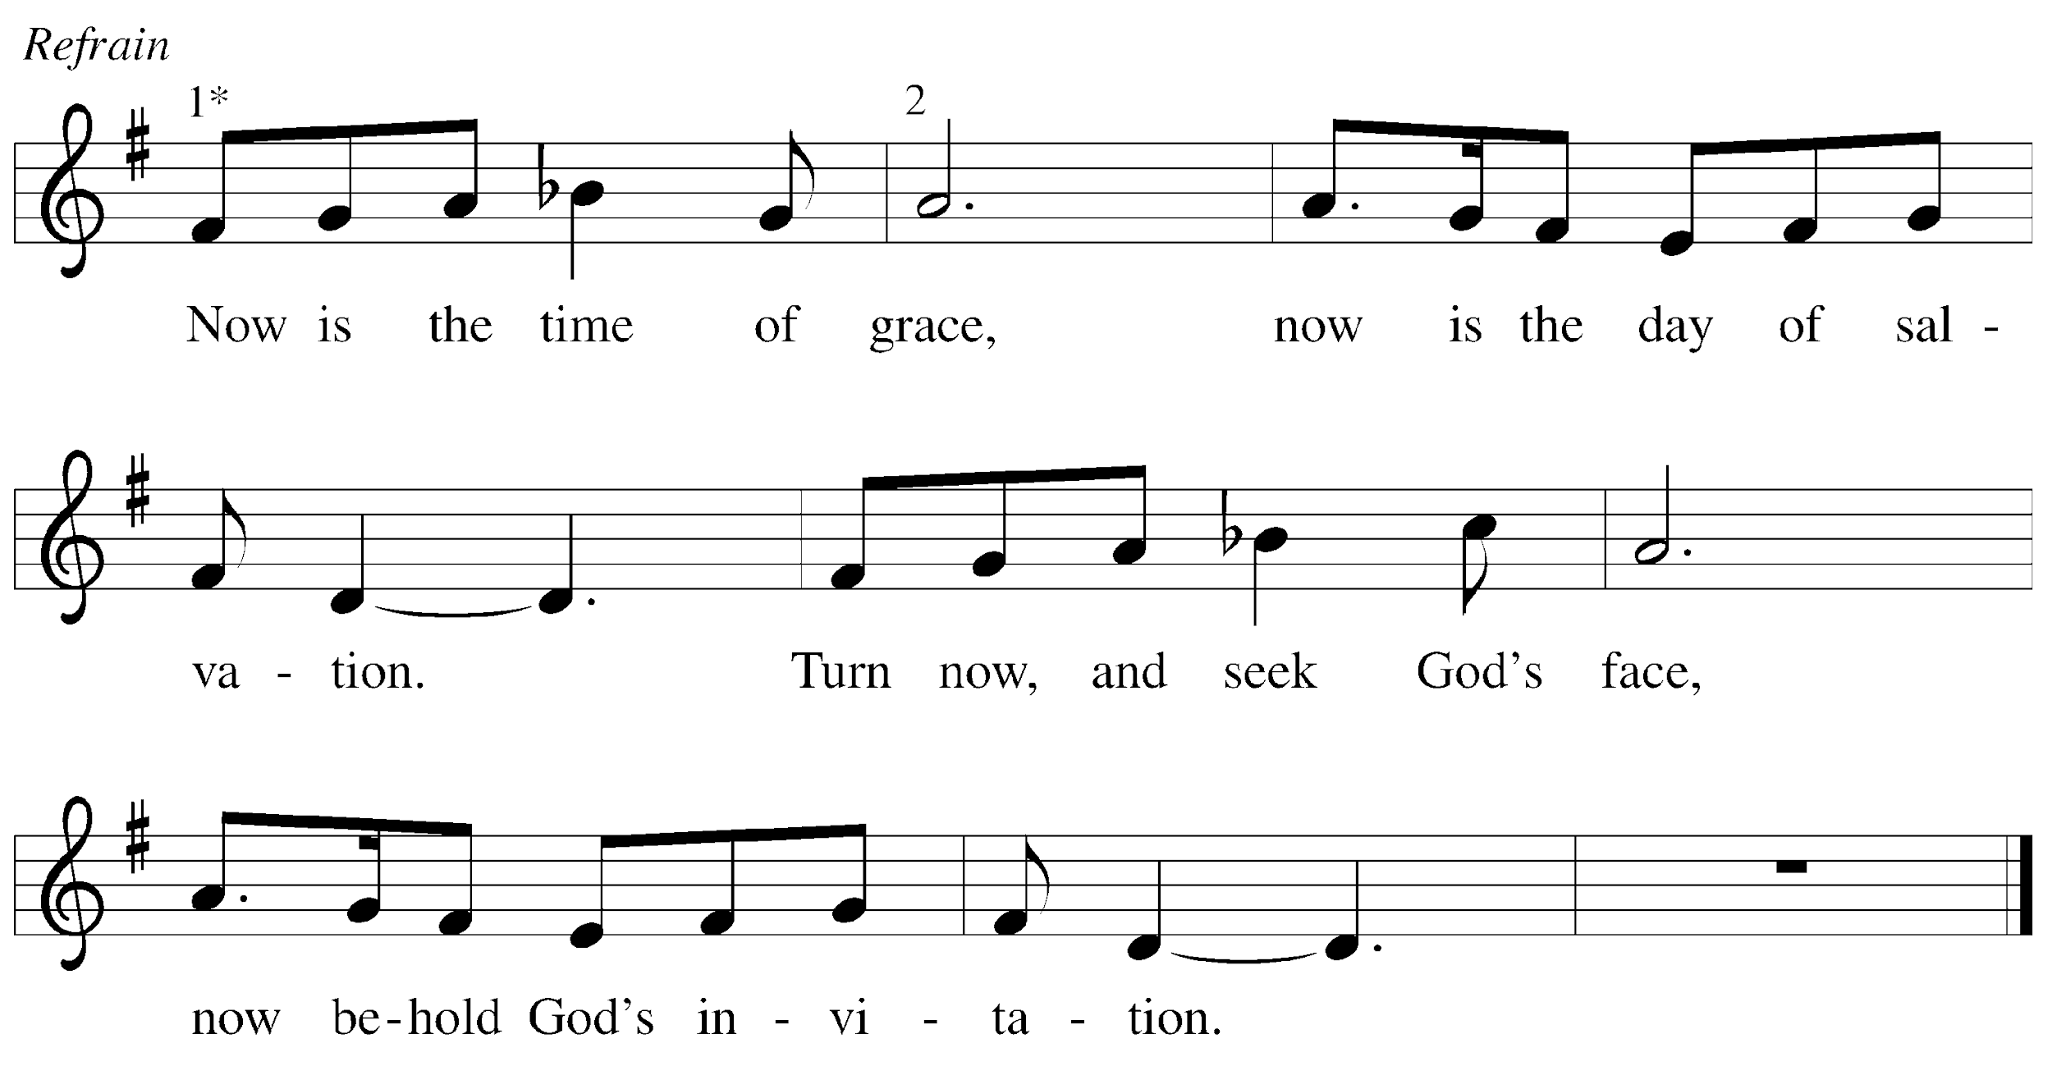

Cantor: This is the feast that God would choose: to loose the bonds of injustice,
To let the captives go free, and to break the yoke of oppression.
Refrain

Cantor: Sharing your bread with the hungry and welcoming homeless in,
Offering hope and off’ring help, this is what God requires.
Refrain

Cantor: Then shall your light break forth as dawn, and healing shall come upon you quickly, then you shall call and God shall answer, God’s love shall go before you.
Refrain
Greeting
The grace of our Lord Jesus Christ, the love of God, and the communion of the Holy Spirit be with you all. And also with you.

Prayer of the Day
Almighty and ever-living God, you hate nothing you have made, and you forgive the sins of all who are penitent. Create in us new and honest hearts, so that, truly repenting of our sins, we may receive from you, the God of all mercy, full pardon and forgiveness through your Son, Jesus Christ, our Savior and Lord, who lives and reigns with you and the Holy Spirit, one God, now and forever. Amen.

Word
God speaks to us in scripture reading, preaching, and song.
First Lesson Isaiah 58:1-12
¹Shout out, do not hold back! Lift up your voice like a trumpet! Announce to my people their rebellion, to the house of Jacob their sins. ²Yet day after day they seek me and delight to know my ways, as if they were a nation that practiced righteousness and did not forsake the ordinance of their God; they ask of me righteous judgments, they delight to draw near to God. ³“Why do we fast, but you do not see? Why humble ourselves, but you do not notice?” Look, you serve your own interest on your fast day, and oppress all your workers. ⁴Look, you fast only to quarrel and to fight and to strike with a wicked fist. Such fasting as you do today will not make your voice heard on high. ⁵Is such the fast that I choose, a day to humble oneself? Is it to bow down the head like a bulrush, and to lie in sackcloth and ashes? Will you call this a fast, a day acceptable to the Lord?
⁶Is not this the fast that I choose: to loose the bonds of injustice, to undo the thongs of the yoke, to let the oppressed go free, and to break every yoke? ⁷Is it not to share your bread with the hungry, and bring the homeless poor into your house; when you see the naked, to cover them, and not to hide yourself from your own kin? ⁸Then your light shall break forth like the dawn, and your healing shall spring up quickly; your vindicator shall go before you, the glory of the Lord shall be your rear guard. ⁹Then you shall call, and the Lord will answer; you shall cry for help, and he will say, Here I am.
If you remove the yoke from among you, the pointing of the finger, the speaking of evil, ¹⁰if you offer your food to the hungry and satisfy the needs of the afflicted, then your light shall rise in the darkness and your gloom be like the noonday. ¹¹The Lord will guide you continually, and satisfy your needs in parched places, and make your bones strong; and you shall be like a watered garden, like a spring of water, whose waters never fail. ¹²Your ancient ruins shall be rebuilt; you shall raise up the foundations of many generations; you shall be called the repairer of the breach, the restorer of streets to live in.

Word of God, Word of Life. Thanks be to God.

Second Lesson 2 Corinthians 5:20b--6:10
^{20b}We entreat you on behalf of Christ, be reconciled to God. ²¹For our sake he made him to be sin who knew no sin, so that in him we might become the righteousness of God. ^{6:1}As we work together with him, we urge you also not to accept the grace of God in vain. ²For he says, “At an acceptable time I have listened to you, and on a day of salvation I have helped you.” See, now is the acceptable time; see, now is the day of salvation! ³We are putting no obstacle in anyone’s way, so that no fault may be found with our ministry, ⁴but as servants of God we have commended ourselves in every way: through great endurance, in afflictions, hardships, calamities, ⁵beatings, imprisonments, riots, labors, sleepless nights, hunger; ⁶by purity, knowledge, patience, kindness, holiness of spirit, genuine love, ⁷truthful speech, and the power of God; with the weapons of righteousness for the right hand and for the left; ⁸in honor and dishonor, in ill repute and good repute. We are treated as impostors, and yet are true; ⁹as unknown, and yet are well known; as dying, and see—we are alive; as punished, and yet not killed; ¹⁰as sorrowful, yet always rejoicing; as poor, yet making many rich; as having nothing, and yet possessing everything.

Word of God, Word of Life. Thanks be to God.

Gospel Acclamation
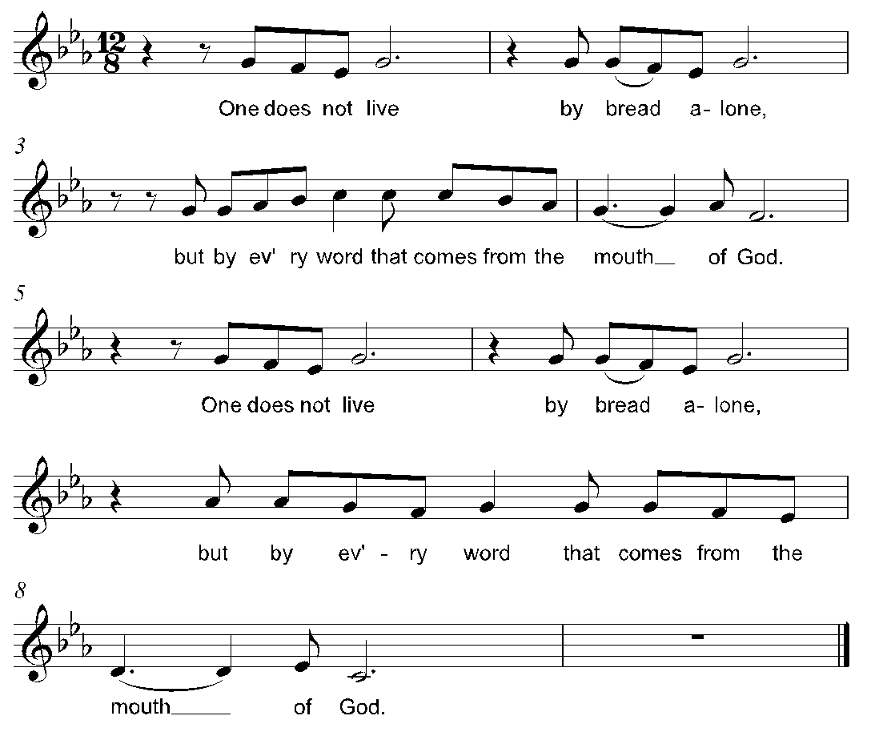

The holy Gospel according to Matthew. Glory to you, O Lord.
Gospel Matthew 6:1-6, 16-21
[Jesus said to the disciples:] ¹“Beware of practicing your piety before others in order to be seen by them; for then you have no reward from your Father in heaven.
²“So whenever you give alms, do not sound a trumpet before you, as the hypocrites do in the synagogues and in the streets, so that they may be praised by others. Truly I tell you, they have received their reward. ³But when you give alms, do not let your left hand know what your right hand is doing, ⁴so that your alms may be done in secret; and your Father who sees in secret will reward you.
⁵“And whenever you pray, do not be like the hypocrites; for they love to stand and pray in the synagogues and at the street corners, so that they may be seen by others. Truly I tell you, they have received their reward. ⁶But whenever you pray, go into your room and shut the door and pray to your Father who is in secret; and your Father who sees in secret will reward you.
¹⁶“And whenever you fast, do not look dismal, like the hypocrites, for they disfigure their faces so as to show others that they are fasting. Truly I tell you, they have received their reward. ¹⁷But when you fast, put oil on your head and wash your face, ¹⁸so that your fasting may be seen not by others but by your Father who is in secret; and your Father who sees in secret will reward you.
¹⁹“Do not store up for yourselves treasures on earth, where moth and rust consume and where thieves break in and steal; ²⁰but store up for yourselves treasures in heaven, where neither moth nor rust consumes and where thieves do not break in and steal. ²¹For where your treasure is, there your heart will be also.”

The Gospel of the Lord. Praise to you, O Christ.

Sermon The Rev. Melody Eastman

Hymn of the Day ELW #326 Bless Now, O God, the Journey
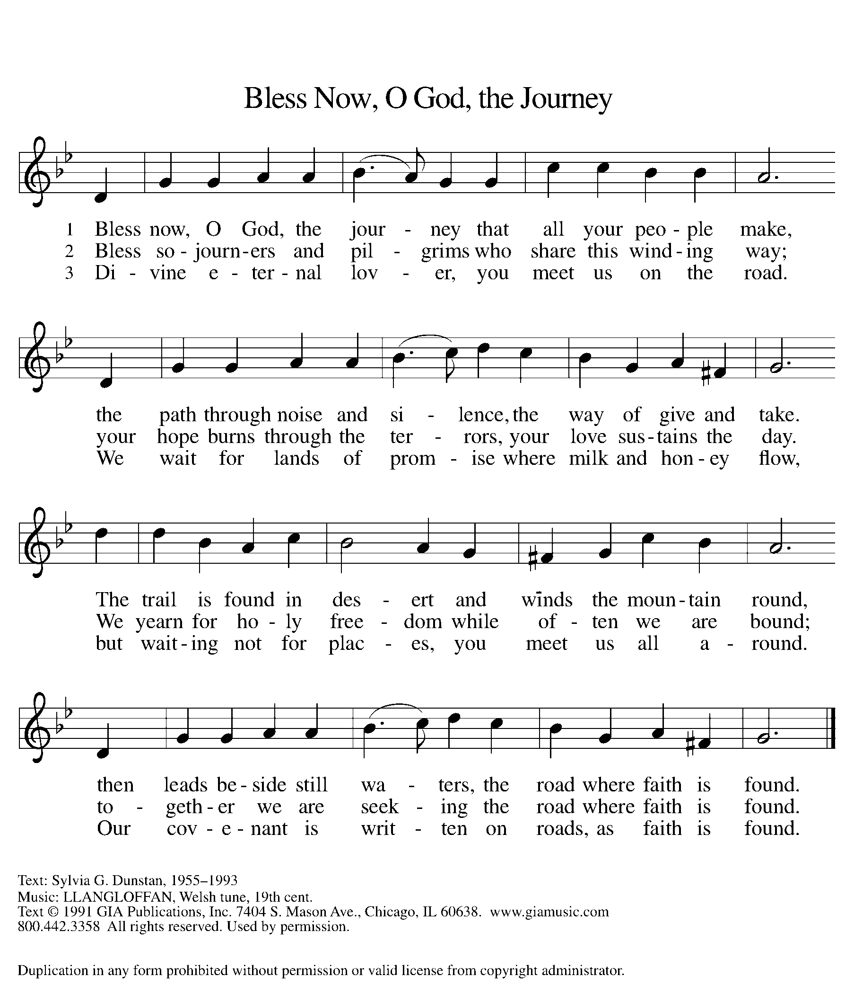

Invitation to Lent
Friends in Christ, today with the whole church we enter the time of remembering Jesus' passover from death to life, and our life in Christ is renewed.

We begin this holy season by acknowledging our need for repentance and for God's mercy. We are created to experience joy in communion with God, to love one another, and to live in harmony with creation. But our sinful rebellion separates us from God, our neighbors, and creation, so that we do not enjoy the life our creator intended.

As disciples of Jesus, we are called to a discipline that contends against evil and resists whatever leads us away from love of God and neighbor. I invite you, therefore, to the discipline of Lent--self-examination and repentance, prayer and fasting, sacrificial giving and works of love--strengthened by the gifts of word and sacrament. Let us continue our journey through these forty days to the great Three Days of Jesus' death and resurrection.

Confession of Sin
Let us confess our sin in the presence of God and of one another.
Silence is kept for reflection and self-examination.

Most holy and merciful God,
we confess to you and to one another, and before the whole company of heaven, that we have sinned by our fault, by our own fault, by our own most grievous fault, in thought, word, and deed, by what we have done and by what we have left undone.

We have not loved you with our whole heart, and mind, and strength. We have not loved our neighbors as ourselves. We have not forgiven others as we have been forgiven. Have mercy on us, O God.

We have shut our ears to your call to serve as Christ served us. We have not been true to the mind of Christ. We have grieved your Holy Spirit. Have mercy on us, O God.

Our past unfaithfulness, the pride, envy, hypocrisy, and apathy that have infected our lives, we
confess to you. Have mercy on us, O God.

Our self-indulgent appetites and ways, and our exploitation of other people, we confess to
you. Have mercy on us, O God.

Our negligence in prayer and worship, and our failure to share the faith that is in us, we confess to you. Have mercy on us, O God.

Our neglect of human need and suffering, and our indifference to injustice and cruelty, we
confess to you. Have mercy on us, O God.

Our false judgments, our uncharitable thoughts toward our neighbors, and our prejudice and contempt toward those who differ from us,
we confess to you. Have mercy on us, O God.

Our waste and pollution of your creation, and our lack of concern for those who come after us, we confess to you. Have mercy on us, O God.

Restore us, O God, and let your anger depart from us. Hear us, O God, for your mercy is great.

Prayer over the Ashes
Almighty God, you have created us out of the dust of the earth. May these ashes be a sign of our mortality and penitence, reminding us that only by the cross of our Lord Jesus Christ are we given eternal life; through the same Jesus Christ, our Savior and Lord. Amen.
Imposition of Ashes
You may mark your forehead with ashes as the pastor speaks the Lenten reminder. If you are worshipping with others, you may speak this line to one another as you mark each other’s foreheads:
Remember that you are dust, and to dust you shall return.

Imposition Conclusion
Accomplish in us, O God, the work of your salvation, that we may show forth your glory in the world. By the cross and passion of your Son, our Savior, bring us with all your saints to the joy of his resurrection. Almighty God have mercy on us, forgive us all our sins through our Lord Jesus Christ, strengthen us in all goodness, and by the power of the Holy Spirit keep us in eternal life. Amen.

Prayers of Intercession
Relying on the promises of God, we pray boldly for the church, the world, and all in need.
A brief silence.

O God, you call your church to be ministers of reconciliation throughout the world. Inspire your church in its proclamation of the gospel and guide its ministries to build up the body of Christ. Lord, in your mercy, hear our prayer.

O God, you created the earth and all its inhabitants and you declared that it is good. Protect mountains and valleys, animals and plants, and direct us to be good stewards of all you have made. Lord, in your mercy, hear our prayer.

O God, you desire peace. Direct governments and leaders to work for the well-being of all people and raise up advocates to speak and serve on behalf of the downtrodden. Lord, in your mercy. hear our prayer.

O God, you are our hope in the midst of despair, our help in the midst of sorrow, and our consolation in the midst of affliction. Grant comfort to all who suffer in body, mind, or spirit and support caregivers who attend to all in need. Lord, in your mercy, hear our prayer.

O God, you are love, and you call us to love one another. Accompany with your grace those journeying toward baptism and call us all to repentance as we prepare to celebrate Christ’s death and resurrection. Lord, in your mercy, hear our prayer.

O God, you are our life and our salvation. We give you thanks for the righteous who have died in faith. Inspire us by their example to proclaim your steadfast love. Lord, in your mercy,
hear our prayer.

We entrust ourselves and all our prayers to you, O faithful God, through Jesus Christ our Lord.
Amen.

Peace
The peace of Christ be with you always. And also with you.

Meal
God feeds us with the presence of Jesus Christ.
Great Thanksgiving
The Lord be with you. And also with you.
Lift up your hearts. We lift them to the lord.
Let us give thanks to the Lord our God. It is right to give our thanks and praise.

Preface
It is indeed right, our duty and our joy, that we should at all times and in all places give thanks and praise to you, almighty and merciful God, through our Savior Jesus Christ. You call your people to cleanse their hearts and prepare with joy for the paschal feast, that, renewed in the gift of baptism, we may come to the fullness of your grace. And so, with all the choirs of angels, with the church on earth and the hosts of heaven, we praise your name and join their unending hymn:

Sanctus
Holy, holy, holy Lord, God of power and might, Heaven and earth are full of your glory.
Hosanna in the highest. Blessed is he who comes in the name of the Lord. Hosanna in the highest.

Thanksgiving at the Table
Blessed are you, O God of the universe. Your mercy is everlasting and your faithfulness endures from age to age.

Praise to you for creating the heavens and the earth. Praise to you for saving the earth from the waters of the flood. Praise to you for bringing the Israelites safely through the sea.
Praise to you for leading your people through the wilderness to the land of milk and honey.
Praise to you for the words and deeds of Jesus, your anointed one. Praise to you for the death and resurrection of Christ. Praise to you for your Spirit poured out on all nations.
In the night in which he was betrayed, our Lord Jesus took bread, and gave thanks; broke it, and gave it to his disciples, saying: Take and eat; this is my body, given for you. Do this for the remembrance of me.

Again, after supper, he took the cup, gave thanks, and gave it for all to drink, saying: This cup is the new covenant in my blood, shed for you and for all people for the forgiveness of sin. Do this for the remembrance of me.

With this bread and cup we remember our Lord's passover from death to life as we proclaim the mystery of faith: Christ has died. Christ is risen. Christ will come again.

O God of resurrection and new life: Pour out your Holy Spirit on us and on these gifts of bread and wine. Bless this feast. Grace our table with your presence. Come, Holy Spirit.

Reveal yourself to us in the breaking of the bread. Raise us up as the body of Christ for the world. Breathe new life into us. Send us forth, burning with justice, peace, and love. Come, Holy Spirit.

With your holy ones of all times and places, with the earth and all its creatures, with sun and moon and stars, we praise you, O God, blessed and holy Trinity, now and forever. Amen.

Lord’s Prayer
Gathered into one by the Holy Spirit, let us pray as Jesus taught us.
Our Father, who art in heaven, hallowed be thy name, thy kingdom come, thy will be done on earth as it is in heaven. Give us this day our daily bread; and forgive us our trespasses, as we forgive those who trespass against us; and lead us not into temptation, but deliver us from evil. For thine is the kingdom, and the power, and the glory, forever and ever. Amen.

Invitation to Communion
Jesus draws the whole world to himself. Come to this meal and be fed.

This is the body of Christ, given for you. (Eat the bread.)
This is the blood of Christ, shed for you. (Drink the wine/juice.)

Post Communion Blessing
The Body and Blood of our Lord Jesus Christ strengthen you and keep you in his grace. Amen.

Post Communion Prayer
God of steadfast love, at this table you gather your people into one body for the sake of the world. Send us in the power of your Spirit, that our lives bear witness to the love that has made us new in Jesus Christ, our Savior and Lord. Amen.

Sending
God blesses us and sends us in mission to the world.
Blessing
You are what God made you to be: created in Christ Jesus for good works, chosen as holy and beloved, freed to serve your neighbor. God bless you ☩ that you may be a blessing, in the name of the holy and life-giving Trinity. Amen.

Sending Hymn ELW #333 Jesus Is a Rock in a Weary Land
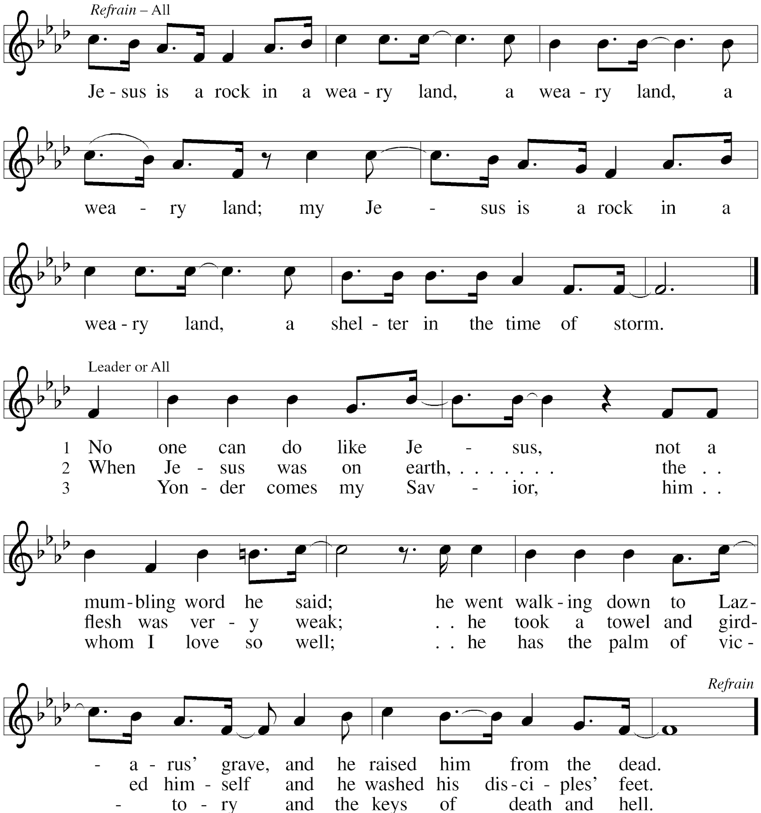

Sent to the World
Go in peace. Share the good news. Thanks be to God.

Postlude

From Sundays and Seasons v.20190109.1233 Copyright © 2021 Augsburg Fortress. All rights reserved. All rights reserved.
Reprinted by permission under Augsburg Fortress Liturgies Annual License #30867.
All rights reserved. Reprinted under OneLicense.net #A-718333.

Every Member a Minister and Missionary!

Phone: 630/469-1555 info@graceglenellyn.org
Fax: 630/469-1561 www.graceglenellyn.org

Pastor
Rev. Melody Eastman office ext. 14 (Cell) 630-674-2887
meastman@graceglenellyn.org

Office Manager
Barbara Sudds office ext. 10
bsudds@graceglenellyn.org

Children & Youth Ministry Coordinator
Becky Ficarella office ext. 17
bficarella@graceglenellyn.org

Minister of Music
Bradford Thompson 219-718-8879
bradfordmthompson@gmail.com

Parish Counselor
Carole LoGalbo M.S., LCPC 630-668-4594
carolelogalbo@yahoo.com

