Grace Lutheran Church
493 Forest Avenue, Glen Ellyn IL 630.469.1555
www.graceglenellyn.org

First Sunday in Lent February 21, 2021

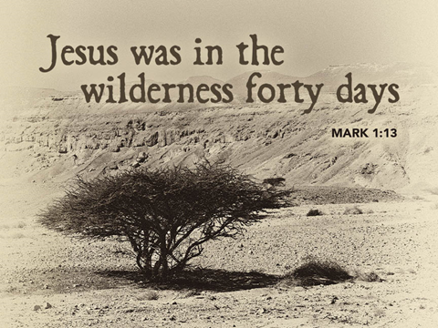

+ Proclaim Christ + Build Community +
+ Serve Our Neighbors +
Introduction
On Ash Wednesday the church began its journey toward baptismal immersion in the death and resurrection of Christ. This year, the Sundays in Lent lead us to focus on five covenants God makes in the Hebrew Scriptures and to use them as lenses through which to view baptism. First Peter connects the way God saved Noah’s family in the flood with the way God saves us through the water of baptism. The baptismal covenant is made with us individually, but the new life we are given in baptism is for the sake of the whole world.

Helpful Reminders for House Church:
- Mute your mic during hymns.
- You may unmute for all group responses. Remember that your host can mute you but cannot unmute you; you must unmute your mic yourself.
- If you are joining by phone, move the mouthpiece away from your mouth unless you are speaking, to avoid broadcasting your breathing.
- Avoid background conversations when your mic is unmuted.
- THANK YOU FOR WORSHIPPING WITH US!

Gathering
The Holy Spirit calls us together as the people of God.
Prelude (Please mute your mic for the prelude)

Confession and Forgiveness (You may unmute your mic)
All may make the sign of the cross, the sign marked at baptism,
as the worship leader begins.

Blessed be the holy Trinity, ☩ one God, the keeper of the covenant, the source of steadfast love, our rock and our redeemer. Amen.

God hears us when we cry, and draws us close in Jesus Christ. Let us return to the one who is full of compassion.
Silence is kept for reflection.

Fountain of living water, pour out your mercy over us. Our sin is heavy, and we long to be free. Rebuild what we have ruined and mend what we have torn. Wash us in your cleansing flood. Make us alive in the Spirit to follow in the way of Jesus, as healers and restorers of the world you so love. Amen.

Beloved, God’s word never fails. The promise rests on grace: by the saving love of Jesus Christ,
the wisdom and power of God, our sins are ☩ forgiven, and God remembers them no more.
Together let us journey in the way of Jesus. Amen.

Opening Hymn (Please mute your mic) ELW #503 A Mighty Fortress Is Our God, sts. 1,3,4
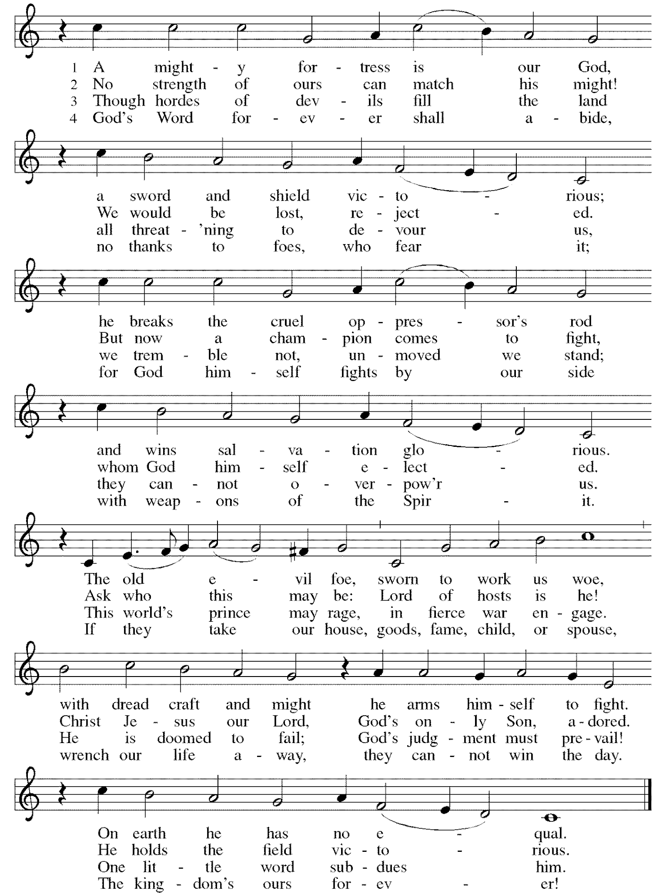
(You may unmute your mic)
Greeting
The grace of our Lord Jesus Christ, the love of God, and the communion of the Holy Spirit be with you all. And also with you.

Prayer of the Day
Holy God, heavenly Father, in the waters of the flood you saved the chosen, and in the wilderness of temptation you protected your Son from sin. Renew us in the gift of baptism. May your holy angels be with us, that the wicked foe may have no power over us, through Jesus Christ, our Savior and Lord, who lives and reigns with you and the Holy Spirit, one God, now and forever. Amen.

Word
God speaks to us in scripture reading, preaching, and song.
First Lesson Genesis 9:8-17
Today’s reading is the conclusion to the flood story. Because of human sin, God destroys the earth by flood, saving only Noah, his family, and the animals on the ark. Yet divine destruction gives way to divine commitment. As in the first creation, God blesses humanity and establishes a covenant with all creatures.

⁸God said to Noah and to his sons with him, ⁹“As for me, I am establishing my covenant with you and your descendants after you, ¹⁰and with every living creature that is with you, the birds, the domestic animals, and every animal of the earth with you, as many as came out of the ark. ¹¹I establish my covenant with you, that never again shall all flesh be cut off by the waters of a flood, and never again shall there be a flood to destroy the earth.” ¹²God said, “This is the sign of the covenant that I make between me and you and every living creature that is with you, for all future generations: ¹³I have set my bow in the clouds, and it shall be a sign of the covenant between me and the earth. ¹⁴When I bring clouds over the earth and the bow is seen in the clouds, ¹⁵I will remember my covenant that is between me and you and every living creature of all flesh; and the waters shall never again become a flood to destroy all flesh. ¹⁶When the bow is in the clouds, I will see it and remember the everlasting covenant between God and every living creature of all flesh that is on the earth.” ¹⁷God said to Noah, “This is the sign of the covenant that I have established between me and all flesh that is on the earth.”

Word of God, Word of Life. Thanks be to God.

The Psalm Read responsively by verse Psalm 25:1-10
Your paths, O Lord, are steadfast love and faithfulness. (Ps. 25:10)
¹To you, O Lord, I lift up my soul.
²My God, I put my trust in you; let me not be put to shame, nor let my enemies triumph over me.
³Let none who look to you be put to shame; rather let those be put to shame who are treacherous.
⁴Show me your ways, O Lord, and teach me your paths.
⁵Lead me in your truth and teach me, for you are the God of my salvation; in you have I trusted all the day long.
⁶Remember, O Lord, your compassion and love, for they are from everlasting.
⁷Remember not the sins of my youth and my transgressions; remember me according to your steadfast love and for the sake of your goodness, O Lord.
⁸You are gracious and upright, O Lord; therefore you teach sinners in your way.
⁹You lead the lowly in justice and teach the lowly your way. ¹⁰All your paths, O Lord, are steadfast love and faithfulness to those who keep your covenant and your testimonies.

Second Lesson 1 Peter 3:18-22
As God acted through Christ’s suffering and death to bring us to God, so God acts through baptism to save us from a sinful existence. This spiritual cleansing marks our new life in Christ.

¹⁸Christ also suffered for sins once for all, the righteous for the unrighteous, in order to bring you to God. He was put to death in the flesh, but made alive in the spirit, ¹⁹in which also he went and made a proclamation to the spirits in prison, ²⁰who in former times did not obey, when God waited patiently in the days of Noah, during the building of the ark, in which a few, that is, eight persons, were saved through water. ²¹And baptism, which this prefigured, now saves you—not as a removal of dirt from the body, but as an appeal to God for a good conscience, through the resurrection of Jesus Christ, ²²who has gone into heaven and is at the right hand of God, with angels, authorities, and powers made subject to him.

Word of God, Word of Life. Thanks be to God.

Gospel Acclamation
One does not live by bread alone, but by every word that comes from the mouth of God.

The holy Gospel according to Mark. Glory to you, O Lord.

Gospel (Please mute your mic) Mark 1:9-15
The Spirit that comes upon Jesus at his baptism sustains him when he is tested by Satan so that he might proclaim the good news of God’s reign.

⁹In those days Jesus came from Nazareth of Galilee and was baptized by John in the Jordan. ¹⁰And just as he was coming up out of the water, he saw the heavens torn apart and the Spirit descending like a dove on him. ¹¹And a voice came from heaven, “You are my Son, the Beloved; with you I am well pleased.”
¹²And the Spirit immediately drove him out into the wilderness. ¹³He was in the wilderness forty days, tempted by Satan; and he was with the wild beasts; and the angels waited on him.
¹⁴Now after John was arrested, Jesus came to Galilee, proclaiming the good news of God, ¹⁵and saying, “The time is fulfilled, and the kingdom of God has come near; repent, and believe in the good news.”

The Gospel of the Lord. Praise to you, O Christ.

Sermon The Rev. Josh Ebener,
Latinx Ministries Coordinator for the Metro Chicago Synod

(You may unmute your mic)
Apostles’ Creed
With the whole church, let us confess our faith.
I believe in God, the Father almighty, creator of heaven and earth. I believe in Jesus Christ, God's only Son, our Lord, who was conceived by the Holy Spirit, born of the virgin Mary, suffered under Pontius Pilate, was crucified, died, and was buried; he descended to the dead. On the third day he rose again; he ascended into heaven, he is seated at the right hand of the Father, and he will come to judge the living and the dead. I believe in the Holy Spirit, the holy catholic church, the communion of saints, the forgiveness of sins, the resurrection of the body, and the life everlasting. Amen.

Prayers of Intercession
Relying on the promises of God, we pray boldly for the church, the world, and all in need.
A brief silence.

In Jesus your realm has come near to us in every place and time. Give your church throughout the world a spirit of humility and repentance; teach us to trust always in the good news of your salvation. Hear us, O God. Your mercy is great.

You have made a covenant of mercy with every living creature. Protect all the earth’s creatures from destruction. Empower the work of biologists, conservationists, and science educators. Hear us, O God. Your mercy is great.

All your paths are steadfast love and faithfulness. Direct the words and actions of leaders in our community and throughout the world, that they may maintain justice for the lowly. Hear us, O God. Your mercy is great.

Even in the wilderness you are with us. Walk alongside migrants and refugees crossing dangerous lands. Tend to those whose lives feel desolate. Give healing and strength to all who suffer, especially Helen, Rich, Dorothy, Sigrid, Anita, Dolores, Carol, Norma, Dorothy and those we name before you now. . . Hear us, O God. Your mercy is great.

In the covenant of baptism you claim us as beloved children. Nurture us in our baptismal identity and teach us to live within it for the sake of others. Strengthen this congregation’s ministries of care and concern. Hear us, O God. Your mercy is great.

In baptism you join us to the death and resurrection of Jesus Christ. We praise you for Evelyn and all those who have died trusting in your faithfulness. Bring us with them to the fullness of your reign. Hear us, O God. Your mercy is great.

We entrust ourselves and all our prayers to you, O faithful God, through Jesus Christ our Lord.
Amen.

The Peace
The peace of the Lord be with you always. And also with you.
If there are others in your household you may share the peace with them.

If your House Church is celebrating Communion, refer to that liturgy here.

The Lord’s Prayer
Gathered into one by the Holy Spirit, let us pray as Jesus taught us.
Our Father in heaven, hallowed be your name, your kingdom come, your will be done, on earth as in heaven. Give us today our daily bread. Forgive us our sins as we forgive those who sin against us. Save us from the time of trial and deliver us from evil. For the kingdom, the power and the glory are yours, now and forever. Amen.

Sending
God blesses us and sends us in mission to the world.
Blessing
We are what God made us to be: created in Christ Jesus for good works, chosen as holy and beloved, freed to serve our neighbor. God bless us ☩ that we may be a blessing, in the name of the holy and life-giving Trinity.

Sending Hymn (Please mute your mic) ELW #325 I Want Jesus to Walk with Me
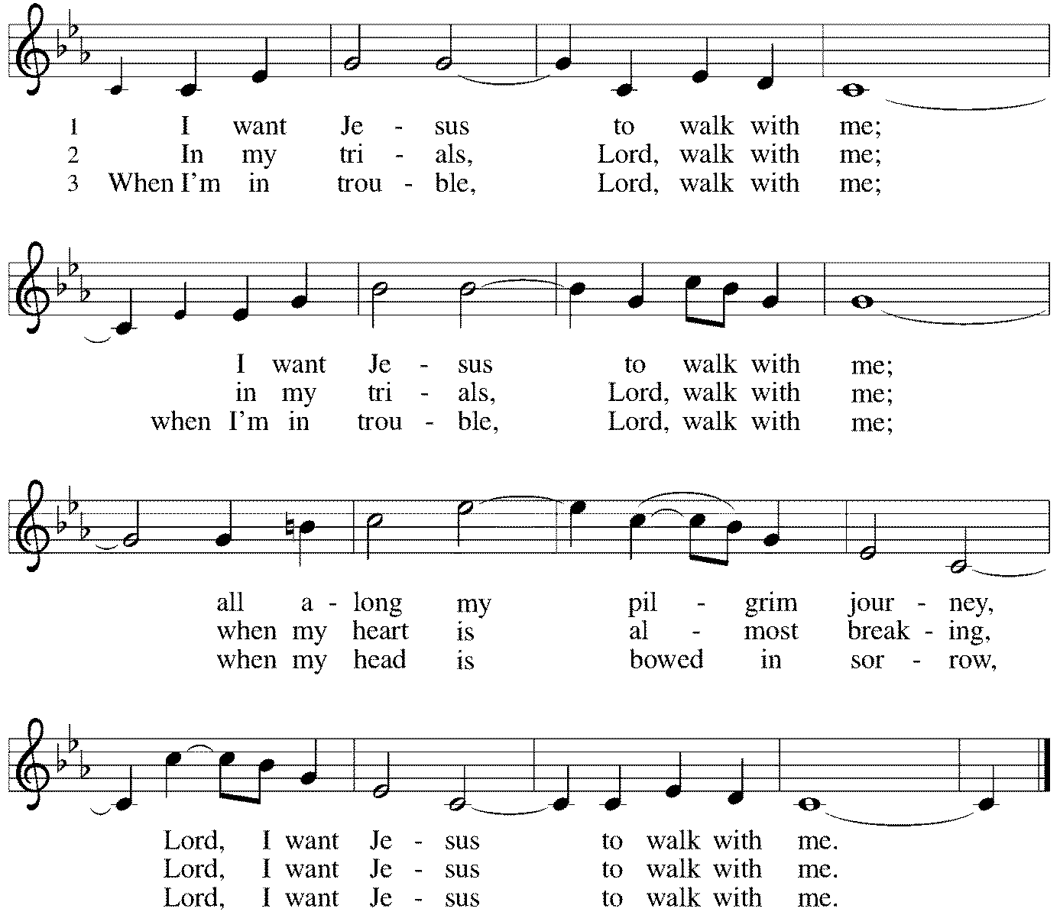

(You may unmute your mic)
Sent to the World
Go in peace. Share the good news. Thanks be to God.

Our thanks to the Metro Chicago Synod and synod staff member Pastor Josh Ebener
for providing this morning’s sermon!
From Sundays and Seasons v .20210119.1257 Copyright © 2021 Augsburg Fortress. All rights reserved.
Reprinted by permission under Augsburg Fortress Liturgies Annual License #30867.
Reprinted under OneLicense.net #A-718333.

Current Prayer Requests
Name Relation to Grace Prayers For
Family and Friends of Evelyn Elson Member Comfort in Grief
Family and Friends of Victor Murdoch Brother of Bill Murdoch Comfort in Grief
Welcome to our New Members Bradford Thompson and Judy Zipprich 2/14
Dorothy Stein Member 92nd Birthday 2/14
Helen Sladek Member Healing & Strength
Rich Davison Member Healing & Strength
Sigrid Elliott Member Healing & Strength
Dorothy Tracy Member Healing & Strength
Ruthie Maddock Friend of the Thompsons Healing & Strength
Sally and Eberhard Slenczka Parents of Karin Slenczka Healing & Strength
Chris Danly Son of Mark & Pat Danly Healing & Strength
Prayers for our homebound Members
Anita Blakemore, Dolores Nosal, Carol Petersen, Norma Petersen, Dorothy Stein

Weekly Announcements
Midweek Lent Worship via Zoom, featuring excerpts from Holden Evening Prayer, Wednesdays at 7:00: Join Pastor Melody and Bradford for a time of prayer and centering, along with reflections on Community as Spiritual Practice: Living Out Faith in Democracy. Pastor Melody will explore many of the questions about whether, when and how collective faith impacts our society. We will look at scriptural foundations, the experience and teachings of Luther, boundaries established in our Constitution, and the praxis of the ELCA. (And yes, it is a spiritual discipline!)

House Church Worship via phone or internet every Sunday morning at 9:30am! We currently have five “House Churches” of worshipping members (each House Church consisting of 6-8 members/families meeting via Zoom or calling in by phone.) If you are unsure how to sign on, go ahead and register and let us know you need some help; we’ll walk you through it! We would be so blessed to have you join us. Register online for a House Church at graceglenellyn.org (on the main page Announcements).

Contributions to Grace: You may continue to mail your contributions to the church office; have your bank mail your contribution to the church office; or contribute on-line through Grace’s website. Please know, pandemic or no, our mission continues! Thank you for your continued support of our ministries at Grace Lutheran.

Contributions to Grace’s Mortgage Reduction Fund are always welcome! Indicate on the contribution that it is for the Mortgage Reduction Fund. Our goal is to make one more additional payment when our loan comes up for renewal in October!

Thrivent Choice Program Members: Be sure to check your account to see if you have any funds to distribute!

Help Needed for Drive-thru Food Collection: Grace will again staff the drive-thru food collection that takes place the first Friday of each month for the GE Food Pantry. The event will be Friday, March 5, from 9am-noon. Three people are needed for each shift, either 9-10:30am or 10:30am-noon. Please contact Carol Asselmeier at carolassel@aol.com if you can help! Thanks.

Food Pantry Needs: Tomato Sauce/Paste/Diced; Olives/Pickles; Chili w/Beans; Manwich; Syrup; Sugar; BBQ Sauce; Crackers; Body Wash; Hand Soap.

Thanks to the community for showing the Food Pantry some LOVE by making us one of the Top Five Non-Profits of the year in Glen Ellyn. The Glen Ellyn Chamber of Commerce will announce the winners in March.

The Food Pantry is now sharing the LOVE to Villa Park families in need. We’re now serving 12 surrounding communities. And thanks to our partnership with Glen Ellyn Kiwanis, we have been able to extend the LOVE to 100 students in Glendale Heights who will now receive weekly backpacks of food items! Because of YOU we can do what we do!

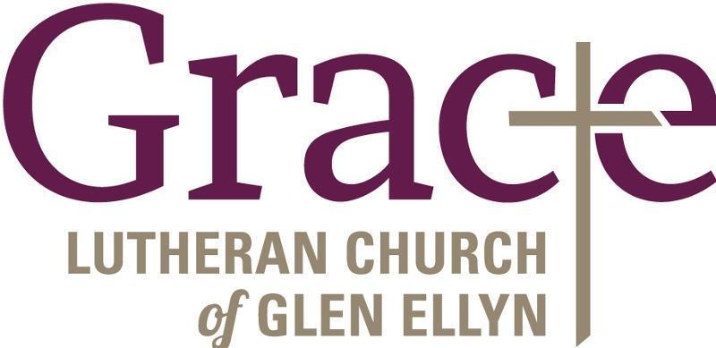
Every Member a Minister and Missionary!

Phone: 630-469-1555 Emergency Pastoral Contact: 630-674-2887
info@graceglenellyn.org www.graceglenellyn.org

Pastor
Rev. Melody Eastman office ext. 14
meastman@graceglenellyn.org

Minister of Music
Bradford Thompson 219-718-8879
bradfordmthompson@gmail.com

Ministry Associate
Becky Ficarella office ext. 17
bficarella@graceglenellyn.org

Office Manager
Barbara Sudds office ext. 10
bsudds@graceglenellyn.org

Parish Counselor
Carole LoGalbo M.S., LCPC 630-668-4594
carolelogalbo@yahoo.com

