Grace Lutheran Church
493 Forest Avenue, Glen Ellyn IL 630.469.1555
www.graceglenellyn.org

Palm Sunday/Sunday of the Passion March 28, 2021

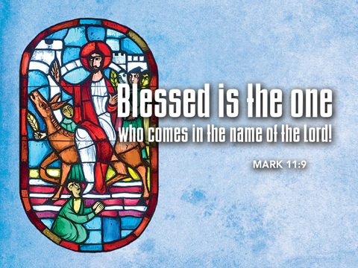

+ Proclaim Christ + Build Community +
+ Serve Our Neighbors +
Introduction
This week, the center of the church’s year, is one of striking contrasts: Jesus rides into Jerusalem surrounded by shouts of glory, only to be left alone to die on the cross, abandoned by even his closest friends. Mark’s gospel presents Jesus in his complete human vulnerability: agitated, grieved, scared, forsaken. Though we lament Christ’s suffering and all human suffering, we also expect God’s salvation: in the wine and bread, Jesus promises that his death will mark a new covenant with all people. We enter this holy week thirsty for the completion of God’s astonishing work.

Gathering
The Holy Spirit calls us together as the people of God.
Prelude

Confession and Forgiveness (You may unmute your mic)
All may make the sign of the cross, the sign marked at baptism,
as the worship leader begins.

Blessed be the holy Trinity, ☩ one God, the keeper of the covenant, the source of steadfast love, our rock and our redeemer. Amen.

God hears us when we cry, and draws us close in Jesus Christ. Let us return to the one who is full of compassion.
Silence is kept for reflection.

Fountain of living water, pour out your mercy over us. Our sin is heavy, and we long to be free. Rebuild what we have ruined and mend what we have torn. Wash us in your cleansing flood. Make us alive in the Spirit to follow in the way of Jesus, as healers and restorers of the world you so love. Amen.

Beloved, God’s word never fails. The promise rests on grace: by the saving love of Jesus Christ,
the wisdom and power of God, our sins are ☩ forgiven, and God remembers them no more.
Together let us journey in the way of Jesus. Amen.

Greeting
Blessed is the one who comes in the name of the Lord. Hosannah in the highest!

Processional Gospel Matthew 21:1-11
The Holy Gospel according to Matthew. Glory to you, O Lord.

Jesus enters Jerusalem
¹When they had come near Jerusalem and had reached Bethphage, at the Mount of Olives, Jesus sent two disciples, ²saying to them, “Go into the village ahead of you, and immediately you will find a donkey tied, and a colt with her; untie them and bring them to me. ³If anyone says anything to you, just say this, ‘The Lord needs them.’ And he will send them immediately.” ⁴This took place to fulfill what had been spoken through the prophet, saying,
⁵“Tell the daughter of Zion, Look, your king is coming to you,
humble, and mounted on a donkey, and on a colt, the foal of a donkey.”
⁶The disciples went and did as Jesus had directed them; ⁷they brought the donkey and the colt, and put their cloaks on them, and he sat on them. ⁸A very large crowd spread their cloaks on the road, and others cut branches from the trees and spread them on the road. ⁹The crowds that went ahead of him and that followed were shouting,
“Hosanna to the Son of David! Blessed is the one who comes in the name of the Lord!
Hosanna in the highest heaven!”
¹⁰When he entered Jerusalem, the whole city was in turmoil, asking, “Who is this?” ¹¹The crowds were saying, “This is the prophet Jesus from Nazareth in Galilee.”

The Gospel of the Lord. Praise to you, O Christ.

Blessing of the Palms
The Lord be with you. And also with you.

Let us pray.
All raise palm branches, as you are able.
We praise you, O God, for redeeming the world through our Savior Jesus Christ. Today he entered the holy city in triumph and was proclaimed messiah and king by those who spread garments and branches along his way. Bless these branches and those who carry them. Grant us grace to follow our Lord in the way of the cross, so that, joined to his death and resurrection, we enter into life with you; through the same Jesus Christ, who lives and reigns with you and the Holy Spirit, one God, now and forever. Amen.

Procession
Let us go forth in peace, in the name of Christ. Amen.

Opening Hymn (Please mute your mic) ELW #344 All Glory, Laud, and Honor, sts. 1,4,5
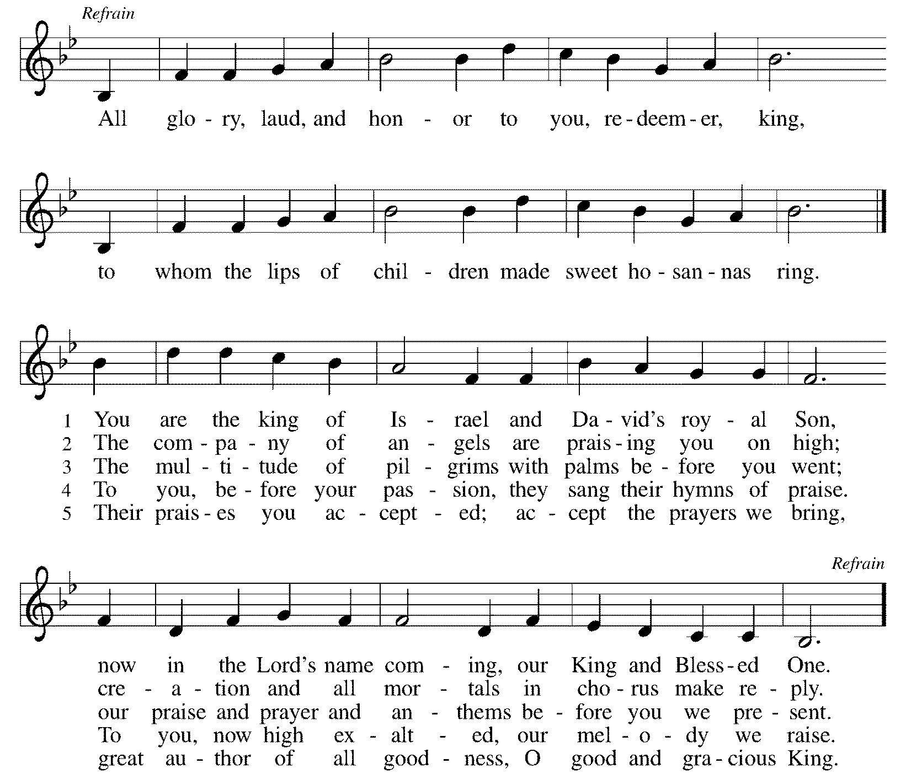

(You may unmute your mic)
Greeting
The grace of our Lord Jesus Christ, the love of God, and the communion of the Holy Spirit be with you all. And also with you.

Prayer of the Day
Everlasting God, in your endless love for the human race you sent our Lord Jesus Christ to take on our nature and to suffer death on the cross. In your mercy enable us to share in his obedience to your will and in the glorious victory of his resurrection, who lives and reigns with you and the Holy Spirit, one God, now and forever. Amen.

Word
God speaks to us in scripture reading, preaching, and song.
First Lesson Isaiah 50:4-9a
This text, the third of the four Servant Songs in Isaiah, speaks of the servant’s obedience in the midst of persecution. Though the servant has been variously understood as the prophet himself or a remnant of faithful Israel, Christians have often recognized the figure of Christ in these poems.

⁴The Lord God has given me the tongue of a teacher, that I may know how to sustain the weary with a word. Morning by morning he wakens— wakens my ear to listen as those who are taught. ⁵The Lord God has opened my ear, and I was not rebellious, I did not turn backward. ⁶I gave my back to those who struck me, and my cheeks to those who pulled out the beard; I did not hide my face from insult and spitting.
⁷The Lord God helps me; therefore I have not been disgraced; therefore I have set my face like flint, and I know that I shall not be put to shame; ⁸he who vindicates me is near. Who will contend with me? Let us stand up together. Who are my adversaries? Let them confront me. ^{9a}It is the Lord God who helps me; who will declare me guilty?

Word of God, Word of Life. Thanks be to God.

The Psalm Read responsively by verse Psalm 31:9-16
Into your hands, O Lord, I commend my spirit. (Ps. 31:5)

⁹Have mercy on me, O Lord, for I am in trouble; my eye is consumed with sorrow, and also my throat and my belly.
¹⁰For my life is wasted with grief, and my years with sighing; my strength fails me because of affliction, and my bones are consumed.
¹¹I am the scorn of all my enemies, a disgrace to my neighbors, a dismay to my acquaintances; when they see me in the street they avoid me.
¹²Like the dead I am forgotten, out of mind; I am as useless as a broken pot.
¹³For I have heard the whispering of the crowd; fear is all around; they put their heads together against me; they plot to take my life.
¹⁴But as for me, I have trusted in you, O Lord. I have said, “You are my God.
¹⁵My times are in your hand; rescue me from the hand of my enemies, and from those who persecute me.
¹⁶Let your face shine upon your servant; save me in your steadfast love.”

Second Lesson Philippians 2:5-11
Paul quotes from an early Christian hymn that describes Jesus’ humble obedience in his incarnation as a human being, even to death, and his exaltation and glory as Lord of all.

⁵Let the same mind be in you that was in Christ Jesus, ⁶who, though he was in the form of God, did not regard equality with God as something to be exploited, ⁷but emptied himself, taking the form of a slave, being born in human likeness. And being found in human form, ⁸he humbled himself and became obedient to the point of death— even death on a cross.
⁹Therefore God also highly exalted him and gave him the name that is above every name, ¹⁰so that at the name of Jesus every knee should bend, in heaven and on earth and under the earth, ¹¹and every tongue should confess that Jesus Christ is Lord, to the glory of God the Father.

Word of God, Word of Life. Thanks be to God.

Gospel Acclamation
Christ humbled himself and became obedient to the point of death—even death on a cross. Therefore God also highly exalted him and gave him the name that is above every name.

(Please mute your mic)
The holy Gospel according to Mark. Glory to you, O Lord.

Gospel Mark 14:1--15:47
The passion story in Mark’s gospel presents Jesus as one who dies abandoned by all. He shows himself to be the true Son of God by giving his life for those who have forsaken him.
(On the Sunday of the Passion, the full passion narrative is read in place of the sermon. The abbreviated text, Mark 15:1-39, is printed below)
^{15:1}As soon as it was morning, the chief priests held a consultation with the elders and scribes and the whole council. They bound Jesus, led him away, and handed him over to Pilate. ²Pilate asked him, “Are you the King of the Jews?” He answered him, “You say so.” ³Then the chief priests accused him of many things. ⁴Pilate asked him again, “Have you no answer? See how many charges they bring against you.” ⁵But Jesus made no further reply, so that Pilate was amazed.
⁶Now at the festival he used to release a prisoner for them, anyone for whom they asked. ⁷Now a man called Barabbas was in prison with the rebels who had committed murder during the insurrection. ⁸So the crowd came and began to ask Pilate to do for them according to his custom. ⁹Then he answered them, “Do you want me to release for you the King of the Jews?” ¹⁰For he realized that it was out of jealousy that the chief priests had handed him over. ¹¹But the chief priests stirred up the crowd to have him release Barabbas for them instead. ¹²Pilate spoke to them again, “Then what do you wish me to do with the man you call the King of the Jews?” ¹³They shouted back, “Crucify him!” ¹⁴Pilate asked them, “Why, what evil has he done?” But they shouted all the more, “Crucify him!” ¹⁵So Pilate, wishing to satisfy the crowd, released Barabbas for them; and after flogging Jesus, he handed him over to be crucified.
¹⁶Then the soldiers led him into the courtyard of the palace (that is, the governor’s headquarters); and they called together the whole cohort. ¹⁷And they clothed him in a purple cloak; and after twisting some thorns into a crown, they put it on him. ¹⁸And they began saluting him, “Hail, King of the Jews!” ¹⁹They struck his head with a reed, spat upon him, and knelt down in homage to him. ²⁰After mocking him, they stripped him of the purple cloak and put his own clothes on him. Then they led him out to crucify him.
²¹They compelled a passer-by, who was coming in from the country, to carry his cross; it was Simon of Cyrene, the father of Alexander and Rufus. ²²Then they brought Jesus to the place called Golgotha (which means the place of a skull). ²³And they offered him wine mixed with myrrh; but he did not take it. ²⁴And they crucified him, and divided his clothes among them, casting lots to decide what each should take.
²⁵It was nine o’clock in the morning when they crucified him. ²⁶The inscription of the charge against him read, “The King of the Jews.” ²⁷And with him they crucified two bandits, one on his right and one on his left. ²⁹Those who passed by derided him, shaking their heads and saying, “Aha! You who would destroy the temple and build it in three days, ³⁰save yourself, and come down from the cross!” ³¹In the same way the chief priests, along with the scribes, were also mocking him among themselves and saying, “He saved others; he cannot save himself. ³²Let the Messiah, the King of Israel, come down from the cross now, so that we may see and believe.” Those who were crucified with him also taunted him.
³³When it was noon, darkness came over the whole land until three in the afternoon. ³⁴At three o’clock Jesus cried out with a loud voice, “Eloi, Eloi, lema sabachthani?” which means, “My God, my God, why have you forsaken me?” ³⁵When some of the bystanders heard it, they said, “Listen, he is calling for Elijah.” ³⁶And someone ran, filled a sponge with sour wine, put it on a stick, and gave it to him to drink, saying, “Wait, let us see whether Elijah will come to take him down.” ³⁷Then Jesus gave a loud cry and breathed his last. ³⁸And the curtain of the temple was torn in two, from top to bottom. ³⁹Now when the centurion, who stood facing him, saw that in this way he breathed his last, he said, “Truly this man was God’s Son!”

The Gospel of the Lord. Praise to you, O Christ.
(You may unmute your mic)
Apostles’ Creed
With the whole church, let us confess our faith.
I believe in God, the Father almighty, creator of heaven and earth. I believe in Jesus Christ, God's only Son, our Lord, who was conceived by the Holy Spirit, born of the virgin Mary, suffered under Pontius Pilate, was crucified, died, and was buried; he descended to the dead. On the third day he rose again; he ascended into heaven, he is seated at the right hand of the Father, and he will come to judge the living and the dead. I believe in the Holy Spirit, the holy catholic church, the communion of saints, the forgiveness of sins, the resurrection of the body, and the life everlasting. Amen.

Prayers of Intercession
Relying on the promises of God, we pray boldly for the church, the world, and all in need.
A brief silence.

In Jesus you came among us as a suffering servant. Give your church humility. Redeem your people from pride and the certainty that we always know your will. Heal us and empower us to confess Christ crucified. Hear us, O God. Your mercy is great.

In creation, life springs from death. Redeem your creation awaiting resurrection: restore lost habitats and endangered species. Create new possibilities for areas affected by climate change, grant relief from natural disasters, and nurture new growth. Hear us, O God. Your mercy is great.

Jesus was handed over to the powers of this world. In all nations, instruct the powerful, that they would not exploit their power but maintain justice. Sustain soldiers, and guide those who command them, that they serve those in greatest need. Hear us, O God. Your mercy is great.

On the cross Jesus joined all who feel forsaken. Abide with those who are condemned to death. Defend those who are falsely accused. Console and strengthen those who are mocked or bullied. Accompany all who suffer especially Jerry, Bob, Sigrid, Dorothy, Rich, Helen, Anita, Dolores, Norma, Carol, Dorothy, and those we name before you now. . . ; grant respite and renewal. Hear us, O God. Your mercy is great.

You called followers to tend Jesus’ body in death. Sustain hospice workers and funeral directors. Bless this congregation’s ministries at times of death: those who plan and lead funerals, those who prepare meals, all who offer support in grief. Hear us, O God. Your mercy is great.
Here other intercessions may be offered.

You inspired the centurion to confess Jesus as your Son. We praise you for the faith you have given to people of all places and times. Give us also such faith to trust the promises of baptism and, with them, to look for the resurrection of the dead. Hear us, O God. Your mercy is great.

We entrust ourselves and all our prayers to you, O faithful God, through Jesus Christ our Lord.
Amen.

The Peace
The peace of the Lord be with you always. And also with you.
If there are others in your household you may share the peace with them.

If your House Church is celebrating Communion, refer to that liturgy here.

The Lord’s Prayer
Gathered into one by the Holy Spirit, let us pray as Jesus taught us.
Our Father, who art in heaven, hallowed be thy name, thy kingdom come, thy will be done on earth as it is in heaven. Give us this day our daily bread; and forgive us our trespasses, as we forgive those who trespass against us; and lead us not into temptation, but deliver us from evil. For thine is the kingdom, and the power, and the glory, forever and ever. Amen.

Sending
God blesses us and sends us in mission to the world.
Blessing
You are what God made you to be: created in Christ Jesus for good works, chosen as holy and beloved, freed to serve your neighbor. God bless you ☩ that you may be a blessing, in the name of the holy and life-giving Trinity.

(Please mute your mic)
Sending Hymn ELW #335 Jesus, Keep Me Near the Cross, sts. 1,2,4
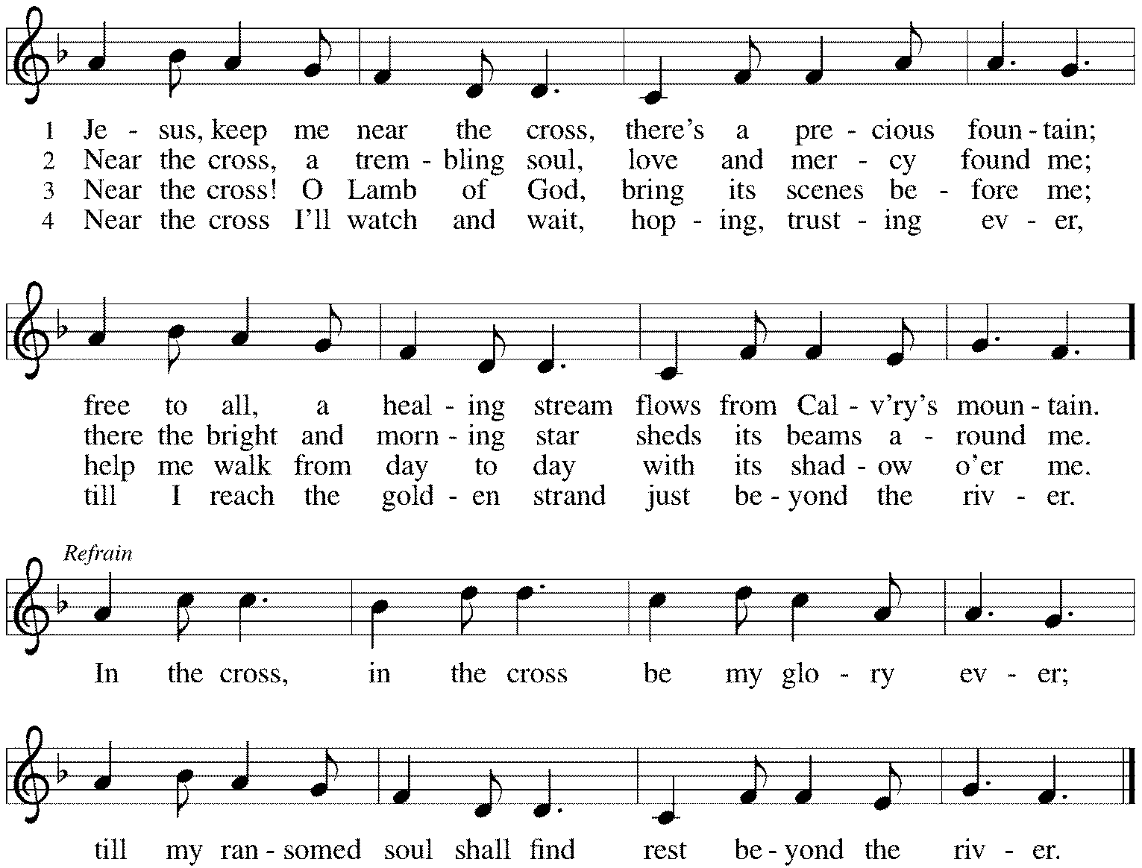

(You may unmute your mic)
Sent to the World
Go in peace. Share the good news. Thanks be to God.

From Sundays and Seasons v .20210119.1257 Copyright © 2021 Augsburg Fortress. All rights reserved.
Reprinted by permission under Augsburg Fortress Liturgies Annual License #30867.
Reprinted under OneLicense.net #A-718333.

Current Prayer Requests
Name Relation to Grace Prayers For
Helen & Jim Sladek Members 63rd Anniversary 3/22
Jerry Jeske Member Healing & Strength
Bob Stein Member Healing & Strength
Helen Sladek Member Healing & Strength
Rich Davison Member Healing & Strength
Sigrid Elliott Member Healing & Strength
Dorothy Tracy Member Healing & Strength
Carol Petersen Member Birthday 4/9 (93)
Ruthie Maddock Friend of the Thompsons Healing & Strength
Chris Danly Son of Mark & Pat Danly Healing & Strength
Prayers for our homebound Members
Anita Blakemore, Dolores Nosal, Carol Petersen, Norma Petersen, Dorothy Stein

Weekly Announcements
Holy Week Schedule
Maundy Thursday: All Church Zoom service at 7:00 p.m., with Communion
Good Friday: All-Church Zoom Tenebrae service at 7:00 p.m.
Easter Sunday: All-Church Zoom service at 9:00 a.m. (½ hour earlier than House Church!), with Communion

In Person Worship Update from the Church Council: The council continues discernment on returning to in person worship. For the time being we will continue our weekly Zoom House Church services. We will be having live Zoom worship services broadcast from Church during Holy Week. This includes Maundy Thursday at 7pm, Good Friday at 7pm and Easter at 9am. Zoom information for those services will be sent out during Holy Week.
We are working on a plan for our return to in person worship. The return date will depend on when church service leaders have been fully vaccinated (for those that choose to) and are comfortable returning to worship. This includes Pastor Melody, Bradford and Ushers. We will also take into account other factors such as community transmission rates, etc. Initially, in person worship will also be broadcast on Zoom so that those that are not yet comfortable returning to in person worship will still be able to participate. Watch for future updates in our weekly eblast and GTY.

Pastor Melody’s days off are Friday and Saturday. If you wish to contact her for non-emergency reasons, the best days to reach her are Monday-Thursday.

The April/May/June copies of Christ in our Home and Sundays and Seasons are in the narthex. Please stop by and pick up your copies.

Communion sets are taped to the white board outside of Barbara’s office. You may pick them up at any time the building is open.

House Church Worship via phone or internet every Sunday morning at 9:30am! We currently have five “House Churches” of worshipping members (each House Church consisting of 6-8 members/families meeting via Zoom or calling in by phone.) If you are unsure how to sign on, go ahead and register and let us know you need some help; we’ll walk you through it! We would be so blessed to have you join us. Register online for a House Church at graceglenellyn.org (on the main page Announcements) or contact Jon Milleville.

Contributions to Grace’s Mortgage Reduction Fund are always welcome! Indicate on the contribution that it is for the Mortgage Reduction Fund. We cannot begin to tell you how thankful we are for your support of this campaign. We aim to have 2021 be one more push towards diminishing the monthly mortgage payment and freeing more of the budget for our Ministries at Grace.

RAMP: We are excited to announce that we have been able to “eliminate the comma” from our mortgage, bringing our total mortgage to under $1,000,000! We will continue this campaign in 2021 as “RAMP” (Reduce Another Mortgage Payment) as we continue to RAMP up to refinance our mortgage with Mission Investment Fund this Fall. If we can raise an additional $100,000 payment prior to our November mortgage refinancing it will take us from $925,000 to $825,000!

Food Pantry Needed Items This Week: Canned Mushrooms; Canned Beef Stew; Sugar; Cooking Oil; Ramen Noodles; Large Juice Bottles; Canned Chicken; Coffee/Tea; Instant White Rice; Hamburger Helper; Sugar.

Phone: 630-469-1555 Emergency Pastoral Contact: 630-674-2887
info@graceglenellyn.org www.graceglenellyn.org

Pastor
Rev. Melody Eastman office ext. 14
meastman@graceglenellyn.org

Minister of Music
Bradford Thompson 219-718-8879
bradfordmthompson@gmail.com

Ministry Associate
Becky Ficarella office ext. 17
bficarella@graceglenellyn.org

Office Manager
Barbara Sudds office ext. 10
bsudds@graceglenellyn.org

Parish Counselor
Carole LoGalbo M.S., LCPC 630-668-4594
carolelogalbo@yahoo.com

