Grace Lutheran Church

A congregation of the Evangelical Lutheran Church in America

493 Forest Avenue, Glen Ellyn IL 630.469.1555
www.GraceGlenEllyn.org

Maundy Thursday April 1, 2021

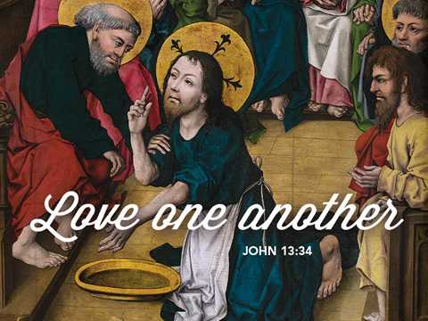

+ Proclaim Christ + Build Community +
+ Serve Our Neighbors +

Introduction
This evening our Lenten observance comes to an end, and we gather with Christians around the world to celebrate the Three Days of Jesus’ death and resurrection. Tonight we remember Christ’s last meal with his disciples, but the central focus is his commandment that we live out the promise embodied in this meal. As Jesus washed his disciples’ feet, so we are called to give and receive love in humble service to one another. Formed into a new body in Christ through this holy meal, we are transformed by the mercy we have received and carry it into the world. Departing worship in solemn silence, we anticipate the coming days.

Gathering
As we begin the great journey of the Three Days, the community gathers in silence for reflection. Tonight’s worship begins with confession and absolution, culminating the Lenten discipline of repentance that began on Ash Wednesday.

Confession and Forgiveness
Friends in Christ, in this Lenten season we have heard our Lord’s call to struggle against sin, death, and the devil—all that keeps us from loving God and each other. This is the struggle to which we were called at baptism. [We have shared this discipline of Lent with new brothers and sisters in Christ who will be baptized at the Easter Vigil.]

Within the community of the church, God never wearies of forgiving sin and giving the peace of reconciliation. On this night let us confess our sin against God and our neighbor, and enter the celebration of the great Three Days reconciled with God and with one another.
Silence is kept for reflection and self-examination.

Most merciful God, we confess that we are captive to sin and cannot free ourselves. We have sinned against you in thought, word, and deed, by what we have done and by what we have left undone. We have not loved you with our whole heart; we have not loved our neighbors as ourselves. For the sake of your Son, Jesus Christ, have mercy on us. Forgive us, renew us, and lead us, so that we may delight in your will and walk in your ways, to the glory of your holy name. Amen.

God, who is rich in mercy, loved us even when we were dead in sin, and made us alive together with Christ. By grace you have been saved. In the name of ☩ Jesus Christ, your sins are forgiven. Almighty God strengthen you with power through the Holy Spirit, that Christ may live in your hearts through faith. Amen.

Greeting
The grace of our Lord Jesus Christ, the love of God, and the communion of the Holy Spirit be with you all. And also with you.

Prayer of the Day
Holy God, source of all love, on the night of his betrayal, Jesus gave us a new commandment, to love one another as he loves us. Write this commandment in our hearts, and give us the will to serve others as he was the servant of all, your Son, Jesus Christ, our Savior and Lord, who lives and reigns with you and the Holy Spirit, one God, now and forever. Amen.

Word
First Lesson Exodus 12:1-4, 11-14
Israel remembered its deliverance from slavery in Egypt by celebrating the festival of Passover. This festival featured the Passover lamb, whose blood was used as a sign to protect God’s people from the threat of death. The early church described the Lord’s supper using imagery from the Passover, especially in portraying Jesus as the lamb who delivers God’s people from sin and death.

¹The Lord said to Moses and Aaron in the land of Egypt: ²This month shall mark for you the beginning of months; it shall be the first month of the year for you. ³Tell the whole congregation of Israel that on the tenth of this month they are to take a lamb for each family, a lamb for each household. ⁴If a household is too small for a whole lamb, it shall join its closest neighbor in obtaining one; the lamb shall be divided in proportion to the number of people who eat of it.
¹¹This is how you shall eat it: your loins girded, your sandals on your feet, and your staff in your hand; and you shall eat it hurriedly. It is the passover of the Lord. ¹²For I will pass through the land of Egypt that night, and I will strike down every firstborn in the land of Egypt, both human beings and animals; on all the gods of Egypt I will execute judgments: I am the Lord. ¹³The blood shall be a sign for you on the houses where you live: when I see the blood, I will pass over you, and no plague shall destroy you when I strike the land of Egypt.
¹⁴This day shall be a day of remembrance for you. You shall celebrate it as a festival to the Lord; throughout your generations you shall observe it as a perpetual ordinance.

Word of God, Word of Life. Thanks be to God.

Psalm Psalm 116:1-2, 12-19
I will lift the cup of salvation and call on the name of the Lord. (Ps. 116:13)

¹I love the Lord, who has heard my voice, and listened to my supplication,
²for the Lord has given ear to me whenever I called.
¹²How shall I repay the Lord for all the good things God has done for me?
¹³I will lift the cup of salvation and call on the name of the Lord.
¹⁴I will fulfill my vows to the Lord in the presence of all God’s people.
¹⁵Precious in your sight, O Lord, is the death of your servants.
¹⁶O Lord, truly I am your servant; I am your servant, the child of your handmaid; you have freed me from my bonds.
¹⁷I will offer you the sacrifice of thanksgiving and call upon the name of the Lord.
¹⁸I will fulfill my vows to the Lord in the presence of all God’s people,
¹⁹in the courts of the Lord‘s house, in the midst of you, O Jerusalem.

Second Lesson 1 Corinthians 11:23-26
In the bread and cup of the Lord’s supper, we experience intimate fellowship with Christ and with one another, because it involves his body given for us and the new covenant in his blood. Faithful participation in this meal is a living proclamation of Christ’s death until he comes in the future.

²³For I received from the Lord what I also handed on to you, that the Lord Jesus on the night when he was betrayed took a loaf of bread, ²⁴and when he had given thanks, he broke it and said, “This is my body that is for you. Do this in remembrance of me.” ²⁵In the same way he took the cup also, after supper, saying, “This cup is the new covenant in my blood. Do this, as often as you drink it, in remembrance of me.” ²⁶For as often as you eat this bread and drink the cup, you proclaim the Lord’s death until he comes.

Word of God, Word of Life. Thanks be to God.

Gospel Acclamation C. Heine
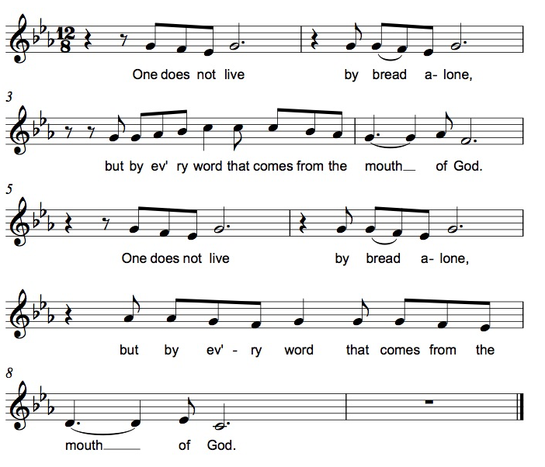

The holy Gospel according to John. Glory to you, O Lord.

Gospel John 13:1-17, 31b-35
The story of the last supper in John’s gospel recalls a remarkable event not mentioned elsewhere: Jesus performs the duty of a slave, washing the feet of his disciples and urging them to do the same for one another.

¹Now before the festival of the Passover, Jesus knew that his hour had come to depart from this world and go to the Father. Having loved his own who were in the world, he loved them to the end. ²The devil had already put it into the heart of Judas son of Simon Iscariot to betray him. And during supper ³Jesus, knowing that the Father had given all things into his hands, and that he had come from God and was going to God, ⁴got up from the table, took off his outer robe, and tied a towel around himself. ⁵Then he poured water into a basin and began to wash the disciples’ feet and to wipe them with the towel that was tied around him. ⁶He came to Simon Peter, who said to him, “Lord, are you going to wash my feet?” ⁷Jesus answered, “You do not know now what I am doing, but later you will understand.” ⁸Peter said to him, “You will never wash my feet.” Jesus answered, “Unless I wash you, you have no share with me.” ⁹Simon Peter said to him, “Lord, not my feet only but also my hands and my head!” ¹⁰Jesus said to him, “One who has bathed does not need to wash, except for the feet, but is entirely clean. And you are clean, though not all of you.” ¹¹For he knew who was to betray him; for this reason he said, “Not all of you are clean.”
¹²After he had washed their feet, had put on his robe, and had returned to the table, he said to them, “Do you know what I have done to you? ¹³You call me Teacher and Lord—and you are right, for that is what I am. ¹⁴So if I, your Lord and Teacher, have washed your feet, you also ought to wash one another’s feet. ¹⁵For I have set you an example, that you also should do as I have done to you. ¹⁶Very truly, I tell you, servants are not greater than their master, nor are messengers greater than the one who sent them. ¹⁷If you know these things, you are blessed if you do them.”
^{31b}“Now the Son of Man has been glorified, and God has been glorified in him. ³²If God has been glorified in him, God will also glorify him in himself and will glorify him at once. ³³Little children, I am with you only a little longer. You will look for me; and as I said to the Jews so now I say to you, ‘Where I am going, you cannot come.’ ³⁴I give you a new commandment, that you love one another. Just as I have loved you, you also should love one another. ³⁵By this everyone will know that you are my disciples, if you have love for one another.”

The Gospel of the Lord. Praise to you, O Christ.

Sermon The Rev. Melody Eastman

Foot Washing

Hymn of the Day ELW #360 Love Consecrates the Humblest Act
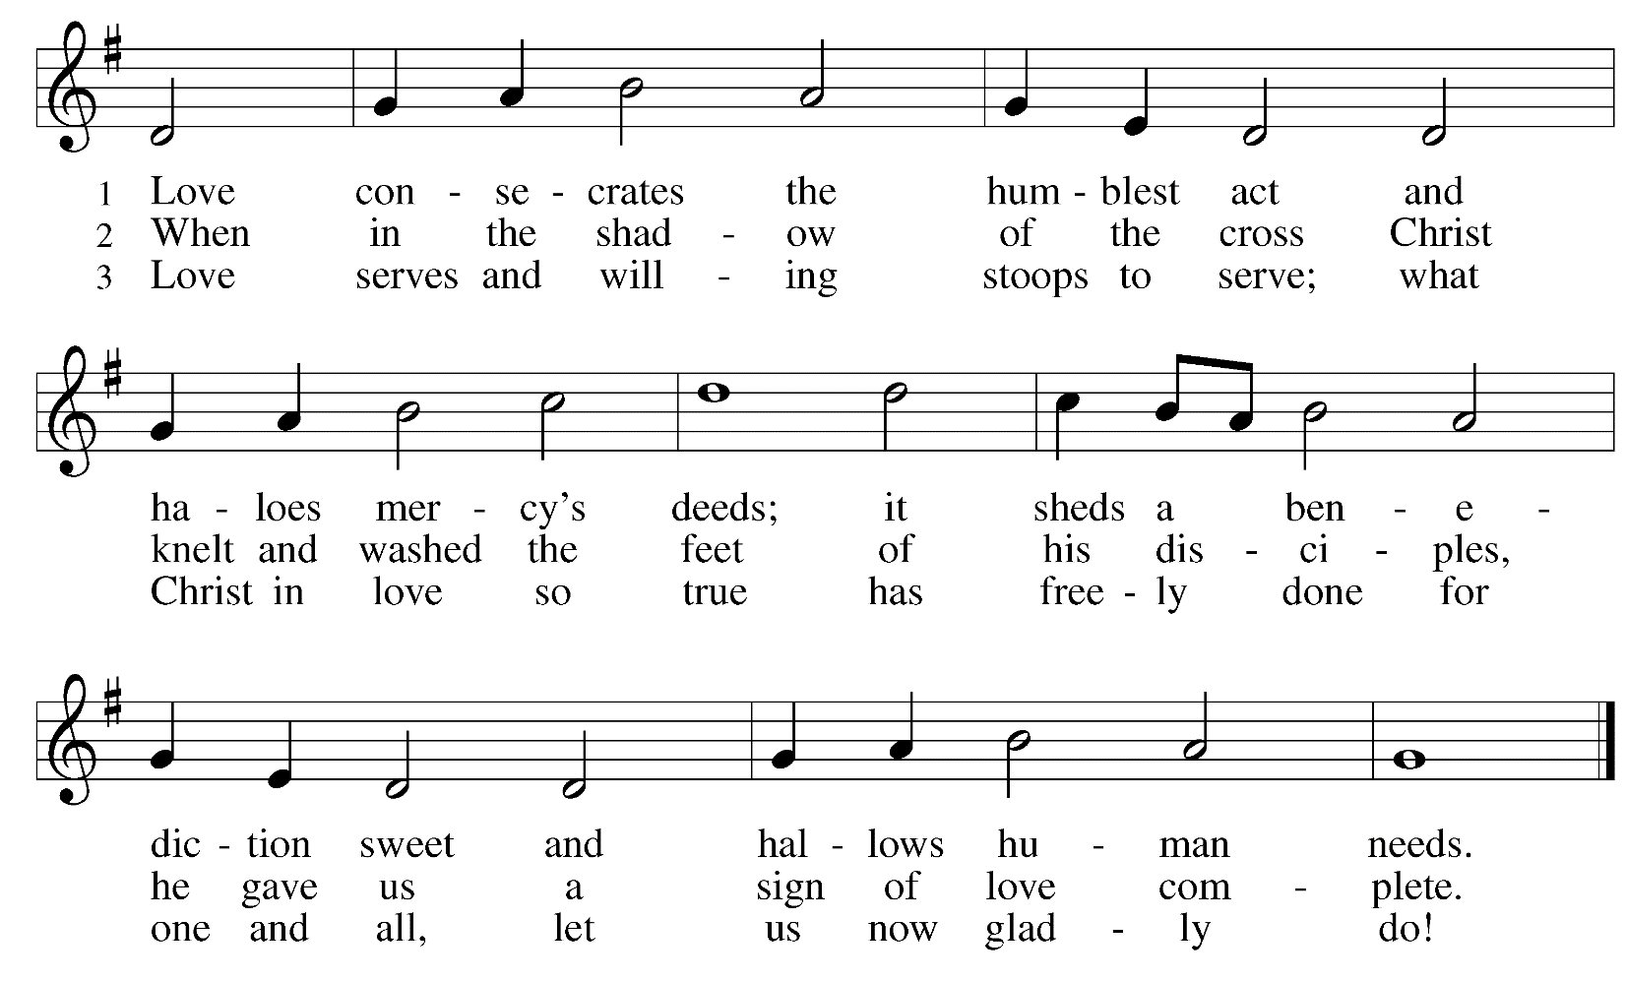

Prayers of Intercession
United by the servant love of God in Christ, we pray this holy night for the needs of the world.
A brief silence.

You call your people to hand on what we receive from you. Form all the baptized into teachers of faith. From one generation to the next, give your church hunger for your promises in the sacraments and joy in receiving and sharing your word. Hear us, O God. Your mercy is great.

Your creation provides all that we need. Cleanse and protect the water you have given for washing and drinking, water on which all life depends. Sustain crops and herds that provide food; teach us how to live so that there is enough for all. Hear us, O God. Your mercy is great.

You redeemed your people from slavery. Preserve people throughout the world who flee violence and oppression. Establish just leadership in place of tyranny and peace in place of war. Hear us, O God. Your mercy is great.

Jesus loved his followers to the end. Grant assurance of that love to all who need it: those living with guilt, those struggling to forgive, those who are lonely or overlooked. Heal the sick and embrace the dying. Hear us, O God. Your mercy is great.

Jesus washed the feet of the one who betrayed him. Inspire this congregation’s ministries of service, that we love as Jesus loved us. Give us renewed courage to serve. Bless the ministry of deacons throughout the church. Hear us, O God. Your mercy is great.
Here other intercessions may be offered.

Your glory shone in the suffering, death, and resurrection of Jesus. We thank you for generations of the faithful who have proclaimed our Lord’s death. Unite us with them in hope until he comes again. Hear us, O God. Your mercy is great.

Hear these and all our prayers, O God, in the name of the one who loves us to the end, Jesus Christ our Redeemer. Amen.

Peace
The peace of Christ be with you always. And also with you.
Please share the peace with those around you.

Meal
Great Thanksgiving
The Lord be with you. And also with you.

Lift up your hearts. We lift them to the lord.

Let us give thanks to the Lord our God. It is right to give our thanks and praise.

Preface
It is indeed right, our duty and our joy, that we should at all times and in all places give thanks and praise to you, almighty and merciful God, through our Savior Jesus Christ, whose suffering and death gave salvation to all. You gather your people around the tree of the cross, transforming death into life. And so, with all the choirs of angels, with the church on earth and the hosts of heaven, we praise your name and join their unending hymn:

Sanctus ELW#190 Holy, Holy, Holy
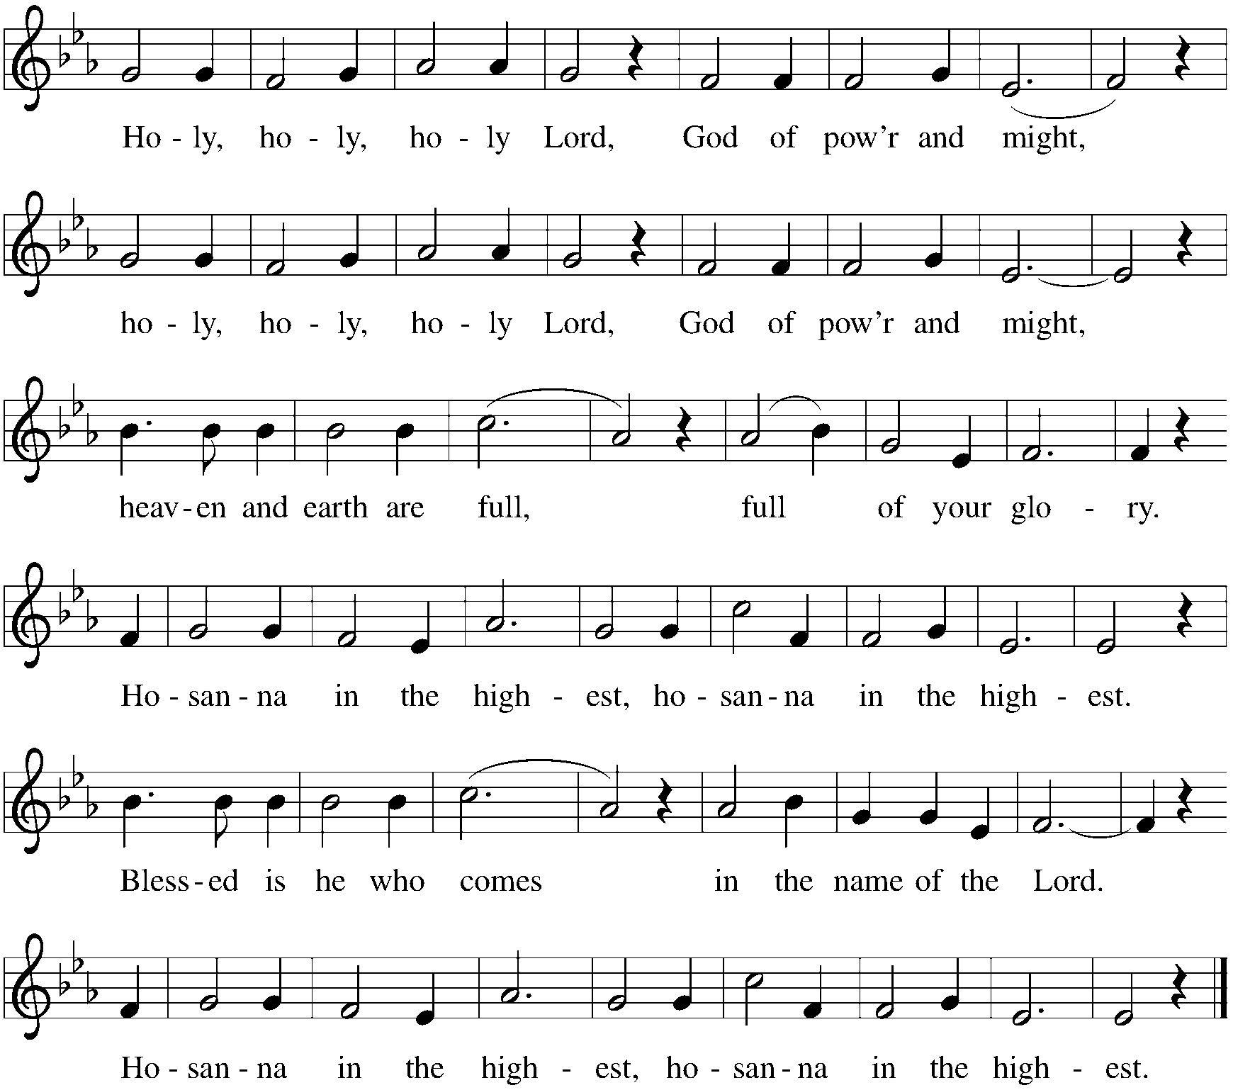

Lord’s Prayer
Gathered into one by the Holy Spirit, let us pray as Jesus taught us.
Our Father in heaven, hallowed be your name. Your kingdom come, your will be done on earth as in heaven. Give us today our daily bread. Forgive us our sins as we forgive those who sin against us. Save us from the time of trial and deliver us from evil. For the kingdom, the power and the glory are yours, now and forever. Amen.

Invitation to Communion
Jesus draws the whole world to himself. Come to this meal and be fed.

Communion
The body of Christ, given for you. (Eat the bread) Amen.
The blood of Christ, shed for you. (Drink the wine/juice) Amen.
Duet Kim Wiebe and Jake Jacobson Steal Away

Post Communion Blessing
The Body and Blood of our Lord Jesus Christ strengthen you and keep you in his grace. Amen.

Post Communion Prayer
Lord Jesus, in a wonderful sacrament you strengthen us with the saving power of your suffering, death, and resurrection. May this sacrament of your body and blood so work in us that the fruits of your redemption will show forth in the way we live, for you live and reign with the Father and the Holy Spirit, one God, now and forever. Amen.

Stripping of the Altar
Psalm 22 is read as the altar is stripped of vessels and paraments, representing Christ’s laying down his power in preparation for Good Friday.
My God, my God, why have you forsaken me? Why are you so far from helping me, from the words of my groaning? ²O my God, I cry by day, but you do not answer; and by night, but find no rest. ³Yet you are holy, enthroned on the praises of Israel.
⁴In you our ancestors trusted; they trusted, and you delivered them. ⁵To you they cried, and were saved; in you they trusted, and were not put to shame.
⁶But I am a worm, and not human; scorned by others, and despised by the people. ⁷All who see me mock at me; they make mouths at me, they shake their heads; ⁸"Commit your cause to the LORD; let him deliver — let him rescue the one in whom he delights!"
⁹Yet it was you who took me from the womb; you kept me safe on my mother's breast. ¹⁰On you I was cast from my birth, and since my mother bore me you have been my God. ¹¹Do not be far from me,for trouble is near and there is no one to help.
¹²Many bulls encircle me, strong bulls of Bashan surround me; ¹³they open wide their mouths at me, like a ravening and roaring lion.
¹⁴I am poured out like water, and all my bones are out of joint; my heart is like wax; it is melted within my breast; ¹⁵my mouth is dried up like a potsherd, and my tongue sticks to my jaws; you lay me in the dust of death.
¹⁶For dogs are all around me; a company of evildoers encircles me. My hands and feet have shriveled; ¹⁷I can count all my bones. They stare and gloat over me; ¹⁸they divide my clothes among themselves, and for my clothing they cast lots.
¹⁹But you, O LORD, do not be far away! O my help, come quickly to my aid! ²⁰Deliver my soul from the sword, my life from the power of the dog! ²¹Save me from the mouth of the lion!
From the horns of the wild oxen you have rescued me.
²²I will tell of your name to my brothers and sisters in the midst of the congregation I will praise you: ²³You who fear the LORD, praise him! All you offspring of Jacob, glorify him;
stand in awe of him, all you offspring of Israel! ²⁴For he did not despise or abhor the affliction of the afflicted; he did not hide his face from me, but heard when I cried to him.
²⁵From you comes my praise in the great congregation; my vows I will pay before those who fear him. ²⁶The poor shall eat and be satisfied; those who seek him shall praise the LORD.
May your hearts live forever!
²⁷All the ends of the earth shall remember and turn to the LORD; and all the families of the nations shall worship before him. ²⁸For dominion belongs to the LORD, and he rules over the nations.
²⁹To him, indeed, shall all who sleep in the earth bow down; before him shall bow all who go down to the dust, and I shall live for him. ³⁰Posterity will serve him; future generations will be told about the LORD, ³¹and proclaim his deliverance to a people yet unborn, saying that he has done it.
Depart in peace.
The service ends in silence and continues tomorrow night at 7:00pm
with the liturgy for Good Friday.

From Sundays and Seasons v.20190109.1233 Copyright © 2021 Augsburg Fortress. All rights reserved.
Reprinted by permission under Augsburg Fortress Liturgies Annual License #30867.
All rights reserved. Reprinted under OneLicense.net #A-718333.

Every Member a Minister and Missionary!

Phone: 630-469-1555 Emergency Pastoral Contact: 630-674-2887
info@graceglenellyn.org www.graceglenellyn.org

Pastor
Rev. Melody Eastman office ext. 14
meastman@graceglenellyn.org

Office Manager
Barbara Sudds office ext. 10
bsudds@graceglenellyn.org

Ministry Associate
Becky Ficarella office ext. 17
bficarella@graceglenellyn.org

Parish Counselor
Carole LoGalbo M.S., LCPC 630-668-4594
carolelogalbo@yahoo.com

Minister of Music
Bradford Thompson 219-718-8879
bradfordmthompson@gmail.com

