Grace Lutheran Church

493 Forest Avenue, Glen Ellyn IL 630.469.1555
www.graceglenellyn.org

Resurrection of Our Lord: Easter Day April 4, 2021

+ Proclaim Christ + Build Community +
+ Serve Our Neighbors +

Introduction
Christ is risen! Jesus is alive, and God has swallowed up death forever. With Mary Magdalene, Mary the mother of James, and Salome, we may feel astonished and confused, unsure of what to make of the empty tomb. But this is why we gather: to proclaim, witness, praise, and affirm the liberating reality of Christ’s death and resurrection. In word and feast, we celebrate God’s unending love, and depart to share this good news with all the world. Alleluia!

Gathering
Welcome/Announcements

Christ is Risen! He is risen indeed! Alleluia!

Prelude Easter Fanfare B. Thompson

Thanksgiving for Baptism
All may make the sign of the cross, the sign marked at baptism, as the presiding minister begins.
Alleluia! Christ is risen. Christ is risen indeed. Alleluia!
Refreshed by the resurrection life we share in Christ, let us give thanks for the gift of baptism.
Water may be poured into the font as the presiding minister gives thanks.
We thank you, risen Christ, for these waters where you make us new, leading us from death to life, from tears to joy. We bless you, risen Christ, that your Spirit comes to us in the grace-filled waters of rebirth, like rains to our thirsting earth, like streams that revive our souls, like cups of cool water shared with strangers. Breathe your peace on your church when we hide in fear.
Clothe us with your mercy and forgiveness. Send us companions on our journey as we share your life. Make us one, risen Christ. Cleanse our hearts. Shower us with life. To you be given all praise, with the Holy Spirit, in the glory of God, now and forever. Amen.

Entrance Hymn ELW #369 Christ the Lord is Risen Today; Alleluia
sts. 1, 4
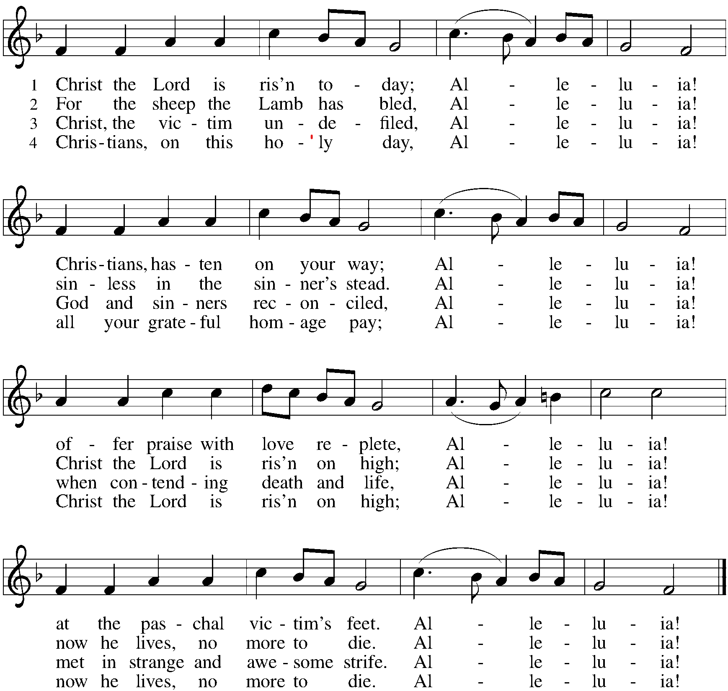

Greeting
The grace of our Lord Jesus Christ, the love of God, and the communion of the Holy Spirit be with you all. And also with you.

Hymn of Praise ELW #367 Now All the Vault of Heaven Resounds
sts. 1, 2
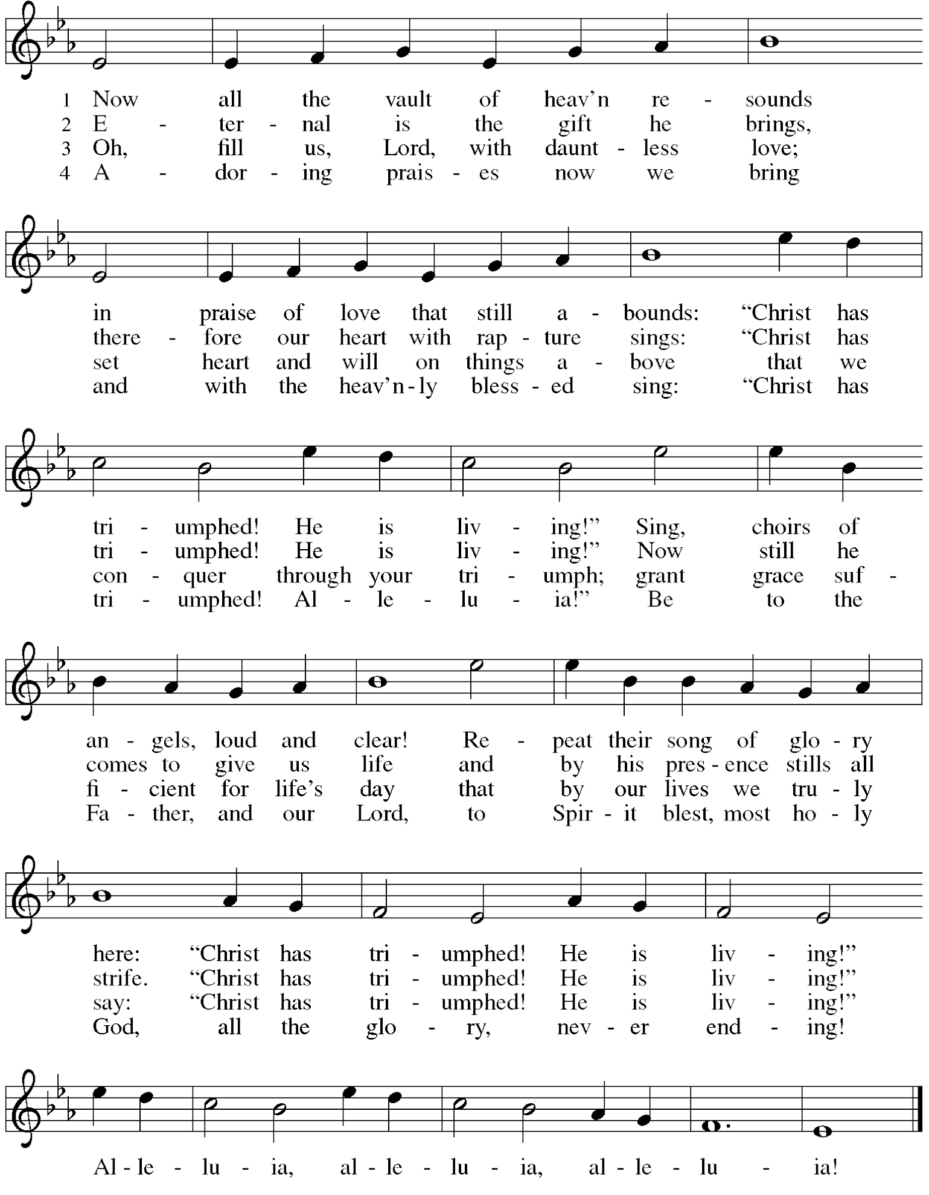

Prayer of the Day
O God, you gave your only Son to suffer death on the cross for our redemption, and by his glorious resurrection you delivered us from the power of death. Make us die every day to sin, that we may live with him forever in the joy of the resurrection, through your Son, Jesus Christ our Lord, who lives and reigns with you and the Holy Spirit, one God, now and forever. Amen.

Word
First Lesson Acts 10:34-43
Peter’s sermon, delivered at the home of Cornelius, a Roman army officer, sums up the essential message of Christianity. Everyone who believes in Jesus, whose life, death, and resurrection fulfilled the words of the prophets, receives forgiveness of sins through his name.

³⁴Peter began to speak to [the people]: “I truly understand that God shows no partiality, ³⁵but in every nation anyone who fears him and does what is right is acceptable to him. ³⁶You know the message he sent to the people of Israel, preaching peace by Jesus Christ—he is Lord of all. ³⁷That message spread throughout Judea, beginning in Galilee after the baptism that John announced: ³⁸how God anointed Jesus of Nazareth with the Holy Spirit and with power; how he went about doing good and healing all who were oppressed by the devil, for God was with him. ³⁹We are witnesses to all that he did both in Judea and in Jerusalem. They put him to death by hanging him on a tree; ⁴⁰but God raised him on the third day and allowed him to appear, ⁴¹not to all the people but to us who were chosen by God as witnesses, and who ate and drank with him after he rose from the dead. ⁴²He commanded us to preach to the people and to testify that he is the one ordained by God as judge of the living and the dead. ⁴³All the prophets testify about him that everyone who believes in him receives forgiveness of sins through his name.”

Word of God, Word of Life. Thanks be to God.

Second Lesson 1 Corinthians 15:1-11
The core of the Christian faith and Paul’s preaching is the death and resurrection of Jesus Christ. As the crucified and risen Christ appeared to the earliest of his followers, so we experience the presence of the Risen One in the preaching of this faith.

¹Now I would remind you, brothers and sisters, of the good news that I proclaimed to you, which you in turn received, in which also you stand, ²through which also you are being saved, if you hold firmly to the message that I proclaimed to you—unless you have come to believe in vain.
³For I handed on to you as of first importance what I in turn had received: that Christ died for our sins in accordance with the scriptures, ⁴and that he was buried, and that he was raised on the third day in accordance with the scriptures, ⁵and that he appeared to Cephas, then to the twelve. ⁶Then he appeared to more than five hundred brothers and sisters at one time, most of whom are still alive, though some have died. ⁷Then he appeared to James, then to all the apostles. ⁸Last of all, as to one untimely born, he appeared also to me. ⁹For I am the least of the apostles, unfit to be called an apostle, because I persecuted the church of God. ¹⁰But by the grace of God I am what I am, and his grace toward me has not been in vain. On the contrary, I worked harder than any of them—though it was not I, but the grace of God that is with me. ¹¹Whether then it was I or they, so we proclaim and so you have come to believe.

Word of God, Word of Life. Thanks be to God.

Gospel Acclamation ELW #388 Be Not Afraid

The holy Gospel according to John. Glory to you, O Lord.

Gospel John 20:1-18
Seeing the risen Christ
¹Early on the first day of the week, while it was still dark, Mary Magdalene came to the tomb and saw that the stone had been removed from the tomb. ²So she ran and went to Simon Peter and the other disciple, the one whom Jesus loved, and said to them, “They have taken the Lord out of the tomb, and we do not know where they have laid him.” ³Then Peter and the other disciple set out and went toward the tomb. ⁴The two were running together, but the other disciple outran Peter and reached the tomb first. ⁵He bent down to look in and saw the linen wrappings lying there, but he did not go in. ⁶Then Simon Peter came, following him, and went into the tomb. He saw the linen wrappings lying there, ⁷and the cloth that had been on Jesus’ head, not lying with the linen wrappings but rolled up in a place by itself. ⁸Then the other disciple, who reached the tomb first, also went in, and he saw and believed; ⁹for as yet they did not understand the scripture, that he must rise from the dead. ¹⁰Then the disciples returned to their homes.
¹¹But Mary stood weeping outside the tomb. As she wept, she bent over to look into the tomb; ¹²and she saw two angels in white, sitting where the body of Jesus had been lying, one at the head and the other at the feet. ¹³They said to her, “Woman, why are you weeping?” She said to them, “They have taken away my Lord, and I do not know where they have laid him.” ¹⁴When she had said this, she turned around and saw Jesus standing there, but she did not know that it was Jesus. ¹⁵Jesus said to her, “Woman, why are you weeping? Whom are you looking for?” Supposing him to be the gardener, she said to him, “Sir, if you have carried him away, tell me where you have laid him, and I will take him away.” ¹⁶Jesus said to her, “Mary!” She turned and said to him in Hebrew, “Rabbouni!” (which means Teacher). ¹⁷Jesus said to her, “Do not hold on to me, because I have not yet ascended to the Father. But go to my brothers and say to them, ‘I am ascending to my Father and your Father, to my God and your God.’ ” ¹⁸Mary Magdalene went and announced to the disciples, “I have seen the Lord”; and she told them that he had said these things to her.

The Gospel of the Lord. Praise to you, O Christ.

Gospel Acclamation ELW #388 Be Not Afraid
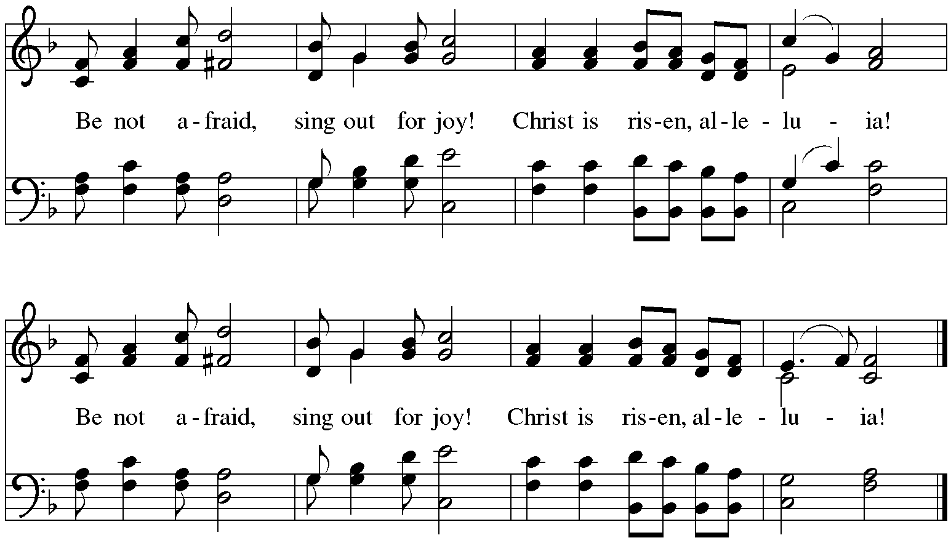
Sermon The Rev. Melody Eastman

Hymn of the Day ELW #362 At the Lamb’s High Feast We Sing
sts. 1, 6, 7, 8
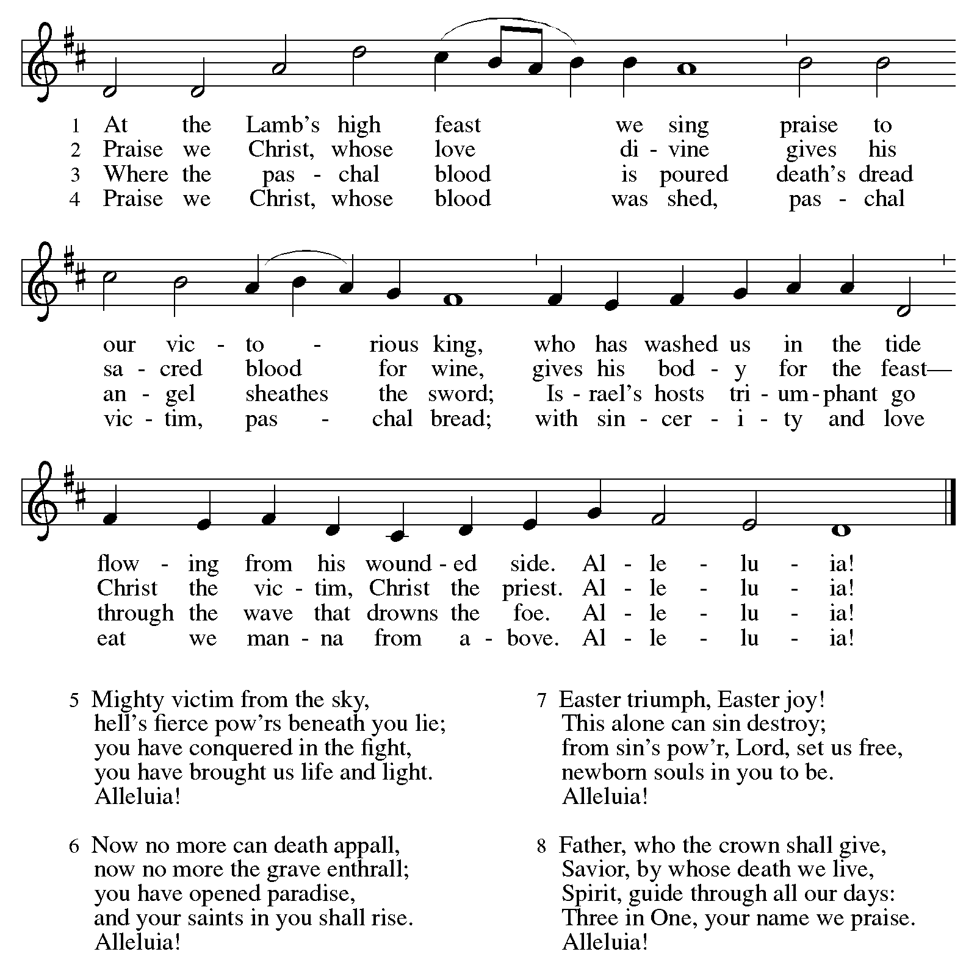

Prayers of Intercession
Alive in the risen Christ by the power of the Holy Spirit, we bring our prayers before God who promises to hear us and answer in steadfast love.
A brief silence.

Praise to you for your power revealed in the resurrection! Fill your church with the power of your love that is stronger than death. Send us to tell the good news wherever death holds sway. Hear us, O God. Your mercy is great.

Praise to you for your life at work in the resurrection! Fill all of creation with your life. Bring it to blossom and flourish; use it to remind us of your persistent grace. Cultivate our care for what you have made. Hear us, O God. Your mercy is great.

Praise to you for the peace made possible in the resurrection! Fill the nations with your peace. Draw together people of all nations and languages; reveal new possibilities and inspire new beginnings. Hear us, O God. Your mercy is great.

Praise to you for the hope of the resurrection! Fill all in need with hope: those who are afraid or confused, those who are sick or suffering, those who are dying, and those who grieve (especially). Assure them of your promises. Hear us, O God. Your mercy is great.

Praise to you for the joy of your resurrection! Fill this assembly with joy as we are called your beloved in baptism. Multiply that joy so that we share it at home, at work, and in our community. Hear us, O God. Your mercy is great.
Here other intercessions may be offered.

Praise to you for your faithfulness revealed in the resurrection! Fill us with trust, that we join with all who have gone before us in proclaiming: “your mercy endures forever!” Hear us, O God. Your mercy is great.

In the hope of new life in Christ, we raise our prayers to you, trusting in your never-ending goodness and mercy; through Jesus Christ our Lord. Amen.

Peace
The peace of Christ be with you always. And also with you.
Please share the peace with others in your household, or by making a sign of peace to those on Zoom.

Meal
Great Thanksgiving p. 152
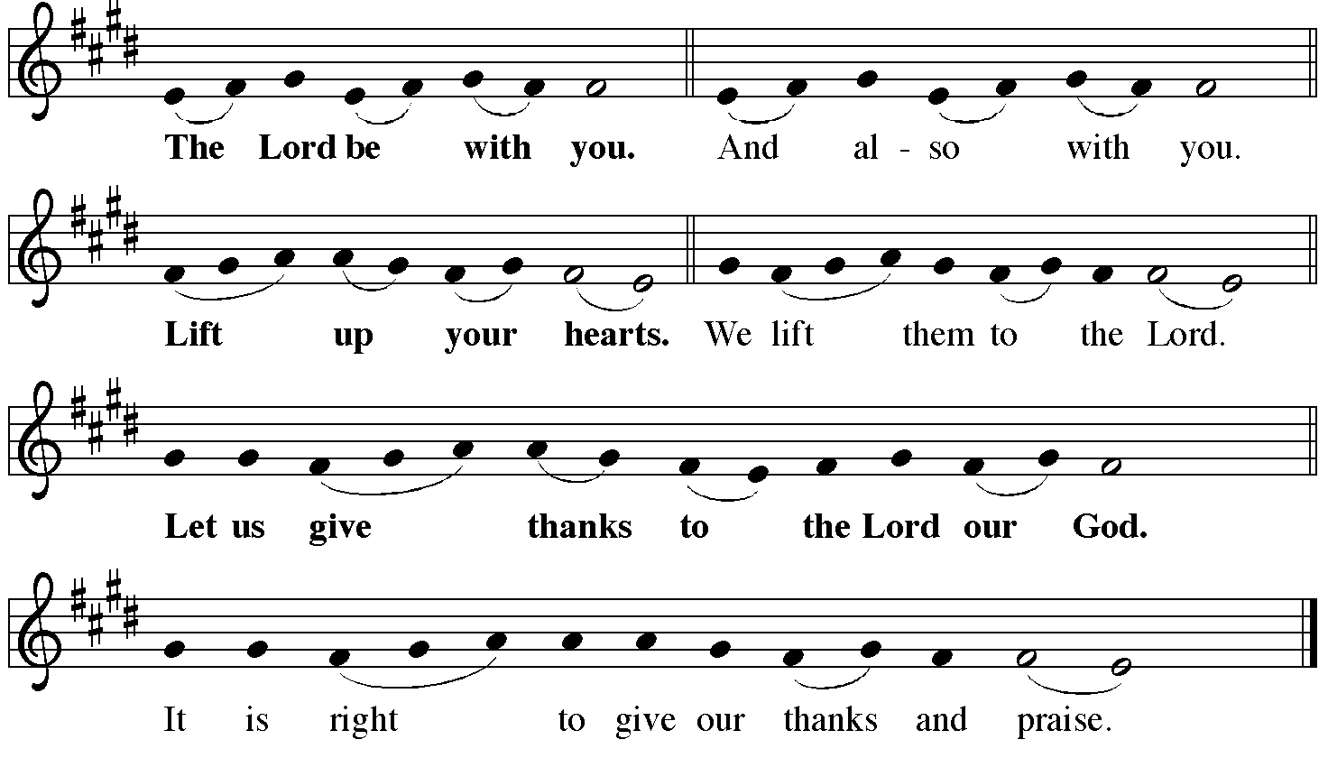

Preface
It is indeed right, our duty and our joy, that we should at all times and in all places give thanks and praise to you, almighty and merciful god, for the glorious resurrection of our Savior Jesus Christ, the true Paschal Lamb who gave himself to take away our sin, who in dying has destroyed death, and in rising has brought us to eternal life. And so, with Mary Magdalene and Peter and all the witnesses of the resurrection, with earth and sea and all their creatures, and with angels and archangels, cherubim and seraphim we praise your name and join their unending hymn:

Sanctus ELW #367 Now All the Vault of Heaven Resounds
sts. 3, 4

Oh, fill us, Lord, with dauntless love;
Set heart and will on things above
That we conquer through your triumph;
Grant grace sufficient for life’s day
That by our lives we truly say:
“Christ has triumphed! He is living!”
Alleluia, alleluia, alleluia!

Adoring praises now we bring
And with the heav’nly blessed sing:
“Christ has triumphed! Alleluia!”
Be to the Father, and our Lord,
To Spirit blest, most holy God,
All the glory, never ending!
Alleluia, alleluia, alleluia!

Thanksgiving at the Table
O God most mighty, O God most merciful, O God our rock and our salvation, hear us as we praise, call us to your table, grant us your life.

When the earth was a formless void, you formed order and beauty. When Abraham and Sarah were barren, you sent them a child. When the Israelites were enslaved, you led them to freedom. Ruth faced starvation, David fought Goliath, and the psalmists cried out for healing,
and full of compassion, you granted the people your life.

You entered our sorrows in Jesus our brother. He was born among the poor, he lived under oppression, he wept over the city. With infinite love, he granted the people your life.

In the night in which he was betrayed, our Lord Jesus took bread, and gave thanks; broke it, and gave it to his disciples, saying: Take and eat; this is my body, given for you. Do this for the remembrance of me.

Again, after supper, he took the cup, gave thanks, and gave it for all to drink, saying: This cup is the new covenant in my blood, shed for you and for all people for the forgiveness of sin. Do this for the remembrance of me.

Remembering his death, we cry out Amen. Amen.
Celebrating his resurrection, we shout Amen. Amen.
Trusting his presence in every time and place, we plead Amen. Amen.

O God, you are Breath: send your Spirit on this meal. O God, you are Bread: feed us with yourself. O God, you are wine: warm our hearts and make us one. O God, you are Fire: transform us with hope.

O God most majestic, O God most motherly, O God our strength and our song, you show us a vision of a tree of life with fruits for all and leaves that heal the nations. Grant us such life,
the life of the Father to the Son, the life of the Spirit of our risen Savior, life in you, now and forever. Amen

The Lord’s Prayer
Gathered into one by the Holy Spirit, let us pray as Jesus taught us.
Our Father, who art in heaven, hallowed be thy name, thy kingdom come, thy will be done on earth as it is in heaven. Give us this day our daily bread; and forgive us our trespasses, as we forgive those who trespass against us; and lead us not into temptation, but deliver us from evil. For thine is the kingdom, and the power, and the glory, forever and ever. Amen.

Invitation to Communion
The risen Christ invites us to this table. Come, eat and be satisfied.

Communion
The Body of Christ, given for you. (Eat the bread.)
The Blood of Christ, shed for you. (Drink the wine/juice.)

Duet Praise to the Lord, the Almighty Kim Wiebe and Jake Jacobson

Post Communion Blessing
May the body and blood of our Lord Jesus Christ strengthen you and keep you in his grace.
Amen.

Post Communion Prayer
Wellspring of joy, through this meal you have put gladness in our hearts. Satisfy the hunger still around us, and send us as joyful witnesses, that your love may bring joy to the hearts of all people, through Jesus Christ our Lord. Amen.

Sending
Blessing
May our glorious God grant you a spirit of wisdom to know and to love the risen Lord Jesus.
The God of life, Father, ☩ Son, and Holy Spirit, bless you now and forever. Amen.

Sending Hymn on next page

Sent to the World
Alleluia! Christ is risen. Christ is risen indeed. Alleluia!
Go in peace. Share the good news. Alleluia! Thanks be to God. Alleluia!

Postlude

Thank you for sharing this celebration of the Resurrection with us!
After the postlude you may unmute your mic and share Easter greetings
with your fellow worshippers.

From Sundays and Seasons v.20190109.1233 Copyright © 2021 Augsburg Fortress. All rights reserved.
Reprinted by permission under Augsburg Fortress Liturgies Annual License #30867.
All rights reserved. Reprinted under OneLicense.net #A-718333.
Sending Hymn ELW #365 Jesus Christ Is Risen Today
sts. 1, 2, 4
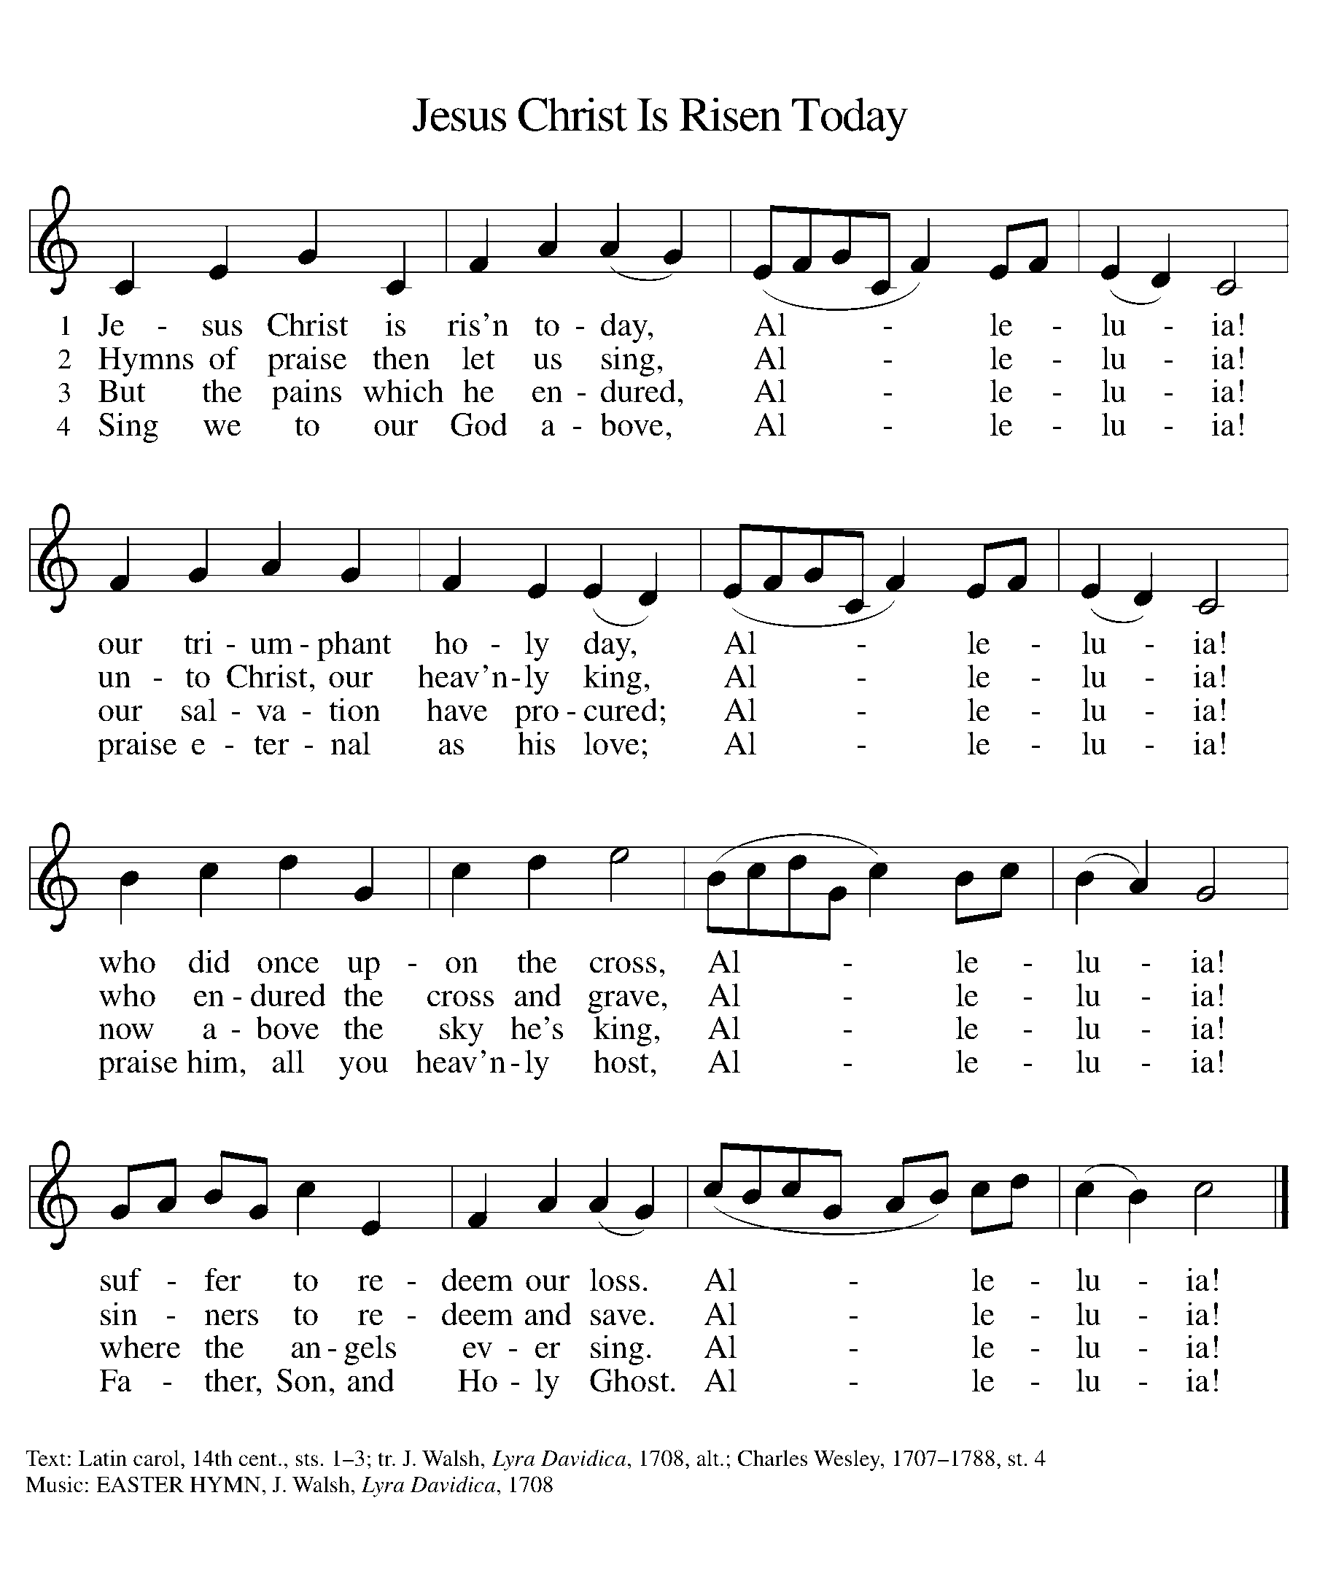
Current Prayer Requests
Please keep these people in your prayers and reach out to our sisters and brothers in Christian love. Names will be left on the list for two weeks, unless you indicate that they should remain in our prayers for a longer period.
Name Relationship Prayer For
Shirley Sauerman Member Healing & Strength
Jerry Jeske Member Healing & Strength
Bob Stein Member Healing & Strength
Helen Sladek Member Healing & Strength
Rich Davison Member Healing & Strength
Sigrid Elliott Member Healing & Strength
Dorothy Tracy Member Healing & Strength
Carol Petersen Member Birthday 4/9 (93)
Ruthie Maddock Friend of the Thompsons Healing & Strength
Elizabeth Amber Friend of Pr. Melody & Marty Healing & Strength
Chris Danly Son of Mark & Pat Danly Healing & Strength
Prayers for our homebound Members
Anita Blakemore, Dolores Nosal, Carol Petersen, Norma Petersen, Dorothy Stein

Easter Plants
Carol Asselmeier in honor of my loving parents
Greg & Donna Barber in memory of Donna’s mother, Lucile Smith
The Ficarella Family
The Graf Family in memory of Mary Buchholz and
in memory of Fred Warnke
Shirley Sauerman in memory of all my loved ones
who have received their promised everlasting life with our Risen Lord
Jerry & Brigitte Miller for God’s many blessings
The Berta family for all of God’s blessings
Marty & Pr. Melody Eastman in memory of Marty Friend,
Lewis & Wilma Eastman and Lee & Jean Beckman

Pastor Melody’s days off are Friday and Saturday. If you wish to contact her for non-emergency reasons, the best days to reach her are Monday-Thursday.

The April/May/June copies of Christ in our Home and Sundays and Seasons are in the narthex. Please stop by and pick up your copies.

Communion sets are taped to the white board outside of Barbara’s office. You may pick them up at any time the building is open.

House Church Worship via phone or internet every Sunday morning at 9:30am! We currently have five “House Churches” of worshipping members (each House Church consisting of 6-8 members/families meeting via Zoom or calling in by phone.) If you are unsure how to sign on, go ahead and register and let us know you need some help; we’ll walk you through it! We would be so blessed to have you join us. Register online for a House Church at graceglenellyn.org (on the main page Announcements) or contact Jon Milleville.

Contributions to Grace: You may continue to mail your contributions, including your weekly Lenten offering, to the church office; have your bank mail your contribution to the church office; or contribute on-line through Grace’s website. Please know, pandemic or no, our mission continues! Thank you for your continued support of our ministries at Grace Lutheran.

RAMP: We are excited to announce that we have been able to “eliminate the comma” from our mortgage, bringing our total mortgage to under $1,000,000! We will continue this campaign in 2021 as “RAMP” (Reduce Another Mortgage Payment) as we continue to RAMP up to refinance our mortgage with Mission Investment Fund this Fall. If we can raise an additional $100,000 payment prior to our November refinancing it will take us from $925,000 to $825,000.

Food Pantry Needed Items This Week: Canned Mushrooms; Canned Beef Stew; Sugar; Cooking Oil; Ramen Noodles; Large Juice Bottles; Canned Chicken; Coffee/Tea; Instant White Rice; Hamburger Helper; Sugar.

Every Member a Minister and Missionary!

Phone: 630-469-1555 Emergency Pastoral Contact: 630-674-2887
info@graceglenellyn.org www.graceglenellyn.org

Pastor
Rev. Melody Eastman office ext. 14
meastman@graceglenellyn.org

Office Manager
Barbara Sudds office ext. 10
bsudds@graceglenellyn.org

Ministry Associate
Becky Ficarella office ext. 17
bficarella@graceglenellyn.org

Parish Counselor
Carole LoGalbo M.S., LCPC 630-668-4594
carolelogalbo@yahoo.com

Minister of Music
Bradford Thompson 219-718-8879
bradfordmthompson@gmail.com

