Grace Lutheran Church

A congregation of the Evangelical Lutheran Church in America

493 Forest Avenue, Glen Ellyn IL 630.469.1555
www.GraceGlenEllyn.org

Maundy Thursday April 9, 2020

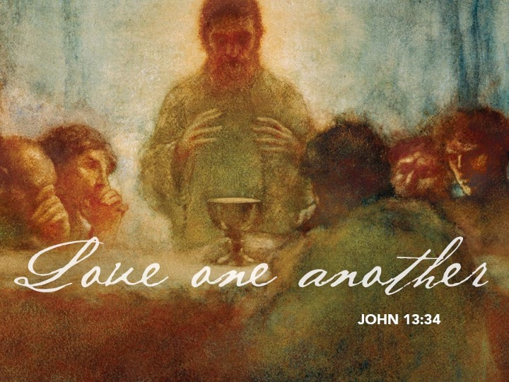

+ Proclaim Christ + Build Community +
+ Serve Our Neighbors +

A Note from Pastor Melody on Worshipping at Home

It is a difficult thing to be without community worship. Along with all the other stresses of “social distancing,” there is a real grief in not being able to be with the other members of the Body of Christ, bringing our collective praise and prayer before God and sharing the Lord’s supper together. Nothing can replace that gift, and there is no real substitute for the physically-gathered Body of Christ worshipping God together.
But that doesn’t mean that we can’t worship. Whether you are sheltering in place with loved ones or on your own, you can still worship. True, you can’t celebrate Holy Communion for yourself. But you can worship, pray, and hear the Word. After all, the pastor isn’t the primary actor in worship in the Lutheran tradition. You are. The pastor and lay leaders lay the groundwork and assist in leading, but the worshipping is done by the people who are gathered to commit time and energy to this sacred act. You aren’t a spectator; you’re the ones actually doing the liturgy.
With that understanding, we are providing these resources so that you can worship at home. We know it’s not the same. But know that it’s still worship, and it still matters. By maintaining the spiritual discipline of setting aside time for God every Sabbath, you will invite the Holy Spirit to keep nourishing you in faith.
In this time, we will be faithful even when we can’t be together. And when we are able to be together again, we will celebrate Easter with a renewed joy in the gathered Body of Christ raised to new life!

Introduction
With nightfall our Lenten observance comes to an end, and along with Christians around the world we celebrate the Three Days of Jesus’ death and resurrection. At the heart of the Maundy Thursday liturgy is Jesus’ commandment to love one another. As Jesus washed the feet of his disciples, we are called to follow his example as we humbly care for one another, especially the poor and the unloved. At the Lord’s table we remember Jesus’ sacrifice of his life, even as we are called to offer ourselves in love for the life of the world.

If you are worshipping with others, you may choose a leader (or leaders) for the service who will read the parts in regular type. Everyone speaks the bolded text.

Throughout the liturgy use singular or plural form
as is appropriate in your context.

Gathering
As we begin the great journey of the Three Days, we gather in silence for reflection. Tonight’s worship begins with confession and absolution, culminating the Lenten discipline of repentance that began on Ash Wednesday.

Confession and Forgiveness
In this Lenten season we have heard our Lord’s call to struggle against sin, death, and the devil—all that keeps us from loving God and each other. This is the struggle to which we were called at baptism.

Within the community of the church, God never wearies of forgiving sin and giving the peace of reconciliation. On this night we confess our sin against God and our neighbor, and enter the celebration of the great Three Days reconciled with God and with one another.
Silence is kept for reflection and self-examination.

Most merciful God,
we confess that we are captive to sin
and cannot free ourselves.
We have sinned against you in thought, word, and deed,
by what we have done and by what we have left undone.
We have not loved you with our whole heart;
we have not loved our neighbors as ourselves.
For the sake of your Son, Jesus Christ,
have mercy on us.
Forgive us, renew us, and lead us,
so that we may delight in your will
and walk in your ways,
to the glory of your holy name. Amen.

God, who is rich in mercy, loved us
even when we were dead in sin,
and made us alive together with Christ.
By grace we have been saved.
In the name of ☩ Jesus Christ, our sins are forgiven.
Almighty God strengthen us with power through the Holy Spirit,
that Christ may live in our hearts through faith.
Amen.

If you are worshipping with others, you make take turns laying hands on one another’s heads and saying:
In obedience to the command of our Lord Jesus Christ, I forgive you all your sins.
Amen.
If you are worshipping on your own, you make the sign of the cross while saying:
In faith I claim and believe the command and promise of Christ: that all my sins have been forgiven. Amen.

Prayer of the Day
Holy God, source of all love, on the night of his betrayal, Jesus gave us a new commandment, to love one another as he loves us. Write this commandment in our hearts, and give us the will to serve others as he was the servant of all, your Son, Jesus Christ, our Savior and Lord, who lives and reigns with you and the Holy Spirit, one God, now and forever.
Amen.

Word

First Lesson Exodus 12:1-4, 11-14
Israel remembered its deliverance from slavery in Egypt by celebrating the festival of Passover. This festival featured the Passover lamb, whose blood was used as a sign to protect God’s people from the threat of death. The early church described the Lord’s supper using imagery from the Passover, especially in portraying Jesus as the lamb who delivers God’s people from sin and death.

¹The Lord said to Moses and Aaron in the land of Egypt: ²This month shall mark for you the beginning of months; it shall be the first month of the year for you. ³Tell the whole congregation of Israel that on the tenth of this month they are to take a lamb for each family, a lamb for each household. ⁴If a household is too small for a whole lamb, it shall join its closest neighbor in obtaining one; the lamb shall be divided in proportion to the number of people who eat of it.
¹¹This is how you shall eat it: your loins girded, your sandals on your feet, and your staff in your hand; and you shall eat it hurriedly. It is the passover of the Lord. ¹²For I will pass through the land of Egypt that night, and I will strike down every firstborn in the land of Egypt, both human beings and animals; on all the gods of Egypt I will execute judgments: I am the Lord. ¹³The blood shall be a sign for you on the houses where you live: when I see the blood, I will pass over you, and no plague shall destroy you when I strike the land of Egypt.
¹⁴This day shall be a day of remembrance for you. You shall celebrate it as a festival to the Lord; throughout your generations you shall observe it as a perpetual ordinance.

Word of God, Word of Life. Thanks be to God.

Second Lesson 1 Corinthians 11:23-26
In the bread and cup of the Lord’s supper, we experience intimate fellowship with Christ and with one another, because it involves his body given for us and the new covenant in his blood. Faithful participation in this meal is a living proclamation of Christ’s death until he comes in the future.

²³For I received from the Lord what I also handed on to you, that the Lord Jesus on the night when he was betrayed took a loaf of bread, ²⁴and when he had given thanks, he broke it and said, “This is my body that is for you. Do this in remembrance of me.” ²⁵In the same way he took the cup also, after supper, saying, “This cup is the new covenant in my blood. Do this, as often as you drink it, in remembrance of me.” ²⁶For as often as you eat this bread and drink the cup, you proclaim the Lord’s death until he comes.

Word of God, Word of Life. Thanks be to God.

Gospel Acclamation (You may sing or read the text) C. Heine
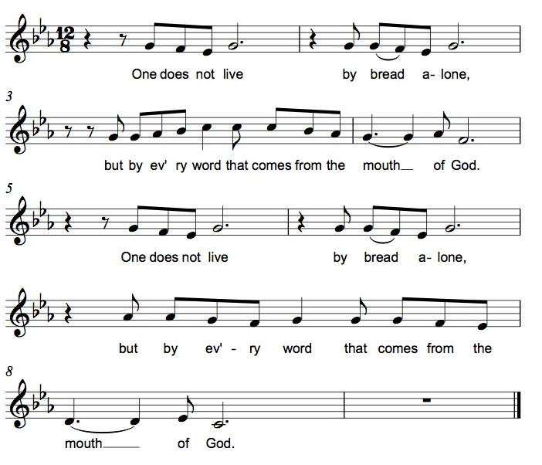

The holy Gospel according to John. Glory to you, O Lord.

*Gospel John 13:1-17, 31b-35
The story of the last supper in John’s gospel recalls a remarkable event not mentioned elsewhere: Jesus performs the duty of a slave, washing the feet of his disciples and urging them to do the same for one another.

¹Now before the festival of the Passover, Jesus knew that his hour had come to depart from this world and go to the Father. Having loved his own who were in the world, he loved them to the end. ²The devil had already put it into the heart of Judas son of Simon Iscariot to betray him. And during supper ³Jesus, knowing that the Father had given all things into his hands, and that he had come from God and was going to God, ⁴got up from the table, took off his outer robe, and tied a towel around himself. ⁵Then he poured water into a basin and began to wash the disciples’ feet and to wipe them with the towel that was tied around him. ⁶He came to Simon Peter, who said to him, “Lord, are you going to wash my feet?” ⁷Jesus answered, “You do not know now what I am doing, but later you will understand.” ⁸Peter said to him, “You will never wash my feet.” Jesus answered, “Unless I wash you, you have no share with me.” ⁹Simon Peter said to him, “Lord, not my feet only but also my hands and my head!” ¹⁰Jesus said to him, “One who has bathed does not need to wash, except for the feet, but is entirely clean. And you are clean, though not all of you.” ¹¹For he knew who was to betray him; for this reason he said, “Not all of you are clean.”
¹²After he had washed their feet, had put on his robe, and had returned to the table, he said to them, “Do you know what I have done to you? ¹³You call me Teacher and Lord—and you are right, for that is what I am. ¹⁴So if I, your Lord and Teacher, have washed your feet, you also ought to wash one another’s feet. ¹⁵For I have set you an example, that you also should do as I have done to you. ¹⁶Very truly, I tell you, servants are not greater than their master, nor are messengers greater than the one who sent them. ¹⁷If you know these things, you are blessed if you do them.”
^{31b}“Now the Son of Man has been glorified, and God has been glorified in him. ³²If God has been glorified in him, God will also glorify him in himself and will glorify him at once. ³³Little children, I am with you only a little longer. You will look for me; and as I said to the Jews so now I say to you, ‘Where I am going, you cannot come.’ ³⁴I give you a new commandment, that you love one another. Just as I have loved you, you also should love one another. ³⁵By this everyone will know that you are my disciples, if you have love for one another.”

The Gospel of the Lord. Praise to you, O Christ.

Sermon The Rev. Melody Eastman

(Available on Grace’s website or YouTube channel)

Hymn ELW #814 Take, Oh Take Me As I Am

Prayers of Intercession
Turning our hearts to God who is gracious and merciful, we pray for the church, the world, and all who are in need.
A brief silence.

God of love, unite your church in its commitment to humble service. Make us your faithful disciples. Speak words of truth and grace through us. Encourage us in self-giving acts of kindness. Let us love one another as you have loved us. Hear us, O God.
Your mercy is great.
God of love, tend to flocks, fields, and vineyards. Bring favorable weather for crops to grow. Guide the hands of those who cultivate, farm, and garden. Let the earth flourish so that all may eat and be satisfied. Hear us, O God.
Your mercy is great.

God of love, you give us a new commandment, to have love for one another. We give thanks for organizations that respond to disasters and for agencies that offer relief and humanitarian aid to populations in need, especially the Glen Ellyn Food Pantry, Lutheran Social Services, and all who work to stem the tide of the pandemic. Hear us, O God.

Your mercy is great.
God of love, give ear to all who call upon you for any need of body or spirit (especially…). Provide for those who do not have enough to eat, those who are unemployed or underemployed, and those who rely on the generosity of others. Hear us, O God.
Your mercy is great.

Here other intercessions may be offered.

God of love, glorify your servants who walked by faith in this life and who now feast with you. Inspire us by the sacrifice of those who were imprisoned, persecuted, or martyred for their faith, especially Dietrich Bonhoeffer. Hear us, O God.
Your mercy is great.

According to your steadfast love, O God, hear these and all our prayers as we commend them to you; through Christ our Lord.
Amen.

Lord’s Prayer
Gathered into one by the Holy Spirit, let us pray as Jesus taught us.
Our Father, who art in heaven, hallowed be thy name, thy kingdom come, thy will be done on earth as it is in heaven. Give us this day our daily bread; and forgive us our trespasses, as we forgive those who trespass against us; and lead us not into temptation, but deliver us from evil. For thine is the kingdom, and the power, and the glory, forever and ever. Amen.

Normally Psalm 22 is read as the altar is stripped of vessels and paraments, representing Christ’s laying down his power in preparation for Good Friday. You may read the psalm to conclude tonight’s service; worship continues with tomorrow night’s Good Friday liturgy.

My God, my God, why have you forsaken me?
Why are you so far from helping me, from the words of my groaning?
²O my God, I cry by day, but you do not answer;
and by night, but find no rest.
³Yet you are holy,
enthroned on the praises of Israel.
⁴In you our ancestors trusted;
they trusted, and you delivered them.
⁵To you they cried, and were saved;
in you they trusted, and were not put to shame.
⁶But I am a worm, and not human;
scorned by others, and despised by the people.
⁷All who see me mock at me;
they make mouths at me, they shake their heads;
⁸"Commit your cause to the LORD; let him deliver —
let him rescue the one in whom he delights!"
⁹Yet it was you who took me from the womb;
you kept me safe on my mother's breast.
¹⁰On you I was cast from my birth,
and since my mother bore me you have been my God.
¹¹Do not be far from me,
for trouble is near
and there is no one to help.
¹²Many bulls encircle me,
strong bulls of Bashan surround me;
¹³they open wide their mouths at me,
like a ravening and roaring lion.
¹⁴I am poured out like water,
and all my bones are out of joint;
my heart is like wax;
it is melted within my breast;
¹⁵my mouth is dried up like a potsherd,
and my tongue sticks to my jaws;
you lay me in the dust of death.
¹⁶For dogs are all around me;
a company of evildoers encircles me.
My hands and feet have shriveled;
¹⁷I can count all my bones.
They stare and gloat over me;
¹⁸they divide my clothes among themselves,
and for my clothing they cast lots.
¹⁹But you, O LORD, do not be far away!
O my help, come quickly to my aid!
²⁰Deliver my soul from the sword,
my life from the power of the dog!
²¹Save me from the mouth of the lion!
From the horns of the wild oxen you have rescued me.

²²I will tell of your name to my brothers and sisters
in the midst of the congregation I will praise you:
²³You who fear the LORD, praise him!
All you offspring of Jacob, glorify him;
stand in awe of him, all you offspring of Israel!
²⁴For he did not despise or abhor
the affliction of the afflicted;
he did not hide his face from me,
but heard when I cried to him.
²⁵From you comes my praise in the great congregation;
my vows I will pay before those who fear him.
²⁶The poor shall eat and be satisfied;
those who seek him shall praise the LORD.
May your hearts live forever!
²⁷All the ends of the earth shall remember
and turn to the LORD;
and all the families of the nations
shall worship before him.
²⁸For dominion belongs to the LORD,
and he rules over the nations.
²⁹To him, indeed, shall all who sleep in the earth bow down;
before him shall bow all who go down to the dust,
and I shall live for him.
³⁰Posterity will serve him;
future generations will be told about the LORD,
³¹and proclaim his deliverance to a people yet unborn,
saying that he has done it.

From Sundays and Seasons v.20190109.1233 Copyright © 2019 Augsburg Fortress. All rights reserved. All rights reserved.
Reprinted by permission under Augsburg Fortress Liturgies Annual License #30867.
All rights reserved. Reprinted under OneLicense.net #A-718333.

Every Member a Minister and Missionary!

Phone: 630-469-1555 Emergency Pastoral Contact: 630-674-2887
info@graceglenellyn.org www.graceglenellyn.org

Pastor
Rev. Melody Eastman office ext. 14
meastman@graceglenellyn.org

Office Manager
Barbara Sudds office ext. 10
bsudds@graceglenellyn.org

Children & Youth Ministry Coordinator
Becky Ficarella office ext. 17
bficarella@graceglenellyn.org

Parish Counselor
Carole LoGalbo M.S., LCPC 630-668-4594
carolelogalbo@yahoo.com

Minister of Music
Bradford Thompson 219-718-8879
bradfordmthompson@gmail.com

