Grace Lutheran Church

493 Forest Avenue, Glen Ellyn IL 630.469.1555
www.graceglenellyn.org

Good Friday April 10, 2019

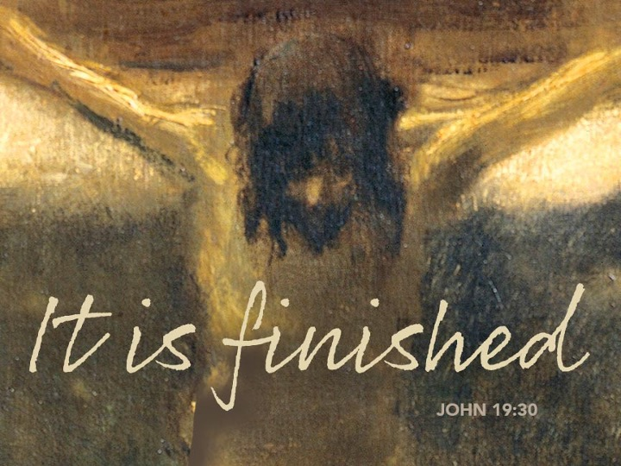

+ Proclaim Christ + Build Community +
+ Serve Our Neighbors +

A Note from Pastor Melody on Worshipping at Home
It is a difficult thing to be without community worship. Along with all the other stresses of “social distancing,” there is a real grief in not being able to be with the other members of the Body of Christ, bringing our collective praise and prayer before God and sharing the Lord’s supper together. Nothing can replace that gift, and there is no real substitute for the physically-gathered Body of Christ worshipping God together.
But that doesn’t mean that we can’t worship. Whether you are sheltering in place with loved ones or on your own, you can still worship. True, you can’t celebrate Holy Communion for yourself. But you can worship, pray, and hear the Word. After all, the pastor isn’t the primary actor in worship in the Lutheran tradition. You are. The pastor and lay leaders lay the groundwork and assist in leading, but the worshipping is done by the people who are gathered to commit time and energy to this sacred act. You aren’t a spectator; you’re the ones actually doing the liturgy.
With that understanding, we are providing these resources so that you can worship at home. We know it’s not the same. But know that it’s still worship, and it still matters. By maintaining the spiritual discipline of setting aside time for God every Sabbath, you will invite the Holy Spirit to keep nourishing you in faith.
In this time, we will be faithful even when we can’t be together. And when we are able to be together again, we will celebrate Easter with a renewed joy in the gathered Body of Christ raised to new life!

Introduction
Life and death stand side by side as we enter into Good Friday. In John’s passion account, Jesus reveals the power and glory of God, even as he is put on trial and sentenced to death. Standing with the disciples at the foot of the cross, we pray for the whole world in the ancient bidding prayer, as Christ’s death offers life to all. We gather in solemn devotion, but always with the promise that the tree around which we assemble is indeed a tree of life. We depart silently, and we anticipate the culmination of the Three Days in the Easter Vigil.

If you are worshipping with others, choose a leader for the parts in plain text. The portions in bold should be spoken by everyone present.

You may prepare for this service by placing a cross or crucifix on your table. If you wish, you may gather and light 7 candles before you begin.

After each reading from the Gospel of John, extinguish one of the candles.
If you do not have 7 candles, you may place 1 candle on your table and extinguish it after the final reading from the gospel.

Prayer of the Day
Almighty God, look with loving mercy on your family, for whom our Lord Jesus Christ was willing to be betrayed, to be given over to the hands of sinners, and to suffer death on the cross; who now lives and reigns with you and the Holy Spirit, one God, forever and ever.
Amen.

Word

First Lesson Isaiah 52:13--53:12
The fourth servant poem promises ultimate vindication for the servant, who made his life an offering for sin. The early church saw in the servant’s pouring himself out to death and being numbered with the transgressors important keys for understanding the death of Jesus.

¹³See, my servant shall prosper; he shall be exalted and lifted up, and shall be very high. ¹⁴Just as there were many who were astonished at him—so marred was his appearance, beyond human semblance, and his form beyond that of mortals— ¹⁵so he shall startle many nations; kings shall shut their mouths because of him; for that which had not been told them they shall see, and that which they had not heard they shall contemplate. ^{53:1}Who has believed what we have heard? And to whom has the arm of the Lord been revealed? ²For he grew up before him like a young plant, and like a root out of dry ground; he had no form or majesty that we should look at him, nothing in his appearance that we should desire him. ³He was despised and rejected by others; a man of suffering and acquainted with infirmity; and as one from whom others hide their faces he was despised, and we held him of no account.
⁴Surely he has borne our infirmities and carried our diseases; yet we accounted him stricken, struck down by God, and afflicted. ⁵But he was wounded for our transgressions, crushed for our iniquities; upon him was the punishment that made us whole, and by his bruises we are healed. ⁶All we like sheep have gone astray; we have all turned to our own way, and the Lord has laid on him the iniquity of us all.
⁷He was oppressed, and he was afflicted, yet he did not open his mouth; like a lamb that is led to the slaughter, and like a sheep that before its shearers is silent, so he did not open his mouth. ⁸By a perversion of justice he was taken away. Who could have imagined his future? For he was cut off from the land of the living, stricken for the transgression of my people. ⁹They made his grave with the wicked and his tomb with the rich, although he had done no violence, and there was no deceit in his mouth.
¹⁰Yet it was the will of the Lord to crush him with pain. When you make his life an offering for sin, he shall see his offspring, and shall prolong his days; through him the will of the Lord shall prosper. ¹¹Out of his anguish he shall see light; he shall find satisfaction through his knowledge. The righteous one, my servant, shall make many righteous, and he shall bear their iniquities. ¹²Therefore I will allot him a portion with the great, and he shall divide the spoil with the strong; because he poured out himself to death, and was numbered with the transgressors; yet he bore the sin of many, and made intercession for the transgressors.

Word of God, Word of Life.
Thanks be to God.

Second Lesson Hebrews 10:16-25
In the death of Jesus, forgiveness of sins is worked and access to God is established. Hence, when we gather together for worship and when we love others we experience anew the benefits of Jesus’ death.

[After the Holy Spirit says,] ¹⁶“This is the covenant that I will make with them
after those days, says the Lord: I will put my laws in their hearts, and I will write them on their minds,” ¹⁷he also adds, “I will remember their sins and their lawless deeds no more.” ¹⁸Where there is forgiveness of these, there is no longer any offering for sin. ¹⁹Therefore, my friends, since we have confidence to enter the sanctuary by the blood of Jesus, ²⁰by the new and living way that he opened for us through the curtain (that is, through his flesh), ²¹and since we have a great priest over the house of God, ²²let us approach with a true heart in full assurance of faith, with our hearts sprinkled clean from an evil conscience and our bodies washed with pure water. ²³Let us hold fast to the confession of our hope without wavering, for he who has promised is faithful. ²⁴And let us consider how to provoke one another to love and good deeds, ²⁵not neglecting to meet together, as is the habit of some, but encouraging one another, and all the more as you see the Day approaching.

Word of God, Word of Life.
Thanks be to God.

Gospel Acclamation
Look to Jesus, who for the sake of the joy that was set before him endured the cross, disregarding its shame, and has taken his seat at the right hand of the throne of God.

The Passion of our Lord Jesus Christ, according to John.
Glory to you, O Lord.

Gospel John 18:1-19:42

On Good Friday, the story of Jesus’ passion—from his arrest to his burial—is read in its entirety.

Hymn Guide My Feet

st. 1

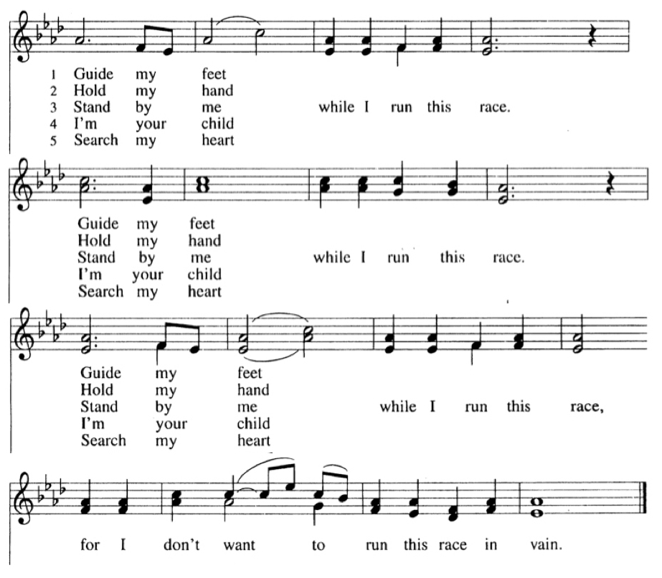

John 18:1-14
Jesus went out with his disciples across the Kidron valley to a place where there was a garden, which he and his disciples entered. Now Judas, who betrayed him, also knew the place, because Jesus often met there with his disciples. So Judas brought a detachment of soldiers together with police from the chief priests and the Pharisees, and they came there with lanterns and torches and weapons.

Then Jesus, knowing all that was to happen to him, came forward and asked them, “Whom are you looking for?” They answered, “Jesus of Nazareth.” Jesus replied, “I am he.” Judas, who betrayed him, was standing with them. When Jesus said to them, “I am he,” they stepped back and fell to the ground. Again he asked them, “Whom are you looking for?” And they said, “Jesus of Nazareth.” Jesus answered, “I told you that I am he. So if you are looking for me, let these men go.” This was to fulfill the word that he had spoken, “I did not lose a single one of those whom you gave me.”

Then Simon Peter, who had a sword, drew it, struck the high priest’s slave, and cut off his right ear. The slave’s name was Malchus. Jesus said to Peter, “Put your sword back into its sheath. Am I not to drink the cup that the Father has given me?” So the soldiers, their officer, and the Jewish police arrested Jesus and bound him.

First they took him to Annas, who was the father-in-law of Caiaphas, the high priest that year. Caiaphas was the one who had advised the Jews that it was better to have one person die for the people. (extinguish 1st candle of 7)

Hymn Guide My Feet st. 2
Hold my hand while I run this race. (3 times)
…for I don’t want to run this race in vain.

John 18:15-27
Simon Peter and another disciple followed Jesus. Since that disciple was known to the high priest, he went with Jesus into the courtyard of the high priest, but Peter was standing outside at the gate. So the other disciple, who was known to the high priest, went out, spoke to the woman who guarded the gate, and brought Peter in. The woman said to Peter, “You are not also one of this man’s disciples, are you?” He said, “I am not.” Now the slaves and the police had made a charcoal fire because it was cold, and they were standing around it and warming themselves. Peter also was standing with them and warming himself.

Then the high priest questioned Jesus about his disciples and about his teaching. Jesus answered, “I have spoken openly to the world; I have always taught in synagogues and in the temple, where all the Jews come together. I have said nothing in secret. Why do you ask me? Ask those who heard what I said to them; they know what I said.” When he had said this, one of the police standing nearby struck Jesus on the face, saying, “Is that how you answer the high priest?” Jesus answered, “If I have spoken wrongly, testify to the wrong. But if I have spoken rightly, why do you strike me?”

Then Annas sent him bound to Caiaphas the high priest. Now Simon Peter was standing and warming himself. They asked him, “You are not also one of his disciples, are you?” He denied it and said, “I am not.” One of the slaves of the high priest, a relative of the man whose ear Peter had cut off, asked, “Did I not see you in the garden with him?” Again Peter denied it, and at that moment the cock crowed. (extinguish 2nd candle of 7)

Hymn Guide My Feet, st. 5
Search my heart while I run this race. (3 times)
…for I don’t want to run this race in vain.

John 18:28-38a
Then they took Jesus from Caiaphas to Pilate’s headquarters. It was early in the morning. They themselves did not enter the headquarters, so as to avoid ritual defilement and to be able to eat the Passover. So Pilate went out to them and said, “What accusation do you bring against this man?” They answered, “If this man were not a criminal, we would not have handed him over to you.” Pilate said to them, “Take him yourselves and judge him according to your law.” The Jews replied, “We are not permitted to put anyone to death.” (This was to fulfill what Jesus had said when he indicated the kind of death he was to die.)

Then Pilate entered the headquarters again, summoned Jesus, and asked him, “Are you the King of the Jews?” Jesus answered, “Do you ask this on your own, or did others tell you about me?” Pilate replied, “I am not a Jew, am I? Your own nation and the chief priests have handed you over to me. What have you done?” Jesus answered, “My kingdom is not from this world. If my kingdom were from this world, my followers would be fighting to keep me from being handed over to the Jews. But as it is, my kingdom is not from here.”

Pilate asked him, “So you are a king?” Jesus answered, “You say that I am a king. For this I was born, and for this I came into the world, to testify to the truth. Everyone who belongs to the truth listens to my voice.” Pilate asked him, “What is truth?” (extinguish 3rd candle of 7)

Hymn Guide My Feet, st. 3
Stand by me while I run this race (3 times)
…for I don’t want to run this race in vain.

John 18:38b-19:16a
After he had said this, he went out to the Jews again and told them, “I find no case against him. But you have a custom that I release someone for you at the Passover. Do you want me to release for you the King of the Jews?” They shouted in reply, “Not this man, but Barabbas!” Now Barabbas was a bandit. Then Pilate took Jesus and had him flogged. And the soldiers wove a crown of thorns and put it on his head, and they dressed him in a purple robe. They kept coming up to him, saying, “Hail, King of the Jews!” and striking him on the face. Pilate went out again and said to them, “Look, I am bringing him out to you to let you know that I find no case against him.” So Jesus came out, wearing the crown of thorns and the purple robe. Pilate said to them, “Here is the man!”
When the chief priests and the police saw him, they shouted, “Crucify him! Crucify him!” Pilate said to them, “Take him yourselves and crucify him; I find no case against him.” The Jews answered him, “We have a law, and according to that law he ought to die because he has claimed to be the Son of God.”
(extinguish 4th candle of 7)

Hymn Guide My Feet, st. 4
I’m your child while I run this race (3 times)
…for I don’t want to run this race in vain.

John 19:8-16a
Now when Pilate heard this, he was more afraid than ever. He entered his headquarters again and asked Jesus, “Where are you from?” But Jesus gave him no answer. Pilate therefore said to him, “Do you refuse to speak to me? Do you not know that I have power to release you, and power to crucify you?” Jesus answered him, “You would have no power over me unless it had been given you from above; therefore the one who handed me over to you is guilty of a greater sin.”
From then on Pilate tried to release him, but the Jews cried out, “If you release this man, you are no friend of the emperor. Everyone who claims to be a king sets himself against the emperor.” When Pilate heard these words, he brought Jesus outside and sat on the judge’s bench at a place called The Stone Pavement, or in Hebrew Gabbatha.
Now it was the day of Preparation for the Passover; and it was about noon. He said to the Jews, “Here is your King!” They cried out, “Away with him! Away with him! Crucify him!” Pilate asked them, “Shall I crucify your King?” The chief priests answered, “We have no king but the emperor.”
Then he handed him over to them to be crucified. (extinguish 5th candle of 7)

Hymn ELW #353 Were You There st.1
Were you there when they crucified my Lord? (2 times)
Oh-h-h-h-, sometimes it causes me to tremble, tremble, tremble.
Were you there when they crucified my Lord?

John 19:16b-30
So they took Jesus; and carrying the cross by himself, he went out to what is called The Place of the Skull, which in Hebrew is called Golgotha. There they crucified him, and with him two others, one on either side, with Jesus between them.

Pilate also had an inscription written and put on the cross. It read, “Jesus of Nazareth, the King of the Jews.” Many of the Jews read this inscription, because the place where Jesus was crucified was near the city; and it was written in Hebrew, in Latin, and in Greek. Then the chief priests of the Jews said to Pilate, “Do not write, ‘The King of the Jews,’ but, ‘This man said, I am King of the Jews.’” Pilate answered, “What I have written I have written.”

When the soldiers had crucified Jesus, they took his clothes and divided them into four parts, one for each soldier. They also took his tunic; now the tunic was seamless, woven in one piece from the top. So they said to one another, “Let us not tear it, but cast lots for it to see who will get it.” This was to fulfill what the scripture says, “They divided my clothes among themselves, and for my clothing they cast lots.” And that is what the soldiers did.

Meanwhile, standing near the cross of Jesus were his mother, and his mother’s sister, Mary the wife of Clopas, and Mary Magdalene. When Jesus saw his mother and the disciple whom he loved standing beside her, he said to his mother, “Woman, here is your son.” Then he said to the disciple, “Here is your mother.” And from that hour the disciple took her into his own home. After this, when Jesus knew that all was now finished, he said (in order to fulfill the scripture), “I am thirsty.” A jar full of sour wine was standing there. So they put a sponge full of the wine on a branch of hyssop and held it to his mouth. When Jesus had received the wine, he said, “It is finished.” Then he bowed his head and gave up his spirit. (extinguish 6th candle of 7)

Hymn ELW 353 Were You There st. 4
Were you there when the sun refused to shine? (2 times)
Oh-h-h-h-, sometimes it causes me to tremble, tremble, tremble.
Were you there when the sun refused to shine?

John 19:31-42
Since it was the day of Preparation, the Jews did not want the bodies left on the cross during the sabbath, especially because that sabbath was a day of great solemnity. So they asked Pilate to have the legs of the crucified men broken and the bodies removed. Then the soldiers came and broke the legs of the first and of the other who had been crucified with him. But when they came to Jesus and saw that he was already dead, they did not break his legs. Instead, one of the soldiers pierced his side with a spear, and at once blood and water came out. (He who saw this has testified so that you also may believe. His testimony is true, and he knows that he tells the truth.) These things occurred so that the scripture might be fulfilled, “None of his bones shall be broken.” And again another passage of scripture says, “They will look on the one whom they have pierced.”

After these things, Joseph of Arimathea, who was a disciple of Jesus, though a secret one because of his fear of the Jews, asked Pilate to let him take away the body of Jesus. Pilate gave him permission; so he came and removed his body. Nicodemus, who had at first come to Jesus by night, also came, bringing a mixture of myrrh and aloes, weighing about a hundred pounds. They took the body of Jesus and wrapped it with the spices in linen cloths, according to the burial custom of the Jews. Now there was a garden in the place where he was crucified, and in the garden there was a new tomb in which no one had ever been laid. And so, because it was the Jewish day of Preparation, and the tomb was nearby, they laid Jesus there. (extinguish final candle)

Hymn ELW #353 Were You There st. 5
Were you there when they laid him in the tomb? (2 times)
Oh-h-h-h-, sometimes it causes me to tremble, tremble, tremble.
Were you there when they laid him in the tomb?

The Gospel of the Lord
Praise to you, O Christ.

Sermon Pastor Melody Eastman

Bidding Prayers

Let us pray, brothers and sisters, for the holy church throughout the world.
Silent prayer.
Almighty and eternal God,
you have shown your glory to all nations in Jesus Christ.
By your Holy Spirit guide the church
and gather it throughout the world.
Help it to persevere in faith, proclaim your name,
and bring the good news of salvation in Christ to all people.
We ask this through Christ our Lord.
Amen.

Let us pray for Elizabeth and Yehiel, our bishops; for Melody, our pastor; and all servants of the church, and for all the people of God.
Silent prayer.
Almighty and eternal God,
your Spirit guides the church and makes it holy.
Strengthen and uphold our bishops, pastors,
other ministers, and lay leaders.
Keep them in health and safety for the good of the church,
and help each of us in our various vocations
to do faithfully the work to which you have called us.
We ask this through Christ our Lord.
Amen.

Let us pray for those preparing for baptism.
Silent prayer.
Almighty and eternal God, you continue to bless the church.
Increase the faith and understanding of those preparing for baptism.
Give them new birth as your children,
and keep them in the faith and communion of your holy church.
We ask this through Christ our Lord.
Amen.

Let us pray for our sisters and brothers who share our faith in Jesus Christ.
Silent prayer.
Almighty and eternal God, you give your church unity.
Look with favor on all who follow Jesus your Son.
Make all the baptized one in the fullness of faith,
and keep us united in the fellowship of love.
We ask this through Christ our Lord.
Amen.

Let us pray for the Jewish people, the first to hear the word of God.
Silent prayer.
Almighty and eternal God,
long ago you gave your promise to Abraham and your teaching to Moses.
Hear our prayers that the people you called and elected as your own
may receive the fulfillment of the covenant’s promises.
We ask this through Christ our Lord.
Amen.

Let us pray for those who do not share our faith in Jesus Christ.
Silent prayer.
Almighty and eternal God, gather into your embrace
all those who call out to you under different names.
Bring an end to inter-religious strife,
and make us more faithful witnesses
of the love made known to us in your Son.
We ask this through Christ our Lord.
Amen.

Let us pray for those who do not believe in God.
Silent prayer.
Almighty and eternal God, you created humanity
so that all may long to know you and find peace in you.
Grant that all may recognize the signs of your love and grace
in the world and in the lives of Christians,
and gladly acknowledge you as the one true God.
We ask this through Christ our Lord.
Amen.

Let us pray for God's creation.
Silent prayer.
Almighty and eternal God,
you are the creator of a magnificent universe.
Hold all the worlds in the arms of your care
and bring all things to fulfillment in you.
We ask this through Christ our Lord.
Amen.

Let us pray for those who serve in public office.
Silent prayer.
Almighty and eternal God,
you are the champion of the poor and oppressed.
In your goodness, give wisdom to those in authority,
so that all people may enjoy justice, peace, freedom,
and a share in the goodness of your creation.
We ask this through Christ our Lord.
Amen.

Let us pray for those in need.
Silent prayer.
Almighty and eternal God,
you give strength to the weary
and new courage to those who have lost heart.
Heal the sick, comfort the dying, give safety to travelers,
free those unjustly deprived of liberty,
and deliver your world from falsehood, hunger, and disease.
Hear the prayers of all who call on you in any trouble,
that they may have the joy of receiving your help in their need.
We ask this through Christ our Lord.
Amen.

Lord’s Prayer p.
Finally, let us pray for all those things for which our Lord would have us ask.
You may chant or speak the Lord’s Prayer.

You may lift the cross while saying:
Adoration of the Cross
Behold the life-giving cross, on which was hung the Savior of the whole world.
Oh, come, let us worship him.

You may place the cross on the table before you and spend time silently reflecting on Christ’s gift given on this night.
The Adoration of the Cross concludes with the following dialogue:

We adore you, O Christ, and we bless you.
By your holy cross you have redeemed the world.

The service ends in silence. We will gather for the Celebration of Christ’s Resurrection on the first Sunday we are able to gather following the shelter-in-place order.

From Sundays and Seasons v.20190109.1233 Copyright © 2019 Augsburg Fortress. All rights reserved. All rights reserved.
Reprinted by permission under Augsburg Fortress Liturgies Annual License #30867.
All rights reserved. Reprinted under OneLicense.net #A-718333.

+ + Serving God in Worship Today + +

Grace Lock Up Sandy Venturoni
Minister of Music Bradford Thompson
Ushers

Every Member a Minister and Missionary!

Phone: 630-469-1555 Emergency Pastoral Contact: 630-674-2887
info@graceglenellyn.org www.graceglenellyn.org

Pastor
Rev. Melody Eastman office ext. 14
meastman@graceglenellyn.org

Office Manager
Barbara Sudds office ext. 10
bsudds@graceglenellyn.org

Children & Youth Ministry Coordinator
Becky Ficarella office ext. 17
bficarella@graceglenellyn.org

Parish Counselor
Carole LoGalbo M.S., LCPC 630-668-4594
carolelogalbo@yahoo.com

Minister of Music
Bradford Thompson 219-718-8879
bradfordmthompson@gmail.com

