Grace Lutheran Church

493 Forest Avenue, Glen Ellyn IL 630.469.1555
www.graceglenellyn.org

Resurrection of Our Lord: Easter Day April 17, 2022

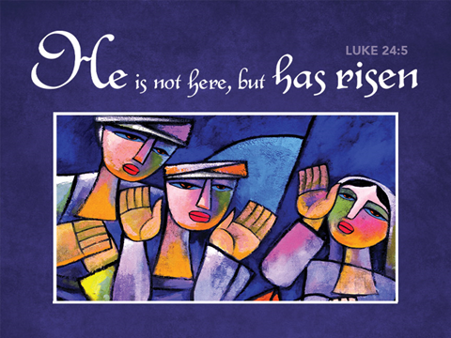

+ Proclaim Christ + Build Community +
+ Serve Our Neighbors +

Especially For Our Guests
Welcome to Grace!
If you are a guest, we’re thankful you’re here today. We hope you will feel Welcomed and spiritually nourished. If you would like to speak to the pastor about the congregation, please let her know directly or call the church office. To enhance your worship experience, you may want to know the following:
· Please join us after service for some great refreshments and Christian Fellowship.
· Parts of the liturgy (worship service) not printed in this bulletin are in the red hymnal (ELW). Page numbers in the hymnal are at the bottom of the page; hymn numbers are the large numbers at the top in the back half of the book.
· All baptized people are welcome at communion. If you would like to come forward for a blessing without taking communion, you can do that too. If you have difficulty walking, feel free to let the usher know and we’ll bring communion to you.
· If you find yourself confused about where we are, ask a neighbor!
· Assisted Listening Devices are available for your use. Please ask an usher.
· Young children are welcome in worship! Parents, you can bring your little ones up front to the PrayGround, a space with tables, chairs and quiet activities to keep our younger members engaged during services. Please sit near your little ones and help them use the space quietly as well as participate with you in worship. If you prefer, there is also a nursery space for you to use with infants or younger toddlers in the overflow room at the rear of the sanctuary. (But we really do like having children up front, if possible!)
· Please take your bulletin home with you. It contains the weekly calendar of events at Grace plus upcoming announcements.

Updated Communion Information
We have returned to the option to commune at the rail with some modifications:
· We are not yet offering the common cup. Red grape juice and white wine are available in individual cups.
· Please do not touch more than one cup. The cups are spaced out to make them easier to remove without touching others.
· If you prefer, you may bring an individual communion kit to the rail and open it there to receive the bread and juice. Or you may remain in the pew and the Pastor will lead you in communion before those at the rail are served.
· Please maintain six feet distance between household groups.

Introduction
“The last enemy to be destroyed is death,” Paul writes. Today Christ is risen, and we gather together with astonishment and joy. Christ is risen, and we have been set free from the bonds of death. Christ is risen, and we are forgiven. Christ is risen, and with the women at the tomb and Peter, we are amazed. Let us rejoice: Christ is risen indeed! Alleluia!

An asterisk (*) indicates that you should stand for that portion of the service. If standing is difficult, please remain seated. Congregation responses are in bold print.

Gathering
The Holy Spirit calls us together as the people of God.
Welcome/Announcements

Christ is Risen! He is risen indeed! Alleluia!

Prelude

*Please stand as you are able and turn to face the font.
*Thanksgiving for Baptism
All may make the sign of the cross, the sign marked at baptism, as the presiding minister begins.

Alleluia! Christ is risen. He is risen indeed. Alleluia!

In the waters of baptism,
we have passed over from death to life with Jesus Christ,
and we are a new creation.
For this saving mystery, and for this water, let us bless God,
who was, who is, and who is to come.

Water may be poured into the font as the presiding minister gives thanks.

We thank you, God, for your river of life,
flowing freely from your throne:
through the earth, through the city, through every living thing.
You rescued Noah and his family from the flood;
You opened wide the sea for the Israelites.
Now in these waters you flood us with mercy,
and our sin is drowned forever.
You open the gate of righteousness
and we pass safely through.
In Jesus Christ, you calm and trouble the waters.
You nourish us and enclose us in safety.
You call us forth and send us out.
In lush and barren places, you are with us.
You have become our salvation.
Now breathe upon this water
and awaken your church once more.
Claim us again as your beloved and holy people.
Quench our thirst; cleanse our hearts; wipe away every tear.
To you, our Beginning and our End,
our Shepherd and Lamb,
be honor, glory, praise, and thanksgiving,
now and forever.
Amen.

*Entrance Hymn ELW #369 Christ the Lord is Risen Today; Alleluia
sts. 1, 4
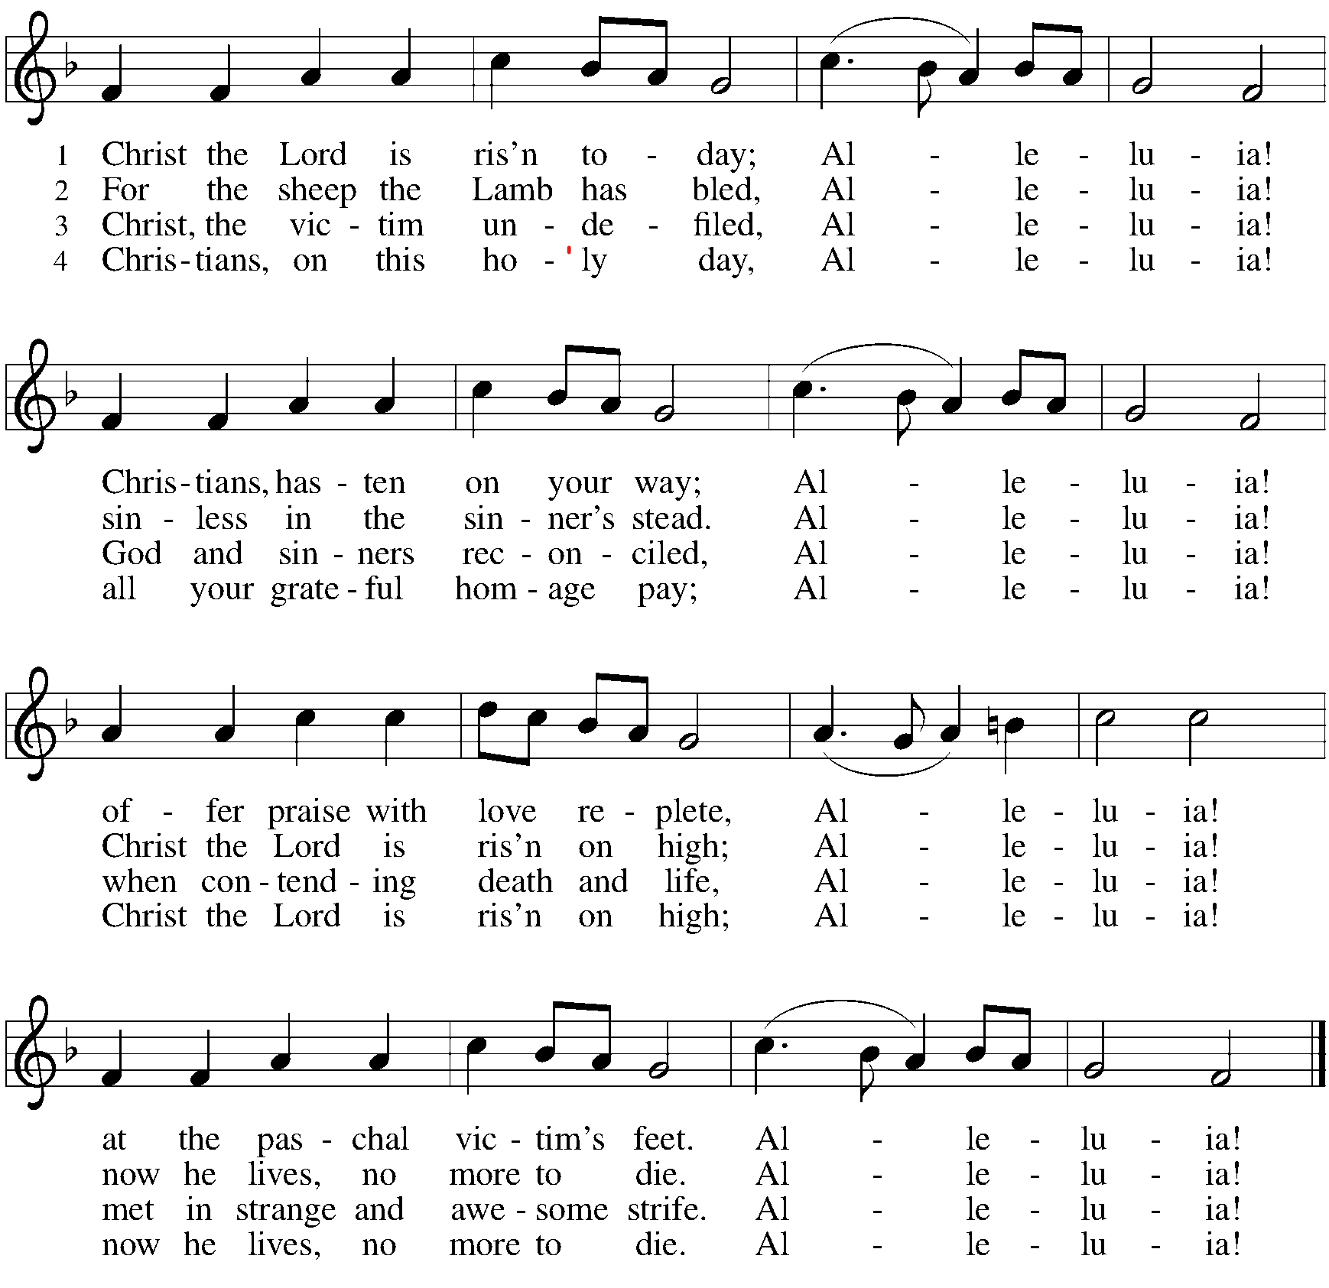

*Greeting
The grace of our Lord Jesus Christ, the love of God, and the communion of the Holy Spirit be with you all. And also with you.

*Hymn of Praise ELW #367 Now All the Vault of Heaven Resounds
sts. 1, 2
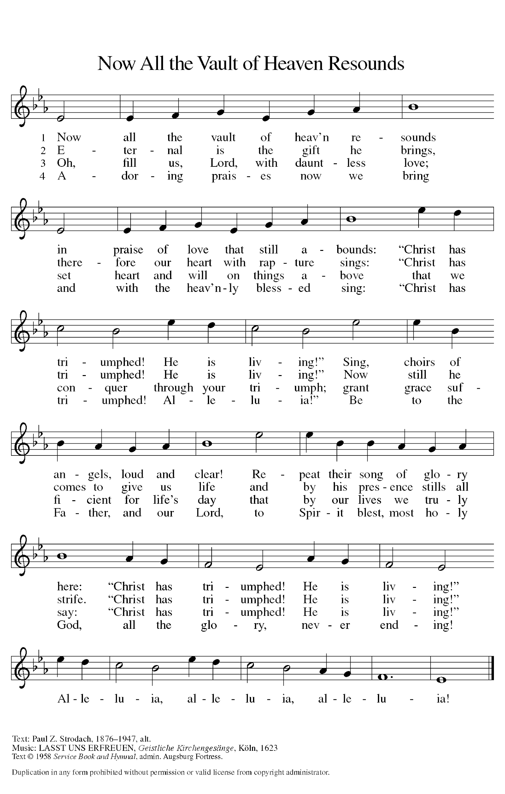

*Prayer of the Day
O God, you gave your only Son to suffer death on the cross for our redemption, and by his glorious resurrection you delivered us from the power of death. Make us die every day to sin, that we may live with him forever in the joy of the resurrection, through your Son, Jesus Christ our Lord, who lives and reigns with you and the Holy Spirit, one God, now and forever. Amen. Be seated.

Word
God speaks to us in scripture reading.
First Lesson Acts 10:34-43
Peter’s sermon, delivered at the home of Cornelius, a Roman army officer, sums up the essential message of Christianity. Everyone who believes in Jesus, whose life, death, and resurrection fulfilled the words of the prophets, receives forgiveness of sins through his name.

³⁴Peter began to speak to [the people]: “I truly understand that God shows no partiality, ³⁵but in every nation anyone who fears him and does what is right is acceptable to him. ³⁶You know the message he sent to the people of Israel, preaching peace by Jesus Christ—he is Lord of all. ³⁷That message spread throughout Judea, beginning in Galilee after the baptism that John announced: ³⁸how God anointed Jesus of Nazareth with the Holy Spirit and with power; how he went about doing good and healing all who were oppressed by the devil, for God was with him. ³⁹We are witnesses to all that he did both in Judea and in Jerusalem. They put him to death by hanging him on a tree; ⁴⁰but God raised him on the third day and allowed him to appear, ⁴¹not to all the people but to us who were chosen by God as witnesses, and who ate and drank with him after he rose from the dead. ⁴²He commanded us to preach to the people and to testify that he is the one ordained by God as judge of the living and the dead. ⁴³All the prophets testify about him that everyone who believes in him receives forgiveness of sins through his name.”

Word of God, Word of Life. Thanks be to God.

Second Lesson 1 Corinthians 15:19-26
Paul describes the consequences of the resurrection, including the promise of new life in Christ to a world that has been in bondage to death. He celebrates the destruction of evil and the establishment of God’s victorious rule over all.

¹⁹If for this life only we have hoped in Christ, we are of all people most to be pitied.
²⁰But in fact Christ has been raised from the dead, the first fruits of those who have died. ²¹For since death came through a human being, the resurrection of the dead has also come through a human being; ²²for as all die in Adam, so all will be made alive in Christ. ²³But each in his own order: Christ the first fruits, then at his coming those who belong to Christ. ²⁴Then comes the end, when he hands over the kingdom to God the Father, after he has destroyed every ruler and every authority and power. ²⁵For he must reign until he has put all his enemies under his feet. ²⁶The last enemy to be destroyed is death.

Word of God, Word of Life. Thanks be to God.

*Please stand as you are able.
*Gospel Acclamation ELW #388 Be Not Afraid

The holy Gospel according to Luke. Glory to you, O Lord.

*Gospel Luke 24:1-12
Evidently expecting to find Jesus’ corpse, some of the women among his followers go to the tomb with embalming spices. After a perplexing encounter with the empty tomb and angelic visitors, the women become the first to proclaim the amazing news of resurrection.

¹On the first day of the week, at early dawn, [the women] came to the tomb, taking the spices that they had prepared. ²They found the stone rolled away from the tomb, ³but when they went in, they did not find the body. ⁴While they were perplexed about this, suddenly two men in dazzling clothes stood beside them. ⁵The women were terrified and bowed their faces to the ground, but the men said to them, “Why do you look for the living among the dead? He is not here, but has risen. ⁶Remember how he told you, while he was still in Galilee, ⁷that the Son of Man must be handed over to sinners, and be crucified, and on the third day rise again.” ⁸Then they remembered his words, ⁹and returning from the tomb, they told all this to the eleven and to all the rest. ¹⁰Now it was Mary Magdalene, Joanna, Mary the mother of James, and the other women with them who told this to the apostles. ¹¹But these words seemed to them an idle tale, and they did not believe them. ¹²But Peter got up and ran to the tomb; stooping and looking in, he saw the linen cloths by themselves; then he went home, amazed at what had happened.

The Gospel of the Lord. Praise to you, O Christ.

*Gospel Acclamation ELW #388 Be Not Afraid

Be seated.

Sermon The Rev. Melody Eastman

*Please stand as you are able
*Hymn of the Day ELW #365 Jesus Christ Is Risen Today
sts. 1, 2, 4

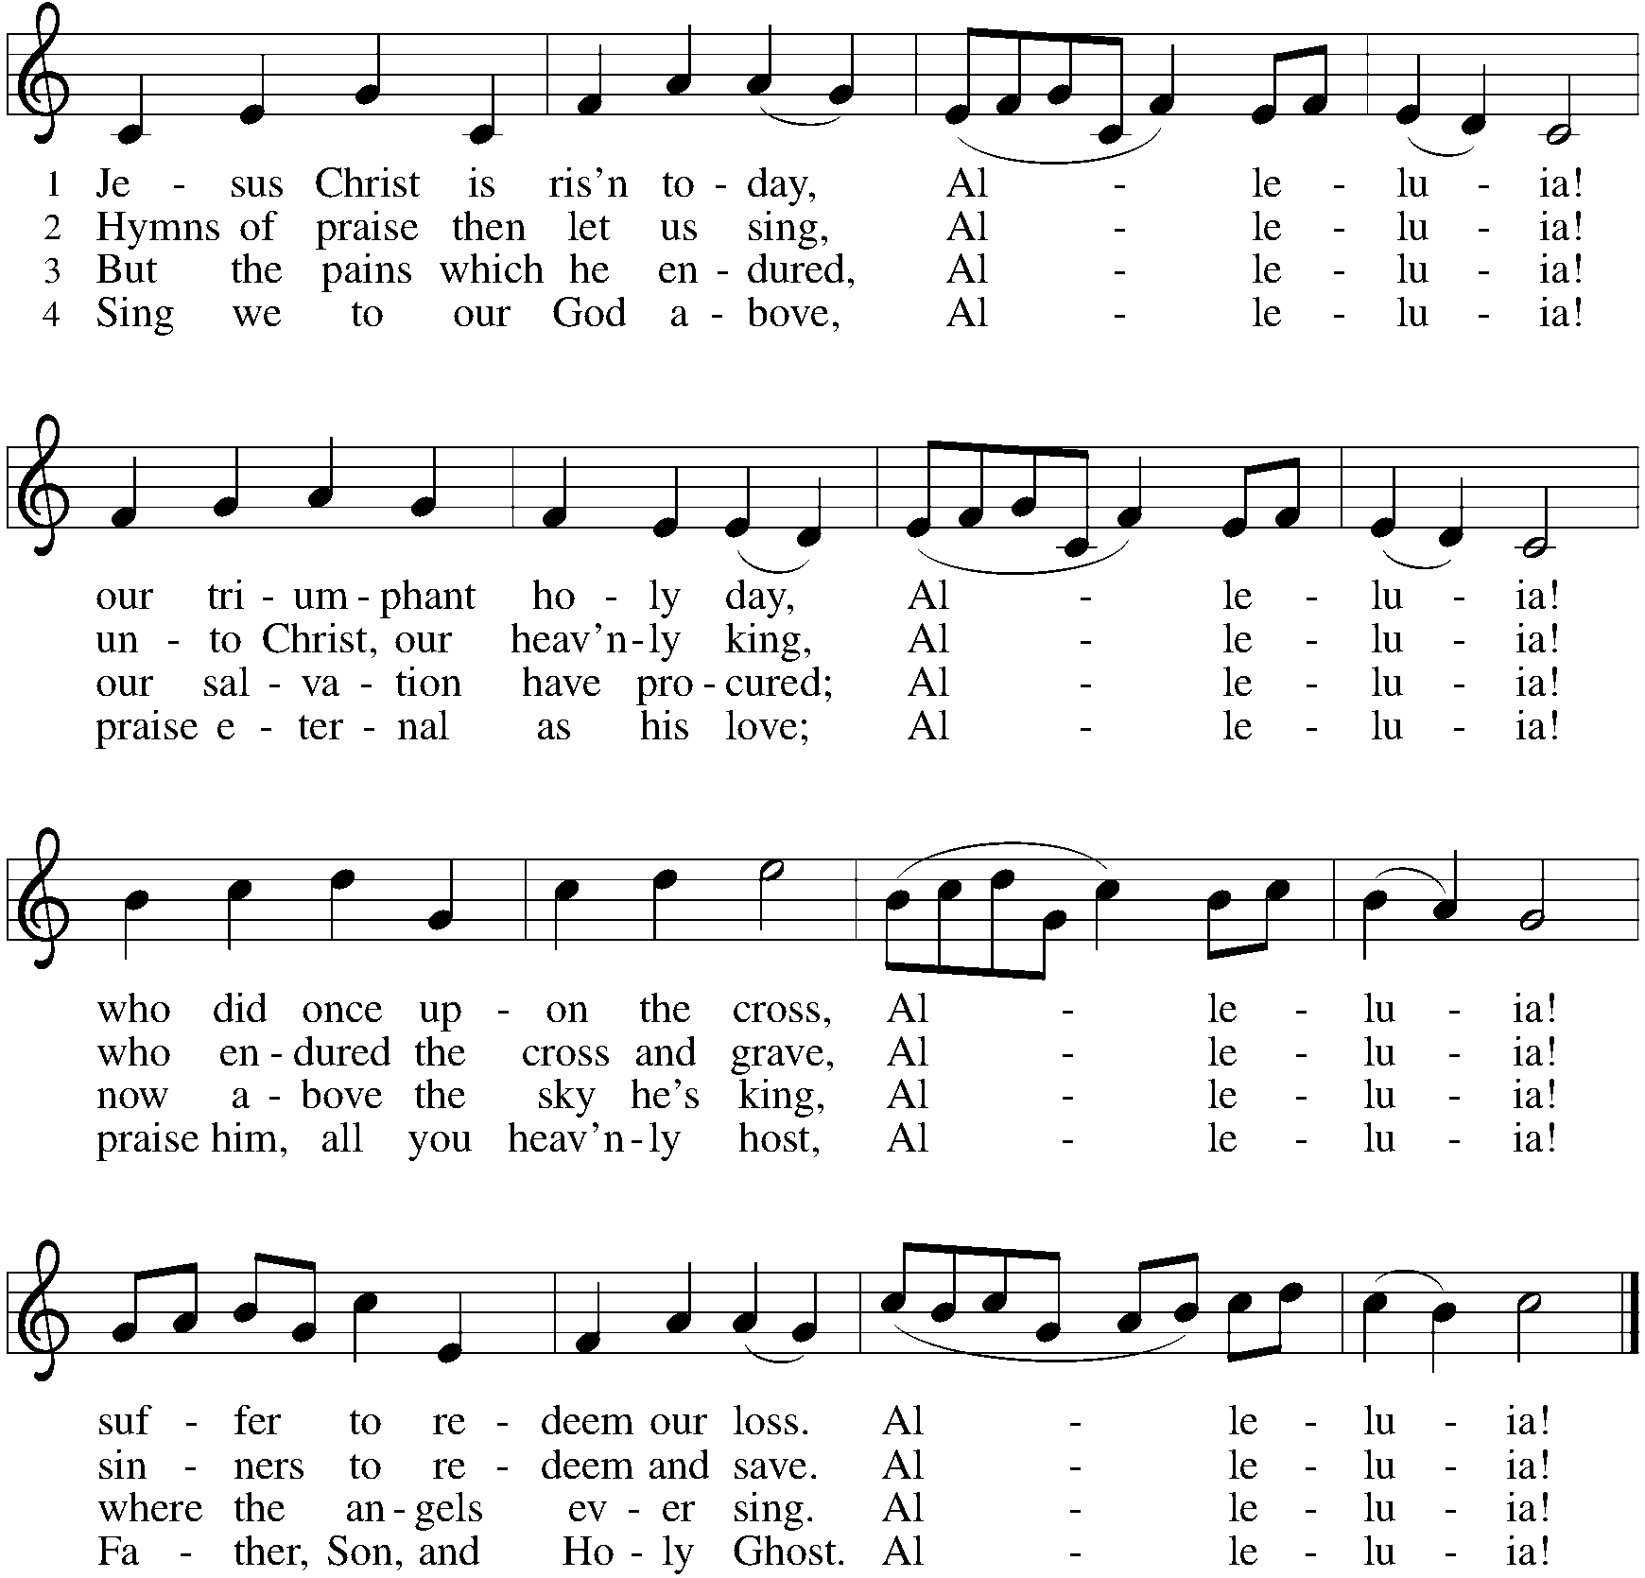

Presentation of New Members
Dear friends, we give thanks for the gift of baptism and for these people, Jacky and Harold Anderson, one with us in the body of Christ, whom we welcome as new members into the life and ministry of this congregation.

Let us pray.
Merciful God, we thank you for these siblings in Christ, whom you have made your own by water and the Word in baptism. You have called them to yourself, enlightened them with the gifts of your Spirit, and nourished them in the community of faith. Uphold your servants in the gifts and promises of baptism, and unite the hearts of all whom you have brought to new birth. We ask this in the name of Christ.
Amen.

Profession of Faith
The presiding minister addresses those making public affirmation of baptism.

I ask you to profess your faith in Christ Jesus, reject sin, and confess the faith of the church.

Do you renounce the devil and all the forces that defy God?
Response: I renounce them.

Do you renounce the powers of this world that rebel against God?
Response: I renounce them.

Do you renounce the ways of sin that draw you from God?
Response: I renounce them.

The assembly may stand and join in the responses. The presiding minister addresses the candidates and the assembly.

Do you believe in God the Father?
I believe in God, the Father almighty, creator of heaven and earth.

Do you believe in Jesus Christ, the Son of God?
I believe in Jesus Christ, God's only Son, our Lord,
who was conceived by the Holy Spirit, born of the virgin Mary,
suffered under Pontius Pilate, was crucified, died, and was buried;
he descended to the dead.
On the third day he rose again; he ascended into heaven,
he is seated at the right hand of the Father,
and he will come to judge the living and the dead.

Do you believe in God the Holy Spirit?
I believe in the Holy Spirit, the holy catholic church,
the communion of saints,
the forgiveness of sins, the resurrection of the body,
and the life everlasting.

The presiding minister addresses those making public affirmation of baptism.
You have made public profession of your faith. Do you intend to continue in the covenant God made with you in holy baptism:
to live among God's faithful people,
to hear the word of God and share in the Lord's supper,
to proclaim the good news of God in Christ through word and deed,
to serve all people, following the example of Jesus,
and to strive for justice and peace in all the earth?
Each person responds: I do, and I ask God to help and guide me.

The minister addresses the assembly.
People of God, do you promise to support this sister and this brother, and pray for them in their life in Christ?
We do, and we ask God to help and guide us.

Let us pray.
We give you thanks for our new members Jacky and Harold,
whom you have drawn to yourself by the love of Jesus Christ
and whom we have welcomed into this household of faith.
Keep us close together in your Spirit,
in the breaking of bread and the prayers, and in service to others.

For Jesus' sake, stir up in Harold and Jacky the gift of your Holy Spirit;
confirm their faith, guide their life,
empower them in their serving, give them patience in suffering, and bring them to everlasting life. Amen.

Let us rejoice with these beloved of Christ who have joined us ministry here at Grace.
We rejoice with you in the life of baptism.
Together we will give thanks and praise to God
and proclaim the good news to all the world.

*Prayers of Intercession
On this day of resurrection joy, let us offer our prayers for ourselves, our neighbors, and our world.
A brief silence.

Renewing God, the good news of your resurrection changed the world. Give church leaders and all the baptized the same excitement as the women at the tomb, and inspire us to share your abundant life. Merciful God, receive our prayer.

Sustaining God, your creation abounds with signs of new life in budding trees and newborn creatures. Provide fertile soil, ample sunlight, and nourishing rain for the growth of plants, and provide farmers with a plentiful harvest. Merciful God, receive our prayer.

Sheltering God, strengthen and sustain all who support vulnerable people across the world. Empower government agencies and international organizations that provide for refugees and migrants forced to leave their homelands. Merciful God, receive our prayer.

Encouraging God, you do a new thing among us. We pray for those gripped by fear and anxiety or who suffer in any way, especially Dorothy, Dolores, Carole, Norma, and those we name before you now. . . Send us as your healing presence to places of hunger, pain, illness, or overwhelming sorrow. Merciful God, receive our prayer.

Surprising God, you offer endless ways for us to delight in your grace. Give this community of faith a sense of joy and wonder in exploring new avenues of faith formation, worship, and discipleship. Merciful God, receive our prayer.
Here other intercessions may be offered.

Resurrecting God, you make us alive in Christ. Thank you for blessing us with faithful witnesses who now rest in you. Merciful God, receive our prayer.

We offer to you these petitions and those we carry in our hearts, trusting in your abundant and ever-present mercy. Amen.

*Peace
The peace of Christ be with you always. And also with you.
Please share the peace with others in your household, or by making a sign of peace to those on Zoom. Please remain standing as you are able.

Meal
God feeds us with the presence of Jesus Christ.
*Offering Prayer
Living God,
you gather the wolf and the lamb to feed together
in your peaceable reign,
and you welcome us all at your table.
Reach out to us through this meal,
and show us your wounded and risen body,
that we may be nourished and believe
in Jesus Christ, our Savior and Lord.
Amen.

*Great Thanksgiving p. 152
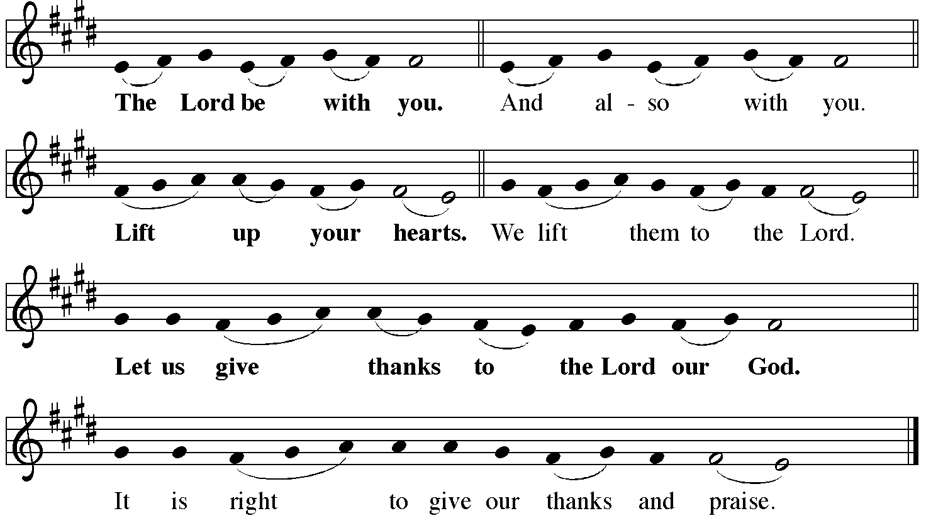

*Preface
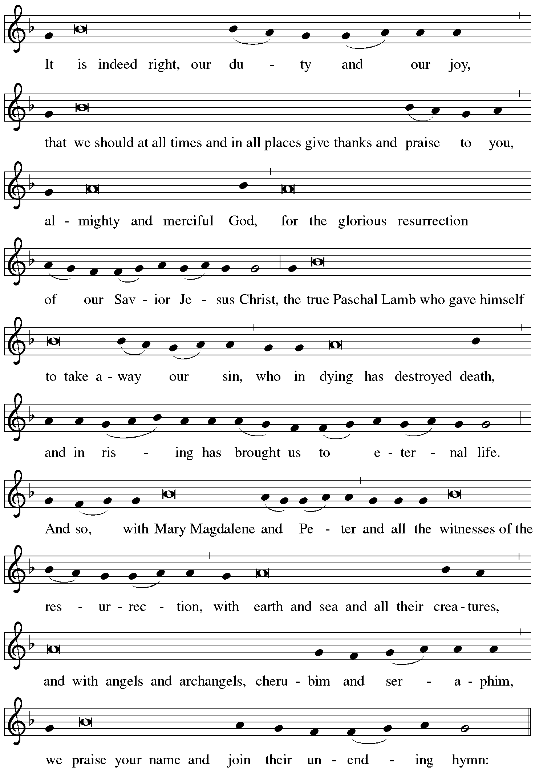
*Sanctus ELW #367 Now All the Vault of Heaven Resounds
sts. 3, 4

Oh, fill us, Lord, with dauntless love;
Set heart and will on things above
That we conquer
through your triumph;
Grant grace sufficient for life’s day
That by our lives we truly say:
“Christ has triumphed! He is living!”
Alleluia, alleluia, alleluia!

Adoring praises now we bring
And with the heav’nly blessed sing:
“Christ has triumphed! Alleluia!”
Be to the Father, and our Lord,
To Spirit blest, most holy God,
All the glory, never ending!
Alleluia, alleluia, alleluia!

*Thanksgiving at the Table
O God most mighty, O God most merciful,
O God our rock and our salvation,
hear us as we praise, call us to your table, grant us your life.

When the earth was a formless void, you formed order and beauty.
When Abraham and Sarah were barren, you sent them a child.
When the Israelites were enslaved, you led them to freedom.
Ruth faced starvation, David fought Goliath,
and the psalmists cried out for healing,
and full of compassion, you granted the people your life.

You entered our sorrows in Jesus our brother.
He was born among the poor, he lived under oppression, he wept over the city.
With infinite love, he granted the people your life.

In the night in which he was betrayed,
our Lord Jesus took bread, and gave thanks;
broke it, and gave it to his disciples, saying:
Take and eat; this is my body, given for you.
Do this for the remembrance of me.

Again, after supper, he took the cup, gave thanks,
and gave it for all to drink, saying:
This cup is the new covenant in my blood,
shed for you and for all people for the forgiveness of sin.
Do this for the remembrance of me.

Remembering his death, we cry out Amen. Amen.
Celebrating his resurrection, we shout Amen. Amen.
Trusting his presence in every time and place, we plead Amen. Amen.

O God, you are Breath: send your Spirit on this meal.
O God, you are Bread: feed us with yourself.
O God, you are wine: warm our hearts and make us one.
O God, you are Fire: transform us with hope.

O God most majestic, O God most motherly, O God our strength and our song,
you show us a vision of a tree of life
with fruits for all and leaves that heal the nations.
Grant us such life,
the life of the Father to the Son,
the life of the Spirit of our risen Savior,
life in you, now and forever.
Amen

*The Lord’s Prayer
Gathered into one by the Holy Spirit, let us pray as Jesus taught us.
Our Father, who art in heaven, hallowed be thy name, thy kingdom come, thy will be done on earth as it is in heaven. Give us this day our daily bread; and forgive us our trespasses, as we forgive those who trespass against us; and lead us not into temptation, but deliver us from evil. For thine is the kingdom, and the power, and the glory, forever and ever. Amen.

*Invitation to Communion
The risen Christ dwells with us here. All who are hungry, all who are thirsty, come.
Be seated.

Agnus Dei ELW #362 At The Lamb’s High Feast We Sing
sts. 1, 2, 4

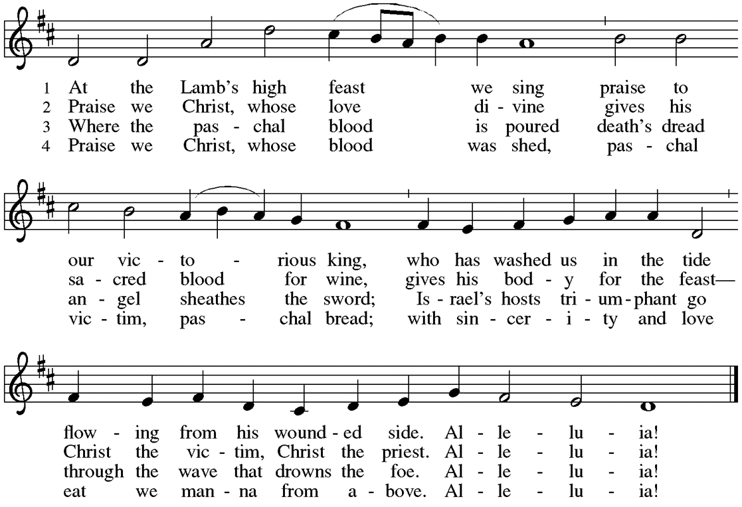

Communion
Those who wish to come to the rail for communion may do so at the ushers’ direction. You may stand or kneel. Please maintain social distancing between households. You may return to your seat by the side aisles after you have received the bread and wine. If you like, you may bring a communion kit with you to receive at the altar.

For those receiving communion in the pew or from home:
This is the body of Christ, given for you. Amen (Eat the bread.)
This is the blood of Christ, shed for you. Amen (Drink the juice.)

*Please stand as you are able.
*Post Communion Blessing
May the body and blood of our Lord Jesus Christ strengthen you and keep you in his grace. Amen.

*Post Communion Prayer
We give you thanks, generous God,
for in this bread and cup
we have tasted the new heaven and earth
where hunger and thirst are no more.
Send us from this table as witnesses to the resurrection,
that through our lives, all may know life in Jesus’ name.
Amen.
Sending
God blesses us and sends us in mission to the world.
*Blessing
God, the Author of life,
Christ, the living Cornerstone,
and the life-giving Spirit of adoption,
☩ bless you now and forever.
Amen.

*Sending Hymn ELW #382 Christ Is Risen! Alleluia!
St. 1 – All St. 2 – Low Voices St. 3 – High Voices St. 4 - All

*Sent to the World
Alleluia! Christ is risen. Christ is risen indeed. Alleluia!
Go in peace. Tell what God has done. Thanks be to God.

Postlude
Thank you for sharing this celebration of the Resurrection with us!
After the postlude, those worshipping on Zoom may unmute your mic and share Easter greetings with your fellow worshippers.
Those attending in person are welcome to join us in the Narthex
for Easter refreshments.

From Sundays and Seasons v.20190109.1233 Copyright © 2022 Augsburg Fortress. All rights reserved.
Reprinted by permission under Augsburg Fortress Liturgies Annual License #30867.
All rights reserved. Reprinted under OneLicense.net #A-718333.

Assisting in Worship Today
Pastor Rev. Melody Eastman
Minister of Music Bradford Thompson
Ministry Associate Becky Ficarella
Altar Care Linda Kelly
Lector Rob Granner
Crucifer Carson Graf
Usher Mario Ficarella, Chuck Miller
Zoom Mark Hamilton, Jon & Cathy Milleville
Fellowship Hour Social Committee

Current Prayer Requests
Please keep these people in your prayers and reach out to our sisters and brothers in Christian love. Names will be left on the list for two weeks, unless you indicate that they should remain in our prayers for a longer period.
Name Relationship Prayer For
Dolores Nosal Member Healing & Strength
Brittany Huizenga Cousin of Cheryl Huizenga Healing & Strength
Matthew Barrera Grandson of Doris Nelson Missing since 12/25
Dorothy Tracy Member Healing & Strength
Norma Petersen Member Healing & Strength
Prayers for our homebound Members
Dolores Nosal, Carol Petersen, Norma Peterson

CROP Hunger Walk: Sunday, May 1 at Faith Lutheran Church. 1pm Registration, 2pm Walk Off. Donate to Team Grace at https://events.crophungerwalk.org/2022/team/grace-lutheran-glen-ellyn-il

Crisis in Ukraine: Your gift through Lutheran World Relief will be matched up to $422,000! Learn more at LWR.org/congregations. Donate online at LWR.org/match. Gifts can also be mailed to Lutheran world Relief, PO Box 17061, Baltimore, MD 21297-1061. Please write “Ukraine Match” in the memo line. The deadline for the match is April 25.

Fellowship Hour: Please join us for coffee and fellowship following Sunday’s worship service. We are looking for additional volunteers to host the coffee hour. Please contact Becky Ficarella or the church office if you are interested.

Quilting Ministry: The quilters meet on the second and fourth Tuesday of every month from 9-10am.

Community Vacation Bible School: Registration is now open for volunteers and participants. Grace Lutheran Church, Faith Lutheran Church, and First Congregational Church Glen Ellyn are presenting this week together in partnership “Compassion Camp - Changing the World with Loving Kindness!” Monday – Friday, June 20-24, 9:00am-12:00pm at Faith Lutheran Church. 41 N. Park Blvd., Glen Ellyn. Register on Grace’s website!

Worship Assistants: With the return to communion at the rail, we are in need of people willing to serve as cross-bearer and communion assistant along with two ushers for each week. If you are able to help with carrying the cross and/or assisting with communion, please contact Susan Jacobson or the church office. Thank you!

Ushers Still Needed: If you are able, please help us meet the need for at least two ushers during the worship service each Sunday—one to monitor needs in the sanctuary and one to stand at the entrance to the sanctuary and monitor the narthex and entrances to the bathrooms. We have occasionally had people we don’t know enter the building and remain for some time, and while we welcome everyone, we also want to be able to make sure everyone in the building is secure. Two ushers help us appropriately monitor both needs in the sanctuary and in the narthex and bathrooms.
-We are in need of one usher to work with Tim Kelly the Sundays in March, July, and November.
-We are in need of one usher to work with Sandy Wenner the Sundays of February, June and October.
Please contact the church office and Barbara can add you to the schedule. Thank you.

Sr. Center Chair Exercise Classes: The exercise class meets Mondays at 10:00am, Tuesdays at 10:00am, and Thursdays at 11:00am. Registration is required as the number of attendees will be limited. Please contact Sue Davison at 630-858-6343 to register.

Easter Plants
Linda and Jeff Berta in memory of our loved ones
Greg and Donna Barber in memory of Joe & Lucile Smith and
Earle & Edna Barber
Lynn and Tim Breitling in honor of our family
Sue and Rich Davison
Pr. Melody and Marty Eastman in loving memory of Marty Friend,
Jean & Lee Beckman, and Wilma & Lewis Eastman
Donna and Joe Jacobo in loving memory of Cirina and Ramon Jacobo
Susan and Jake Jacobson in memory of our mothers
Linda and Tim Kelly Glory to God
Paula and Jim Kregor
Carole LoGalbo in memory of Robert LoGalbo
Brigitte and Jerry Miller for God’s many blessings
Doris Nelson
Bonnie Paganis in memory of George Goodrich
Paul Rom in loving memory of Helen Rom
Shirley Sauerman in memory of all my loved ones
who have received their promised everlasting life with our Risen Lord
Helen Sladek in memory of James Sladek
Barbara Sudds in memory of my parents
The Family of Joan Uhlhorn and Ernst & Wilma Thielberg
in honor of their memory

Every Member a Minister and Missionary!

Phone: 630-469-1555 Emergency Pastoral Contact: 630-674-2887
info@graceglenellyn.org www.graceglenellyn.org

Pastor
Rev. Melody Eastman office ext. 14
meastman@graceglenellyn.org

Minister of Music
Bradford Thompson 219-718-8879
bradfordmthompson@gmail.com

Ministry Associate
Becky Ficarella office ext. 17
bficarella@graceglenellyn.org

Office Manager
Barbara Sudds office ext. 10
bsudds@graceglenellyn.org

Parish Counselor
Carole LoGalbo M.S., LCPC 630-668-4594
carolelogalbo@yahoo.com

