Grace Lutheran Church

493 Forest Avenue, Glen Ellyn IL 630.469.1555
www.graceglenellyn.org

Third Sunday of Easter April 23, 2023

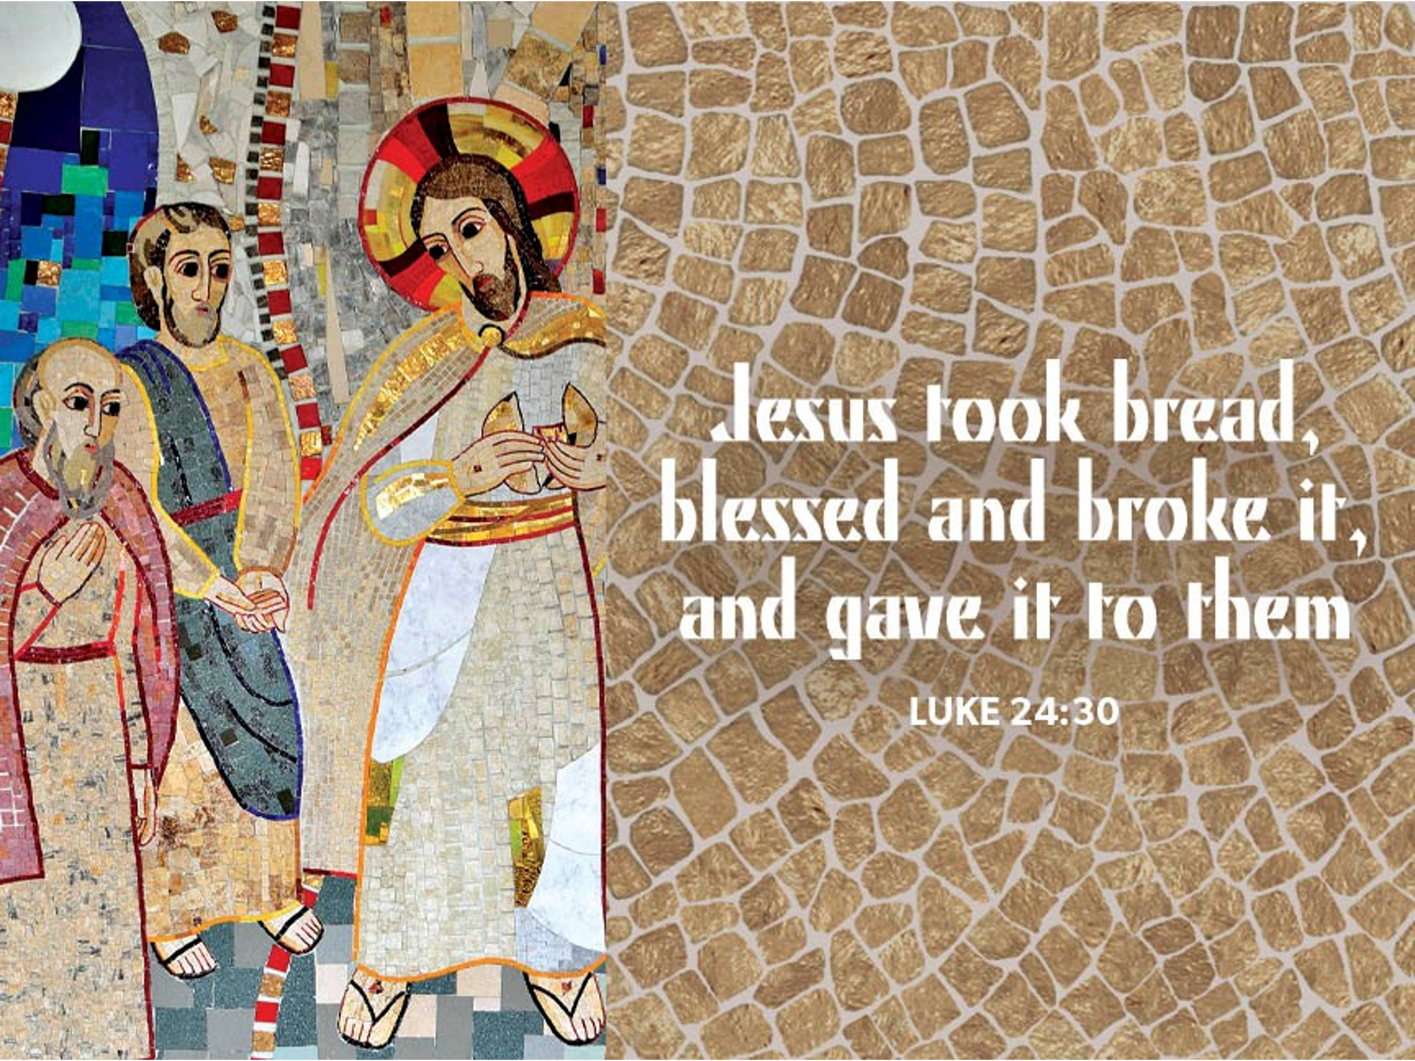

+ Proclaim Christ + Build Community +
+ Serve Our Neighbors +

Introduction
Today’s gospel begins with two disciples walking to Emmaus, overcome with sadness, loss, and disappointment. They had hoped Jesus, who was crucified, would be the one to redeem Israel! Yet the risen Christ walks with them and then opens their eyes in the breaking of the bread. Each Sunday our hearts burn within us as the scriptures are proclaimed and Christ appears to us as bread is broken and wine is poured. The story of Emmaus becomes the pattern of our worship each Lord’s day.

Gathering
The Holy Spirit calls us together as the people of God.
Welcome/Announcements

Prelude

*Please stand as you are able.

*Thanksgiving for Baptism
All may make the sign of the cross, the sign that is marked at baptism, as the presiding minister begins.
Blessed be the holy Trinity, ☩ one God, by whose hand we are given new birth, by whose speaking we are given new life. Amen.

Joined to Christ in the waters of baptism, we are welcomed, restored, and supported as citizens of the new creation. Let us give thanks for the gift of baptism. Holy God, holy and merciful, holy and mighty, you are the river of life, you are the everlasting wellspring. In mercy and might you have freed us from death and raised us with Jesus, the firstborn of the dead. In baptismal waters our old life is washed away, and in them we are born anew.
Water may be poured into the font as the presiding minister continues.

Glory to you for oceans and lakes, for rivers and streams. Honor to you for waters that wash us clean, quench our thirst, and nurture both crops and creatures. Praise to you for the life-giving water of baptism, the outpouring of the Spirit of the new creation.

Wash away our sin and all that separates us from you. Empower our witness to your resurrection.
Strengthen our resolve in seeking justice for all.

Satisfy the world’s need through this living water. Where drought dries the earth, bring refreshment. Where despair prevails, grant hope. Where chaos reigns, bring peace. We ask this through Christ, who with you and the Spirit reigns forever. Amen.

*Entrance Hymn ELW #522 As We Gather at Your Table

*Greeting
The grace of our Lord Jesus Christ, the love of God, and the communion of the Holy Spirit be with you all. And also with you.

*Hymn of Praise ELW #362 At the Lamb’s High Feast We Sing
sts. 1,5

*Prayer of the Day
O God, your Son makes himself known to all his disciples in the breaking of bread. Open the eyes of our faith, that we may see him in his redeeming work, who lives and reigns with you and the Holy Spirit, one God, now and forever. Amen. Be seated.
Word
God speaks to us in scripture reading.
First Lesson Acts 2:14a; 36-41
Today’s reading is the conclusion of Peter’s sermon preached following the giving of the Holy Spirit to the apostles on the day of Pentecost. The center of his preaching is the bold declaration that God has made the crucified Jesus both Lord and Christ.

^{14a}Peter, standing with the eleven, raised his voice and addressed [the crowd], ³⁶“Therefore let the entire house of Israel know with certainty that God has made him both Lord and Messiah, this Jesus whom you crucified.”
³⁷Now when they heard this, they were cut to the heart and said to Peter and to the other apostles, “Brothers, what should we do?” ³⁸Peter said to them, “Repent, and be baptized every one of you in the name of Jesus Christ so that your sins may be forgiven; and you will receive the gift of the Holy Spirit. ³⁹For the promise is for you, for your children, and for all who are far away, everyone whom the Lord our God calls to him.” ⁴⁰And he testified with many other arguments and exhorted them, saying, “Save yourselves from this corrupt generation.” ⁴¹So those who welcomed his message were baptized, and that day about three thousand persons were added.

Word of God, Word of Life. Thanks be to God.
Second Lesson 1 Peter 1:17-23
The imagery of exile is used to help the readers of this letter understand that they are strangers in a strange land. Christians no longer belong to this age. Through the death of Christ we belong to God, so that our focus, faith, and hope are no longer on such things as silver or gold.

¹⁷If you invoke as Father the one who judges all people impartially according to their deeds, live in reverent fear during the time of your exile. ¹⁸You know that you were ransomed from the futile ways inherited from your ancestors, not with perishable things like silver or gold, ¹⁹but with the precious blood of Christ, like that of a lamb without defect or blemish. ²⁰He was destined before the foundation of the world, but was revealed at the end of the ages for your sake. ²¹Through him you have come to trust in God, who raised him from the dead and gave him glory, so that your faith and hope are set on God.
²²Now that you have purified your souls by your obedience to the truth so that you have genuine mutual love, love one another deeply from the heart. ²³You have been born anew, not of perishable but of imperishable seed, through the living and enduring word of God.

Word of God, Word of Life. Thanks be to God.

*Please stand as you are able.
*Gospel Acclamation
The holy Gospel according to Luke. Glory to you, O Lord.
*Gospel Luke 24:13-35
The colorful story of Jesus’ appearance to two disciples on the road to Emmaus answers the question of how Jesus is to be recognized among us. Here, he is revealed through the scriptures and in the breaking of bread.

¹³Now on that same day [when Jesus had appeared to Mary Magdalene,] two [disciples] were going to a village called Emmaus, about seven miles from Jerusalem, ¹⁴and talking with each other about all these things that had happened. ¹⁵While they were talking and discussing, Jesus himself came near and went with them, ¹⁶but their eyes were kept from recognizing him. ¹⁷And he said to them, “What are you discussing with each other while you walk along?” They stood still, looking sad. ¹⁸Then one of them, whose name was Cleopas, answered him, “Are you the only stranger in Jerusalem who does not know the things that have taken place there in these days?” ¹⁹He asked them, “What things?” They replied, “The things about Jesus of Nazareth, who was a prophet mighty in deed and word before God and all the people, ²⁰and how our chief priests and leaders handed him over to be condemned to death and crucified him. ²¹But we had hoped that he was the one to redeem Israel. Yes, and besides all this, it is now the third day since these things took place. ²²Moreover, some women of our group astounded us. They were at the tomb early this morning, ²³and when they did not find his body there, they came back and told us that they had indeed seen a vision of angels who said that he was alive. ²⁴Some of those who were with us went to the tomb and found it just as the women had said; but they did not see him.” ²⁵Then he said to them, “Oh, how foolish you are, and how slow of heart to believe all that the prophets have declared! ²⁶Was it not necessary that the Messiah should suffer these things and then enter into his glory?” ²⁷Then beginning with Moses and all the prophets, he interpreted to them the things about himself in all the scriptures.
²⁸As they came near the village to which they were going, he walked ahead as if he were going on. ²⁹But they urged him strongly, saying, “Stay with us, because it is almost evening and the day is now nearly over.” So he went in to stay with them. ³⁰When he was at the table with them, he took bread, blessed and broke it, and gave it to them. ³¹Then their eyes were opened, and they recognized him; and he vanished from their sight. ³²They said to each other, “Were not our hearts burning within us while he was talking to us on the road, while he was opening the scriptures to us?” ³³That same hour they got up and returned to Jerusalem; and they found the eleven and their companions gathered together. ³⁴They were saying, “The Lord has risen indeed, and he has appeared to Simon!” ³⁵Then they told what had happened on the road, and how he had been made known to them in the breaking of the bread.

The Gospel of the Lord. Praise to you, O Christ. Be seated.

Sermon The Rev. Melody Eastman

*Please stand as you are able.
*Hymn of the Day ACS #938 Christ Has Risen
Choir only on st. 1; Congregation on sts. 2-4
*Please stand as you are able
*Prayers of Intercession
Each petition concludes with Hear us, O God. Congregation responds Your mercy is great.

Rejoicing in the victory of Christ’s resurrection, we lift our prayers and praise to you, almighty and eternal God; through Jesus Christ, our risen Lord. Amen.

*Peace
The peace of Christ be with you always. And also with you.
Please share the peace with others in your household, or by making a sign of peace to those on Zoom. You may then be seated as the table is prepared.

Gathering of Gifts
We gather gifts for those in need and for the church’s mission.

Music During Offering

*Please stand as you are able. The gifts are brought forward while the congregation sings:
*Offertory ELW #531 The Trumpets Sound, the Angels Sing
st. 1

Meal
God feeds us with the presence of Jesus Christ.
*Offering Prayer
Living God, you gather the wolf and the lamb to feed together in your peaceable reign, and you welcome us all at your table. Reach out to us through this meal, and show us your wounded and risen body, that we may be nourished and believe in Jesus Christ, our Savior and Lord. Amen.

*Great Thanksgiving
The Lord be with you. And also with you.
Lift up your hearts. We lift them to the Lord.
Let us give thanks to the Lord our God. It is right to give our thanks and praise.

*Preface

*Sanctus p. 181 Holy, Holy, Holy

*Thanksgiving at the Table
. . . For as often as we eat of this bread and drink from this cup, we proclaim the Lord’s death until he comes.
Christ has died. Christ is risen. Christ will come again.

Remembering, therefore, his salutary command, his life-giving passion and death, his glorious resurrection and ascension, and the promise of his coming again, we give thanks to you, O Lord God Almighty, not as we ought but as we are able; we ask you mercifully to accept our praise and thanksgiving and with your Word and Holy Spirit to bless us, your servants, and these your own gifts of bread and wine, so that we and all who share in the body and blood of Christ may be filled with heavenly blessing and grace, and, receiving the forgiveness of sin, may be formed to live as your holy people and be given our inheritance with all your saints.

To you, O God, Father, Son, and Holy Spirit, be all honor and glory in your holy church, now and forever.
Amen.
*The Lord’s Prayer Ecumenical Version
Gathered into one by the Holy Spirit, let us pray as Jesus taught us.
Our Father in heaven, hallowed be your name, your kingdom come, your will be done, on earth as in heaven. Give us today our daily bread. Forgive us our sins as we forgive those who sin against us. Save us from the time of trial and deliver us from evil. For the kingdom, the power and the glory are yours, now and forever. Amen.

*Invitation to Communion
The risen Christ dwells with us here. All who are hungry, all who are thirsty, come. Be seated.

Communion
Those who wish to come to the rail for communion may do so at the ushers’ direction. You may stand or kneel. You may return to your seat by the side aisles after you have received the bread and wine.

For those receiving communion in the pew or from home:
This is the body of Christ, given for you. Amen (Eat the bread.)
This is the blood of Christ, shed for you. Amen (Drink the juice.)

Agnus Dei p. 182 Lamb of God

Music During Communion ELW #466 In the Singing

*Please stand as you are able.
*Post Communion Blessing
May the body and blood of our Lord Jesus Christ strengthen you and keep you in his grace. Amen.

*Post Communion Prayer
We give you thanks, generous God, for in this bread and cup we have tasted the new heaven and earth
where hunger and thirst are no more. Send us from this table as witnesses to the resurrection, that through our lives, all may know life in Jesus’ name. Amen.
Sending
God blesses us and sends us in mission to the world.
*Blessing
The God of all, who raised ☩ Jesus from the dead, bless us by the power of the Holy Spirit to live in the new creation. Amen.

*Sending Hymn ELW #647 Let Us Talents and Tongues Employ

*Sent to the World
Go in peace. Serve the Risen One. Thanks be to God.

Postlude

From Sundays and Seasons v.20190109.1233 Copyright © 2023 Augsburg Fortress. All rights reserved.
Reprinted by permission under Augsburg Fortress Liturgies Annual License #30867.
All rights reserved. Reprinted under OneLicense.net #A-718333.

Assisting in Worship Today
Worship Leader Rev. Melody Eastman
Minister of Music Bradford Thompson
Altar Care Sue Davison, Cathy Milleville
Lector Vince Hardt
Ushers Mark Drager
Zoom Mark Hamilton, Jon & Cathy Milleville
Fellowship Hour Linda Berta
Altar Flowers Tim & Linda Kelly in memory of their parents

Current Prayer Requests
Please keep these people in your prayers and reach out to our sisters and brothers in Christian love. Names will be left on the list for two weeks, unless you indicate that they should remain in our prayers for a longer period.
Name Relationship Prayer For
Greg Barber Member Healing & Strength
Norm & Carol Wandke Members 71st Anniversary 4/26
Charlie Creager Son of Sara & Chuck Creager Born April 10
Ryker Spreenberg Gr. Niece of Barbara Sudds Born April 13
Kathy Meyer Mother of Susi Nelson Healing & Strength
Luke Pajowski Relative of the Roetes Healing & Strength
Lori Garabrandt Niece of Lois Pertle Healing & Strength
Brittany Huizenga Cousin of Cheryl Huizenga Healing & Strength
Prayers for our homebound Members
Norma Peterson, Dorothy Tracy

CROP Walk: This interfaith mission to reduce hunger and poverty has not changed and, in fact, the need for local and global food supply is even more imperative - so let’s get engaged and do everything we can to raise funds to fight hunger!! We will start our Crop Walk outside Gary Memorial Methodist Church, 224 N. Main St. in Wheaton and take a walk together.

1) Let’s Walk: Sunday, May 7th at 1pm for registration with a 2pm walk off.
Action: Sign-up on this website so we can see everyone who will be walking!! Or contact me, Mike Pertle, and I can sign you up!! Even family and friends in other cities and states can participate!!
2) Donate: Please continue to encourage people to donate to this cause. This web page enables online contributions and we welcome donations now through May!!
Action: Send this link to family and friends anywhere in the U.S. who want to help support our local and global food supplies!! If you sign up to walk, they can donate directly to Church World Service or to Grace Lutheran Church in Glen Ellyn. Any amount is appreciated!! To donate, sign up to walk on the website and it is up and running now!! Make Checks payable to CWS/Crop.

https://events.crophungerwalk.org/2023/team/grace-lutheran-glen-ellyn-il

Follow us on facebook at https://www.facebook.com/Glen-EllynWheaton-CROP-Hunger- Walk-384858704862610/

What's important is that we remain purposeful to this cause so mark your calendars for Sunday, May 7th and participate any way you can!
Thank you. Mike Pertle mike.pertle@gmail.com, 630-488-0880

Children’s Ministry Coordinator Position: Grace is seeking someone to fill the position of Children’s Ministry Coordinator—a somewhat pared down position previously held by Becky Ficarella. This position will focus on faith formation and events for our kids in Sunday School, and will involve working with teachers and parents, organizing curriculum and materials, working with VBS, and coordinating with the pastor on Confirmation ministry. The position will require roughly 10-12 hours per week on a flexible schedule. If you are interested, please contact Pastor Melody.

Grace Arts and Apps: Calling all artists of all ages and those with art they would like to share. The Social Committee is hosting an Arts and Apps event on Sunday June 4 after worship in the narthex. We will exhibit artwork of Grace's members for the congregation to see while enjoying some light refreshments in the form of appetizers. Do you have some art that you have made as a hobby or profession? Do you own some artwork you would like to bring and show that day? There will be a sign-up in the narthex so we know how many tables to set up. And, if you don't have any art to share, perhaps you would like to make an appetizer to share.

Every Member a Minister and Missionary!

Phone: 630-469-1555 Emergency Pastoral Contact: 630-674-2887
info@graceglenellyn.org www.graceglenellyn.org

Pastor
Rev. Melody Eastman office ext. 14
meastman@graceglenellyn.org

Minister of Music
Bradford Thompson 219-718-8879
bradfordmthompson@gmail.com

Office Manager
Barbara Sudds office ext. 10
bsudds@graceglenellyn.org

Parish Counselor
Carole LoGalbo M.S., LCPC 630-668-4594
carolelogalbo@yahoo.com

