Grace Lutheran Church

493 Forest Avenue, Glen Ellyn IL 630.469.1555
www.graceglenellyn.org

Second Sunday of Easter April 24, 2022

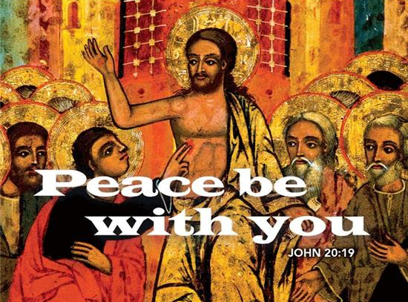

+ Proclaim Christ + Build Community +
+ Serve Our Neighbors +
Especially For Our Guests
Welcome to Grace!
If you are a guest, we’re thankful you’re here today. We hope you will feel Welcomed and spiritually nourished. If you would like to speak to the pastor about the congregation, please let her know directly or call the church office. To enhance your worship experience, you may want to know the following:
· Please join us after service for some great refreshments and Christian Fellowship.
· Parts of the liturgy (worship service) not printed in this bulletin are in the red hymnal (ELW). Page numbers in the hymnal are at the bottom of the page; hymn numbers are the large numbers at the top in the back half of the book.
· All baptized people are welcome at communion. If you would like to come forward for a blessing without taking communion, you can do that too. If you have difficulty walking, feel free to let the usher know and we’ll bring communion to you.
· If you find yourself confused about where we are, ask a neighbor!
· Assisted Listening Devices are available for your use. Please ask an usher.
· Young children are welcome in worship! Parents, you can bring your little ones up front to the PrayGround, a space with tables, chairs and quiet activities to keep our younger members engaged during services. Please sit near your little ones and help them use the space quietly as well as participate with you in worship. If you prefer, there is also a nursery space for you to use with infants or younger toddlers in the overflow room at the rear of the sanctuary. (But we really do like having children up front, if possible!)
· Please take your bulletin home with you. It contains the weekly calendar of events at Grace plus upcoming announcements.

Updated Communion Information
We have returned to the option to commune at the rail with some modifications:
· We are not yet offering the common cup. Red grape juice and white wine are available in individual cups.
· Please do not touch more than one cup. The cups are spaced out to make them easier to remove without touching others.
· If you prefer, you may bring an individual communion kit to the rail and open it there to receive the bread and juice. Or you may remain in the pew and the Pastor will lead you in communion before those at the rail are served.
· Please maintain six feet distance between household groups.

Introduction
“The last enemy to be destroyed is death,” Paul writes. Today Christ is risen, and we gather together with astonishment and joy. Christ is risen, and we have been set free from the bonds of death. Christ is risen, and we are forgiven. Christ is risen, and with the women at the tomb and Peter, we are amazed. Let us rejoice: Christ is risen indeed! Alleluia!

An asterisk (*) indicates that you should stand for that portion of the service. If standing is difficult, please remain seated. Congregation responses are in bold print.

Gathering
The Holy Spirit calls us together as the people of God.
Welcome/Announcements

Prelude

*Please stand as you are able and turn to face the font.
*Thanksgiving for Baptism
All may make the sign of the cross, the sign marked at baptism, as the presiding minister begins.

Alleluia! Christ is risen. Christ is risen indeed. Alleluia!

In the waters of baptism, we have passed over from death to life with Jesus Christ, and we are a new creation.
For this saving mystery, and for this water, let us bless God, who was, who is, and who is to come.

We thank you, God, for your river of life, flowing freely from your throne: through the earth, through the city, through every living thing. You rescued Noah and his family from the flood; You opened wide the sea for the Israelites. Now in these waters you flood us with mercy, and our sin is drowned forever. You open the gate of righteousness and we pass safely through. In Jesus Christ, you calm and trouble the waters. You nourish us and enclose us in safety. You call us forth and send us out. In lush and barren places, you are with us. You have become our salvation. Now breathe upon this water and awaken your church once more. Claim us again as your beloved and holy people. Quench our thirst; cleanse our hearts; wipe away every tear. To you, our Beginning and our End, our Shepherd and Lamb, be honor, glory, praise, and thanksgiving, now and forever.
Amen.

*Entrance Hymn ELW #386 O Sons and Daughters, Let Us Sing
sts. 1-3

*Greeting
The grace of our Lord Jesus Christ, the love of God, and the communion of the Holy Spirit be with you all. And also with you.

*Hymn of Praise ELW #367 Now All the Vault of Heaven Resounds
sts. 1
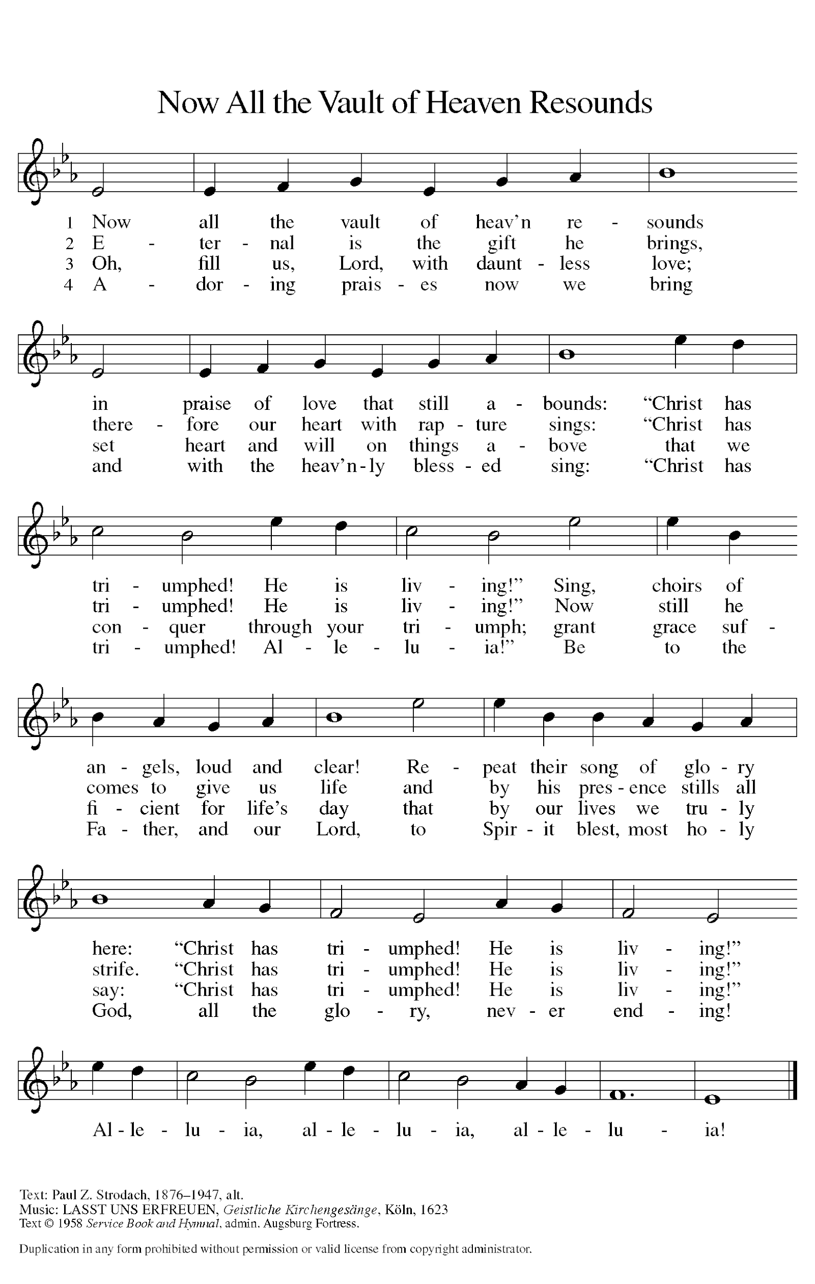

*Prayer of the Day
O God of life, you reach out to us amid our fears with the wounded hands of your risen Son. By your Spirit’s breath revive our faith in your mercy, and strengthen us to be the body of your Son, Jesus Christ, our Savior and Lord, who lives and reigns with you and the Holy Spirit, one God, now and forever. Amen. Be seated.

Word
God speaks to us in scripture reading.
First Lesson Acts 5:27-32
Peter has been arrested for proclaiming the good news of Jesus’ death and resurrection. His response to the charges of the high priest summarizes the early church’s proclamation of forgiveness of sin through repentance.

²⁷When they had brought [the apostles,] they had them stand before the council. The high priest questioned them, ²⁸saying, “We gave you strict orders not to teach in this name, yet here you have filled Jerusalem with your teaching and you are determined to bring this man’s blood on us.” ²⁹But Peter and the apostles answered, “We must obey God rather than any human authority. ³⁰The God of our ancestors raised up Jesus, whom you had killed by hanging him on a tree. ³¹God exalted him at his right hand as Leader and Savior that he might give repentance to Israel and forgiveness of sins. ³²And we are witnesses to these things, and so is the Holy Spirit whom God has given to those who obey him.”

Word of God, Word of Life. Thanks be to God.

Psalm Psalm 118:14-29
¹⁴The Lord is my strength and my song, and has become my salvation.
¹⁵Shouts of rejoicing and salvation echo in the tents of the righteous: “The right hand of the Lord acts valiantly!
¹⁶The right hand of the Lord is exalted! The right hand of the Lord acts valiantly!”
¹⁷I shall not die, but live, and declare the works of the Lord.
¹⁸The Lord indeed punished me sorely, but did not hand me over to death.
¹⁹Open for me the gates of righteousness; I will enter them and give thanks to the Lord.
²⁰“This is the gate of the Lord; here the righteous may enter.”
²¹I give thanks to you, for you have answered me and you have become my salvation.
²²The stone that the builders rejected has become the chief cornerstone.
²³By the Lord has this been done; it is marvelous in our eyes.
²⁴This is the day that the Lord has made; let us rejoice and be glad in it.
²⁵Hosanna! O Lord, save us!

Second Lesson Revelation 1:4-8
The book of Revelation recounts a mystical vision of the risen Christ experienced by a Christian prophet named John. Here he describes Christ as a timeless redeemer, the beginning, present, and end of all time.

⁴John to the seven churches that are in Asia:
Grace to you and peace from him who is and who was and who is to come, and from the seven spirits who are before his throne, ⁵and from Jesus Christ, the faithful witness, the firstborn of the dead, and the ruler of the kings of the earth.
To him who loves us and freed us from our sins by his blood, ⁶and made us to be a kingdom, priests serving his God and Father, to him be glory and dominion forever and ever. Amen.
⁷Look! He is coming with the clouds; every eye will see him,
even those who pierced him;
and on his account all the tribes of the earth will wail.
So it is to be. Amen.
⁸“I am the Alpha and the Omega,” says the Lord God, who is and who was and who is to come, the Almighty.

Word of God, Word of Life. Thanks be to God.

*Please stand as you are able.
*Gospel Acclamation ELW #388 Be Not Afraid

The holy Gospel according to John. Glory to you, O Lord.

*Gospel John 20:19-31
The unprecedented events of the day of resurrection continue as the risen Jesus appears to his fearful disciples. A week later, after Thomas worships Jesus, Jesus pronounces that the blessings of the resurrection are also for those who “have not seen and yet believe.”

¹⁹When it was evening on that day, the first day of the week, and the doors of the house where the disciples had met were locked for fear of the Jews, Jesus came and stood among them and said, “Peace be with you.” ²⁰After he said this, he showed them his hands and his side. Then the disciples rejoiced when they saw the Lord. ²¹Jesus said to them again, “Peace be with you. As the Father has sent me, so I send you.” ²²When he had said this, he breathed on them and said to them, “Receive the Holy Spirit. ²³If you forgive the sins of any, they are forgiven them; if you retain the sins of any, they are retained.”
²⁴But Thomas (who was called the Twin), one of the twelve, was not with them when Jesus came. ²⁵So the other disciples told him, “We have seen the Lord.” But he said to them, “Unless I see the mark of the nails in his hands, and put my finger in the mark of the nails and my hand in his side, I will not believe.”
²⁶A week later his disciples were again in the house, and Thomas was with them. Although the doors were shut, Jesus came and stood among them and said, “Peace be with you.” ²⁷Then he said to Thomas, “Put your finger here and see my hands. Reach out your hand and put it in my side. Do not doubt but believe.” ²⁸Thomas answered him, “My Lord and my God!” ²⁹Jesus said to him, “Have you believed because you have seen me? Blessed are those who have not seen and yet have come to believe.”
³⁰Now Jesus did many other signs in the presence of his disciples, which are not written in this book. ³¹But these are written so that you may come to believe that Jesus is the Messiah, the Son of God, and that through believing you may have life in his name.

The Gospel of the Lord. Praise to you, O Christ.

*Gospel Acclamation ELW #388 Be Not Afraid
Be seated.

Sermon The Rev. Melody Eastman

*Please stand as you are able
*Hymn of the Day ELW #386 O Sons and Daughters, Let Us Sing

St. 4 - All
That night the apostles met in fear;
Among them came their master dear,
And said, “My peace be with you here.”
Alleluia!

St. 5 – Low Voices
When Thomas first the tidings heard
That they had seen the risen Lord,
He doubted the disciples’ word.
Alleluia!

St. 6 – High Voices
“My pierced side, O Thomas, See,
And look upon my hands, my feet;
Not faithless, but believing be.”
Alleluia!

St. 7 – All
No longer Thomas then denied;
He saw the feet, the hands, the side;
You are my Lord and God!” he cried.
Alleluia!

*The Nicene Creed
With the whole church, let us confess our faith.
We believe in one God, the Father, the Almighty, maker of heaven and earth, of all that is, seen and unseen.

We believe in one Lord, Jesus Christ, the only Son of God, eternally begotten of the Father, God from God, Light from Light, true God from true God, begotten, not made, of one Being with the Father; through him all things were made. For us and for our salvation he came down from heaven, was incarnate of the Holy Spirit and the virgin Mary and became truly human. For our sake he was crucified under Pontius Pilate; he suffered death and was buried. On the third day he rose again in accordance with the scriptures; he ascended into heaven and is seated at the right hand of the Father. He will come again in glory to judge the living and the dead, and his kingdom will have no end.

We believe in the Holy Spirit, the Lord, the giver of life, who proceeds from the Father and the Son, who with the Father and the Son is worshiped and glorified, who has spoken through the prophets. We believe in one holy catholic and apostolic church. We acknowledge one baptism for the forgiveness of sins. We look for the resurrection of the dead, and the life of the world to come. Amen.

*Prayers of Intercession
Set free from captivity to sin and death, we pray to the God of resurrection for the church, people in need, and all of creation.
A brief silence.

Holy One who acts righteously, equip your church as witnesses of your goodness to go and tell others of your abundant love, that they may believe that Jesus is our salvation and life. God, in your mercy, hear our prayer.

Renew your people’s commitment to use resources responsibly and to live well with your creation. Invite us to recognize and nurture signs of resurrection life in the natural world. God, in your mercy, hear our prayer.

Direct those who are given human authority to lead with humility and compassion. By your Holy Spirit channel their attention toward serving those who are most in need. God, in your mercy, hear our prayer.

Uphold your children who cry out to you especially Dorothy, Dolores, Norma, Carol, Brittany, and those we name before you now. . . Wherever people are overcome by the fear of death, breathe into them your life and peace. God, in your mercy, hear our prayer.

Inspire those who lead your people in worship and praise, especially the music ministries of this congregation. With joyful motion and sound, send us forth with praise that we cannot keep to ourselves. God, in your mercy, hear our prayer.

Give us the words of your saints who, like Thomas, boldly confessed your Son as Lord and God. With Jesus our leader, empower us to live according to his ways. God, in your mercy, hear our prayer.

In your mercy, O God, respond to these prayers, and renew us by your life-giving Spirit; through Jesus Christ, our Savior.
Amen.

*Peace
The peace of Christ be with you always. And also with you.
Please share the peace with others in your household, or by making a sign of peace to those on Zoom. Please remain standing as you are able.

Meal
God feeds us with the presence of Jesus Christ.
*Offering Prayer
Living God, you gather the wolf and the lamb to feed together in your peaceable reign, and you welcome us all at your table. Reach out to us through this meal, and show us your wounded and risen body, that we may be nourished and believe in Jesus Christ, our Savior and Lord. Amen.

*Great Thanksgiving
The Lord be with you. And also with you.
Lift up your hearts. We lift them to the Lord.
Let us give thanks to the Lord our God. It is right to give our thanks and praise.

*Preface

*Sanctus ELW #367 Now All the Vault of Heaven Resounds
sts. 3, 4

Oh, fill us, Lord, with dauntless love;
Set heart and will on things above
That we conquer
through your triumph;
Grant grace sufficient for life’s day
That by our lives we truly say:
“Christ has triumphed! He is living!”
Alleluia, alleluia, alleluia!

Adoring praises now we bring
And with the heav’nly blessed sing:
“Christ has triumphed! Alleluia!”
Be to the Father, and our Lord,
To Spirit blest, most holy God,
All the glory, never ending!
Alleluia, alleluia, alleluia!

*Thanksgiving at the Table
. . . This cup is the new covenant in my blood, shed for you and for all people for the forgiveness of sin. Do this for the remembrance of me.

Remembering his death, we cry out Amen. Amen.
Celebrating his resurrection, we shout Amen. Amen.
Trusting his presence in every time and place, we plead Amen. Amen.

. . . Grant us such life, the life of the Father to the Son, the life of the Spirit of our risen Savior, life in you, now and forever. Amen

*The Lord’s Prayer
Gathered into one by the Holy Spirit, let us pray as Jesus taught us.
Our Father in heaven, hallowed be your name, your kingdom come, your will be done, on earth as in heaven. Give us today our daily bread. Forgive us our sins as we forgive those who sin against us. Save us from the time of trial and deliver us from evil. For the kingdom, the power, and the glory are yours, now and forever. Amen.

*Invitation to Communion
The risen Christ dwells with us here. All who are hungry, all who are thirsty, come. Be seated.

Agnus Dei ELW #362 At The Lamb’s High Feast We Sing
sts. 1, 2, 4
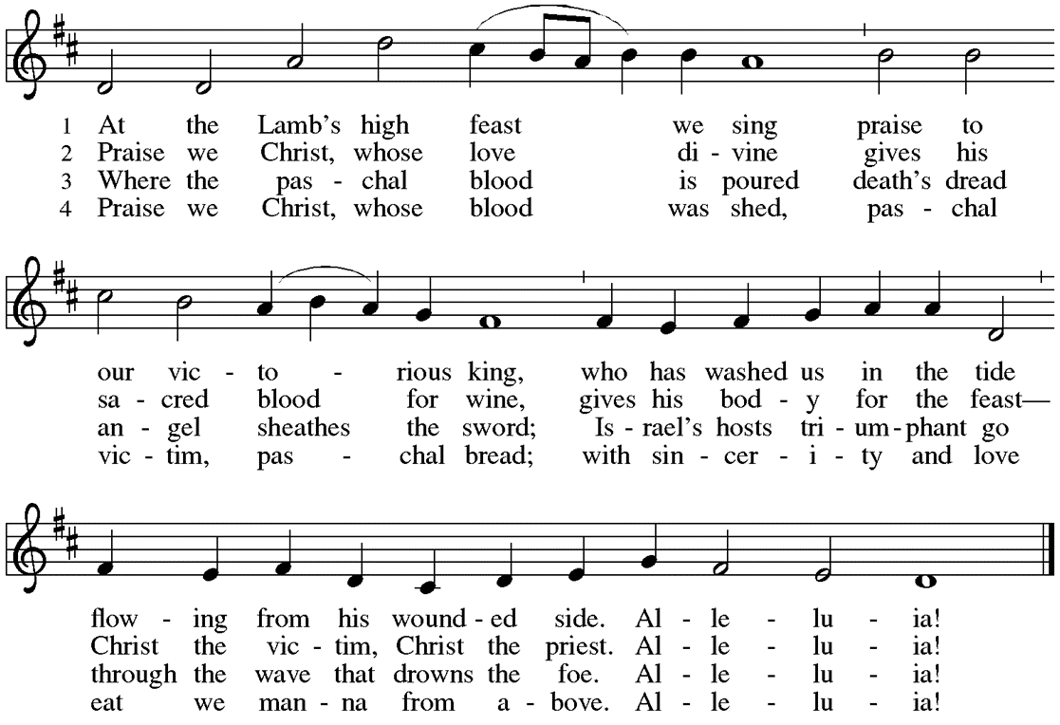
Communion
Those who wish to come to the rail for communion may do so at the ushers’ direction. You may stand or kneel. Please maintain social distancing between households. You may return to your seat by the side aisles after you have received the bread and wine. If you like, you may bring a communion kit with you to receive at the altar.

For those receiving communion in the pew or from home:
This is the body of Christ, given for you. Amen (Eat the bread.)
This is the blood of Christ, shed for you. Amen (Drink the juice.)

*Please stand as you are able.
*Post Communion Blessing
May the body and blood of our Lord Jesus Christ strengthen you and keep you in his grace. Amen.

*Post Communion Prayer
We give you thanks, generous God, for in this bread and cup we have tasted the new heaven and earth
where hunger and thirst are no more. Send us from this table as witnesses to the resurrection, that through our lives, all may know life in Jesus’ name. Amen.
Sending
God blesses us and sends us in mission to the world.
*Blessing
God, the Author of life, Christ, the living Cornerstone, and the life-giving Spirit of adoption, ☩ bless you now and forever. Amen.

*Sending Hymn ELW #390 The Risen Christ
St. 1 – All St. 2 – All St. 3 – Organ St. 4 - All

*Sent to the World
Alleluia! Christ is risen. Christ is risen indeed. Alleluia!
Go in peace. Tell what God has done. Thanks be to God.

Postlude

From Sundays and Seasons v.20190109.1233 Copyright © 2022 Augsburg Fortress. All rights reserved.
Reprinted by permission under Augsburg Fortress Liturgies Annual License #30867.
All rights reserved. Reprinted under OneLicense.net #A-718333.

Assisting in Worship Today
Pastor Rev. Melody Eastman
Minister of Music Bradford Thompson
Ministry Associate Becky Ficarella
Altar Care Linda Kelly
Lector Susan Jacobson
Usher Mario Ficarella, Chuck Miller
Zoom Mark Hamilton, Jon & Cathy Milleville
Fellowship Hour Doris Nelson

Current Prayer Requests
Please keep these people in your prayers and reach out to our sisters and brothers in Christian love. Names will be left on the list for two weeks, unless you indicate that they should remain in our prayers for a longer period.
Name Relationship Prayer For
Norm & Carol Wandke Members 70th Anniversary (4/26)
Dolores Nosal Member Healing & Strength
Brittany Huizenga Cousin of Cheryl Huizenga Healing & Strength
Matthew Barrera Grandson of Doris Nelson Missing since 12/25
Dorothy Tracy Member Healing & Strength
Norma Petersen Member Healing & Strength
Prayers for our homebound Members
Dolores Nosal, Carol Petersen

First Church of Christ, Scientist: Due to declining membership and property issues at their church building on the corner of Main Street and Hawthorne Boulevard in Glen Ellyn, they found it necessary to sell their church building as they were unable to afford the needed repairs. They approached Grace about sharing our worship space with them and we found that we are able to slide them in between our worship service at 9am and Falam’s worship service at 1pm so beginning today, April 24, First Church of Christ, Scientist will use our Sanctuary at 11am on Sunday and also on Wednesday evening in the Sanctuary or Great Room. First Church of Christ, Scientist is aware that in the future Grace may make a decision to move to a later worship time at which time they would need to move their service to an earlier time or find another location for their service. Please introduce yourself as we welcome them to Grace.

CROP Hunger Walk: Sunday, May 1 at Faith Lutheran Church. 1pm Registration, 2pm Walk Off. Sign up to walk or donate to Team Grace at https://events.crophungerwalk.org/2022/team/grace-lutheran-glen-ellyn-il

FaithTalk! Thursday, May 5, 12:30-2:00pm: Did you know there are two version of the Creation story in the Bible? One appears in Genesis 1, and the other (which is probably older) appears in Genesis 2. There are a lot of similarities, but also a lot of differences. Why are they different? And why are they both in there anyway?
In May, Pastor Melody will lead us in a comparison of the two versions and talk about the differences and meanings of each. (Spoiler: they’re both true but neither is particularly accurate.) Curious? Join us in the downstairs Kitchen Room.
FaithTalk is an informal, open, spirited conversation for people with questions and a desire to dig deeper into faith, the world, God, and all matters spiritual. We love new ideas and working through tough issues, and we love one another even though we think about things differently.
It’s not a closed group - you are welcome to join us at any time. We meet on the 1st Thursday of the month in the basement kitchen/group room (formerly called the Youth room). Discussion runs from 12:30-200p. If you have attended one of the Senior Center classes that ends at noon, you are welcome to bring a brown bag and eat your lunch before our “official conversation starts.

Crisis in Ukraine: Your gift through Lutheran World Relief will be matched up to $422,000! Learn more at LWR.org/congregations. Donate online at LWR.org/match. Gifts can also be mailed to Lutheran world Relief, PO Box 17061, Baltimore, MD 21297-1061. Please write “Ukraine Match” in the memo line. The deadline for the match is April 25.

Fellowship Hour: Please join us for coffee and fellowship following Sunday’s worship service. We are looking for additional volunteers to host the coffee hour. Please contact Becky Ficarella or the church office if you are interested.

Adult and Bell Choirs: The choirs meet on Wednesdays at 7:00pm. Contact Bradford Thompson if you would like to share your voice or bell ringing skills with Grace. bradfordmthompson@gmail.com

Quilting Ministry: The quilters meet on the second and fourth Tuesday of every month from 9-10am.

Community Vacation Bible School: Registration is now open for volunteers and participants. Grace Lutheran Church, Faith Lutheran Church, and First Congregational Church Glen Ellyn are presenting this week together in partnership “Compassion Camp - Changing the World with Loving Kindness!” Monday – Friday, June 20-24, 9:00am-12:00pm at Faith Lutheran Church. 41 N. Park Blvd., Glen Ellyn. Register on Grace’s website!

Worship Assistants: With the return to communion at the rail, we are in need of people willing to serve as cross-bearer and communion assistant along with two ushers for each week. If you are able to help with carrying the cross and/or assisting with communion, please contact Susan Jacobson or the church office. Thank you!

Ushers Still Needed: If you are able, please help us meet the need for at least two ushers during the worship service each Sunday—one to monitor needs in the sanctuary and one to stand at the entrance to the sanctuary and monitor the narthex and entrances to the bathrooms. We have occasionally had people we don’t know enter the building and remain for some time, and while we welcome everyone, we also want to be able to make sure everyone in the building is secure. Two ushers help us appropriately monitor both needs in the sanctuary and in the narthex and bathrooms.
Please contact the church office and Barbara can add you to the schedule. Thank you.
Sr. Center Chair Exercise Classes: The exercise class meets Mondays at 10:00am, Tuesdays at 10:00am, and Thursdays at 11:00am. Registration is required as the number of attendees will be limited. Please contact Sue Davison at 630-858-6343 to register.

Freedom Songs of the Civil Rights Movement in Concert at Glen Ellyn History Center on Fri. April 29 – 7:00pm:
The Glen Ellyn Historical Society presents a Concert of Songs of the Civil Rights Movement in the Glen Ellyn History Center, 800 N. Main Street. The program is celebrating the 50th anniversary of the Civil Rights Movement and features award winning folksinger Chris Vallillo, performing pivotal songs from the music that inspired and sustained this landmark movement. A combination of music and Vallillo's firsthand account of the historic struggle reflects the impact of music to our nation's most important social cause. Songs became the backbone of the nonviolent civil disobedience movement led by Dr. King and others. This is a FREE program that is partially supported by a grant from the Illinois Arts Council Agency. Refreshments are served. Call 630-469-1867 and check the website at www.gehs.org for more details.

Every Member a Minister and Missionary!

Phone: 630-469-1555 Emergency Pastoral Contact: 630-674-2887
info@graceglenellyn.org www.graceglenellyn.org

Pastor
Rev. Melody Eastman office ext. 14
meastman@graceglenellyn.org

Minister of Music
Bradford Thompson 219-718-8879
bradfordmthompson@gmail.com

Ministry Associate
Becky Ficarella office ext. 17
bficarella@graceglenellyn.org

Office Manager
Barbara Sudds office ext. 10
bsudds@graceglenellyn.org

Parish Counselor
Carole LoGalbo M.S., LCPC 630-668-4594
carolelogalbo@yahoo.com

