Grace Lutheran Church

493 Forest Avenue, Glen Ellyn IL 630.469.1555
www.graceglenellyn.org

Fourth Sunday of Easter April 30, 2023

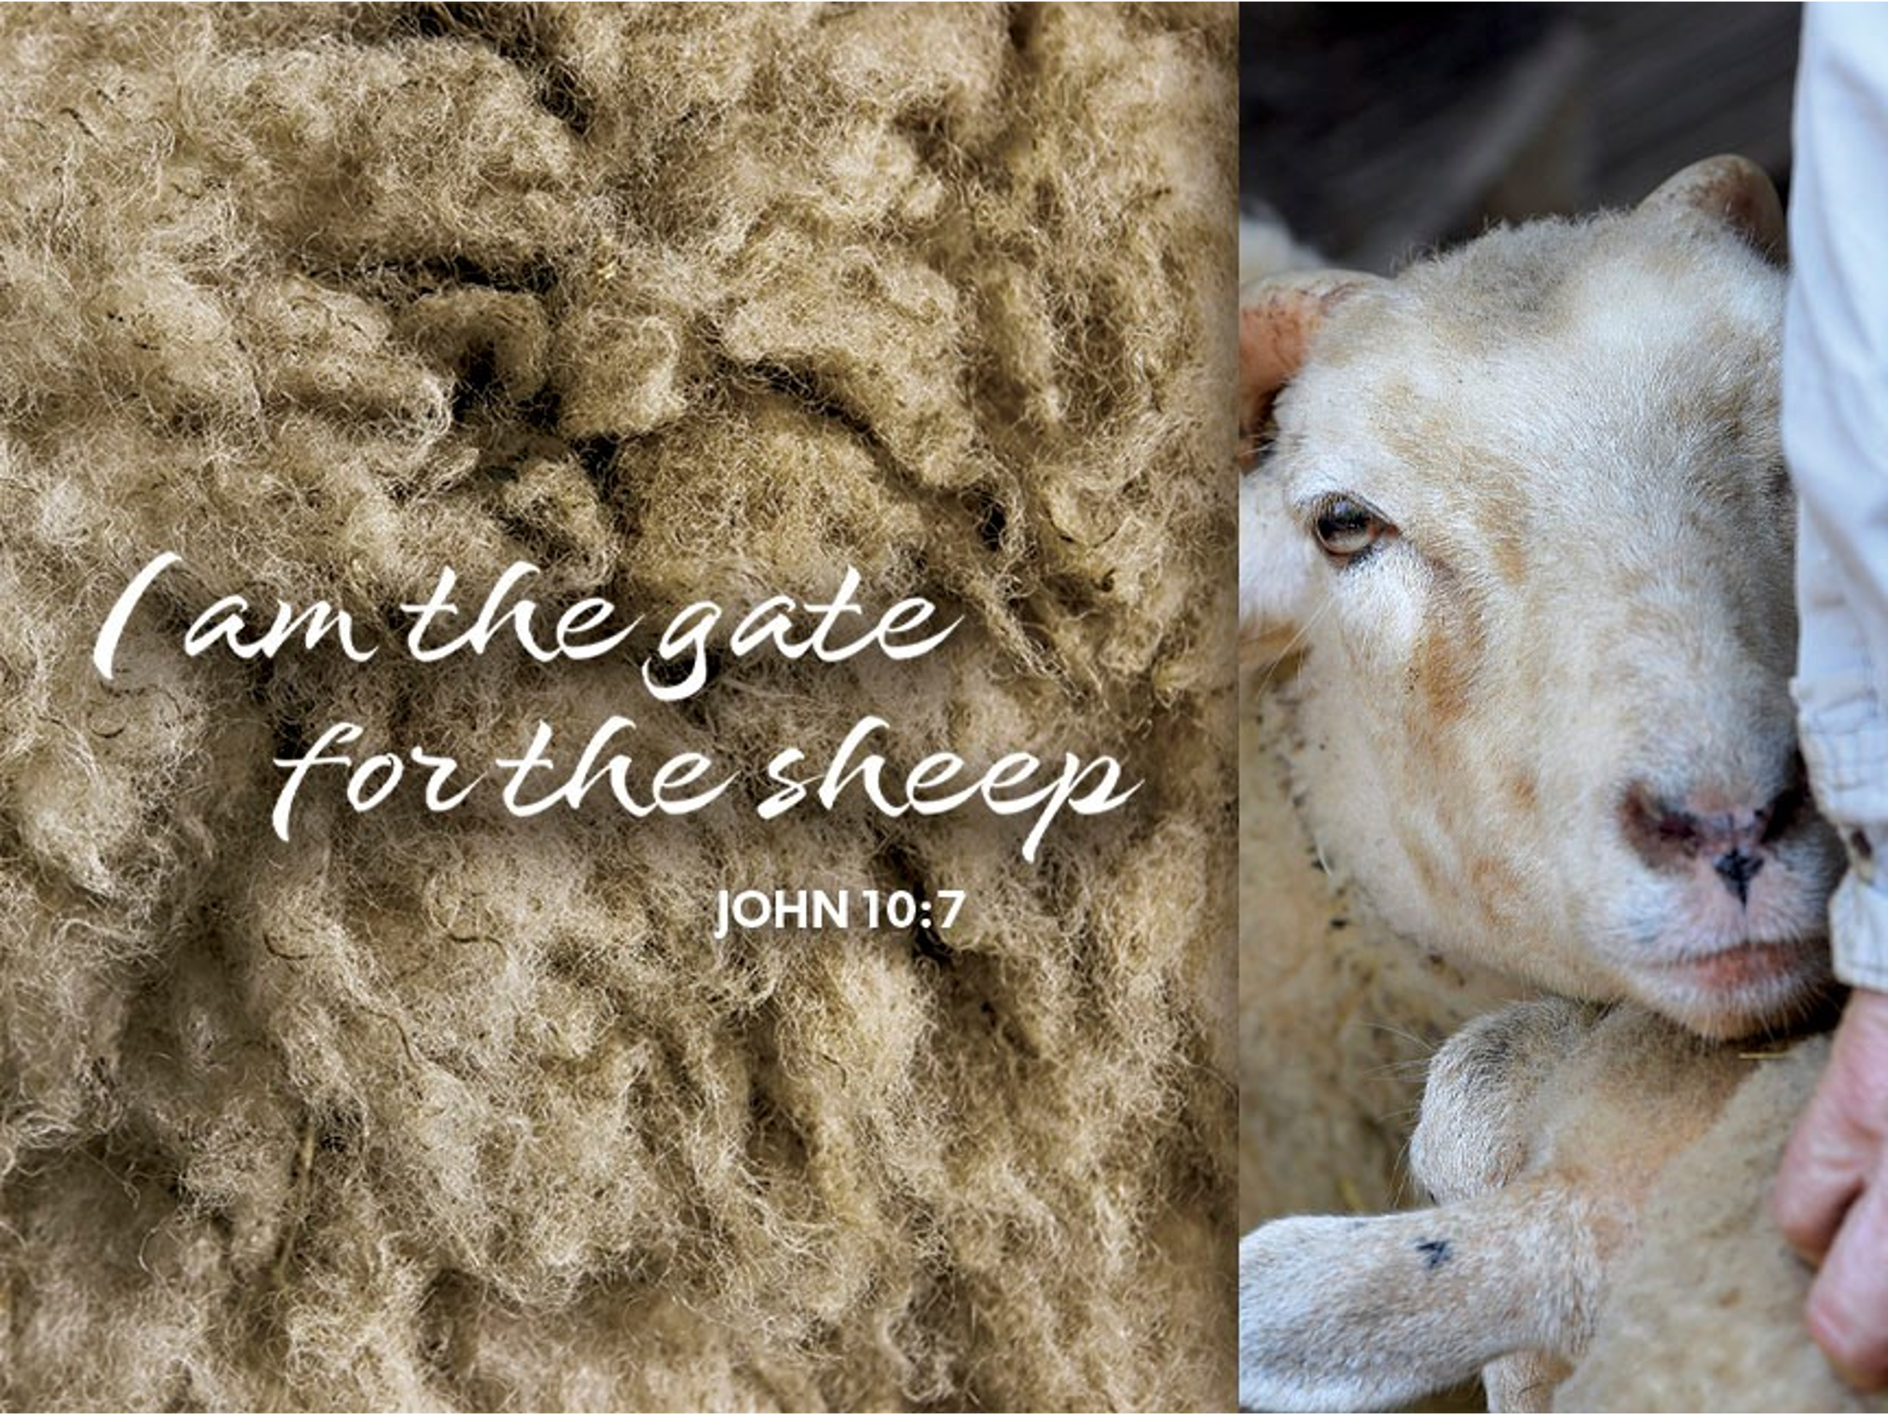

+ Proclaim Christ + Build Community +
+ Serve Our Neighbors +

Introduction
Today is sometimes called “Good Shepherd Sunday.” Jesus is called the “gate” of the sheep in today’s gospel. The risen Christ opens the way to abundant life. He anoints our heads with oil and guides us beside the still waters of our baptism. Each Sunday he spreads a feast before us amid the world’s violence and war. We go forth to be signs of the resurrection and extend God’s tender care to all creation.

An asterisk (*) indicates that you should stand for that portion of the service. If standing is difficult, please remain seated. The Congregation responses are in bold print.

Gathering
The Holy Spirit calls us together as the people of God.
Welcome/Announcements

Prelude

*Please stand as you are able.
*Thanksgiving for Baptism
All may make the sign of the cross, the sign that is marked at baptism, as the presiding minister begins.
Blessed be the holy Trinity, ☩ one God, by whose hand we are given new birth, by whose speaking we are given new life. Amen.

Joined to Christ in the waters of baptism, we are welcomed, restored, and supported as citizens of the new creation. Let us give thanks for the gift of baptism. Holy God, holy and merciful, holy and mighty, you are the river of life, you are the everlasting wellspring. In mercy and might you have freed us from death and raised us with Jesus, the firstborn of the dead. In baptismal waters our old life is washed away, and in them we are born anew.
Water may be poured into the font as the presiding minister continues.

Glory to you for oceans and lakes, for rivers and streams. Honor to you for waters that wash us clean, quench our thirst, and nurture both crops and creatures. Praise to you for the life-giving water of baptism, the outpouring of the Spirit of the new creation.

Wash away our sin and all that separates us from you. Empower our witness to your resurrection. Strengthen our resolve in seeking justice for all.

Satisfy the world’s need through this living water. Where drought dries the earth, bring refreshment. Where despair prevails, grant hope. Where chaos reigns, bring peace. We ask this through Christ, who with you and the Spirit reigns forever. Amen.

*Entrance Hymn God Welcomes All
God welcomes all, strangers and friends;
God’s love is strong and it never ends. (repeat)
*Greeting
The grace of our Lord Jesus Christ, the love of God, and the communion of the Holy Spirit be with you all. And also with you.

*Hymn of Praise ELW #362 At the Lamb’s High Feast We Sing
sts. 1,5

*Prayer of the Day
O God our shepherd, you know your sheep by name and lead us to safety through the valleys of death. Guide us by your voice, that we may walk in certainty and security to the joyous feast prepared in your house, through Jesus Christ, our Savior and Lord, who lives and reigns with you and the Holy Spirit, one God, now and forever. Amen. Be seated.
Word
God speaks to us in scripture reading.
First Lesson Acts 2:42-47
Today’s reading is a description of life in the community following Peter’s sermon on the day of Pentecost, when the Spirit was poured out on God’s people. The new community is sustained in worship and fellowship, shares what they have, and ensures that everyone has enough.

⁴²[The baptized] devoted themselves to the apostles’ teaching and fellowship, to the breaking of bread and the prayers. ⁴³Awe came upon everyone, because many wonders and signs were being done by the apostles. ⁴⁴All who believed were together and had all things in common; ⁴⁵they would sell their possessions and goods and distribute the proceeds to all, as any had need. ⁴⁶Day by day, as they spent much time together in the temple, they broke bread at home and ate their food with glad and generous hearts, ⁴⁷praising God and having the goodwill of all the people. And day by day the Lord added to their number those who were being saved.

Word of God, Word of Life. Thanks be to God.
Second Lesson 1 Peter 2:19-25
Doing the right things does not guarantee that one will not experience difficulties, hardships, rejection, or even suffering. Here Christ is presented as the model for our path of endurance and loyalty to God, particularly amid adversity.

¹⁹It is a credit to you if, being aware of God, you endure pain while suffering unjustly. ²⁰If you endure when you are beaten for doing wrong, what credit is that? But if you endure when you do right and suffer for it, you have God’s approval. ²¹For to this you have been called, because Christ also suffered for you, leaving you an example, so that you should follow in his steps.
²²“He committed no sin, and no deceit was found in his mouth.”
²³When he was abused, he did not return abuse; when he suffered, he did not threaten; but he entrusted himself to the one who judges justly. ²⁴He himself bore our sins in his body on the cross, so that, free from sins, we might live for righteousness; by his wounds you have been healed. ²⁵For you were going astray like sheep, but now you have returned to the shepherd and guardian of your souls.

Word of God, Word of Life. Thanks be to God.

*Please stand as you are able.
*Gospel Acclamation
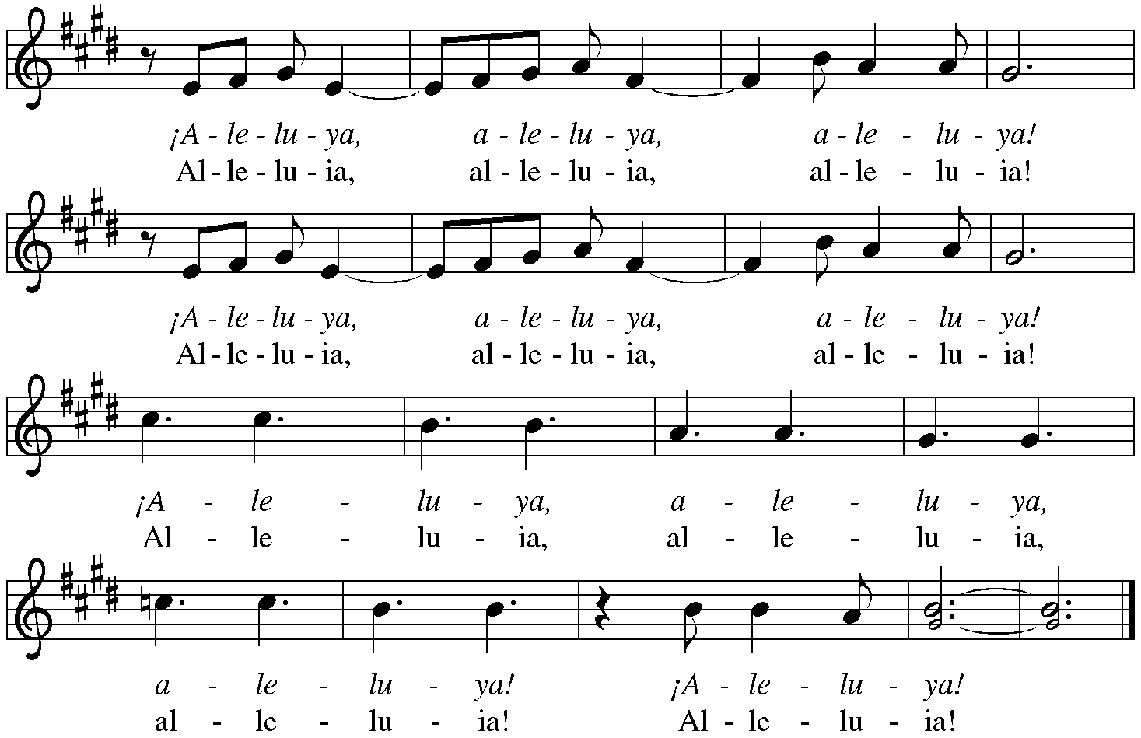

The holy Gospel according to John. Glory to you, O Lord.

*Gospel John 10:1-10
Jesus uses an image familiar to the people of his day to make a point about spiritual leadership. Those who listen to Jesus are led to abundant life.

[Jesus said:] ¹“Very truly, I tell you, anyone who does not enter the sheepfold by the gate but climbs in by another way is a thief and a bandit. ²The one who enters by the gate is the shepherd of the sheep. ³The gatekeeper opens the gate for him, and the sheep hear his voice. He calls his own sheep by name and leads them out. ⁴When he has brought out all his own, he goes ahead of them, and the sheep follow him because they know his voice. ⁵They will not follow a stranger, but they will run from him because they do not know the voice of strangers.” ⁶Jesus used this figure of speech with them, but they did not understand what he was saying to them.
⁷So again Jesus said to them, “Very truly, I tell you, I am the gate for the sheep. ⁸All who came before me are thieves and bandits; but the sheep did not listen to them. ⁹I am the gate. Whoever enters by me will be saved, and will come in and go out and find pasture. ¹⁰The thief comes only to steal and kill and destroy. I came that they may have life, and have it abundantly.”

The Gospel of the Lord. Praise to you, O Christ. Be seated.

Children’s Presentation

*Please stand as you are able.
*Hymn of the Day ELW #780 Shepherd Me, O God
sts. 1,2,3,5

*Please stand as you are able
*Prayers of Intercession
Each petition concludes with Hear us, O God. The congregation responds, “Your mercy is great.”

*Peace
The peace of Christ be with you always. And also with you.
Please share the peace with others in your household, or by making a sign of peace to those on Zoom. You may then be seated as the table is prepared.

Gathering of Gifts
We gather gifts for those in need and for the church’s mission.

Music During Offering

*Please stand as you are able. The gifts are brought forward while the congregation sings:

*Offertory ELW #531 The Trumpets Sound, the Angels Sing
st. 1
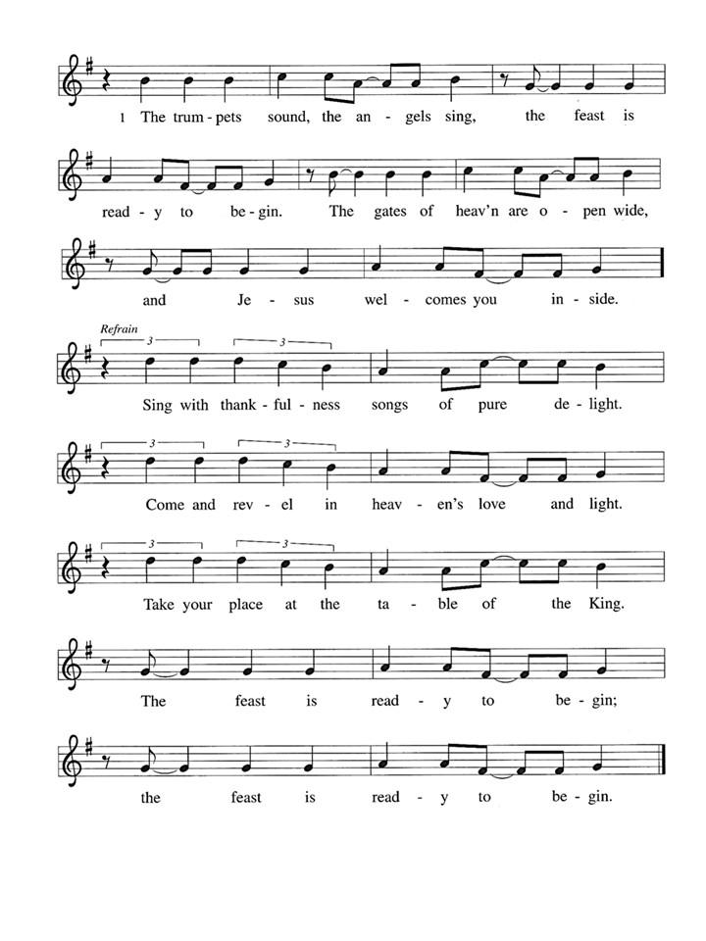

Meal
God feeds us with the presence of Jesus Christ.
*Offering Prayer
Generous God, in this meal you offer your very self. We give thanks for these gifts of the earth. In the breaking of this bread reveal to us the Risen One. In the pouring of this wine pour us out in service to the world; through Christ our Lord. Amen.

*Great Thanksgiving
The Lord be with you. And also with you.
Lift up your hearts. We lift them to the Lord.
Let us give thanks to the Lord our God. It is right to give our thanks and praise.

*Preface

Sanctus p. 181 Holy, Holy, Holy

*Thanksgiving at the Table
. . . For as often as we eat of this bread and drink from this cup, we proclaim the Lord’s death until he comes.
Christ has died. Christ is risen. Christ will come again.

Remembering, therefore, his salutary command, his life-giving passion and death, his glorious resurrection and ascension, and the promise of his coming again, we give thanks to you, O Lord God Almighty, not as we ought but as we are able; we ask you mercifully to accept our praise and thanksgiving and with your Word and Holy Spirit to bless us, your servants, and these your own gifts of bread and wine, so that we and all who share in the body and blood of Christ may be filled with heavenly blessing and grace, and, receiving the forgiveness of sin, may be formed to live as your holy people and be given our inheritance with all your saints.

To you, O God, Father, Son, and Holy Spirit, be all honor and glory in your holy church, now and forever. Amen.

*The Lord’s Prayer Ecumenical Version
Gathered into one by the Holy Spirit, let us pray as Jesus taught us.
Our Father in heaven, hallowed be your name, your kingdom come, your will be done, on earth as in heaven. Give us today our daily bread. Forgive us our sins as we forgive those who sin against us. Save us from the time of trial and deliver us from evil. For the kingdom, the power and the glory are yours, now and forever. Amen.

*Invitation to Communion
Come and know Christ, broken and poured out for you. Be seated.
Communion
Those who wish to come to the rail for communion may do so at the ushers’ direction. You may stand or kneel. You may return to your seat by the side aisles after you have received the bread and wine.

For those receiving communion in the pew or from home:
This is the body of Christ, given for you. Amen (Eat the bread.)
This is the blood of Christ, shed for you. Amen (Drink the juice.)

Agnus Dei p. 182 Lamb of God
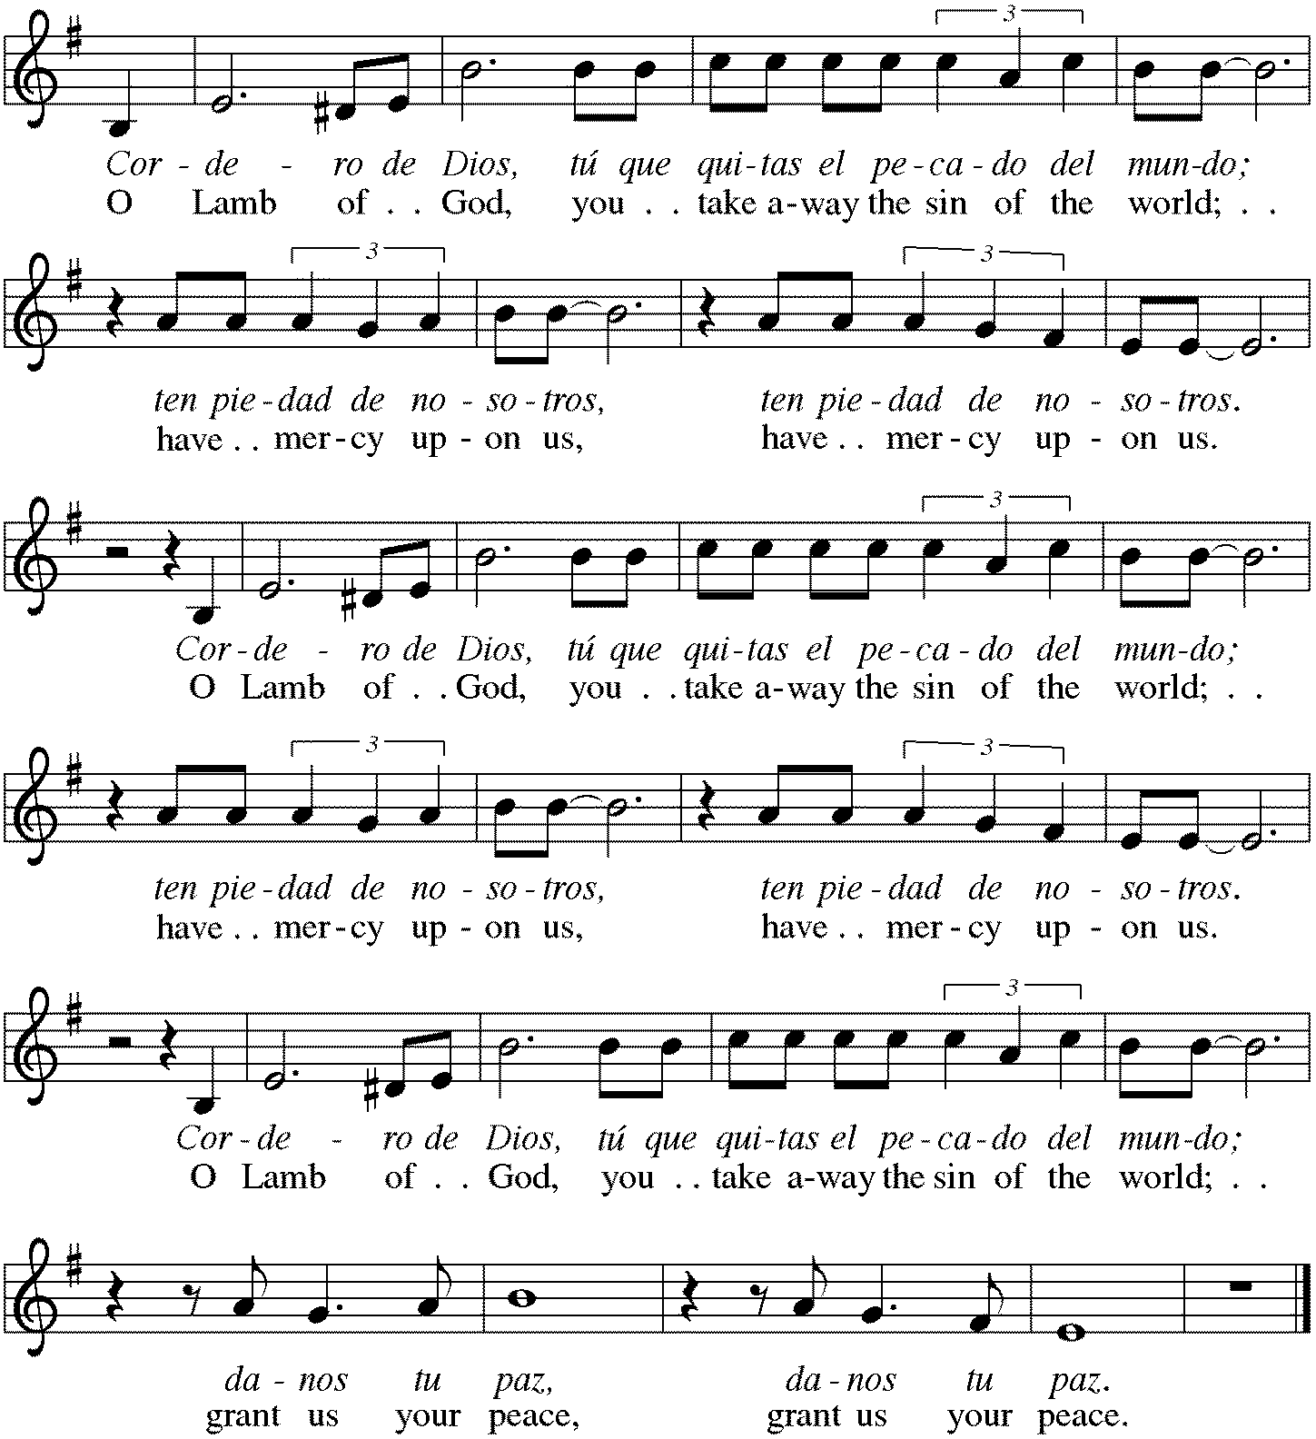
Music During Communion ELW #502 The King of Love My Shepherd Is
sts. 1,3,4
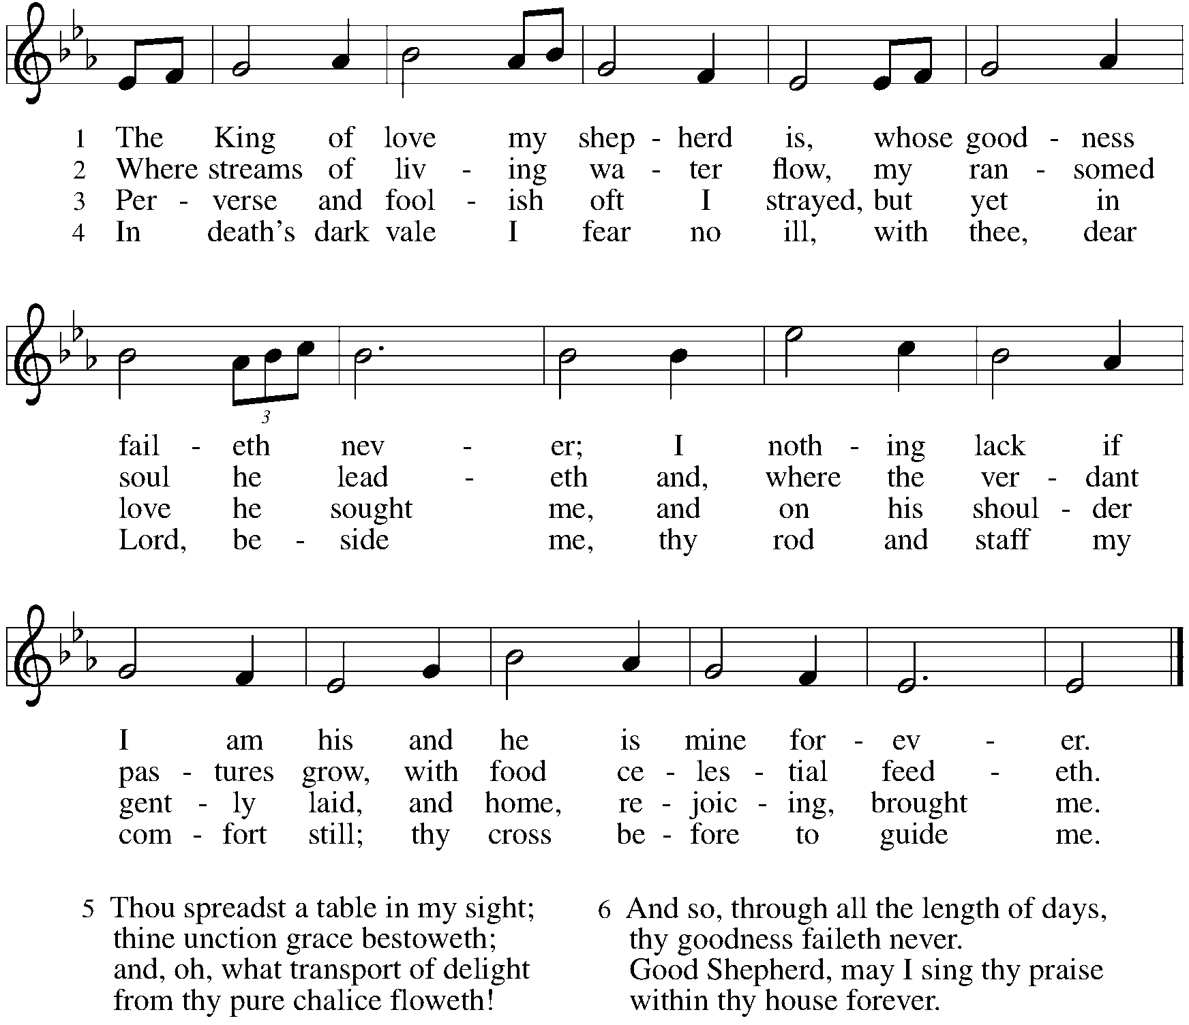

*Please stand as you are able.
*Post Communion Blessing
May the body and blood of our Lord Jesus Christ strengthen you and keep you in his grace. Amen.

*Post Communion Prayer
Gracious God, in you we live and move and have our being. With your word and this meal of grace, you have nourished our life together. Strengthen us to show your love and serve the world in Jesus’ name. Amen.
Sending
God blesses us and sends us in mission to the world.
*Blessing
The God of all, who raised ☩ Jesus from the dead, bless us by the power of the Holy Spirit to live in the new creation. Amen.

*Sending Hymn ELW #361 The Day of Resurrection!
sts. 1,3
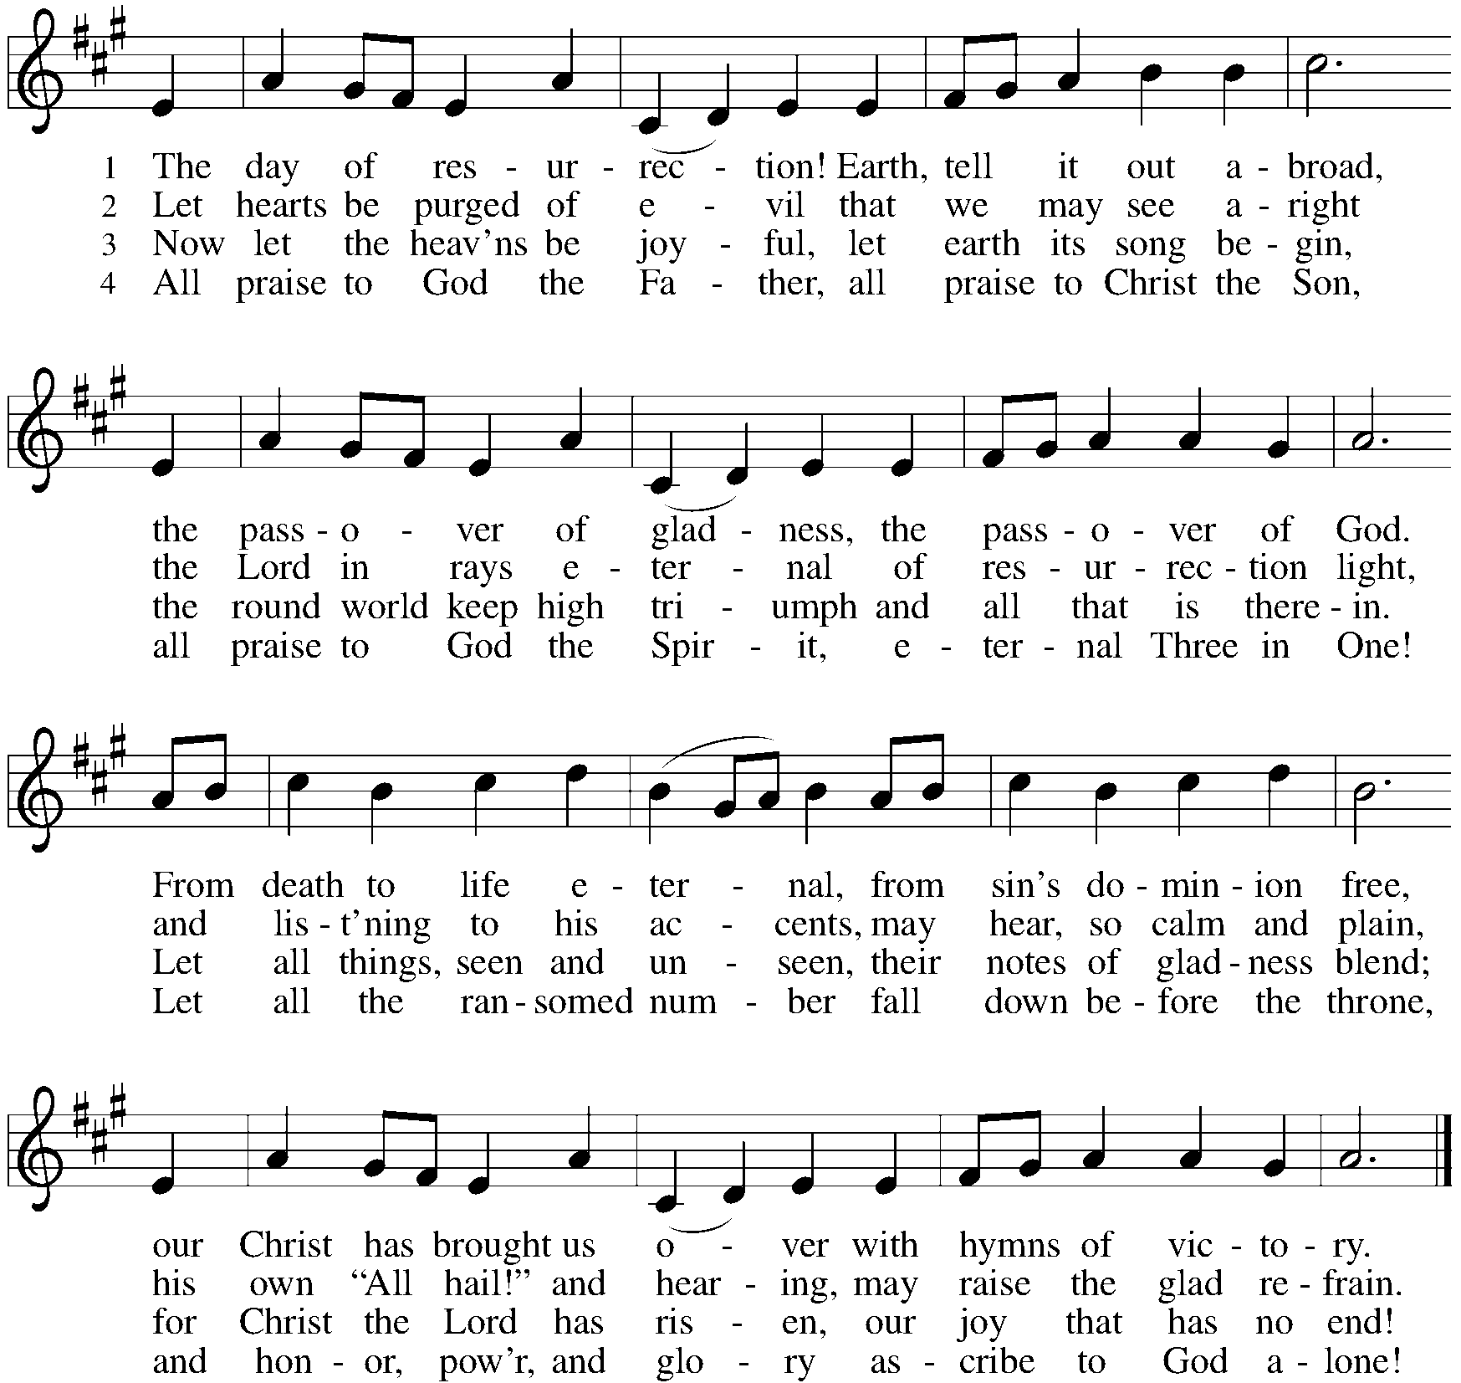

*Sent to the World
Go in peace. Serve the Risen One. Thanks be to God.

Postlude
Our thanks to the Children’s Ministry for bringing us the Word this morning!

From Sundays and Seasons v.20190109.1233 Copyright © 2023 Augsburg Fortress. All rights reserved.
Reprinted by permission under Augsburg Fortress Liturgies Annual License #30867.
All rights reserved. Reprinted under OneLicense.net #A-718333.
Assisting in Worship Today
Worship Leader Rev. Melody Eastman
Minister of Music Bradford Thompson
Altar Care Sue Davison, Cathy Milleville
Crucifer Evelyn Dieter
Lector Elizabeth Dieter
Ushers Mark Drager
Zoom Mark Hamilton, Jon & Cathy Milleville
Fellowship Hour Michele Fenske

Current Prayer Requests
Please keep these people in your prayers and reach out to our sisters and brothers in Christian love. Names will be left on the list for two weeks, unless you indicate that they should remain in our prayers for a longer period.
Name Relationship Prayer For
Greg Barber Member Healing & Strength
Rich Davison Member Healing & Strength
Marilyn Goodrich Member 95th Birthday 5/5
Norm & Carol Wandke Members 71st Anniversary 4/26
Charlie Creager Son of Sara & Chuck Creager Born April 10
Ryker Spreenberg Gr. Niece of Barbara Sudds Born April 13
Kathy Meyer Mother of Susi Nelson Healing & Strength
Luke Pajowski Relative of the Roetes Healing & Strength
Lori Garabrandt Niece of Lois Pertle Healing & Strength
Brittany Huizenga Cousin of Cheryl Huizenga Healing & Strength
Prayers for our homebound Members
Norma Peterson, Dorothy Tracy

Weekly Announcements
Today - Let's Talk About Race: The sharing circle on racial healing will be meeting after worship today, April 30. We meet to explore the ways in which experiences of race and racial disparities are affecting our lives and our community. The format of the sharing circle is based on a mutual agreement to create a safe space for all who choose to participate and to practice deep listening as we talk about difficult topics. We will be meeting in the Great Room and all are welcome to join.

FaithTalk: Join us from 12:30-2:00 on Thursday, May 4. Did you know there are many different types of prayer in the Christian tradition, and many ways to pray? We continue our exploration of prayer by looking at different ways of prayer in Christianity and other traditions. Along with the spiritual strength we draw from prayer, the practice of prayer is also connected with several benefits to both physical and emotional well-being. Regardless of your own experience with prayer, you might find something new that clicks with you!! FaithTalk meets on the lower level.

CROP Walk: This interfaith mission to reduce hunger and poverty has not changed and, in fact, the need for local and global food supply is even more imperative - so let’s get engaged and do everything we can to raise funds to fight hunger!! We will start our Crop Walk outside Gary Memorial Methodist Church, 224 N. Main Street in Wheaton and take a walk together.
1) Let’s Walk: Sunday, May 7 at 1pm for registration with a 2pm walk off.
Action: Sign-up on this website so we can see everyone who will be walking!! Or contact me, Mike Pertle, and I can sign you up!! Even family and friends in other cities and states can participate!!
2) Donate: Please continue to encourage people to donate to this cause. This web page enables online contributions and we welcome donations now through May!!
Action: Send this link to family and friends anywhere in the U.S. who want to help support our local and global food supplies!! If you sign up to walk, they can donate directly to Church World Service or to Grace Lutheran Church in Glen Ellyn. Any amount is appreciated!! To donate, sign up to walk on the website and it is up and running now!! Make Checks payable to CWS/Crop.
https://events.crophungerwalk.org/2023/team/grace-lutheran-glen-ellyn-il

Follow us on facebook at https://www.facebook.com/Glen-EllynWheaton-CROP-Hunger- Walk-384858704862610/

What's important is that we remain purposeful to this cause so mark your calendars for Sunday, May 7th and participate any way you can!
Thank you. Mike Pertle mike.pertle@gmail.com, 630-488-0880

Children’s Ministry Coordinator Position: Grace is seeking someone to fill the position of Children’s Ministry Coordinator—a somewhat pared down position previously held by Becky Ficarella. This position will focus on faith formation and events for our kids in Sunday School, and will involve working with teachers and parents, organizing curriculum and materials, working with VBS, and coordinating with the pastor on Confirmation ministry. The position will require roughly 10-12 hours per week on a flexible schedule. If you are interested, please contact Pastor Melody.

Grace Arts and Apps: Calling all artists of all ages and those with art they would like to share. The Social Committee is hosting an Arts and Apps event on Sunday June 4 after worship in the narthex. We will exhibit artwork of Grace's members for the congregation to see while enjoying some light refreshments in the form of appetizers. Do you have some art that you have made as a hobby or profession? Do you own some artwork you would like to bring and show that day? There will be a sign-up in the narthex so we know how many tables to set up. And, if you don't have any art to share, perhaps you would like to make an appetizer to share.

Giving DuPage Days May 1-5: A 5-day online fundraiser to support your favorite charity. There are 98 charities with descriptions of their work listed on this website looking for your generosity. www.givingdupageday.org/organizations

An Unfinished Journey: African American Music in its Pivotal Decades: Glen Ellyn History Center at 800 N. Main St., Saturday, April 29 at 2pm. Clarence Goodman, a professional musician and speaker, will present a multimedia program, a musical concert, and an electronic slideshow with narrative, about critical songs in critical decades of African American experience. This promises to be a moving and educational program/concert. Please join us! Refreshments served. Admission $5

PADS: For May 2, we're looking for meals - fresh cooked hot or cold that can be put in the containers that we already have. For example: A pan of homemade Chili.

We also need Frozen dinners or Shelf stable foods and fruit like oranges, apples and bananas. Dessert items are also welcome. Please remember that a third of our guests are children when making food selections.

Of course, all food donations are appreciated. If anyone has contacts with restaurants or stores who would like to help, please let us know.

Please leave donated food for PADS (1st Tuesday of the month) upstairs in the Church Kitchen via the gym. - Food from the Church is picked up about 2:00pm on Tuesday. Or, it can be dropped off here at our house - we usually leave for the site around 4:15pm. (1N346 Prairie Ave, GE - last house on the left - 630-790-1612)

If you'd like a closer look at what we do and who we serve, please join us at the IHC (Interim Housing Center) - previously a red roof inn - on the south side of Butterfield just west of Highland Ave between 5 and 5:30pm - east side of building room 106. We are always looking for volunteers to help us distribute the food.

A group does come over the Sunday before PADS day at around 1pm to help prepare food. So if you have any food that needs to be separated or packed in individual bags or containers. If possible please bring that food prior to 1pm on Sunday.

Thank you for your support and helping members in our community. Thank you so much for all your support! Joe and Donna Jacobo

A Kentucky Derby Celebration, featuring Leslie Goddard: Glen Ellyn History Center at 800 N. Main St., Saturday, May 6 at 2pm. Get in the mood for the evening's running of the Derby by joining us for a special afternoon celebration. Leslie Goddard will offer a presentation on Kentucky Derby History and Traditions. Adults $10, GEHS Members $8, Students 18 and under $5. Refreshments, program at 2 p.m.

People of Grace: Please join the People of Grace for dinner and fun conversation on Tuesday, May 16. The group meets monthly on the third Tuesday at 7pm. The location will vary each month to keep it fresh. Please contact Jeff Nelson at jeff.nelson@vlses.com if you are interested in attending.

Every Member a Minister and Missionary!

Phone: 630-469-1555 Emergency Pastoral Contact: 630-674-2887
info@graceglenellyn.org www.graceglenellyn.org

Pastor
Rev. Melody Eastman office ext. 14
meastman@graceglenellyn.org

Minister of Music
Bradford Thompson 219-718-8879
bradfordmthompson@gmail.com

Office Manager
Barbara Sudds office ext. 10
bsudds@graceglenellyn.org

Parish Counselor
Carole LoGalbo M.S., LCPC 630-668-4594
carolelogalbo@yahoo.com

