Grace Lutheran Church

493 Forest Avenue, Glen Ellyn IL 630.469.1555
www.graceglenellyn.org

Fifth Sunday of Easter May 2, 2021

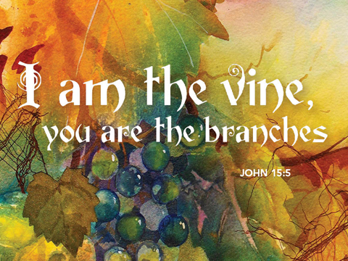

+ Proclaim Christ + Build Community +
+ Serve Our Neighbors +

Introduction
This Sunday’s image of how the risen Christ shares his life with us is the image of the vine. Christ the vine and we the branches are alive in each other, in the mystery of mutual abiding described in the gospel and the first letter of John. Baptism makes us a part of Christ’s living and life-giving self and makes us alive with Christ’s life. As the vine brings food to the branches, Christ feeds us at his table. We are sent out to bear fruit for the life of the world.

Gathering
The Holy Spirit calls us together as the people of God.
Welcome/Announcements

Helpful Reminders for House Church:
- Mute your mic during hymns.
- You may unmute for all group responses. Remember that your host can mute you but cannot unmute you; you must unmute your mic yourself.
- If you are joining by phone, move the mouthpiece away from your mouth unless you are speaking, to avoid broadcasting your breathing.
- Avoid background conversations when your mic is unmuted.
- Congregation responses are in Bold (black).
- THANK YOU FOR WORSHIPPING WITH US!

Prelude (Please mute your mic for the prelude.)

Thanksgiving for Baptism (You may unmute your mic.)
All may make the sign of the cross, the sign marked at baptism, as the presiding minister begins.
Alleluia! Christ is risen. Christ is risen indeed. Alleluia!
Refreshed by the resurrection life we share in Christ, let us give thanks for the gift of baptism.

Water may be poured as the leader gives thanks.

We thank you, risen Christ, for these waters where you make us new, leading us from death to life, from tears to joy. We bless you, risen Christ, that your Spirit comes to us in the grace-filled waters of rebirth, like rains to our thirsting earth, like streams that revive our souls, like cups of cool water shared with strangers. Breathe your peace on your church when we hide in fear. Clothe us with your mercy and forgiveness. Send us companions on our journey as we share your life. Make us one, risen Christ. Cleanse our hearts. Shower us with life. To you be given all praise, with the Holy Spirit, in the glory of God, now and forever. Amen.

Entrance Hymn (Mute your mic) ELW #821 Shout to the Lord
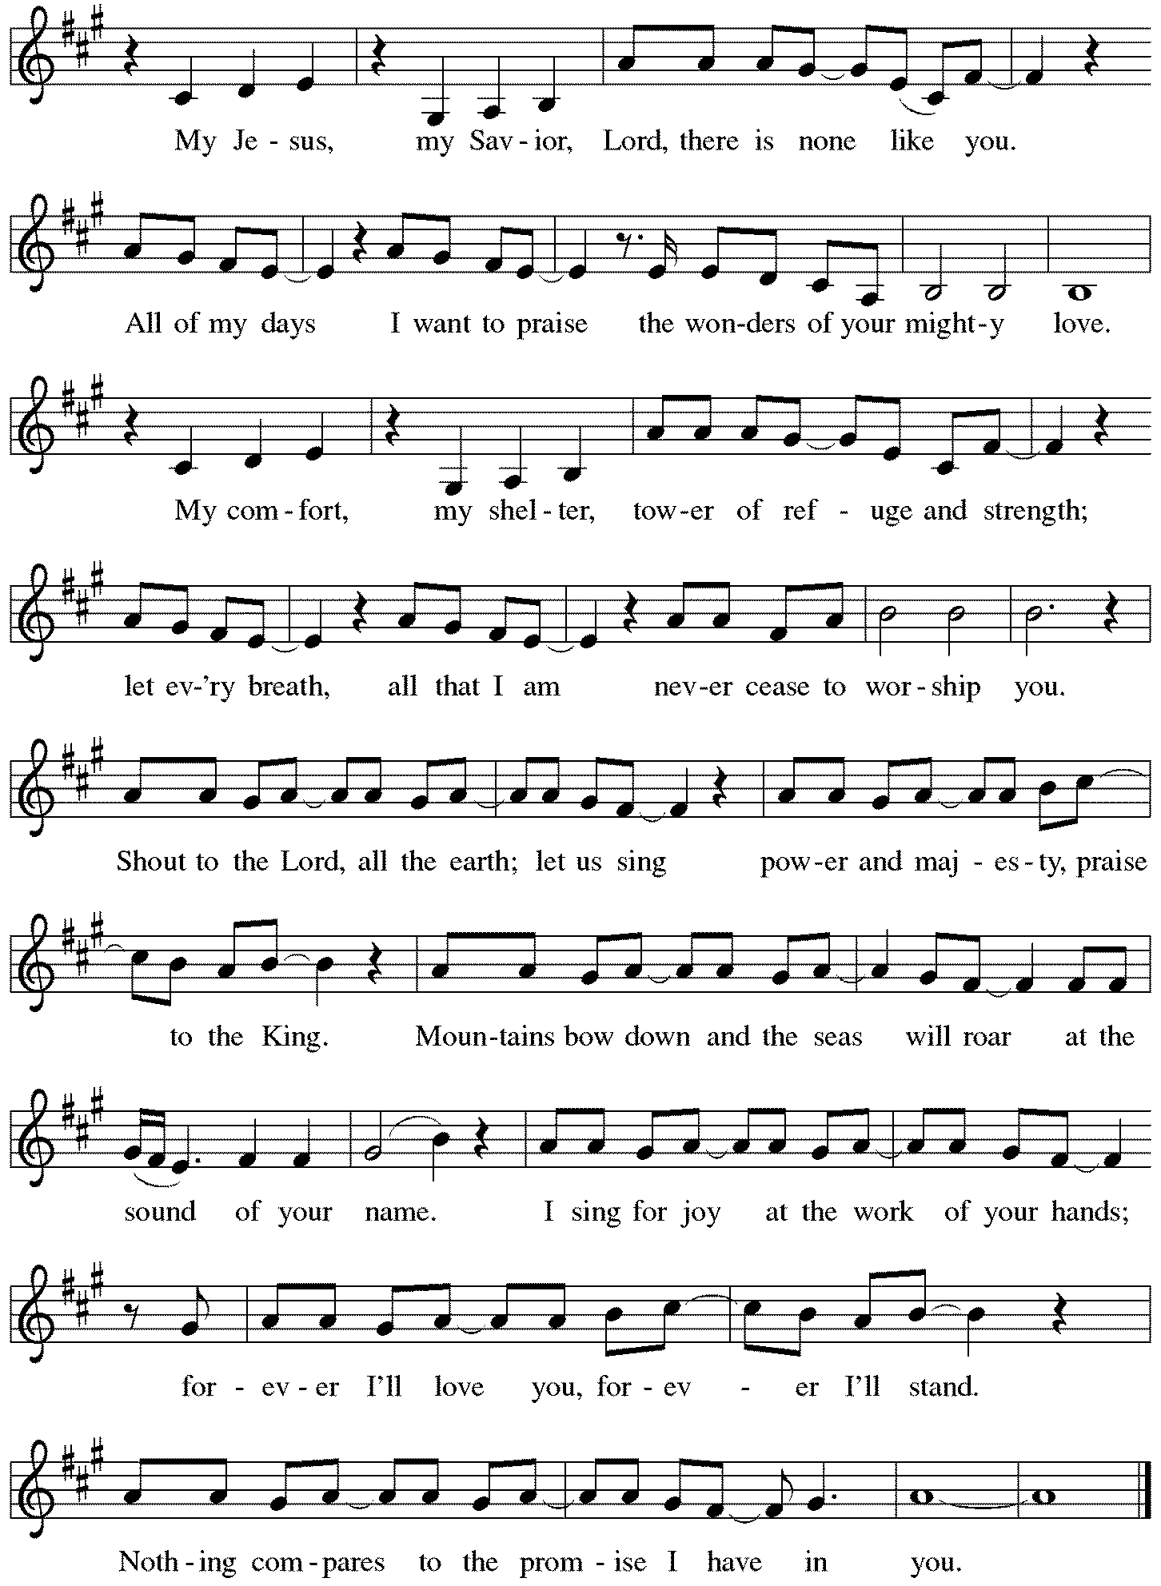
Greeting (Unmute your mic)
The grace of our Lord Jesus Christ, the love of God, and the communion of the Holy Spirit be with you all. And also with you.

Prayer of the Day
O God, you give us your Son as the vine apart from whom we cannot live. Nourish our life in his resurrection, that we may bear the fruit of love and know the fullness of your joy, through Jesus Christ, our Savior and Lord, who lives and reigns with you and the Holy Spirit, one God, now and forever. Amen.

Word
God speaks to us in scripture reading, preaching, and song.
First Lesson Acts 8:26-40
Led by the Spirit, Philip encounters an Ethiopian official who is returning to his African home after having been to Jerusalem to worship. Philip uses their encounter to proclaim the gospel to him. Upon coming to faith in Jesus, he is baptized by Philip.

²⁶An angel of the Lord said to Philip, “Get up and go toward the south to the road that goes down from Jerusalem to Gaza.” (This is a wilderness road.) ²⁷So he got up and went. Now there was an Ethiopian eunuch, a court official of the Candace, queen of the Ethiopians, in charge of her entire treasury. He had come to Jerusalem to worship ²⁸and was returning home; seated in his chariot, he was reading the prophet Isaiah. ²⁹Then the Spirit said to Philip, “Go over to this chariot and join it.” ³⁰So Philip ran up to it and heard him reading the prophet Isaiah. He asked, “Do you understand what you are reading?” ³¹He replied, “How can I, unless someone guides me?” And he invited Philip to get in and sit beside him. ³²Now the passage of the scripture that he was reading was this:
“Like a sheep he was led to the slaughter, and like a lamb silent before its shearer, so he does not open his mouth. ³³In his humiliation justice was denied him. Who can describe his generation? For his life is taken away from the earth.”
³⁴The eunuch asked Philip, “About whom, may I ask you, does the prophet say this, about himself or about someone else?” ³⁵Then Philip began to speak, and starting with this scripture, he proclaimed to him the good news about Jesus. ³⁶As they were going along the road, they came to some water; and the eunuch said, “Look, here is water! What is to prevent me from being baptized?” ³⁸He commanded the chariot to stop, and both of them, Philip and the eunuch, went down into the water, and Philip baptized him. ³⁹When they came up out of the water, the Spirit of the Lord snatched Philip away; the eunuch saw him no more, and went on his way rejoicing. ⁴⁰But Philip found himself at Azotus, and as he was passing through the region, he proclaimed the good news to all the towns until he came to Caesarea.

Word of God, Word of Life. Thanks be to God.
Psalm Psalm 22:25-31
All the ends of the earth shall remember and turn to the Lord. (Ps. 22:27)

²⁵From you comes my praise in the great assembly; I will perform my vows in the sight of those who fear the Lord.
²⁶The poor shall eat and be satisfied, Let those who seek the Lord give praise! May your hearts live forever!
²⁷All the ends of the earth shall remember and turn to the Lord; all the families of nations shall bow before God.
²⁸For dominion belongs to the Lord, who rules over the nations.
²⁹Indeed, all who sleep in the earth shall bow down in worship; all who go down to the dust, though they be dead, shall kneel before the Lord.
³⁰Their descendants shall serve the Lord, whom they shall proclaim to generations to come.
³¹They shall proclaim God’s deliverance to a people yet unborn, saying to them, “The Lord has acted!”

Second Lesson 1 John 4:7-21
We love God and others because God first loved us. We cannot say we love God, whom we have not seen, while hating fellow Christians, whom we regularly see. Love toward God is to be matched by love toward others because the essence of God is love.

⁷Beloved, let us love one another, because love is from God; everyone who loves is born of God and knows God. ⁸Whoever does not love does not know God, for God is love. ⁹God’s love was revealed among us in this way: God sent his only Son into the world so that we might live through him. ¹⁰In this is love, not that we loved God but that he loved us and sent his Son to be the atoning sacrifice for our sins. ¹¹Beloved, since God loved us so much, we also ought to love one another. ¹²No one has ever seen God; if we love one another, God lives in us, and his love is perfected in us.
¹³By this we know that we abide in him and he in us, because he has given us of his Spirit. ¹⁴And we have seen and do testify that the Father has sent his Son as the Savior of the world. ¹⁵God abides in those who confess that Jesus is the Son of God, and they abide in God. ¹⁶So we have known and believe the love that God has for us.
God is love, and those who abide in love abide in God, and God abides in them. ¹⁷Love has been perfected among us in this: that we may have boldness on the day of judgment, because as he is, so are we in this world. ¹⁸There is no fear in love, but perfect love casts out fear; for fear has to do with punishment, and whoever fears has not reached perfection in love. ¹⁹We love because he first loved us. ²⁰Those who say, “I love God,” and hate their brothers or sisters, are liars; for those who do not love a brother or sister whom they have seen, cannot love God whom they have not seen. ²¹The commandment we have from him is this: those who love God must love their brothers and sisters also.

Word of God, Word of Life. Thanks be to God.
Gospel Acclamation
Alleluia. I am the vine, you are the branches. Those who abide in me and I in them bear much fruit. Alleluia. (John 15:5)

The holy Gospel according to John. Glory to you, O Lord.

Gospel John 15:1-8
On the night of his arrest, Jesus taught his disciples about the relationship they would have with him. Those who abide in his word and love bear fruit, for apart from him, they can do nothing.

[Jesus said:] ¹“I am the true vine, and my Father is the vinegrower. ²He removes every branch in me that bears no fruit. Every branch that bears fruit he prunes to make it bear more fruit. ³You have already been cleansed by the word that I have spoken to you. ⁴Abide in me as I abide in you. Just as the branch cannot bear fruit by itself unless it abides in the vine, neither can you unless you abide in me. ⁵I am the vine, you are the branches. Those who abide in me and I in them bear much fruit, because apart from me you can do nothing. ⁶Whoever does not abide in me is thrown away like a branch and withers; such branches are gathered, thrown into the fire, and burned. ⁷If you abide in me, and my words abide in you, ask for whatever you wish, and it will be done for you. ⁸My Father is glorified by this, that you bear much fruit and become my disciples.”

The Gospel of the Lord. Praise to you, O Christ.

Sermon The Rev. Melody Eastman

Prayers of Intercession (You may unmute your mic)
Alive in the risen Christ by the power of the Holy Spirit, we bring our prayers before God who promises to hear us and answer in steadfast love.
A brief silence.

God of all fruitfulness, you abide in your church and your church abides in you. Cleanse us by your word and give yourself to the whole church on earth so that it bears fruit and witnesses to your love. Hear us, O God. Your mercy is great.

You have created the heavens and the earth. As we wonder at the beauty of creation, may we seek vital connections among all that depends on the earth for life. Hear us, O God. Your mercy is great.

You rule the nations with justice and love. Give the leaders of the earth assurance of your abiding presence, that they lead not by fear but with love for those they are called to serve. Hear us, O God. Your mercy is great.

You have loved us so that we can love others. We pray for all in need of your love: those who are poor, lowly, outcast, weak, or fearful. Provide for the needs of all, especially Cathy, Jim, Jerry, Shirley, Dorothy, Bob, Sigrid, Dolores, Carol, Norma, Dorothy, and those we name before you now…. Hear us, O God. Your mercy is great.
Here other intercessions may be offered.

You gather us with all the saints by the power of your Spirit. With them, may our hearts live forever in your keeping. Hear us, O God. Your mercy is great.

In the hope of new life in Christ, we raise our prayers to you, trusting in your never-ending goodness and mercy; through Jesus Christ our Lord. Amen.

Peace
The peace of Christ be with you always. And also with you.
Please share the peace with others in your household, or by making a sign of peace to those on Zoom.

If your House Church is celebrating Communion, refer to that liturgy here.

The Lord’s Prayer
Gathered into one by the Holy Spirit, let us pray as Jesus taught us.
Our Father in heaven, hallowed be your name. Your kingdom come, your will be done on earth as in heaven. Give us today our daily bread. Forgive us our sins as we forgive those who sin against us. Save us from the time of trial and deliver us from evil. For the kingdom, the power and the glory are yours, now and forever. Amen.

Sending
God blesses us and sends us in mission to the world.
Blessing
May our glorious God grant us a spirit of wisdom to know and to love the risen Lord Jesus.
The God of life, Father, ☩ Son, and Holy Spirit, bless us now and forever.

Sending Hymn (Mute your mic) ELW #674 Let Us Talents and Tongues Employ
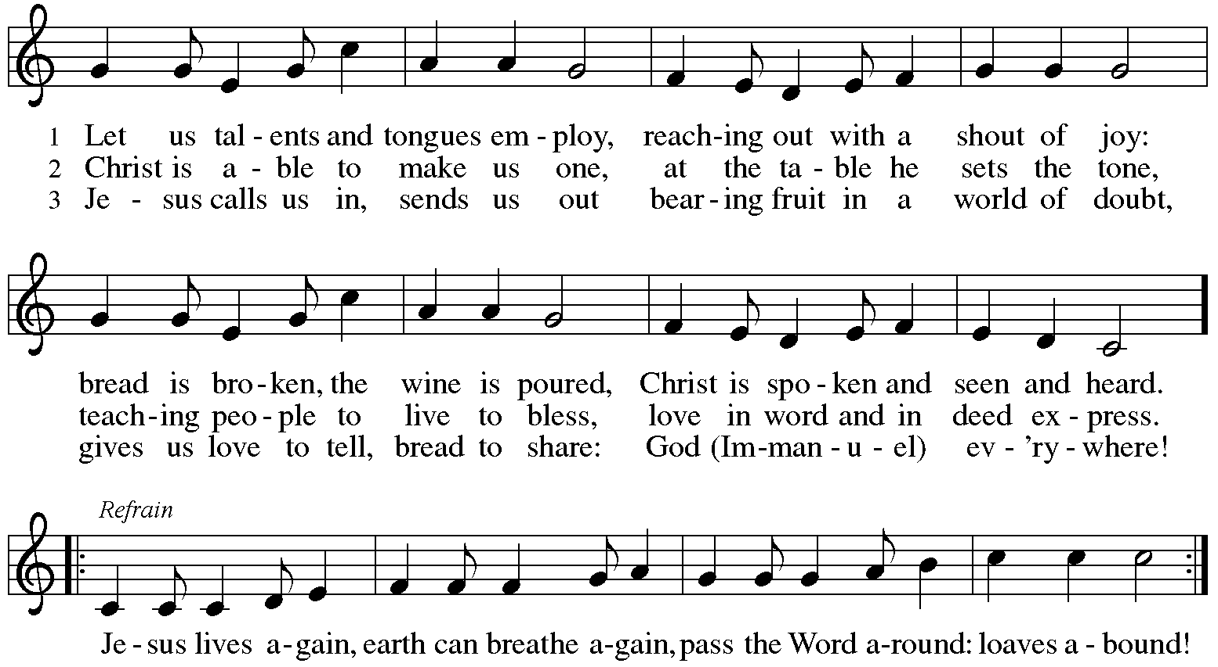

Sent to the World (Unmute your mic.)
Alleluia! Christ is risen. Christ is risen indeed. Alleluia!
Go in peace. Share the good news. Alleluia! Thanks be to God. Alleluia!
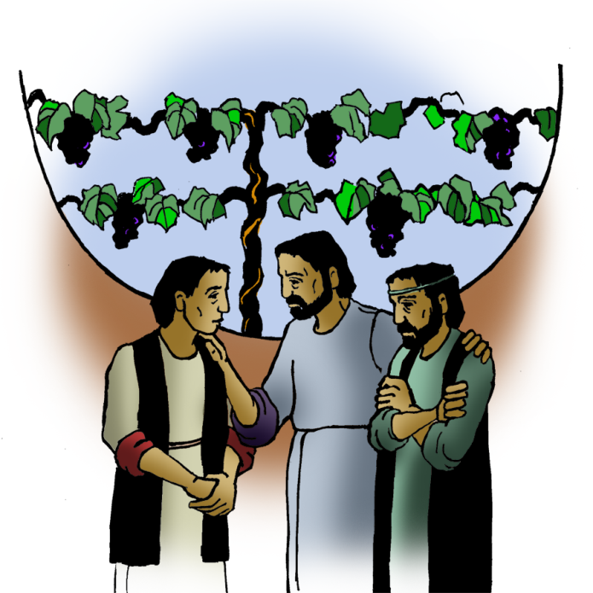

From Sundays and Seasons
v.20190109.1233 Copyright © 2021 Augsburg Fortress. All rights reserved.
Reprinted by permission under Augsburg Fortress Liturgies Annual License #30867.
All rights reserved. Reprinted under OneLicense.net #A-718333.
Current Prayer Requests
Please keep these people in your prayers and reach out to our sisters and brothers in Christian love. Names will be left on the list for two weeks, unless you indicate that they should remain in our prayers for a longer period.

Name Relationship Prayer For
Jim Sladek Member Healing & Strength
Shirley Sauerman Member Healing & Strength
Jerry Jeske Member Healing & Strength
Bob Stein Member Healing & Strength
Cathy Milleville Member Healing & Strength
Sigrid Elliott Member Healing & Strength
Dorothy Tracy Member Healing & Strength
Ruthie Maddock Friend of the Thompsons Healing & Strength
Elizabeth Amber Friend of Pr. Melody & Marty Healing & Strength
Chris Danly Son of Mark & Pat Danly Healing & Strength
Prayers for our homebound Members
Dolores Nosal, Carol Petersen, Norma Petersen, Dorothy Stein

2021 Glen Ellyn/Wheaton CROP Walk: Sunday, May 2nd! Team Grace is about 1/3 of the way to our fundraising goal for this year’s CROP Walk, happening this Sunday. You can support us by donating here:
https://events.crophungerwalk.org/2021/team/grace-lutheran-glen-ellyn-il?fbclid=IwAR1gnUTEqrCEy9ep3os5wd-5stFLGJ3vv4klwkOp3Xx2WD4XQqtq_cHH954
If you'd like to walk, you can do that at 1:00 (or any time that works for you) on May 2nd, anywhere you like, as far as you like. Or you can meet the Grace team at Grace at 1:00, and we'll walk together. (There is no initial gathering or check-in.)
Follow us on Facebook at https://www.facebook.com/Glen-EllynWheaton-CROP-Hunger-
Walk-384858704862610/

Sue Davison in the Glen Ellyn Sr. Center is now offering her weekly Monday Chair Exercise Class and monthly Book Club. Registration is required as the number of attendees will be limited. The exercise class meets Mondays at 10:00am and the Book Club will meet on the third Tuesday of the month at 11:00am. Sue also plans to offer weekly Thursday Chair Exercise Classes beginning May 6 at 11:00am. Please contact Sue at 630-858-6343 to register.

House Church Worship via phone or internet every Sunday morning at 9:30am! We currently have five “House Churches” of worshipping members (each House Church consisting of 6-8 members/families meeting via Zoom or calling in by phone.) If you are unsure how to sign on, go ahead and register and let us know you need some help; we’ll walk you through it! We would be so blessed to have you join us. Register online for a House Church at graceglenellyn.org (on the main page Announcements) or contact Becky Ficarella.

Contributions to Grace: You may continue to mail your contributions to the church office; have your bank mail your contribution to the church office; or contribute on-line through Grace’s website. Please know, pandemic or no, our mission continues! Thank you for your continued support of our ministries at Grace Lutheran.

RAMP: Our mortgage reduction campaign has been renamed “RAMP” (Reduce Another Mortgage Payment) as we continue to RAMP up to refinance our mortgage with Mission Investment Fund this Fall. If we can raise an additional $100,000 payment prior to our November refinancing it will take us from $925,000 to $825,000.

Food Pantry Needed Items This Week: Apples/Oranges/Cucumbers; Boxed Pasta; Jarred Applesauce/Spaghetti Sauce; Cat & Dog Food; Paper Towels; Dish Soap; Shampoo.

Share Our Spirit: Celebrity Tequila Tasting for Cinco de Mayo! The Food Pantry’s official “spirits expert,” Patrick Brophy, is back for a special zoom event slated for Friday, May 7 at 7pm. In honor of the celebration of Cinco de Mayo that week, Patrick will be guiding attendees through tequilas developed by celebrities. The Zoom will also feature margarita and other tequila recipes. All proceeds from your $200 kit (enough for two participants) will benefit the Pantry. Register here: https://us02web.zoom.us/webinar/register/WN_9qyAQC_XSsOiL_7Vg-dzdw

Every Member a Minister and Missionary!

Phone: 630-469-1555 Emergency Pastoral Contact: 630-674-2887
info@graceglenellyn.org www.graceglenellyn.org

Pastor
Rev. Melody Eastman office ext. 14
meastman@graceglenellyn.org

Minister of Music
Bradford Thompson 219-718-8879
bradfordmthompson@gmail.com

Ministry Associate
Becky Ficarella office ext. 17
bficarella@graceglenellyn.org

Office Manager
Barbara Sudds office ext. 10
bsudds@graceglenellyn.org

Parish Counselor
Carole LoGalbo M.S., LCPC 630-668-4594
carolelogalbo@yahoo.com

