Grace Lutheran Church

493 Forest Avenue, Glen Ellyn IL 630.469.1555
www.graceglenellyn.org

Fourth Sunday PLSIP* May 3, 2020
*Post-Lent, Shelter-In-Place

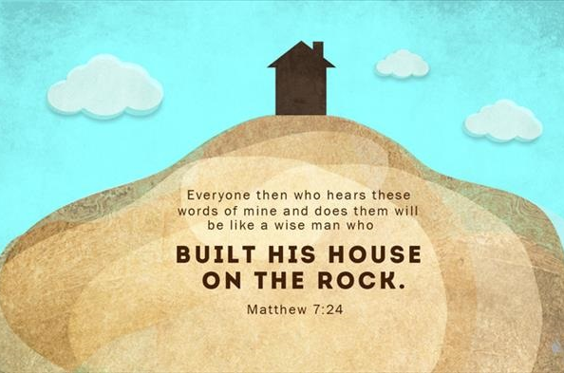

+ Proclaim Christ + Build Community +
+ Serve Our Neighbors +

Gathering
Even when we are apart, the Holy Spirit binds us together as the people of God.

Opening Hymn ELW #512 Lord, Let My Heart Be Good Soil

Greeting
The grace of our Lord Jesus Christ, the love of God, and the communion of the Holy Spirit be with you all. And also with you.

Prayer of the Day
O God our Rock, you are the only solid foundation for our hope. When uncertainty surrounds us, uphold us and give us such a courage as inspires others to put their trust in you. We ask this through the one who reveals your love to us, Jesus Christ, our Lord. Amen.

Word
God speaks to us in scripture reading, preaching, and song.

First Lesson Psalm 16
¹Protect me, O God, for in you I take refuge. ²I say to the LORD, "You are my LORD; I have no good apart from you." ³As for the holy ones in the land, they are the noble, in whom is all my delight. ⁴Those who choose another god multiply their sorrows; their drink offerings of blood I will not pour out or take their names upon my lips. ⁵The LORD is my chosen portion and my cup; you hold my lot. ⁶The boundary lines have fallen for me in pleasant places; I have a goodly heritage. ⁷I bless the LORD who gives me counsel; in the night also my heart instructs me. ⁸I keep the LORD always before me; because he is at my right hand, I shall not be moved. ⁹Therefore my heart is glad, and my soul rejoices; my body also rests secure. ¹⁰For you do not give me up to Sheol, or let your faithful one see the Pit. ¹¹You show me the path of life. In your presence there is fullness of joy; in your right hand are pleasures forevermore.

Word of God, Word of Life. Thanks be to God.

Second Lesson Romans 12:9-13

⁹Let love be genuine; hate what is evil, hold fast to what is good; ¹⁰love one another with mutual affection; outdo one another in showing honor. ¹¹Do not lag in zeal, be ardent in spirit, serve the Lord. ¹²Rejoice in hope, be patient in suffering, persevere in prayer. ¹³Contribute to the needs of the saints; extend hospitality to strangers.

Word of God, Word of Life. Thanks be to God.

Gospel Acclamation
Your Word is a lamp unto my feet, and a light unto my path. I long for your salvation, Lord, and your law is my delight.

The holy Gospel according to John. Glory to you, O Lord.

Gospel Matthew 7:24-27
²⁴"Everyone then who hears these words of mine and acts on them will be like a wise man who built his house on rock. ²⁵The rain fell, the floods came, and the winds blew and beat on that house, but it did not fall, because it had been founded on rock. ²⁶And everyone who hears these words of mine and does not act on them will be like a foolish man who built his house on sand. ²⁷The rain fell, and the floods came, and the winds blew and beat against that house, and it fell — and great was its fall!"
The Gospel of the Lord. Praise to you, O Christ.

Sermon (Available at www.GraceGlenEllyn.org) The Rev. Melody Eastman

Hymn of the Day ELW #597 My Hope Is Built on Nothing Less

Apostles’ Creed

With the whole church, let us confess our faith.
I believe in God, the Father almighty, creator of heaven and earth. I believe in Jesus Christ, God's only Son, our Lord, who was conceived by the Holy Spirit, born of the virgin Mary, suffered under Pontius Pilate, was crucified, died, and was buried; he descended to the dead. On the third day he rose again; he ascended into heaven, he is seated at the right hand of the Father, and he will come to judge the living and the dead. I believe in the Holy Spirit, the holy catholic church, the communion of saints, the forgiveness of sins, the resurrection of the body, and the life everlasting. Amen.

Prayers of Intercession
Gathered together by the Holy Spirit, we pray for the church, the world, and all who are in need.
Silence for reflection.

Mighty God, we pray for the Church around the world. May our faith be built upon a solid foundation of rock, trusting in your promise of resurrection life in times of confusion and transition. Lord, in your mercy, hear our prayer.

Holy Counselor, we pray for all nations and their leaders during this time. Inspire the hearts of governments and leaders to make decisions that serve the whole, preserving life and respecting the humanity of each of your beloved children. Lord, in your mercy, hear our prayer.

Holy Savior, we pray for the wisdom to respect and protect all of your creation. Help inspire new ways of living that are in line with sustainable care of this world. Bless those who are beginning gardens, planting seeds in the rich soil of this earth. May they take joy in the loving care and harvest, sharing the abundance with those around them. Lord, in your mercy, hear our prayer.

Gracious Spirit, we thank you for the witness and joy of our members celebrating birthdays this week, especially Marilyn Goodrich on her 92nd and Bob Clauss on his 90th. May the love of family and friends surround them across every distance. Lord, in your mercy, hear our prayer.

Loving Creator, we pray for those who are sick and afflicted, and those who have had medical needs put on hold due to the pandemic. We pray for those struggling with mental health or addiction issues, finding that time in isolation is more challenging for their condition. Comfort those in pain and give hope to those who need encouragement, especially Nancy, Sigrid, Dorothy, Anita, Bob, Evelyn, Carol and Norma. Lord, in your mercy, hear our prayer.

Comforting Spirit, grant your strength and hope to all who grieve the loss of loved ones, especially the families and friends of the Rev. Roy Wilhelm (brother to Helen Sladek), John Nelson (father to Kim Jokela and Jeff Nelson), and Annette Westbrook (longtime friend of Jan Miller). May your resurrection promise bring peace to all who mourn. Lord, in your mercy, hear our prayer.

Holy God, we give you thanks. You give us a foundation of rock and not of sand. Your Word gives us strength and your promises show us we have nothing to fear. Thank you for your amazing grace in our lives. Lord, in your mercy, hear our prayer.

Into your hands, O Lord, we commend all for whom we pray, trusting in your mercy through Jesus Christ, our Savior and Lord. Amen.

The Lord’s Prayer
Gathered into one by the Holy Spirit, let us pray as Jesus taught us.
Our Father, who art in heaven, hallowed be thy name, thy kingdom come, thy will be done on earth as it is in heaven. Give us this day our daily bread; and forgive us our trespasses, as we forgive those who trespass against us; and lead us not into temptation, but deliver us from evil. For thine is the kingdom, and the power, and the glory, forever and ever. Amen.

Blessing
May the One who guides our ways and guards our paths in all times and places grant us courage and strength, and bring us peace in the midst of trial. Almighty God, Father, ☩ Son, and Holy Spirit, bless us now and forever. Amen.

Hymn ELW #779 Amazing Grace

From Sundays and Seasons v.20190109.1233 Copyright © 2020 Augsburg Fortress. All rights reserved.
Reprinted by permission under Augsburg Fortress Liturgies Annual License #30867.
Reprinted under OneLicense.net #A-718333.
Current Prayer Requests
Please keep these people in your prayers and reach out to our sisters and brothers in Christian love. Names will be left on the list for two weeks, unless you indicate that they should remain in our prayers for a longer period.
Name Relation to Grace Prayers For
Marilyn Goodrich Member 92nd Birthday (5/5)
Robert Clauss Member 90th Birthday (5/6)
Ken & Joan Frank Members 63rd Anniversary (4/26)
Carol & Norm Wandke Members 68th Anniversary (4/26)
Family of John Nelson Father to Kim Jokela & Jeff Nelson Comfort in Grief
Family of The Rev. Roy Wilhelm Helen Sladek’s Brother Comfort in Grief
Family of Annette Westbrook Long-time friend of Jan Miller Comfort in Grief
Chris Danly Son of Mark & Pat Danly Healing & Strength
Nancy Lantz Member Healing & Strength
Sigrid Elliott Friend of Grace Healing & Strength
David Dean Son of Lenore Dean Healing & Strength
Dorothy Tracy Member Healing & Strength
Mark Frerichs and Family Friend of Sue Pagnoni Safety & Strength
Susan Papierski Food Pantry Director Healing & Strength
Prayers for our homebound Members
Anita Blakemore, Bob Clauss, Evelyn Elson, Carol Petersen, Norma Petersen

January through April 2020 Contribution statements will be mailed out the first week of May. Thank you all for your continued support of the ministries at Grace.

Request from Rev. Seth Carey: DuPage PADs has been given the impossibility of doing business as usual and the need to keep our homeless population sheltered (in place, if possible). DuPage PADS is utilizing a combination of family reunification efforts and temporary housing in the form of motel stays. Naturally, this is very expensive.
PADS is currently housing 90 people in 75 rooms, and has already raised nearly $200k in individual donations and state grants. Which is great news, except that they are projecting this effort to cost between $100-$150k per month.
As such, I am reaching out to my friends and colleagues who are also PADS partners and supporters to see if you will join me in an attempt to raise an additional $100k.
Response from Grace: Based on this request from Rev. Seth Carey, Grace Council authorized a one-time payment of $1,000 from our Outreach budget to assist in this effort to house our homeless population.

A big “Thank You” to everyone that joined us in our “Shopping Cart Brigade in April” food drive supporting the Glen Ellyn Food Pantry. In the course of one day, our small group gathered 150 bags of food - enough to serve 65 households for two weeks – and raised $450. Thank you so much!
In addition to the tangible gifts, it is also important to let the volunteers at the Pantry know that the community supports them – especially during the extreme challenges they are facing. It does make a difference.
Thanks again! Dominic LoGalbo

Do you like to paint? The “wedge room” in the basement needs to have its ceiling painted. Some scraping is required and please do not paint the copper pipes! Would you like to take this on? This is a one person job you can do at your convenience day or night. Bring your own painting supplies. The room is 470 s.f. and we have two gallons of paint on hand. The room is not locked, so just contact the office next week to let me know when you want to come in and if it is after business hours I’ll make sure you have access into the building. Thank you, Barbara

This year’s CROP Walk is virtual and socially distant, but no less vital! On Sunday, May 3 at 1:00, Team Grace will be walking to do our bit in the battle against hunger. Can you support us? No matter how small the gift, every penny helps bring hope to someone. Donate here—and THANK YOU!
https://www.crophungerwalk.org/glenellynil/Team/View/126231/Grace-Lutheran

There is a free emotional support text line available from the IL Dept. of Human Services for people experiencing stress or mental health issues related to COVID-19. If you’d like to talk to a mental health professional (anonymously), text “TALK” to 5-5-2-0-2-0. You will receive a call from a counselor employed by a local community mental health center within 24 hours. See Grace’s website for more details.

Grace Family, We have made the decision to cancel the Community VBS Program for the week of June 22-26th due to the COVID-19 pandemic. We will be sending communication out to those already registered to participate and volunteer within the coming weeks. We will offer a different opportunity later in the summer and will be sure to communicate those details as soon as they are available.
With Thanks! Becky

Reminder: Liturgy, sermon, and children’s bulletin will be available on the website Sunday morning.

Grace’s website is being updated almost daily with new resources, including instrumental and sing-along music from Bradford; coloring pages for relaxing, meditation and prayer; coloring pages for little ones; links to videos and articles to help you manage stress and anxiety; and, of course, Wednesday and Sunday sermons from Pastor Melody. And more resources are in the planning, so check back often! Resources are available online at www.GraceGlenEllyn.org. and https://www.youtube.com/results?search_query=Grace+Glen+Ellyn

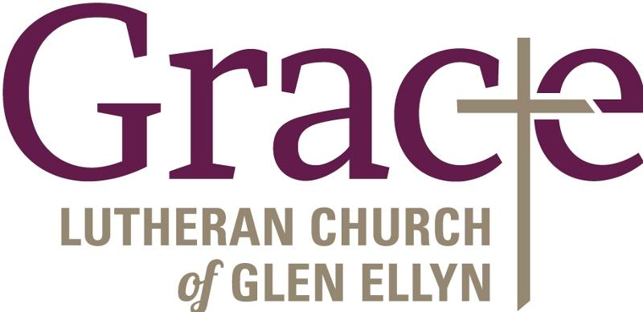

Every Member a Minister and Missionary!

Phone: 630-469-1555 Emergency Pastoral Contact: 630-674-2887
info@graceglenellyn.org www.graceglenellyn.org

Pastor
Rev. Melody Eastman office ext. 14
meastman@graceglenellyn.org

Minister of Music
Bradford Thompson 219-718-8879
bradfordmthompson@gmail.com

Ministry Associate
Becky Ficarella office ext. 17
bficarella@graceglenellyn.org

Office Manager
Barbara Sudds office ext. 10
bsudds@graceglenellyn.org

Parish Counselor
Carole LoGalbo M.S., LCPC 630-668-4594
carolelogalbo@yahoo.com

