Grace Lutheran Church

493 Forest Avenue, Glen Ellyn IL 630.469.1555
www.graceglenellyn.org

Fourth Sunday of Easter May 8, 2022

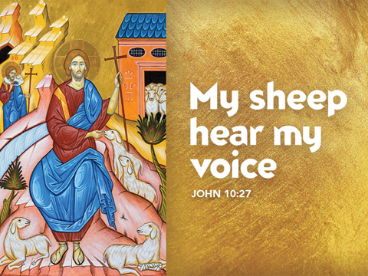

+ Proclaim Christ + Build Community +
+ Serve Our Neighbors +

Introduction
The gift of new life, of eternal life, is the gift of the risen Christ. It is the promise of Jesus. It was true for Dorcas in Joppa. It was true for those “who have come out of the great ordeal” in the Revelation vision. It is true for us and for all the baptized: Surely goodness and mercy shall follow me all the days of my life, and I will dwell in the house of the Lord forever.

An asterisk (*) indicates that you should stand for that portion of the service. If standing is difficult, please remain seated. Congregation responses are in bold print.

Gathering
The Holy Spirit calls us together as the people of God.
Welcome/Announcements
Prelude

*Please stand as you are able and turn to face the font.
*Thanksgiving for Baptism
All may make the sign of the cross, the sign marked at baptism, as the presiding minister begins.

Alleluia! Christ is risen. Christ is risen indeed. Alleluia!

. . . Now breathe upon this water and awaken your church once more. Claim us again as your beloved and holy people. Quench our thirst; cleanse our hearts; wipe away every tear. To you, our beginning and our End, our Shepherd and Lamb, be honor, glory, praise, and thanksgiving, now and forever. Amen.

*Entrance Hymn ELW # 502 The King of Love My Shepherd Is
sts 1, 2, 4, 6
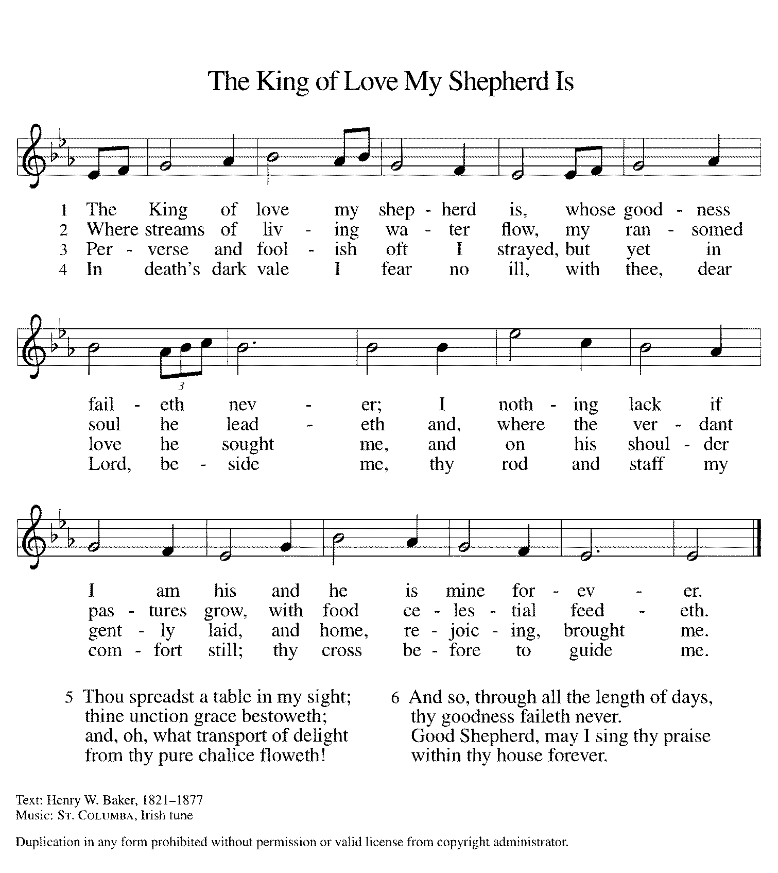
*Greeting
The grace of our Lord Jesus Christ, the love of God, and the communion of the Holy Spirit be with you all.
And also with you.

*Hymn of Praise ELW #164 Glory to God
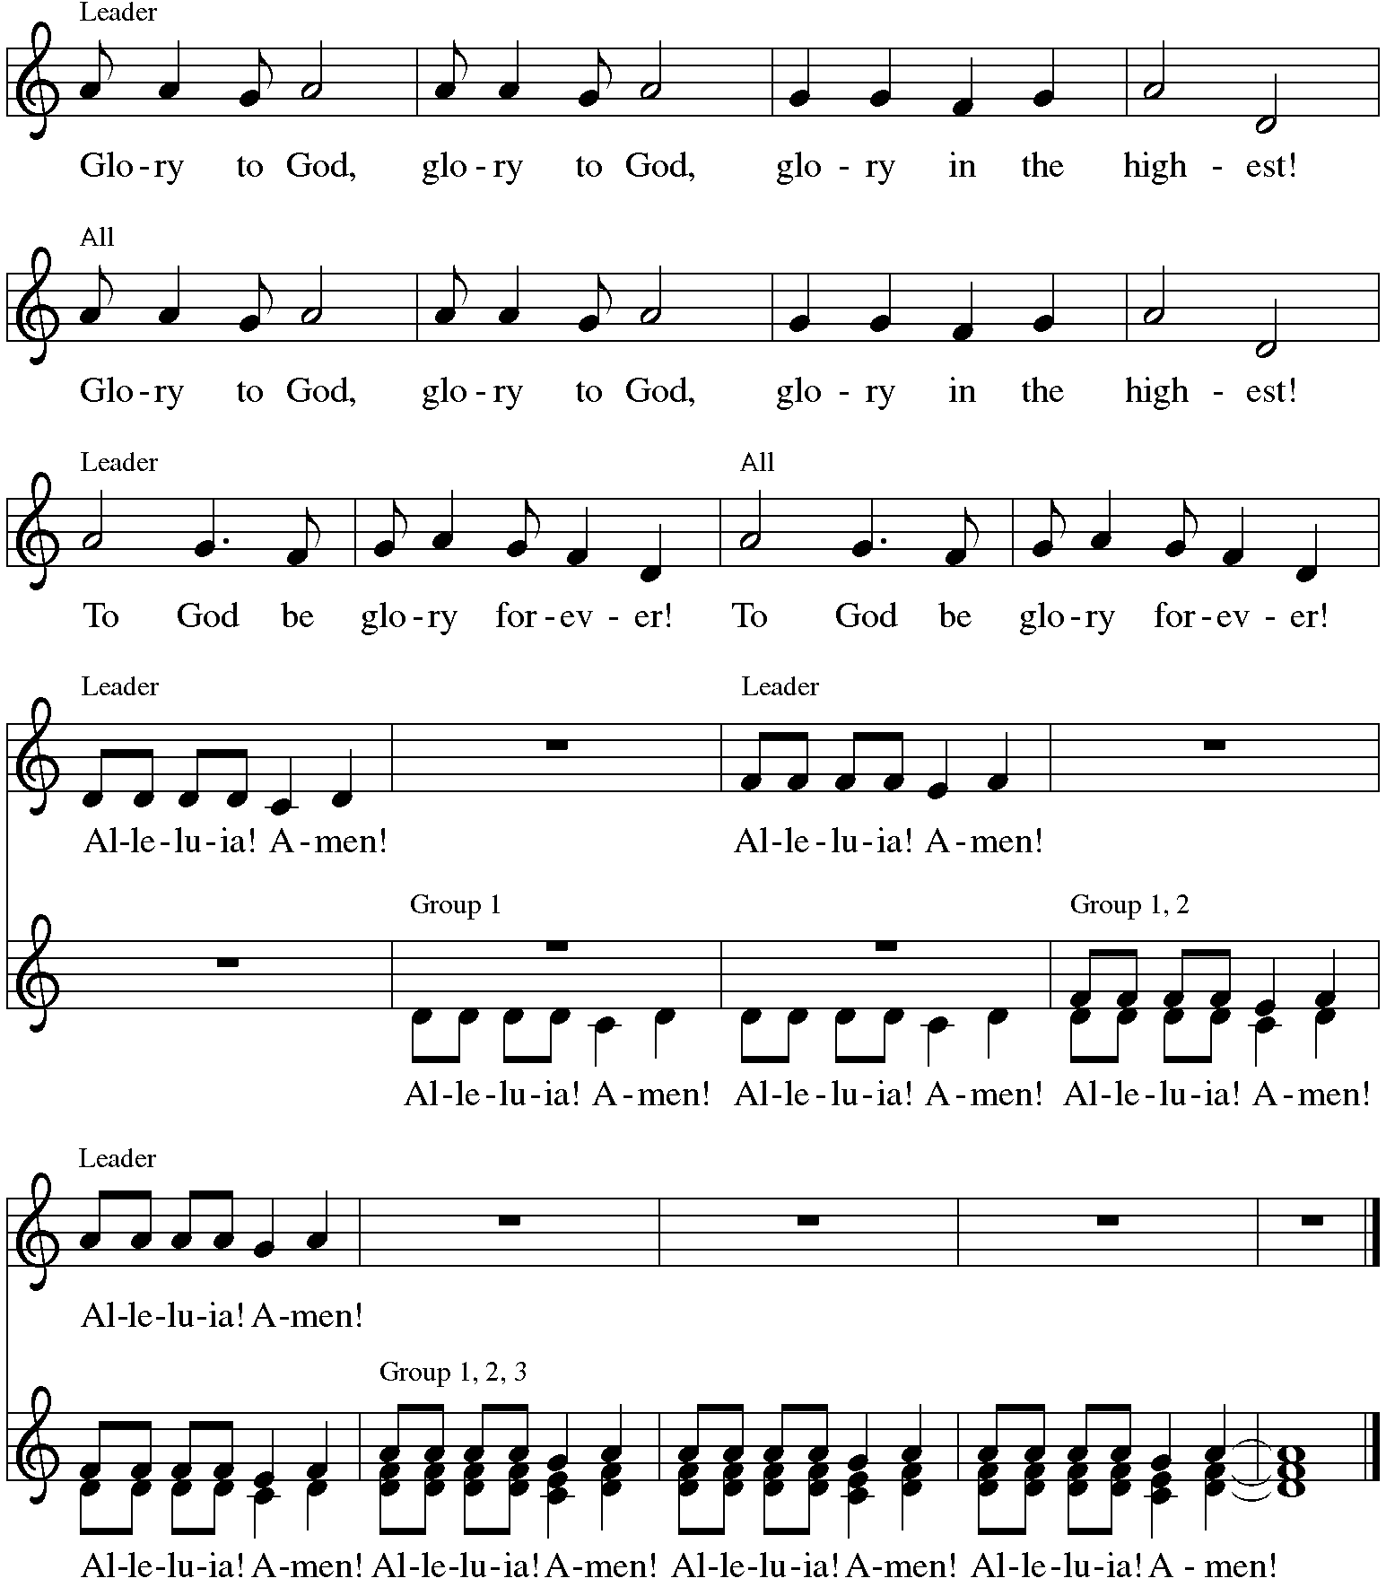
*Prayer of the Day
O God of peace, you brought again from the dead our Lord Jesus Christ, the great shepherd of the sheep. By the blood of your eternal covenant, make us complete in everything good that we may do your will, and work among us all that is well-pleasing in your sight, through Jesus Christ, our Savior and Lord, who lives and reigns with you and the Holy Spirit, one God, now and forever. Amen. Be seated.

Word
God speaks to us in scripture reading.
First Lesson Acts 9:36-43
Dorcas was a faithful and devoted woman of charity in the community of Joppa. Her kindness and her work with clothing were well-known, especially to the widows in town. When she fell ill and died, Peter raised her back to life through the power of prayer.

³⁶Now in Joppa there was a disciple whose name was Tabitha, which in Greek is Dorcas. She was devoted to good works and acts of charity. ³⁷At that time she became ill and died. When they had washed her, they laid her in a room upstairs. ³⁸Since Lydda was near Joppa, the disciples, who heard that Peter was there, sent two men to him with the request, “Please come to us without delay.” ³⁹So Peter got up and went with them; and when he arrived, they took him to the room upstairs. All the widows stood beside him, weeping and showing tunics and other clothing that Dorcas had made while she was with them. ⁴⁰Peter put all of them outside, and then he knelt down and prayed. He turned to the body and said, “Tabitha, get up.” Then she opened her eyes, and seeing Peter, she sat up. ⁴¹He gave her his hand and helped her up. Then calling the saints and widows, he showed her to be alive. ⁴²This became known throughout Joppa, and many believed in the Lord. ⁴³Meanwhile he stayed in Joppa for some time with a certain Simon, a tanner.

Word of God, Word of Life. Thanks be to God.

Psalm Psalm 23
The Psalm is read responsively by verse.
¹The Lord is my shepherd; I shall not be in want.
²The Lord makes me lie down in green pastures and leads me beside still waters.
³You restore my soul, O Lord, and guide me along right pathways for your name’s sake.
⁴Though I walk through the valley of the shadow of death, I shall fear no evil; for you are with me; your rod and your staff, they comfort me.
⁵You prepare a table before me in the presence of my enemies; you anoint my head with oil, and my cup is running over.
⁶Surely goodness and mercy shall follow me all the days of my life, and I will dwell in the house of the Lord forever.

Second Lesson Revelation 7:9-17
Christ is the shepherd who leads his faithful to springs of the water of life. Christ is also the lamb who vanquishes sin and suffering.

⁹After this I looked, and there was a great multitude that no one could count, from every nation, from all tribes and peoples and languages, standing before the throne and before the Lamb, robed in white, with palm branches in their hands. ¹⁰They cried out in a loud voice, saying, “Salvation belongs to our God who is seated on the throne, and to the Lamb!” ¹¹And all the angels stood around the throne and around the elders and the four living creatures, and they fell on their faces before the throne and worshiped God, ¹²singing, “Amen! Blessing and glory and wisdom and thanksgiving and honor and power and might be to our God forever and ever! Amen.”
¹³Then one of the elders addressed me, saying, “Who are these, robed in white, and where have they come from?” ¹⁴I said to him, “Sir, you are the one that knows.” Then he said to me, “These are they who have come out of the great ordeal; they have washed their robes and made them white in the blood of the Lamb.
¹⁵For this reason they are before the throne of God, and worship him day and night within his temple, and the one who is seated on the throne will shelter them. ¹⁶They will hunger no more, and thirst no more; the sun will not strike them, nor any scorching heat; ¹⁷for the Lamb at the center of the throne will be their shepherd, and he will guide them to springs of the water of life, and God will wipe away every tear from their eyes.”

Word of God, Word of Life. Thanks be to God.

*Please stand as you are able.
*Gospel Acclamation Hallelujah!

The holy Gospel according to John. Glory to you, O Lord.
*Gospel John 10:22-30
Jesus responds to questions about his identity with the remarkable claim that he and the Father are one. Those who understand this are his sheep; they hear his voice, follow, and will never be snatched from his hand.
²²At that time the festival of the Dedication took place in Jerusalem. It was winter, ²³and Jesus was walking in the temple, in the portico of Solomon. ²⁴So the Jews gathered around him and said to him, “How long will you keep us in suspense? If you are the Messiah, tell us plainly.” ²⁵Jesus answered, “I have told you, and you do not believe. The works that I do in my Father’s name testify to me; ²⁶but you do not believe, because you do not belong to my sheep. ²⁷My sheep hear my voice. I know them, and they follow me. ²⁸I give them eternal life, and they will never perish. No one will snatch them out of my hand. ²⁹What my Father has given me is greater than all else, and no one can snatch it out of the Father’s hand. ³⁰The Father and I are one.”

The Gospel of the Lord. Praise to you, O Christ. Be seated.

Sermon The Rev. Melody Eastman

*Please stand as you are able
*Hymn of the Day ELW# 364 Christ Has Arisen, Alleluia!

Refrain and stanzas 4 and 5 on next page.

*The Nicene Creed
With the whole church, let us confess our faith.
We believe in one God, the Father, the Almighty, maker of heaven and earth,
of all that is, seen and unseen.

We believe in one Lord, Jesus Christ, the only Son of God,
eternally begotten of the Father, God from God, Light from Light,
true God from true God, begotten, not made, of one Being with the Father;
through him all things were made.
For us and for our salvation he came down from heaven,
was incarnate of the Holy Spirit and the virgin Mary and became truly human.
For our sake he was crucified under Pontius Pilate;
he suffered death and was buried.
On the third day he rose again in accordance with the scriptures;
he ascended into heaven and is seated at the right hand of the Father.
He will come again in glory to judge the living and the dead,
and his kingdom will have no end.

We believe in the Holy Spirit, the Lord, the giver of life,
who proceeds from the Father and the Son,
who with the Father and the Son is worshiped and glorified,
who has spoken through the prophets.
We believe in one holy catholic and apostolic church.
We acknowledge one baptism for the forgiveness of sins.
We look for the resurrection of the dead, and the life of the world to come. Amen.

*Prayers of Intercession
Set free from captivity to sin and death, we pray to the God of resurrection for the church, people in need, and all of creation.
A brief silence.

Gentle Shepherd, enable your church to respond to the voice of Jesus. Give us unfailing trust, unafraid to join in Jesus’ work of renewing all things. God, in your mercy, hear our prayer.

Feed your people at the table of creation. Prepare a safe place for those whose environments are dangerous or unhealthy, especially those making difficult journeys. Prosper your creation for the sake of every living thing. God, in your mercy, hear our prayer.

Warm the hearts of all who celebrate and all who mourn on Mother’s Day. Accompany those yearning to be mothers. Help us to heal from broken family relationships and open us to receive your nurturing love from all who serve mothering roles in our lives. God, in your mercy, hear our prayer.

Seek out those who weep while they await healing or consolation especially Carol, Dorothy, Dolores, Carol, Norma, Brittany, and those we name before you now. . . Set people in their path who can provide the care they need, and wipe away every tear from their eyes. God, in your mercy, hear our prayer.

Inspire the words of prophets and saints who employ innovative imagery to stretch our understanding. Send Christ to instruct us with motherly care. God, in your mercy, hear our prayer.
Enfold us in the great multitude of saints from every nation, from all tribes and peoples and languages. Wash us in your saving grace every day, guiding us to your waters of life. God, in your mercy, hear our prayer.

In your mercy, O God, respond to these prayers, and renew us by your life-giving Spirit; through Jesus Christ, our Savior. Amen.

*Peace
The peace of Christ be with you always. And also with you.
Please share the peace with others in your household, or by making a sign of peace to those on Zoom. Please remain standing as you are able.

Meal
God feeds us with the presence of Jesus Christ.
*Offering Prayer
Living God, you gather the wolf and the lamb to feed together in your peaceable reign, and you welcome us all at your table. Reach out to us through this meal, and show us your wounded and risen body, that we may be nourished and believe in Jesus Christ, our Savior and Lord. Amen.

*Great Thanksgiving
The Lord be with you. And also with you.
Lift up your hearts. We lift them to the Lord.
Let us give thanks to the Lord our God. It is right to give our thanks and praise.

*Preface
It is indeed right, our duty and our joy,
that we should at all times and in all places give thanks and praise to you,
almighty and merciful God,
for the glorious resurrection of our Savior Jesus Christ,
the true Paschal Lamb who gave himself to take away our sin;
who in dying has destroyed death,
and in rising has brought us to eternal life.
And so, with Mary Magdalene and Peter and all the witnesses of the resurrection,
with earth and sea and all their creatures,
and with angels and archangels, cherubim and seraphim,
we praise your name and join their unending hymn:

*Sanctus Holy, Holy, Holy C. Heine
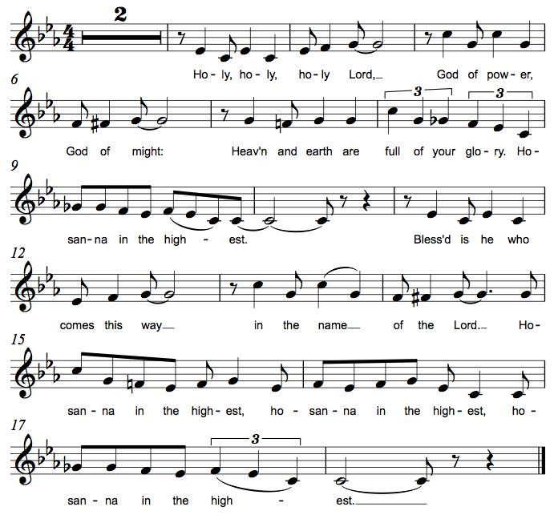

*Thanksgiving at the Table
. . . This cup is the new covenant in my blood, shed for you and for all people for the forgiveness of sin.
Do this for the remembrance of me.

Remembering his death, we cry out Amen. Amen.
Celebrating his resurrection, we shout Amen. Amen.
Trusting his presence in every time and place, we plead Amen. Amen.

. . . Grant us such life, the life of the Father to the Son, the life of the Spirit of our risen Savior, life in you, now and forever. Amen

*The Lord’s Prayer
Gathered into one by the Holy Spirit, let us pray as Jesus taught us.
Our Father in heaven, hallowed be your name, your kingdom come, your will be done, on earth as in heaven. Give us today our daily bread. Forgive us our sins as we forgive those who sin against us.
Save us from the time of trial and deliver us from evil. For the kingdom, the power, and the glory are yours, now and forever. Amen.

*Invitation to Communion
The risen Christ dwells with us here. All who are hungry, all who are thirsty, come. Be seated.

Lamb of God M.B. Eastman
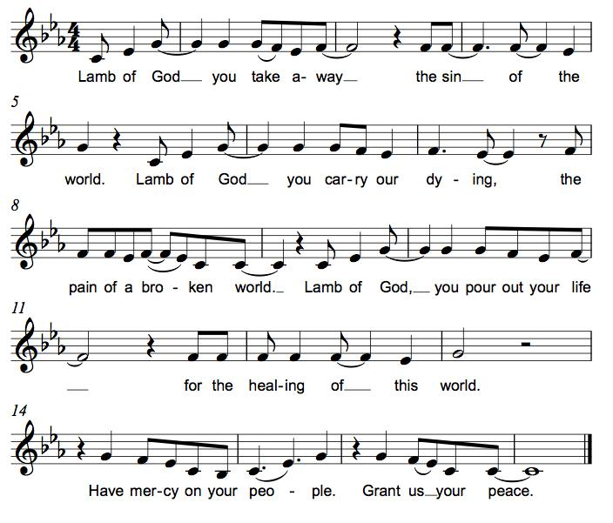

Communion
Those who wish to come to the rail for communion may do so at the ushers’ direction. You may stand or kneel. Please maintain social distancing between households. You may return to your seat by the side aisles after you have received the bread and wine. If you like, you may bring a communion kit with you to receive at the altar.

For those receiving communion in the pew or from home:
This is the body of Christ, given for you. Amen (Eat the bread.)
This is the blood of Christ, shed for you. Amen (Drink the juice.)
*Please stand as you are able.
*Post Communion Blessing
May the body and blood of our Lord Jesus Christ strengthen you and keep you in his grace. Amen.

*Post Communion Prayer
We give you thanks, generous God, for in this bread and cup we have tasted the new heaven and earth
where hunger and thirst are no more. Send us from this table as witnesses to the resurrection, that through our lives, all may know life in Jesus’ name. Amen.

Sending
God blesses us and sends us in mission to the world.
*Blessing
God, the Author of life, Christ, the living Cornerstone, and the life-giving Spirit of adoption, ☩ bless you now and forever. Amen.

*Sending Hymn ELW # 595 Jesus Loves Me!
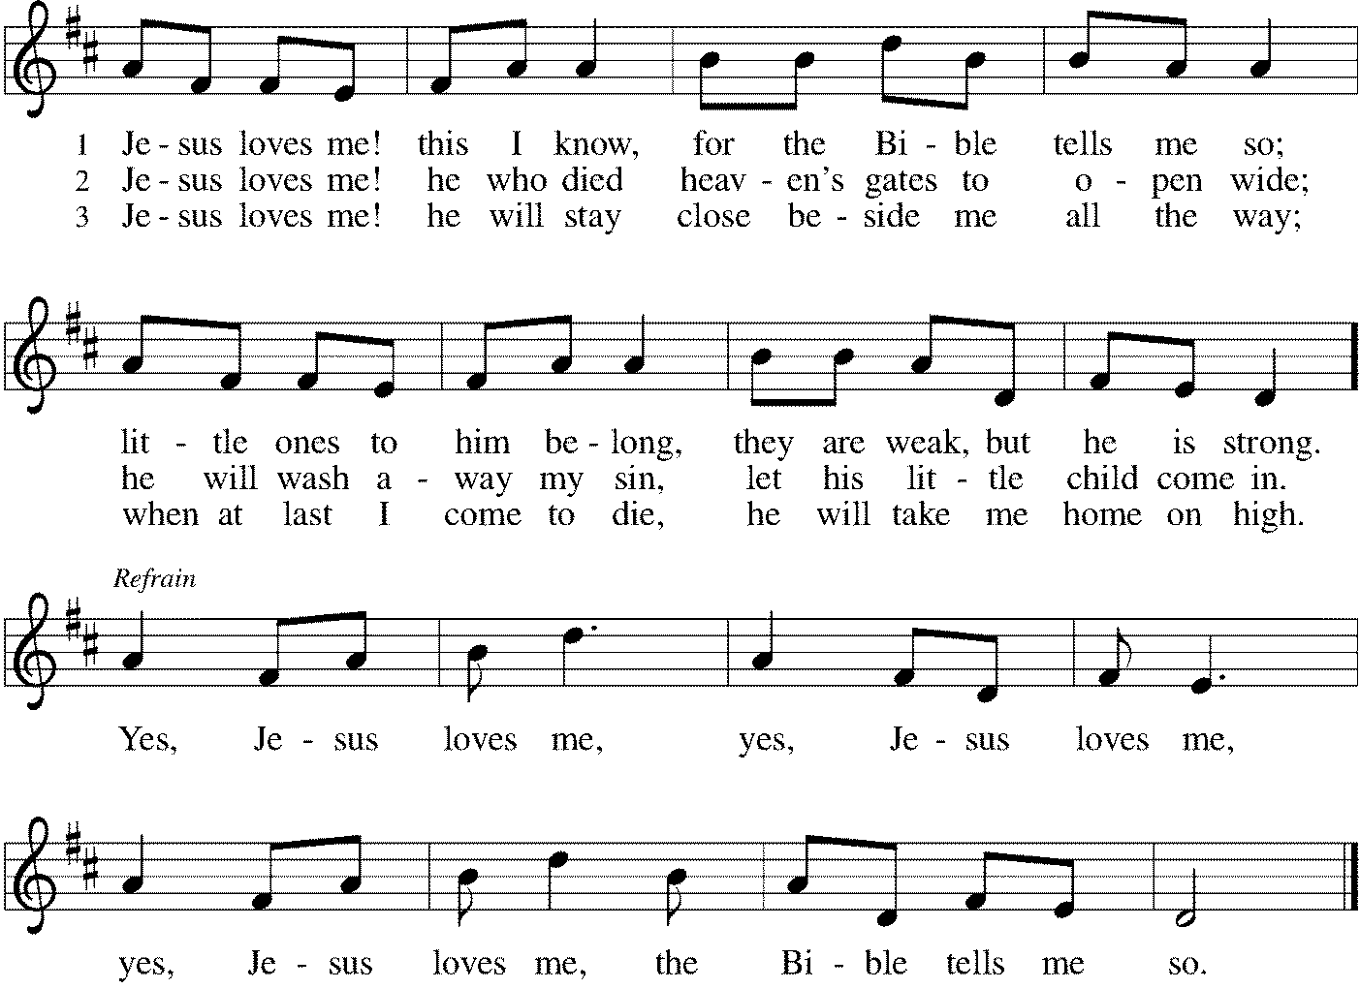

*Sent to the World
Alleluia! Christ is risen. Christ is risen indeed. Alleluia!
Go in peace. Tell what God has done. Thanks be to God.

Postlude
From Sundays and Seasons v.20190109.1233 Copyright © 2022 Augsburg Fortress. All rights reserved.
Reprinted by permission under Augsburg Fortress Liturgies Annual License #30867.
All rights reserved. Reprinted under OneLicense.net #A-718333.

Assisting in Worship Today
Pastor Rev. Melody Eastman
Minister of Music Bradford Thompson
Ministry Associate Becky Ficarella
Altar Care Cheryl Huizenga
Lector Vince Hardt
Usher Mark Drager, John Jokela
Zoom Mark Hamilton, Jon & Cathy Milleville
Fellowship Hour Sue Davison
Chancel Flowers Given by JoAnn Griffin in memory of Paul Griffin

Current Prayer Requests
Please keep these people in your prayers and reach out to our sisters and brothers in Christian love. Names will be left on the list for two weeks, unless you indicate that they should remain in our prayers for a longer period.
Name Relationship Prayer For
Carol Wandke Member Healing & Strength
Marilyn Goodrich Member 94th Birthday (5/5)
Dolores Nosal Member Healing & Strength
Brittany Huizenga Cousin of Cheryl Huizenga Healing & Strength
Dorothy Tracy Member Healing & Strength
Norma Petersen Member Healing & Strength
Prayers for our homebound Members
Dolores Nosal, Carol Petersen, Norma Petersen

Weekly Announements
The church office is closed through Monday, May 9. Articles and Photos for the June issue of GTY are due to the church office on Monday, May 9. Insert pages are due to the office by Sunday, May 15.

Grace Gives: Wednesday, May 11 from 5-8pm at Portillo’s located at 235 North Avenue in Glendale Heights. 20% of sales will benefit our organization. Order online or in app for pickup using code PORTILLOS2 before checkout in the “Apply Offer” field, or show the flyer or a digital version to casher when ordering at the restaurant. Valid on drive thru, pickup, curbside, and in restaurant orders.

Drivers Needed: We have two Grace members who need a ride to church on Sunday mornings. One from Beacon Hill in Lombard and one near President Street and Geneva Road in Wheaton. Do you think you could help out with this? Your commitment would be once every 5-6 weeks. They are so thankful to be able to come to worship. If you think this would work for you, please call or email or call Cathy Milleville 630-653-0957 or jmilleville@comcast.net.

Worship Assistants: With the return to communion at the rail, we are in need of people willing to serve as cross-bearer and communion assistant along with two ushers for each week. If you are able to help with carrying the cross and/or assisting with communion, please contact Susan Jacobson or the church office. Thank you!
Fellowship Hour: Please join us for coffee and fellowship following Sunday’s worship service. We are looking for additional volunteers to host the coffee hour. Please contact Becky Ficarella or the church office if you are interested.

Adult and Bell Choirs: The choirs meet on Wednesdays at 7:00pm. Contact Bradford Thompson if you would like to share your voice or bell ringing skills with Grace. bradfordmthompson@gmail.com

Save the Date! Progressive Dinner! Saturday, June 11: We are planning on restarting the Progressive Dinner on Saturday, June 11th. We will have two options for sign up. Appetizers Only or Appetizers and Dinner. We are planning on the Appetizer House to be held outside for those who still are uncomfortable eating inside but would like to re-connect with your Grace family. Appetizers will start at 5:30pm, with dinner houses to follow at 7:30pm. Please sign up on the poster in the Narthex for a great evening. Questions, please call Susi Nelson at 630-297-3620.

Community Vacation Bible School: Registration is now open for volunteers and participants. Grace Lutheran Church, Faith Lutheran Church, and First Congregational Church Glen Ellyn are presenting this week together in partnership “Compassion Camp - Changing the World with Loving Kindness!” Monday – Friday, June 20-24, 9:00am-12:00pm at Faith Lutheran Church. 41 N. Park Blvd., Glen Ellyn. Register on Grace’s website!

Quilting Ministry: The quilters meet on the second and fourth Tuesday of every month from 9-10am.

Meet Nancy Drew, America's First Girl Detective: On Saturday, May 14 at 2:00pm, the Glen Ellyn Historical Society at 800 N. Main Street in Glen Ellyn welcomes Susan Becker's program about America's first girl detective, Nancy Drew. For all who have read the Nancy Drew detective series, the program is a great walk down memory lane. Becker describes the origin of the plucky girl detective and how the books were adapted for movies and television. The program speaker is a lifelong Nancy Drew reader and fan. The program on May 14 is sponsored by Priscilla and Jarold Anderson. This is a free program. Refreshments are served. Great program for school age students.

ESL Tutors Needed! St. Andrew Lutheran Church in West Chicago will be hosting one on one ESL tutoring with TEACH likely on Thursdays. There will be two-part training for tutors to teach English as a Second Language to adults on May 19 & June 2 from 10am-12pm at St. Andrew, 155 N. Prince Crossing Road. Go to www.teachempowers.org for more information or to register.

Crisis in Ukraine: The match has been met but more is needed! Learn more at LWR.org/congregations. Donate online at LWR.org. Gifts can also be mailed to Lutheran World Relief, PO Box 17061, Baltimore, MD 21297-1061. Please write “Ukraine” in the memo line.

Every Member a Minister and Missionary!
Phone: 630-469-1555 Emergency Pastoral Contact: 630-674-2887
info@graceglenellyn.org www.graceglenellyn.org

Pastor
Rev. Melody Eastman office ext. 14
meastman@graceglenellyn.org

Minister of Music
Bradford Thompson 219-718-8879
bradfordmthompson@gmail.com

Ministry Associate
Becky Ficarella office ext. 17
bficarella@graceglenellyn.org

Office Manager
Barbara Sudds office ext. 10
bsudds@graceglenellyn.org

Parish Counselor
Carole LoGalbo M.S., LCPC 630-668-4594
carolelogalbo@yahoo.com

