Grace Lutheran Church

493 Forest Avenue, Glen Ellyn IL 630.469.1555
www.graceglenellyn.org

Sixth Sunday of Easter May 9, 2021

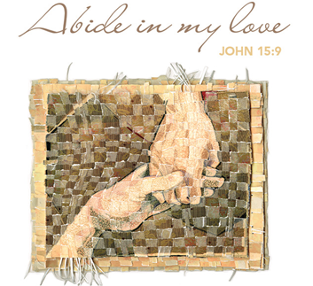

+ Proclaim Christ + Build Community +
+ Serve Our Neighbors +

Introduction
This Sunday’s image of the life the risen Christ shares with us is the image of friendship. We are called to serve others as Jesus came to serve; but for John’s gospel, the image of servanthood is too hierarchical, too distant, to capture the essence of life with Christ. Friendship captures the love, the joy, the deep mutuality of the relationship into which Christ invites us. The Greeks believed that true friends are willing to die for each other. This is the mutual love of Christian community commanded by Christ and enabled by the Spirit.

Gathering
The Holy Spirit calls us together as the people of God.
Welcome/Announcements

Helpful Reminders for House Church:
- Mute your mic during hymns.
- You may unmute for all group responses. Remember that your host can mute you but cannot unmute you; you must unmute your mic yourself.
- If you are joining by phone, move the mouthpiece away from your mouth unless you are speaking, to avoid broadcasting your breathing.
- Avoid background conversations when your mic is unmuted.
- Congregation responses are in Bold (black).
- THANK YOU FOR WORSHIPPING WITH US!

Prelude (Please mute your mic for the prelude.)

Thanksgiving for Baptism (You may unmute your mic.)
All may make the sign of the cross, the sign marked at baptism, as the presiding minister begins.
Alleluia! Christ is risen. Christ is risen indeed. Alleluia!
Refreshed by the resurrection life we share in Christ, let us give thanks for the gift of baptism.

Water may be poured as the leader gives thanks.

We thank you, risen Christ, for these waters where you make us new, leading us from death to life, from tears to joy. We bless you, risen Christ, that your Spirit comes to us in the grace-filled waters of rebirth, like rains to our thirsting earth, like streams that revive our souls, like cups of cool water shared with strangers. Breathe your peace on your church when we hide in fear. Clothe us with your mercy and forgiveness. Send us companions on our journey as we share your life. Make us one, risen Christ. Cleanse our hearts. Shower us with life. To you be given all praise, with the Holy Spirit, in the glory of God, now and forever. Amen.

Entrance Hymn (Mute your mic) ELW #631 Love Divine, All Loves Excelling, sts. 1-3
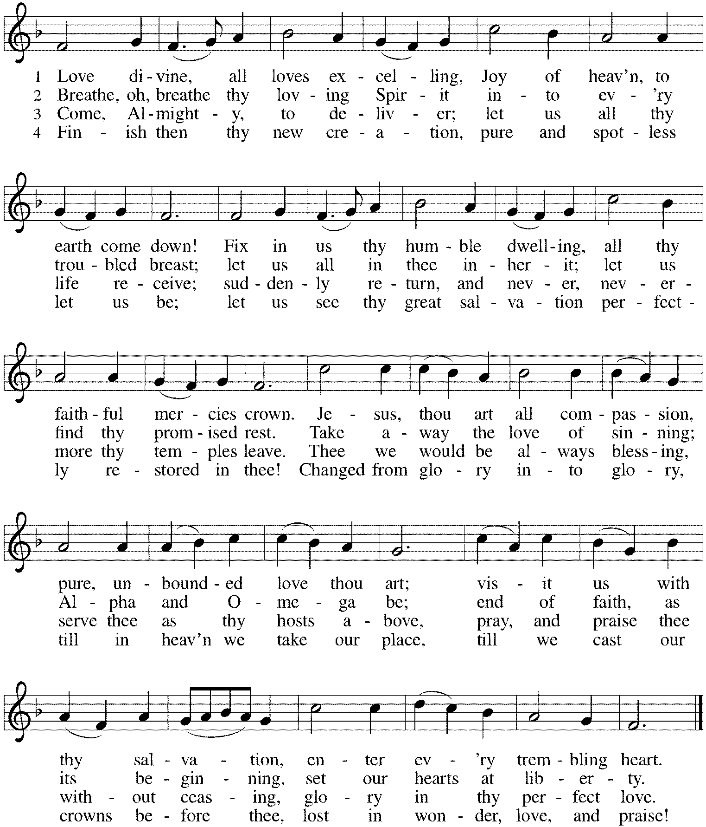

Greeting (Unmute your mic)
The grace of our Lord Jesus Christ, the love of God, and the communion of the Holy Spirit be with you all. And also with you.
Prayer of the Day
O God, you have prepared for those who love you joys beyond understanding. Pour into our hearts such love for you that, loving you above all things, we may obtain your promises, which exceed all we can desire; through Jesus Christ, your Son and our Lord, who lives and reigns with you and the Holy Spirit, one God, now and forever. Amen.

Word
God speaks to us in scripture reading, preaching, and song.
First Lesson Acts 10:44-48
While Peter shares the good news of Jesus with a Gentile soldier and his family, the Holy Spirit comes upon them. Recognizing that the Spirit works inclusively in the lives of both Jews and Gentiles, Peter commands that these Gentiles also be baptized in the name of Jesus Christ.

⁴⁴While Peter was still speaking, the Holy Spirit fell upon all who heard the word. ⁴⁵The circumcised believers who had come with Peter were astounded that the gift of the Holy Spirit had been poured out even on the Gentiles, ⁴⁶for they heard them speaking in tongues and extolling God. Then Peter said, ⁴⁷“Can anyone withhold the water for baptizing these people who have received the Holy Spirit just as we have?” ⁴⁸So he ordered them to be baptized in the name of Jesus Christ. Then they invited him to stay for several days.

Word of God, Word of Life. Thanks be to God.

Psalm Psalm 98
Shout with joy to the Lord, all you lands. (Ps. 98:4)

¹Sing a new song to the Lord, who has done marvelous things, whose right hand and holy arm have won the victory.
²O Lord, you have made known your victory, you have revealed your righteousness in the sight of the nations.
³You remember your steadfast love and faithfulness to the house of Israel; all the ends of the earth have seen the victory of our God.
⁴Shout with joy to the Lord, all you lands; lift up your voice, rejoice, and sing.
⁵Sing to the Lord with the harp, with the harp and the voice of song.
⁶With trumpets and the sound of the horn shout with joy before the king, the Lord.
⁷Let the sea roar, and all that fills it, the world and those who dwell therein.
⁸Let the rivers clap their hands, and let the hills ring out with joy before the Lord, who comes to judge the earth.
⁹The Lord will judge the world with righteousness and the peoples with equity.

Second Lesson 1 John 5:1-6
God’s children believe that Jesus is the Messiah and love God by keeping God’s commandments. Thus the world is conquered not through military might but through love and faith.

¹Everyone who believes that Jesus is the Christ has been born of God, and everyone who loves the parent loves the child. ²By this we know that we love the children of God, when we love God and obey his commandments. ³For the love of God is this, that we obey his commandments. And his commandments are not burdensome, ⁴for whatever is born of God conquers the world. And this is the victory that conquers the world, our faith. ⁵Who is it that conquers the world but the one who believes that Jesus is the Son of God?
⁶This is the one who came by water and blood, Jesus Christ, not with the water only but with the water and the blood. And the Spirit is the one that testifies, for the Spirit is the truth.

Word of God, Word of Life. Thanks be to God.

Gospel Acclamation
Alleluia. Those who love me will keep my word, and my Father will love them, and we will come to them and make our home with them. Alleluia. (John 14:23)

The holy Gospel according to John. Glory to you, O Lord.

Gospel John 15:9-17
On the night of his arrest, Jesus delivers a final testimony to his disciples to help them in the days ahead. Here, he repeats the most important of all his commands, that they love one another.

[Jesus said:] ⁹“As the Father has loved me, so I have loved you; abide in my love. ¹⁰If you keep my commandments, you will abide in my love, just as I have kept my Father’s commandments and abide in his love. ¹¹I have said these things to you so that my joy may be in you, and that your joy may be complete.
¹²“This is my commandment, that you love one another as I have loved you. ¹³No one has greater love than this, to lay down one’s life for one’s friends. ¹⁴You are my friends if you do what I command you. ¹⁵I do not call you servants any longer, because the servant does not know what the master is doing; but I have called you friends, because I have made known to you everything that I have heard from my Father. ¹⁶You did not choose me but I chose you. And I appointed you to go and bear fruit, fruit that will last, so that the Father will give you whatever you ask him in my name. ¹⁷I am giving you these commands so that you may love one another.”

The Gospel of the Lord. Praise to you, O Christ.

Sermon The Rev. Melody Eastman

Prayers of Intercession (You may unmute your mic)
Alive in the risen Christ by the power of the Holy Spirit, we bring our prayers before God who promises to hear us and answer in steadfast love.
A brief silence.

Loving God, you call us to be your fruit-bearing church. Strengthen the bonds among all Christian churches. Today we pray for the Moravian Church, giving thanks for the life and witness of Nicolaus Ludwig von Zinzendorf, renewer of the church and hymnwriter. Hear us, O God. Your mercy is great.

Creating God, the earth praises you. The seas roar and the hills sing for joy. Fill the earth with your love so that by their song, all creatures of land and sea and sky, burrowing and soaring, may call us to join with them in praise. Hear us, O God. Your mercy is great.

Faithful Savior, you conquer the world not with weapons but with undying love. Plant your word in the hearts of the nations’ leaders and give them your Spirit, so that the peoples of the world may live in peace. Hear us, O God. Your mercy is great.

Caring Healer, you forget no one and accompany the lonely. Be present with those who are sick or suffering, especially Cathy, Jerry, Bob, Jim, Sigrid, Shirley, Dolores, Carol, Norma, Dorothy, and those we name before you now. . . Provide for those needing homes or medical care and point us towards life-changing responses to these needs in our own communities. Be with the dying. Hear us, O God. Your mercy is great.

Gracious God, all honor and glory and blessing belong to you. We thank you and praise you for the faith and witness of Marilyn Goodrich and Bob Stein, and we ask your blessing on them as they celebrate their 93rd birthday. We praise you for the faith of all the saints. Be near us as we await the day when we will feast with the risen Christ forever. Hear us, O God. Your mercy is great.

Gracious God, as a mother comforts her child, you comfort us. Bless mothers and mothering people in our lives. Comfort those who miss their mothers, mothers who grieve, those who grieve because they cannot be mothers, and those who have never known a loving mother. Hear us, O God. Your mercy is great.
Here other intercessions may be offered.

Gentle Redeemer, all who die in you abide in your presence forever. We remember with thanksgiving those who shared your love throughout their lives. Keep us united with them in your lasting love. Hear us, O God. Your mercy is great.

In the hope of new life in Christ, we raise our prayers to you, trusting in your never-ending goodness and mercy; through Jesus Christ our Lord. Amen.

Peace
The peace of Christ be with you always. And also with you.
Please share the peace with others in your household, or by making a sign of peace to those on Zoom.

If your House Church is celebrating Communion, refer to that liturgy here.

The Lord’s Prayer
Gathered into one by the Holy Spirit, let us pray as Jesus taught us.
Our Father in heaven, hallowed be your name. Your kingdom come, your will be done on earth as in heaven. Give us today our daily bread. Forgive us our sins as we forgive those who sin against us. Save us from the time of trial and deliver us from evil. For the kingdom, the power and the glory are yours, now and forever. Amen.

Sending
God blesses us and sends us in mission to the world.
Blessing
May our glorious God grant us a spirit of wisdom to know and to love the risen Lord Jesus.
The God of life, Father, ☩ Son, and Holy Spirit, bless us now and forever.
Sending Hymn (Mute your mic) ELW #836 Joyful, Joyful We Adore Thee
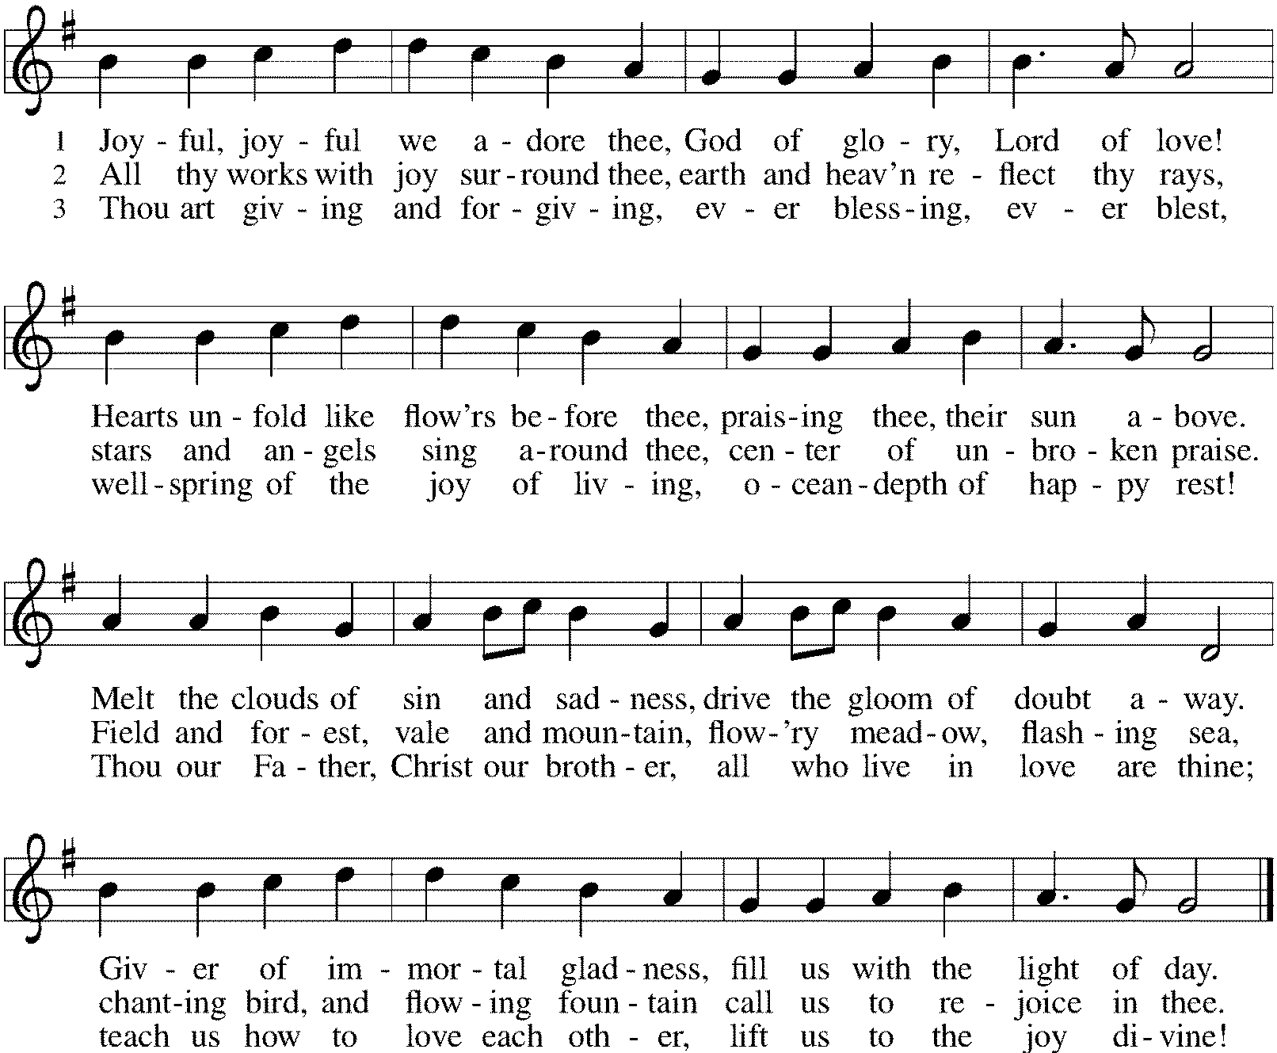

Sent to the World (Unmute your mic.)
Alleluia! Christ is risen. Christ is risen indeed. Alleluia!
Go in peace. Share the good news. Alleluia! Thanks be to God. Alleluia!

From Sundays and Seasons
v.20190109.1233 Copyright © 2021 Augsburg Fortress. All rights reserved.
Reprinted by permission under Augsburg Fortress Liturgies Annual License #30867.
All rights reserved. Reprinted under OneLicense.net #A-718333.

Current Prayer Requests
Please keep these people in your prayers and reach out to our sisters and brothers in Christian love. Names will be left on the list for two weeks, unless you indicate that they should remain in our prayers for a longer period.

Name Relationship Prayer For
Marilyn Goodrich Member 93rd Birthday (5/5)
Bob Stein Member 93rd Birthday (5/14)
Jim Sladek Member Healing & Strength
Shirley Sauerman Member Healing & Strength
Jerry Jeske Member Healing & Strength
Bob Stein Member Healing & Strength
Cathy Milleville Member Healing & Strength
Sigrid Elliott Member Healing & Strength
Dorothy Tracy Member Healing & Strength
Elizabeth Amber Friend of Pr. Melody & Marty Healing & Strength
Chris Danly Son of Mark & Pat Danly Healing & Strength
Prayers for our homebound Members
Dolores Nosal, Carol Petersen, Norma Petersen, Dorothy Stein

Church Gardens Need Volunteers: As you know, the breathtaking gardens at Grace have been because of the love and care given by Sandy Venturoni. Sandy needs to step back from tending to the gardens although she will still be responsible for the three pots at the handicap door. We need a couple of volunteers to take over this role. Sandy will provide guidance so you will not be going into this blindly. Please contact the church office asap if this is something you would be interested in doing.

Wednesday Morning In-Person Bible Study Resumes: The Wednesday 7:30am Bible Study met on May 5th for the first time since COVID began. All are welcome to participate. Discussion centers on the Gospel for the upcoming Sunday plus other topics of interest. Tim Stephan and Tim Frakes are regulars with this group meeting in the Narthex at Grace. Please contact the church office if you have any questions.
Chair Exercise and monthly Book Club. Registration is required as the number of attendees will be limited. The exercise class meets Mondays at 10:00am and Thursdays at 11:00am. The Book Club will meet on the third Tuesday of the month at 11:00am. Please contact Sue Davison at 630-858-6343 to register.

Bradford’s Livestream Music Session: Looking for something to do on Wednesday evenings? Join Bradford for LIVE music sessions broadcast directly from Grace! Let the meditative sounds of drums, guitar, and keyboards heal your woes and soothe your souls. Wednesdays at 7:00pm. Bradford plans to change up the music and the musicians each week. This is still a work in progress to please be patient with the format tweaks!
Just click on the link Wednesday evening at 7:00pm to join Bradford on his YouTube channel:
https://youtube.com/channel/UCbgfoPipBLAlY3hAkVKoI8Q

FaithTalk is returning! We have a new schedule, meeting on the 1st Thursday of the month from 12:30-2:00, beginning June 3. If you are attending Sue Davison’s exercise class that ends at noon, bring a lunch and join us in the basement after class. Those who like can eat lunch together and we’ll begin our discussion at 12:30.

House Church Worship via phone or internet every Sunday morning at 9:30am! We currently have three “House Churches” of worshipping members (each House Church consisting of 6-8 members/families meeting via Zoom or calling in by phone.) If you are unsure how to sign on, go ahead and register and let us know you need some help; we’ll walk you through it! We would be so blessed to have you join us. Register online for a House Church at graceglenellyn.org (on the main page Announcements) or contact Becky Ficarella. May 30 will be the last date for House Church.

In-Person Worship Returning: Grace will return to in-person worship in the Sanctuary on Sunday, June 6 at 9:00am. Worship assistants will be needed. Please contact your scheduler for the groups you volunteer with to get scheduled. More details will follow.

Worship Driver Needed: Shirley Sauerman would be most grateful for a ride to and from worship on Sunday mornings. Shirley lives at Beacon Hill in Lombard on Finley Road. Please contact the church office if you can provide transportation. If we can get several volunteers it would only require a commitment of every few weeks.

Contributions to Grace: You may continue to mail your contributions to the church office; have your bank mail your contribution to the church office; or contribute on-line through Grace’s website. Please know, pandemic or no, our mission continues! Thank you for your continued support of our ministries at Grace Lutheran.

RAMP: Our mortgage reduction campaign has been renamed “RAMP” (Reduce Another Mortgage Payment) as we continue to RAMP up to refinance our mortgage with Mission Investment Fund this Fall. If we can raise an additional $100,000 payment prior to our November refinancing it will take us from $925,000 to $825,000.

CROP Hunger Walk: Donations are still being accepted through the month of May. Donations can be made online at events.crophungerwalk.org/2021/mike-pertle or checks made out to CROP Hunger Walk can be mailed to the church office.

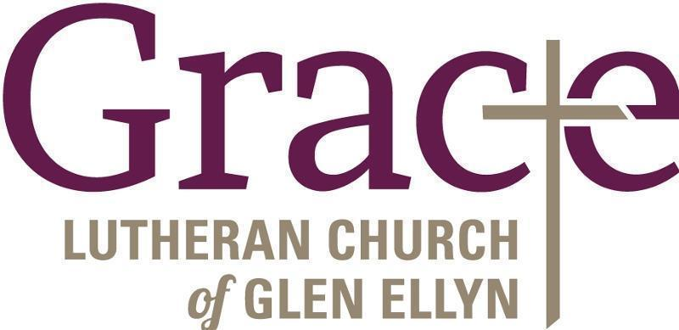

Every Member a Minister and Missionary!

Phone: 630-469-1555 Emergency Pastoral Contact: 630-674-2887
info@graceglenellyn.org www.graceglenellyn.org

Pastor
Rev. Melody Eastman office ext. 14
meastman@graceglenellyn.org

Minister of Music
Bradford Thompson 219-718-8879
bradfordmthompson@gmail.com

Ministry Associate
Becky Ficarella office ext. 17
bficarella@graceglenellyn.org

Office Manager
Barbara Sudds office ext. 10
bsudds@graceglenellyn.org

Parish Counselor
Carole LoGalbo M.S., LCPC 630-668-4594
carolelogalbo@yahoo.com

