Grace Lutheran Church

493 Forest Avenue, Glen Ellyn IL 630.469.1555
www.graceglenellyn.org

Sixth Sunday of Easter May 14, 2023

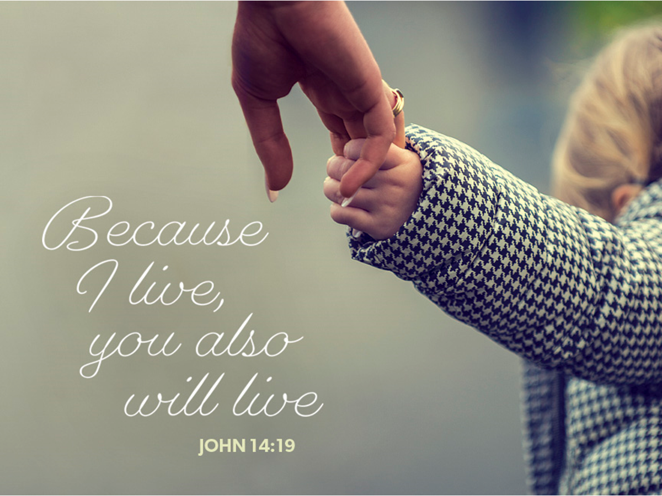

+ Proclaim Christ + Build Community +
+ Serve Our Neighbors +

Introduction
Jesus does not abandon his followers. Through the Holy Spirit, Jesus comes to abide with his disciples of every generation. As Pentecost draws near, we are reminded that the risen Christ dwells in us as the Spirit of truth. We receive this Spirit in baptism and pray that in our gathering around the Lord’s table the Spirit will transform us to be the body of the risen Christ in the world.

An asterisk (*) indicates that you should stand for that portion of the service. If standing is difficult, please remain seated. The Congregation responses are in bold print.

Gathering
The Holy Spirit calls us together as the people of God.
Welcome/Announcements

Prelude

*Please stand as you are able.
*Thanksgiving for Baptism
All may make the sign of the cross, the sign that is marked at baptism, as the presiding minister begins.
Blessed be the holy Trinity, ☩ one God, by whose hand we are given new birth, by whose speaking we are given new life. Amen.

Joined to Christ in the waters of baptism, we are welcomed, restored, and supported as citizens of the new creation. Let us give thanks for the gift of baptism. Holy God, holy and merciful, holy and mighty, you are the river of life, you are the everlasting wellspring. In mercy and might you have freed us from death and raised us with Jesus, the firstborn of the dead. In baptismal waters our old life is washed away, and in them we are born anew.
Water may be poured into the font as the presiding minister continues.

Glory to you for oceans and lakes, for rivers and streams. Honor to you for waters that wash us clean, quench our thirst, and nurture both crops and creatures. Praise to you for the life-giving water of baptism, the outpouring of the Spirit of the new creation.

Wash away our sin and all that separates us from you. Empower our witness to your resurrection. Strengthen our resolve in seeking justice for all.

Satisfy the world’s need through this living water. Where drought dries the earth, bring refreshment. Where despair prevails, grant hope. Where chaos reigns, bring peace. We ask this through Christ, who with you and the Spirit reigns forever. Amen.

*Entrance Hymn ELW #631 Love Divine, All Loves Excelling
sts. 1,2
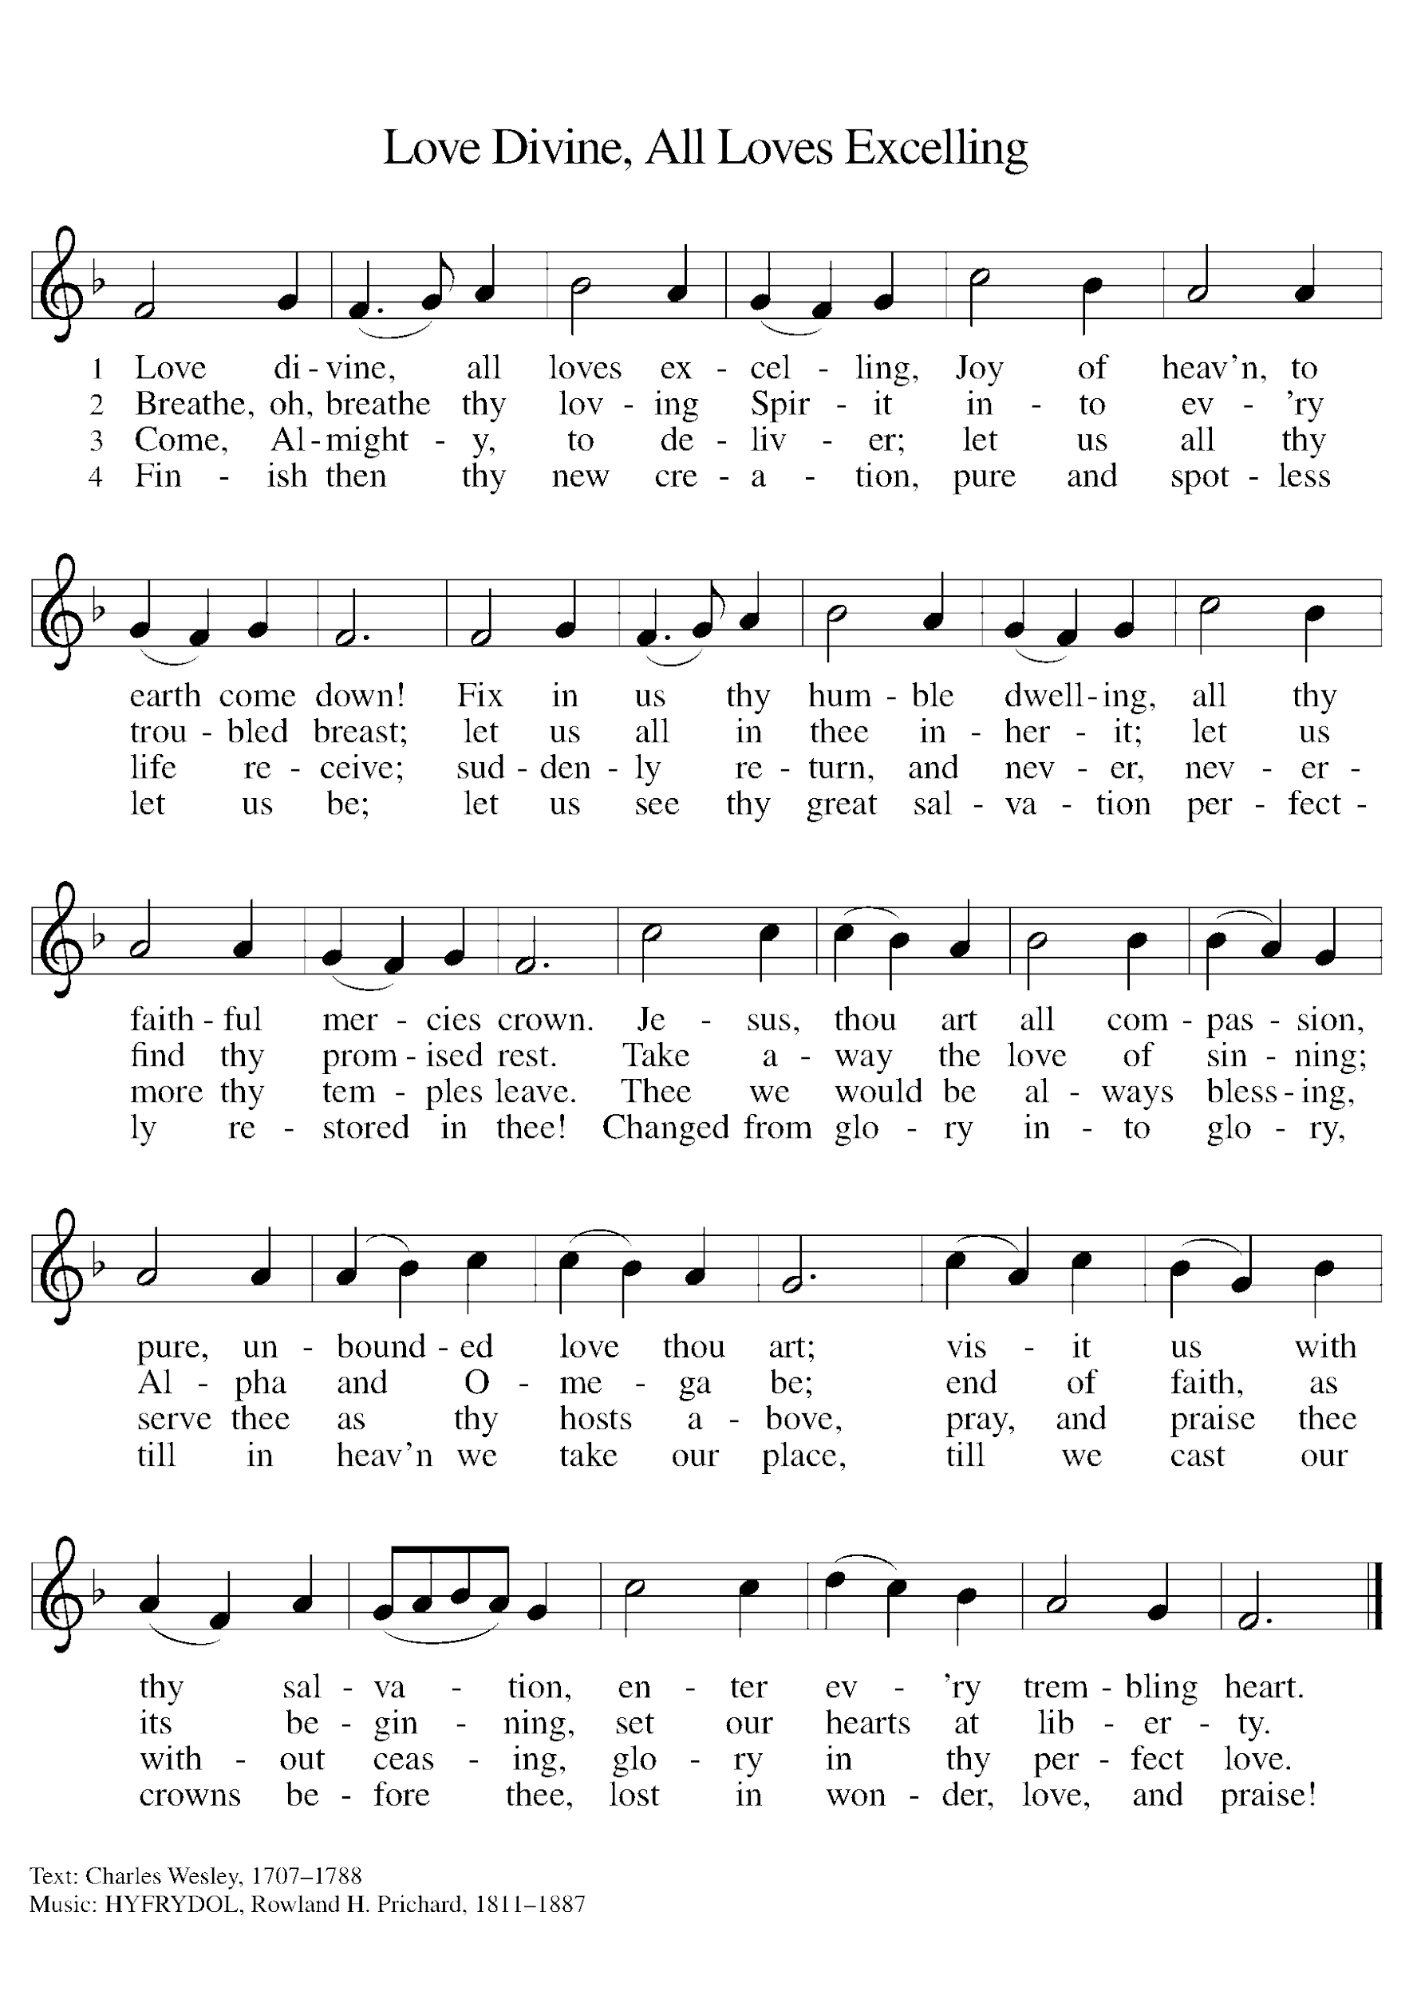

*Greeting
The grace of our Lord Jesus Christ, the love of God, and the communion of the Holy Spirit be with you all. And also with you.

*Hymn of Praise ELW p. 176 Gloria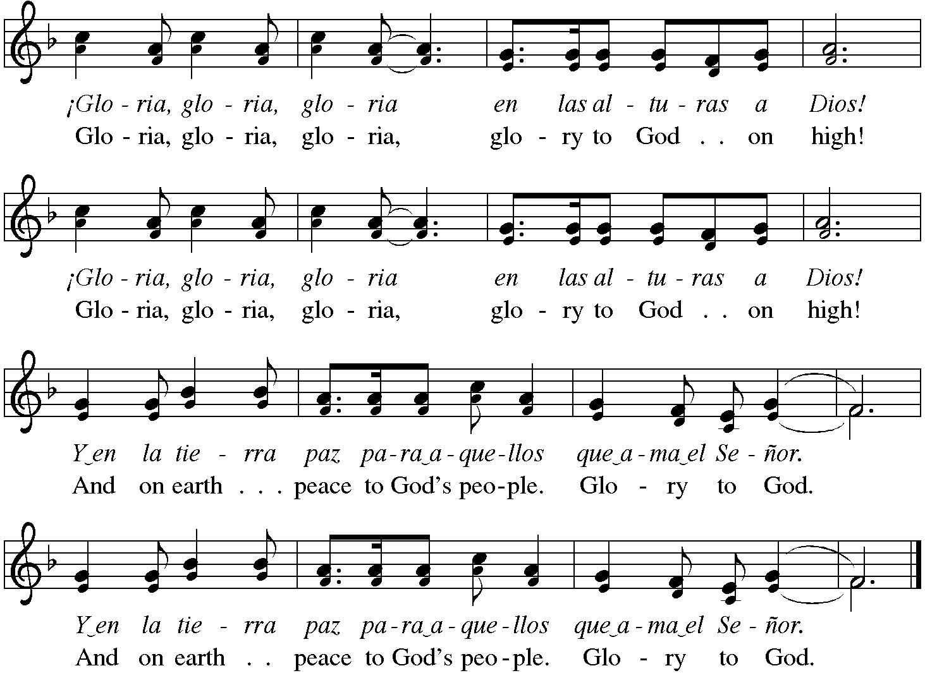

*Prayer of the Day
Almighty and ever-living God, you hold together all things in heaven and on earth. In your great mercy receive the prayers of all your children, and give to all the world the Spirit of your truth and peace, through Jesus Christ, our Savior and Lord, who lives and reigns with you and the Holy Spirit, one God, now and forever. Amen. Be seated.
Word
God speaks to us in scripture reading.
First Lesson Acts 17:22-31
In Athens, Paul faces the challenge of proclaiming the gospel to Greeks who know nothing of either Jewish or Christian tradition. He proclaims that the “unknown god” whom they worship is the true Lord of heaven and earth who will judge the world with justice through Jesus, whom God has raised from the dead.

²²Paul stood in front of the Areopagus and said, “Athenians, I see how extremely religious you are in every way. ²³For as I went through the city and looked carefully at the objects of your worship, I found among them an altar with the inscription, ‘To an unknown god.’ What therefore you worship as unknown, this I proclaim to you. ²⁴The God who made the world and everything in it, he who is Lord of heaven and earth, does not live in shrines made by human hands, ²⁵nor is he served by human hands, as though he needed anything, since he himself gives to all mortals life and breath and all things. ²⁶From one ancestor he made all nations to inhabit the whole earth, and he allotted the times of their existence and the boundaries of the places where they would live, ²⁷so that they would search for God and perhaps grope for him and find him—though indeed he is not far from each one of us. ²⁸For ‘In him we live and move and have our being’; as even some of your own poets have said,
‘For we too are his offspring.’
²⁹Since we are God’s offspring, we ought not to think that the deity is like gold, or silver, or stone, an image formed by the art and imagination of mortals. ³⁰While God has overlooked the times of human ignorance, now he commands all people everywhere to repent, ³¹because he has fixed a day on which he will have the world judged in righteousness by a man whom he has appointed, and of this he has given assurance to all by raising him from the dead.”

Word of God, Word of Life. Thanks be to God.

Second Lesson 1 Peter 3:13-22
The author of 1 Peter encourages Christians to remain faithful even in the face of defamation and persecution. In baptism we are made clean to act in accordance with what is right.

¹³Who will harm you if you are eager to do what is good? ¹⁴But even if you do suffer for doing what is right, you are blessed. Do not fear what they fear, and do not be intimidated, ¹⁵but in your hearts sanctify Christ as Lord. Always be ready to make your defense to anyone who demands from you an accounting for the hope that is in you; ¹⁶yet do it with gentleness and reverence. Keep your conscience clear, so that, when you are maligned, those who abuse you for your good conduct in Christ may be put to shame. ¹⁷For it is better to suffer for doing good, if suffering should be God’s will, than to suffer for doing evil. ¹⁸For Christ also suffered for sins once for all, the righteous for the unrighteous, in order to bring you to God. He was put to death in the flesh, but made alive in the spirit, ¹⁹in which also he went and made a proclamation to the spirits in prison, ²⁰who in former times did not obey, when God waited patiently in the days of Noah, during the building of the ark, in which a few, that is, eight persons, were saved through water. ²¹And baptism, which this prefigured, now saves you—not as a removal of dirt from the body, but as an appeal to God for a good conscience, through the resurrection of Jesus Christ, ²²who has gone into heaven and is at the right hand of God, with angels, authorities, and powers made subject to him.

Word of God, Word of Life. Thanks be to God.

*Please stand as you are able.
*Gospel Acclamation

The holy Gospel according to John. Glory to you, O Lord.

*Gospel John 14:15-21
In final words to his disciples on the night of his arrest, Jesus encourages obedience to his commandments and speaks of the Spirit, who will be with them forever.

[Jesus said to the disciples:] ¹⁵“If you love me, you will keep my commandments. ¹⁶And I will ask the Father, and he will give you another Advocate, to be with you forever. ¹⁷This is the Spirit of truth, whom the world cannot receive, because it neither sees him nor knows him. You know him, because he abides with you, and he will be in you.
¹⁸“I will not leave you orphaned; I am coming to you. ¹⁹In a little while the world will no longer see me, but you will see me; because I live, you also will live. ²⁰On that day you will know that I am in my Father, and you in me, and I in you. ²¹They who have my commandments and keep them are those who love me; and those who love me will be loved by my Father, and I will love them and reveal myself to them.”

The Gospel of the Lord. Praise to you, O Christ. Be seated.

Sermon Rev. Melody Eastman

*Please stand as you are able.
*Hymn of the Day ELW #804 Come Down, O Love Divine
sts. 1,4
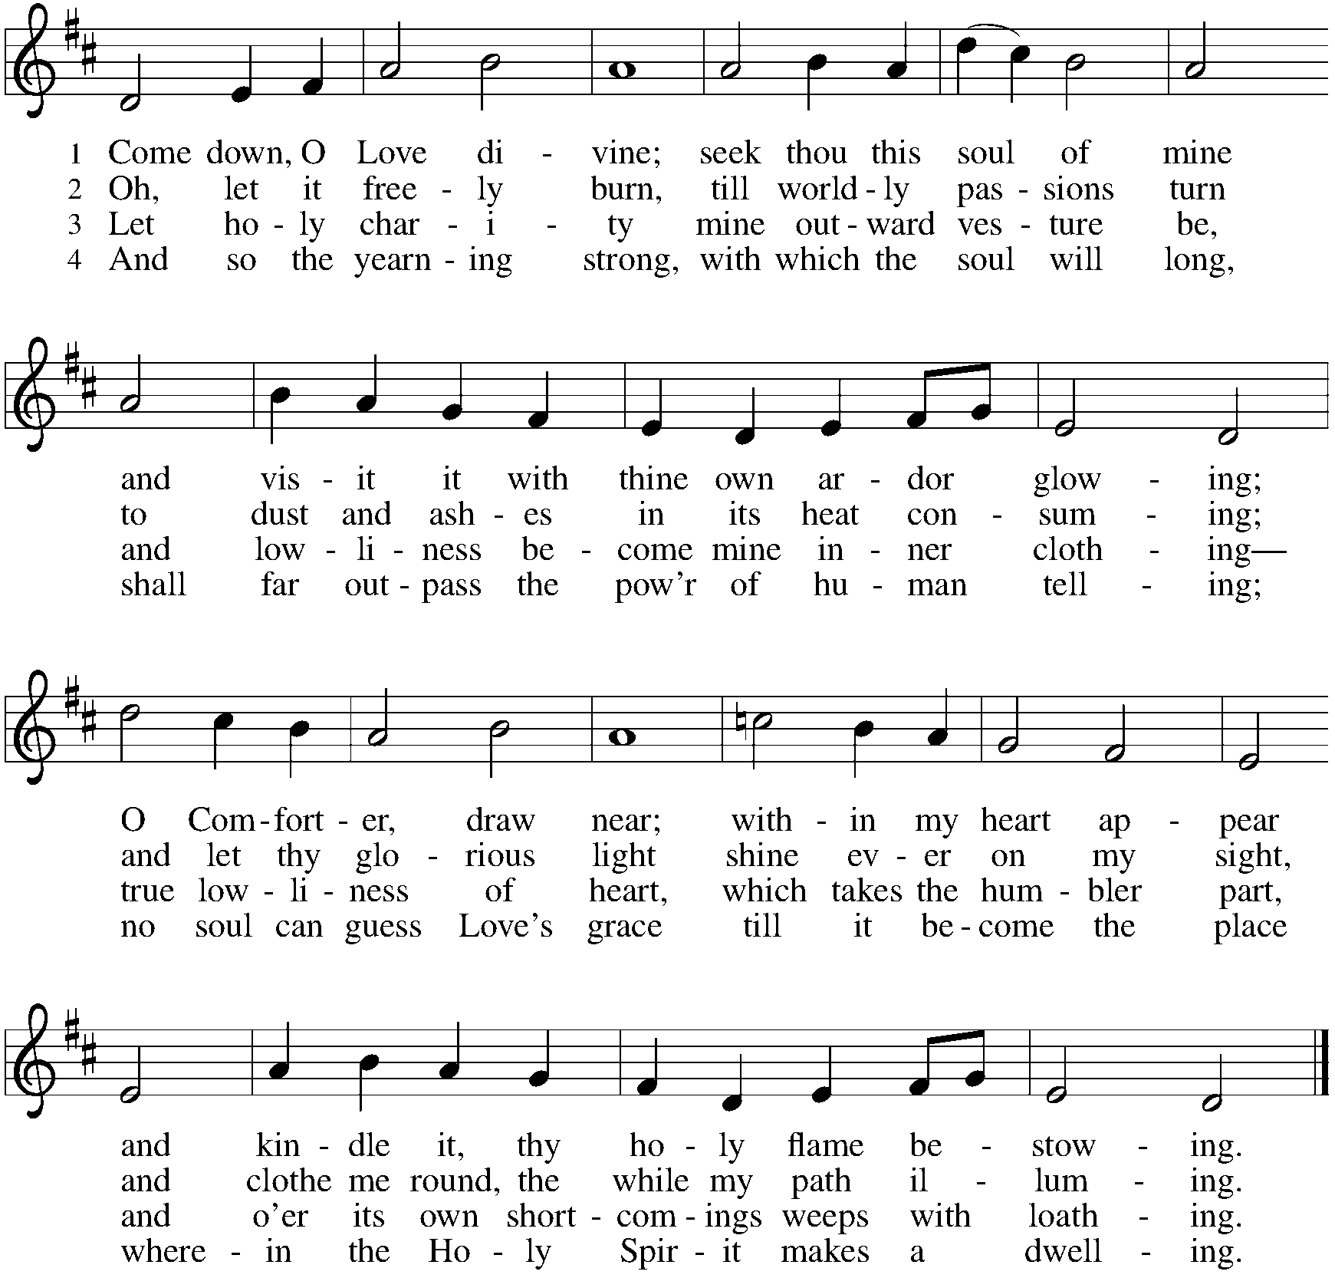

*Please stand as you are able
*Prayers of Intercession
Each petition concludes with “Hear us, O God.” Congregation responds, “Your mercy is great.”

Rejoicing in the victory of Christ’s resurrection, we lift our prayers and praise to you, almighty and eternal God; through Jesus Christ, our risen Lord. Amen.

*Peace
The peace of Christ be with you always. And also with you.
Gathering of Gifts
We gather gifts for those in need and for the church’s mission.

Music During Offering

*Please stand as you are able. The gifts are brought forward while the congregation sings:
*Offertory ELW #531 The Trumpets Sound, the Angels Sing
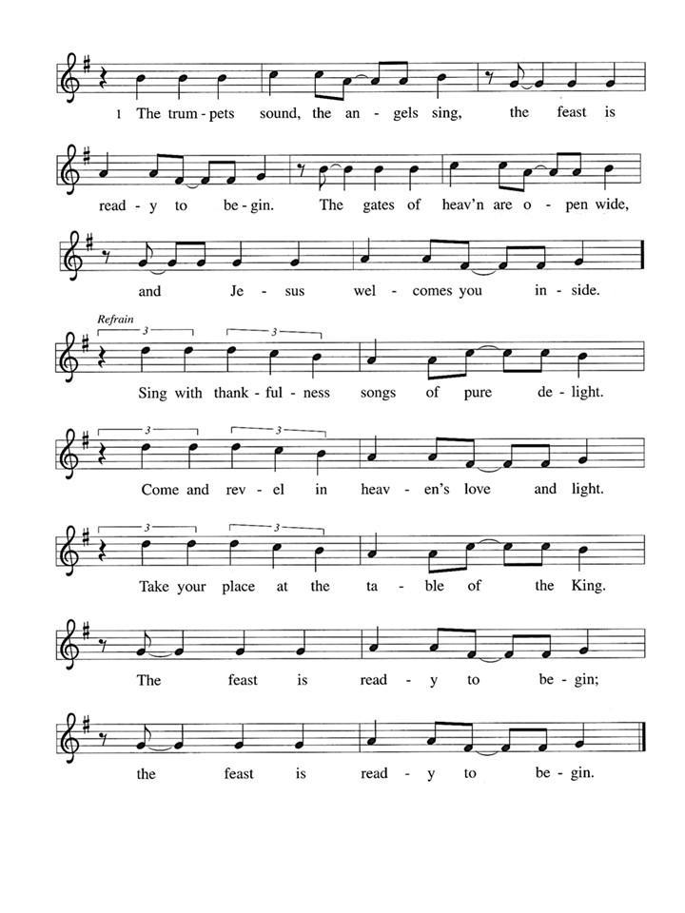

Meal
God feeds us with the presence of Jesus Christ.
*Offering Prayer
Generous God, in this meal you offer your very self. We give thanks for these gifts of the earth. In the breaking of this bread reveal to us the Risen One. In the pouring of this wine pour us out in service to the world; through Christ our Lord. Amen.

*Great Thanksgiving
The Lord be with you. And also with you.
Lift up your hearts. We lift them to the Lord.
Let us give thanks to the Lord our God. It is right to give our thanks and praise.

*Preface

Sanctus p. 181 Holy, Holy, Holy
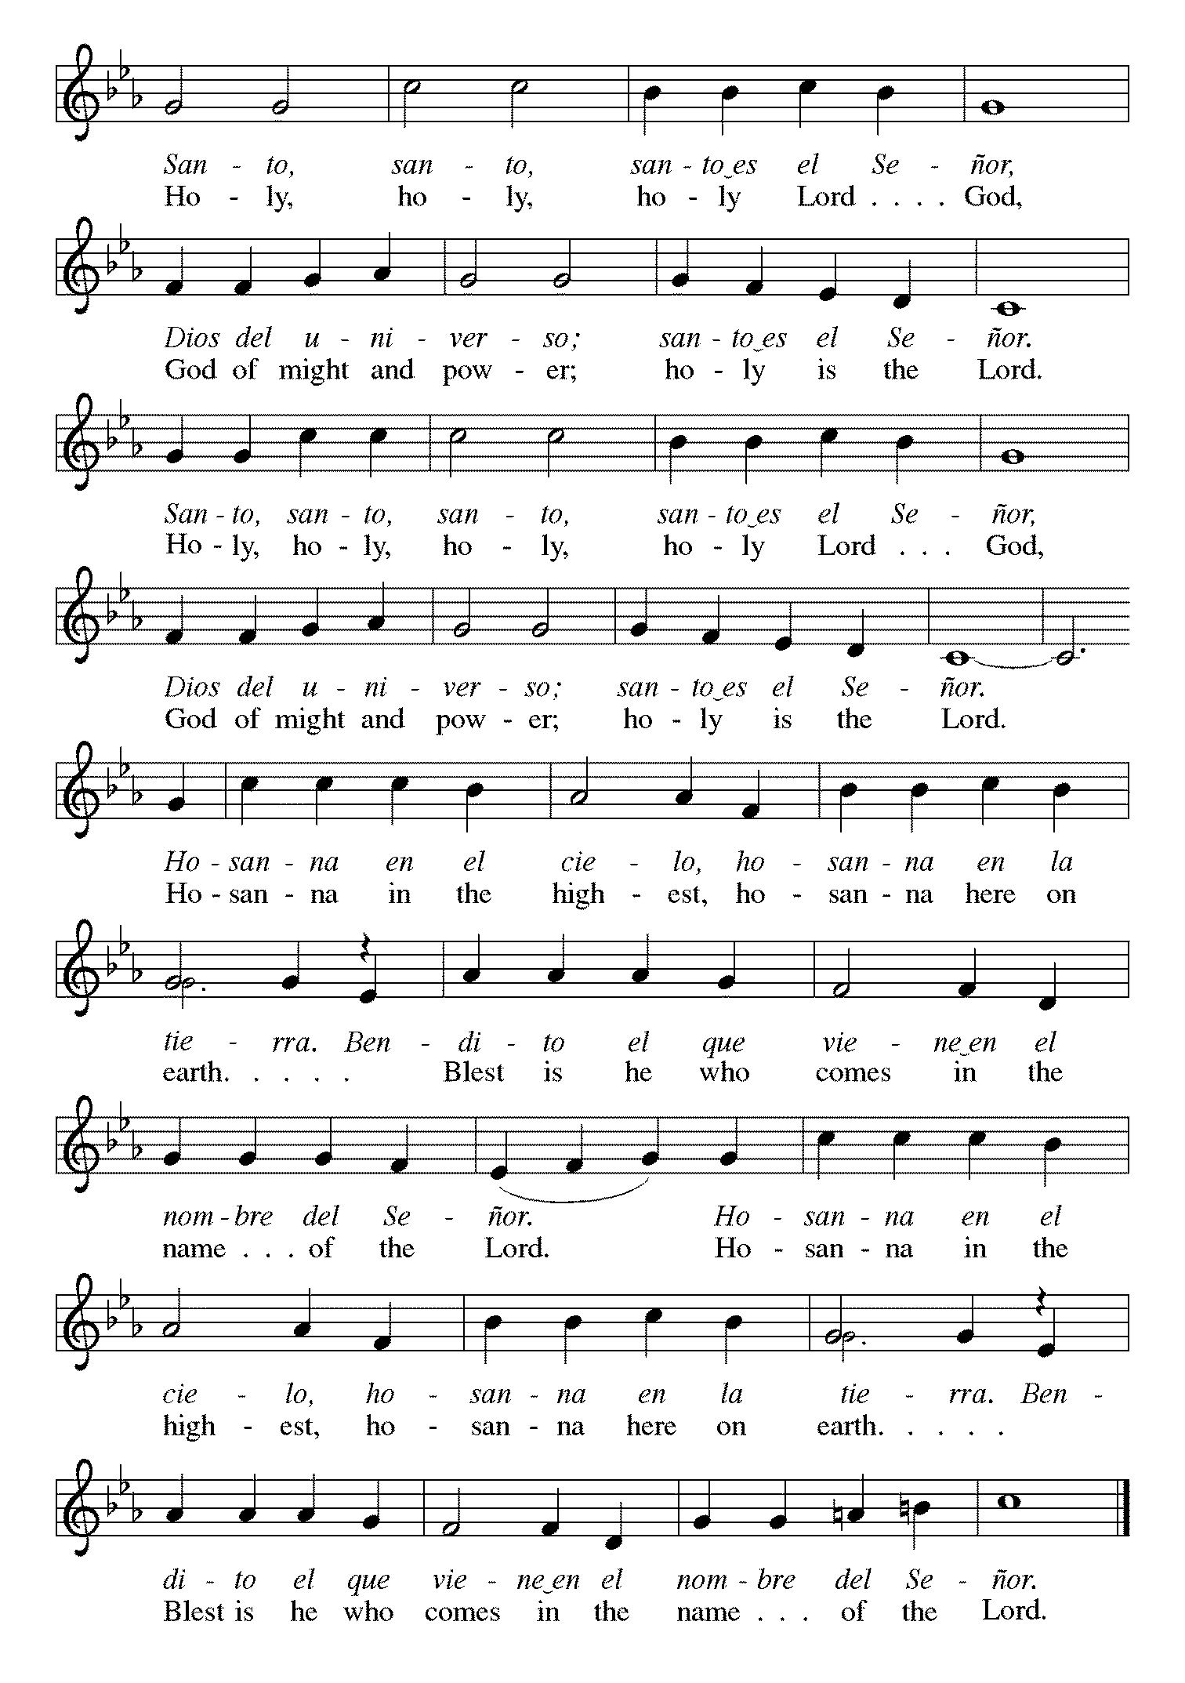

*Thanksgiving at the Table
. . . Again, after supper, he took the cup, gave thanks, and gave it for all to drink, saying: This cup is the new covenant in my blood, shed for you and for all people for the forgiveness of sin. Do this for the remembrance of me. For as often as we eat of this bread and drink from this cup, we proclaim the Lord’s death until he comes. Christ has died. Christ is risen. Christ will come again.

Remembering, therefore, his salutary command, his life-giving passion and death, his glorious resurrection and ascension, and the promise of his coming again, we give thanks to you, O Lord God Almighty, not as we ought but as we are able; we ask you mercifully to accept our praise and thanksgiving and with your Word and Holy Spirit to bless us, your servants, and these your own gifts of bread and wine, so that we and all who share in the body and blood of Christ may be filled with heavenly blessing and grace, and, receiving the forgiveness of sin, may be formed to live as your holy people and be given our inheritance with all your saints.

To you, O God, Father, Son, and Holy Spirit, be all honor and glory in your holy church, now and forever.
Amen.

*The Lord’s Prayer
Gathered into one by the Holy Spirit, let us pray as Jesus taught us.
Our Father, who art in heaven, hallowed be thy name, thy kingdom come, thy will be done on earth as it is in heaven. Give us this day our daily bread; and forgive us our trespasses, as we forgive those who trespass against us; and lead us not into temptation, but deliver us from evil. For thine is the kingdom, and the power, and the glory, forever and ever. Amen.

*Invitation to Communion
Come and know Christ, broken and poured out for you. Be seated.

Communion
For those receiving communion in the pew or from home:
This is the body of Christ, given for you. Amen (Eat the bread.)
This is the blood of Christ, shed for you. Amen (Drink the juice.)
Agnus Dei p. 182 Lamb of God
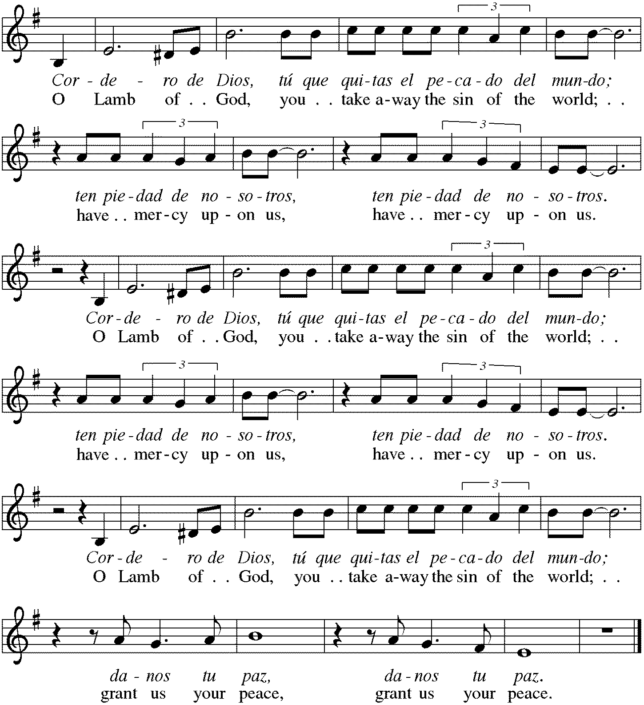

Music During Communion ELW #613 Thy Holy Wings
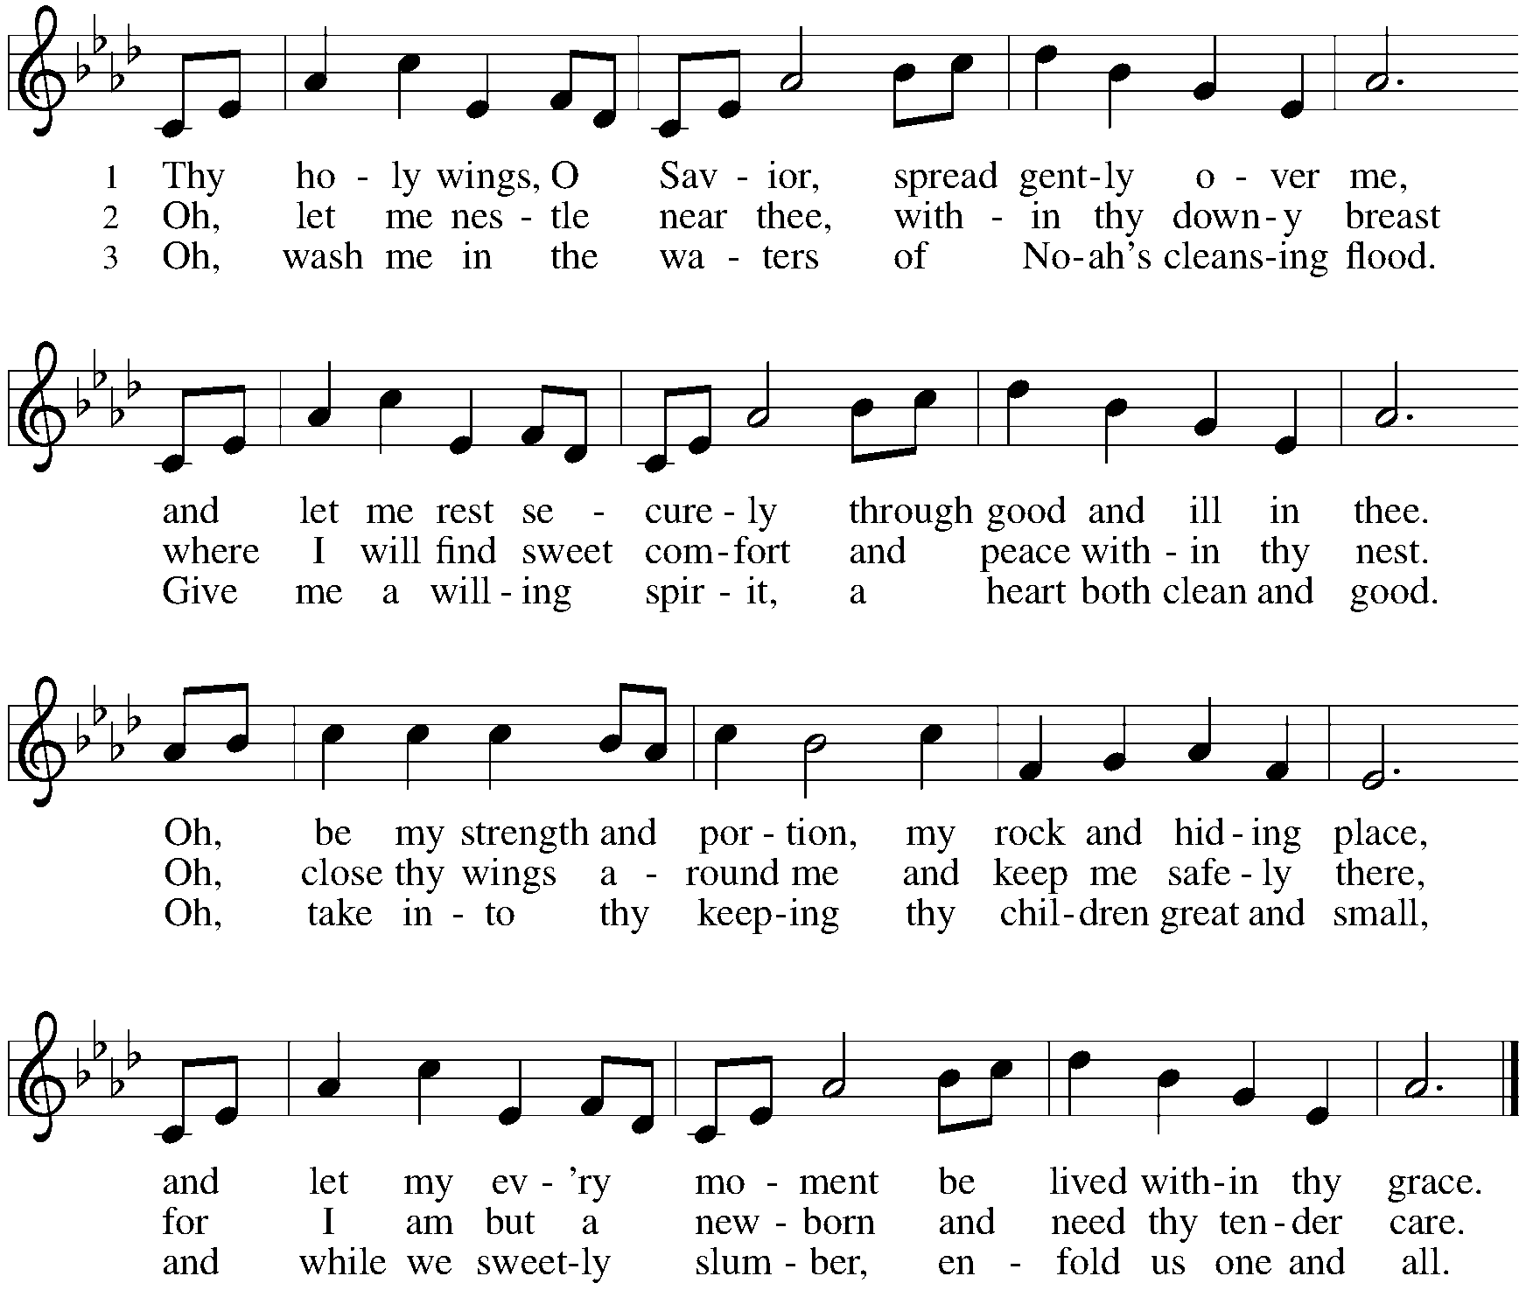

*Please stand as you are able.
*Post Communion Blessing
May the body and blood of our Lord Jesus Christ strengthen you and keep you in his grace. Amen.

*Post Communion Prayer
Gracious God, in you we live and move and have our being. With your word and this meal of grace, you have nourished our life together. Strengthen us to show your love and serve the world in Jesus’ name. Amen.

Sending
God blesses us and sends us in mission to the world.
*Blessing
The God of all, who raised ☩ Jesus from the dead, bless us by the power of the Holy Spirit to live in the new creation. Amen.

*Sending Hymn ELW #839 Now Thank We All Our God
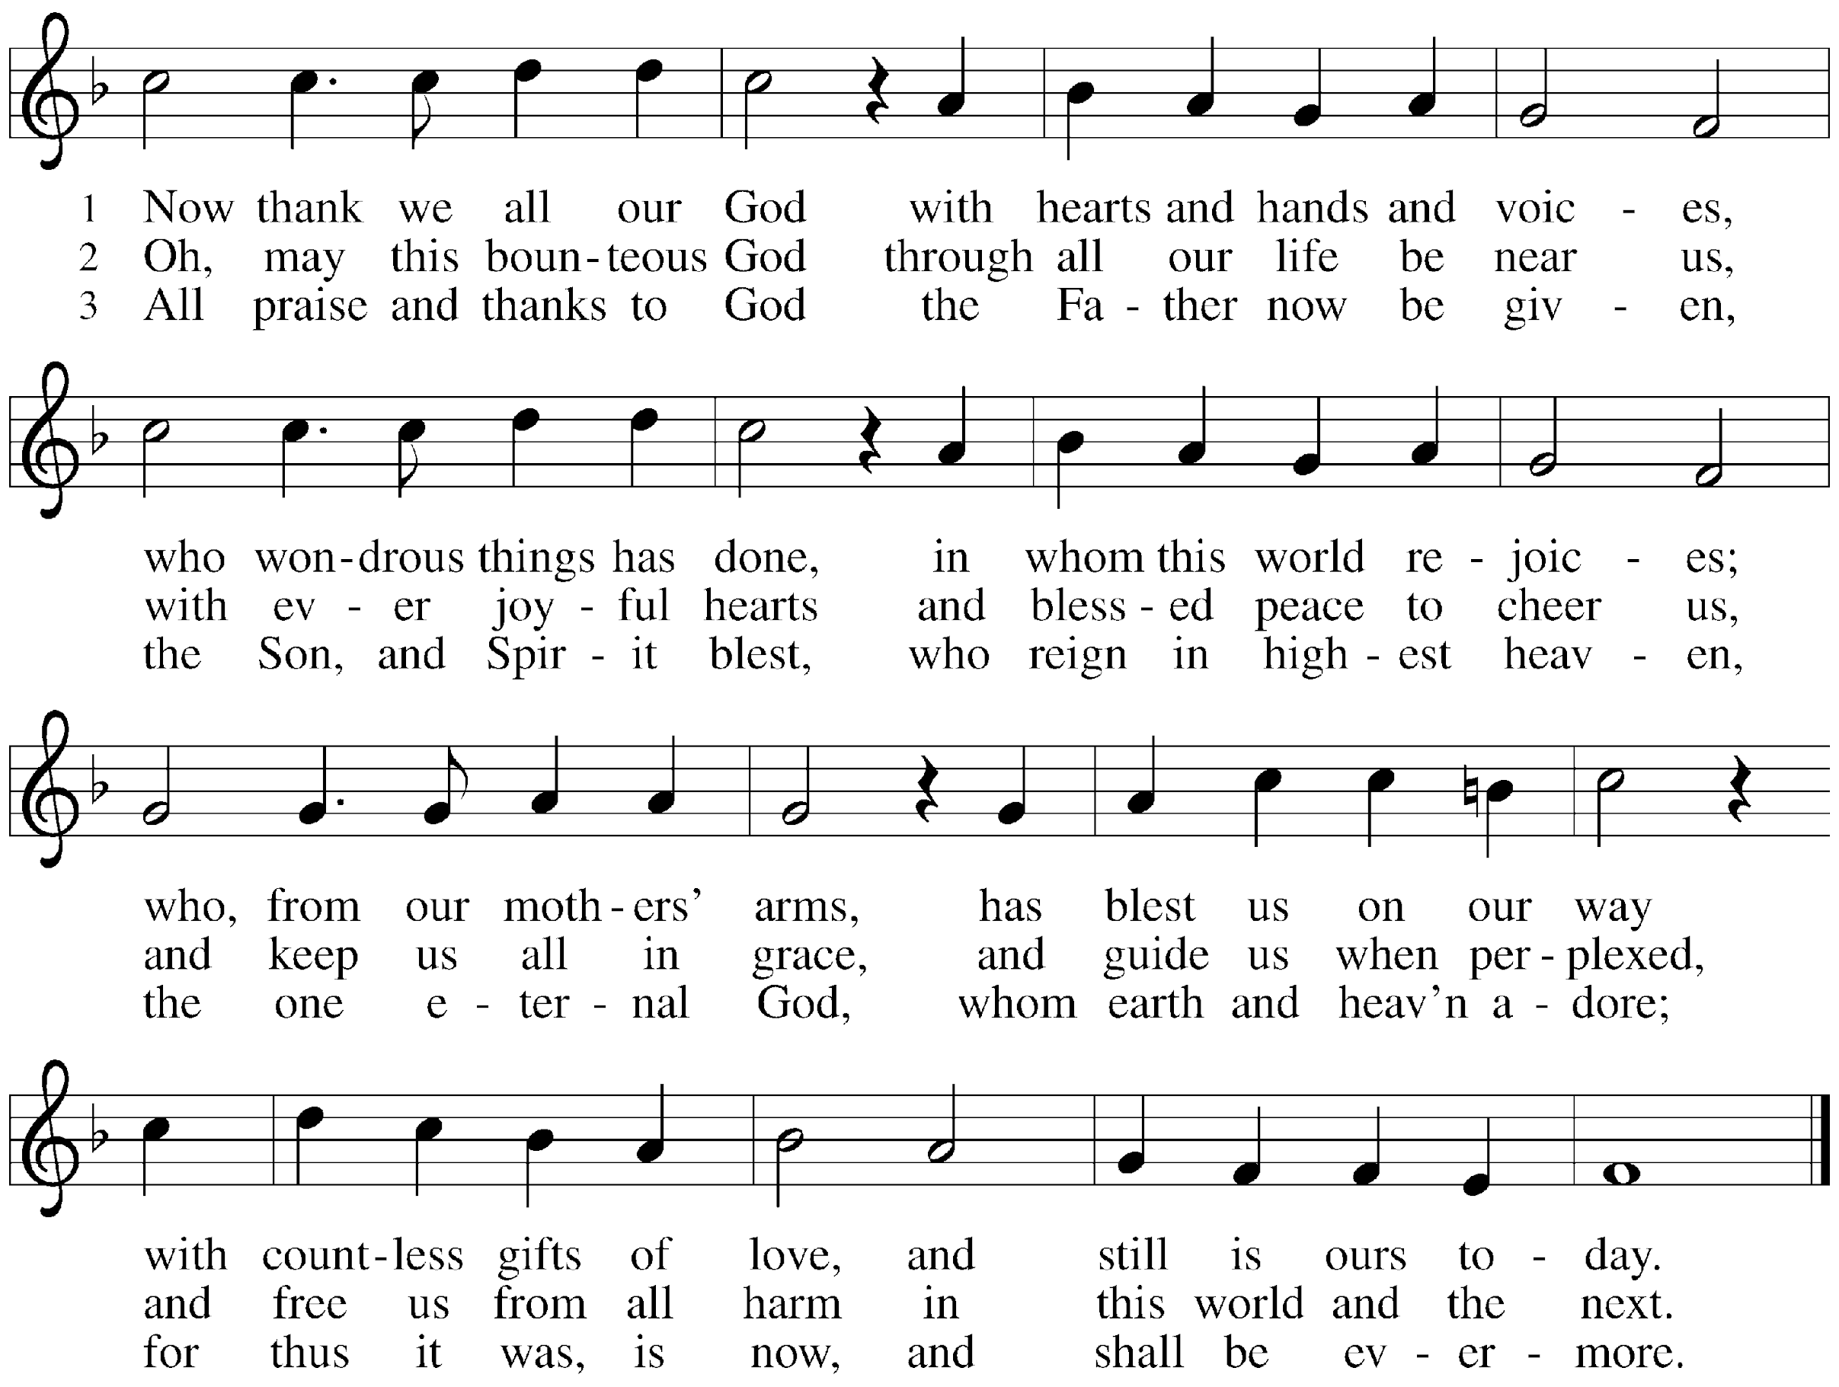

*Sent to the World
Go in peace. Serve the Risen One. Thanks be to God.

Postlude

From Sundays and Seasons v.20190109.1233 Copyright © 2023 Augsburg Fortress. All rights reserved.
Reprinted by permission under Augsburg Fortress Liturgies Annual License #30867.
All rights reserved. Reprinted under OneLicense.net #A-718333.

Assisting in Worship Today
Worship Leader Rev. Melody Eastman
Minister of Music Bradford Thompson
Altar Care Linda Kelly
Lector Karen Kregor
Ushers Jacky Anderson, Jeff Nelson
Zoom Mark Hamilton, Jon & Cathy Milleville
Fellowship Hour Jean Jeske
Altar Flowers Jerry & Brigitte Miller in memory and honor of Mom
Current Prayer Requests
Name Relationship Prayer For
Greg Barber Member Healing & Strength
Rich Davison Member Healing & Strength
Greg & Donna Barber Members 51st Anniversary 5/13
Marilyn Goodrich Member 95th Birthday 5/5
Kathy Meyer Mother of Susi Nelson Healing & Strength
Luke Pajowski Relative of the Roetes Healing & Strength
Lori Garabrandt Niece of Lois Pertle Healing & Strength
Prayers for our homebound Members
Norma Peterson, Dorothy Tracy
Weekly Announcements
West Suburban Barn Dance with Jonathan Whitall: Sunday, May 14 at 2:00pm. Join us for the All Ages West Suburban Barn Dance in the second floor gym at Grace Lutheran Church! It will be an afternoon of fun dancing to LIVE fiddle tunes. All dances taught; no partner needed. Come at 2pm for an hour of kid-friendly dances, followed by contras, squares and much more. FYI: Jonathan has the gym reserved for the second Sunday of every month starting in September!
CROPWalk: Thank you all for your support on May 7. What a great day for a walk!!! We will be accepting donations until Friday, May 26th. We’re at $14,846 (online) and we hope to hit the $25,000 goal once all the cash and checks are accounted for. Donate on the website now!! Make Checks payable to CWS/Crop. Mike Pertle mike.pertle@gmail.com, 630-488-0880

https://events.crophungerwalk.org/2023/team/grace-lutheran-glen-ellyn-il

Children’s Ministry Coordinator Position: Grace is seeking someone to fill the position of Children’s Ministry Coordinator—a somewhat pared down position previously held by Becky Ficarella. This position will focus on faith formation and events for our kids in Sunday School, and will involve working with teachers and parents, organizing curriculum and materials, working with VBS, and coordinating with the pastor on Confirmation ministry. The position will require roughly 10-12 hours per week on a flexible schedule. If you are interested, please contact Pastor Melody.

People of Grace at Reserve 22: Please join the People of Grace for dinner and fun conversation on Tuesday, May 16 at 7pm. Please RSVP to Jeff Nelson at jeff.nelson@vlses.com if you are planning to attend.

Confirmation Service: Sunday, May 21 at 10am. Join us as we celebrate with Evelyn Dieter, Abby Nelson, and Lilly Nelson in the rite of confirmation. There will be a reception following the Confirmation Service. Please join us in congratulating our Confirmands!

Sharing Circle: Let's Talk About Race. In May, the sharing circle on racial healing will be meeting after worship on May 21. Using The Little Book of Racial Healing (by Thomas Norman DeWolf and Jodie Geddes) as a starting point, we explore the ways in which experiences of race and racial disparities are affecting our lives and our community. The format of the sharing circle is based on a mutual agreement to create a safe space for all who choose to participate and to practice deep listening as we talk about difficult topics. We will be meeting in the Great Room and all are welcome to join.

Grace Arts and Apps: Calling all artists of all ages and those with art they would like to share. The Social Committee is hosting an Arts and Apps event on Sunday, June 4 after worship in the narthex. We will exhibit artwork of Grace's members for the congregation to see while enjoying some light refreshments in the form of appetizers. Do you have some art that you have made as a hobby or profession? Do you own some artwork you would like to bring and show that day? There will be a sign-up in the narthex so we know how many tables to set up. And, if you don't have any art to share, perhaps you would like to make an appetizer to share.

A reminder about Pastor Melody’s days off: Pastor Melody’s days off are Friday and Saturday. If you wish to reach out to her for a non-emergency communication, it is best to do so Monday through Thursday. In particular, text messages received on her days off are most likely to get lost in the string of other texts she receives. Email is the best way to be sure she will get your message at a time when she can respond. Of course, in case of a pastoral emergency (death or serious illness/injury) you may reach out to her via phone, text or email at any time.

Every Member a Minister and Missionary!

Phone: 630-469-1555 Emergency Pastoral Contact: 630-674-2887
info@graceglenellyn.org www.graceglenellyn.org

Pastor
Rev. Melody Eastman office ext. 14
meastman@graceglenellyn.org

Minister of Music
Bradford Thompson 219-718-8879
bradfordmthompson@gmail.com

Office Manager
Barbara Sudds office ext. 10
bsudds@graceglenellyn.org

Parish Counselor
Carole LoGalbo M.S., LCPC 630-668-4594
carolelogalbo@yahoo.com

