Grace Lutheran Church

Fifth Sunday of Easter May 15, 2022

Introduction
Easter initiates a new day. It anticipates a new heaven and a new earth. The risen Christ is making all things new. In the mystery of holy baptism God has made new people of us. Today Jesus invites us to see everyone in a new light—through the lens of love.

An asterisk (*) indicates that you should stand for that portion of the service. If standing is difficult, please remain seated. Congregation responses are in bold print.

Gathering
The Holy Spirit calls us together as the people of God.

Welcome/Announcements

Prelude Krystal Bells Amazing Grace

*Please stand as you are able and turn to face the font.
*Thanksgiving for Baptism
All may make the sign of the cross, the sign marked at baptism, as the presiding minister begins.

Alleluia! Christ is risen. Christ is risen indeed. Alleluia!

In the waters of baptism, we have passed over from death to life with Jesus Christ, and we are a new creation. For this saving mystery, and for this water, let us bless God, who was, who is, and who is to come.

We thank you, God, for your river of life, flowing freely from your throne: through the earth, through the city, through every living thing. You rescued Noah and his family from the flood; You opened wide the sea for the Israelites. Now in these waters you flood us with mercy, and our sin is drowned forever. You open the gate of righteousness and we pass safely through. In Jesus Christ, you calm and trouble the waters. You nourish us and enclose us in safety. You call us forth and send us out. In lush and barren places, you are with us. You have become our salvation. Now breathe upon this water and awaken your church once more. Claim us again as your beloved and holy people. Quench our thirst; cleanse our hearts; wipe away every tear. To you, our Beginning and our End, our Shepherd and Lamb, be honor, glory, praise, and thanksgiving, now and forever.
Amen.

*Entrance Hymn God Welcomes All

*Greeting
The grace of our Lord Jesus Christ, the love of God, and the communion of the Holy Spirit be with you all.
And also with you

*Hymn of Praise ELW #164 Glory to God
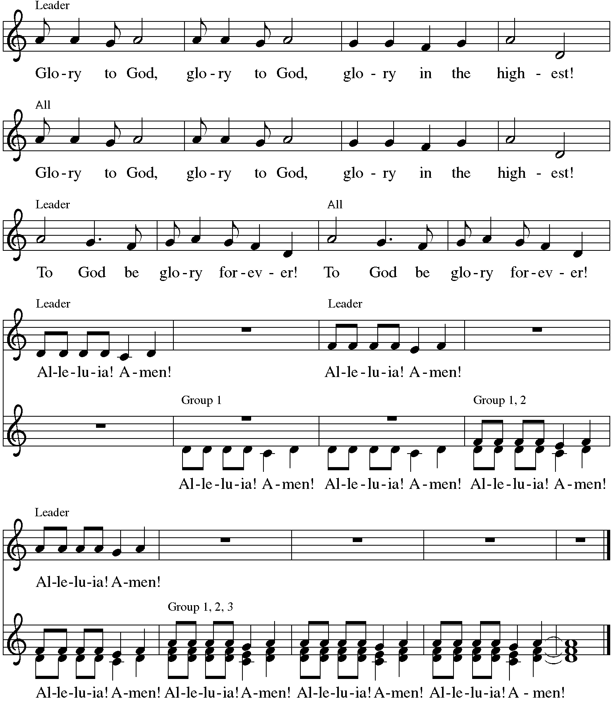

*Prayer of the Day
O Lord God, you teach us that without love, our actions gain nothing. Pour into our hearts your most excellent gift of love, that, made alive by your Spirit, we may know goodness and peace, through your Son, Jesus Christ, our Savior and Lord, who lives and reigns with you and the Holy Spirit, one God, now and forever. Amen. Be seated.
Word
God speaks to us in scripture reading.
First Lesson Acts 11:1-18
In defense of his earlier baptism of non-Jewish believers, Peter demonstrates to the members of the Jerusalem church that God’s intention to love Gentiles as well as Jews is revealed in Jesus’ testimony. In this way the mission to the Gentiles is officially authorized.

¹Now the apostles and the believers who were in Judea heard that the Gentiles had also accepted the word of God. ²So when Peter went up to Jerusalem, the circumcised believers criticized him, ³saying, “Why did you go to uncircumcised men and eat with them?” ⁴Then Peter began to explain it to them, step by step, saying, ⁵“I was in the city of Joppa praying, and in a trance I saw a vision. There was something like a large sheet coming down from heaven, being lowered by its four corners; and it came close to me. ⁶As I looked at it closely I saw four-footed animals, beasts of prey, reptiles, and birds of the air. ⁷I also heard a voice saying to me, ‘Get up, Peter; kill and eat.’ ⁸But I replied, ‘By no means, Lord; for nothing profane or unclean has ever entered my mouth.’ ⁹But a second time the voice answered from heaven, ‘What God has made clean, you must not call profane.’ ¹⁰This happened three times; then everything was pulled up again to heaven. ¹¹At that very moment three men, sent to me from Caesarea, arrived at the house where we were. ¹²The Spirit told me to go with them and not to make a distinction between them and us. These six brothers also accompanied me, and we entered the man’s house. ¹³He told us how he had seen the angel standing in his house and saying, ‘Send to Joppa and bring Simon, who is called Peter; ¹⁴he will give you a message by which you and your entire household will be saved.’ ¹⁵And as I began to speak, the Holy Spirit fell upon them just as it had upon us at the beginning. ¹⁶And I remembered the word of the Lord, how he had said, ‘John baptized with water, but you will be baptized with the Holy Spirit.’ ¹⁷If then God gave them the same gift that he gave us when we believed in the Lord Jesus Christ, who was I that I could hinder God?” ¹⁸When they heard this, they were silenced. And they praised God, saying, “Then God has given even to the Gentiles the repentance that leads to life.”

Word of God, Word of Life. Thanks be to God.

Psalm Psalm 148
The Psalm is read responsively by verse.
¹Hallelujah! Praise the Lord from the heavens; praise God in the heights.
²Praise the Lord, all you angels; sing praise, all you hosts of heaven.
³Praise the Lord, sun and moon; sing praise, all you shining stars.
⁴Praise the Lord, heaven of heavens, and you waters above the heavens.
⁵Let them praise the name of the Lord, who commanded, and they were created,
⁶who made them stand fast forever and ever, giving them a law that shall not pass away.
⁷Praise the Lord from the earth, you sea monsters and all deeps;
⁸fire and hail, snow and fog, tempestuous wind, doing God’s will;
⁹mountains and all hills, fruit trees and all cedars;
¹⁰wild beasts and all cattle, creeping things and flying birds;
¹¹sovereigns of the earth and all peoples, princes and all rulers of the world;
¹²young men and maidens, old and young together.
¹³Let them praise the name of the Lord, whose name only is exalted, whose splendor is over earth and heaven.
¹⁴The Lord has raised up strength for the people and praise for all faithful servants, the children of Israel, a people who are near the Lord. Hallelujah!

Second Lesson Revelation 21:1-6
John’s vision shows us that in the resurrection the new age has dawned; God dwells with us already. Yet we wait for the time when the tears that cloud our vision will be wiped away. Then we will see the new heaven, new earth, and new Jerusalem.

¹I saw a new heaven and a new earth; for the first heaven and the first earth had passed away, and the sea was no more. ²And I saw the holy city, the new Jerusalem, coming down out of heaven from God, prepared as a bride adorned for her husband. ³And I heard a loud voice from the throne saying, “See, the home of God is among mortals. He will dwell with them; they will be his peoples, and God himself will be with them; ⁴he will wipe every tear from their eyes. Death will be no more; mourning and crying and pain will be no more, for the first things have passed away.”
⁵And the one who was seated on the throne said, “See, I am making all things new.” Also he said, “Write this, for these words are trustworthy and true.” ⁶Then he said to me, “It is done! I am the Alpha and the Omega, the beginning and the end. To the thirsty I will give water as a gift from the spring of the water of life.”

Word of God, Word of Life. Thanks be to God.

*Please stand as you are able.
*Gospel Acclamation Hallelujah!

The holy Gospel according to John. Glory to you, O Lord.
*Gospel John 13:31-35
After washing the disciples’ feet, predicting his betrayal, and then revealing his betrayer, Jesus speaks of his glorification on the cross. This deep complicated love of Jesus, even to death on the cross, will be the distinctive mark of Jesus’ community.

³¹When he had gone out, Jesus said, “Now the Son of Man has been glorified, and God has been glorified in him. ³²If God has been glorified in him, God will also glorify him in himself and will glorify him at once. ³³Little children, I am with you only a little longer. You will look for me; and as I said to the Jews so now I say to you, ‘Where I am going, you cannot come.’ ³⁴I give you a new commandment, that you love one another. Just as I have loved you, you also should love one another. ³⁵By this everyone will know that you are my disciples, if you have love for one another.”

The Gospel of the Lord. Praise to you, O Christ. Be seated.

Proclamation in Drama & Song “Dear Journal: I’m a Christian!” Children of Grace

*Please stand as you are able
*Hymn of the Day ELW #377 Alleluia! Jesus is Risen! sts. 1, 3, 5
*The Nicene Creed
With the whole church, let us confess our faith.
We believe in one God, the Father, the Almighty, maker of heaven and earth,
of all that is, seen and unseen.
We believe in one Lord, Jesus Christ, the only Son of God, eternally begotten of the Father, God from God, Light from Light, true God from true God, begotten, not made, of one Being with the Father; through him all things were made. For us and for our salvation he came down from heaven, was incarnate of the Holy Spirit and the virgin Mary and became truly human. For our sake he was crucified under Pontius Pilate; he suffered death and was buried. On the third day he rose again in accordance with the scriptures; he ascended into heaven and is seated at the right hand of the Father. He will come again in glory to judge the living and the dead, and his kingdom will have no end.
We believe in the Holy Spirit, the Lord, the giver of life, who proceeds from the Father and the Son, who with the Father and the Son is worshiped and glorified, who has spoken through the prophets. We believe in one holy catholic and apostolic church. We acknowledge one baptism for the forgiveness of sins. We look for the resurrection of the dead, and the life of the world to come. Amen.

*Prayers of Intercession
Set free from captivity to sin and death, we pray to the God of resurrection for the church, people in need, and all of creation.
A brief silence.
Loving God, lead us to follow your Spirit, rather than our own prejudices or desires, as the church cares for one another. Open us to perceive your gifts in those we least expect. God, in your mercy, hear our prayer.

Inspire us to praise you through the beauty and majesty of the natural world around us. Urge us toward more deliberate care of the world you have made. God, in your mercy, hear our prayer.

Humble the rulers of nations before your splendor. Direct them to the people who need their attention most, and turn them from the temptation to hoard wealth or power. God, in your mercy, hear our prayer.

Hasten to dwell among those who are in pain or distress, especially Carol, Dolores, Norma, Carol, Brittany, and those we name before you now. . . As Christ enters our deepest suffering, remain with those experiencing despair and great need. God, in your mercy, hear our prayer.

Place holy love at the center of all our relationships and communities. By your love heal us, convict us, and renew us. Bring an end to racism in our churches and communities. Let everyone know your goodness by the love we show one another. God, in your mercy, hear our prayer.

Be with all who celebrate and increase their joy, especially Greg and Donna Barber who celebrated their 50th wedding anniversary on the 13th. God, in your mercy, hear our prayer.

We thank you and praise you for the faith and witness of Dolores Nosal, and we ask your blessing on her as she celebrates her 98th birthday this week. God, in your mercy, hear our prayer.

Give us a place in the diverse company of your beloved saints. Teach us the value of each person’s identity, and bless us with a shared identity as your children, kindred of Christ. God, in your mercy, hear our prayer.

In your mercy, O God, respond to these prayers, and renew us by your life-giving Spirit; through Jesus Christ, our Savior. Amen.
*Peace
The peace of Christ be with you always. And also with you.
Please share the peace with others in your household, or by making a sign of peace to those on Zoom. Please remain standing as you are able.
Meal
God feeds us with the presence of Jesus Christ.
*Offering Prayer
Living God, you gather the wolf and the lamb to feed together in your peaceable reign, and you welcome us all at your table. Reach out to us through this meal, and show us your wounded and risen body, that we may be nourished and believe in Jesus Christ, our Savior and Lord. Amen.

*Great Thanksgiving
The Lord be with you. And also with you.
Lift up your hearts. We lift them to the Lord.
Let us give thanks to the Lord our God. It is right to give our thanks and praise.

*Preface
*Sanctus Holy, Holy, Holy C. Heine
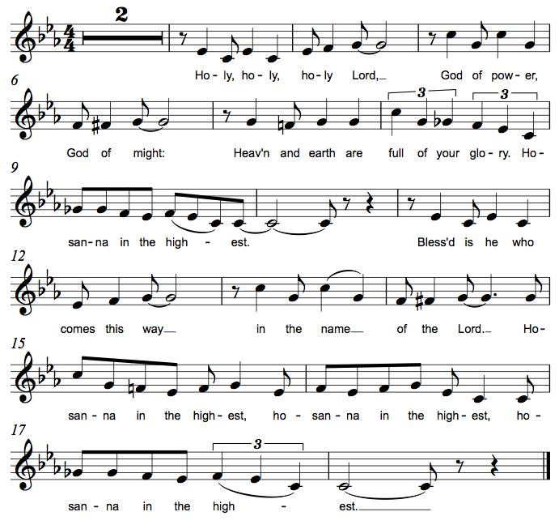
*Thanksgiving at the Table
. . . Again, after supper, he took the cup, gave thanks, and gave it for all to drink, saying: This cup is the new covenant in my blood, shed for you and for all people for the forgiveness of sin. Do this for the remembrance of me.

Remembering his death, we cry out Amen. Amen.
Celebrating his resurrection, we shout Amen. Amen.
Trusting his presence in every time and place, we plead Amen. Amen.

O God, you are Breath: send your Spirit on this meal. O God, you are Bread: feed us with yourself. O God, you are wine: warm our hearts and make us one. O God, you are Fire: transform us with hope.

. . . O God our strength and our song, you show us a vision of a tree of life with fruits for all and leaves that heal the nations. Grant us such life, the life of the Father to the Son, the life of the Spirit of our risen Savior, life in you, now and forever. Amen.

*The Lord’s Prayer
Gathered into one by the Holy Spirit, let us pray as Jesus taught us.
Our Father, who art in heaven, hallowed be thy name, thy kingdom come, thy will be done on earth as it is in heaven. Give us this day our daily bread; and forgive us our trespasses, as we forgive those who trespass against us; and lead us not into temptation, but deliver us from evil. For thine is the kingdom, and the power, and the glory, forever and ever. Amen.

*Invitation to Communion
The risen Christ dwells with us here. All who are hungry, all who are thirsty, come. Be seated.

Lamb of God M.B. Eastman
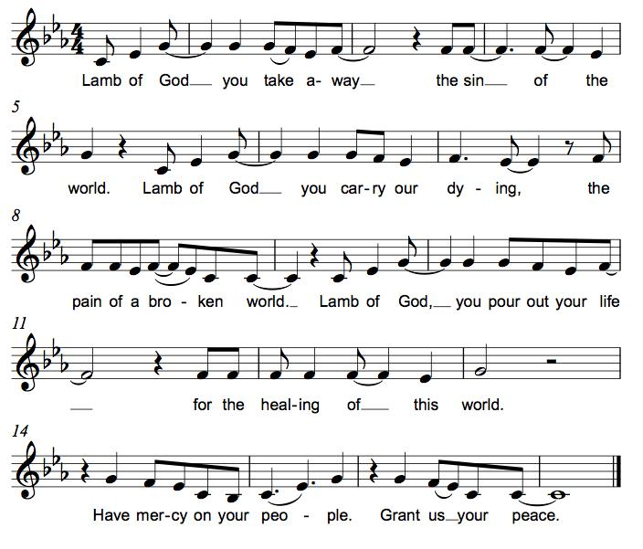
Communion
Those who wish to come to the rail for communion may do so at the ushers’ direction. You may stand or kneel. Please maintain social distancing between households. You may return to your seat by the side aisles after you have received the bread and wine. If you like, you may bring a communion kit with you to receive at the altar.

For those receiving communion in the pew or from home:
This is the body of Christ, given for you. Amen (Eat the bread.)
This is the blood of Christ, shed for you. Amen (Drink the juice.)

*Please stand as you are able.
*Post Communion Blessing
May the body and blood of our Lord Jesus Christ strengthen you and keep you in his grace. Amen.

*Post Communion Prayer
We give you thanks, generous God, for in this bread and cup we have tasted the new heaven and earth
where hunger and thirst are no more. Send us from this table as witnesses to the resurrection, that through our lives, all may know life in Jesus’ name. Amen.
Sending
God blesses us and sends us in mission to the world.
*Blessing
God, the Author of life, Christ, the living Cornerstone, and the life-giving Spirit of adoption, ☩ bless you now and forever. Amen.

*Sending Hymn ELW # 677 This Little Light of Mine
1 This little light of mine, I'm goin'-a let it shine; (3 times)
let it shine, let it shine, let it shine.

2 Hide it under a bushel? NO! I’m goin’-a let is shine; (3 times)
let it shine, let it shine, let it shine.

3 Ev'rywhere I go, I'm goin'-a let it shine; (3 times)
let it shine, let it shine, let it shine.

4 Jesus gave it to me, I'm goin'-a let it shine; (3 times)
let it shine, let it shine, let it shine.

*Sent to the World
Alleluia! Christ is risen. Christ is risen indeed. Alleluia!
Go in peace. Tell what God has done. Thanks be to God.

Postlude
Our thanks to Cyndy Drager for creating and producing today’s presentation!

From Sundays and Seasons v.20190109.1233 Copyright © 2022 Augsburg Fortress. All rights reserved.
Reprinted by permission under Augsburg Fortress Liturgies Annual License #30867.
All rights reserved. Reprinted under OneLicense.net #A-718333.

Assisting in Worship Today
Pastor Rev. Melody Eastman
Minister of Music Bradford Thompson
Ministry Associate Becky Ficarella
Altar Care Cheryl Huizenga
Lector Jason Graf
Usher Mark Drager, John Jokela
Zoom Mark Hamilton, Jon & Cathy Milleville
Fellowship Hour Andy Swiston

Current Prayer Requests
Please keep these people in your prayers and reach out to our sisters and brothers in Christian love. Names will be left on the list for two weeks, unless you indicate that they should remain in our prayers for a longer period.
Name Relationship Prayer For
Greg & Donna Barber Members 50th Anniversary (5/13)
Dolores Nosal Member 98th Birthday (5/18)
Marilyn Goodrich Member 94th Birthday (5/5)
Carol Wandke Member Healing & Strength
Dolores Nosal Member Healing & Strength
Brittany Huizenga Cousin of Cheryl Huizenga Healing & Strength
Dorothy Tracy Member Healing & Strength
Norma Petersen Member Healing & Strength
Prayers for our homebound Members
Dolores Nosal, Carol Petersen, Norma Petersen

Weekly Announements
Confirmation Sunday: Join us for the confirmation reception following worship on Sunday, May 29.

Save the Date! Progressive Dinner! Saturday, June 11: We are planning on restarting the Progressive Dinner on Saturday, June 11th. We will have two options for sign up. “Appetizers Only” or “Appetizers and Dinner.” We are planning on the Appetizer House to be held outside for those who still are uncomfortable eating inside but would like to re-connect with your Grace family. Appetizers will start at 5:30pm, with dinner houses to follow at 7:30pm. Please sign up on the poster in the Narthex for a great evening. Questions, please call Susi Nelson at 630-297-3620.

Community Vacation Bible School: Registration is now open for volunteers and participants. Grace Lutheran Church, Faith Lutheran Church, and First Congregational Church Glen Ellyn are presenting this week together in partnership “Compassion Camp - Changing the World with Loving Kindness!” Monday – Friday, June 20-24, 9:00am-12:00pm at Faith Lutheran Church. 41 N. Park Blvd., Glen Ellyn. Register on Grace’s website!

Quilting Ministry: The quilters meet on the second and fourth Tuesday of every month from 9-10am.

ESL Tutors Needed! St. Andrew Lutheran Church in West Chicago will be hosting one on one ESL tutoring with TEACH likely on Thursdays. There will be two-part training for tutors to teach English as a Second Language to adults on May 19 & June 2 from 10am-12pm at St. Andrew, 155 N. Prince Crossing Road. Go to www.teachempowers.org for more information or to register.

