Grace Lutheran Church

493 Forest Avenue, Glen Ellyn IL 630.469.1555
www.graceglenellyn.org

Ascension of Our Lord May 16, 2021

+ Proclaim Christ + Build Community +
+ Serve Our Neighbors +

Introduction
In today’s readings the risen Christ ascends into heaven and his followers are assured that the Spirit will empower them to be witnesses throughout the earth. The disciples are told to not gaze up into heaven to look for Jesus (Acts 1:11); we find his presence among us as we proclaim the word and share the Easter feast. We, too, long for the Spirit to enliven our faith and invigorate our mission.

Gathering
The Holy Spirit calls us together as the people of God.
Welcome/Announcements

Helpful Reminders for House Church:
- Mute your mic during hymns.
- You may unmute for all group responses. Remember that your host can mute you but cannot unmute you; you must unmute your mic yourself.
- If you are joining by phone, move the mouthpiece away from your mouth unless you are speaking, to avoid broadcasting your breathing.
- Avoid background conversations when your mic is unmuted.
- Congregation responses are in Bold (black).
- THANK YOU FOR WORSHIPPING WITH US!

Prelude (Please mute your mic for the prelude.)

Thanksgiving for Baptism (You may unmute your mic.)
All may make the sign of the cross, the sign marked at baptism, as the presiding minister begins.
Alleluia! Christ is risen. Christ is risen indeed. Alleluia!
Refreshed by the resurrection life we share in Christ, let us give thanks for the gift of baptism.

Water may be poured as the leader gives thanks.

We thank you, risen Christ, for these waters where you make us new, leading us from death to life, from tears to joy. We bless you, risen Christ, that your Spirit comes to us in the grace-filled waters of rebirth, like rains to our thirsting earth, like streams that revive our souls, like cups of cool water shared with strangers. Breathe your peace on your church when we hide in fear. Clothe us with your mercy and forgiveness. Send us companions on our journey as we share your life. Make us one, risen Christ. Cleanse our hearts. Shower us with life. To you be given all praise, with the Holy Spirit, in the glory of God, now and forever. Amen.

Entrance Hymn (Mute your mic) ELW #744 Lord, Be Glorified
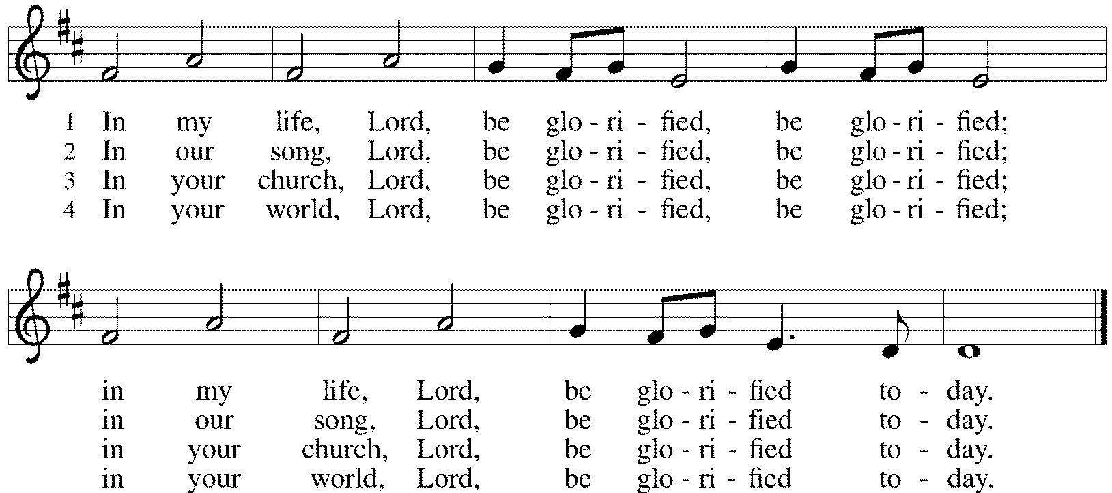

Greeting (Unmute your mic)
The grace of our Lord Jesus Christ, the love of God, and the communion of the Holy Spirit be with you all. And also with you.

Prayer of the Day
Almighty God, your blessed Son, our Savior Jesus Christ, ascended far above all heavens that he might fill all things. Mercifully give us faith to trust that, as he promised, he abides with us on earth to the end of time, the one who lives and reigns with you and the Holy Spirit, one God, now and forever. Amen.

Word
God speaks to us in scripture reading, preaching, and song.
First Lesson Acts 1: 1-11
Before he is lifted into heaven, Jesus promises that the missionary work of the disciples will spread out from Jerusalem to all the world, and that the disciples will be accompanied and empowered by the Holy Spirit. His words provide an outline of the book of Acts.

[Luke writes:] 1In the first book, Theophilus, I wrote about all that Jesus did and taught from the beginning 2until the day when he was taken up to heaven, after giving instructions through the Holy Spirit to the apostles whom he had chosen. 3After his suffering he presented himself alive to them by many convincing proofs, appearing to them during forty days and speaking about the kingdom of God. 4While staying with them, he ordered them not to leave Jerusalem, but to wait there for the promise of the Father. “This,” he said, “is what you have heard from me; 5for John baptized with water, but you will be baptized with the Holy Spirit not many days from now.”
6So when they had come together, they asked him, “Lord, is this the time when you will restore the kingdom to Israel?” 7He replied, “It is not for you to know the times or periods that the Father has set by his own authority. 8But you will receive power when the Holy Spirit has come upon you; and you will be my witnesses in Jerusalem, in all Judea and Samaria, and to the ends of the earth.” 9When he had said this, as they were watching, he was lifted up, and a cloud took him out of their sight. 10While he was going and they were gazing up toward heaven, suddenly two men in white robes stood by them. 11They said, “Men of Galilee, why do you stand looking up toward heaven? This Jesus, who has been taken up from you into heaven, will come in the same way as you saw him go into heaven.”

Word of God, Word of Life. Thanks be to God.

Psalm Psalm 93
Ever since the world began, your throne has been established. (Ps. 93:2)

¹The Lord is king, robed in majesty; the Lord is robed in majesty and armed with strength. The Lord has made the world so sure that it cannot be moved.
²Ever since the world began, your throne has been established; you are from everlasting.
³The waters have lifted up, O Lord, the waters have lifted up their voice; the waters have lifted up their pounding waves.
⁴Mightier than the sound of many waters, mightier than the breakers of the sea, mightier is the Lord who dwells on high.
⁵Your testimonies are very sure, and holiness befits your house, O Lord, forever and forevermore.

Second Lesson Ephesians 1:15-23
The risen and exalted Christ reigns over the entire universe. The author of Ephesians prays that we are given the wisdom to know the power of the risen Christ and the empowering hope that the knowledge of this inheritance provides.

15I have heard of your faith in the Lord Jesus and your love toward all the saints, and for this reason 16I do not cease to give thanks for you as I remember you in my prayers. 17I pray that the God of our Lord Jesus Christ, the Father of glory, may give you a spirit of wisdom and revelation as you come to know him, 18so that, with the eyes of your heart enlightened, you may know what is the hope to which he has called you, what are the riches of his glorious inheritance among the saints, 19and what is the immeasurable greatness of his power for us who believe, according to the working of his great power. 20God put this power to work in Christ when he raised him from the dead and seated him at his right hand in the heavenly places, 21far above all rule and authority and power and dominion, and above every name that is named, not only in this age but also in the age to come. 22And he has put all things under his feet and has made him the head over all things for the church, 23which is his body, the fullness of him who fills all in all.

Word of God, Word of Life. Thanks be to God.

Gospel Acclamation
Alleluia. Go and make disciples of all nations, says the Lord; I am with you always, to the end of the age. Alleluia. (Matt. 28:19, 20)

The holy Gospel according to John. Glory to you, O Lord.

Gospel Luke 24:44-53
On the day of his ascension, Jesus leaves his disciples with a commission, a blessing, and a promise of the Holy Spirit.

44[Jesus said to the eleven and those with them,] “These are my words that I spoke to you while I was still with you—that everything written about me in the law of Moses, the prophets, and the psalms must be fulfilled.”45Then he opened their minds to understand the scriptures, 46and he said to them, “Thus it is written, that the Messiah is to suffer and to rise from the dead on the third day, 47and that repentance and forgiveness of sins is to be proclaimed in his name to all nations, beginning from Jerusalem. 48You are witnesses of these things. 49And see, I am sending upon you what my Father promised; so stay here in the city until you have been clothed with power from on high.”
50Then he led them out as far as Bethany, and, lifting up his hands, he blessed them. 51While he was blessing them, he withdrew from them and was carried up into heaven. 52And they worshiped him, and returned to Jerusalem with great joy; 53and they were continually in the temple blessing God.

The Gospel of the Lord. Praise to you, O Christ.

Sermon The Rev. Melody Eastman

Prayers of Intercession (You may unmute your mic)
Alive in the risen Christ by the power of the Holy Spirit, we bring our prayers before God who promises to hear us and answer in steadfast love.

A brief silence.

You call the whole church on earth to worship and bless you. Empower your church to bear joyful witness to your love made known in Jesus Christ. Hear us, O God. Your mercy is great.
You have fashioned a habitat for all your creatures and you fill the earth with your glory. Give rain where it is needed and rescue those inundated by floods. Mend what we have torn in the fabric of creation and replenish and nourish your world. Hear us, O God. Your mercy is great.

In the majesty of your love, you rule the world with justice and mercy. Give those in authority the spirit of your love, so that all who are hungry and poor receive food and resources, and all people flourish and live in peace (local or global places of need may be named). Hear us, O God. Your mercy is great.

You heal those who are sick and bind up the brokenhearted. Attend to the cares and needs of those who are hurting, hopeless or sick in our congregation, community, workplaces, schools, and families, especially. Cathy, Sigrid, Bob, Jerry, Jim, Shirley, Carol, Dolores, Norma, Dorothy and those we name before you now. . . Hear us, O God. Your mercy is great.

You have gathered us in this congregation, enlightened our hearts, and given us a share of the immeasurable greatness of your power. We thank you for the witness and faith of Delores Nosal, celebrating her 97th birthday this week. Bless her celebration with joy. Hear us, O God. Your mercy is great.
Here other intercessions may be offered.

In raising Christ from the dead, you put your great power to work in the world. Raise us and all who have died in the faith with Christ. We remember saints in our lives and in our community. Thank you for their gifts among us. Hear us, O God. Your mercy is great.

In the hope of new life in Christ, we raise our prayers to you, trusting in your never-ending goodness and mercy; through Jesus Christ our Lord. Amen.

Peace
The peace of Christ be with you always. And also with you.
Please share the peace with others in your household, or by making a sign of peace to those on Zoom.

If your House Church is celebrating Communion, refer to that liturgy here.

The Lord’s Prayer
Gathered into one by the Holy Spirit, let us pray as Jesus taught us.
Our Father in heaven, hallowed be your name. Your kingdom come, your will be done on earth as in heaven. Give us today our daily bread. Forgive us our sins as we forgive those who sin against us. Save us from the time of trial and deliver us from evil. For the kingdom, the power and the glory are yours, now and forever. Amen.

Sending
God blesses us and sends us in mission to the world.
Blessing
May our glorious God grant us a spirit of wisdom to know and to love the risen Lord Jesus.
The God of life, Father, ☩ Son, and Holy Spirit, bless us now and forever.

Sending Hymn (Mute your mic) ELW #657 Rose, O Sun of Righteousness, sts. 1,2,4,5
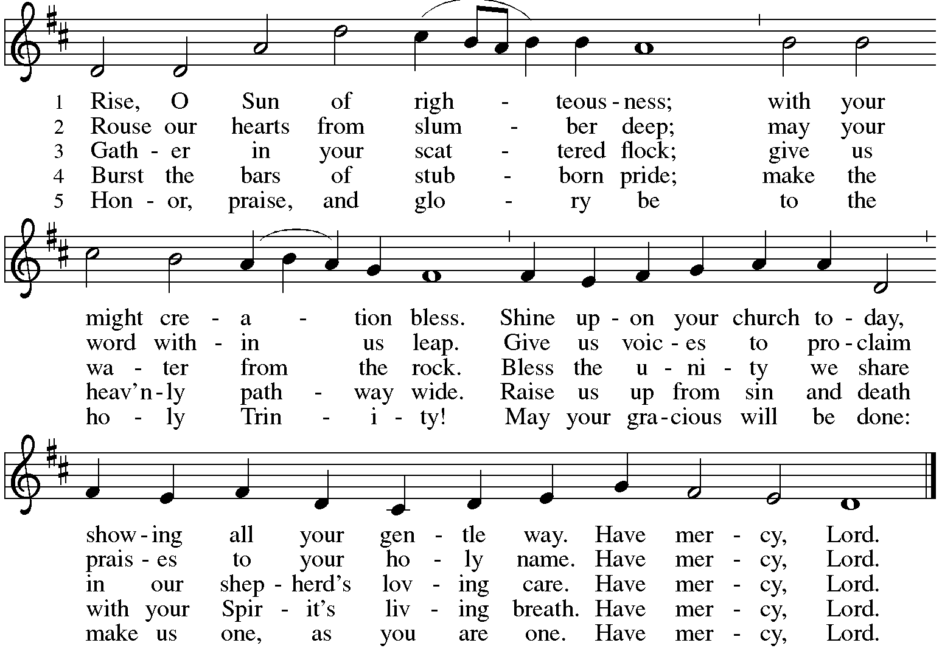

Sent to the World (Unmute your mic.)
Alleluia! Christ is risen. Christ is risen indeed. Alleluia!
Go in peace. Share the good news. Alleluia! Thanks be to God. Alleluia!

From Sundays and Seasons
v.20190109.1233 Copyright © 2021 Augsburg Fortress. All rights reserved.
Reprinted by permission under Augsburg Fortress Liturgies Annual License #30867.
All rights reserved. Reprinted under OneLicense.net #A-718333.
Current Prayer Requests
Please keep these people in your prayers and reach out to our sisters and brothers in Christian love. Names will be left on the list for two weeks, unless you indicate that they should remain in our prayers for a longer period.
Name Relationship Prayer For
Dolores Nosal Member 97th Birthday (5/18)
Bob Stein Member 93rd Birthday (5/14)
Marilyn Goodrich Member 93rd Birthday (5/5)
Jim Sladek Member Healing & Strength
Shirley Sauerman Member Healing & Strength
Jerry Jeske Member Healing & Strength
Bob Stein Member Healing & Strength
Cathy Milleville Member Healing & Strength
Sigrid Elliott Member Healing & Strength
Dorothy Tracy Member Healing & Strength
Tammy Rollo Friend of Barbara Sudds Healing & Strength
Elizabeth Amber Friend of Pr. Melody & Marty Healing & Strength
Chris Danly Son of Mark & Pat Danly Healing & Strength
Prayers for our homebound Members
Dolores Nosal, Carol Petersen, Norma Petersen, Dorothy Stein

Church Gardens Need Volunteers: As you know, the breathtaking gardens at Grace have been because of the love and care given by Sandy Venturoni. Sandy needs to step back from tending to the gardens although she will still be responsible for the three pots at the handicap door. We need a couple of volunteers to take over this role. Sandy will provide guidance so you will not be going into this blindly. Please contact the church office asap if this is something you would be interested in doing.

Chair Exercise and monthly Book Club. Registration is required as the number of attendees will be limited. The exercise class meets Mondays at 10:00am and Thursdays at 11:00am. The Book Club will meet on the third Tuesday of the month at 11:00am. Please contact Sue Davison at 630-858-6343 to register.

FaithTalk is returning! We have a new schedule, meeting on the 1st Thursday of the month from 12:30-2:00, beginning June 3. If you are attending Sue Davison’s exercise class that ends at noon, bring a lunch and join us in the basement after class. Those who like can eat lunch together and we’ll begin our discussion at 12:30.

Wednesday Morning Bible Study Resumes: The Wednesday 7:30am Bible Study met on May 5th for the first time since COVID began. All are welcome to participate. Discussion centers on the Gospel for the upcoming Sunday plus other topics of interest. Tim Stephan and Tim Frakes are regulars with this group meeting in the Narthex at Grace. Please contact the church office if you have any questions.

Bradford’s Livestream Music Session: Looking for something to do on Wednesday evenings? Join Bradford for LIVE music sessions broadcast directly from Grace! Let the meditative sounds of drums, guitar, and keyboards heal your woes and soothe your souls. Wednesdays at 7:00pm. Bradford plans to change up the music and include various musicians each week. This is still a work in progress so please be patient with the format tweaks!
Just click on the link Wednesday evening at 7:00pm to join Bradford on his YouTube channel:
https://youtube.com/channel/UCbgfoPipBLAlY3hAkVKoI8Q

In-Person Worship Returning: Grace will return to in-person worship in the Sanctuary on Sunday, June 6 at 9:00am. Worship assistants will be needed. Please contact your scheduler for the groups you volunteer with to get scheduled. More details will follow.

Worship Driver Needed: Shirley Sauerman would be most grateful for a ride to and from worship on Sunday mornings. Shirley lives at Beacon Hill in Lombard on Finley Road. Please contact the church office if you can provide transportation. If we can get several volunteers it would only require a commitment of once every few weeks.

House Church Worship via phone or internet every Sunday morning at 9:30am! We currently have three “House Churches” of worshipping members (each House Church consisting of 14 +/- members/families meeting via Zoom or calling in by phone.) If you are unsure how to sign on, go ahead and register and let us know you need some help; we’ll walk you through it! We would be so blessed to have you join us. Register online for a House Church at graceglenellyn.org (on the main page Announcements) or contact Becky Ficarella. May 30 will be the last date for House Church.

Contributions to Grace: You may continue to mail your contributions to the church office; have your bank mail your contribution to the church office; or contribute on-line through Grace’s website. Please know, pandemic or no, our mission continues! Thank you for your continued support of our ministries at Grace Lutheran.

RAMP: Our mortgage reduction campaign has been renamed “RAMP” (Reduce Another Mortgage Payment) as we continue to RAMP up to refinance our mortgage with Mission Investment Fund this Fall. If we can raise an additional $100,000 payment prior to our November refinancing it will take us from $925,000 to $825,000.

CROP Hunger Walk: Donations are still being accepted through the month of May. Donations can be made online at events.crophungerwalk.org/2021/mike-pertle or checks made out to CROP Hunger Walk can be mailed to the church office.

Women of Grace Returns! We will meet on Thursday, June 10 at Reserve 22. We have two reservations at 7:00pm for 10people at two outdoor tables. There will be a sign up to attend on the Women of Grace Facebook page. Let Becky Ficarella know if you plan to attend.

Every Member a Minister and Missionary!

Phone: 630-469-1555 Emergency Pastoral Contact: 630-674-2887
info@graceglenellyn.org www.graceglenellyn.org

Pastor
Rev. Melody Eastman office ext. 14
meastman@graceglenellyn.org

Minister of Music
Bradford Thompson 219-718-8879
bradfordmthompson@gmail.com

Ministry Associate
Becky Ficarella office ext. 17
bficarella@graceglenellyn.org

Office Manager
Barbara Sudds office ext. 10
bsudds@graceglenellyn.org

Parish Counselor
Carole LoGalbo M.S., LCPC 630-668-4594
carolelogalbo@yahoo.com

