Grace Lutheran Church

493 Forest Avenue, Glen Ellyn IL 630.469.1555
www.graceglenellyn.org

Sixth Sunday of Easter May 22, 2022

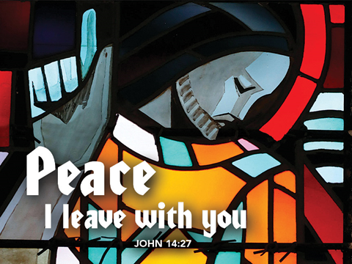

+ Proclaim Christ + Build Community +
+ Serve Our Neighbors +

Especially For Our Guests
Welcome to Grace!
If you are a guest, we’re thankful you’re here today. We hope you will feel Welcomed and spiritually nourished. If you would like to speak to the pastor about the congregation, please let her know directly or call the church office. To enhance your worship experience, you may want to know the following:
· Please join us after service for some great refreshments and Christian Fellowship.
· Parts of the liturgy (worship service) not printed in this bulletin are in the red hymnal (ELW). Page numbers in the hymnal are at the bottom of the page; hymn numbers are the large numbers at the top in the back half of the book.
· All baptized people are welcome at communion. If you would like to come forward for a blessing without taking communion, you can do that too. If you have difficulty walking, feel free to let the usher know and we’ll bring communion to you.
· If you find yourself confused about where we are, ask a neighbor!
· Assisted Listening Devices are available for your use. Please ask an usher.
· Young children are welcome in worship! Parents, you can bring your little ones up front to the PrayGround, a space with tables, chairs and quiet activities to keep our younger members engaged during services. Please sit near your little ones and help them use the space quietly as well as participate with you in worship. If you prefer, there is also a nursery space for you to use with infants or younger toddlers in the overflow room at the rear of the sanctuary. (But we really do like having children up front, if possible!)
· Please take your bulletin home with you. It contains the weekly calendar of events at Grace plus upcoming announcements.

Updated Communion Information
We have returned to the option to commune at the rail with some modifications:
· We are not yet offering the common cup. Red grape juice and white wine are available in individual cups.
· Please do not touch more than one cup. The cups are spaced out to make them easier to remove without touching others.
· If you prefer, you may bring an individual communion kit to the rail and open it there to receive the bread and juice. Or you may remain in the pew and the Pastor will lead you in communion before those at the rail are served.
· Please maintain six feet distance between household groups.

Introduction
Visions abound in the readings for the sixth Sunday of Easter. Paul has a vision about what to do. John has a vision of what will be. Jesus provides visions of peace that surpasses human understanding and power beyond human imagination.

An asterisk (*) indicates that you should stand for that portion of the service. If standing is difficult, please remain seated. Congregation responses are in bold print.

Gathering
The Holy Spirit calls us together as the people of God.

Welcome/Announcements

Prelude

*Please stand as you are able and turn to face the font.
*Thanksgiving for Baptism
All may make the sign of the cross, the sign marked at baptism, as the presiding minister begins.

Alleluia! Christ is risen. Christ is risen indeed. Alleluia!

In the waters of baptism,
we have passed over from death to life with Jesus Christ,
and we are a new creation.
For this saving mystery, and for this water, let us bless God,
who was, who is, and who is to come.

We thank you, God, for your river of life,
flowing freely from your throne:
through the earth, through the city, through every living thing.
You rescued Noah and his family from the flood;
You opened wide the sea for the Israelites.
Now in these waters you flood us with mercy,
and our sin is drowned forever.
You open the gate of righteousness
and we pass safely through.
In Jesus Christ, you calm and trouble the waters.
You nourish us and enclose us in safety.
You call us forth and send us out.
In lush and barren places, you are with us.
You have become our salvation.
Now breathe upon this water
and awaken your church once more.
Claim us again as your beloved and holy people.
Quench our thirst; cleanse our hearts; wipe away every tear.
To you, our Beginning and our End,
our Shepherd and Lamb,
be honor, glory, praise, and thanksgiving,
now and forever.
Amen.

*Entrance Hymn I’ve Got Peace like a River

*Greeting
The grace of our Lord Jesus Christ, the love of God, and the communion of the Holy Spirit be with you all. And also with you.

*Hymn of Praise ELW #164 Glory to God
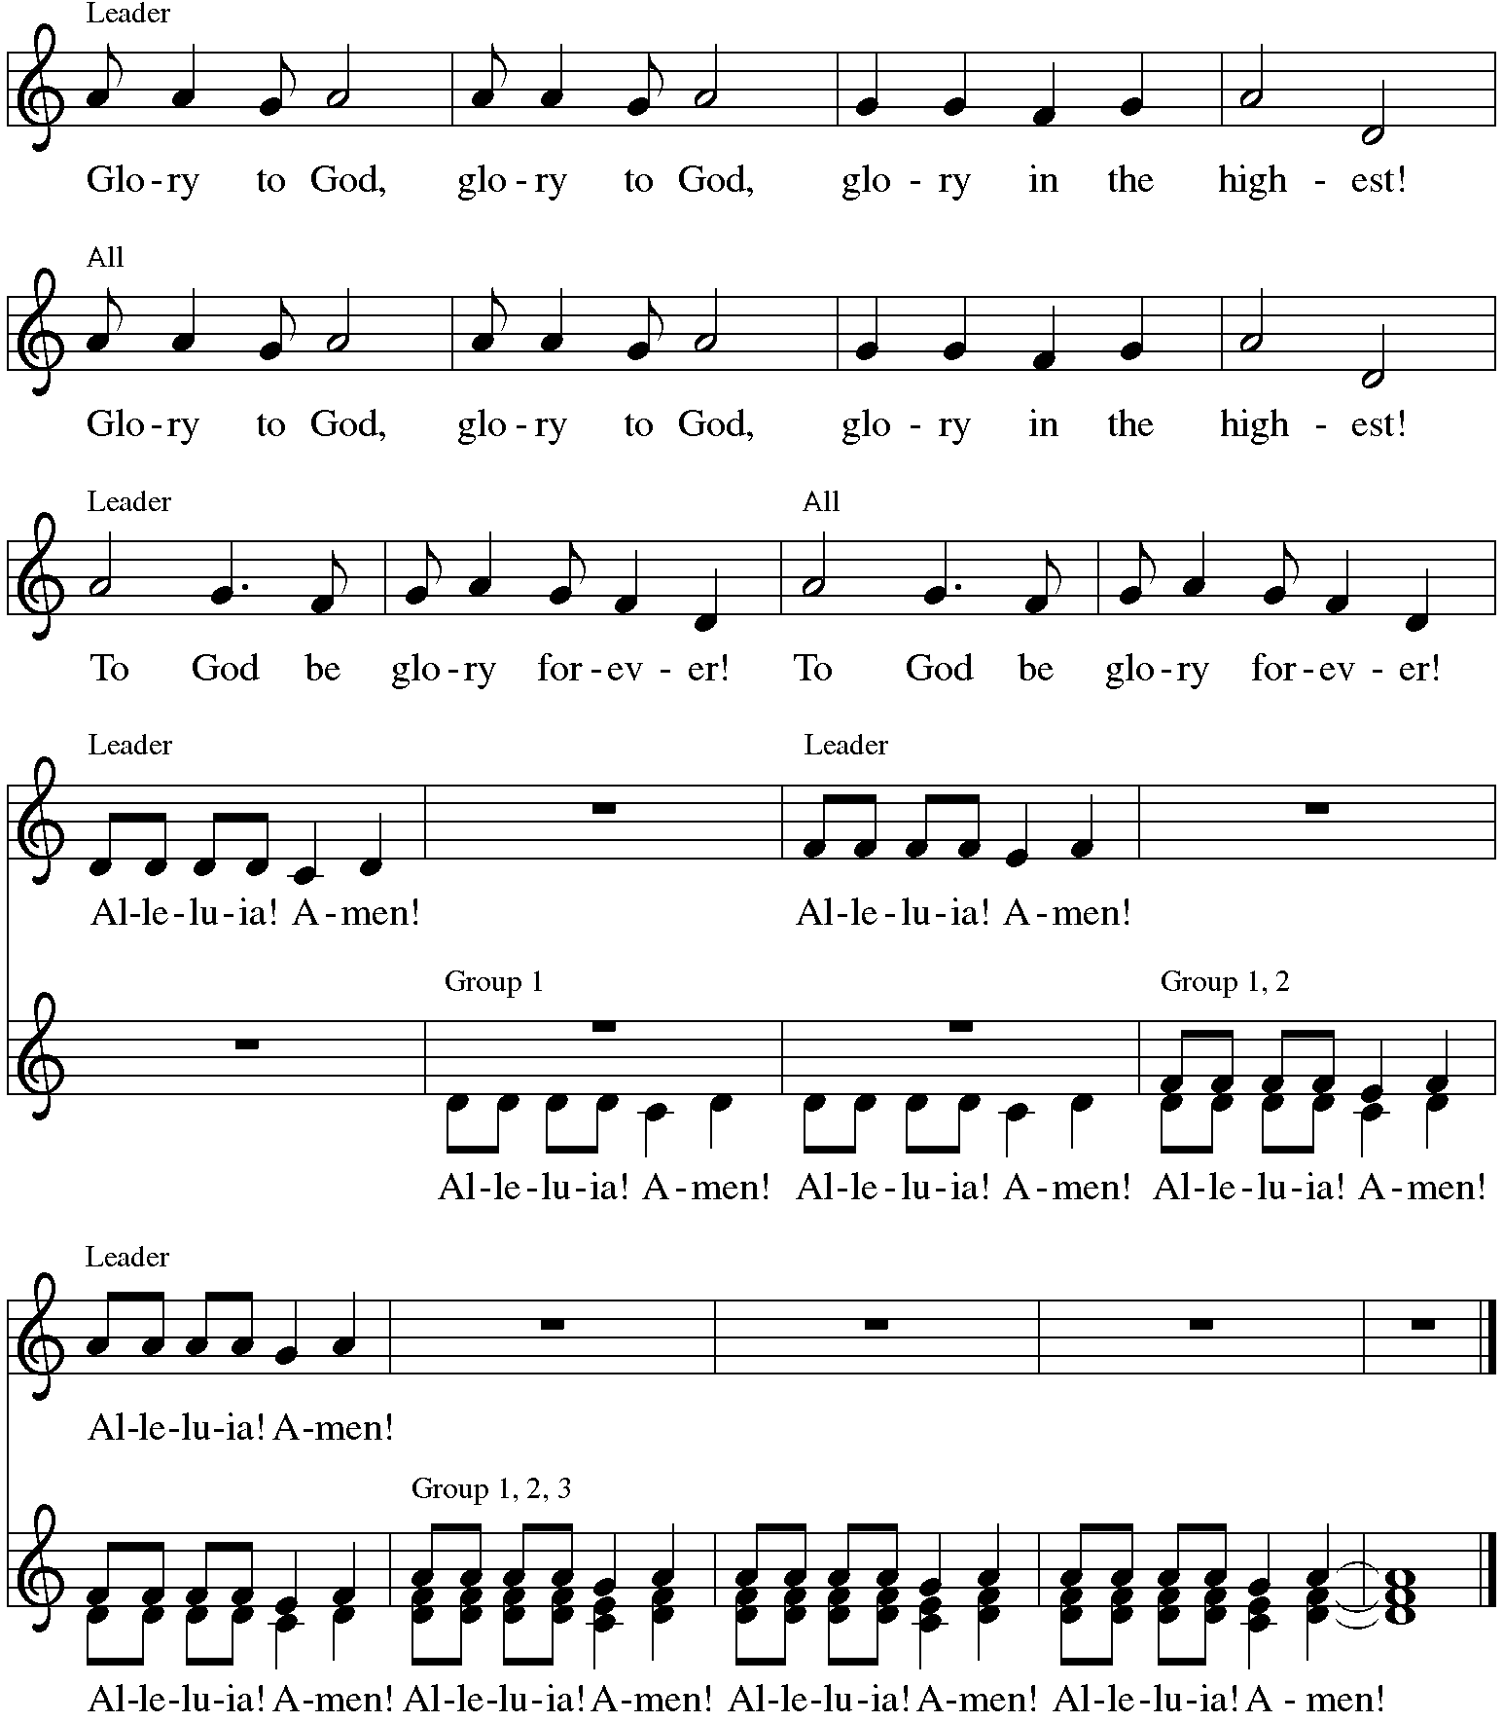

*Prayer of the Day
Bountiful God, you gather your people into your realm, and you promise us food from your tree of life. Nourish us with your word, that empowered by your Spirit we may love one another and the world you have made, through Jesus Christ, our Savior and Lord, who lives and reigns with you and the Holy Spirit, one God, now and forever. Amen. Be seated.
Word
God speaks to us in scripture reading.
First Lesson Acts 16:9-15
A vision compels Paul to move his ministry into Greece. There he meets Lydia, an important person in the business community, whose heart has been opened by God to receive the gospel. Her conversion and baptism provide the impetus for the founding of the church at Philippi.

⁹During the night Paul had a vision: there stood a man of Macedonia pleading with him and saying, “Come over to Macedonia and help us.” ¹⁰When he had seen the vision, we immediately tried to cross over to Macedonia, being convinced that God had called us to proclaim the good news to them.
¹¹We set sail from Troas and took a straight course to Samothrace, the following day to Neapolis, ¹²and from there to Philippi, which is a leading city of the district of Macedonia and a Roman colony. We remained in this city for some days. ¹³On the sabbath day we went outside the gate by the river, where we supposed there was a place of prayer; and we sat down and spoke to the women who had gathered there. ¹⁴A certain woman named Lydia, a worshiper of God, was listening to us; she was from the city of Thyatira and a dealer in purple cloth. The Lord opened her heart to listen eagerly to what was said by Paul. ¹⁵When she and her household were baptized, she urged us, saying, “If you have judged me to be faithful to the Lord, come and stay at my home.” And she prevailed upon us.

Word of God, Word of Life. Thanks be to God.

Psalm Psalm 67
The Psalm is read responsively by verse.
¹May God be merciful to us and bless us; may the light of God’s face shine upon us.
²Let your way be known upon earth, your saving health among all nations.
³Let the peoples praise you, O God; let all the peoples praise you.
⁴Let the nations be glad and sing for joy, for you judge the peoples with equity and guide all the nations on earth.
⁵Let the peoples praise you, O God; let all the peoples praise you.
⁶The earth has brought forth its increase; God, our own God, has blessed us.
⁷May God give us blessing, and may all the ends of the earth stand in awe.

Second Lesson Revelation 21:10, 22--22:5
John’s vision of a new Jerusalem coming out of heaven provides continuity with God’s past actions. Yet in this new city, God’s presence replaces the temple, and the glory of God and the Lamb supplants sun and moon.

¹⁰And in the spirit [one of the angels] carried me away to a great, high mountain and showed me the holy city Jerusalem coming down out of heaven from God.
²²I saw no temple in the city, for its temple is the Lord God the Almighty and the Lamb. ²³And the city has no need of sun or moon to shine on it, for the glory of God is its light, and its lamp is the Lamb. ²⁴The nations will walk by its light, and the kings of the earth will bring their glory into it. ²⁵Its gates will never be shut by day—and there will be no night there. ²⁶People will bring into it the glory and the honor of the nations. ²⁷But nothing unclean will enter it, nor anyone who practices abomination or falsehood, but only those who are written in the Lamb’s book of life.
^{22:1}Then the angel showed me the river of the water of life, bright as crystal, flowing from the throne of God and of the Lamb ²through the middle of the street of the city. On either side of the river is the tree of life with its twelve kinds of fruit, producing its fruit each month; and the leaves of the tree are for the healing of the nations. ³Nothing accursed will be found there any more. But the throne of God and of the Lamb will be in it, and his servants will worship him; ⁴they will see his face, and his name will be on their foreheads. ⁵And there will be no more night; they need no light of lamp or sun, for the Lord God will be their light, and they will reign forever and ever.

Word of God, Word of Life. Thanks be to God.

*Please stand as you are able.
*Gospel Acclamation Hallelujah!

The holy Gospel according to John. Glory to you, O Lord.
*Gospel John 14:23-29
As Jesus talks of returning to the Father, he promises to send the Advocate, the Holy Spirit, who will teach Jesus’ followers and remind them of all that Jesus taught. Even more, those in whom God makes a home will experience a peace that overcomes fear.

²³Jesus answered [Judas (not Iscariot),] “Those who love me will keep my word, and my Father will love them, and we will come to them and make our home with them. ²⁴Whoever does not love me does not keep my words; and the word that you hear is not mine, but is from the Father who sent me.
²⁵“I have said these things to you while I am still with you. ²⁶But the Advocate, the Holy Spirit, whom the Father will send in my name, will teach you everything, and remind you of all that I have said to you. ²⁷Peace I leave with you; my peace I give to you. I do not give to you as the world gives. Do not let your hearts be troubled, and do not let them be afraid. ²⁸You heard me say to you, ‘I am going away, and I am coming to you.’ If you loved me, you would rejoice that I am going to the Father, because the Father is greater than I. ²⁹And now I have told you this before it occurs, so that when it does occur, you may believe.”

The Gospel of the Lord. Praise to you, O Christ. Be seated.

Sermon The Rev. John Freidheim

*Please stand as you are able
*Hymn of the Day ELW #631 Love Divine, All Loves Excelling
sts. 1-3
*The Nicene Creed
With the whole church, let us confess our faith.

We believe in one God, the Father, the Almighty, maker of heaven and earth,
of all that is, seen and unseen.

We believe in one Lord, Jesus Christ, the only Son of God,
eternally begotten of the Father, God from God, Light from Light,
true God from true God, begotten, not made, of one Being with the Father;
through him all things were made.
For us and for our salvation he came down from heaven,
was incarnate of the Holy Spirit and the virgin Mary and became truly human.
For our sake he was crucified under Pontius Pilate;
he suffered death and was buried.
On the third day he rose again in accordance with the scriptures;
he ascended into heaven and is seated at the right hand of the Father.
He will come again in glory to judge the living and the dead,
and his kingdom will have no end.

We believe in the Holy Spirit, the Lord, the giver of life,
who proceeds from the Father and the Son,
who with the Father and the Son is worshiped and glorified,
who has spoken through the prophets.
We believe in one holy catholic and apostolic church.
We acknowledge one baptism for the forgiveness of sins.
We look for the resurrection of the dead, and the life of the world to come. Amen.

*Prayers of Intercession
Set free from captivity to sin and death, we pray to the God of resurrection for the church, people in need, and all of creation.
A brief silence.

God of new life, open your church to the unexpected ways your Spirit is at work. Guide bishops, pastors, deacons, and lay leaders in their visioning, partnership, and planning. Surround us with your peace. God, in your mercy, hear our prayer.

Give a vision of increase and abundant harvest for farmers, laborers, and gardeners who are beginning their growing season. Join their efforts with the goodness of creation to feed all living things. God, in your mercy, hear our prayer.

Shine your light of wisdom and peace among nations. When those in power seek to assert dominance over others, confound their ways and make them yield to your humble authority. God, in your mercy, hear our prayer.

Give safe haven to those who seek healing, liberation, or peace, especially Carol, Dolores, Norma, Carol, Brittany, and those we name before you now. . . Create places filled with hospitality where hurting people find your loving presence and wholeness. God, in your mercy, hear our prayer.

Uphold the work of ministries and organizations in our communities who assist people experiencing homelessness, citizens returning from prison, and all marginalized people. Accomplish your will through their efforts. God, in your mercy, hear our prayer.
Here other intercessions may be offered.

Assemble your people at rivers, streams, and fonts, where we remember our baptism and welcome others into the communion of saints. Gather us with those who have died when we meet together at your river of life. God, in your mercy, hear our prayer.

In your mercy, O God, respond to these prayers, and renew us by your life-giving Spirit; through Jesus Christ, our Savior. Amen.

*Peace
The peace of Christ be with you always. And also with you.
Please share the peace with others in your household, or by making a sign of peace to those on Zoom. Please remain standing as you are able.

Meal
God feeds us with the presence of Jesus Christ.
*Offering Prayer
Living God,
you gather the wolf and the lamb to feed together
in your peaceable reign,
and you welcome us all at your table.
Reach out to us through this meal,
and show us your wounded and risen body,
that we may be nourished and believe
in Jesus Christ, our Savior and Lord.
Amen.

*Great Thanksgiving
The Lord be with you. And also with you.
Lift up your hearts. We lift them to the Lord.
Let us give thanks to the Lord our God. It is right to give our thanks and praise.

*Preface
It is indeed right, our duty and our joy,
that we should at all times and in all places give thanks and praise to you,
almighty and merciful God,
for the glorious resurrection of our Savior Jesus Christ,
the true Paschal Lamb who gave himself to take away our sin;
who in dying has destroyed death,
and in rising has brought us to eternal life.
And so, with Mary Magdalene and Peter and all the witnesses of the resurrection,
with earth and sea and all their creatures,
and with angels and archangels, cherubim and seraphim,
we praise your name and join their unending hymn:

*Sanctus Holy, Holy, Holy C. Heine
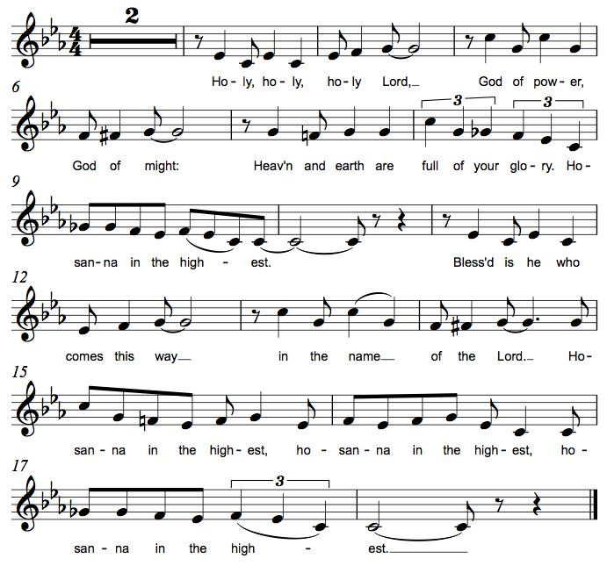

*Thanksgiving at the Table
O God most mighty, O God most merciful,
O God our rock and our salvation,
hear us as we praise, call us to your table, grant us your life.

When the earth was a formless void, you formed order and beauty.
When Abraham and Sarah were barren, you sent them a child.
When the Israelites were enslaved, you led them to freedom.
Ruth faced starvation, David fought Goliath,
and the psalmists cried out for healing,
and full of compassion, you granted the people your life.

You entered our sorrows in Jesus our brother.
He was born among the poor, he lived under oppression, he wept over the city.
With infinite love, he granted the people your life.

In the night in which he was betrayed,
our Lord Jesus took bread, and gave thanks;
broke it, and gave it to his disciples, saying:
Take and eat; this is my body, given for you.
Do this for the remembrance of me.

Again, after supper, he took the cup, gave thanks,
and gave it for all to drink, saying:
This cup is the new covenant in my blood,
shed for you and for all people for the forgiveness of sin.
Do this for the remembrance of me.

Remembering his death, we cry out Amen. Amen.
Celebrating his resurrection, we shout Amen. Amen.
Trusting his presence in every time and place, we plead Amen. Amen.

O God, you are Breath: send your Spirit on this meal.
O God, you are Bread: feed us with yourself.
O God, you are wine: warm our hearts and make us one.
O God, you are Fire: transform us with hope.

O God most majestic, O God most motherly, O God our strength and our song,
you show us a vision of a tree of life
with fruits for all and leaves that heal the nations.
Grant us such life,
the life of the Father to the Son,
the life of the Spirit of our risen Savior,
life in you, now and forever.
Amen

*The Lord’s Prayer
Gathered into one by the Holy Spirit, let us pray as Jesus taught us.
Our Father, who art in heaven, hallowed be thy name, thy kingdom come, thy will be done on earth as it is in heaven. Give us this day our daily bread; and forgive us our trespasses, as we forgive those who trespass against us; and lead us not into temptation, but deliver us from evil. For thine is the kingdom, and the power, and the glory, forever and ever. Amen.

*Invitation to Communion
The risen Christ dwells with us here. All who are hungry, all who are thirsty, come.
Be seated.

Lamb of God M.B. Eastman
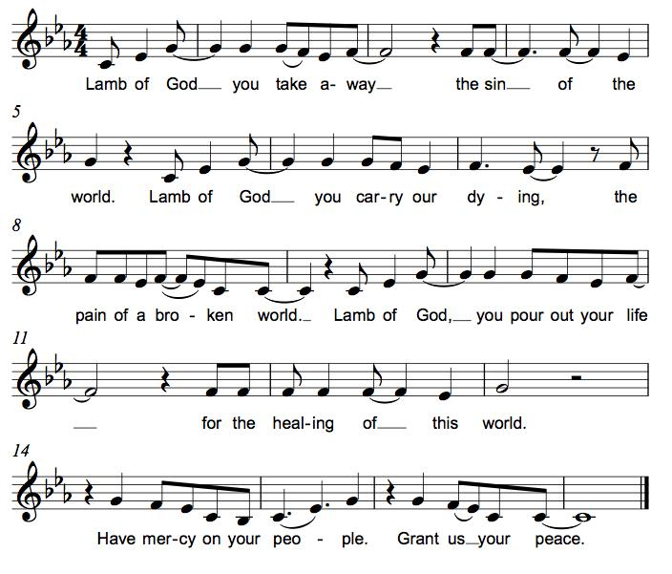

Communion
Those who wish to come to the rail for communion may do so at the ushers’ direction. You may stand or kneel. Please maintain social distancing between households. You may return to your seat by the side aisles after you have received the bread and wine. If you like, you may bring a communion kit with you to receive at the altar.

For those receiving communion in the pew or from home:
This is the body of Christ, given for you. Amen (Eat the bread.)
This is the blood of Christ, shed for you. Amen (Drink the juice.)

*Please stand as you are able.
*Post Communion Blessing
May the body and blood of our Lord Jesus Christ strengthen you and keep you in his grace. Amen.

*Post Communion Prayer
We give you thanks, generous God,
for in this bread and cup
we have tasted the new heaven and earth
where hunger and thirst are no more.
Send us from this table as witnesses to the resurrection,
that through our lives, all may know life in Jesus’ name.
Amen.
Sending
God blesses us and sends us in mission to the world.
*Blessing
God, the Author of life,
Christ, the living Cornerstone,
and the life-giving Spirit of adoption,
☩ bless you now and forever.
Amen.

*Sending Hymn ELW #763 My Life Flows On in Endless Song
sts. 1, 2, 4

*Sent to the World
Alleluia! Christ is risen. Christ is risen indeed. Alleluia!

Go in peace. Tell what God has done. Thanks be to God.

Postlude

Our warm thanks to the Rev. John Freidheim
for preaching and presiding today!

From Sundays and Seasons v.20190109.1233 Copyright © 2022 Augsburg Fortress. All rights reserved.
Reprinted by permission under Augsburg Fortress Liturgies Annual License #30867.
All rights reserved. Reprinted under OneLicense.net #A-718333.

Assisting in Worship Today
Supply Pastor Rev. John Freidheim
Minister of Music Bradford Thompson
Ministry Associate Becky Ficarella
Altar Care Cheryl Huizenga
Lector Rob Granner
Usher Mark Drager, John Jokela
Zoom Mark Hamilton, Jon & Cathy Milleville
Fellowship Hour Linda Berta

Current Prayer Requests
Please keep these people in your prayers and reach out to our sisters and brothers in Christian love. Names will be left on the list for two weeks, unless you indicate that they should remain in our prayers for a longer period.
Name Relationship Prayer For
Greg & Donna Barber Members 50th Anniversary (5/13)
Dolores Nosal Member 98th Birthday (5/18)
Carol Wandke Member Healing & Strength
Dolores Nosal Member Healing & Strength
Brittany Huizenga Cousin of Cheryl Huizenga Healing & Strength
Dorothy Tracy Member Healing & Strength
Norma Petersen Member Healing & Strength
Prayers for our homebound Members
Dolores Nosal, Carol Petersen, Norma Petersen

Weekly Announements

Confirmation Sunday: Join us next Sunday, May 29 for the confirmation of Leah Fenske and Matthew LoGalbo. A reception will follow the service.

Drivers Needed: We have two Grace members who need a ride to church on Sunday mornings. One from Beacon Hill in Lombard and one near President Street and Geneva Road in Wheaton. Do you think you could help out with this? Your commitment would be once every 5-6 weeks. They are so thankful to be able to come to worship. If you think this would work for you, please call or email or call Cathy Milleville 630-653-0957 or jmilleville@comcast.net.

Worship Assistants: With the return to communion at the rail, we are in need of people willing to serve as cross-bearer and communion assistant along with two ushers for each week. If you are able to help with carrying the cross and/or assisting with communion, please contact Susan Jacobson or the church office. Thank you!

Fellowship Hour: Please join us for coffee and fellowship following Sunday’s worship service. We are looking for additional volunteers to host the coffee hour. Please contact Becky Ficarella or the church office if you are interested.

Adult and Bell Choirs: The choirs meet on Wednesdays at 7:00pm. Contact Bradford Thompson if you would like to share your voice or bell ringing skills with Grace. bradfordmthompson@gmail.com

Save the Date! Progressive Dinner! Saturday, June 11: We are planning on restarting the Progressive Dinner on Saturday, June 11th. We will have two options for sign up. Appetizers Only or Appetizers and Dinner. We are planning on the Appetizer House to be held outside for those who still are uncomfortable eating inside but would like to re-connect with your Grace family. Appetizers will start at 5:30pm, with dinner houses to follow at 7:30pm. Please sign up on the poster in the Narthex for a great evening. Questions, please call Susi Nelson at 630-297-3620.

Community Vacation Bible School: Registration is now open for volunteers and participants. Grace Lutheran Church, Faith Lutheran Church, and First Congregational Church Glen Ellyn are presenting this week together in partnership “Compassion Camp - Changing the World with Loving Kindness!” Monday – Friday, June 20-24, 9:00am-12:00pm at Faith Lutheran Church. 41 N. Park Blvd., Glen Ellyn. Register on Grace’s website!

Quilting Ministry: The quilters meet on the second and fourth Tuesday of every month from 9-10am.

ESL Tutors Needed! St. Andrew Lutheran Church in West Chicago will be hosting one on one ESL tutoring with TEACH likely on Thursdays. There will be two-part training for tutors to teach English as a Second Language to adults on May 19 & June 2 from 10am-12pm at St. Andrew, 155 N. Prince Crossing Road. Go to www.teachempowers.org for more information or to register.

Crisis in Ukraine: The match has been met but more is needed! Learn more at LWR.org/congregations. Donate online at LWR.org. Gifts can also be mailed to Lutheran World Relief, PO Box 17061, Baltimore, MD 21297-1061. Please write “Ukraine” in the memo line.

Every Member a Minister and Missionary!

Phone: 630-469-1555 Emergency Pastoral Contact: 630-674-2887
info@graceglenellyn.org www.graceglenellyn.org

Pastor
Rev. Melody Eastman office ext. 14
meastman@graceglenellyn.org

Minister of Music
Bradford Thompson 219-718-8879
bradfordmthompson@gmail.com

Ministry Associate
Becky Ficarella office ext. 17
bficarella@graceglenellyn.org

Office Manager
Barbara Sudds office ext. 10
bsudds@graceglenellyn.org

Parish Counselor
Carole LoGalbo M.S., LCPC 630-668-4594
carolelogalbo@yahoo.com

