Grace Lutheran Church

493 Forest Avenue, Glen Ellyn IL 630.469.1555
www.graceglenellyn.org

Day of Pentecost May 23, 2021

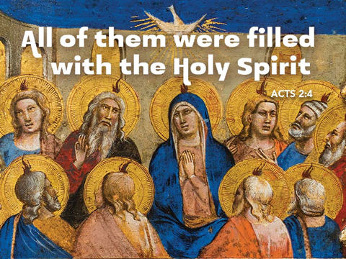

+ Proclaim Christ + Build Community +
+ Serve Our Neighbors +

Introduction
Fifty days after Easter, we celebrate the outpouring of the Holy Spirit on Pentecost. Crossing all boundaries that would separate us, the Spirit brings the wideness of God’s mercy to places we least expect it—to a crowd of strangers of different lands and tongues, to dry bones, to our weak hearts. Jesus promises his disciples that they will be accompanied by the Holy Spirit, and that this Spirit reveals the truth. We celebrate that we too have been visited with this same Spirit. Guided by the truth, we join together in worship, and then disperse to share the fullness of Christ’s love with the world.

Gathering
The Holy Spirit calls us together as the people of God.
Welcome/Announcements

Helpful Reminders for those joining via Zoom:
- The host will mute you when you join, and you will remain muted until the end of the service.
- You are welcome to join in all congregation responses (in Bold black.) and hymns.
- At the end of the service you may unmute your mic to share greetings with your fellow worshippers. If you dialed in on the phone, press *6. Remember, your host cannot unmute you.
- THANK YOU FOR WORSHIPPING WITH US!

Prelude
*Please stand as you are able and turn to face the font.
*Thanksgiving for Baptism
All may make the sign of the cross, the sign marked at baptism, as the presiding minister begins.

Alleluia! Christ is risen. Christ is risen indeed. Alleluia!

Refreshed by the resurrection life we share in Christ, let us give thanks for the gift of baptism.
Water may be poured into the font as the presiding minister gives thanks.

We thank you, risen Christ, for these waters where you make us new, leading us from death to life, from tears to joy. We bless you, risen Christ, that your Spirit comes to us in the grace-filled waters of rebirth, like rains to our thirsting earth, like streams that revive our souls, like cups of cool water shared with strangers. Breathe your peace on your church when we hide in fear.
Clothe us with your mercy and forgiveness. Send us companions on our journey as we share your life. Make us one, risen Christ. Cleanse our hearts. Shower us with life. To you be given all praise, with the Holy Spirit, in the glory of God, now and forever. Amen.

*Entrance Hymn ELW #401 Gracious Spirit, Heed Our Pleading
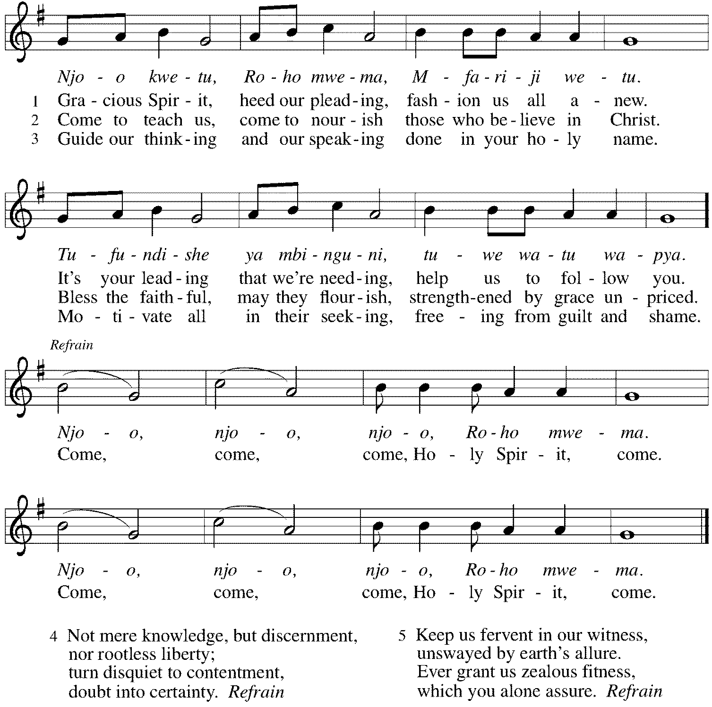

*Greeting
The grace of our Lord Jesus Christ, the love of God, and the communion of the Holy Spirit be with you all. And also with you.

*Hymn of Praise ELW #821 Shout to the Lord
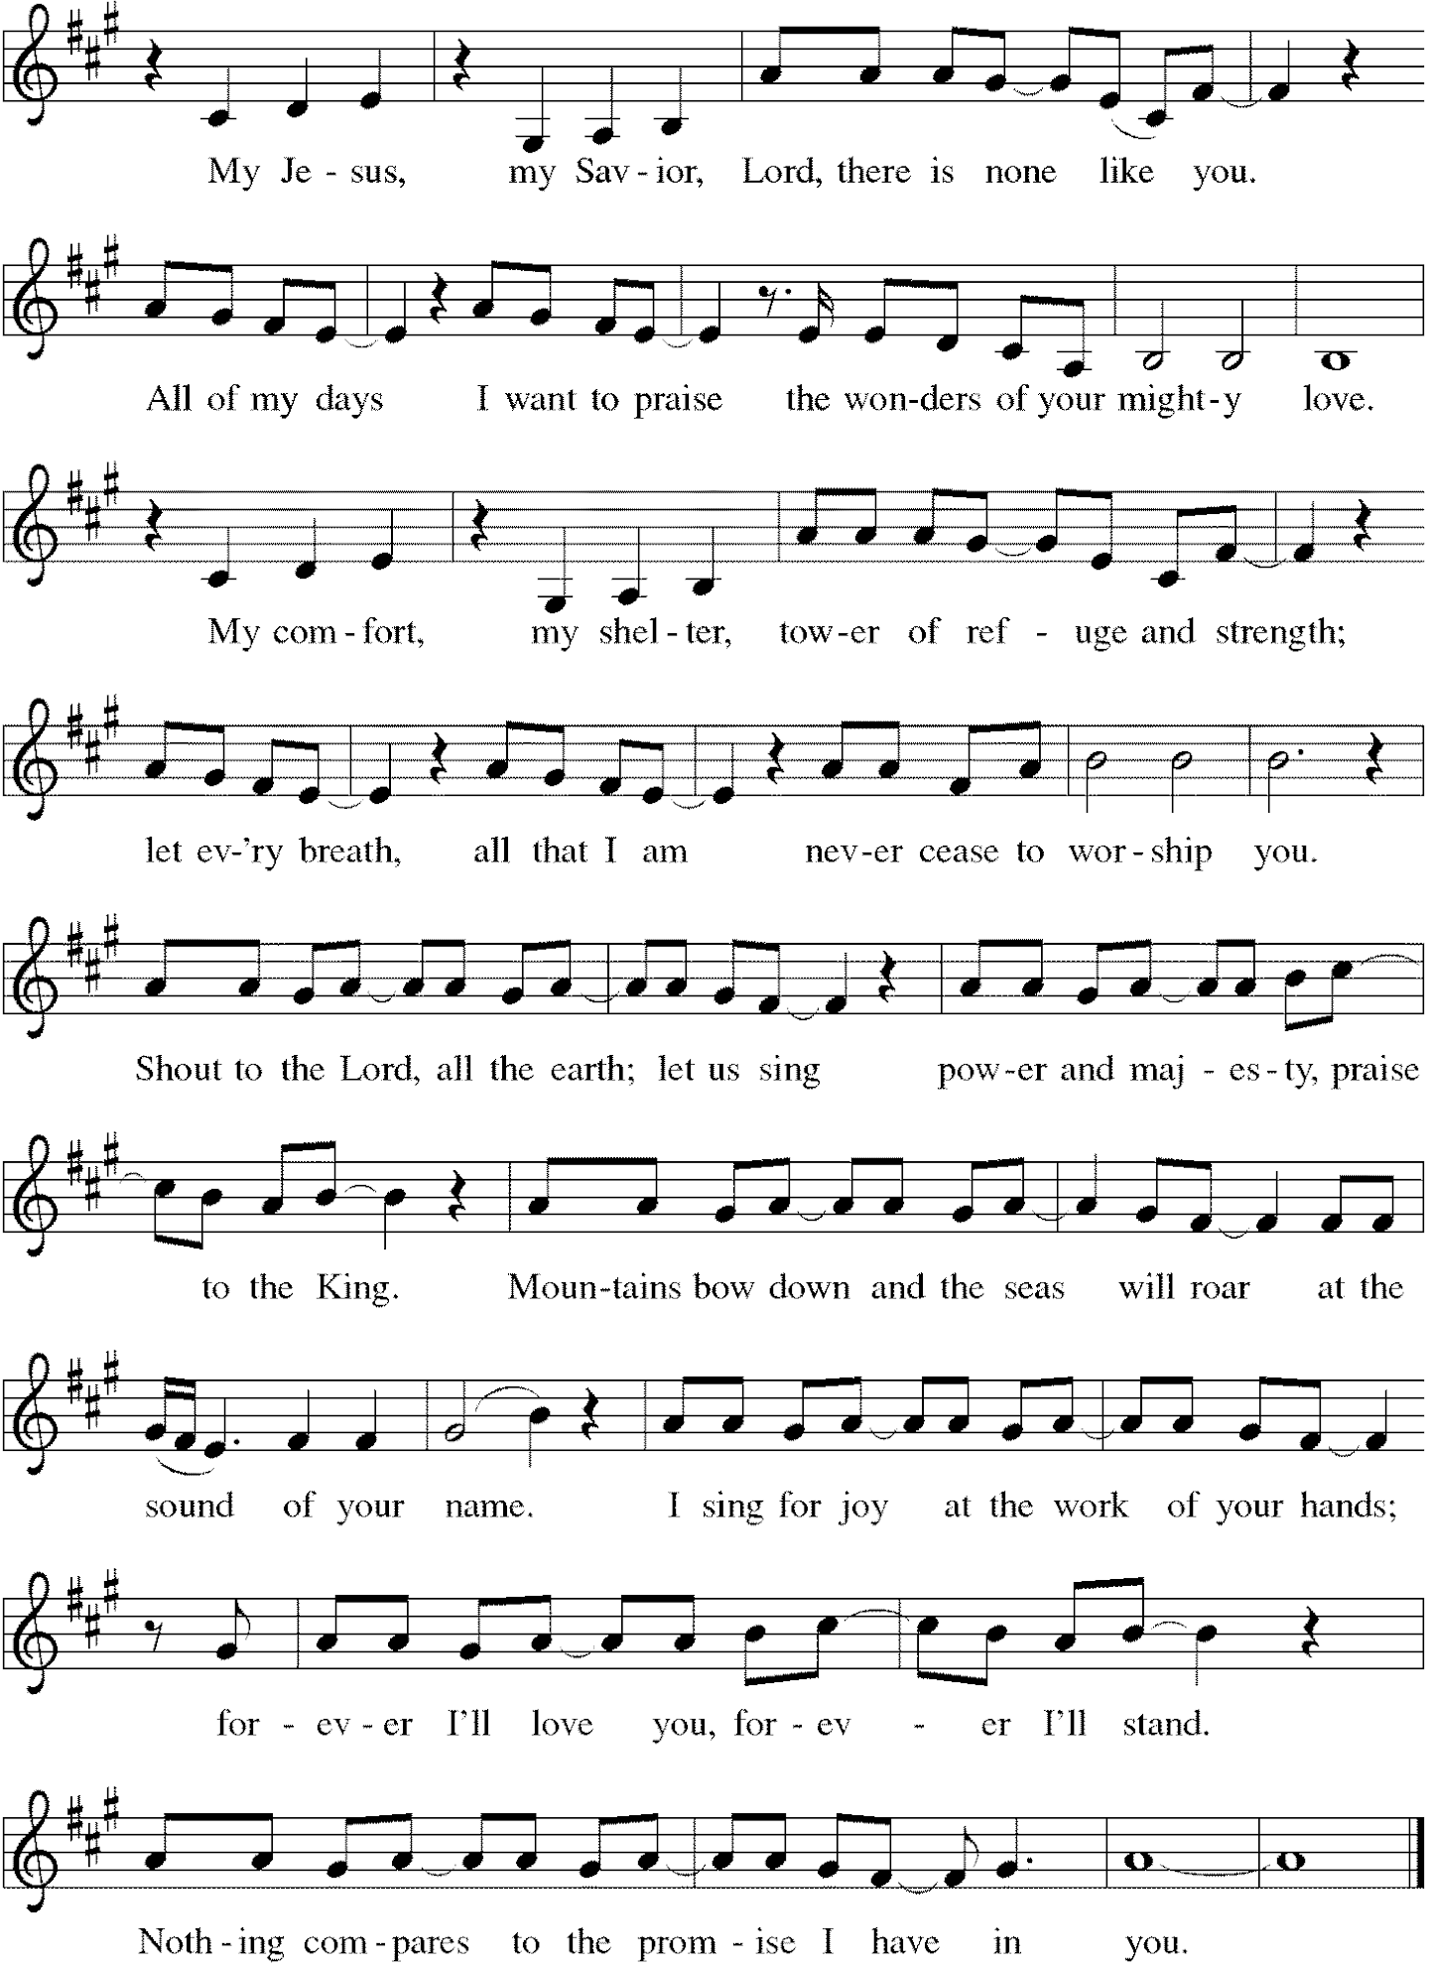
*Prayer of the Day
Mighty God, you breathe life into our bones, and your Spirit brings truth to the world. Send us this Spirit, transform us by your truth, and give us language to proclaim your gospel, through Jesus Christ, our Savior and Lord, who lives and reigns with you and the Holy Spirit, one God, now and forever. Amen. Be seated.
Word
God speaks to us in scripture reading, preaching, and song.
First Lesson Acts 2:1-21
Originally Pentecost was a Jewish thanksgiving-type festival celebrated seven weeks after Passover. On this particular Pentecost, however, the Holy Spirit is poured out upon the entire community of believers just as Jesus had promised and the scriptures had prophesied. Empowered by the Spirit, the entire community bears witness to God’s activity in multiple languages.

¹When the day of Pentecost had come, [the apostles] were all together in one place. ²And suddenly from heaven there came a sound like the rush of a violent wind, and it filled the entire house where they were sitting. ³Divided tongues, as of fire, appeared among them, and a tongue rested on each of them. ⁴All of them were filled with the Holy Spirit and began to speak in other languages, as the Spirit gave them ability.
⁵Now there were devout Jews from every nation under heaven living in Jerusalem. ⁶And at this sound the crowd gathered and was bewildered, because each one heard them speaking in the native language of each. ⁷Amazed and astonished, they asked, “Are not all these who are speaking Galileans? ⁸And how is it that we hear, each of us, in our own native language? ⁹Parthians, Medes, Elamites, and residents of Mesopotamia, Judea and Cappadocia, Pontus and Asia, ¹⁰Phrygia and Pamphylia, Egypt and the parts of Libya belonging to Cyrene, and visitors from Rome, both Jews and proselytes, ¹¹Cretans and Arabs—in our own languages we hear them speaking about God’s deeds of power.” ¹²All were amazed and perplexed, saying to one another, “What does this mean?” ¹³But others sneered and said, “They are filled with new wine.”
¹⁴But Peter, standing with the eleven, raised his voice and addressed them, “Men of Judea and all who live in Jerusalem, let this be known to you, and listen to what I say. ¹⁵Indeed, these are not drunk, as you suppose, for it is only nine o’clock in the morning. ¹⁶No, this is what was spoken through the prophet Joel: ¹⁷‘In the last days it will be, God declares, that I will pour out my Spirit upon all flesh, and your sons and your daughters shall prophesy, and your young men shall see visions, and your old men shall dream dreams. ¹⁸Even upon my slaves, both men and women, in those days I will pour out my Spirit; and they shall prophesy. ¹⁹And I will show portents in the heaven above and signs on the earth below, blood, and fire, and smoky mist. ²⁰The sun shall be turned to darkness and the moon to blood, before the coming of the Lord’s great and glorious day. ²¹Then everyone who calls on the name of the Lord shall be saved.’ ”

Word of God, Word of Life. Thanks be to God.
Psalm Psalm 104:24-34, 35b
Send forth your Spirit and renew the face of the earth. (Ps. 104:30)

24How manifold are your | works, O Lord!
In wisdom you have made them all; the earth is full | of your creatures.
25Yonder is the sea, great and wide, with its swarms too man- | y to number,
living things both | small and great.
26There go the ships | to and fro,
and Leviathan, which you made for the | sport of it.
27All of them | look to you
to give them their food | in due season.
28You give it to them; they | gather it;
you open your hand, and they are filled | with good things.
29When you hide your face, | they are terrified;
when you take away their breath, they die and return | to their dust.
30You send forth your Spirit, and they | are created;
and so you renew the face | of the earth.
31May the glory of the Lord en- | dure forever;
O Lord, rejoice in | all your works.
32You look at the earth | and it trembles;
you touch the mountains | and they smoke.
33I will sing to the Lord as long | as I live;
I will praise my God while I | have my being.
34May these words of | mine please God.
I will rejoice | in the Lord.
35bBless the Lord, | O my soul.
Hal- | lelujah!

Second Lesson Romans 8:22-27
By pouring the Holy Spirit into our hearts, God gives us the promised first fruit of eternal life so that we await God’s future in hope. In the meantime, the Spirit also intercedes for us by carrying the prayers of our weak human hearts to God.

²²We know that the whole creation has been groaning in labor pains until now; ²³and not only the creation, but we ourselves, who have the first fruits of the Spirit, groan inwardly while we wait for adoption, the redemption of our bodies. ²⁴For in hope we were saved. Now hope that is seen is not hope. For who hopes for what is seen? ²⁵But if we hope for what we do not see, we wait for it with patience.
²⁶Likewise the Spirit helps us in our weakness; for we do not know how to pray as we ought, but that very Spirit intercedes with sighs too deep for words. ²⁷And God, who searches the heart, knows what is the mind of the Spirit, because the Spirit intercedes for the saints according to the will of God.

Word of God, Word of Life. Thanks be to God.

*Please stand as you are able.
Gospel Acclamation
Alleluia. Come, Holy Spirit, fill the hearts of your faithful, and kindle in us the fire of your love. Alleluia.

The holy Gospel according to John. Glory to you, O Lord.

Gospel John 15:26-27; 16:4b-15
While speaking to his disciples before his death, Jesus refers to the Holy Spirit as “the Helper” and describes the difference the Spirit will make in their lives and in the world.

[Jesus said,] ²⁶“When the Advocate comes, whom I will send to you from the Father, the Spirit of truth who comes from the Father, he will testify on my behalf. ²⁷You also are to testify because you have been with me from the beginning.
^{16:4b}“I did not say these things to you from the beginning, because I was with you. ⁵But now I am going to him who sent me; yet none of you asks me, ‘Where are you going?’ ⁶But because I have said these things to you, sorrow has filled your hearts. ⁷Nevertheless I tell you the truth: it is to your advantage that I go away, for if I do not go away, the Advocate will not come to you; but if I go, I will send him to you. ⁸And when he comes, he will prove the world wrong about sin and righteousness and judgment: ⁹about sin, because they do not believe in me; ¹⁰about righteousness, because I am going to the Father and you will see me no longer; ¹¹about judgment, because the ruler of this world has been condemned.
¹²“I still have many things to say to you, but you cannot bear them now. ¹³When the Spirit of truth comes, he will guide you into all the truth; for he will not speak on his own, but will speak whatever he hears, and he will declare to you the things that are to come. ¹⁴He will glorify me, because he will take what is mine and declare it to you. ¹⁵All that the Father has is mine. For this reason I said that he will take what is mine and declare it to you.”

The Gospel of the Lord. Praise to you, O Christ. Be seated.

Sermon The Rev. Melody Eastman

*Please stand as you are able.
*Hymn of the Day ELW #407 O Living Breath of God
Be seated.

Affirmation of Baptism
Ellen Rose Danly
Some friends play at friendship but a true friend sticks closer than one’s nearest kin.
Proverbs 18:24

Thomas George Danly
So do not worry about tomorrow, for tomorrow will bring worries of its own.
Today’s trouble is enough for today.
Matthew 6:34

Emma Olivia Dieter
Charm is deceptive, and beauty is vain; but a woman who fears the Lord is to be praised.
Proverbs 31:30

Raleigh B Hamilton
But to all who received him, who believed in his name,
he gave power to become children of God.
John 1:12

Matthew Joseph LoGalbo
Therefore, my beloved, be steadfast, immovable, always excelling in the work of the Lord, knowing that in the Lord your labor is not in vain.
1 Corinthians 15:58

Presentation
Dear friends, we give thanks for the gift of baptism and for these people, one with us in the body of Christ, who are making public affirmation of their baptism:
Confirmands, along with their families and godparents, come forward as their names are read.

Ellen Rose Danly, Thomas George Danly, Emma Olivia Dieter, Raleigh B Hamilton,
Matthew Joseph LoGalbo.

Let us pray. Merciful God, we thank you for these brothers and sisters, whom you have made your own by water and the Word in baptism. You have called them to yourself, enlightened them with the gifts of your Spirit, and nourished them in the community of faith. Uphold your servants in the gifts and promises of baptism, and unite the hearts of all whom you have brought to new birth. We ask this in the name of Christ. Amen.

Profession of Faith
Matthew, Raleigh, Emma, Tom and Ellie, I ask you to profess your faith in Christ Jesus, reject sin, and confess the faith of the church.
Do you renounce the devil and all the forces that defy God?
I renounce them.

Do you renounce the powers of this world that rebel against God?
I renounce them.

Do you renounce the ways of sin that draw you from God?
I renounce them.

*The congregation may stand to join in the profession of faith.
Do you believe in God the Father?
I believe in God, the Father almighty, creator of heaven and earth.

Do you believe in Jesus Christ, the Son of God?
I believe in Jesus Christ, God’s only Son, our Lord, who was conceived by the Holy Spirit, born of the virgin Mary, suffered under Pontius Pilate, was crucified, died, and was buried; he descended to the dead. On the third day he rose again; he ascended into heaven, he is seated at the right hand of the Father, and he will come to judge the living and the dead.

Do you believe in God the Holy Spirit?
I believe in the Holy Spirit, the holy catholic church, the communion of saints, the forgiveness of sins, the resurrection of the body, and the life everlasting.

Affirmation
You have made public profession of your faith. Do you intend to continue in the covenant God made with you in holy baptism: to live among God’s faithful people, to hear the word of God and share in the Lord’s supper, to proclaim the good news of God in Christ through word and deed, to serve all people, following the example of Jesus, and to strive for justice and peace in all the earth?
Those making affirmation answer in turn:
I do, and I ask God to help and guide me.

People of God, do you promise to support these brothers and sisters and pray for them in their life in Christ? We do, and we ask God to help and guide us.

Those making affirmation may kneel.
Let us pray. We give you thanks, O God, that through water and the Holy Spirit you give us new birth, cleanse us from sin, and raise us to eternal life.

Stir up in Ellen Rose / Thomas George / Emma Olivia / Raleigh / Matthew Joseph the gift of your Holy Spirit: the spirit of wisdom and understanding, the spirit of counsel and might, the spirit of knowledge and the fear of the Lord, the spirit of joy in your presence, both now and forever. Amen.

After the laying on of hands for each confirmand, the cantor sings:

Let us rejoice with these brothers and sisters in Christ.
We rejoice with you in the life of baptism. Together we will give thanks and praise to God and proclaim the good news to all the world.

The congregation may offer acclamation for the faith milestone we celebrate today.
*Prayers of Intercession
Alive in the risen Christ by the power of the Holy Spirit, we bring our prayers before God who promises to hear us and answer in steadfast love.
A brief silence.

Gracious God, you give the Holy Spirit to your church, filling it with many and varied gifts. In the church throughout the world, strengthen us in our visioning and dreaming, that it may discover anew the Spirit’s creative work. Hear us, O God. Your mercy is great.

God of life, your mighty works are too numerous to count. The earth is full of your creatures, living things both great and small. Open your hand and give them the necessities of this life. Send your fresh Spirit over the face of the earth. Hear us, O God. Your mercy is great.

God of the nations, at the sound of the rushing wind, people speaking different languages proclaimed and heard together your deeds of power. Fill the leaders of nations with your Holy Spirit, so that they exercise your gracious will in the lives of people. Hear us, O God. Your mercy is great.

God of faithfulness, you tend to the needs of your people, even the sighs of our hearts. Hear those who cry out to you in distress. Restore to wholeness all who are in any need this day especially Cathy, Shirley, Jim, Sigrid, Bob, Dolores, Carol, Norma, Dorothy, and those we name before you now. . . Hear us, O God. Your mercy is great.

God of love, fill this congregation with gratitude for the gifts we have received from you. Renew our ministries, heal our divisions, and open us to the needs of our neighbors. Hear us, O God. Your mercy is great.
Here other intercessions may be offered.

God of hope, those who have died in you raise their eternal song of praise. We give you thanks for the life of our brother Jerry and pray that you send your comfort to Jean and all who grieve his death this past week. We praise you for the many gifts of your people and rejoice in the witness of your saints. Hear us, O God. Your mercy is great.

In the hope of new life in Christ, we raise our prayers to you, trusting in your never-ending goodness and mercy; through Jesus Christ our Lord. Amen.

*Peace
The peace of Christ be with you always. And also with you.
Please share the peace with others in your household, or by making a sign of peace to those on Zoom, and then be seated.
Meal
God feeds us with the presence of Jesus Christ.

*Please stand as you are able.
*Offering Prayer
God of love, you call us beloved children and welcome us to your table. Receive our lives and the gifts we offer. Abide with us and send us in service to a suffering world; for the sake of your beloved Child, Jesus Christ. Amen.

*Great Thanksgiving
The Lord be with you. And also with you.
Lift up your hearts. We lift them to the Lord.
Let us give thanks to the Lord our God. It is right to give our thanks and praise.

*Preface
. . . And so, with Mary Magdalene and Peter and all the witnesses of the resurrection, with earth and sea and all their creatures, and with angels and archangels, cherubim and seraphim, we praise your name and join their unending hymn:
*Sanctus ELW #525 You Are Holy
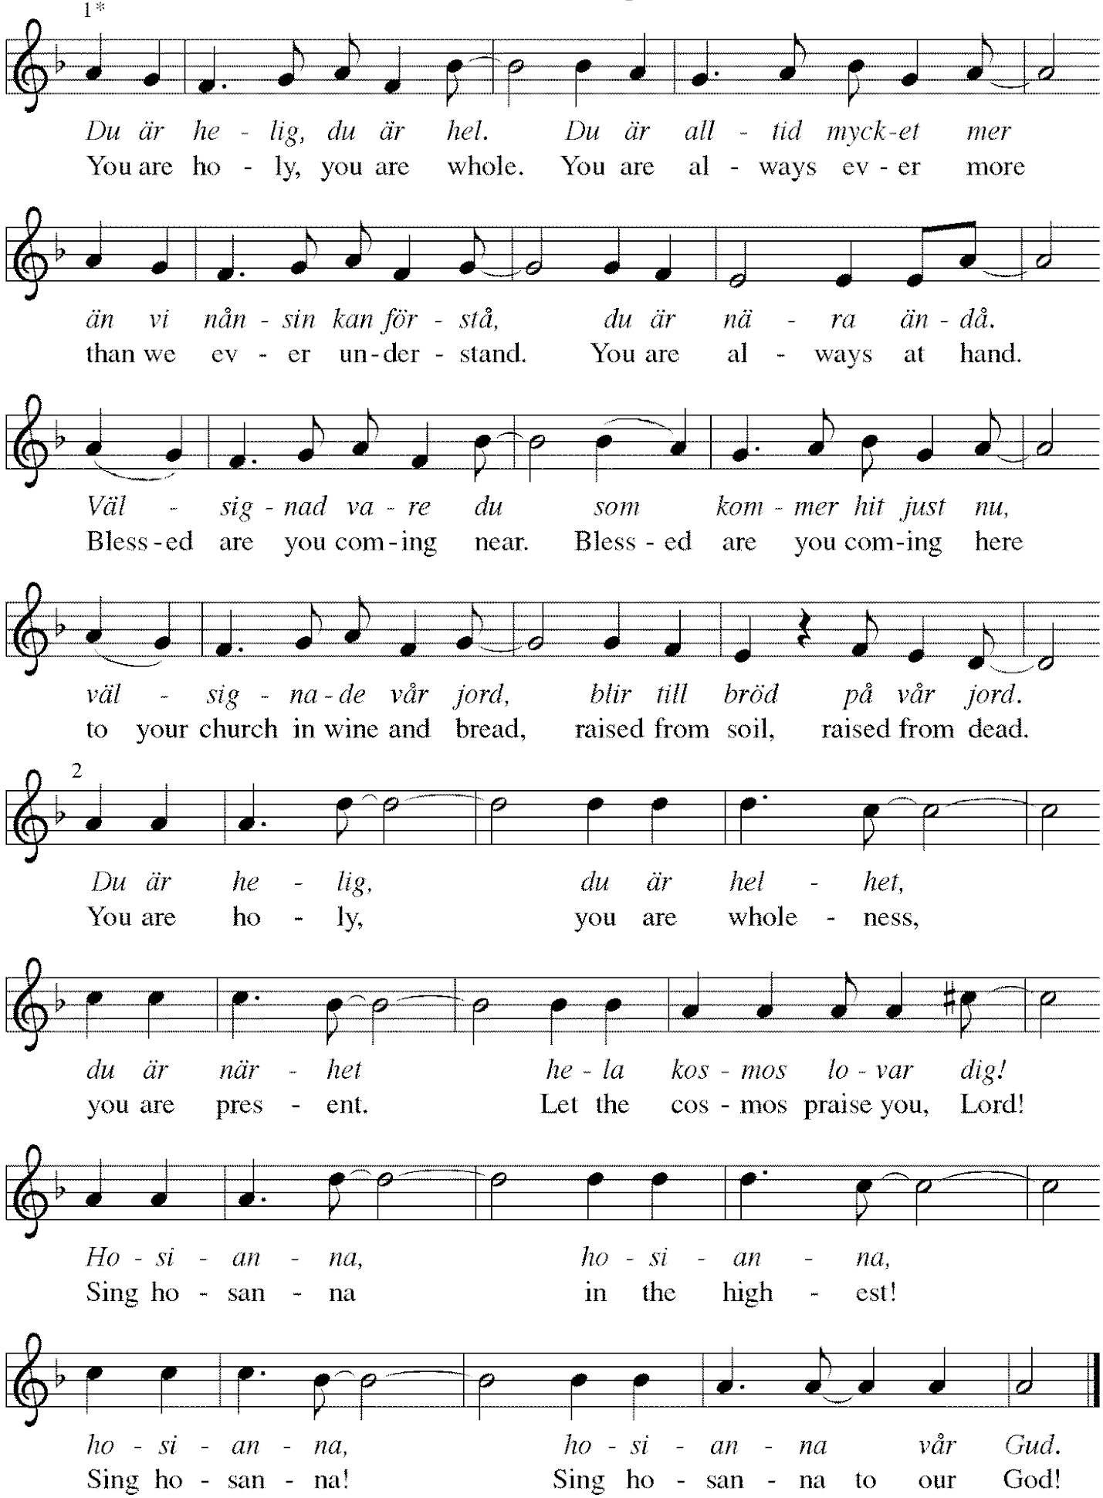
*Thanksgiving at the Table
. . . With this bread and cup we remember our Lord's passover from death to life as we proclaim the mystery of faith: Christ has died. Christ is risen. Christ will come again.

O God of resurrection and new life: Pour out your Holy Spirit on us and on these gifts of bread and wine. Bless this feast. Grace our table with your presence. Come, Holy Spirit.

Reveal yourself to us in the breaking of the bread. Raise us up as the body of Christ for the world. Breathe new life into us. Send us forth, burning with justice, peace, and love. Come, Holy Spirit.

With your holy ones of all times and places, with the earth and all its creatures, with sun and moon and stars, we praise you, O God, blessed and holy Trinity, now and forever. Amen.

*The Lord’s Prayer
Gathered into one by the Holy Spirit, let us pray as Jesus taught us.
Our Father, who art in heaven, hallowed be thy name. Thy kingdom come, thy will be done on earth as it is in heaven. Give us this day our daily bread, and forgive us our trespasses, as we forgive those who trespass against us; and lead us not into temptation, but deliver us from evil. For thine is the kingdom, and the power, and the glory, forever and ever. Amen.

*Invitation to Communion
If you have difficulty opening your communion, please signal an usher for assistance.
The risen Christ invites us to this table. Come, eat and be satisfied. Be Seated.

This is the Body of Christ, given for you. (Eat the bread.)
This is the blood of Christ, shed for you. (Drink the wine/juice.)

After communion you may place the packaging in the basket in your pew or dispose of it in the containers in the narthex as you leave.
Agnus Dei ELW #336 Lamb of God, st. 1

*Please stand as you are able.
*Post-Communion Blessing
The body and blood of our Lord Jesus Christ strengthen you and keep you in his grace. Amen.

*Prayer after Communion
Wellspring of joy, through this meal you have put gladness in our hearts. Satisfy the hunger still around us, and send us as joyful witnesses, that your love may bring joy to the hearts of all people, through Jesus Christ our Lord. Amen.

Sending
God blesses us and sends us in mission to the world.
*Blessing
May our glorious God grant us a spirit of wisdom to know and to love the risen Lord Jesus.
The God of life, Father, ☩ Son, and Holy Spirit, bless us now and forever. Amen.

*Sending Hymn ELW #643 We Are All One in Christ
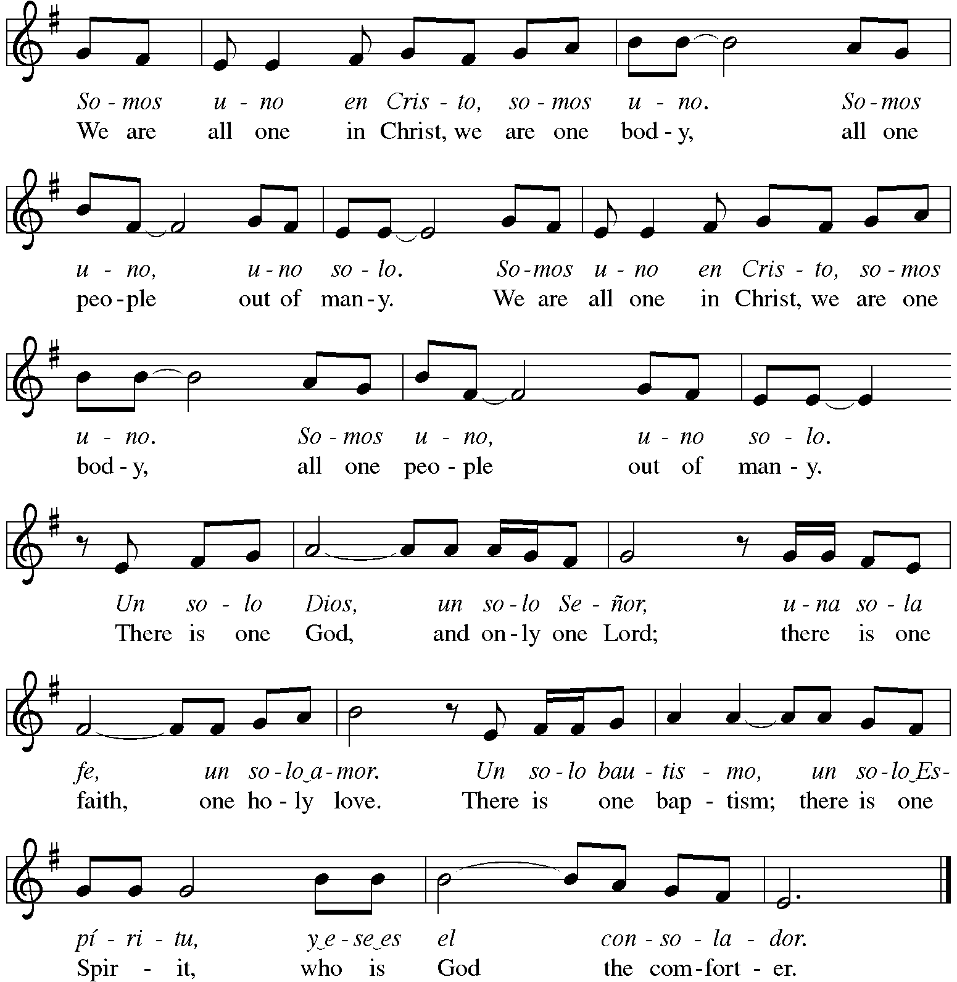
*Sent to the World
Alleluia! Christ is risen. Christ is risen indeed. Alleluia!
Go in peace. Share the good news. Alleluia! Thanks be to God. Alleluia!

Postlude
After the postlude, those who have joined via Zoom may unmute your mics
and share a greeting with your fellow worshippers.

From Sundays and Seasons
v.20190109.1233 Copyright © 2021 Augsburg Fortress. All rights reserved.
Reprinted by permission under Augsburg Fortress Liturgies Annual License #30867.
All rights reserved. Reprinted under OneLicense.net #A-718333.

Current Prayer Requests
Please keep these people in your prayers and reach out to our sisters and brothers in Christian love. Names will be left on the list for two weeks, unless you indicate that they should remain in our prayers for a longer period.
Name Relationship Prayer For
Family of Jerry Jeske Member Comfort in Grief
Dolores Nosal Member 97th Birthday 5/18
Bob Stein Member 93rd Birthday 5/14
Bob Stein Member Healing & Strength
Cathy Milleville Member Healing & Strength
Sigrid Elliott Member Healing & Strength
Dorothy Tracy Member Healing & Strength
Elizabeth Amber Friend of Pr. Melody & Marty Healing & Strength
Chris Danly Son of Mark & Pat Danly Healing & Strength
Tammy Rollo Friend of Barbara Sudds Healing & Strength
Prayers for our homebound Members
Dolores Nosal, Carol Petersen, Norma Petersen, Dorothy Stein

In-Person Worship Returning: Grace will return to in-person worship in the Sanctuary on Sunday, June 6 at 9:00am. Worship assistants will be needed. Please contact your scheduler for the groups you volunteer with to get scheduled.

Chair Exercise and monthly Book Club. Registration is required as the number of attendees will be limited. The exercise class meets Mondays at 10:00am and Thursdays at 11:00am. The Book Club will meet on the third Tuesday of the month at 11:00am. Please contact Sue at 630-858-6343 to register.

FaithTalk resumes on June 3 at 12:30: We will meet downstairs on the 1st Thursday of each month from 12:30-2:00. If you are attending Sue Davison’s exercise class in the morning, bring a sack lunch and eat together before we start!

Contributions to Grace: You may continue to mail your contributions to the church office; have your bank mail your contribution to the church office; or contribute on-line through Grace’s website. Please know, pandemic or no, our mission continues! Thank you for your continued support of our ministries at Grace Lutheran.

CROP Hunger Walk: Donations are still being accepted through the month of May. Donations can be made online at events.crophungerwalk.org/2021/mike-pertle or checks made out to CROP Hunger Walk can be mailed to the church office.

Women of Grace Returns! We will meet on Thursday, June 10 at Reserve 22. We have two reservations at 7:00pm for 10people at two outdoor tables. There will be a sign up to attend on the Women of Grace Facebook page. Let Becky Ficarella know if you plan to attend.

RAMP: Our mortgage reduction campaign has been renamed “RAMP” (Reduce Another Mortgage Payment) as we continue to RAMP up to refinance our mortgage with Mission Investment Fund this Fall. If we can raise an additional $100,000 payment prior to our November refinancing it will take us from $925,000 to $825,000.

Every Member a Minister and Missionary!

Phone: 630-469-1555 Emergency Pastoral Contact: 630-674-2887
info@graceglenellyn.org www.graceglenellyn.org

Pastor
Rev. Melody Eastman office ext. 14
meastman@graceglenellyn.org

Minister of Music
Bradford Thompson 219-718-8879
bradfordmthompson@gmail.com

Ministry Associate
Becky Ficarella office ext. 17
bficarella@graceglenellyn.org

Office Manager
Barbara Sudds office ext. 10
bsudds@graceglenellyn.org

Parish Counselor
Carole LoGalbo M.S., LCPC 630-668-4594
carolelogalbo@yahoo.com

