Grace Lutheran Church

493 Forest Avenue, Glen Ellyn IL 630.469.1555
www.graceglenellyn.org

Day of Pentecost May 28, 2023

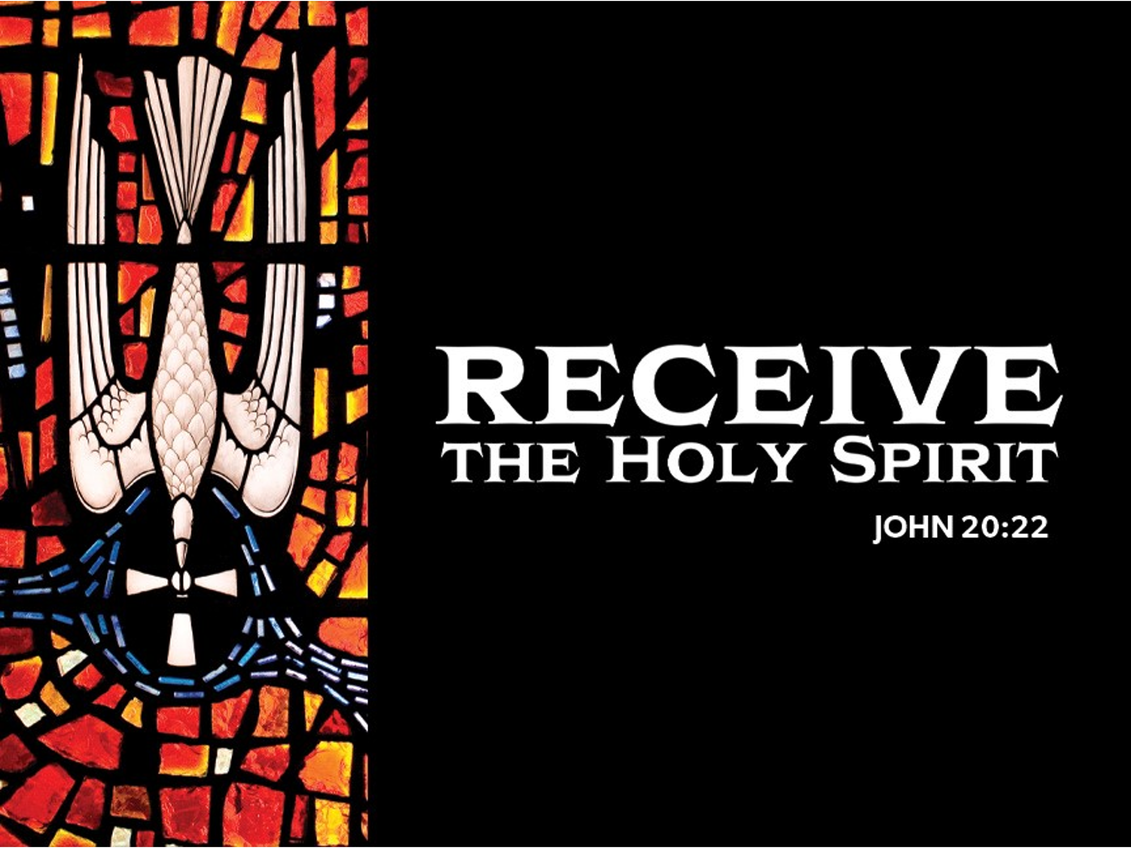

+ Proclaim Christ + Build Community +
+ Serve Our Neighbors +

Especially For Our Guests
Welcome to Grace!
If you are a guest, we’re thankful you’re here today. We hope you will feel Welcomed and spiritually nourished. If you would like to speak to the pastor about the congregation, please let her know directly or call the church office. To enhance your worship experience, you may want to know the following:
· Please join us after service for some great refreshments and Christian Fellowship.
· Parts of the liturgy (worship service) not printed in this bulletin are in the red hymnal (ELW). Page numbers in the hymnal are at the bottom of the page; hymn numbers are the large numbers at the top in the back half of the book.
· All baptized people are welcome at communion. If you would like to come forward for a blessing without taking communion, you can do that too. If you have difficulty walking, feel free to let the usher know and we’ll bring communion to you.
· If you find yourself confused about where we are, ask a neighbor!
· Assisted Listening Devices are available for your use. Please ask an usher.
· Young children are welcome in worship! Parents, you can bring your little ones up front to the PrayGround, a space with tables, chairs and quiet activities to keep our younger members engaged during services. Please sit near your little ones and help them use the space quietly as well as participate with you in worship. If you prefer, there is also a nursery space for you to use with infants or younger toddlers in the overflow room at the rear of the sanctuary. (But we really do like having children up front, if possible!)
· Please take your bulletin home with you. It contains the weekly calendar of events at Grace plus upcoming announcements.

Introduction
Pentecost derives its name from the Jewish festival celebrating the harvest and the giving of the law on Mount Sinai fifty days after Passover. Fifty days after Easter, we celebrate the Holy Spirit as God’s presence within and among us. In Acts the Spirit arrives in rushing wind and flame, bringing God’s presence to all people. Paul reminds us that though we each have different capacities, we are unified in the Spirit that equips us with these gifts. Jesus breathes the Holy Spirit on his disciples, empowering them to forgive sin. We celebrate that we too are given the breath of the Holy Spirit and sent out to proclaim God’s redeeming love to all the world.

An asterisk (*) indicates that you should stand for that portion of the service. If standing is difficult, please remain seated. The Congregation responses are in bold print.
Gathering
The Holy Spirit calls us together as the people of God.
Welcome/Announcements

Prelude

*Please stand as you are able.
*Thanksgiving for Baptism
All may make the sign of the cross, the sign that is marked at baptism, as the presiding minister begins.
Blessed be the holy Trinity, ☩ one God,
by whose hand we are given new birth,
by whose speaking we are given new life. Amen.

Joined to Christ in the waters of baptism,
we are welcomed, restored, and supported
as citizens of the new creation.
Let us give thanks for the gift of baptism.
Holy God, holy and merciful,
holy and mighty, you are the river of life,
you are the everlasting wellspring.
In mercy and might you have freed us from death
and raised us with Jesus, the firstborn of the dead.
In baptismal waters our old life is washed away,
and in them we are born anew.
Water may be poured into the font as the presiding minister continues.

Glory to you for oceans and lakes,
for rivers and streams.
Honor to you for waters that wash us clean,
quench our thirst, and nurture both crops and creatures.
Praise to you for the life-giving water of baptism,
the outpouring of the Spirit of the new creation.

Wash away our sin and all that separates us from you.
Empower our witness to your resurrection.
Strengthen our resolve in seeking justice for all.

Satisfy the world’s need through this living water.
Where drought dries the earth, bring refreshment.
Where despair prevails, grant hope.
Where chaos reigns, bring peace.
We ask this through Christ,
who with you and the Spirit reigns forever. Amen.

*Entrance Hymn ELW #407 O Living Breath of God
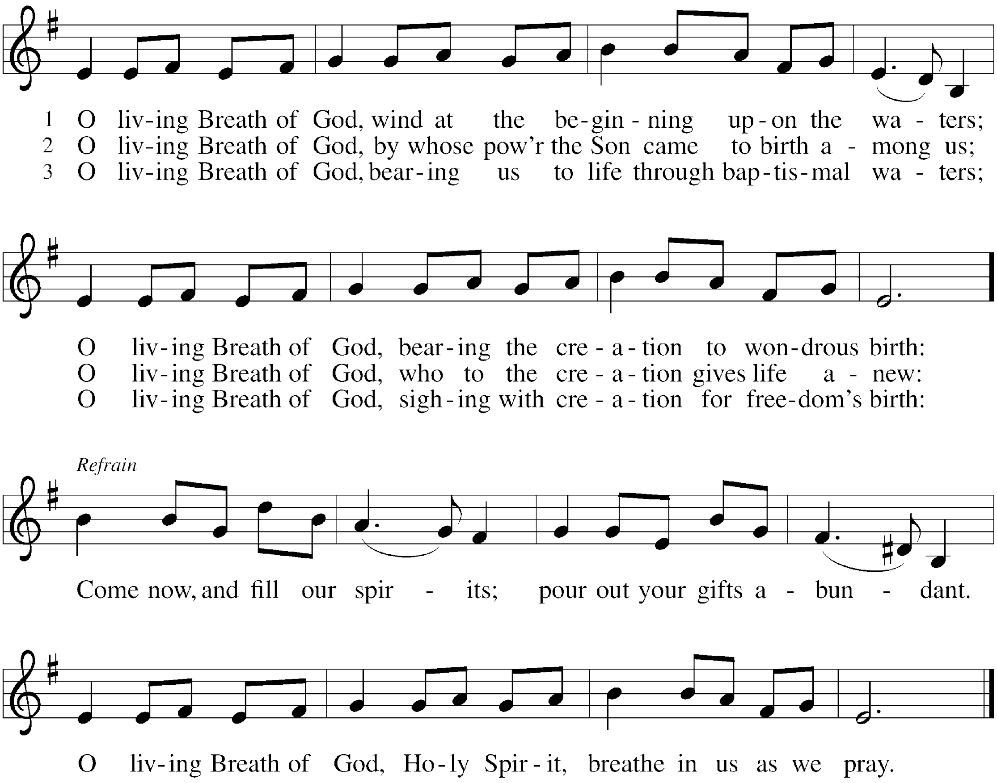

*Greeting
The grace of our Lord Jesus Christ, the love of God, and the communion of the Holy Spirit be with you all. And also with you.

*Hymn of Praise PBS #97 O God of Fire, O Word of Flame
sts 1,2
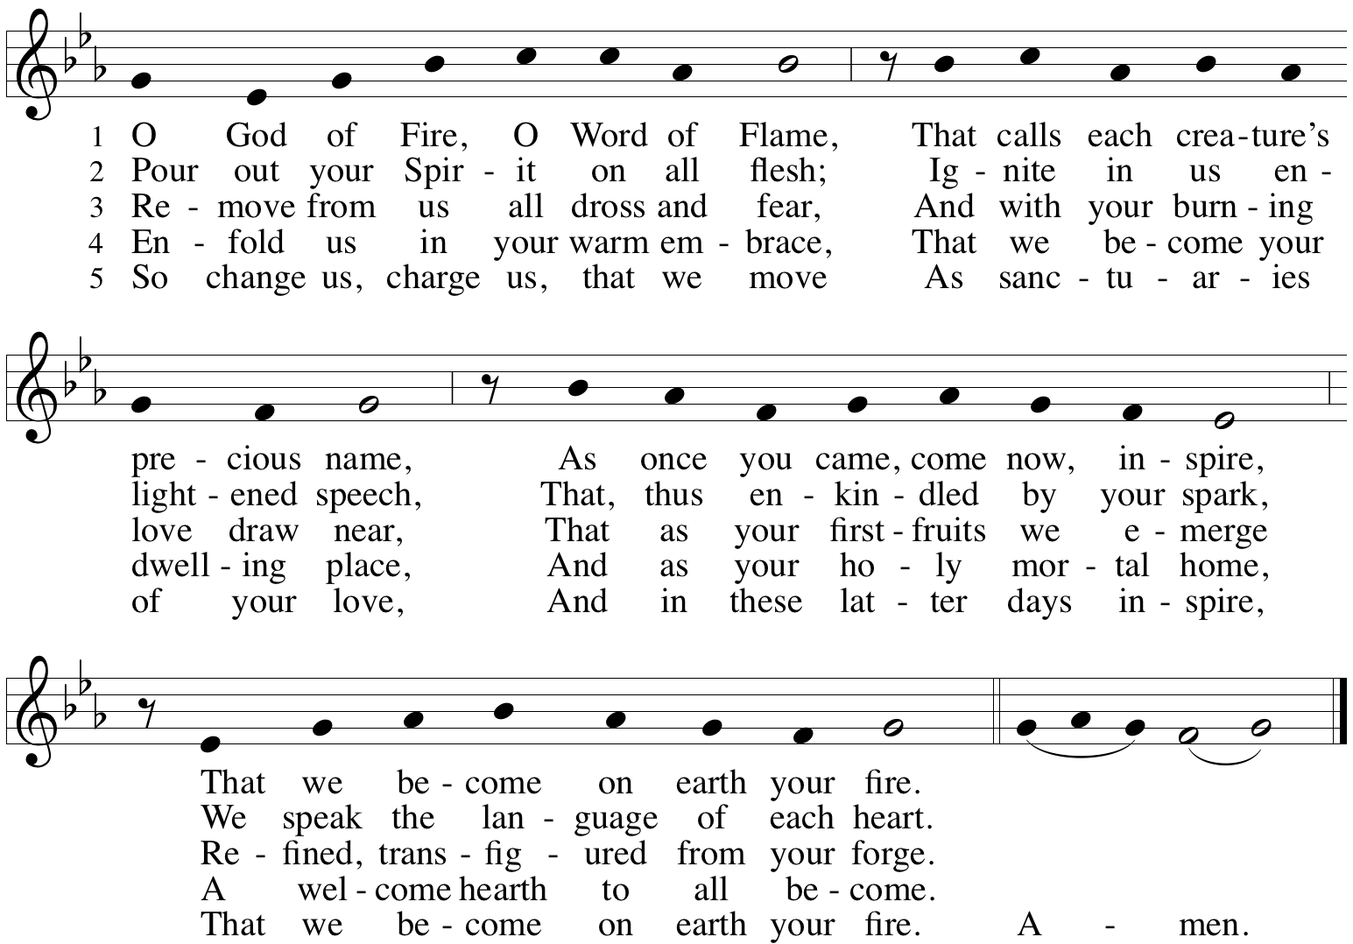

*Prayer of the Day
O God, on this day you open the hearts of your faithful people by sending into us your Holy Spirit. Direct us by the light of that Spirit, that we may have a right judgment in all things and rejoice at all times in your peace, through Jesus Christ, your Son and our Lord, who lives and reigns with you and the Holy Spirit, one God, now and forever. Amen. Be seated.

Word
God speaks to us in scripture reading.
First Lesson Acts 2:1-21
Pentecost was a Jewish harvest festival that marked the fiftieth day after Passover. Luke portrays the Holy Spirit being poured out upon the disciples before the gathered and astonished people assembled in Jerusalem for the festival. Filled with the Spirit, the disciples were able to witness to the power of Christ’s resurrection.

¹When the day of Pentecost had come, [the apostles] were all together in one place. ²And suddenly from heaven there came a sound like the rush of a violent wind, and it filled the entire house where they were sitting. ³Divided tongues, as of fire, appeared among them, and a tongue rested on each of them. ⁴All of them were filled with the Holy Spirit and began to speak in other languages, as the Spirit gave them ability.
⁵Now there were devout Jews from every nation under heaven living in Jerusalem. ⁶And at this sound the crowd gathered and was bewildered, because each one heard them speaking in the native language of each. ⁷Amazed and astonished, they asked, “Are not all these who are speaking Galileans? ⁸And how is it that we hear, each of us, in our own native language? ⁹Parthians, Medes, Elamites, and residents of Mesopotamia, Judea and Cappadocia, Pontus and Asia, ¹⁰Phrygia and Pamphylia, Egypt and the parts of Libya belonging to Cyrene, and visitors from Rome, both Jews and proselytes, ¹¹Cretans and Arabs—in our own languages we hear them speaking about God’s deeds of power.” ¹²All were amazed and perplexed, saying to one another, “What does this mean?” ¹³But others sneered and said, “They are filled with new wine.”
¹⁴But Peter, standing with the eleven, raised his voice and addressed them, “Men of Judea and all who live in Jerusalem, let this be known to you, and listen to what I say. ¹⁵Indeed, these are not drunk, as you suppose, for it is only nine o’clock in the morning. ¹⁶No, this is what was spoken through the prophet Joel: ¹⁷‘In the last days it will be, God declares, that I will pour out my Spirit upon all flesh, and your sons and your daughters shall prophesy, and your young men shall see visions, and your old men shall dream dreams. ¹⁸Even upon my slaves, both men and women, in those days I will pour out my Spirit; and they shall prophesy. ¹⁹And I will show portents in the heaven above and signs on the earth below, blood, and fire, and smoky mist. ²⁰The sun shall be turned to darkness and the moon to blood, before the coming of the Lord’s great and glorious day. ²¹Then everyone who calls on the name of the Lord shall be saved.’ ”

Word of God, Word of Life. Thanks be to God.

Second Lesson 1 Corinthians 12:3b-13
Paul is helping the Corinthians understand the relationship between our God-given unity and Spirit-created diversity. The Spirit creates the unity of faith and gives all Christians diverse gifts for the common benefit of all. We need one another’s diverse spiritual gifts because the same Spirit has given them to each person for the common good.

^{3b}No one can say “Jesus is Lord” except by the Holy Spirit.
⁴Now there are varieties of gifts, but the same Spirit; ⁵and there are varieties of services, but the same Lord; ⁶and there are varieties of activities, but it is the same God who activates all of them in everyone. ⁷To each is given the manifestation of the Spirit for the common good. ⁸To one is given through the Spirit the utterance of wisdom, and to another the utterance of knowledge according to the same Spirit, ⁹to another faith by the same Spirit, to another gifts of healing by the one Spirit, ¹⁰to another the working of miracles, to another prophecy, to another the discernment of spirits, to another various kinds of tongues, to another the interpretation of tongues. ¹¹All these are activated by one and the same Spirit, who allots to each one individually just as the Spirit chooses.
¹²For just as the body is one and has many members, and all the members of the body, though many, are one body, so it is with Christ. ¹³For in the one Spirit we were all baptized into one body—Jews or Greeks, slaves or free—and we were all made to drink of one Spirit.

Word of God, Word of Life. Thanks be to God.

*Please stand as you are able.
*Gospel Acclamation PBS #97 O God of Fire, O Word of Flame
sts 3,5

The holy Gospel according to John. Glory to you, O Lord.
*Gospel John 20:19-23
The risen Jesus appears to his disciples, offering them a benediction, a commission, and the gift of the Holy Spirit.

¹⁹When it was evening on that day, the first day of the week, and the doors of the house where the disciples had met were locked for fear of the Jews, Jesus came and stood among them and said, “Peace be with you.” ²⁰After he said this, he showed them his hands and his side. Then the disciples rejoiced when they saw the Lord. ²¹Jesus said to them again, “Peace be with you. As the Father has sent me, so I send you.” ²²When he had said this, he breathed on them and said to them, “Receive the Holy Spirit. ²³If you forgive the sins of any, they are forgiven them; if you retain the sins of any, they are retained.”

The Gospel of the Lord. Praise to you, O Christ. Be seated.

Sermon Rev. Melody Eastman

*Please stand as you are able.
*Hymn of the Day ELW #401 Gracious Spirit, Heed Our Pleading
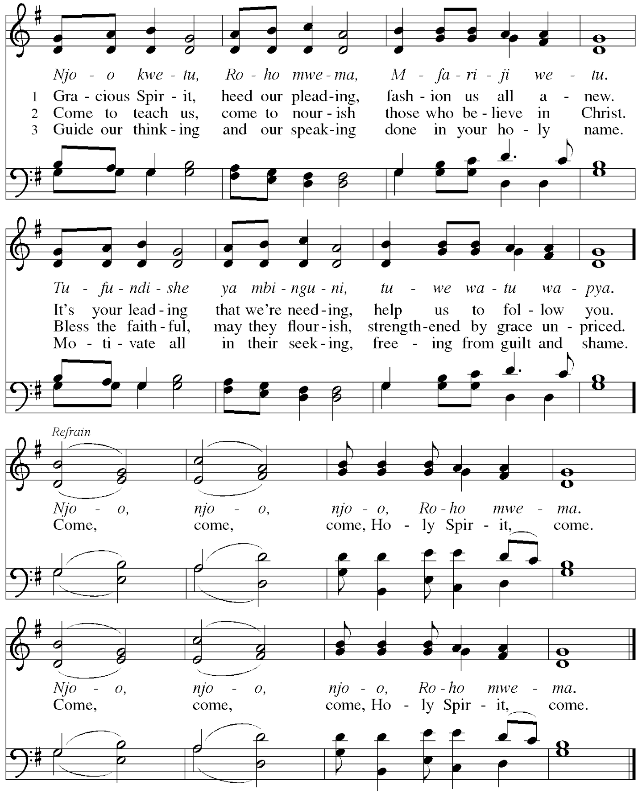

*Please stand as you are able
*Prayers of Intercession
United in the hope and joy of the resurrection, let us pray for the church, the world, and all in need.
A brief silence.

Passionate God, you sent your Spirit through the gifts of fire, wind, and word. As you equipped the disciples for their work, equip us to bring the good news to all those who long for you. Hear us, O God.
Your mercy is great.

Restoring God, wind and flame bring life and destruction throughout the world. We pray for those who work with wind energy, for migratory birds, for protection for lands facing destructive fire, for forestry managers and firefighters. Renew the face of the earth. Hear us, O God.
Your mercy is great.

Ever-present God, your spirit embraces all. Send your spirit of understanding to immigrants, refugees, and any experiencing language barriers. Bless the work of translators, ESL teachers, ambassadors, and international peace organizations. Safely guide those fleeing war and danger. Hear us, O God.
Your mercy is great.

Merciful God, you anoint us with your spirit. Bless nurses, doctors, midwives, chaplains, counselors, and hospice workers as they care for those in need. We pray for all who seek your comfort especially Greg, Rich, Norma, Dorothy, and those we name before you now. . . Hear us, O God.
Your mercy is great.

Generous God, you impart a variety of gifts. Set aflame the desire to learn from one another, especially those who differ from us. Make your presence known through missionaries, peace workers, and through the outreach ministries of our synod and community. Hear us, O God.
Your mercy is great.
Here other intercessions may be offered.

Life-giving God, we give thanks for those who have died and risen to new life in you. As we observe Memorial Day, we remember those who died in military service. Comfort all who mourn, and usher in a world where war is no more. Hear us, O God.
Your mercy is great.

Rejoicing in the victory of Christ’s resurrection, we lift our prayers and praise to you, almighty and eternal God; through Jesus Christ, our risen Lord. Amen.

*Peace
The peace of Christ be with you always. And also with you.
Please share the peace with others in your household, or by making a sign of peace to those on Zoom. You may then be seated as the table is prepared.

Gathering of Gifts
We gather gifts for those in need and for the church’s mission.

Music During Offering

*Please stand as you are able. The gifts are brought forward while the congregation sings:
*Offertory Breathe on Me, Breath of God

Breathe on me, Breath of God, fill me with life anew,
That I might love the things you love
And do what you would do.

Meal
God feeds us with the presence of Jesus Christ.
*Offering Prayer
Generous God,
in this meal you offer your very self.
We give thanks for these gifts of the earth.
In the breaking of this bread reveal to us the Risen One.
In the pouring of this wine
pour us out in service to the world;
through Christ our Lord.
Amen.

*Great Thanksgiving
The Lord be with you.
And also with you.

Lift up your hearts.
We lift them to the Lord.

Let us give thanks to the Lord our God.
It is right to give our thanks and praise.

*Preface
It is indeed right, our duty and our joy,
that we should at all times and in all places
give thanks and praise to you, almighty and merciful God,
through our Savior Jesus Christ.
Fulfilling the promise of the resurrection,
you pour out the fire of your Spirit,
uniting in one body people of every nation and tongue.
And so, with Mary Magdalene and Peter and all the witnesses of the resurrection,
with earth and sea and all their creatures,
and with angels and archangels, cherubim and seraphim,
we praise your name and join their unending hymn:

Sanctus ELW #399 O Holy Spirit, Root of Life
sts. 1,2
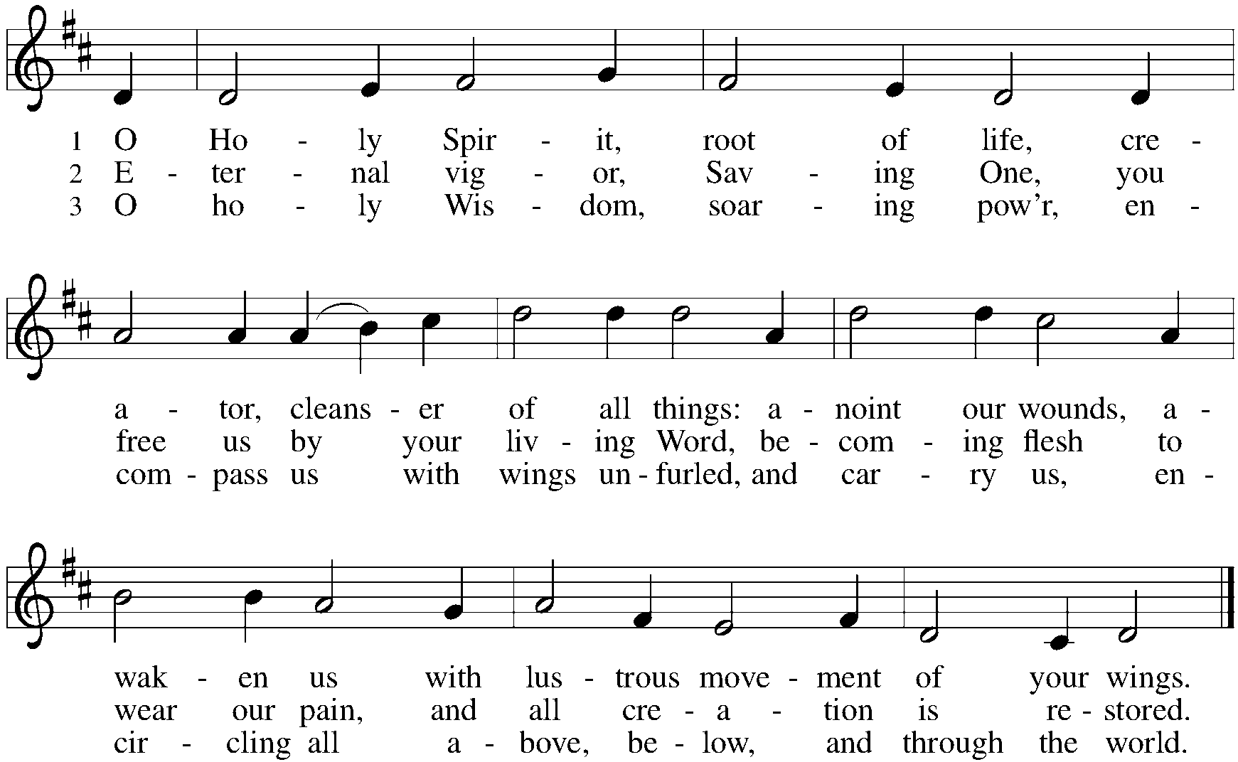

*Thanksgiving at the Table
Blessed are you, O God of the universe.
Your mercy is everlasting
and your faithfulness endures from age to age.

Praise to you for creating the heavens and the earth.
Praise to you for saving the earth from the waters of the flood.
Praise to you for bringing the Israelites safely through the sea.
Praise to you for leading your people through the wilderness
to the land of milk and honey.
Praise to you for the words and deeds of Jesus, your anointed one.
Praise to you for the death and resurrection of Christ.
Praise to you for your Spirit poured out on all nations.

In the night in which he was betrayed,
our Lord Jesus took bread, and gave thanks;
broke it, and gave it to his disciples, saying:
Take and eat; this is my body, given for you.
Do this for the remembrance of me.

Again, after supper, he took the cup, gave thanks,
and gave it for all to drink, saying:
This cup is the new covenant in my blood,
shed for you and for all people for the forgiveness of sin.
Do this for the remembrance of me.

With this bread and cup
we remember our Lord’s passover from death to life
as we proclaim the mystery of faith:
Christ has died.
Christ is risen.
Christ will come again.

O God of resurrection and new life:
Pour out your Holy Spirit on us
and on these gifts of bread and wine.
Bless this feast.
Grace our table with your presence.
Come, Holy Spirit.

Reveal yourself to us in the breaking of the bread.
Raise us up as the body of Christ for the world.
Breathe new life into us.
Send us forth,
burning with justice, peace, and love.
Come, Holy Spirit.

With your holy ones of all times and places,
with the earth and all its creatures,
with sun and moon and stars,
we praise you, O God,
blessed and holy Trinity,
now and forever.
Amen.

*The Lord’s Prayer Ecumenical Version
Gathered into one by the Holy Spirit, let us pray as Jesus taught us.
Our Father in heaven, hallowed be your name, your kingdom come, your will be done, on earth as in heaven. Give us today our daily bread. Forgive us our sins as we forgive those who sin against us. Save us from the time of trial and deliver us from evil. For the kingdom, the power and the glory are yours, now and forever. Amen.

*Invitation to Communion
Come and know Christ, broken and poured out for you. Be seated.

Communion
Those who wish to come to the rail for communion may do so at the ushers’ direction. You may stand or kneel. You may return to your seat by the side aisles after you have received the bread and wine.

For those receiving communion in the pew or from home:
This is the body of Christ, given for you. Amen (Eat the bread.)
This is the blood of Christ, shed for you. Amen (Drink the juice.)

Agnus Dei ELW #399 O Holy Spirit, Root of Life
st. 3

Music During Communion ACS #942 Every Time I Feel the Spirit

Stanzas on next page

*Please stand as you are able.
*Post Communion Blessing
May the body and blood of our Lord Jesus Christ strengthen you and keep you in his grace. Amen.

*Post Communion Prayer
Gracious God, in you we live and move and have our being.
With your word and this meal of grace,
you have nourished our life together.
Strengthen us to show your love
and serve the world in Jesus’ name. Amen.

Sending
God blesses us and sends us in mission to the world.
*Blessing
The God of all,
who raised ☩ Jesus from the dead,
bless us by the power of the Holy Spirit
to live in the new creation. Amen.

*Sending Hymn ELW #400 God of Tempest, God of Whirlwind
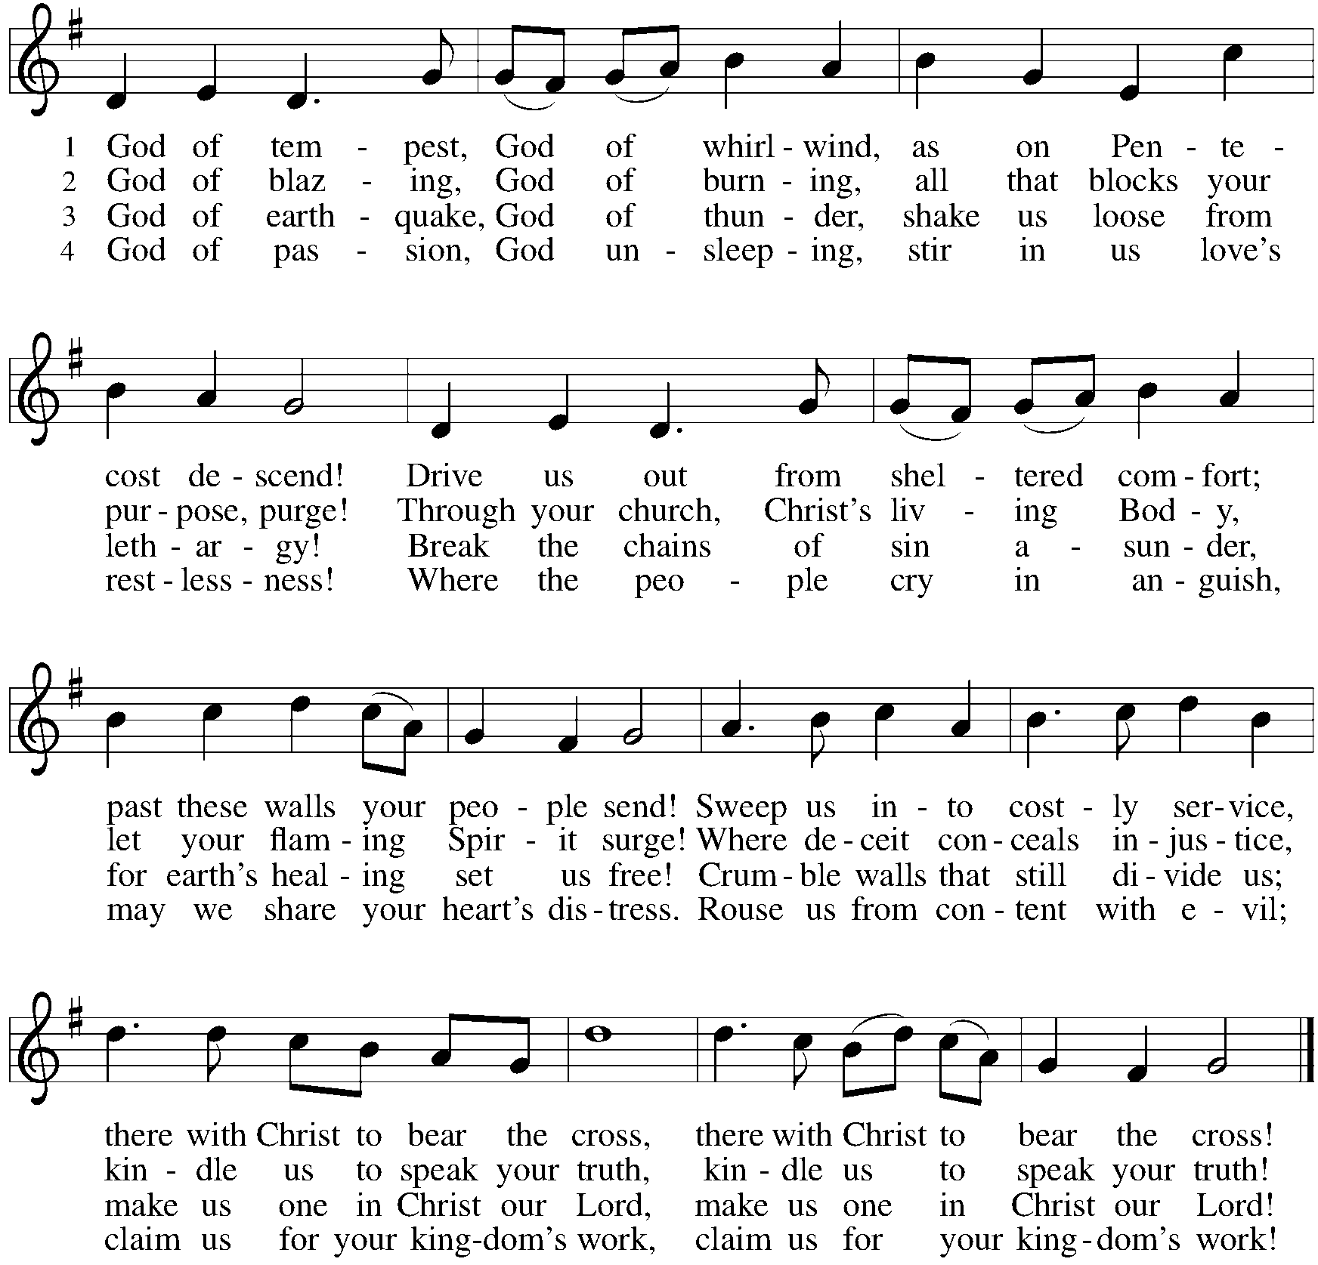

*Sent to the World
Go in peace. Serve the Risen One. Thanks be to God.

Postlude

From Sundays and Seasons v.20190109.1233 Copyright © 2023 Augsburg Fortress. All rights reserved.
Reprinted by permission under Augsburg Fortress Liturgies Annual License #30867.
All rights reserved. Reprinted under OneLicense.net #A-718333.

Assisting in Worship Today
Worship Leader Rev. Melody Eastman
Minister of Music Bradford Thompson
Altar Care Cathy Milleville
Lector Susan Jacobson
Ushers Jacky Anderson, Jeff Nelson
Zoom Mark Hamilton, Jon & Cathy Milleville
Fellowship Hour Andy Swiston
Altar Flowers Jerry & Brigitte Miller for God’s many blessings

Current Prayer Requests
Name Relationship Prayer For
Greg Barber Member Healing & Strength
Rich Davison Member Healing & Strength
Kathy Meyer Mother of Susi Nelson Healing & Strength
Lori Garabrandt Niece of Lois Pertle Healing & Strength
Prayers for our homebound Members
Norma Peterson, Dorothy Tracy

Weekly Announcements

Pr. Melody will be on vacation Monday, June 5 through Saturday, June 17. In case of a pastoral emergency, please contact Pastor Shelly Satran at Faith Lutheran, 630-469-2361. (If calling after church hours, follow the prompts to get the emergency pastoral care contact number.)

FaithTalk: Join us on Thursday, June 1 from 12:30-2:00pm. In recognition of the first day of Pride Month, we’re going to look at the movement and process in the ELCA for inclusion of the LGBTQIA+ community in the life of the church. How did the conversation get started, when did it gain steam, how did decisions about policy get made, and what is the church doing and saying today? This is a great illustration of how our faith expresses itself as a reforming movement, and how our church engages the conversations and movements that flow though, and sometimes divide, our society.

As always, even with a serious topic there’s still a lot of room for laughter! Please feel welcome, even if you’ve never attended before. FaithTalk meets on the lower level.

PADS: For June 6th, we're looking for meals (that could feed up to 10 people) - fresh cooked, hot or cold, that can be put in the containers that we already have. For example: a pan of homemade Chili. We do have some food supplies on hand, frozen pork loin, frozen hamburger and frozen Jimmy Dean hot sausage and sausage patties that we can supply for your cooking use.

If cooking is not an option, we can always use frozen dinners or shelf stable foods and fruits like oranges, apples and bananas. Dessert items are also welcome. Please remember that a third of our guests are children when making food selections.

Of course, all food donations are appreciated. If anyone has contacts with restaurants or stores who would like to help, please let us know.

Please leave donated food for PADS (1st Tuesday of the month) upstairs in the church kitchen via the gym. Food from the church is picked up about 2:00pm on Tuesday. Or it can be dropped off here at our house (1N346 Prairie Ave, GE - last house on the left - 630-790-1612). We usually leave for the PADS site around 4:15pm.

If you'd like a closer look at what we do and who we serve, please join us at the IHC (Interim Housing Center) - previously a Red Roof Inn - on the south side of Butterfield just west of Highland Ave between 5pm and 5:30pm - east side of the building Room 106. We are always looking for volunteers to help us distribute the food.

Thank you so much for your support and for helping members in our community!
Joe and Donna Jacobo

Grace Arts and Apps: Calling all artists of all ages and those with art they would like to share. The Social Committee is hosting an Arts and Apps event on Sunday, June 4 after worship in the narthex. We will exhibit artwork of Grace's members for the congregation to see while enjoying some light refreshments in the form of appetizers. Do you have some art that you have made as a hobby or profession? Do you own some artwork you would like to bring and show that day? There will be a sign-up in the narthex so we know how many tables to set up. And, if you don't have any art to share, perhaps you would like to make an appetizer to share.

Sharing Circle: Let's Talk About Race. In May, the sharing circle on racial healing will be meeting after worship on June 11. Using The Little Book of Racial Healing (by Thomas Norman DeWolf and Jodie Geddes) as a starting point, we explore the ways in which experiences of race and racial disparities are affecting our lives and our community. The format of the sharing circle is based on a mutual agreement to create a safe space for all who choose to participate and to practice deep listening as we talk about difficult topics. We will be meeting in the Great Room, and all are welcome to join.

A reminder about Pastor Melody’s days off: Pastor Melody’s days off are Friday and Saturday. If you wish to reach out to her for a non-emergency communication, it is best to do so Monday through Thursday. In particular, text messages received on her days off are most likely to get lost in the string of other texts she receives. Email is the best way to be sure she will get your message at a time when she can respond. Of course, in case of a pastoral emergency (death or serious illness/injury) you may reach out to her via phone, text or email at any time.

Every Member a Minister and Missionary!

Phone: 630-469-1555 Emergency Pastoral Contact: 630-674-2887
info@graceglenellyn.org www.graceglenellyn.org

Pastor
Rev. Melody Eastman office ext. 14
meastman@graceglenellyn.org

Minister of Music
Bradford Thompson 219-718-8879
bradfordmthompson@gmail.com

Office Manager
Barbara Sudds office ext. 10
bsudds@graceglenellyn.org

Parish Counselor
Carole LoGalbo M.S., LCPC 630-668-4594
carolelogalbo@yahoo.com

