Grace Lutheran Church

493 Forest Avenue, Glen Ellyn IL 630.469.1555
www.graceglenellyn.org

Seventh Sunday of Easter May 29, 2022

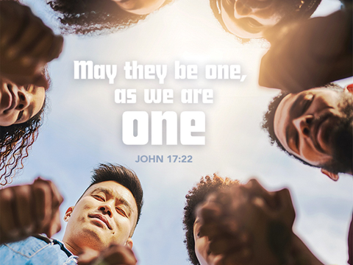

+ Proclaim Christ + Build Community +
+ Serve Our Neighbors +

Especially For Our Guests
Welcome to Grace!
If you are a guest, we’re thankful you’re here today. We hope you will feel Welcomed and spiritually nourished. If you would like to speak to the pastor about the congregation, please let her know directly or call the church office. To enhance your worship experience, you may want to know the following:
· Please join us after service for some great refreshments and Christian Fellowship.
· Parts of the liturgy (worship service) not printed in this bulletin are in the red hymnal (ELW). Page numbers in the hymnal are at the bottom of the page; hymn numbers are the large numbers at the top in the back half of the book.
· All baptized people are welcome at communion. If you would like to come forward for a blessing without taking communion, you can do that too. If you have difficulty walking, feel free to let the usher know and we’ll bring communion to you.
· If you find yourself confused about where we are, ask a neighbor!
· Assisted Listening Devices are available for your use. Please ask an usher.
· Young children are welcome in worship! Parents, you can bring your little ones up front to the PrayGround, a space with tables, chairs and quiet activities to keep our younger members engaged during services. Please sit near your little ones and help them use the space quietly as well as participate with you in worship. If you prefer, there is also a nursery space for you to use with infants or younger toddlers in the overflow room at the rear of the sanctuary. (But we really do like having children up front, if possible!)
· Please take your bulletin home with you. It contains the weekly calendar of events at Grace plus upcoming announcements.
· Due to COVID concerns we are not passing the offering plate during worship. You may place your gifts to Grace Lutheran in the black box on table in the Narthex. Thank you.

Updated Communion Information
We have returned to the option to commune at the rail with some modifications:
· We are not yet offering the common cup. Red grape juice and white wine are available in individual cups.
· Please do not touch more than one cup. The cups are spaced out to make them easier to remove without touching others.
· If you prefer, you may bring an individual communion kit to the rail and open it there to receive the bread and juice. Or you may remain in the pew and the Pastor will lead you in communion before those at the rail are served.
· Please maintain six feet distance between household groups.

Introduction
It is possible to hear in Jesus’ high priestly prayer, a prayer he offered shortly before his death, the petitions of the ascended Christ for his own throughout history—to our day—and beyond. Jesus prays for us. In holy baptism we become believers in God, have our robes washed in the flood of Christ’s forgiveness, and receive the gift of life forever with all the saints.

An asterisk (*) indicates that you should stand for that portion of the service. If standing is difficult, please remain seated. Congregation responses are in bold print.

Gathering
The Holy Spirit calls us together as the people of God.

Welcome/Announcements

Prelude

*Please stand as you are able and turn to face the font.
*Thanksgiving for Baptism
All may make the sign of the cross, the sign marked at baptism, as the presiding minister begins.

Alleluia! Christ is risen. Christ is risen indeed. Alleluia!

In the waters of baptism,
we have passed over from death to life with Jesus Christ,
and we are a new creation.
For this saving mystery, and for this water, let us bless God,
who was, who is, and who is to come.

We thank you, God, for your river of life,
flowing freely from your throne:
through the earth, through the city, through every living thing.
You rescued Noah and his family from the flood;
You opened wide the sea for the Israelites.
Now in these waters you flood us with mercy,
and our sin is drowned forever.
You open the gate of righteousness
and we pass safely through.
In Jesus Christ, you calm and trouble the waters.
You nourish us and enclose us in safety.
You call us forth and send us out.
In lush and barren places, you are with us.
You have become our salvation.
Now breathe upon this water
and awaken your church once more.
Claim us again as your beloved and holy people.
Quench our thirst; cleanse our hearts; wipe away every tear.
To you, our Beginning and our End,
our Shepherd and Lamb,
be honor, glory, praise, and thanksgiving,
now and forever.
Amen.

*Entrance Hymn ELW #657 Rise, O Sun of Righteousness

*Greeting
The grace of our Lord Jesus Christ, the love of God, and the communion of the Holy Spirit be with you all. And also with you.

*Hymn of Praise ELW #164 Glory to God
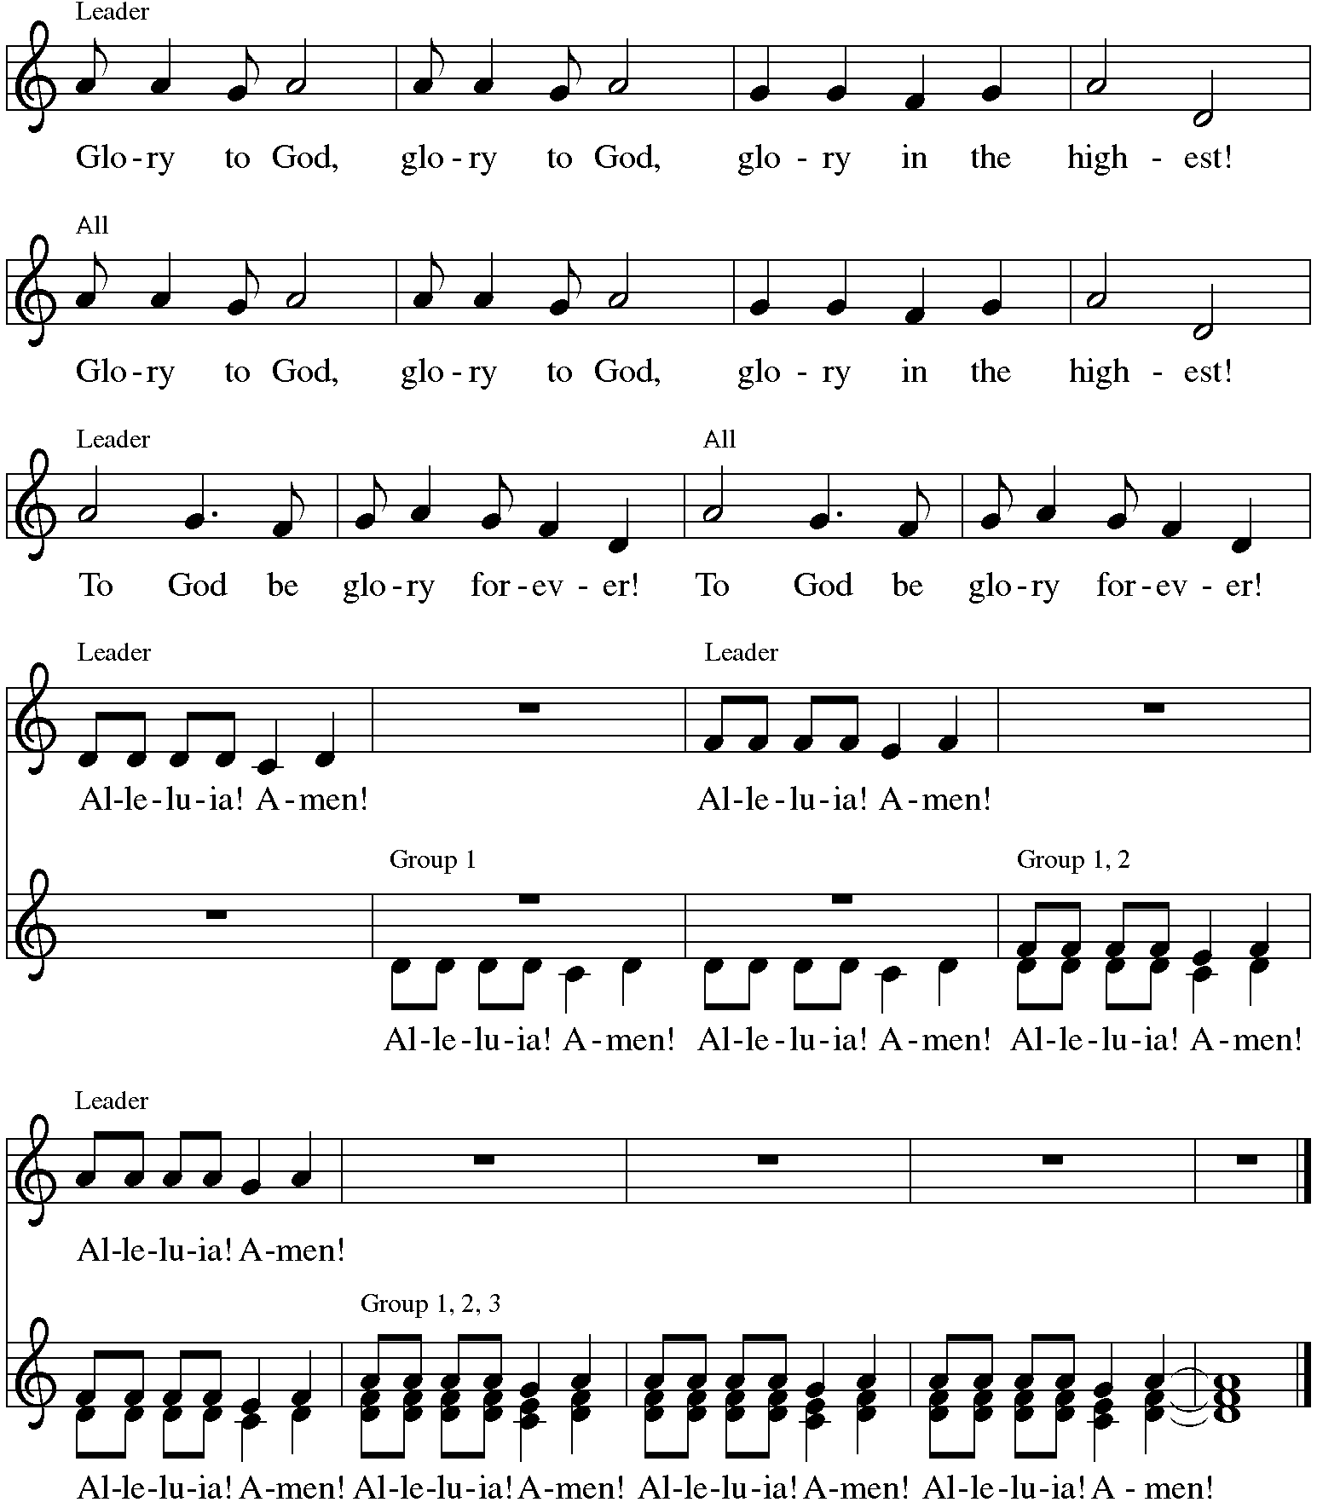

*Prayer of the Day
O God, form the minds of your faithful people into your one will. Make us love what you command and desire what you promise, that, amid all the changes of this world, our hearts may be fixed where true joy is found, your Son, Jesus Christ our Lord, who lives and reigns with you and the Holy Spirit, one God, now and forever. Amen. Be seated.
Word
God speaks to us in scripture reading.
First Lesson Acts 16:16-34
Those who had enslaved a girl and used her powers to tell fortunes threw Paul and Silas into jail for ordering the spirit to come out of her and consequently ruining their business. In prison, Paul and Silas bring the good news of the gospel to the jailer and his family.

¹⁶One day, as we were going to the place of prayer, we met a slave-girl who had a spirit of divination and brought her owners a great deal of money by fortune-telling. ¹⁷While she followed Paul and us, she would cry out, “These men are slaves of the Most High God, who proclaim to you a way of salvation.” ¹⁸She kept doing this for many days. But Paul, very much annoyed, turned and said to the spirit, “I order you in the name of Jesus Christ to come out of her.” And it came out that very hour.
¹⁹But when her owners saw that their hope of making money was gone, they seized Paul and Silas and dragged them into the marketplace before the authorities. ²⁰When they had brought them before the magistrates, they said, “These men are disturbing our city; they are Jews ²¹and are advocating customs that are not lawful for us as Romans to adopt or observe.” ²²The crowd joined in attacking them, and the magistrates had them stripped of their clothing and ordered them to be beaten with rods. ²³After they had given them a severe flogging, they threw them into prison and ordered the jailer to keep them securely. ²⁴Following these instructions, he put them in the innermost cell and fastened their feet in the stocks.
²⁵About midnight Paul and Silas were praying and singing hymns to God, and the prisoners were listening to them. ²⁶Suddenly there was an earthquake, so violent that the foundations of the prison were shaken; and immediately all the doors were opened and everyone’s chains were unfastened. ²⁷When the jailer woke up and saw the prison doors wide open, he drew his sword and was about to kill himself, since he supposed that the prisoners had escaped. ²⁸But Paul shouted in a loud voice, “Do not harm yourself, for we are all here.” ²⁹The jailer called for lights, and rushing in, he fell down trembling before Paul and Silas. ³⁰Then he brought them outside and said, “Sirs, what must I do to be saved?” ³¹They answered, “Believe on the Lord Jesus, and you will be saved, you and your household.” ³²They spoke the word of the Lord to him and to all who were in his house. ³³At the same hour of the night he took them and washed their wounds; then he and his entire family were baptized without delay. ³⁴He brought them up into the house and set food before them; and he and his entire household rejoiced that he had become a believer in God.

Word of God, Word of Life. Thanks be to God.

Psalm Psalm 97
The Psalm is read responsively by verse.
¹The Lord reigns; let the earth rejoice; let the multitude of the isles be glad.
²Clouds and darkness surround the Lord, righteousness and justice are the foundations of God’s throne.
³Fire goes before the Lord, burning up enemies on every side.
⁴Lightnings light up the world; the earth sees and trembles.
⁵The mountains melt like wax before the Lord of all the earth.
⁶The heavens declare your righteousness, O Lord, and all the peoples see your glory.
⁷Confounded be all who worship carved images and delight in false gods! Bow down before the Lord, all you gods.
⁸Zion hears and is glad, and the cities of Judah rejoice, because of your judgments, O Lord.
⁹For you are the Lord, most high over all the earth; you are exalted far above all gods.
¹⁰You who love the Lord, hate evil! God guards the lives of the saints and rescues them from the hand of the wicked.
¹¹Light dawns for the righteous, and joy for the honest of heart.
¹²Rejoice in the Lord, you righteous, and give thanks to God’s holy name.

Second Lesson Revelation 22:12-14, 16-17, 20-21
The ascended Christ, hidden from our sight, promises to come again. We eagerly pray, “Come, Lord Jesus,” with all who respond to this invitation.

¹²“See, I am coming soon; my reward is with me, to repay according to everyone’s work. ¹³I am the Alpha and the Omega, the first and the last, the beginning and the end.”
¹⁴Blessed are those who wash their robes, so that they will have the right to the tree of life and may enter the city by the gates. ¹⁶“It is I, Jesus, who sent my angel to you with this testimony for the churches. I am the root and the descendant of David, the bright morning star.” ¹⁷The Spirit and the bride say, “Come.” And let everyone who hears say, “Come.” And let everyone who is thirsty come. Let anyone who wishes take the water of life as a gift. ²⁰The one who testifies to these things says, “Surely I am coming soon.” Amen. Come, Lord Jesus! ²¹The grace of the Lord Jesus be with all the saints. Amen.

Word of God, Word of Life. Thanks be to God.

*Please stand as you are able.
*Gospel Acclamation Hallelujah!

The holy Gospel according to John. Glory to you, O Lord.
*Gospel John 17:20-26
Jesus prays that the life of his followers will be characterized by an intimate unity of identity with God. To be so identified with God means also to share in God’s mission: to proclaim the word that will bring others into this same unity.

[Jesus prayed:] ²⁰“I ask not only on behalf of these, but also on behalf of those who will believe in me through their word, ²¹that they may all be one. As you, Father, are in me and I am in you, may they also be in us, so that the world may believe that you have sent me. ²²The glory that you have given me I have given them, so that they may be one, as we are one, ²³I in them and you in me, that they may become completely one, so that the world may know that you have sent me and have loved them even as you have loved me. ²⁴Father, I desire that those also, whom you have given me, may be with me where I am, to see my glory, which you have given me because you loved me before the foundation of the world.
²⁵“Righteous Father, the world does not know you, but I know you; and these know that you have sent me. ²⁶I made your name known to them, and I will make it known, so that the love with which you have loved me may be in them, and I in them.

The Gospel of the Lord. Praise to you, O Christ. Be seated.

Sermon The Rev. Melody Eastman

*Please stand as you are able
*Hymn of the Day ELW #643 We Are All One in Christ
Be seated.

Affirmation of Baptism
Leah Fenske
Matthew LoGalbo
Presentation
Dear friends, we give thanks for the gift of baptism and for these people, one with us in the body of Christ, who are making public affirmation of their baptism:

Leah Fenske, Matthew LoGalbo

Confirmands, along with their families and godparents, come forward as their names are read.

Let us pray. Merciful God, we thank you for these brothers and sisters, whom you have made your own by water and the Word in baptism. You have called them to yourself, enlightened them with the gifts of your Spirit, and nourished them in the community of faith. Uphold your servants in the gifts and promises of baptism, and unite the hearts of all whom you have brought to new birth. We ask this in the name of Christ. Amen.

Profession of Faith
I ask you to profess your faith in Christ Jesus, reject sin, and confess the faith of the church.
Do you renounce the devil and all the forces that defy God?
R I renounce them.

Do you renounce the powers of this world that rebel against God?
R I renounce them.

Do you renounce the ways of sin that draw you from God?
R I renounce them.

*The congregation may stand to join in the profession of faith.
Do you believe in God the Father?
I believe in God, the Father almighty, creator of heaven and earth.

Do you believe in Jesus Christ, the Son of God?
I believe in Jesus Christ, God’s only Son, our Lord, who was conceived by the Holy Spirit, born of the virgin Mary, suffered under Pontius Pilate, was crucified, died, and was buried; he descended to the dead. On the third day he rose again; he ascended into heaven, he is seated at the right hand of the Father, and he will come to judge the living and the dead.

Do you believe in God the Holy Spirit?
I believe in the Holy Spirit, the holy catholic church, the communion of saints, the forgiveness of sins, the resurrection of the body, and the life everlasting.
The congregation may be seated.
Affirmation
You have made public profession of your faith. Do you intend to continue in the covenant God made with you in holy baptism: to live among God’s faithful people, to hear the word of God and share in the Lord’s supper, to proclaim the good news of God in Christ through word and deed, to serve all people, following the example of Jesus, and to strive for justice and peace in all the earth?
R I do, and I ask God to help and guide me.

People of God, do you promise to support these brothers and sisters and pray for them in their life in Christ? We do, and we ask God to help and guide us.

Those making affirmation may kneel.
Let us pray. We give you thanks, O God, that through water and the Holy Spirit you give us new birth, cleanse us from sin, and raise us to eternal life.

Stir up in Leah/Matthew the gift of your Holy Spirit: the spirit of wisdom and understanding, the spirit of counsel and might, the spirit of knowledge and the fear of the Lord, the spirit of joy in your presence, both now and forever. Amen.

After the laying on of hands for each confirmand, the congregation sings:

Confirmands and families stand and face the congregation.
Let us rejoice with these beloved siblings in Christ.
We rejoice with you in the life of baptism. Together we will give thanks and praise to God and proclaim the good news to all the world.

The congregation may offer acclamation for the faith milestone we celebrate today.
Confirmands, along with their families and godparents, may return to their seats.

*Please stand as you are able.
*Prayers of Intercession
Set free from captivity to sin and death, we pray to the God of resurrection for the church, people in need, and all of creation.
A brief silence.

Holy God, make your people one as you and your Son are one. Extend the gifts we have been given by your Spirit to all people, especially those experiencing division or questioning your love. God, in your mercy, hear our prayer.

Make worthy the work of scientists who look to the stars and planets, as well as scientists who look to atoms and molecules. Bring innovation and well-being to humanity through their discoveries. God, in your mercy, hear our prayer.

Keep in our minds those who have died in war, both military and civilians. May we honor them by seeking peaceful solutions to the conflicts that arise among nations and peoples. God, in your mercy, hear our prayer.

Grant freedom to all who are overwhelmed by chronic illness, depression, or constant worry, especially Carol, Dolores, Norma, Carol, Brittany, and those we name before you now. . . Open them to receive health and salvation in Christ Jesus through the Spirit’s gift of faith. God, in your mercy, hear our prayer.

Stir imagination and understanding throughout the church in the work of poets, theologians, and hymnwriters. Lead us into new visions and fresh expressions of your presence. God, in your mercy, hear our prayer.
Here other intercessions may be offered.

Unite us with the saints who have died and been raised in Jesus. Train us to wait with eager longing for Christ to come again, even as we sense his presence with us now. God, in your mercy, hear our prayer.

In your mercy, O God, respond to these prayers, and renew us by your life-giving Spirit; through Jesus Christ, our Savior. Amen.

*Peace
The peace of Christ be with you always. And also with you.
Please share the peace with others in your household, or by making a sign of peace to those on Zoom. Please remain standing as you are able.

Meal
God feeds us with the presence of Jesus Christ.
*Offering Prayer
Living God,
you gather the wolf and the lamb to feed together
in your peaceable reign,
and you welcome us all at your table.
Reach out to us through this meal,
and show us your wounded and risen body,
that we may be nourished and believe
in Jesus Christ, our Savior and Lord.
Amen.

*Great Thanksgiving
The Lord be with you. And also with you.
Lift up your hearts. We lift them to the Lord.
Let us give thanks to the Lord our God. It is right to give our thanks and praise.

*Preface
It is indeed right, our duty and our joy,
that we should at all times and in all places give thanks and praise to you,
almighty and merciful God,
for the glorious resurrection of our Savior Jesus Christ,
the true Paschal Lamb who gave himself to take away our sin;
who in dying has destroyed death,
and in rising has brought us to eternal life.
And so, with Mary Magdalene and Peter and all the witnesses of the resurrection,
with earth and sea and all their creatures,
and with angels and archangels, cherubim and seraphim,
we praise your name and join their unending hymn:

*Sanctus Holy, Holy, Holy C. Heine
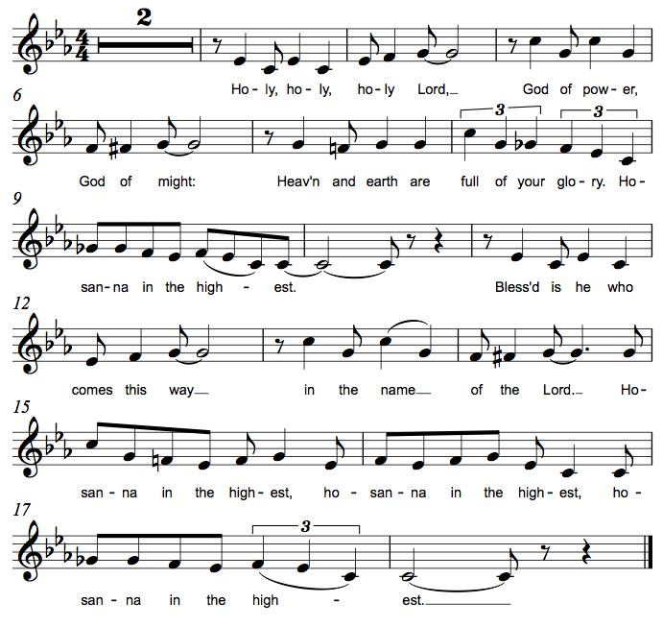

*Thanksgiving at the Table
O God most mighty, O God most merciful,
O God our rock and our salvation,
hear us as we praise, call us to your table, grant us your life.

When the earth was a formless void, you formed order and beauty.
When Abraham and Sarah were barren, you sent them a child.
When the Israelites were enslaved, you led them to freedom.
Ruth faced starvation, David fought Goliath,
and the psalmists cried out for healing,
and full of compassion, you granted the people your life.

You entered our sorrows in Jesus our brother.
He was born among the poor, he lived under oppression, he wept over the city.
With infinite love, he granted the people your life.

In the night in which he was betrayed,
our Lord Jesus took bread, and gave thanks;
broke it, and gave it to his disciples, saying:
Take and eat; this is my body, given for you.
Do this for the remembrance of me.

Again, after supper, he took the cup, gave thanks,
and gave it for all to drink, saying:
This cup is the new covenant in my blood,
shed for you and for all people for the forgiveness of sin.
Do this for the remembrance of me.

Remembering his death, we cry out Amen. Amen.
Celebrating his resurrection, we shout Amen. Amen.
Trusting his presence in every time and place, we plead Amen. Amen.

O God, you are Breath: send your Spirit on this meal.
O God, you are Bread: feed us with yourself.
O God, you are wine: warm our hearts and make us one.
O God, you are Fire: transform us with hope.

O God most majestic, O God most motherly, O God our strength and our song,
you show us a vision of a tree of life
with fruits for all and leaves that heal the nations.
Grant us such life,
the life of the Father to the Son,
the life of the Spirit of our risen Savior,
life in you, now and forever.
Amen

*The Lord’s Prayer
Gathered into one by the Holy Spirit, let us pray as Jesus taught us.
Our Father, who art in heaven, hallowed be thy name, thy kingdom come, thy will be done on earth as it is in heaven. Give us this day our daily bread; and forgive us our trespasses, as we forgive those who trespass against us; and lead us not into temptation, but deliver us from evil. For thine is the kingdom, and the power, and the glory, forever and ever. Amen.

*Invitation to Communion
The risen Christ dwells with us here. All who are hungry, all who are thirsty, come.
Be seated.

Lamb of God M.B. Eastman
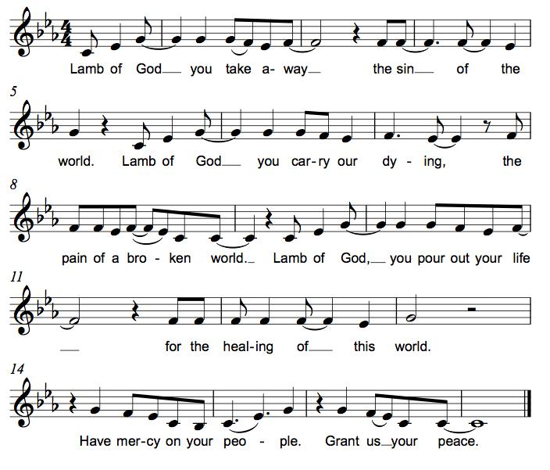

Communion
Those who wish to come to the rail for communion may do so at the ushers’ direction. You may stand or kneel. Please maintain social distancing between households. You may return to your seat by the side aisles after you have received the bread and wine. If you like, you may bring a communion kit with you to receive at the altar.

For those receiving communion in the pew or from home:
This is the body of Christ, given for you. Amen (Eat the bread.)
This is the blood of Christ, shed for you. Amen (Drink the juice.)

*Please stand as you are able.
*Post Communion Blessing
May the body and blood of our Lord Jesus Christ strengthen you and keep you in his grace. Amen.

*Post Communion Prayer
We give you thanks, generous God,
for in this bread and cup
we have tasted the new heaven and earth
where hunger and thirst are no more.
Send us from this table as witnesses to the resurrection,
that through our lives, all may know life in Jesus’ name.
Amen.
Sending
God blesses us and sends us in mission to the world.
*Blessing
God, the Author of life,
Christ, the living Cornerstone,
and the life-giving Spirit of adoption,
☩ bless you now and forever.
Amen.

*Sending Hymn ELW #655 Son of God, Eternal Savior
sts. 1, 2, 4

*Sent to the World
Alleluia! Christ is risen. Christ is risen indeed. Alleluia!

Go in peace. Tell what God has done. Thanks be to God.

Postlude

From Sundays and Seasons v.20190109.1233 Copyright © 2022 Augsburg Fortress. All rights reserved.
Reprinted by permission under Augsburg Fortress Liturgies Annual License #30867.
All rights reserved. Reprinted under OneLicense.net #A-718333.

Assisting in Worship Today
Pastor Rev. Melody Eastman
Minister of Music Bradford Thompson
Ministry Associate Becky Ficarella
Altar Care Cheryl Huizenga
Lector Rob Granner
Usher Mark Drager, John Jokela
Zoom Mark Hamilton, Jon & Cathy Milleville
Fellowship Hour Social Ministry

Current Prayer Requests
Please keep these people in your prayers and reach out to our sisters and brothers in Christian love. Names will be left on the list for two weeks, unless you indicate that they should remain in our prayers for a longer period.
Name Relationship Prayer For
Carol Wandke Member Healing & Strength
Dolores Nosal Member Healing & Strength
Brittany Huizenga Cousin of Cheryl Huizenga Healing & Strength
Dorothy Tracy Member Healing & Strength
Norma Petersen Member Healing & Strength
Prayers for our homebound Members
Dolores Nosal, Carol Petersen, Norma Petersen

Weekly Announements

Drivers Needed: We have two Grace members who need a ride to church on Sunday mornings. One from Beacon Hill in Lombard and one near President Street and Geneva Road in Wheaton. Do you think you could help out with this? Your commitment would be once every 5-6 weeks. They are so thankful to be able to come to worship. If you think this would work for you, please call or email or call Cathy Milleville 630-653-0957 or jmilleville@comcast.net.

Worship Assistants: With the return to communion at the rail, we are in need of people willing to serve as cross-bearer and communion assistant along with two ushers for each week. If you are able to help with carrying the cross and/or assisting with communion, please contact Susan Jacobson or the church office. Thank you!

Fellowship Hour: Please join us for coffee and fellowship following Sunday’s worship service. We are looking for additional volunteers to host the coffee hour. Please contact Becky Ficarella or the church office if you are interested.

Save the Date! Progressive Dinner! Saturday, June 11: We are planning on restarting the Progressive Dinner on Saturday, June 11th. We will have two options for sign up. Appetizers Only or Appetizers and Dinner. We are planning on the Appetizer House to be held outside for those who still are uncomfortable eating inside but would like to re-connect with your Grace family. Appetizers will start at 5:30pm, with dinner houses to follow at 7:30pm. Please sign up on the poster in the Narthex for a great evening. Questions, please call Susi Nelson at 630-297-3620.

Community Vacation Bible School: Registration is now open for volunteers and participants. Grace Lutheran Church, Faith Lutheran Church, and First Congregational Church Glen Ellyn are presenting this week together in partnership “Compassion Camp - Changing the World with Loving Kindness!” Monday – Friday, June 20-24, 9:00am-12:00pm at Faith Lutheran Church. 41 N. Park Blvd., Glen Ellyn. Register on Grace’s website!

Quilting Ministry: The quilters meet on the second and fourth Tuesday of every month from 9-10am.

Every Member a Minister and Missionary!

Phone: 630-469-1555 Emergency Pastoral Contact: 630-674-2887
info@graceglenellyn.org www.graceglenellyn.org

Pastor
Rev. Melody Eastman office ext. 14
meastman@graceglenellyn.org

Minister of Music
Bradford Thompson 219-718-8879
bradfordmthompson@gmail.com

Ministry Associate
Becky Ficarella office ext. 17
bficarella@graceglenellyn.org

Office Manager
Barbara Sudds office ext. 10
bsudds@graceglenellyn.org

Parish Counselor
Carole LoGalbo M.S., LCPC 630-668-4594
carolelogalbo@yahoo.com

