Grace Lutheran Church

493 Forest Avenue, Glen Ellyn IL 630.469.1555
www.graceglenellyn.org

Day of Pentecost May 31, 2020

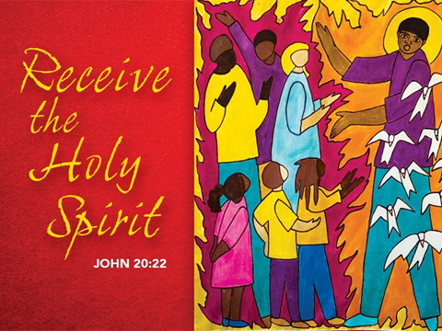

+ Proclaim Christ + Build Community +
+ Serve Our Neighbors +

Gathering
Even when we are apart, the Holy Spirit binds us together as the people of God.

Opening Hymn ELW #401 Gracious Spirit, Heed Our Pleading

Greeting
The grace of our Lord Jesus Christ, the love of God, and the communion of the Holy Spirit be with you all. And also with you.

Prayer of the Day
O God, on this day you open the hearts of your faithful people by sending into us your Holy Spirit. Direct us by the light of that Spirit, that we may have a right judgment in all things and rejoice at all times in your peace, through Jesus Christ, your Son and our Lord, who lives and reigns with you and the Holy Spirit, one God, now and forever. Amen.

Word
God speaks to us in scripture reading, preaching, and song.

First Lesson Acts 2:1-21
Pentecost was a Jewish harvest festival that marked the fiftieth day after Passover. Luke portrays the Holy Spirit being poured out upon the disciples before the gathered and astonished people assembled in Jerusalem for the festival. Filled with the Spirit, the disciples were able to witness to the power of Christ’s resurrection.

¹When the day of Pentecost had come, [the apostles] were all together in one place. ²And suddenly from heaven there came a sound like the rush of a violent wind, and it filled the entire house where they were sitting. ³Divided tongues, as of fire, appeared among them, and a tongue rested on each of them. ⁴All of them were filled with the Holy Spirit and began to speak in other languages, as the Spirit gave them ability.
⁵Now there were devout Jews from every nation under heaven living in Jerusalem. ⁶And at this sound the crowd gathered and was bewildered, because each one heard them speaking in the native language of each. ⁷Amazed and astonished, they asked, “Are not all these who are speaking Galileans? ⁸And how is it that we hear, each of us, in our own native language? ⁹Parthians, Medes, Elamites, and residents of Mesopotamia, Judea and Cappadocia, Pontus and Asia, ¹⁰Phrygia and Pamphylia, Egypt and the parts of Libya belonging to Cyrene, and visitors from Rome, both Jews and proselytes, ¹¹Cretans and Arabs—in our own languages we hear them speaking about God’s deeds of power.” ¹²All were amazed and perplexed, saying to one another, “What does this mean?” ¹³But others sneered and said, “They are filled with new wine.”
¹⁴But Peter, standing with the eleven, raised his voice and addressed them, “Men of Judea and all who live in Jerusalem, let this be known to you, and listen to what I say. ¹⁵Indeed, these are not drunk, as you suppose, for it is only nine o’clock in the morning. ¹⁶No, this is what was spoken through the prophet Joel:
¹⁷‘In the last days it will be, God declares, that I will pour out my Spirit upon all flesh, and your sons and your daughters shall prophesy, and your young men shall see visions, and your old men shall dream dreams. ¹⁸Even upon my slaves, both men and women, in those days I will pour out my Spirit; and they shall prophesy. ¹⁹And I will show portents in the heaven above and signs on the earth below, blood, and fire, and smoky mist. ²⁰The sun shall be turned to darkness and the moon to blood, before the coming of the Lord’s great and glorious day. ²¹Then everyone who calls on the name of the Lord shall be saved.’ ”

Word of God, Word of Life. Thanks be to God.

Second Lesson 1 Corinthians 12:3b-13
Paul is helping the Corinthians understand the relationship between our God-given unity and Spirit-created diversity. The Spirit creates the unity of faith and gives all Christians diverse gifts for the common benefit of all. We need one another’s diverse spiritual gifts because the same Spirit has given them to each person for the common good.

^{3b}No one can say “Jesus is Lord” except by the Holy Spirit.
⁴Now there are varieties of gifts, but the same Spirit; ⁵and there are varieties of services, but the same Lord; ⁶and there are varieties of activities, but it is the same God who activates all of them in everyone. ⁷To each is given the manifestation of the Spirit for the common good. ⁸To one is given through the Spirit the utterance of wisdom, and to another the utterance of knowledge according to the same Spirit, ⁹to another faith by the same Spirit, to another gifts of healing by the one Spirit, ¹⁰to another the working of miracles, to another prophecy, to another the discernment of spirits, to another various kinds of tongues, to another the interpretation of tongues. ¹¹All these are activated by one and the same Spirit, who allots to each one individually just as the Spirit chooses.
¹²For just as the body is one and has many members, and all the members of the body, though many, are one body, so it is with Christ. ¹³For in the one Spirit we were all baptized into one body—Jews or Greeks, slaves or free—and we were all made to drink of one Spirit.

Word of God, Word of Life. Thanks be to God.

Gospel Acclamation
Your Word is a lamp unto my feet, and a light unto my path. I long for your salvation, Lord, and your law is my delight.

The holy Gospel according to John. Glory to you, O Lord.

Gospel John 20:19-23
The risen Jesus appears to his disciples, offering them a benediction, a commission, and the gift of the Holy Spirit.

¹⁹When it was evening on that day, the first day of the week, and the doors of the house where the disciples had met were locked for fear of the Jews, Jesus came and stood among them and said, “Peace be with you.” ²⁰After he said this, he showed them his hands and his side. Then the disciples rejoiced when they saw the Lord. ²¹Jesus said to them again, “Peace be with you. As the Father has sent me, so I send you.” ²²When he had said this, he breathed on them and said to them, “Receive the Holy Spirit. ²³If you forgive the sins of any, they are forgiven them; if you retain the sins of any, they are retained.”
The Gospel of the Lord. Praise to you, O Christ.

Sermon (Available at www.GraceGlenEllyn.org) The Rev. Melody Eastman

Apostles’ Creed

With the whole church, let us confess our faith.
I believe in God, the Father almighty, creator of heaven and earth. I believe in Jesus Christ, God's only Son, our Lord, who was conceived by the Holy Spirit, born of the virgin Mary, suffered under Pontius Pilate, was crucified, died, and was buried; he descended to the dead. On the third day he rose again; he ascended into heaven, he is seated at the right hand of the Father, and he will come to judge the living and the dead. I believe in the Holy Spirit, the holy catholic church, the communion of saints, the forgiveness of sins, the resurrection of the body, and the life everlasting. Amen.

Prayers of Intercession
Uplifted by the promised hope of healing and resurrection, we join the people of God in all times and places in praying for the church, the world, and all who are in need.
A brief silence.
We call on your spirit of unity, giving thanks for our different vocations. Activate and utilize the diverse gifts present in your church, that they reveal your love for all. Lord, in your mercy,
hear our prayer.

We call on your spirit of life, present in air, wind, humidity, storms, and oxygen in our atmosphere, breathing energy into all things. Heal with your breath the whole creation, especially those who struggle to breathe due to air pollution. Lord, in your mercy,
hear our prayer.

We call on your spirit of righteousness. Wherever we as a people are divided, unite us. Wherever we are prideful, humble us. Give each one of us a heart for justice and empathy. As our nation is again are torn by violence against people of color, help us transform our communities with justice, understanding, and hope. Lord, in your mercy,
hear our prayer.

We call on your spirit of healing. Bless nurses, doctors, midwives, chaplains, counselors, and hospice workers as they care for those in need. We pray for all who long for comfort, especially Dorothy, Sigrid, Chris, David, Anita, Bob, Evelyn, Carol, Norma, and those we name before you now. . . Lord, in your mercy,
hear our prayer.

We call on your spirit of friendship. As Elizabeth welcomed Mary to her home, give us a spirit of welcome to those whom we meet in this congregation and outside these doors. Surprise us daily with unexpected grace, that we rejoice in every blessing you send. Lord, in your mercy,
hear our prayer.
Here other intercessions may be offered.

We call on your spirit of hope. As you have led your saints in all times and places, stir in us the desire to follow their example, leading us from death to new life in you. Lord, in your mercy,
hear our prayer.

With bold confidence in your love, almighty God, we place all for whom we pray into your eternal care; through Christ our Lord. Amen.

The Lord’s Prayer Ecumenical Version
Gathered into one by the Holy Spirit, let us pray as Jesus taught us.
Our Father in heaven, hallowed be your name, your kingdom come, your will be done, on earth as in heaven. Give us today our daily bread. Forgive us our sins as we forgive those who sin against us. Save us from the time of trial and deliver us from evil. For the kingdom, the power and the glory are yours, now and forever. Amen.

Blessing
May the One who brought forth Jesus from the dead raise you to new life, fill you with hope,
and turn your mourning into dancing. Almighty God, Father, ☩ Son, and Holy Spirit, bless you now and forever. Amen.

Hymn ELW #407 O, Living Breath of God

From Sundays and Seasons v.20190109.1233 Copyright © 2020 Augsburg Fortress. All rights reserved.
Reprinted by permission under Augsburg Fortress Liturgies Annual License #30867.
Reprinted under OneLicense.net #A-718333.

Current Prayer Requests
Name Relation to Grace Prayers For
Chris Danly Son of Mark & Pat Danly Healing & Strength
Sigrid Elliott Friend of Grace Healing & Strength
David Dean Son of Lenore Dean Healing & Strength
Dorothy Tracy Member Healing & Strength
Prayers for our homebound Members
Anita Blakemore, Bob Clauss, Evelyn Elson, Carol Petersen, Norma Petersen

Top Needs List for the Glen Ellyn Food Pantry
Below is a specific list of items that are in the highest demand. You'll notice non-shelf stable items on this list. Due to COVID-19, we've had to suspend grocery recovery from local stores so we haven't been able to get our regular meat, produce, and frozen items. We're hoping you can help.
- Frozen/Refrigerated: ground beef, chicken, pizza, frozen veggies
- Produce: potatoes, onions, apples, oranges
- Staples: flour, sugar, pancake/syrup, dried/canned beans (pinto, kidney, white), canned peas/mixed veggies, peanut butter/jelly, white/brown/flavored boxed rice, hamburger helper, canned chili, canned pasta ravioli
- Personal Care: laundry detergent, shampoo

Grace’s website is being updated regularly with new resources, including instrumental and sing-along music from Bradford; coloring pages for relaxing, meditation and prayer; coloring pages for little ones; links to videos and articles to help you manage stress and anxiety; and, of course, Sunday sermons from Pastor Melody. Resources are available online at www.GraceGlenEllyn.org. and https://www.youtube.com/results?search_query=Grace+Glen+Ellyn

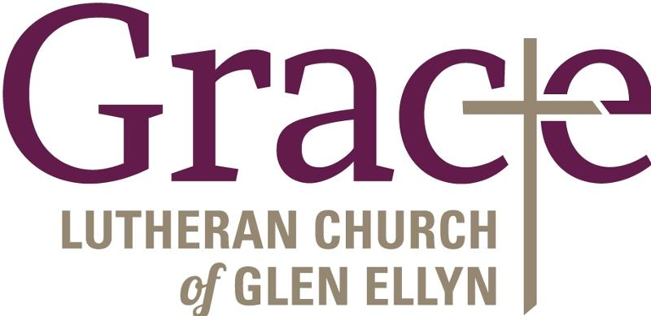

Every Member a Minister and Missionary!

Phone: 630-469-1555 Emergency Pastoral Contact: 630-674-2887
info@graceglenellyn.org www.graceglenellyn.org

Pastor
Rev. Melody Eastman office ext. 14
meastman@graceglenellyn.org

Minister of Music
Bradford Thompson 219-718-8879
bradfordmthompson@gmail.com

Ministry Associate
Becky Ficarella office ext. 17
bficarella@graceglenellyn.org

Office Manager
Barbara Sudds office ext. 10
bsudds@graceglenellyn.org

Parish Counselor
Carole LoGalbo M.S., LCPC 630-668-4594
carolelogalbo@yahoo.com

