Grace Lutheran Church

493 Forest Avenue, Glen Ellyn IL 630.469.1555
www.graceglenellyn.org

The Holy Trinity June 4, 2023

+ Proclaim Christ + Build Community +
+ Serve Our Neighbors +

Especially For Our Guests
Welcome to Grace!
If you are a guest, we’re thankful you’re here today. We hope you will feel Welcomed and spiritually nourished. If you would like to speak to the pastor about the congregation, please let her know directly or call the church office. To enhance your worship experience, you may want to know the following:
· Please join us after service for some great refreshments and Christian Fellowship.
· Parts of the liturgy (worship service) not printed in this bulletin are in the red hymnal (ELW). Page numbers in the hymnal are at the bottom of the page; hymn numbers are the large numbers at the top in the back half of the book.
· All baptized people are welcome at communion. If you would like to come forward for a blessing without taking communion, you can do that too. If you have difficulty walking, feel free to let the usher know and we’ll bring communion to you.
· If you find yourself confused about where we are, ask a neighbor!
· Assisted Listening Devices are available for your use. Please ask an usher.
· Young children are welcome in worship! Parents, you can bring your little ones up front to the PrayGround, a space with tables, chairs and quiet activities to keep our younger members engaged during services. Please sit near your little ones and help them use the space quietly as well as participate with you in worship. If you prefer, there is also a nursery space for you to use with infants or younger toddlers in the overflow room at the rear of the sanctuary. (But we really do like having children up front, if possible!)
· Please take your bulletin home with you. It contains the weekly calendar of events at Grace plus upcoming announcements.

Introduction
Though the word trinity is not found in the scriptures, today’s second reading includes the apostolic greeting that begins the liturgy: The grace of our Lord Jesus Christ, the love of God, and the communion of the Holy Spirit be with you all. In the gospel Jesus sends his disciples forth to baptize in the name of the Father, and the Son, and the Holy Spirit. More than a doctrine, the Trinity expresses the heart of our faith: we have experienced the God of creation made known in Jesus Christ and with us always through the Holy Spirit. We celebrate the mystery of the Holy Trinity in word and sacrament, as we profess the creed, and as we are sent into the world to bear witness to our faith.

An asterisk (*) indicates that you should stand for that portion of the service. If standing is difficult, please remain seated. The Congregation responses are in bold print.
Gathering
The Holy Spirit calls us together as the people of God.
Welcome/Announcements

Prelude

*Please stand as you are able.
*Confession and Forgiveness
All may make the sign of the cross, the sign that is marked at baptism, as the presiding minister begins.
Blessed be the holy Trinity, ☩ one God,
who greets us in this and every season,
whose word never fails,
whose promise is sure.
Amen.

Let us confess our sin in the presence of God
and of our neighbors.
Merciful God,
we confess that we have sinned.
We have hurt our community.
We have squandered your blessings.
We have hoarded your bounty.
In the name of Jesus,
forgive us and grant us your mercy.
Silence is kept for reflection.

Righteous God,
we confess that we have sinned.
We have failed to be honest.
We have lacked the courage to speak.
We have spoken falsely.
In the name of Jesus,
forgive us and grant us your mercy.
Silence is kept for reflection.

God is a cup of cold water when we thirst.
God offers boundless grace when we fail.
Claim the gift of God’s mercy:
you are freed and forgiven
in the name of ☩ Jesus Christ. Amen.

*Entrance Hymn ELW #819 Come, All You People
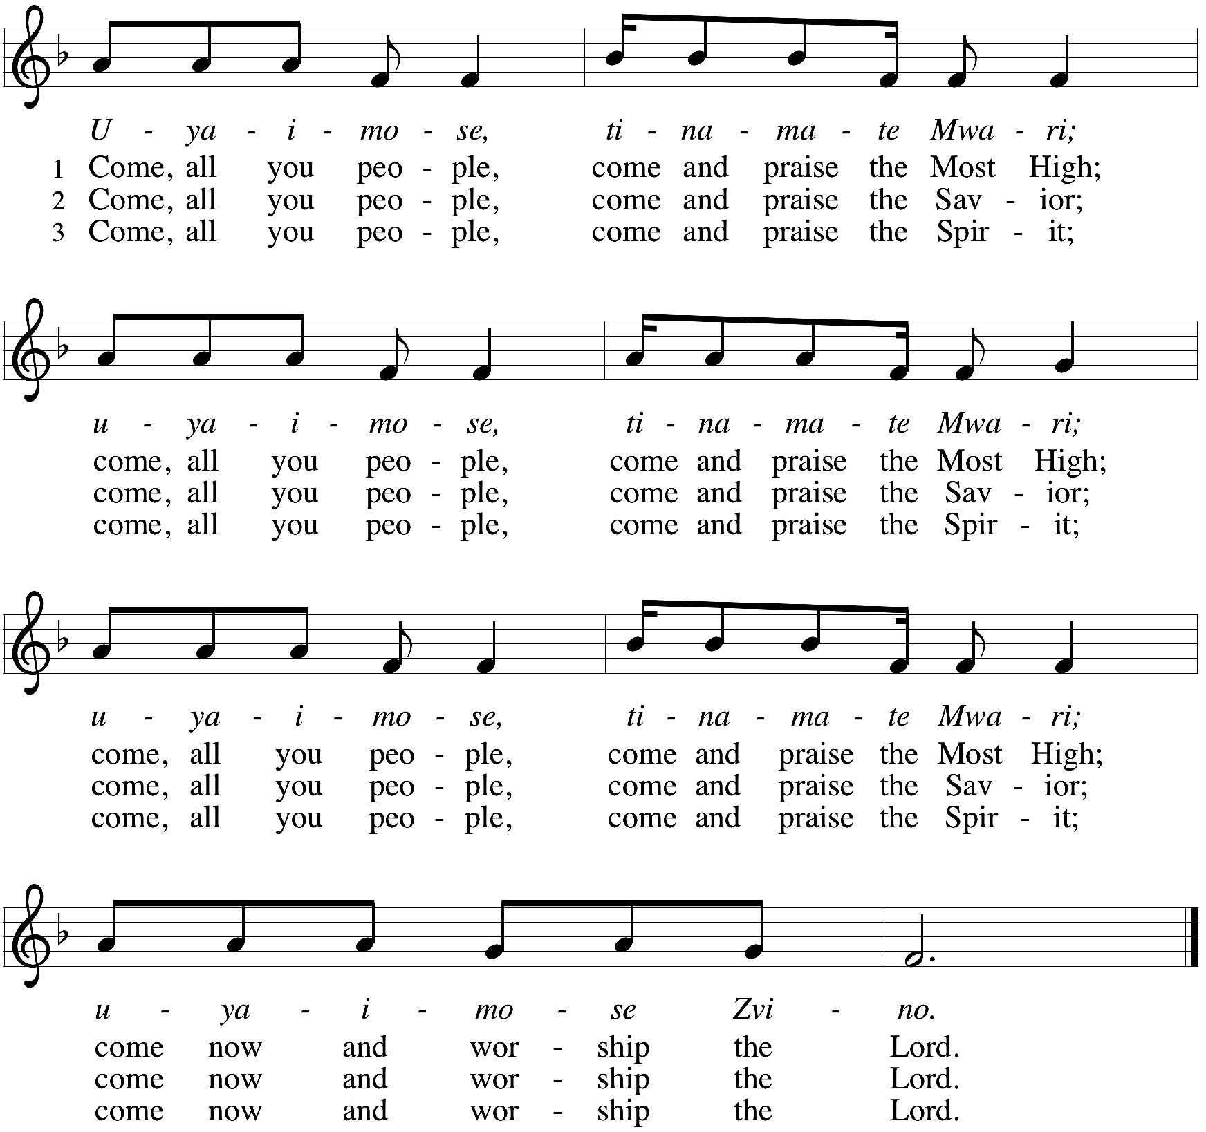

*Greeting
The grace of our Lord Jesus Christ, the love of God, and the communion of the Holy Spirit be with you all. And also with you.

*Kyrie Cantor sings Stanzas, Congregation joins on Refrain C. Heine
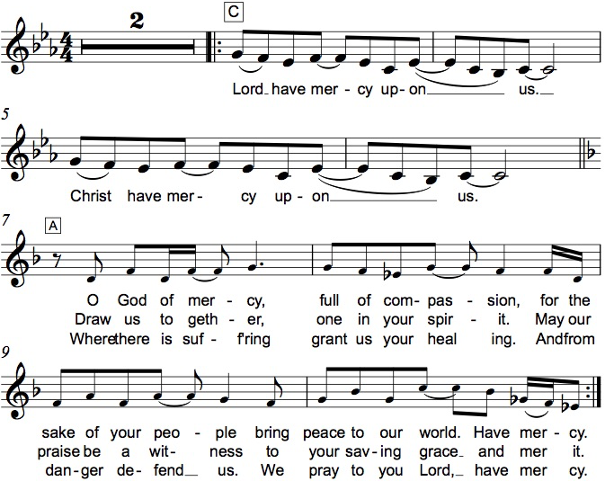

*Prayer of the Day
Almighty Creator and ever-living God: we worship your glory, eternal Three-in-One, and we praise your power, majestic One-in-Three. Keep us steadfast in this faith, defend us in all adversity, and bring us at last into your presence, where you live in endless joy and love, Father, Son, and Holy Spirit, one God, now and forever. Amen. Be seated.

Word
God speaks to us in scripture reading.

First Lesson Genesis 1:1--2:4a
At the beginning of time, God the Creator, God the powerful Word, and God the life-giving Spirit form the earth and all its inhabitants. God sees that all this created work is good and then rests on the seventh day.

¹In the beginning when God created the heavens and the earth, ²the earth was a formless void and darkness covered the face of the deep, while a wind from God swept over the face of the waters. ³Then God said, “Let there be light”; and there was light. ⁴And God saw that the light was good; and God separated the light from the darkness. ⁵God called the light Day, and the darkness he called Night. And there was evening and there was morning, the first day.
⁶And God said, “Let there be a dome in the midst of the waters, and let it separate the waters from the waters.” ⁷So God made the dome and separated the waters that were under the dome from the waters that were above the dome. And it was so. ⁸God called the dome Sky. And there was evening and there was morning, the second day.
⁹And God said, “Let the waters under the sky be gathered together into one place, and let the dry land appear.” And it was so. ¹⁰God called the dry land Earth, and the waters that were gathered together he called Seas. And God saw that it was good. ¹¹Then God said, “Let the earth put forth vegetation: plants yielding seed, and fruit trees of every kind on earth that bear fruit with the seed in it.” And it was so. ¹²The earth brought forth vegetation: plants yielding seed of every kind, and trees of every kind bearing fruit with the seed in it. And God saw that it was good. ¹³And there was evening and there was morning, the third day.
¹⁴And God said, “Let there be lights in the dome of the sky to separate the day from the night; and let them be for signs and for seasons and for days and years, ¹⁵and let them be lights in the dome of the sky to give light upon the earth.” And it was so. ¹⁶God made the two great lights—the greater light to rule the day and the lesser light to rule the night—and the stars. ¹⁷God set them in the dome of the sky to give light upon the earth, ¹⁸to rule over the day and over the night, and to separate the light from the darkness. And God saw that it was good. ¹⁹And there was evening and there was morning, the fourth day.
²⁰And God said, “Let the waters bring forth swarms of living creatures, and let birds fly above the earth across the dome of the sky.” ²¹So God created the great sea monsters and every living creature that moves, of every kind, with which the waters swarm, and every winged bird of every kind. And God saw that it was good. ²²God blessed them, saying, “Be fruitful and multiply and fill the waters in the seas, and let birds multiply on the earth.” ²³And there was evening and there was morning, the fifth day.
²⁴And God said, “Let the earth bring forth living creatures of every kind: cattle and creeping things and wild animals of the earth of every kind.” And it was so. ²⁵God made the wild animals of the earth of every kind, and the cattle of every kind, and everything that creeps upon the ground of every kind. And God saw that it was good.
²⁶Then God said, “Let us make humankind in our image, according to our likeness; and let them have dominion over the fish of the sea, and over the birds of the air, and over the cattle, and over all the wild animals of the earth, and over every creeping thing that creeps upon the earth.”
²⁷So God created humankind in his image, in the image of God he created them; male and female he created them.
²⁸God blessed them, and God said to them, “Be fruitful and multiply, and fill the earth and subdue it; and have dominion over the fish of the sea and over the birds of the air and over every living thing that moves upon the earth.” ²⁹God said, “See, I have given you every plant yielding seed that is upon the face of all the earth, and every tree with seed in its fruit; you shall have them for food. ³⁰And to every beast of the earth, and to every bird of the air, and to everything that creeps on the earth, everything that has the breath of life, I have given every green plant for food.” And it was so. ³¹God saw everything that he had made, and indeed, it was very good. And there was evening and there was morning, the sixth day.
^{2:1}Thus the heavens and the earth were finished, and all their multitude. ²And on the seventh day God finished the work that he had done, and he rested on the seventh day from all the work that he had done. ³So God blessed the seventh day and hallowed it, because on it God rested from all the work that he had done in creation.
^{4a}These are the generations of the heavens and the earth when they were created.

Word of God, Word of Life. Thanks be to God.

Second Lesson 2 Corinthians 13:11-13
Paul closes a challenging letter to the Corinthians with an appeal to Christian fellowship grounded in the triune harmony of Christ’s grace, God’s love, and the Spirit’s partnership.

[Paul writes:] ¹¹Finally, brothers and sisters, farewell. Put things in order, listen to my appeal, agree with one another, live in peace; and the God of love and peace will be with you. ¹²Greet one another with a holy kiss. All the saints greet you.
¹³The grace of the Lord Jesus Christ, the love of God, and the communion of the Holy Spirit be with all of you.

Word of God, Word of Life. Thanks be to God.

*Please stand as you are able.
*Gospel Acclamation Hallelujah! C. Heine

The holy Gospel according to Matthew. Glory to you, O Lord.

*Gospel Matthew 28:16-20
After his resurrection, Jesus summons his remaining disciples and commissions them to baptize and teach all nations in the name of the Father, Son, and Holy Spirit.

¹⁶Now the eleven disciples went to Galilee, to the mountain to which Jesus had directed them. ¹⁷When they saw him, they worshiped him; but some doubted. ¹⁸And Jesus came and said to them, “All authority in heaven and on earth has been given to me. ¹⁹Go therefore and make disciples of all nations, baptizing them in the name of the Father and of the Son and of the Holy Spirit, ²⁰and teaching them to obey everything that I have commanded you. And remember, I am with you always, to the end of the age.”

The Gospel of the Lord. Praise to you, O Christ. Be seated.

Sermon Rev. Melody Eastman

*Please stand as you are able.
*Hymn of the Day ELW #450 I Bind unto Myself Today
sts. 1,2,3,5

*Please stand as you are able
*Prayers of Intercession
Trusting in God’s abundant mercy, let us offer our prayers for a world in need.
A brief silence.

Holy three, holy one, you call the church to make disciples of all nations. Encourage bishops, pastors, and deacons in their proclamation of the gospel and direct all the baptized into lives of humble service. God, in your mercy, hear our prayer.

Holy three, holy one, you spoke creation into being and called it good. Protect lands and waters threatened by human misuse and sustain living creatures of every kind: wild animals, birds, fish, and every creeping thing. God, in your mercy,
hear our prayer.

Holy three, holy one, you have given humankind authority over the earth. Raise up leaders who listen earnestly, speak honestly, and govern thoughtfully. Heal divisions between nations, so that we might agree with one another and live in peace. God, in your mercy, hear our prayer.

Holy three, holy one, you promise to be with us always, to the end of the age. Surround those most in need of your healing presence: any who are lonely, all who are grieving, and those who are sick especially Harold, Greg, Rich, Norma, Dorothy, and those we name before you now. . . God, in your mercy, hear our prayer.

Holy three, holy one, you set the earth on its axis, and we experience the seasons. Strengthen those enduring challenges this summer: those who suffer in the heat, parents overwhelmed by childcare responsibilities, and children experiencing food insecurity outside of school. God, in your mercy, hear our prayer.
Here other intercessions may be offered.

All honor and glory and blessing belong to you. We thank you and praise you for the faith and witness of Judy Zipprich, and we ask your blessing on her as she celebrates her 81st birthday. We praise you for the faith of all the saints. Be near us as we await the day when we will feast with the risen Christ forever. God, in your mercy, hear our prayer.

Holy three, holy one, you give rest when our work is done. We give thanks for all the saints who now rest in you, confident in the promise of resurrection life in the age to come. God, in your mercy, hear our prayer.

Receive our prayers and answer us, O God, in the name of Jesus Christ.
Amen.

*Peace
The peace of Christ be with you always. And also with you.
Please share the peace with others in your household, or by making a sign of peace to those on Zoom. You may then be seated as the table is prepared.

Gathering of Gifts
We gather gifts for those in need and for the church’s mission.

Music During Offering

*Please stand as you are able. The gifts are brought forward while the congregation sings:
*Offertory Response C. Heine
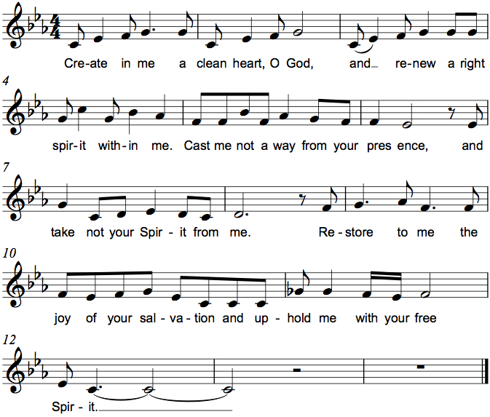

Meal
God feeds us with the presence of Jesus Christ.
*Offering Prayer
God of field and forest, sea and sky,
you are the giver of all good things.
Sustain us with these gifts of your creation,
and multiply your graciousness in us,
that the world may be fed with your love,
through Jesus Christ, our Savior and Lord.
Amen.

*Great Thanksgiving C. Heine
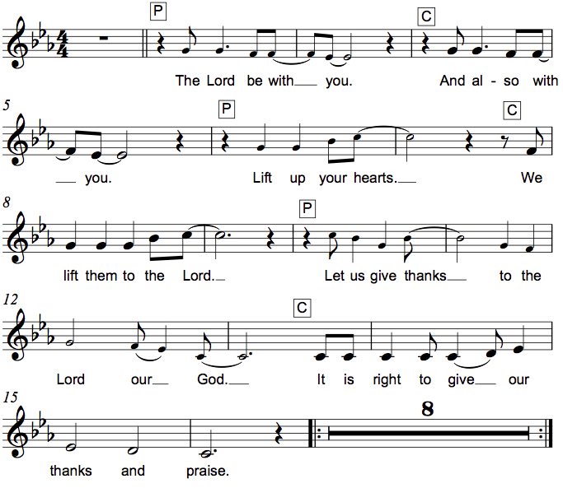
*Preface
It is indeed right, our duty and our joy,
that we should at all times and in all places give thanks and praise to you,
almighty and merciful God.
You reveal your glory as the glory of the Father, the Son, and the Holy Spirit:
equal in majesty, undivided in splendor,
one Lord, one God, ever to be adored in your eternal glory.
And so, with all the choirs of angels,
with the church on earth and the hosts of heaven,
we praise your name and join their unending hymn:

*Sanctus Holy, Holy, Holy C. Heine
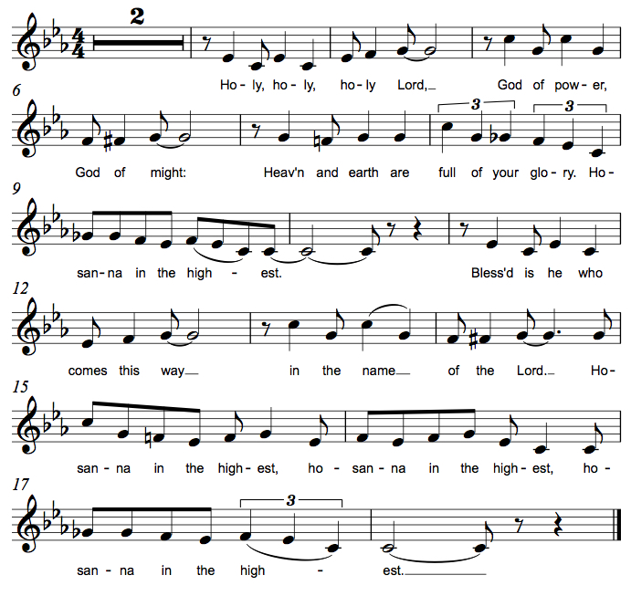

*Thanksgiving at the Table
Blessed are you, O God of the universe.
Your mercy is everlasting
and your faithfulness endures from age to age.

Praise to you for creating the heavens and the earth.
Praise to you for saving the earth from the waters of the flood.
Praise to you for bringing the Israelites safely through the sea.
Praise to you for leading your people through the wilderness
to the land of milk and honey.
Praise to you for the words and deeds of Jesus, your anointed one.
Praise to you for the death and resurrection of Christ.
Praise to you for your Spirit poured out on all nations.

In the night in which he was betrayed,
our Lord Jesus took bread, and gave thanks;
broke it, and gave it to his disciples, saying:
Take and eat; this is my body, given for you.
Do this for the remembrance of me.

Again, after supper, he took the cup, gave thanks,
and gave it for all to drink, saying:
This cup is the new covenant in my blood,
shed for you and for all people for the forgiveness of sin.
Do this for the remembrance of me.

With this bread and cup
we remember our Lord’s passover from death to life
as we proclaim the mystery of faith:
Christ has died.
Christ is risen.
Christ will come again.
O God of resurrection and new life:
Pour out your Holy Spirit on us
and on these gifts of bread and wine.
Bless this feast.
Grace our table with your presence.
Come, Holy Spirit.

Reveal yourself to us in the breaking of the bread.
Raise us up as the body of Christ for the world.
Breathe new life into us.
Send us forth,
burning with justice, peace, and love.
Come, Holy Spirit.

With your holy ones of all times and places,
with the earth and all its creatures,
with sun and moon and stars,
we praise you, O God,
blessed and holy Trinity,
now and forever.
Amen.

*The Lord’s Prayer Ecumenical Version
Gathered into one by the Holy Spirit, let us pray as Jesus taught us.
Our Father in heaven, hallowed be your name, your kingdom come, your will be done, on earth as in heaven. Give us today our daily bread. Forgive us our sins as we forgive those who sin against us. Save us from the time of trial and deliver us from evil. For the kingdom, the power and the glory are yours, now and forever. Amen.

*Invitation to Communion
All people are called to Christ’s table. Come, eat what is good. Be seated.

Communion
Those who wish to come to the rail for communion may do so at the ushers’ direction. You may stand or kneel. You may return to your seat by the side aisles after you have received the bread and wine.

For those receiving communion in the pew or from home:
This is the body of Christ, given for you. Amen (Eat the bread.)
This is the blood of Christ, shed for you. Amen (Drink the juice.)

Lamb of God M. B. Eastman

Music During Communion ELW 684 Creating God, Your Fingers Trace

*Please stand as you are able.
*Post Communion Blessing
May the body and blood of our Lord Jesus Christ strengthen you and keep you in his grace. Amen.

*Post Communion Prayer
We thank you, generous God,
for the refreshment we have received
at your banquet table.
Send us now to spread your generosity into all the world,
through the one who is our dearest treasure,
Jesus Christ, our Savior and Lord.
Amen.

Sending
God blesses us and sends us in mission to the world.
*Blessing
The God who calls across the cosmos and speaks in the smallest seed
☩ bless, keep, and sustain you now and to the end of the age.
Amen.

*Sending Hymn ELW #412 Come, Join the Dance of Trinity

*Sent to the World
Go in peace. Share the harvest. Thanks be to God.
Postlude

From Sundays and Seasons v.20190109.1233 Copyright © 2023 Augsburg Fortress. All rights reserved.
Reprinted by permission under Augsburg Fortress Liturgies Annual License #30867.
All rights reserved. Reprinted under OneLicense.net #A-718333.

Assisting in Worship Today
Worship Leader Rev. Melody Eastman
Minister of Music Bradford Thompson
Altar Care Cheryl Huizenga
Lector Heather Graf
Ushers Jacky Anderson, Jeff Nelson
Zoom Mark Hamilton, Jon & Cathy Milleville
Fellowship Hour Social Ministry

Current Prayer Requests
Name Relationship Prayer For
Judy Zipprich Member 81st Birthday 6/5
Harold Anderson Member Healing & Strength
Greg Barber Member Healing & Strength
Rich Davison Member Healing & Strength
Kathy Meyer Mother of Susi Nelson Healing & Strength
Lori Garabrandt Niece of Lois Pertle Healing & Strength
Prayers for our homebound Members
Norma Peterson, Dorothy Tracy

Weekly Announcements

Pr. Melody will be on vacation Monday, June 5 through Saturday, June 17. In case of a pastoral emergency, please contact Pastor Shelly Satran at Faith Lutheran, 630-469-2361. (If calling after church hours, follow the prompts to get the emergency pastoral care contact number.)

PADS: For June 6th, we're looking for meals (that could feed up to 10 people) - fresh cooked, hot or cold, that can be put in the containers that we already have. For example: a pan of homemade Chili. We do have some food supplies on hand, frozen pork loin, frozen hamburger and frozen Jimmy Dean hot sausage and sausage patties that we can supply for your cooking use.

If cooking is not an option, we can always use frozen dinners or shelf stable foods and fruits like oranges, apples and bananas. Dessert items are also welcome. Please remember that a third of our guests are children when making food selections.

Of course, all food donations are appreciated. If anyone has contacts with restaurants or stores who would like to help, please let us know.

Please leave donated food for PADS (1st Tuesday of the month) upstairs in the church kitchen via the gym. Food from the church is picked up about 2:00pm on Tuesday. Or it can be dropped off here at our house (1N346 Prairie Ave, GE - last house on the left - 630-790-1612). We usually leave for the PADS site around 4:15pm.

If you'd like a closer look at what we do and who we serve, please join us at the IHC (Interim Housing Center) - previously a Red Roof Inn - on the south side of Butterfield just west of Highland Ave between 5pm and 5:30pm - east side of the building Room 106. We are always looking for volunteers to help us distribute the food.

Thank you so much for your support and for helping members in our community!
Joe and Donna Jacobo

Grace Arts and Apps: Calling all artists of all ages and those with art they would like to share. The Social Committee is hosting an Arts and Apps event on Sunday, June 4 after worship in the narthex. We will exhibit artwork of Grace's members for the congregation to see while enjoying some light refreshments in the form of appetizers. Do you have some art that you have made as a hobby or profession? Do you own some artwork you would like to bring and show that day? There will be a sign-up in the narthex so we know how many tables to set up. And, if you don't have any art to share, perhaps you would like to make an appetizer to share.

Sharing Circle: Let's Talk About Race. In May, the sharing circle on racial healing will be meeting after worship on June 11. Using The Little Book of Racial Healing (by Thomas Norman DeWolf and Jodie Geddes) as a starting point, we explore the ways in which experiences of race and racial disparities are affecting our lives and our community. The format of the sharing circle is based on a mutual agreement to create a safe space for all who choose to participate and to practice deep listening as we talk about difficult topics. We will be meeting in the Great Room, and all are welcome to join.

Every Member a Minister and Missionary!

Phone: 630-469-1555 Emergency Pastoral Contact: 630-674-2887
info@graceglenellyn.org www.graceglenellyn.org

Pastor
Rev. Melody Eastman office ext. 14
meastman@graceglenellyn.org

Minister of Music
Bradford Thompson 219-718-8879
bradfordmthompson@gmail.com

Office Manager
Barbara Sudds office ext. 10
bsudds@graceglenellyn.org

Parish Counselor
Carole LoGalbo M.S., LCPC 630-668-4594
carolelogalbo@yahoo.com

