Grace Lutheran Church

493 Forest Avenue, Glen Ellyn IL 630.469.1555
www.graceglenellyn.org

2nd Sunday after Pentecost June 6, 2021

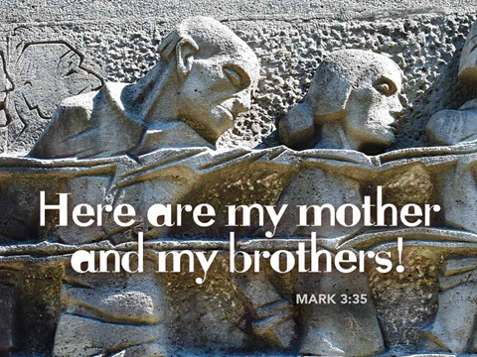

+ Proclaim Christ + Build Community +
+ Serve Our Neighbors +

Introduction
A house divided against itself cannot stand. Jesus makes this observation in light of charges that he is possessed. He is possessed, not by a demon, but by the Holy Spirit. We who have received the Holy Spirit through baptism have been joined to Christ’s death and resurrection and knit together in the body of Christ. Those with whom we sing and pray this day are Jesus’ family. With them we go forth in peace to do the will of God.
Gathering
The Holy Spirit calls us together as the people of God.
Welcome/Announcements
Helpful Reminders for those joining via Zoom:
- The host will mute you when you join, and you will remain muted until the end of the service.
- You are welcome to join in all congregation responses (in Bold black.) and hymns.
- At the end of the service you may unmute your mic to share greetings with your fellow worshippers. If you dialed in on the phone, press *6. Remember, your host cannot unmute you.
- THANK YOU FOR WORSHIPPING WITH US!
Helpful Reminders for those joining in person:
- Please continue to wear your mask except when taking communion.
- Maintain 6’ distance between family groups
- Remain in your pews for communion.
- You may place your offering in the boxes in the narthex.
- There will be no communal speaking or singing.

Prelude

*Please stand as you are able and turn to face the font.
*Confession and Forgiveness
All may make the sign of the cross, the sign marked at baptism, as the presiding minister begins.
Blessed be the holy Trinity,☩ one God, the God of manna, the God of miracles, the God of mercy. Amen.

Drawn to Christ and seeking God’s abundance, let us confess our sin.
Silence is kept for reflection.

God, our provider, help us. It is hard to believe there is enough to share. We question your ways when they differ from the ways of the world in which we live. We turn to our own understanding rather than trusting in you. We take offense at your teachings and your ways.
Turn us again to you. Where else can we turn? Share with us the words of eternal life
and feed us for life in the world. Amen.

Beloved people of God: in Jesus, the manna from heaven, you are fed and nourished. By Jesus, the worker of miracles, there is always more than enough. Through Jesus, ☩ the bread of life, you are shown God’s mercy: you are forgiven and loved into abundant life. Amen.

*Entrance Hymn ELW #768 Lead Me, Guide Me
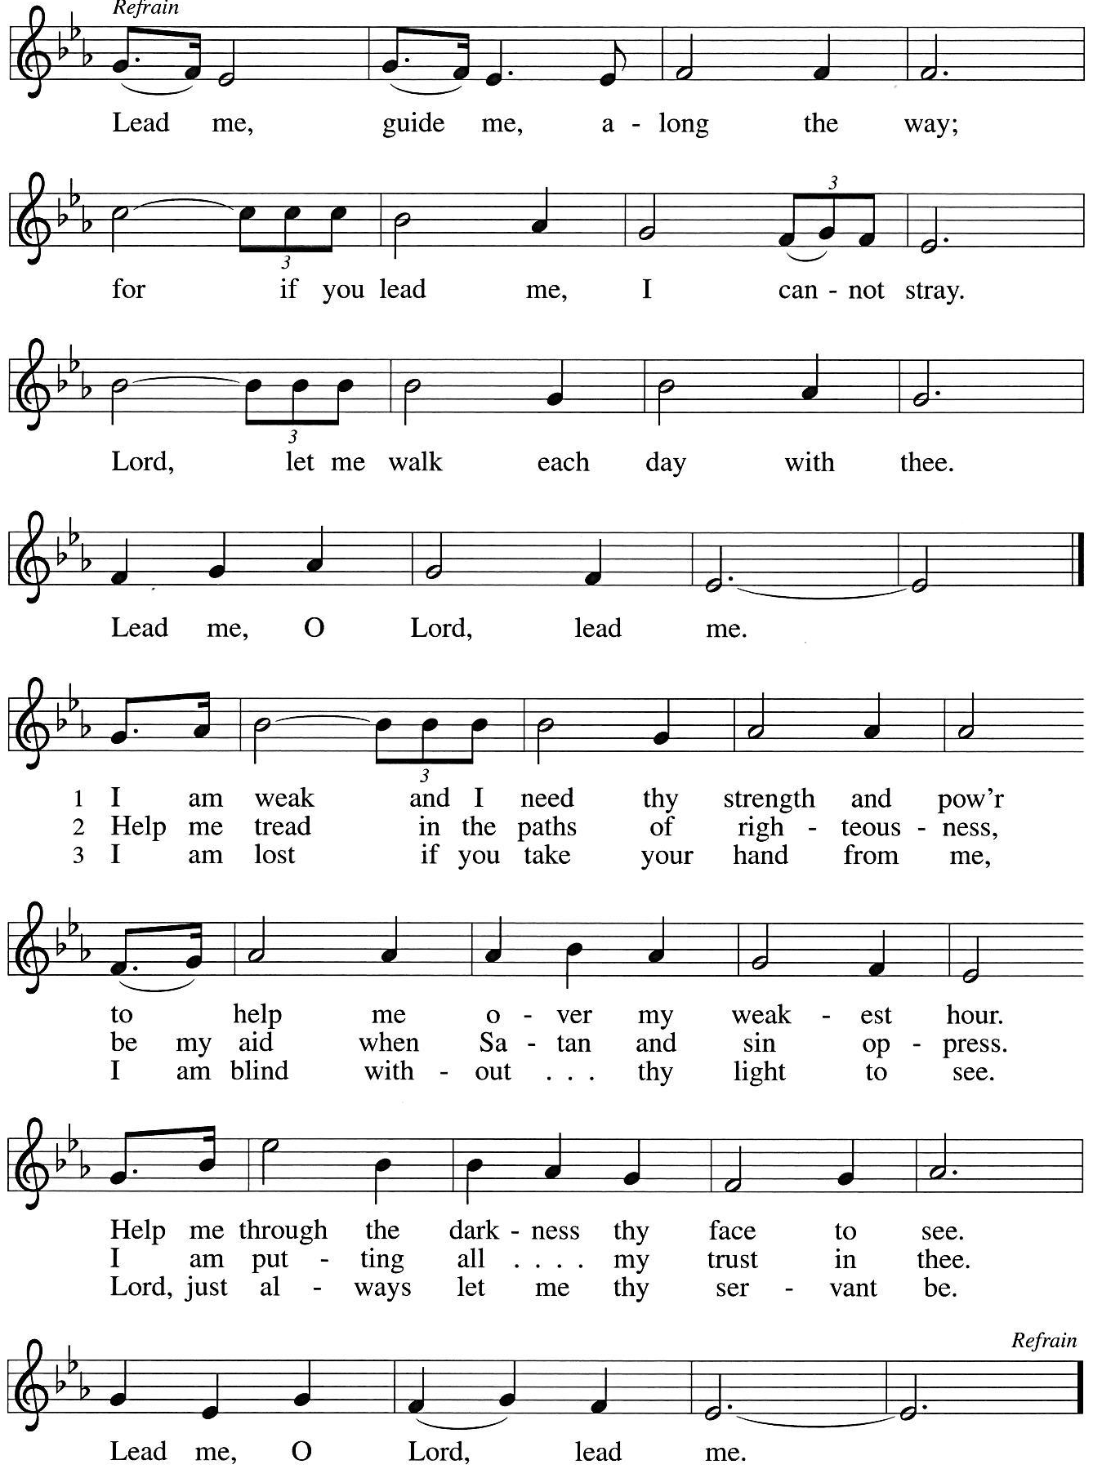
*Greeting
The grace of our Lord Jesus Christ, the love of God, and the communion of the Holy Spirit be with you all. And also with you.

*Hymn of Praise ELW #821 Shout to the Lord
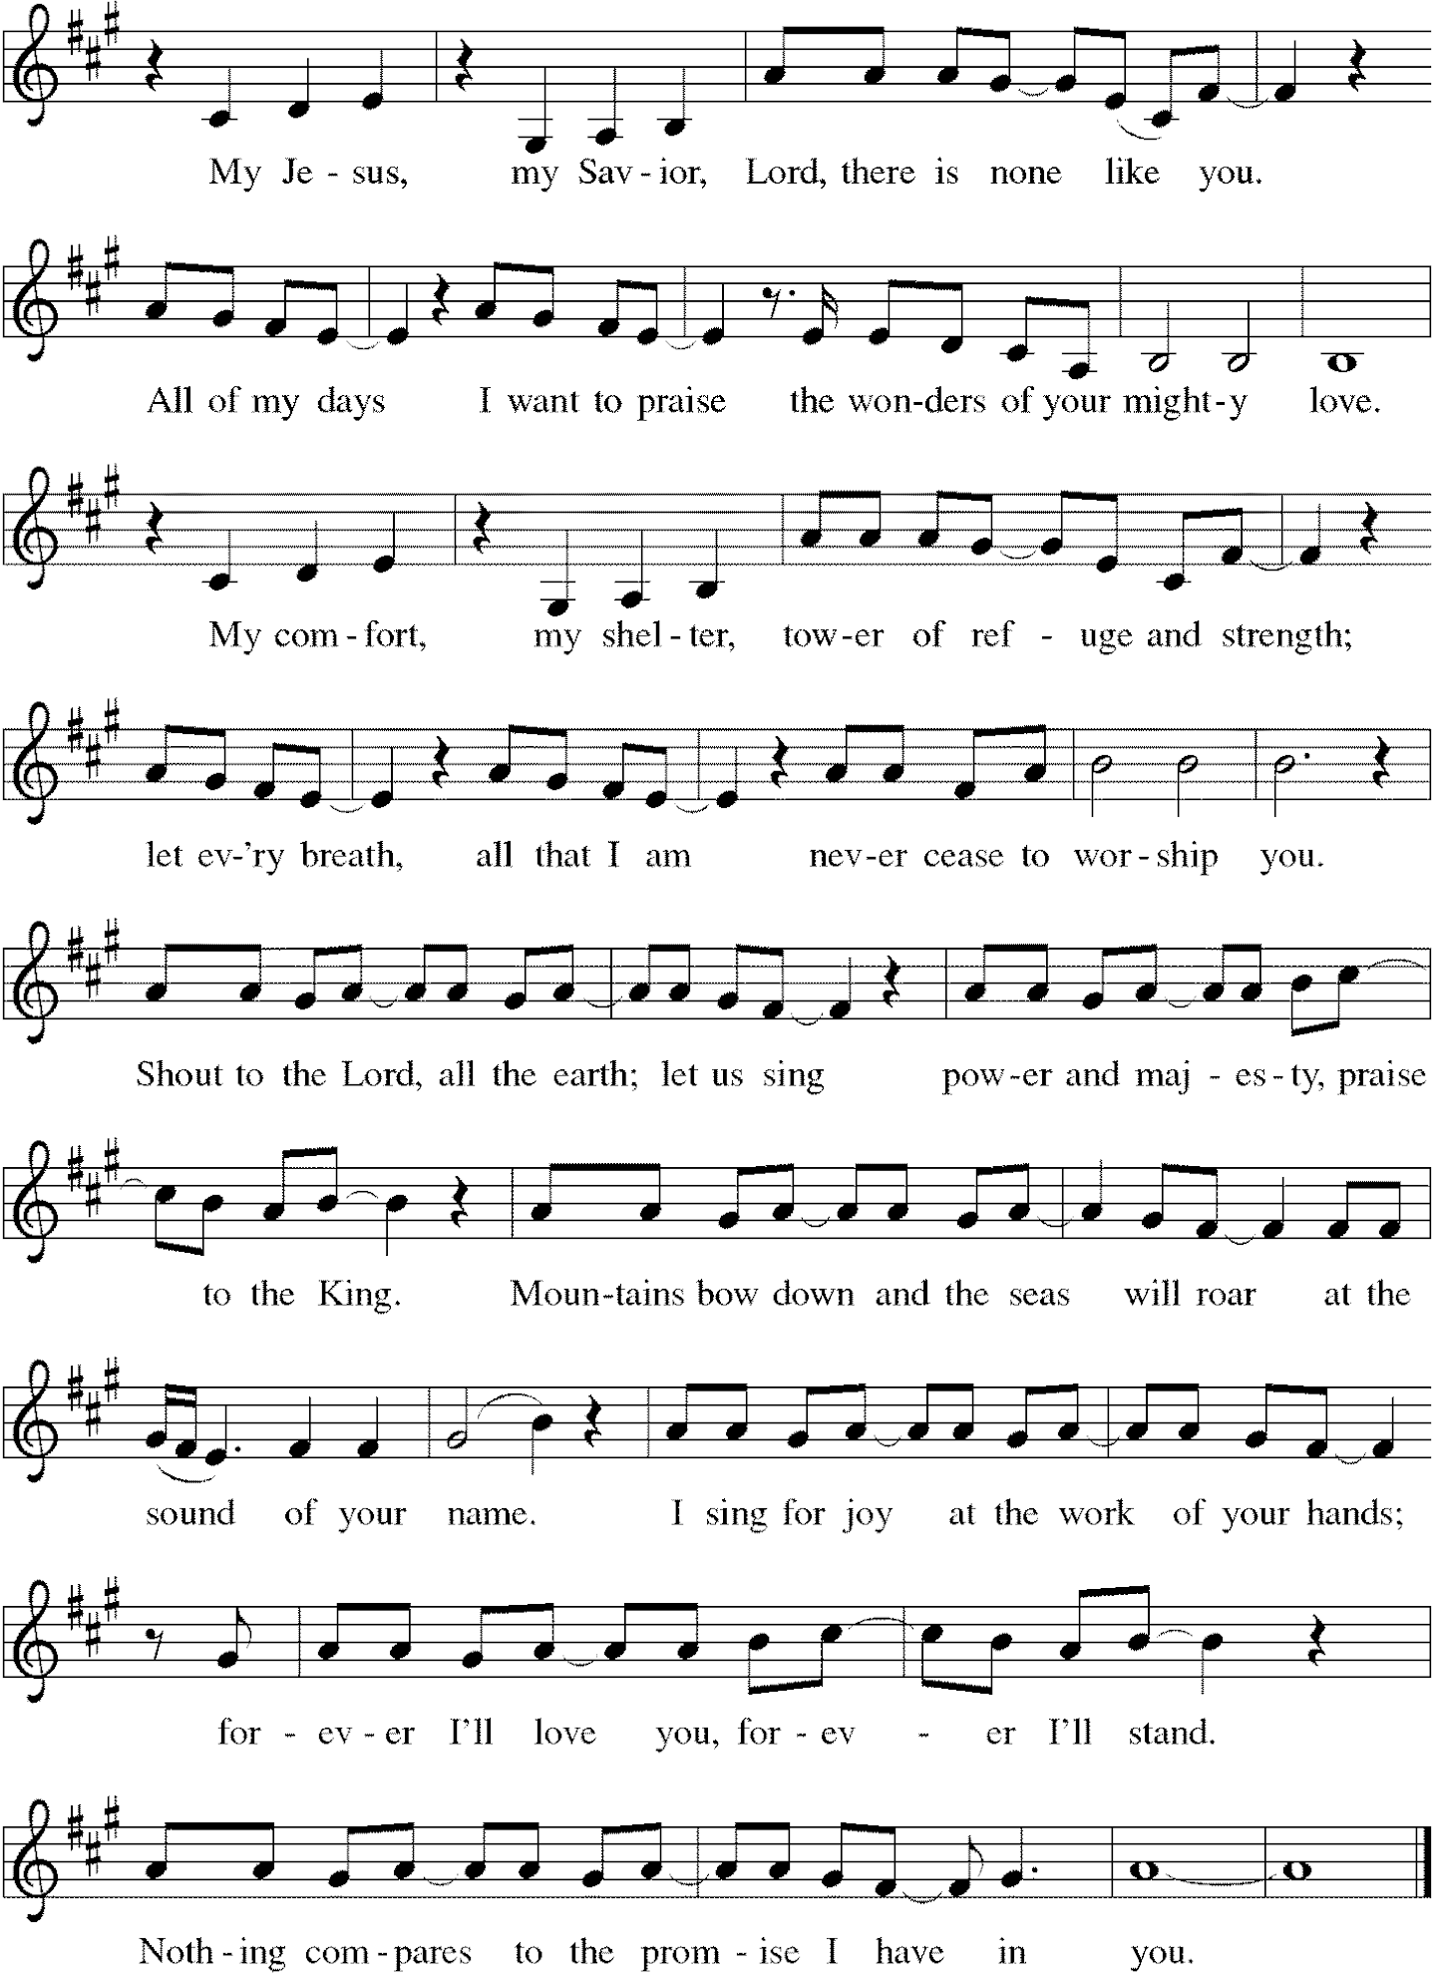
*Prayer of the Day
All-powerful God, in Jesus Christ you turned death into life and defeat into victory. Increase our faith and trust in him, that we may triumph over all evil in the strength of the same Jesus Christ, our Savior and Lord. Amen. Be seated.
Word
God speaks to us in scripture reading, preaching, and song.
First Lesson Genesis 3:8-15
Immediately after Adam and Eve eat the forbidden fruit, they hide from God. Neither takes responsibility for their sin, instead blaming each other, the snake, and even God. The curse on the snake was understood as a messianic prophecy by the early church, who associated Eve’s “offspring” with Christ.

⁸[Adam and Eve] heard the sound of the Lord God walking in the garden at the time of the evening breeze, and the man and his wife hid themselves from the presence of the Lord God among the trees of the garden. ⁹But the Lord God called to the man, and said to him, “Where are you?” ¹⁰He said, “I heard the sound of you in the garden, and I was afraid, because I was naked; and I hid myself.” ¹¹He said, “Who told you that you were naked? Have you eaten from the tree of which I commanded you not to eat?” ¹²The man said, “The woman whom you gave to be with me, she gave me fruit from the tree, and I ate.” ¹³Then the Lord God said to the woman, “What is this that you have done?” The woman said, “The serpent tricked me, and I ate.” ¹⁴The Lord God said to the serpent, “Because you have done this, cursed are you among all animals and among all wild creatures; upon your belly you shall go, and dust you shall eat all the days of your life. ¹⁵I will put enmity between you and the woman, and between your offspring and hers; he will strike your head, and you will strike his heel.”

Word of God, Word of Life. Thanks be to God.

Psalm Psalm 130

¹Out of the depths
I cry to you, O Lord;
²O Lord, hear my voice!
Let your ears be attentive to the voice of my supplication.
³If you were to keep watch over sins,
O Lord, who could stand?
⁴Yet with you is forgiveness,
in order that you may be feared.
⁵I wait for you, O Lord; my soul waits;
in your word | is my hope.
⁶My soul waits for the Lord more than those who keep watch for the morning,
more than those who keep watch for the morning.
⁷O Israel, wait for the Lord, for with the Lord there is steadfast love;
with the Lord there is plenteous redemption.
⁸For the Lord shall redeem Israel
from all their sins.

Second Lesson 2 Corinthians 4:13--5:1
Life in the present is transitory and cannot compare with the eternal home God has prepared for us. So we do not despair no matter what life might bring because we know that as God raised Jesus from the dead, God promises to bring us into eternal life.

¹³Just as we have the same spirit of faith that is in accordance with scripture—“I believed, and so I spoke”—we also believe, and so we speak, ¹⁴because we know that the one who raised the Lord Jesus will raise us also with Jesus, and will bring us with you into his presence. ¹⁵Yes, everything is for your sake, so that grace, as it extends to more and more people, may increase thanksgiving, to the glory of God.
¹⁶So we do not lose heart. Even though our outer nature is wasting away, our inner nature is being renewed day by day. ¹⁷For this slight momentary affliction is preparing us for an eternal weight of glory beyond all measure, ¹⁸because we look not at what can be seen but at what cannot be seen; for what can be seen is temporary, but what cannot be seen is eternal.
^{5:1}For we know that if the earthly tent we live in is destroyed, we have a building from God, a house not made with hands, eternal in the heavens.

Word of God, Word of Life. Thanks be to God.

*Please stand as you are able.
Gospel Acclamation C. Heine
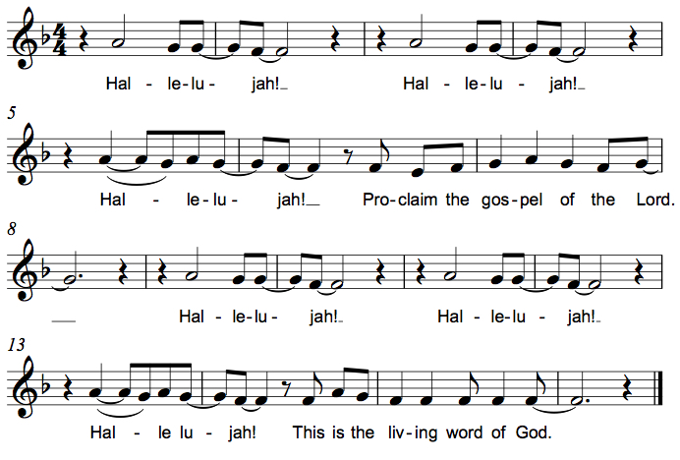

The holy Gospel according to John. Glory to you, O Lord.

Gospel John 15:26-27; 16:4b-15
While speaking to his disciples before his death, Jesus refers to the Holy Spirit as “the Helper” and describes the difference the Spirit will make in their lives and in the world.

[Jesus said,] ²⁶“When the Advocate comes, whom I will send to you from the Father, the Spirit of truth who comes from the Father, he will testify on my behalf. ²⁷You also are to testify because you have been with me from the beginning.
^{16:4b}“I did not say these things to you from the beginning, because I was with you. ⁵But now I am going to him who sent me; yet none of you asks me, ‘Where are you going?’ ⁶But because I have said these things to you, sorrow has filled your hearts. ⁷Nevertheless I tell you the truth: it is to your advantage that I go away, for if I do not go away, the Advocate will not come to you; but if I go, I will send him to you. ⁸And when he comes, he will prove the world wrong about sin and righteousness and judgment: ⁹about sin, because they do not believe in me; ¹⁰about righteousness, because I am going to the Father and you will see me no longer; ¹¹about judgment, because the ruler of this world has been condemned.
¹²“I still have many things to say to you, but you cannot bear them now. ¹³When the Spirit of truth comes, he will guide you into all the truth; for he will not speak on his own, but will speak whatever he hears, and he will declare to you the things that are to come. ¹⁴He will glorify me, because he will take what is mine and declare it to you. ¹⁵All that the Father has is mine. For this reason I said that he will take what is mine and declare it to you.”

The Gospel of the Lord. Praise to you, O Christ. Be seated.

Sermon The Rev. Melody Eastman

*Please stand as you are able.
*Hymn of the Day ELW #697 Just a Closer Walk With Thee

*Prayers of Intercession
Let us come before the triune God in prayer.
A brief silence.

God of wholeness, we pray for believers all over the globe. Unify us in service of the gospel, that we may work together as beloved siblings to share your love with all. Lord, in your mercy, hear our prayer.

God of the cosmos, we pray for creation; the gardens, waterways and creatures near to us and diverse forms of life that remain unseen. Teach us to treat the natural world with reverence, seeking restoration when human divisions have caused harm to your beloved creation. Lord, in your mercy, hear our prayer.

God of all people, we pray for harmony among the nations. Cast out from us unclean spirits of greed and fear, that we may work in solidarity with one another for the common good. Lord, in your mercy, hear our prayer.

God of abundance, we pray for those who are oppressed or in any need. Encourage those who have begun to lose heart. Strengthen and renew us with your Spirit. Lord, in your mercy, hear our prayer.

God of righteousness, we pray for this holy house of worship. Set our gaze upon things eternal, that in thanksgiving for your mercy, we may extend grace to more and more people. Lord, in your mercy, hear our prayer.
Here other intercessions may be offered.

God of the ages, in your goodness you have sent us faithful witnesses for every time and place. We give you thanks for those saints who now rest in your eternal mercy. Lord, in your mercy, hear our prayer.

We lift our prayers to you, O God, trusting in your abiding grace. Amen.

*Peace
The peace of Christ be with you always. And also with you.
Please share the peace with others in your household, or by making a sign of peace to those on Zoom, and then be seated.
Meal
God feeds us with the presence of Jesus Christ.

*Please stand as you are able.
*Offering Prayer
God of love, you call us beloved children and welcome us to your table. Receive our lives and the gifts we offer. Abide with us and send us in service to a suffering world; for the sake of your beloved Child, Jesus Christ. Amen.

*Great Thanksgiving
The Lord be with you. And also with you.
Lift up your hearts. We lift them to the Lord.
Let us give thanks to the Lord our God. It is right to give our thanks and praise.

*Preface
. . . And so, with all the choirs of angels, with the church on earth and the hosts of heaven,
we praise your name and join their unending hymn:

*Sanctus C. Heine
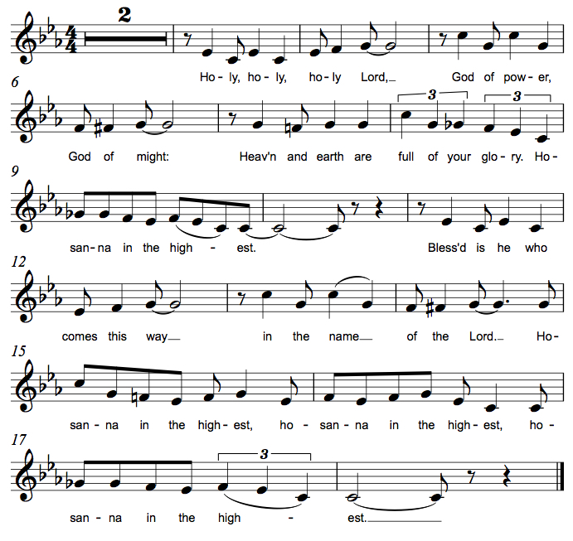
*Thanksgiving at the Table
. . . For as often as we eat of this bread and drink from this cup, we proclaim the Lord's death until he comes. Christ has died. Christ is risen. Christ will come again.

. . . To you, O God, Father, Son, and Holy Spirit, be all honor and glory in your holy church, now and forever. Amen.

*The Lord’s Prayer
Gathered into one by the Holy Spirit, let us pray as Jesus taught us.
Our Father in heaven, hallowed be your name, your kingdom come, your will be done,
on earth as in heaven. Give us today our daily bread. Forgive us our sins as we forgive those who sin against us. Save us from the time of trial and deliver us from evil.
For the kingdom, the power, and the glory are yours, now and forever. Amen.

*Invitation to Communion
If you have difficulty opening your communion, please signal an usher for assistance.
Christ has set the table with more than enough for all. Come! Be Seated.

This is the Body of Christ, given for you. (Eat the bread.)
This is the blood of Christ, shed for you. (Drink the wine/juice.)
Amen.

After communion you may place the packaging in the basket in your pew or dispose of it in the containers in the narthex as you leave.

Agnus Dei M.B. Eastman

*Please stand as you are able.
*Post-Communion Blessing
The body and blood of our Lord Jesus Christ strengthen you and keep you in his grace. Amen.

*Prayer after Communion
Jesus, Bread of life, we have received from your table more than we could ever ask. As you have nourished us in this meal, now strengthen us to love the world with your own life. In your name we pray. Amen.

Sending
God blesses us and sends us in mission to the world.
*Blessing
The blessing of God, who provides for us, feeds us, and journeys with us, ☩ be upon you now and forever. Amen.

*Sending Hymn Printed on Next Page ELW #860 I’m So Glad Jesus Lifted Me

*Sent to the World
Go in peace. You are the body of Christ. Thanks be to God.

Postlude
After the postlude, those who have joined via Zoom may unmute your mics
and share a greeting with your fellow worshippers.
*Sending Hymn ELW #860 I’m So Glad Jesus Lifted Me
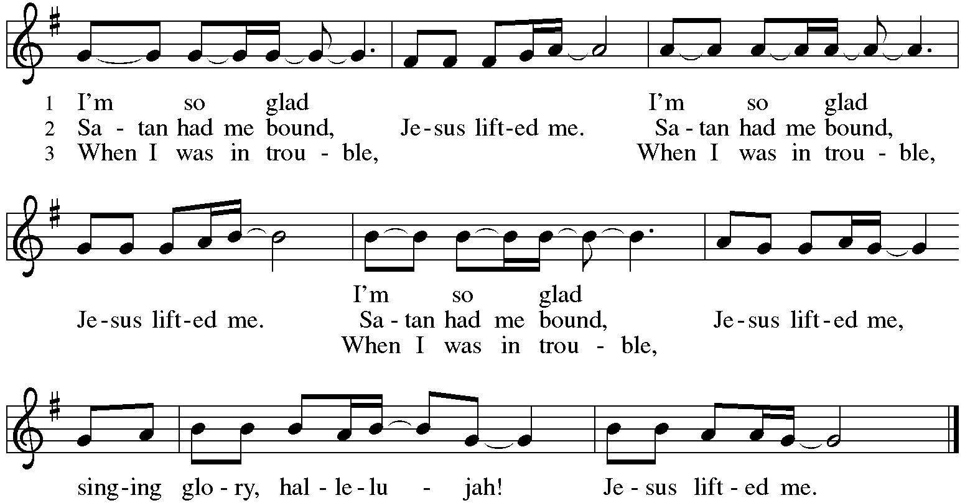

From Sundays and Seasons
v.20190109.1233 Copyright © 2021 Augsburg Fortress. All rights reserved.
Reprinted by permission under Augsburg Fortress Liturgies Annual License #30867.
All rights reserved. Reprinted under OneLicense.net #A-718333.

Assisting in Worship Today
Lector Vince Hardt
Music Marty Eastman
Ushers
Altar Flowers Given by Rich and Sue Davison to the honor and glory of God.

Current Prayer Requests
Please keep these people in your prayers and reach out to our sisters and brothers in Christian love. Names will be left on the list for two weeks, unless you indicate that they should remain in our prayers for a longer period.
Name Relationship Prayer For
Bob Stein Member Healing & Strength
Jim Sladek Member Healing & Strength
Cathy Milleville Member Healing & Strength
Sigrid Elliott Member Healing & Strength
Dorothy Tracy Member Healing & Strength
Elizabeth Amber Friend of Pr. Melody & Marty Healing & Strength
Chris Danly Son of Mark & Pat Danly Healing & Strength
Tammy Rollo Friend of Barbara Sudds Healing & Strength
Prayers for our homebound Members
Dolores Nosal, Carol Petersen, Norma Petersen, Dorothy Stein

Pr. Melody is on vacation Monday, June 7 through Saturday, June 19. Pr. Charles Plummer will be on call for all pastoral emergencies. Pr. Charles can be reached at 630-210-5841.

Multi-Church Worship Service Sunday, June 20: To kick off the week of VBS, Grace Lutheran/Faith Lutheran/First Congregational will hold a combine outdoor worship service at Faith Lutheran at 8:30am. Pastors from all three churches will lead the service. There will not be a worship service at Grace or a Grace Zoom worship on that day. Bring lawn chairs or a blanket and join us at 8:30.

In-Person Wednesday Morning 7:30am Bible Study at Grace: All are welcome to participate. Discussion centers on the Gospel for the upcoming Sunday plus other topics of interest. Tim Stephan, Jerry Miller, Kathy Gallian, Sue Pagnoni, and Tim Frakes are regulars with this group meeting in the Narthex at Grace. Please contact the church office if you have any questions.

Women of Grace Returns! We will meet on Thursday, June 10 at Reserve 22. We have two reservations at 7:00pm for 10 people at two outdoor tables. There will be a sign up to attend on the Women of Grace Facebook page. Let Becky Ficarella know if you plan to attend.

RAMP: Our mortgage reduction campaign has been renamed “RAMP” (Reduce Another Mortgage Payment) as we continue to RAMP up to refinance our mortgage with Mission Investment Fund this Fall. If we can raise an additional $100,000 payment prior to our November refinancing it will take us from $925,000 to $825,000.

Blood Drive Coordinator Needed: Brad Goertzen has been Grace’s Blood Drive Coordinator but Brad has accepted a new job in Florida and he and Lisa will be relocating there in the next couple of months. We are on Versiti’s schedule to hold a blood drive at Grace in July so we are in need of someone to take over as Blood Drive Coordinator asap. Brad has been holding two blood drives per year - January and July - but those months are not set in stone. Brad can be reach at bradgoertzen@gmail.com to answer any questions or you can contact the church office also.

Bradford’s Livestream Music Session: Looking for something to do on Wednesday evenings? Join Bradford for LIVE music sessions broadcast directly from Grace! Let the meditative sounds of drums, guitar, and keyboards heal your woes and soothe your souls. Wednesdays at 7:00pm. Bradford plans to change up the music and include various musicians each week. This is still a work in progress so please be patient with the format tweaks!
Just click on the link Wednesday evening at 7:00pm to join Bradford on his YouTube channel:
https://youtube.com/channel/UCbgfoPipBLAlY3hAkVKoI8Q

Chair Exercise and monthly Book Club. Registration is required as the number of attendees will be limited. The exercise class meets Mondays at 10:00am and Thursdays at 11:00am. The Book Club will meet on the third Tuesday of the month at 11:00am. Please contact Sue at 630-858-6343 to register.

Shopping Cart Brigade: Hallelujah! There WILL be a 4th of July parade and fireworks in 2021! As you know, Grace has spear-headed food collection for the GE Food Pantry for many years through our now famous “shopping cart brigade.” This year we will coordinate our activities with Pantry staff and volunteers. A crew from Grace is needed! This is a great family event - friends welcome! The parade will be held Sunday, July 4 beginning at noon.
Each partner church for the GEFP holds one or two food drives spaced throughout the year. Grace’s main contribution to this effort is the July parade. Please join us in this effort to raise awareness of food insecurity within our community. Contact Carol Asselmeier at carolassel@aol.com or call at 630-244-3235 to sign up. Thanks!!

Every Member a Minister and Missionary!

Phone: 630-469-1555 Emergency Pastoral Contact: 630-674-2887
info@graceglenellyn.org www.graceglenellyn.org

Pastor
Rev. Melody Eastman office ext. 14
meastman@graceglenellyn.org

Minister of Music
Bradford Thompson 219-718-8879
bradfordmthompson@gmail.com

Ministry Associate
Becky Ficarella office ext. 17
bficarella@graceglenellyn.org

Office Manager
Barbara Sudds office ext. 10
bsudds@graceglenellyn.org

Parish Counselor
Carole LoGalbo M.S., LCPC 630-668-4594
carolelogalbo@yahoo.com

