Grace Lutheran Church

493 Forest Avenue, Glen Ellyn IL 630.469.1555
www.graceglenellyn.org

Second Sunday after Pentecost June 11, 2023

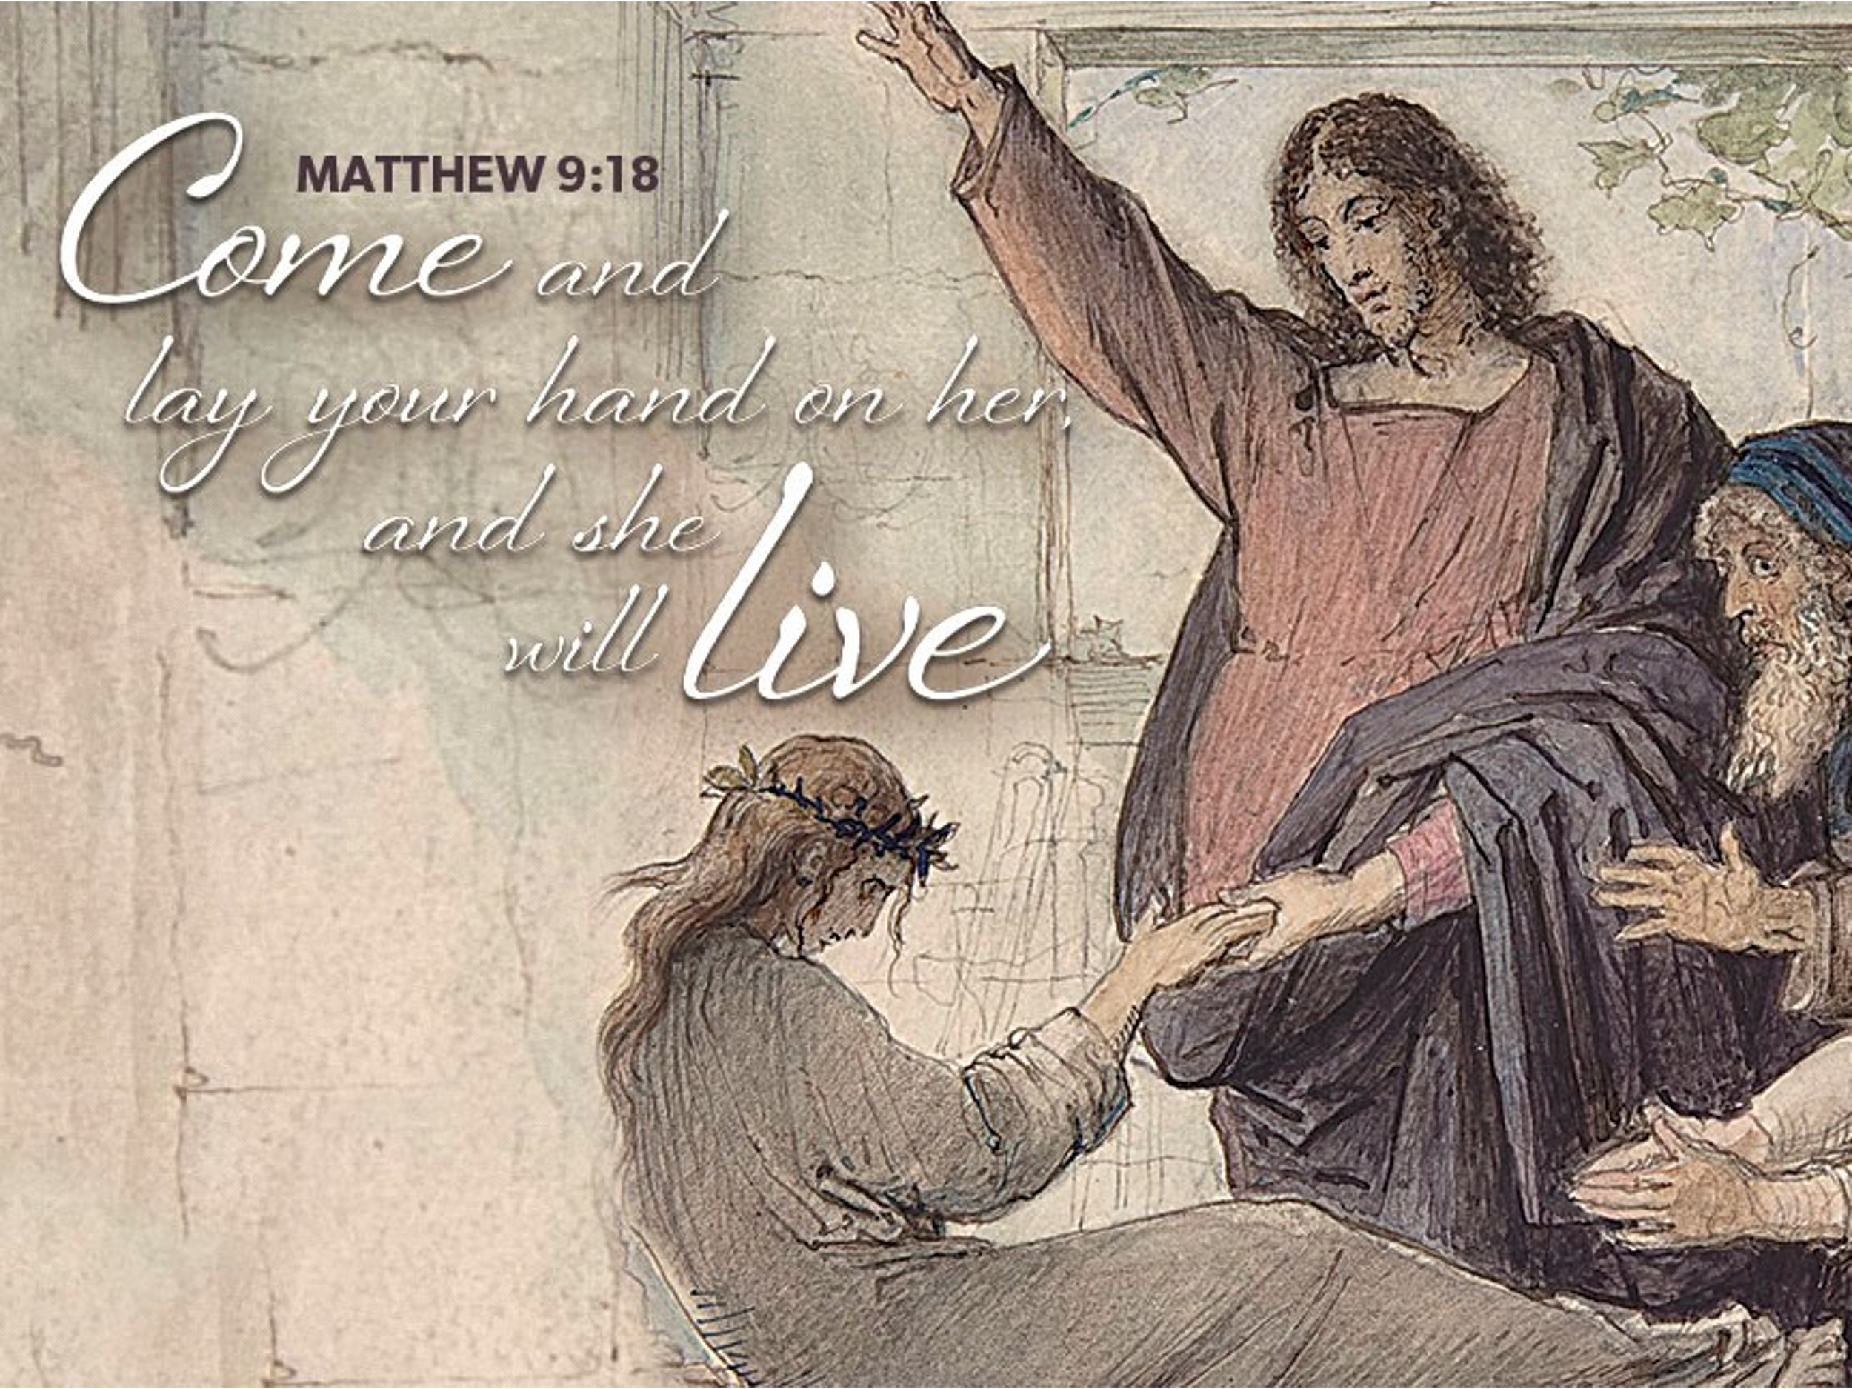

+ Proclaim Christ + Build Community +
+ Serve Our Neighbors +
Introduction
Though Jesus was a devout Jew who practiced his faith, he was criticized for eating with tax collectors and sinners—the religiously nonobservant. Jesus criticizes the self-righteous and reminds us that mercy is to be at the heart of our religious practices. God continues to be made known in those on the margins of society, like Matthew the tax collector and the hemorrhaging woman. As we gather each Lord’s day we receive the healing that makes us well and sends us forth to be signs of God’s mercy for the world.

An asterisk (*) indicates that you should stand for that portion of the service. If standing is difficult, please remain seated. The Congregation responses are in bold print.

Gathering
The Holy Spirit calls us together as the people of God.
Welcome/Announcements

Prelude

*Please stand as you are able.
*Confession and Forgiveness
All may make the sign of the cross, the sign that is marked at baptism, as the presiding minister begins.
Blessed be the holy Trinity, ☩ one God, who greets us in this and every season, whose word never fails, whose promise is sure. Amen.

Let us confess our sin in the presence of God and of our neighbors.

Merciful God,
we confess that we have sinned. We have hurt our community. We have squandered your blessings. We have hoarded your bounty. In the name of Jesus, forgive us and grant us your mercy.
Silence is kept for reflection.

Righteous God,
we confess that we have sinned. We have failed to be honest. We have lacked the courage to speak. We have spoken falsely. In the name of Jesus, forgive us and grant us your mercy.
Silence is kept for reflection.

God is a cup of cold water when we thirst. God offers boundless grace when we fail. Claim the gift of God’s mercy: you are freed and forgiven in the name of ☩ Jesus Christ. Amen.

*Entrance Hymn ELW #858 Praise to the Lord, the Almighty
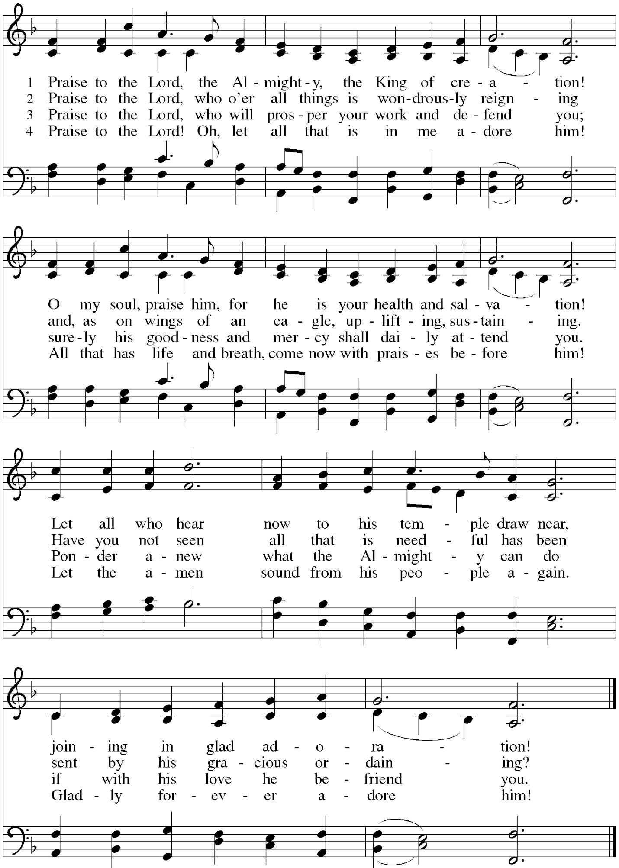
*Greeting
The grace of our Lord Jesus Christ, the love of God, and the communion of the Holy Spirit be with you all. And also with you.

*Kyrie Cantor sings [A] Stanzas, Congregation joins on [C] Refrain C. Heine
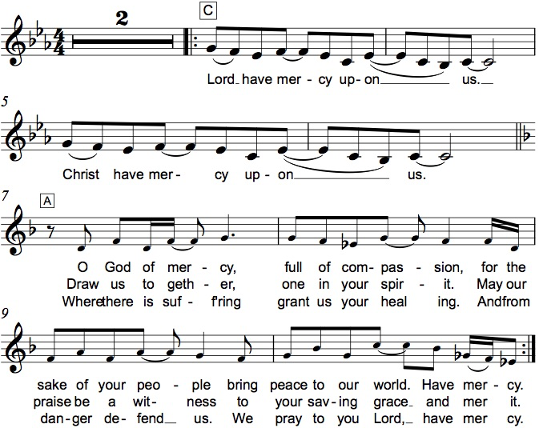

*Prayer of the Day
O God, you are the source of life and the ground of our being. By the power of your Spirit bring healing to this wounded world, and raise us to the new life of your Son, Jesus Christ, our Savior and Lord. Amen. Be seated.

Word
God speaks to us in scripture reading.
First Lesson Hosea 5:15—6:6
Because the people have trusted in military powers and not God, God decides to withdraw from the scene until Israel acknowledges its guilt and seeks God’s face. The response of the people does not acknowledge this guilt and is as fickle as fog or dew burned away quickly by the sun. God desires loyalty rather than words or meaningless deeds.

¹⁵I will return again to my place until they acknowledge their guilt and seek my face. In their distress they will beg my favor:
^{6:1}“Come, let us return to the Lord; for it is he who has torn, and he will heal us; he has struck down, and he will bind us up. ²After two days he will revive us; on the third day he will raise us up, that we may live before him. ³Let us know, let us press on to know the Lord; his appearing is as sure as the dawn; he will come to us like the showers, like the spring rains that water the earth.”
⁴What shall I do with you, O Ephraim? What shall I do with you, O Judah? Your love is like a morning cloud, like the dew that goes away early. ⁵Therefore I have hewn them by the prophets,
I have killed them by the words of my mouth, and my judgment goes forth as the light. ⁶For I desire steadfast love and not sacrifice, the knowledge of God rather than burnt offerings.

Word of God, Word of Life. Thanks be to God.

Second Lesson Romans 4:13-25
Paul presents Abraham as a living model of right relationships. For Abraham and for us, a right relationship with God involves trusting that God’s promises will be fulfilled because God makes the dead alive and calls into existence what otherwise does not exist.

¹³The promise that he would inherit the world did not come to Abraham or to his descendants through the law but through the righteousness of faith. ¹⁴If it is the adherents of the law who are to be the heirs, faith is null and the promise is void. ¹⁵For the law brings wrath; but where there is no law, neither is there violation.
¹⁶For this reason it depends on faith, in order that the promise may rest on grace and be guaranteed to all his descendants, not only to the adherents of the law but also to those who share the faith of Abraham (for he is the father of all of us, ¹⁷as it is written, “I have made you the father of many nations”)—in the presence of the God in whom he believed, who gives life to the dead and calls into existence the things that do not exist. ¹⁸Hoping against hope, he believed that he would become “the father of many nations,” according to what was said, “So numerous shall your descendants be.” ¹⁹He did not weaken in faith when he considered his own body, which was already as good as dead (for he was about a hundred years old), or when he considered the barrenness of Sarah’s womb. ²⁰No distrust made him waver concerning the promise of God, but he grew strong in his faith as he gave glory to God, ²¹being fully convinced that God was able to do what he had promised. ²²Therefore his faith “was reckoned to him as righteousness.” ²³Now the words, “it was reckoned to him,” were written not for his sake alone, ²⁴but for ours also. It will be reckoned to us who believe in him who raised Jesus our Lord from the dead, ²⁵who was handed over to death for our trespasses and was raised for our justification.

Word of God, Word of Life. Thanks be to God.

*Please stand as you are able.
*Gospel Acclamation Hallelujah! C. Heine

The holy Gospel according to Matthew. Glory to you, O Lord.

*Gospel Matthew 9:9-13, 18-26
Jesus demonstrates God’s mercy and power, accepting the unacceptable and curing the incurable. Even the dead receive new life.

⁹As Jesus was walking along, he saw a man called Matthew sitting at the tax booth; and he said to him, “Follow me.” And he got up and followed him.
¹⁰And as he sat at dinner in the house, many tax collectors and sinners came and were sitting with him and his disciples. ¹¹When the Pharisees saw this, they said to his disciples, “Why does your teacher eat with tax collectors and sinners?” ¹²But when he heard this, he said, “Those who are well have no need of a physician, but those who are sick. ¹³Go and learn what this means, ‘I desire mercy, not sacrifice.’ For I have come to call not the righteous but sinners.”
¹⁸While he was saying these things to them, suddenly a leader of the synagogue came in and knelt before him, saying, “My daughter has just died; but come and lay your hand on her, and she will live.” ¹⁹And Jesus got up and followed him, with his disciples. ²⁰Then suddenly a woman who had been suffering from hemorrhages for twelve years came up behind him and touched the fringe of his cloak, ²¹for she said to herself, “If I only touch his cloak, I will be made well.” ²²Jesus turned, and seeing her he said, “Take heart, daughter; your faith has made you well.” And instantly the woman was made well. ²³When Jesus came to the leader’s house and saw the flute players and the crowd making a commotion, ²⁴he said, “Go away; for the girl is not dead but sleeping.” And they laughed at him. ²⁵But when the crowd had been put outside, he went in and took her by the hand, and the girl got up. ²⁶And the report of this spread throughout that district.

The Gospel of the Lord. Praise to you, O Christ. Be seated.

Sermon The Rev. John Freidheim

*Please stand as you are able.
*Hymn of the Day ELW #587 There’s a Wideness in God’s Mercy
sts. 1-3
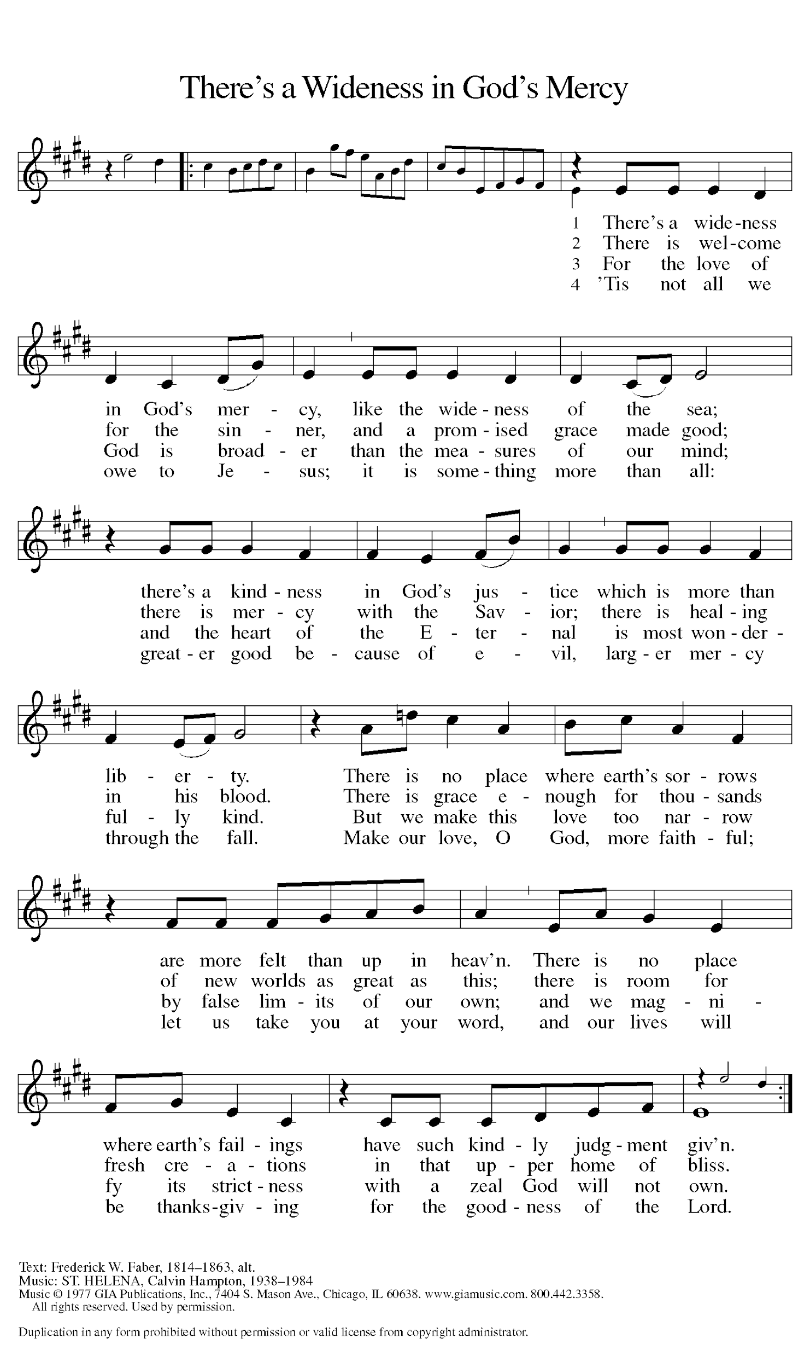
*Please stand as you are able
*Prayers of Intercession
Trusting in God’s abundant mercy, let us offer our prayers for a world in need.
A brief silence.

We pray, O God, for the church. Unite us with any on the margins, that the whole world recognizes that your mercy is greater than our human capacity to restrict it. God, in your mercy, hear our prayer.

We pray, O God, for creation. Tend forests and fields and safeguard all cattle, birds, and wild animals. Preserve lakes, rivers, and oceans and send rains to water the earth. Revive lands recovering from natural disasters. God, in your mercy, hear our prayer.

We pray, O God, for the nations. Awaken in our leaders compassion for people who have too often felt forgotten or neglected, and inspire policy solutions that promote equity and inclusion. God, in your mercy, hear our prayer.

We pray, O God, for all who are in need. Accompany anyone enduring chronic illness, any who suffer in secret, and those grieving a loved one’s death. Send healing for all who plead for relief from sickness or pain especially Harold, Greg, Rich, Norma, Dorothy, and those we name before you now. . . God, in your mercy, hear our prayer.

All honor and glory and blessing belong to you. We thank you and praise you for the faith and witness of Doris Nelson, and we ask your blessing on her as she celebrates her 86th birthday and be with all who celebrate and increase their joy, especially Chuck & Jan Miller as they celebrate their 61st wedding anniversary. We praise you for the faith of all the saints. Be near us as we await the day when we will feast with the risen Christ forever. God, in your mercy, hear our prayer.

We pray, O God, for the eradication of racial hatred. On this week when we commemorate the Emanuel Nine, we implore you to cast out the demons of white supremacy that make us believe lies about ourselves and our neighbors. God, in your mercy, hear our prayer.
Here other intercessions may be offered.

We give thanks, O God, for Barnabas and all the saints. Renew our faith that you can do what you have promised and raise us, with all our beloved dead, to new life. God, in your mercy, hear our prayer.

Receive our prayers and answer us, O God, in the name of Jesus Christ. Amen.

*Peace
The peace of Christ be with you always. And also with you.
Please share the peace with others in your household, or by making a sign of peace to those on Zoom. You may then be seated as the table is prepared.

Gathering of Gifts
We gather gifts for those in need and for the church’s mission.

Music During Offering

*Please stand as you are able. The gifts are brought forward while the congregation sings:
*Offertory Response C. Heine
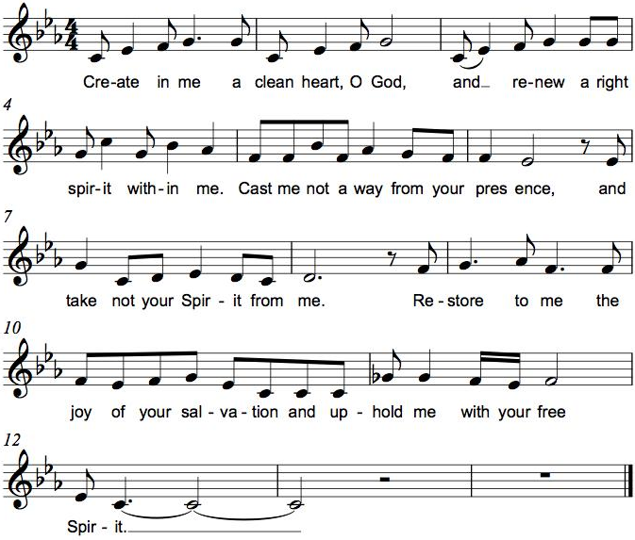

Meal
God feeds us with the presence of Jesus Christ.
*Offering Prayer
God of field and forest, sea and sky, you are the giver of all good things. Sustain us with these gifts of your creation, and multiply your graciousness in us, that the world may be fed with your love, through Jesus Christ, our Savior and Lord. Amen.

*Great Thanksgiving
The Lord be with you. And also with you.
Lift up your hearts. We lift them to the Lord.
Let us give thanks to the Lord our God. It is right to give our thanks and praise.

*Preface
*Sanctus Holy, Holy, Holy C. Heine
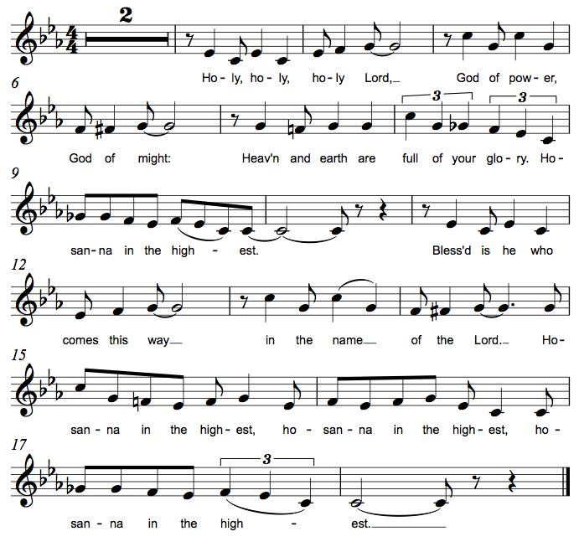

*Thanksgiving at the Table
. . . With this bread and cup we remember our Lord’s passover from death to life as we proclaim the mystery of faith: Christ has died. Christ is risen. Christ will come again.

O God of resurrection and new life: Pour out your Holy Spirit on us and on these gifts of bread and wine. Bless this feast. Grace our table with your presence. Come, Holy Spirit.

Reveal yourself to us in the breaking of the bread. Raise us up as the body of Christ for the world. Breathe new life into us. Send us forth, burning with justice, peace, and love. Come, Holy Spirit.

With your holy ones of all times and places, with the earth and all its creatures, with sun and moon and stars, we praise you, O God, blessed and holy Trinity, now and forever. Amen.

*The Lord’s Prayer
Gathered into one by the Holy Spirit, let us pray as Jesus taught us.
Our Father, who art in heaven, hallowed be thy name, thy kingdom come, thy will be done on earth as it is in heaven. Give us this day our daily bread; and forgive us our trespasses, as we forgive those who trespass against us; and lead us not into temptation, but deliver us from evil. For thine is the kingdom, and the power, and the glory, forever and ever. Amen.

*Invitation to Communion
All people are called to Christ’s table. Come, eat what is good. Be seated.

Communion
Those who wish to come to the rail for communion may do so at the ushers’ direction. You may stand or kneel. You may return to your seat by the side aisles after you have received the bread and wine.

For those receiving communion in the pew or from home:
This is the body of Christ, given for you. Amen (Eat the bread.)
This is the blood of Christ, shed for you. Amen (Drink the juice.)

Lamb of God M. B. Eastman

Music During Communion ELW 556 Morning Has Broken
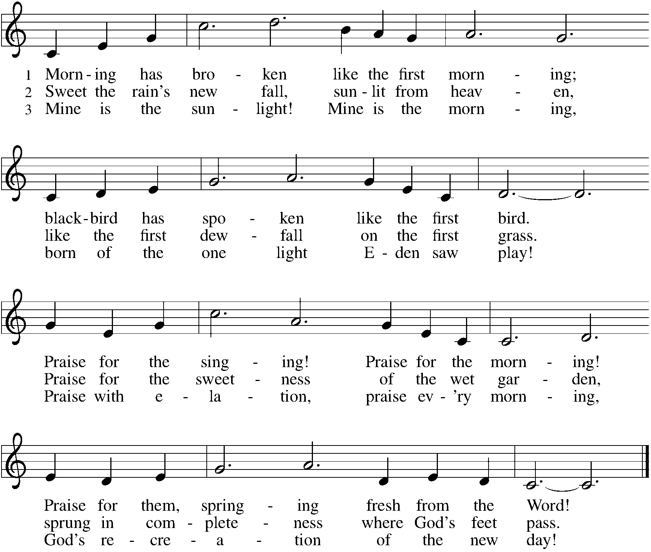

*Please stand as you are able.
*Post Communion Blessing
May the body and blood of our Lord Jesus Christ strengthen you and keep you in his grace. Amen.

*Post Communion Prayer
We thank you, generous God, for the refreshment we have received at your banquet table. Send us now to spread your generosity into all the world, through the one who is our dearest treasure, Jesus Christ, our Savior and Lord. Amen.

Sending
God blesses us and sends us in mission to the world.
*Blessing
The God who calls across the cosmos and speaks in the smallest seed ☩ bless, keep, and sustain you now and to the end of the age. Amen.
*Sending Hymn ELW #836 Joyful, Joyful, We Adore Thee
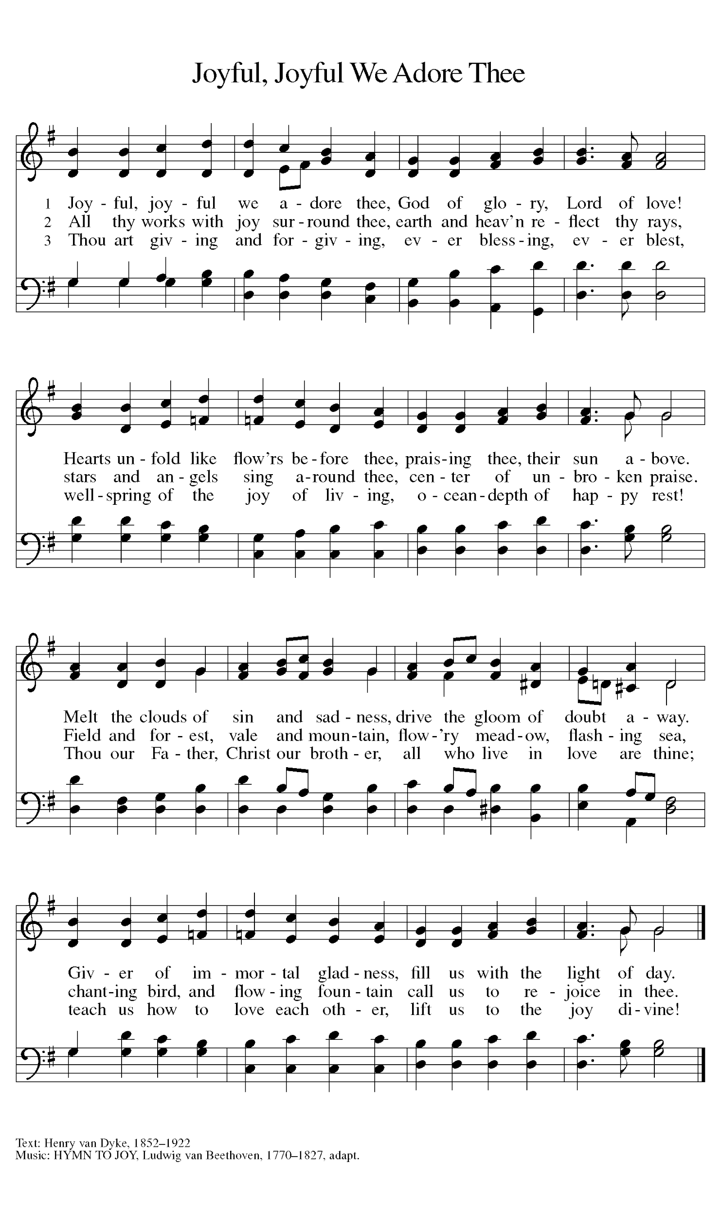

*Sent to the World
Go in peace. Share the harvest. Thanks be to God.

Postlude
Thank you to Pr. John Freidheim for leading us in worship today.

From Sundays and Seasons v.20190109.1233 Copyright © 2023 Augsburg Fortress. All rights reserved.
Reprinted by permission under Augsburg Fortress Liturgies Annual License #30867.
All rights reserved. Reprinted under OneLicense.net #A-718333.

Assisting in Worship Today
Worship Leader Rev. John Freidheim
Minister of Music Bradford Thompson
Altar Care Cheryl Huizenga
Lector Jeff Nelson
Ushers Jacky Anderson, Jeff Nelson
Zoom Mark Hamilton, Jon & Cathy Milleville
Fellowship Hour Doris Nelson
Altar Flowers Chuck & Jan Miller in honor of their 61st Anniversary

Current Prayer Requests
Name Relationship Prayer For
Chuck & Jan Miller Members 61st Anniversary 6/16
Doris Nelson Member 86th Birthday 6/16
Judy Zipprich Member 81st Birthday 6/5
Harold Anderson Member Healing & Strength
Greg Barber Member Healing & Strength
Rich Davison Member Healing & Strength
Kathy Meyer Mother of Susi Nelson Healing & Strength
Lori Garabrandt Niece of Lois Pertle Healing & Strength
Prayers for our homebound Members
Norma Peterson, Dorothy Tracy

Weekly Announcements

Pr. Melody will be on vacation through Saturday, June 17. In case of a pastoral emergency, please contact Pastor Shelly Satran at Faith Lutheran, 630-469-2361. (If calling after church hours, follow the prompts to get the emergency pastoral care contact number.)

TODAY - Sharing Circle: Let's Talk About Race. In June, the sharing circle on racial healing will be meeting after worship on June 11 and June 25. Using The Little Book of Racial Healing (by Thomas Norman DeWolf and Jodie Geddes) as a starting point, we explore the ways in which experiences of race and racial disparities are affecting our lives and our community. The format of the sharing circle is based on a mutual agreement to create a safe space for all who choose to participate and to practice deep listening as we talk about difficult topics. We will be meeting in the Great Room, and all are welcome to join.

People of Grace: Please join the People of Grace for dinner and fun conversation on Tuesday, June 20. The group meets monthly on the third Tuesday at 7pm. The location will vary each month to keep it fresh. Please RSVP to Jeff Nelson at jeff.nelson@vlses.com if you are planning to attend.

Every Member a Minister and Missionary!

Phone: 630-469-1555 Emergency Pastoral Contact: 630-674-2887
info@graceglenellyn.org www.graceglenellyn.org

Pastor
Rev. Melody Eastman office ext. 14
meastman@graceglenellyn.org

Minister of Music
Bradford Thompson 219-718-8879
bradfordmthompson@gmail.com

Office Manager
Barbara Sudds office ext. 10
bsudds@graceglenellyn.org

Parish Counselor
Carole LoGalbo M.S., LCPC 630-668-4594
carolelogalbo@yahoo.com

