Grace Lutheran Church

493 Forest Avenue, Glen Ellyn IL 630.469.1555
www.graceglenellyn.org

3rd Sunday after Pentecost June 13, 2021

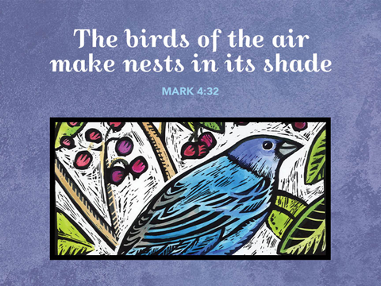

+ Proclaim Christ + Build Community +
+ Serve Our Neighbors +

Introduction
The mustard seed becomes a great shrub that shelters the birds, recalling ancient images of the tree of life. We’d expect a cedar or a sequoia, but Jesus finds the power of God better imaged in a tiny, no-account seed. It’s not the way we expect divine activity to look. Yet the tree of life is here, in the cross around which we gather, the tree into which we are grafted through baptism, the true vine that nourishes us with its fruit in the cup we share. It may not appear all that impressive, but while nobody’s looking it grows with a power beyond our understanding.
Gathering
The Holy Spirit calls us together as the people of God.
Welcome/Announcements
Helpful Reminders for those joining via Zoom:
- The host will mute you when you join, and you will remain muted until the end of the service.
- You are welcome to join in all congregation responses (in Bold black.) and hymns.
- At the end of the service you may unmute your mic to share greetings with your fellow worshippers. If you dialed in on the phone, press *6. Remember, your host cannot unmute you.
- THANK YOU FOR WORSHIPPING WITH US!
Helpful Reminders for those joining in person:
- Please continue to wear your mask except when taking communion.
- Maintain 6’ distance between family groups
- Remain in your pews for communion.
- You may place your offering in the boxes in the narthex.
- There will be no communal speaking or singing.

Prelude

*Please stand as you are able and turn to face the font.
*Confession and Forgiveness
All may make the sign of the cross, the sign marked at baptism, as the presiding minister begins.
Blessed be the holy Trinity,☩ one God, the God of manna, the God of miracles, the God of mercy. Amen.

Drawn to Christ and seeking God’s abundance, let us confess our sin.
Silence is kept for reflection.

God, our provider, help us. It is hard to believe there is enough to share. We question your ways when they differ from the ways of the world in which we live. We turn to our own understanding rather than trusting in you. We take offense at your teachings and your ways.
Turn us again to you. Where else can we turn? Share with us the words of eternal life
and feed us for life in the world. Amen.

Beloved people of God: in Jesus, the manna from heaven, you are fed and nourished. By Jesus, the worker of miracles, there is always more than enough. Through Jesus, ☩ the bread of life, you are shown God’s mercy: you are forgiven and loved into abundant life. Amen. Be seated.

Entrance Hymn ELW #807 Come, Thou Fount of Every Blessing
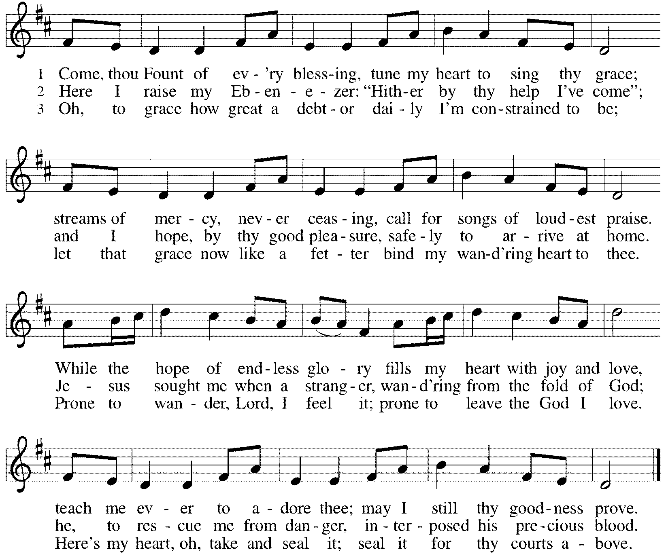

*Please stand as you are able
*Greeting
The grace of our Lord Jesus Christ, the love of God, and the communion of the Holy Spirit be with you all. And also with you.

*Hymn of Praise ELW #821 Shout to the Lord
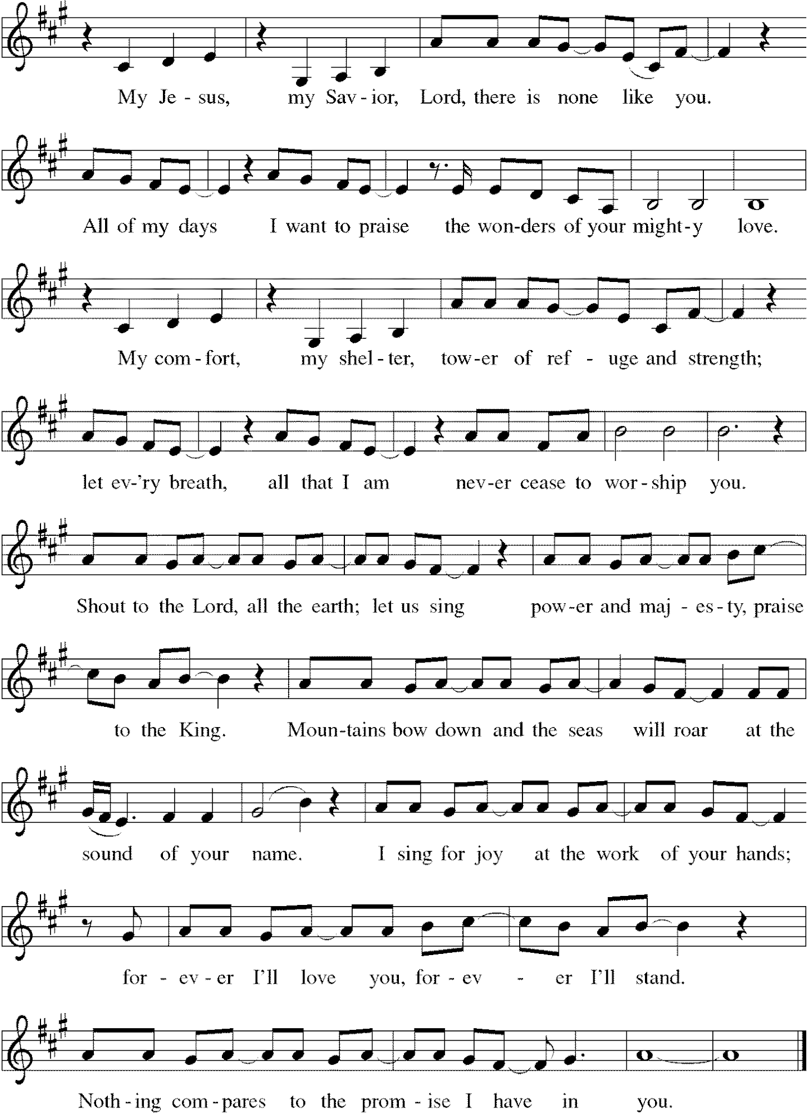
*Prayer of the Day
O God, you are the tree of life, offering shelter to all the world. Graft us into yourself and nurture our growth, that we may bear your truth and love to those in need, through Jesus Christ, our Savior and Lord. Amen. Be seated.

Word
God speaks to us in scripture reading, preaching, and song.
First Lesson Ezekiel 17:22-24
Tree imagery is used in a messianic prophecy to tell how the Lord will choose someone from Judah’s royal family (the cedar tree) to reign over all creation. This tree will be planted on Mount Zion, the location of the holy temple.

²²Thus says the Lord God: I myself will take a sprig from the lofty top of a cedar; I will set it out. I will break off a tender one from the topmost of its young twigs; I myself will plant it on a high and lofty mountain. ²³On the mountain height of Israel I will plant it, in order that it may produce boughs and bear fruit, and become a noble cedar. Under it every kind of bird will live; in the shade of its branches will nest winged creatures of every kind. ²⁴All the trees of the field shall know that I am the Lord. I bring low the high tree, I make high the low tree; I dry up the green tree and make the dry tree flourish. I the Lord have spoken; I will accomplish it.

Word of God, Word of Life. Thanks be to God.

Psalm Psalm 92:1-4, 12-15
The righteous shall spread abroad like a cedar of Lebanon. (Ps. 92:12)

¹It is a good thing to give thanks to the Lord, to sing praise to your name, O Most High;
²to herald your love in the morning and your faithfulness at night;
³on the psaltery, and on the lyre, and to the melody of the harp.
⁴For you have made me glad by your acts, O Lord; and I shout for joy because of the works of your hands.
¹²The righteous shall flourish like a palm tree, and shall spread abroad like a cedar of Lebanon.
¹³Those who are planted in the house of the Lord shall flourish in the courts of our God;
¹⁴they shall still bear fruit in old age; they shall be green and succulent;
¹⁵that they may show how upright the Lord is, my rock, in whom there is no injustice.

Second Lesson 2 Corinthians 5:6-17
Paul encourages believers to live by faith and not by sight. We do not consider Jesus from a human perspective but through the eyes of faith, believing he died for all and was raised. All who are in Christ are now in God’s new creation.

⁶So we are always confident; even though we know that while we are at home in the body we are away from the Lord—⁷for we walk by faith, not by sight. ⁸Yes, we do have confidence, and we would rather be away from the body and at home with the Lord. ⁹So whether we are at home or away, we make it our aim to please him. ¹⁰For all of us must appear before the judgment seat of Christ, so that each may receive recompense for what has been done in the body, whether good or evil.
[¹¹Therefore, knowing the fear of the Lord, we try to persuade others; but we ourselves are well known to God, and I hope that we are also well known to your consciences. ¹²We are not commending ourselves to you again, but giving you an opportunity to boast about us, so that you may be able to answer those who boast in outward appearance and not in the heart. ¹³For if we are beside ourselves, it is for God; if we are in our right mind, it is for you. ] ¹⁴For the love of Christ urges us on, because we are convinced that one has died for all; therefore all have died. ¹⁵And he died for all, so that those who live might live no longer for themselves, but for him who died and was raised for them.
¹⁶From now on, therefore, we regard no one from a human point of view; even though we once knew Christ from a human point of view, we know him no longer in that way. ¹⁷So if anyone is in Christ, there is a new creation: everything old has passed away; see, everything has become new!

Word of God, Word of Life. Thanks be to God.

*Please stand as you are able.
Gospel Acclamation C. Heine
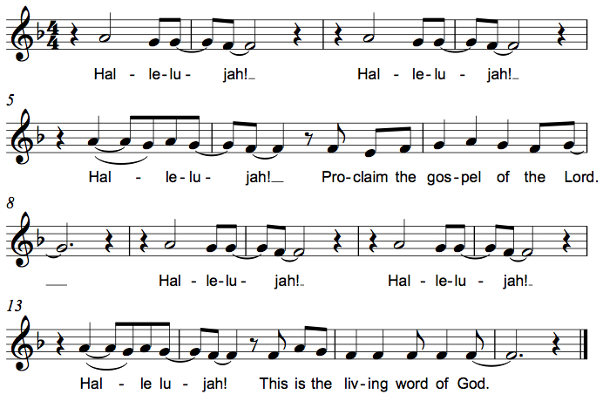

The holy Gospel according to Mark. Glory to you, O Lord.

*Gospel Mark 4:26-34
Jesus frequently uses parables to teach ordinary people as they are able to hear and understand. Images of sowing and growing show the vitality of God’s kingdom.

²⁶[Jesus] said, “The kingdom of God is as if someone would scatter seed on the ground,²⁷and would sleep and rise night and day, and the seed would sprout and grow, he does not know how. ²⁸The earth produces of itself, first the stalk, then the head, then the full grain in the head. ²⁹But when the grain is ripe, at once he goes in with his sickle, because the harvest has come.”
³⁰He also said, “With what can we compare the kingdom of God, or what parable will we use for it? ³¹It is like a mustard seed, which, when sown upon the ground, is the smallest of all the seeds on earth; ³²yet when it is sown it grows up and becomes the greatest of all shrubs, and puts forth large branches, so that the birds of the air can make nests in its shade.”
³³With many such parables he spoke the word to them, as they were able to hear it; ³⁴he did not speak to them except in parables, but he explained everything in private to his disciples.

The Gospel of the Lord. Praise to you, O Christ. Be seated.

Sermon The Rev. Keith Fry

Hymn of the Day ELW #554 Lord, Your Hands Have Formed
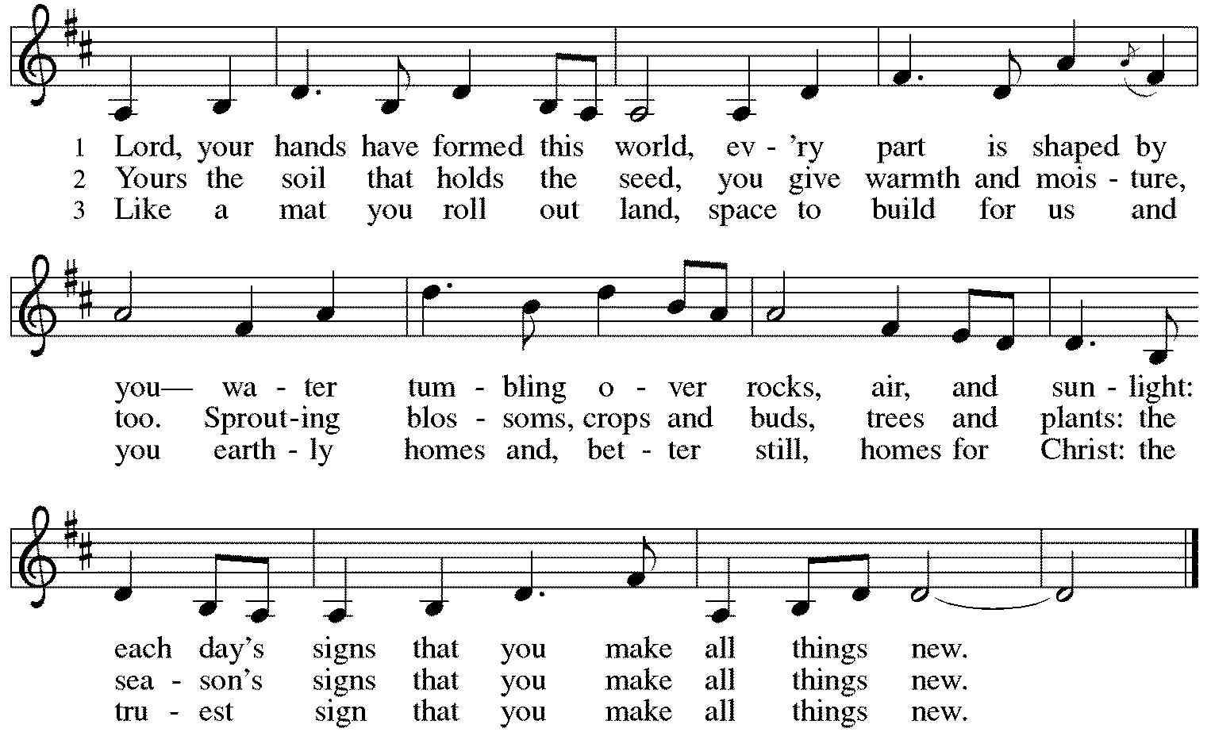
*Please stand as you are able.
*Prayers of Intercession
Let us come before the triune God in prayer.
A brief silence.

Holy God, you plant the seeds of faith in every nation. Enliven your church, so that the good news of your grace may root and grow throughout the world. Lord, in your mercy, hear our prayer.

Creator, even the trees, shrubs, and flowers delight in your goodness. From the depths of the soil to the highest mountain, bring forth new plants. Restore growth to places suffering drought. Lord, in your mercy, hear our prayer.

Judge of nations, we pray for our leaders and those in power. Grant them the ability to regard those under their charge with humility, dedicating their lives in service to others. Lord, in your mercy, hear our prayer.

Divine comforter, you show compassion to those in need and provide relief to those who call on you. Bless all who suffer, especially people trapped in cycles of poverty and homelessness. Lord, in your mercy, hear our prayer.

Be with all who celebrate and increase their joy, especially Chuck & Jan Miller as they celebrate their 59th wedding anniversary and Tom & Elaine Roete as they celebrate their 53rd. Lord, in your mercy, hear our prayer.

Sovereign God, this house of worship belongs to you. We give thanks and pray for our church musicians. We dedicate to you the joyful noise that comes from this place; the cries of children, the melody of voice and instruments, and the songs from our hearts. Lord, in your mercy, hear our prayer.
Here other intercessions may be offered.

Eternal God, we give thanks for our ancestors in the faith who are now at home with you. We look forward to that day when we are reunited in your new creation. Lord, in your mercy,
hear our prayer.

We lift our prayers to you, O God, trusting in your abiding grace. Amen.

*Peace
The peace of Christ be with you always. And also with you.
Please share the peace with others in your household, or by making a sign of peace to those on Zoom. Please remain standing.
Meal
God feeds us with the presence of Jesus Christ.

*Please stand as you are able.
*Offering Prayer
Jesus, Bread of life, you have set this table with your very self,
and called us to the feast of plenty.
Gather what has been sown among us,
and strengthen us in this meal.
Make us to be what we receive here,
your body for the life of the world.
Amen.

*Great Thanksgiving
The Lord be with you.
And also with you.

Lift up your hearts.
We lift them to the Lord.

Let us give thanks to the Lord our God.
It is right to give our thanks and praise.

*Preface
It is indeed right, our duty and our joy,
that we should at all times and in all places give thanks and praise to you,
almighty and merciful God, through our Savior Jesus Christ;
who on this day overcame death and the grave,
and by his glorious resurrection opened to us the way of everlasting life.
And so, with all the choirs of angels,
with the church on earth and the hosts of heaven,
we praise your name and join their unending hymn:

*Sanctus C. Heine
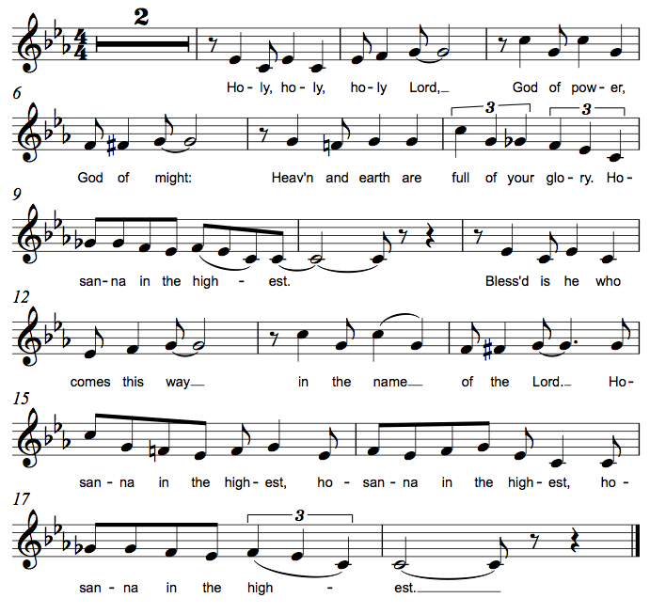

*Thanksgiving at the Table
You are indeed holy, almighty and merciful God.
You are most holy,
and great is the majesty of your glory.

You so loved the world that you gave your only Son,
so that everyone who believes in him may not perish
but have eternal life.

We give you thanks for his coming into the world
to fulfill for us your holy will
and to accomplish all things for our salvation.

In the night in which he was betrayed,
our Lord Jesus took bread, and gave thanks;
broke it, and gave it to his disciples, saying:
Take and eat; this is my body, given for you.
Do this for the remembrance of me.

Again, after supper, he took the cup, gave thanks,
and gave it for all to drink, saying:
This cup is the new covenant in my blood,
shed for you and for all people for the forgiveness of sin.
Do this for the remembrance of me.

For as often as we eat of this bread and drink from this cup,
we proclaim the Lord's death until he comes.
Christ has died. Christ is risen. Christ will come again.

Remembering, therefore, his salutary command,
his life-giving passion and death,
his glorious resurrection and ascension,
and the promise of his coming again,
we give thanks to you, O Lord God Almighty,
not as we ought but as we are able;
we ask you mercifully to accept our praise and thanksgiving
and with your Word and Holy Spirit to bless us, your servants,
and these your own gifts of bread and wine,
so that we and all who share in the body and blood of Christ
may be filled with heavenly blessing and grace,
and, receiving the forgiveness of sin,
may be formed to live as your holy people
and be given our inheritance with all your saints.

To you, O God, Father, Son, and Holy Spirit,
be all honor and glory in your holy church, now and forever.
Amen.

*The Lord’s Prayer
Gathered into one by the Holy Spirit, let us pray as Jesus taught us.
Our Father in heaven, hallowed be your name, your kingdom come, your will be done,
on earth as in heaven. Give us today our daily bread. Forgive us our sins as we forgive those who sin against us. Save us from the time of trial and deliver us from evil.
For the kingdom, the power, and the glory are yours, now and forever. Amen.

*Invitation to Communion
If you have difficulty opening your communion, please signal an usher for assistance.
Christ has set the table with more than enough for all. Come! Be Seated.

This is the Body of Christ, given for you. (Eat the bread.)
This is the blood of Christ, shed for you. (Drink the wine/juice.)
Amen.

After communion you may place the packaging in the basket in your pew or dispose of it in the containers in the narthex as you leave.

Agnus Dei M.B. Eastman
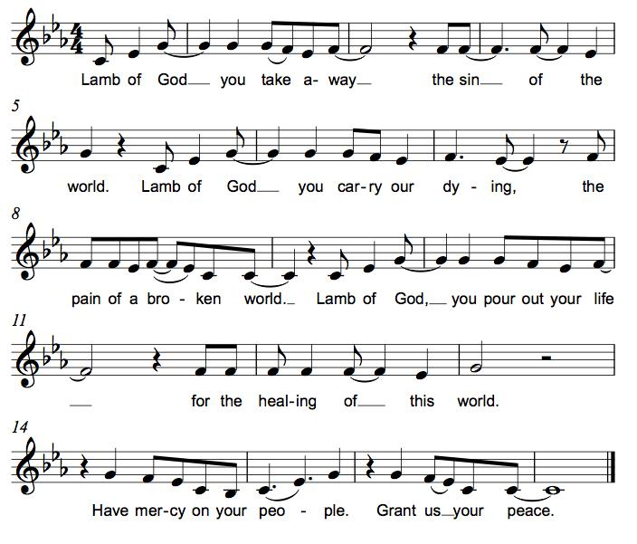

*Please stand as you are able.
*Post-Communion Blessing
The body and blood of our Lord Jesus Christ strengthen you and keep you in his grace. Amen.

*Prayer after Communion
Jesus, Bread of life, we have received from your table more than we could ever ask. As you have nourished us in this meal, now strengthen us to love the world with your own life. In your name we pray. Amen.

Sending
God blesses us and sends us in mission to the world.
*Blessing
The blessing of God, who provides for us, feeds us, and journeys with us, ☩ be upon you now and forever. Amen.

*Sending Hymn ELW #679 For the Fruit of All Creation
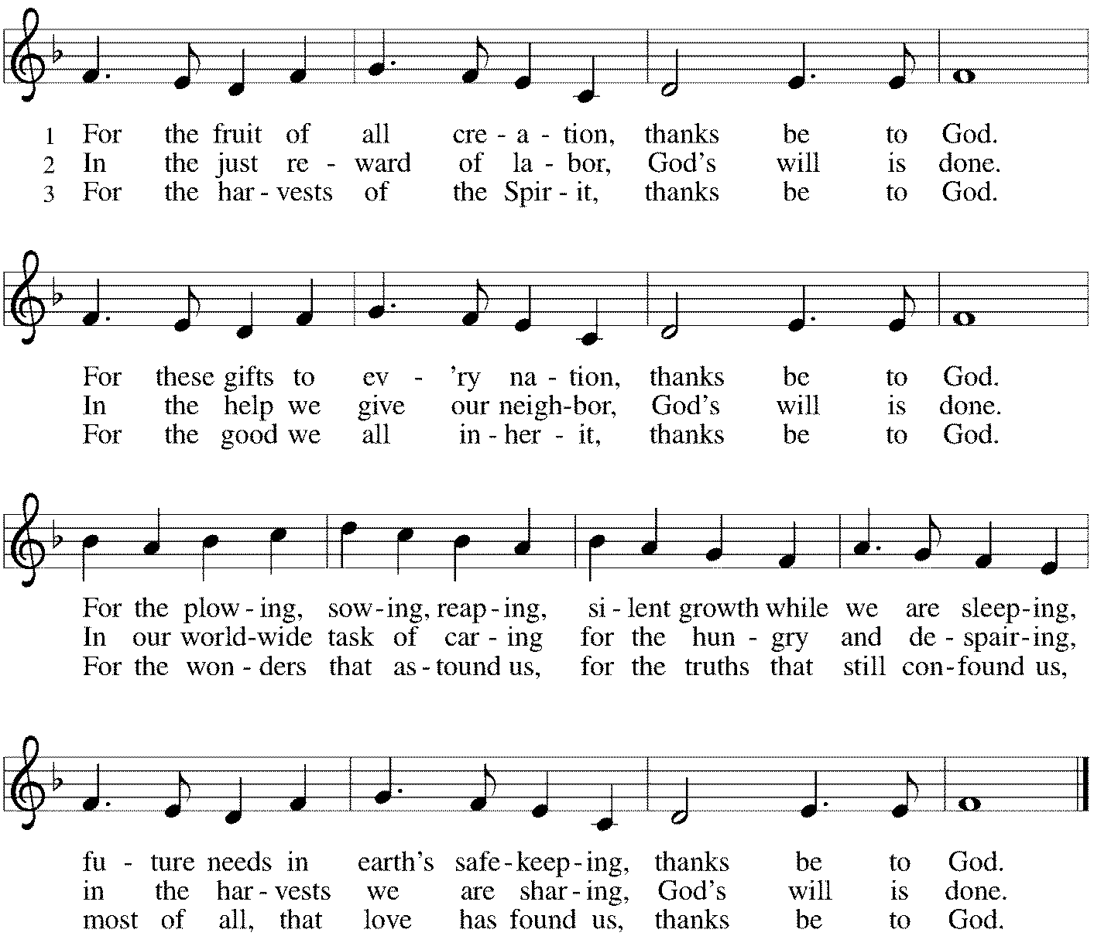

*Sent to the World
Go in peace. You are the body of Christ. Thanks be to God.

Postlude
After the postlude, those who have joined via Zoom may unmute your mics
and share a greeting with your fellow worshippers.

Thank you to Rev. Keith Fry for being with us today! Pr. Fry is Assistant to the Secretary and Executive for OS Administration at the ELCA.

From Sundays and Seasons
v.20190109.1233 Copyright © 2021 Augsburg Fortress. All rights reserved.
Reprinted by permission under Augsburg Fortress Liturgies Annual License #30867.
All rights reserved. Reprinted under OneLicense.net #A-718333.

Assisting in Worship Today
Lector Jeff Nelson
Music Bradford Thompson
Ushers Mark Hamilton, Jeff Nelson
Altar Flowers Mario & Becky Ficarella

Current Prayer Requests
Please keep these people in your prayers and reach out to our sisters and brothers in Christian love. Names will be left on the list for two weeks, unless you indicate that they should remain in our prayers for a longer period.
Name Relationship Prayer For
Bob Stein Member Healing & Strength
Jim Sladek Member Healing & Strength
Cathy Milleville Member Healing & Strength
Sigrid Elliott Member Healing & Strength
Dorothy Tracy Member Healing & Strength
Elizabeth Amber Friend of Pr. Melody & Marty Healing & Strength
Chris Danly Son of Mark & Pat Danly Healing & Strength
Tammy Rollo Friend of Barbara Sudds Healing & Strength
Prayers for our homebound Members
Dolores Nosal, Carol Petersen, Norma Petersen, Dorothy Stein

Pr. Melody is on vacation through Saturday, June 19. Pr. Charles Plummer will be on call for all pastoral emergencies. Pr. Charles can be reached at 630-210-5841.

Multi-Church Worship Service Sunday, June 20: To kick off the week of VBS, Grace Lutheran/Faith Lutheran/First Congregational will hold a combined outdoor worship service at Faith Lutheran at 8:30am. Pastors from all three churches will lead the service. There will not be a worship service at Grace or a Grace Zoom worship on that day. Bring lawn chairs or a blanket and join us at 8:30.

Ushers Needed: Each of our four usher teams are in need of one new team member. Team 1 (January, May, September); Team 2 (February, June, October); Team 3 (March, July, November; Team 4 (April, August, December). Please contact the church office if you can volunteer for one of these teams or sign up in the Narthex.

In-Person Wednesday Morning 7:30am Bible Study at Grace: All are welcome to participate. Discussion centers on the Gospel for the upcoming Sunday plus other topics of interest. Tim Stephan, Jerry Miller, Kathy Gallian, Sue Pagnoni, and Tim Frakes are regulars with this group meeting in the Narthex at Grace. Please contact the church office if you have any questions.

RAMP: Our mortgage reduction campaign has been renamed “RAMP” (Reduce Another Mortgage Payment) as we continue to RAMP up to refinance our mortgage with Mission Investment Fund this Fall. If we can raise an additional $100,000 payment prior to our November refinancing it will take us from $925,000 to $825,000.

Bradford’s Livestream Music Session: Looking for something to do on Wednesday evenings? Join Bradford for LIVE music sessions broadcast directly from Grace! Let the meditative sounds of drums, guitar, and keyboards heal your woes and soothe your souls. Wednesdays at 7:00pm. Bradford plans to change up the music and include various musicians each week. This is still a work in progress so please be patient with the format tweaks!
Just click on the link Wednesday evening at 7:00pm to join Bradford on his YouTube channel:
https://youtube.com/channel/UCbgfoPipBLAlY3hAkVKoI8Q

Chair Exercise and monthly Book Club: Registration is required as the number of attendees will be limited. The exercise class meets Mondays at 10:00am and Thursdays at 11:00am. The Book Club will meet on the third Tuesday of the month at 11:00am. Please contact Sue at 630-858-6343 to register.

Shopping Cart Brigade: Hallelujah! There WILL be a 4th of July parade and fireworks in 2021! As you know, Grace has spear-headed food collection for the GE Food Pantry for many years through our now famous “shopping cart brigade.” This year we will coordinate our activities with Pantry staff and volunteers. A crew from Grace is needed! This is a great family event - friends welcome! The parade will be held Sunday, July 4 beginning at noon.
Each partner church for the GEFP holds one or two food drives spaced throughout the year. Grace’s main contribution to this effort is the July parade. Please join us in this effort to raise awareness of food insecurity within our community. Contact Carol Asselmeier at carolassel@aol.com or call at 630-244-3235 to sign up. Thanks!!

Every Member a Minister and Missionary!

Phone: 630-469-1555 Emergency Pastoral Contact: 630-674-2887
info@graceglenellyn.org www.graceglenellyn.org

Pastor
Rev. Melody Eastman office ext. 14
meastman@graceglenellyn.org

Minister of Music
Bradford Thompson 219-718-8879
bradfordmthompson@gmail.com

Ministry Associate
Becky Ficarella office ext. 17
bficarella@graceglenellyn.org

Office Manager
Barbara Sudds office ext. 10
bsudds@graceglenellyn.org

Parish Counselor
Carole LoGalbo M.S., LCPC 630-668-4594
carolelogalbo@yahoo.com

