Grace Lutheran Church

493 Forest Avenue, Glen Ellyn IL 630.469.1555
www.graceglenellyn.org

2nd Sunday of Pentecost June 19, 2022

+ Proclaim Christ + Build Community +
+ Serve Our Neighbors +

Especially For Our Guests
Welcome to Grace!
If you are a guest, we’re thankful you’re here today. We hope you will feel Welcomed and spiritually nourished. If you would like to speak to the pastor about the congregation, please let her know directly or call the church office. To enhance your worship experience, you may want to know the following:
· Please join us after service for some great refreshments and Christian Fellowship.
· Parts of the liturgy (worship service) not printed in this bulletin are in the red hymnal (ELW). Page numbers in the hymnal are at the bottom of the page; hymn numbers are the large numbers at the top in the back half of the book.
· All baptized people are welcome at communion. If you would like to come forward for a blessing without taking communion, you can do that too. If you have difficulty walking, feel free to let the usher know and we’ll bring communion to you.
· If you find yourself confused about where we are, ask a neighbor!
· Assisted Listening Devices are available for your use. Please ask an usher.
· Young children are welcome in worship! Parents, you can bring your little ones up front to the PrayGround, a space with tables, chairs and quiet activities to keep our younger members engaged during services. Please sit near your little ones and help them use the space quietly as well as participate with you in worship. If you prefer, there is also a nursery space for you to use with infants or younger toddlers in the overflow room at the rear of the sanctuary. (But we really do like having children up front, if possible!)
· Please take your bulletin home with you. It contains the weekly calendar of events at Grace plus upcoming announcements.
· Due to COVID concerns we are not passing the offering plate during worship. You may place your gifts to Grace Lutheran in the black box on table in the Narthex. Thank you.

Updated Communion Information
We have returned to the option to commune at the rail with some modifications:
· We are not yet offering the common cup. Red grape juice and white wine are available in individual cups.
· Please do not touch more than one cup. The cups are spaced out to make them easier to remove without touching others.
· Please maintain six feet distance between household groups.
An asterisk (*) indicates that you should stand for that portion of the service. If standing is difficult, please remain seated. Congregation responses are in bold print.
Gathering
The Holy Spirit calls us together as the people of God.
Welcome/Announcements

Prelude

*Please stand as you are able and turn to face the font.
Confession and Forgiveness
All may make the sign of the cross, the sign that is marked at baptism, as the presiding minister begins.
Blessed be the holy Trinity,☩ one God,
whose steadfast love endures forever.
Amen.

Let us confess our sin in the presence of God and of one another.
Silence is kept for reflection.
Merciful God,
we confess that we have not followed your path
but have chosen our own way.
Instead of putting others before ourselves,
we long to take the best seats at the table.
When met by those in need,
we have too often passed by on the other side.
Set us again on the path of life.
Save us from ourselves
and free us to love our neighbors.
Amen.

Hear the good news!
God does not deal with us according to our sins
but delights in granting pardon and mercy.
In the name of ☩ Jesus Christ, your sins are forgiven.
You are free to love as God loves.
Amen.
*Entrance Hymn ELW #843 Praise the One Who Breaks the Darkness
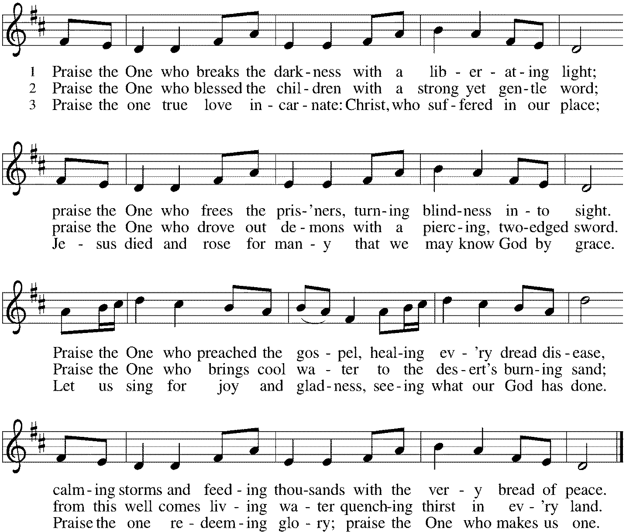

*Greeting
The grace of our Lord Jesus Christ, the love of God, and the communion of the Holy Spirit be with you all. And also with you.

*Kyrie p. 138
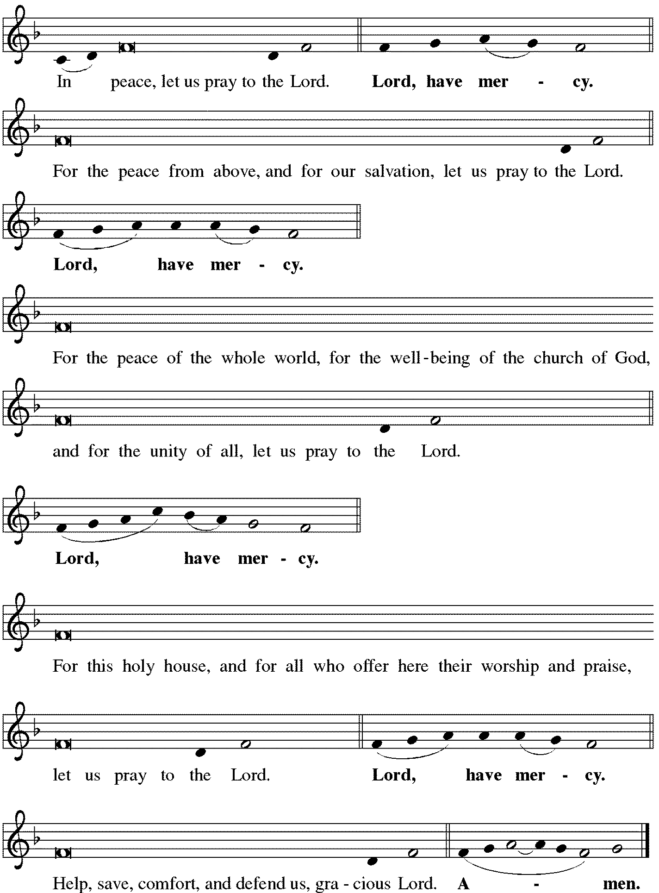

*Canticle of Praise p. 140 This is the Feast

Continued on next page
*Prayer of the Day
O Lord God, we bring before you the cries of a sorrowing world. In your mercy set us free from the chains that bind us, and defend us from everything that is evil, through Jesus Christ, our Savior and Lord. Amen. Be seated.

Word
God speaks to us in scripture reading.
First Lesson Isaiah 65:1-9
The prophet announces God’s impatience. The people’s self-absorption is idolatry, and images of practices that displease God fill this reading. Like a vintner who crushes the grape to release the wine, God will use Israel’s exile to establish a new community of the faithful.

¹I was ready to be sought out by those who did not ask, to be found by those who did not seek me. I said, “Here I am, here I am,” to a nation that did not call on my name. ²I held out my hands all day long to a rebellious people, who walk in a way that is not good, following their own devices; ³a people who provoke me to my face continually, sacrificing in gardens and offering incense on bricks; ⁴who sit inside tombs, and spend the night in secret places; who eat swine’s flesh, with broth of abominable things in their vessels; ⁵who say, “Keep to yourself, do not come near me, for I am too holy for you.” These are a smoke in my nostrils, a fire that burns all day long. ⁶See, it is written before me: I will not keep silent, but I will repay; I will indeed repay into their laps ⁷their iniquities and their ancestors’ iniquities together, says the Lord; because they offered incense on the mountains and reviled me on the hills, I will measure into their laps full payment for their actions. ⁸Thus says the Lord: As the wine is found in the cluster, and they say, “Do not destroy it, for there is a blessing in it,” so I will do for my servants’ sake, and not destroy them all. ⁹I will bring forth descendants from Jacob, and from Judah inheritors of my mountains; my chosen shall inherit it, and my servants shall settle there.

Word of God, Word of Life. Thanks be to God.

Psalm Psalm 22:19-28
The Psalm is read responsively by verse.
¹⁹But you, O Lord, be not far away; O my help, hasten to my aid.
²⁰Deliver me from the sword, my life from the power of the dog.
²¹Save me from the lion’s mouth! From the horns of wild bulls you have rescued me.
²²I will declare your name to my people; in the midst of the assembly I will praise you.
²³You who fear the Lord, give praise! All you of Jacob’s line, give glory. Stand in awe of the Lord, all you offspring of Israel.
²⁴For the Lord does not despise nor abhor the poor in their poverty; neither is the Lord’s face hidden from them; but when they cry out, the Lord hears them.
²⁵From you comes my praise in the great assembly; I will perform my vows in the sight of those who fear the Lord.
²⁶The poor shall eat and be satisfied, Let those who seek the Lord give praise! May your hearts live forever!
²⁷All the ends of the earth shall remember and turn to the Lord; all the families of nations shall bow before God.
²⁸For dominion belongs to the Lord, who rules over the nations.

Second Lesson Galatians 3:23-29
For Paul, baptism is a powerful bond that unites people not only with God but with other believers. Those who call themselves children of God experience a transformation that removes prejudices of race, social class, or gender in favor of true unity in Christ.
²³Now before faith came, we were imprisoned and guarded under the law until faith would be revealed. ²⁴Therefore the law was our disciplinarian until Christ came, so that we might be justified by faith. ²⁵But now that faith has come, we are no longer subject to a disciplinarian, ²⁶for in Christ Jesus you are all children of God through faith. ²⁷As many of you as were baptized into Christ have clothed yourselves with Christ. ²⁸There is no longer Jew or Greek, there is no longer slave or free, there is no longer male and female; for all of you are one in Christ Jesus. ²⁹And if you belong to Christ, then you are Abraham’s offspring, heirs according to the promise.

Word of God, Word of Life. Thanks be to God.
*Please stand as you are able.
Gospel Acclamation p. 142 Alleluia
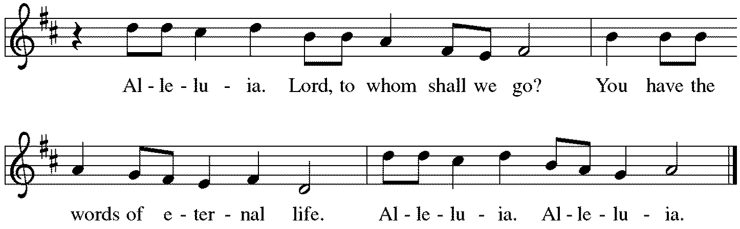

The holy Gospel according to Luke. Glory to you, O Lord.
*Gospel Luke 8:26-39
Jesus’ mission includes foreigners and his authority extends to the casting out of demons. Some who witness Jesus’ work are seized with confusion and fear, but the man who was healed is commissioned to give testimony to God’s mercy and power.

²⁶Then [Jesus and his disciples] arrived at the country of the Gerasenes, which is opposite Galilee. ²⁷As he stepped out on land, a man of the city who had demons met him. For a long time he had worn no clothes, and he did not live in a house but in the tombs. ²⁸When he saw Jesus, he fell down before him and shouted at the top of his voice, “What have you to do with me, Jesus, Son of the Most High God? I beg you, do not torment me”—²⁹for Jesus had commanded the unclean spirit to come out of the man. (For many times it had seized him; he was kept under guard and bound with chains and shackles, but he would break the bonds and be driven by the demon into the wilds.) ³⁰Jesus then asked him, “What is your name?” He said, “Legion”; for many demons had entered him. ³¹They begged him not to order them to go back into the abyss.
³²Now there on the hillside a large herd of swine was feeding; and the demons begged Jesus to let them enter these. So he gave them permission. ³³Then the demons came out of the man and entered the swine, and the herd rushed down the steep bank into the lake and was drowned.
³⁴When the swineherds saw what had happened, they ran off and told it in the city and in the country. ³⁵Then people came out to see what had happened, and when they came to Jesus, they found the man from whom the demons had gone sitting at the feet of Jesus, clothed and in his right mind. And they were afraid. ³⁶Those who had seen it told them how the one who had been possessed by demons had been healed. ³⁷Then all the people of the surrounding country of the Gerasenes asked Jesus to leave them; for they were seized with great fear. So he got into the boat and returned. ³⁸The man from whom the demons had gone begged that he might be with him; but Jesus sent him away, saying, ³⁹“Return to your home, and declare how much God has done for you.” So he went away, proclaiming throughout the city how much Jesus had done for him.

The Gospel of the Lord. Praise to you, O Christ. Be seated.

Sermon The Rev. Melody Eastman

*Please stand as you are able.
*Hymn of the Day ELW #860 I’m So Glad Jesus Lifted Me
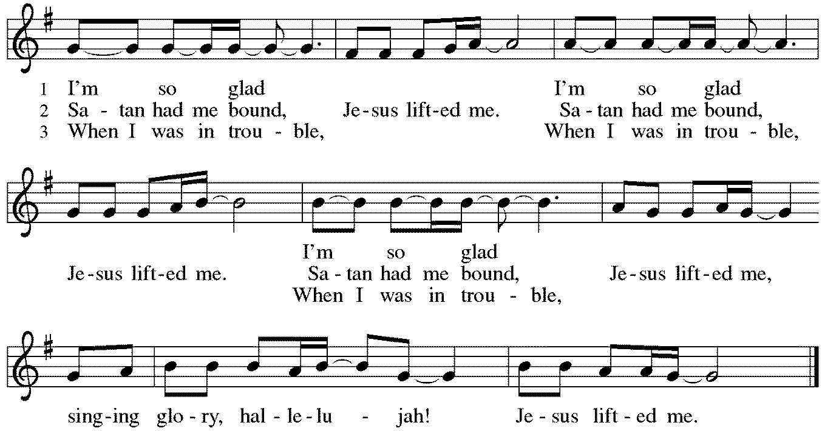

*Apostles’ Creed
With the whole church, let us confess our faith.
I believe in God, the Father almighty, creator of heaven and earth. I believe in Jesus Christ, God's only Son, our Lord, who was conceived by the Holy Spirit, born of the virgin Mary, suffered under Pontius Pilate, was crucified, died, and was buried; he descended to the dead. On the third day he rose again; he ascended into heaven, he is seated at the right hand of the Father, and he will come to judge the living and the dead. I believe in the Holy Spirit, the holy catholic church, the communion of saints, the forgiveness of sins, the resurrection of the body, and the life everlasting. Amen.
*Prayers of Intercession
United in Christ and guided by the Spirit, we pray for the church, the creation, and all in need.
A brief silence.
Holy God, you hear the cries of those who seek you. Equip your church with evangelists who reveal the continuous call of your outstretched hands and your promises of a home in you. God of grace, hear our prayer.

You hear the cries of the earth. Restore places where land, air, and waterways have been harmed. Guide us to develop and implement sources of energy and food production that do not destroy the earth. God of grace, hear our prayer.

You hear the cries of those who are marginalized or cast out. On this Juneteenth observance, guide us continually toward the end of oppression in all its forms, especially white supremacy. Bring true freedom and human flourishing to all your beloved children. God of grace, hear our prayer.

You hear the cries of those who suffer. Come to the aid of all who are homeless, naked, hungry, and sick especially Carol, Dorothy, Dolores, Norma, Brittany, and those we name before you now. . . Bring peace to any experiencing mental illness, that they can clearly recognize your loving presence. God of grace, hear our prayer.

You hear the cries of those who celebrate and those who grieve on this Father’s Day. Nurture mutual love and tender care in all relationships. Comfort those for whom this day brings sadness or longing. God of grace, hear our prayer.
Here other intercessions may be offered.

Be with all who celebrate and increase their joy, especially Tom and Elaine Roete as they celebrate their 54th wedding anniversary. God of grace, hear our prayer.

We give thanks for the faithful departed whose lives proclaimed all you had done for them. At the last, unite us with them as we make our home in you. God of grace, hear our prayer.

God of every time and place, in Jesus’ name and filled with your Holy Spirit, we entrust these spoken prayers and those in our hearts into your holy keeping. Amen.

*Peace
The peace of Christ be with you always. And also with you.
Please share the peace with others in your household, or by making a sign of peace to those on Zoom. Be seated.

Meal
God feeds us with the presence of Jesus Christ.
*Please stand as you are able.
*Offering Prayer
God of abundance:
you have set before us a plentiful harvest.
As we feast on your goodness,
strengthen us to labor in your field,
and equip us to bear fruit for the good of all,
in the name of Jesus.
Amen.

*Great Thanksgiving p. 144
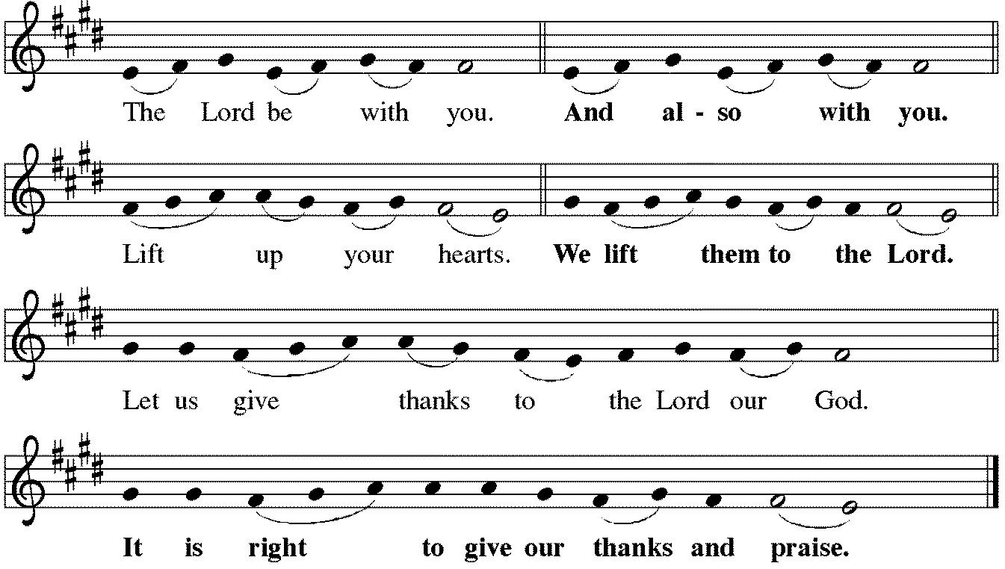

*Preface

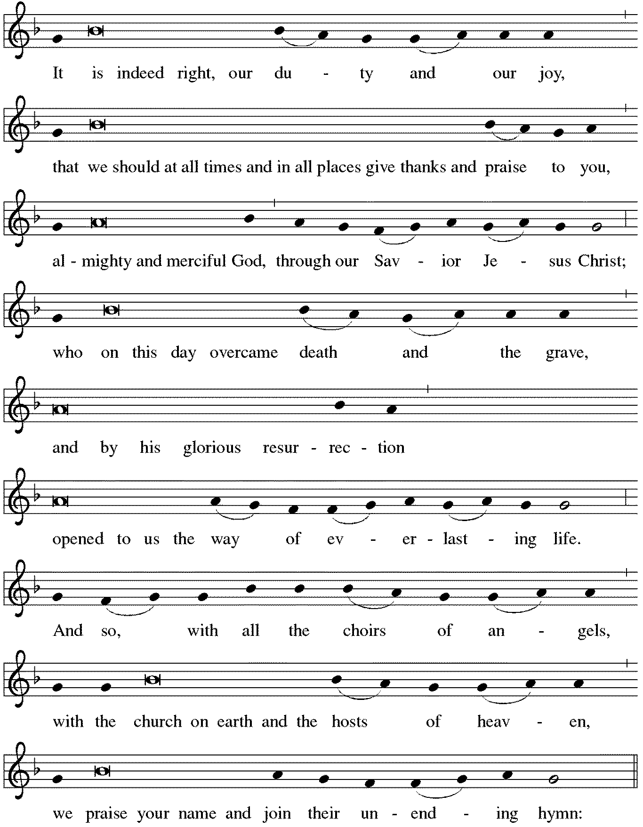

*Sanctus p. 144 Holy, Holy, Holy
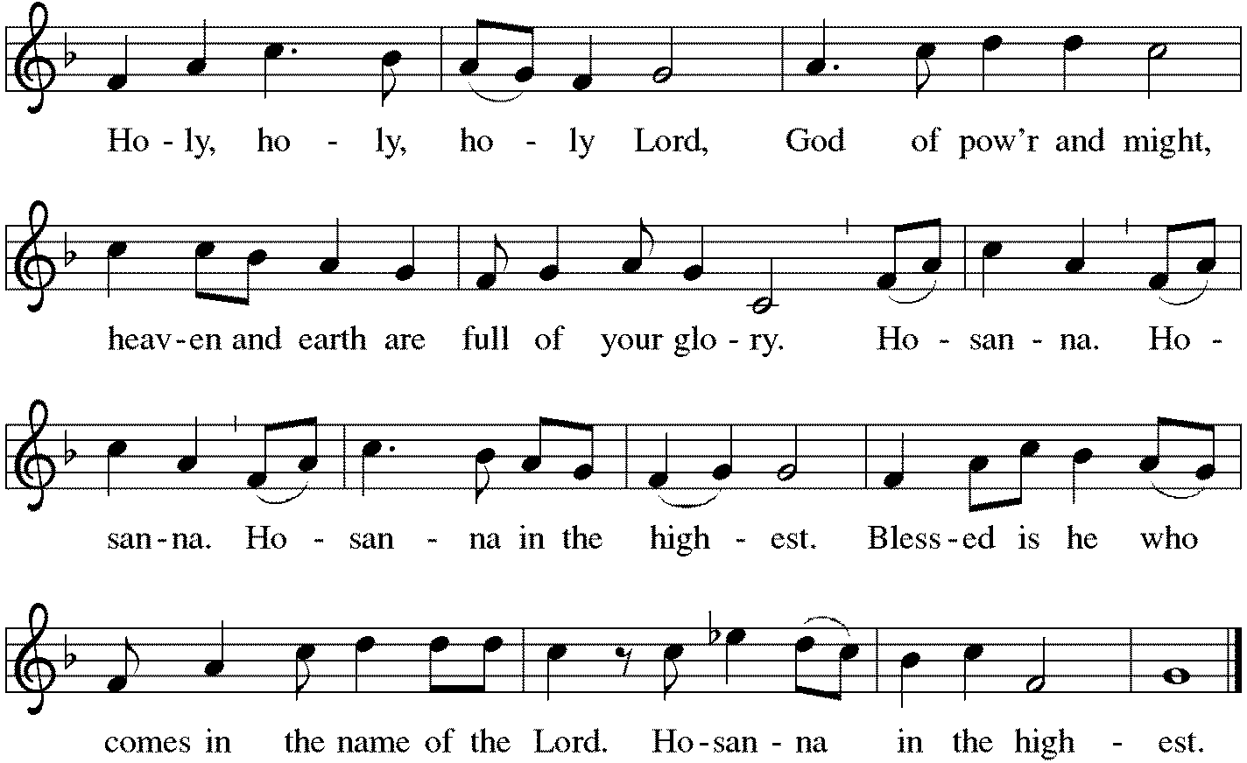

*Thanksgiving at the Table
Holy God, you alone are holy, you alone are God.

The universe declares your praise:
beyond the stars; beneath the sea; within each cell; with every breath.
We praise you, O God.

Generations bless your faithfulness:
through the water; by night and day; across the wilderness;
out of exile; into the future.
We bless you, O God.

We give you thanks for your dear Son:
at the heart of human life; near to those who suffer; beside the sinner;
among the poor; with us now.
We thank you, O God.

In the night in which he was betrayed,
our Lord Jesus took bread, and gave thanks;
broke it, and gave it to his disciples, saying:
Take and eat; this is my body, given for you.
Do this for the remembrance of me.

Again, after supper, he took the cup, gave thanks,
and gave it for all to drink, saying:
This cup is the new covenant in my blood,
shed for you and for all people for the forgiveness of sin.
Do this for the remembrance of me.

Remembering his love for us
on the way, at the table,
and to the end,
we proclaim the mystery of faith:
Christ has died. Christ is risen. Christ will come again.

We pray for the gift of your Spirit:
in our gathering; within this meal; among your people; throughout the world.

Blessing, praise, and thanks to you,
holy God, through Christ Jesus, by your Spirit, in your church, without end.
Amen.

*The Lord’s Prayer
Gathered into one by the Holy Spirit, let us pray as Jesus taught us.
Our Father in heaven, hallowed be your name; your kingdom come, your will be done on earth as in heaven. Give us today our daily bread. Forgive us our sins as we forgive those who sin against us. Save us from the time of trial and deliver us from evil. For the kingdom, the power, and the glory are yours, now and forever. Amen.

*Invitation to Communion
In Christ’s presence there is fullness of joy. Come to the banquet. Be seated.

Communion p. 146 Lamb of God
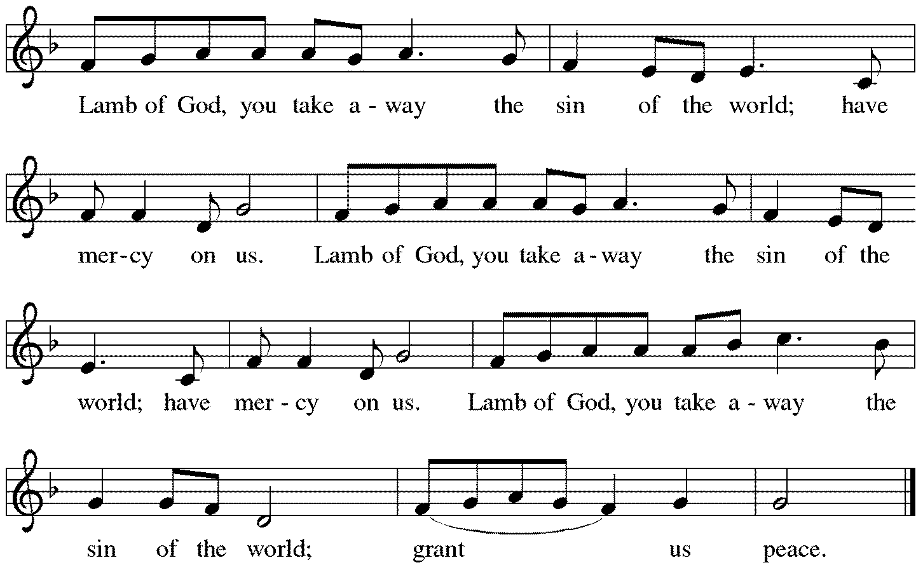

Communion
Those who wish to come to the rail for communion may do so at the ushers’ direction. You may stand or kneel. Please maintain social distancing between households. You may return to your seat by the side aisles after you have received the bread and wine.

For those receiving communion from home:
This is the body of Christ, given for you. Amen (Eat the bread.)
This is the blood of Christ, shed for you. Amen (Drink the juice.)

*Please stand as you are able.
*Post Communion Blessing
May the body and blood of our Lord Jesus Christ
strengthen you and keep you in his grace. Amen.

*Post Communion Prayer
Life-giving God,
through this meal you have bandaged our wounds
and fed us with your mercy.
Now send us forth to live for others,
both friend and stranger,
that all may come to know your love.
This we pray in the name of Jesus.
Amen.
Sending
God blesses us and sends us in mission to the world.
*Blessing
The God of peace,
Father, ☩ Son, and Holy Spirit,
bless you, comfort you,
and show you the path of life
this day and always.
Amen.

*Sending Hymn ELW #886 Oh, For a Thousand Tongues to Sing
sts. 1,3,4,6
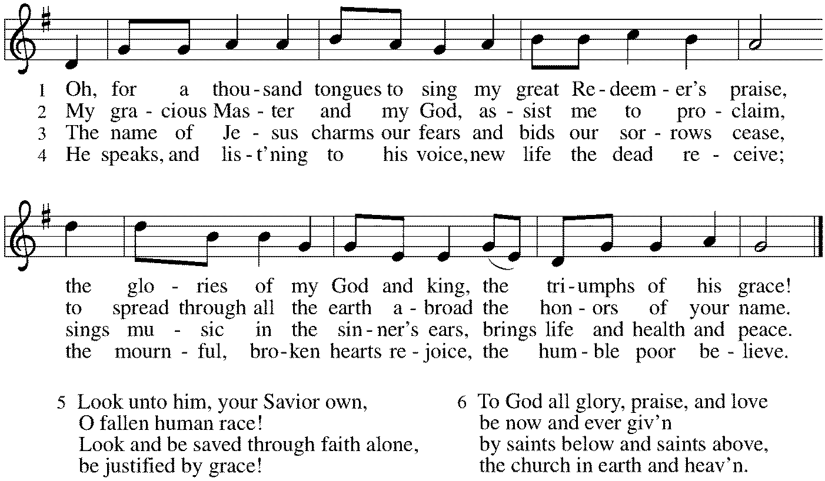

*Sent to the World
Go in peace. Love your neighbor. Thanks be to God.

Postlude

From Sundays and Seasons v.20190109.1233 Copyright © 2022 Augsburg Fortress. All rights reserved.
Reprinted by permission under Augsburg Fortress Liturgies Annual License #30867.
All rights reserved. Reprinted under OneLicense.net #A-718333.

Assisting in Worship Today
Pastor Rev. Melody Eastman
Minister of Music Bradford Thompson
Ministry Associate Becky Ficarella
Altar Care Donna Barber
Lector Heather Graf
Usher Jeff Nelson
Zoom Mark Hamilton, Jon & Cathy Milleville
Fellowship Hour Social Ministry

Current Prayer Requests
Please keep these people in your prayers and reach out to our sisters and brothers in Christian love. Names will be left on the list for two weeks, unless you indicate that they should remain in our prayers for a longer period.
Name Relationship Prayer For
Tom & Elaine Roete Members 54th Anniversary (6/22)
Chuck & Jan Miller Members 60th Anniversary (6/16)
Carol Wandke Member Healing & Strength
Dolores Nosal Member Healing & Strength
Brittany Huizenga Cousin of Cheryl Huizenga Healing & Strength
Dorothy Tracy Member Healing & Strength
Norma Petersen Member Healing & Strength
Prayers for our homebound Members
Dolores Nosal, Carol Petersen, Norma Petersen

Weekly Announcements

Summer Play Group at Lake Ellyn Park in June! Join Grace members at Lake Ellyn for a play group gathering on Mondays, 9-11am. We meet up at the park and let the kids play! Birth –Elementary age students with an adult are welcomed to join. We will meet each Monday in June except for June 20th which will be our Vacation Bible School gathering that week at Faith Lutheran Church in Glen Ellyn.

Worship Assistants: With the return to communion at the rail, we are in need of people willing to serve as cross-bearer and communion assistant along with two ushers for each week. If you are able to help with carrying the cross and/or assisting with communion, please contact Susan Jacobson or the church office. Thank you!

People of Grace, Tuesday June 21st at 7pm: Women of Grace and Men of Grace are COMBINED this summer! We have decided to merge our groups into one for summer fellowship at Reserve 22 in Glen Ellyn. Please RSVP to Jeff Nelson or Becky Ficarella if you plan to join us. Our July date is 7/19 and August is 8/16. See you there!

Vacation Bible School Volunteer Needs! June 20-June 24
Can you help in any of these areas? We have over 100 students signed up!!!
Let Becky Ficarella know 847-347-0928 or bficarella@graceglenellyn.org

Village Chief we need 3-4 more LEADERS to run our Village Small Groups. You will co-lead with another a group of 8-12 students through their VBS Day. You lead and move the group from activity to activity much like a camp counselor. You will have small moments of downtime to keep the group engaged and focused on the day's theme. You are provided with all of the material needed. High School - Adult are the perfect age to manage this group. Many Faith Formation teachers make wonderful Village Chiefs.
Snacks Team needs 2-3 people to work in the kitchen and prepare fruit, supplies for baking and deliver food to various groups. We need help Monday - Friday, 8:50-11:30am each day.
Games Team needs 2-4 more assistants to help run games with each village. Monday-Friday 9-12.

Sunday Worship Time to Change this Fall: The Church Council received several requests from congregation members to review the start time of our Sunday Worship Service. After a thoughtful discussion, it was unanimously decided to make a change. Beginning on Rally Day, September 11, 2022 Sunday Worship time at Grace will begin at 10am and Faith Formation will be at 9am.

Sr. Center Movie: Friday, June 24 at 10am the movie “The Shack” will be shown in the Gr. Room. All are welcome to attend.

Sr. Center Chair Exercise Classes: The exercise class meets Mondays and Tuesdays at 10:00am. The Thursday class will NOT meet June through August. Registration is required as the number of attendees will be limited. Please contact Sue Davison at 630-858-6343 to register.

Quilting Ministry: The quilters meet on the second and fourth Tuesday of every month from 9-10am.

Every Member a Minister and Missionary!

Phone: 630-469-1555 Emergency Pastoral Contact: 630-674-2887
info@graceglenellyn.org www.graceglenellyn.org

Pastor
Rev. Melody Eastman office ext. 14
meastman@graceglenellyn.org

Minister of Music
Bradford Thompson 219-718-8879
bradfordmthompson@gmail.com

Ministry Associate
Becky Ficarella office ext. 17
bficarella@graceglenellyn.org

Office Manager
Barbara Sudds office ext. 10
bsudds@graceglenellyn.org

Parish Counselor
Carole LoGalbo M.S., LCPC 630-668-4594
carolelogalbo@yahoo.com

