Grace Lutheran Church

493 Forest Avenue, Glen Ellyn IL 630.469.1555
www.graceglenellyn.org

4th Sunday after Pentecost June 28, 2020

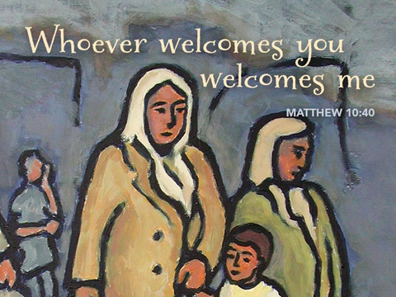

+ Proclaim Christ + Build Community +
+ Serve Our Neighbors +

Introduction
The welcome of baptism is for all God’s children. This baptismal gift sets us free from the power of sin and death. In today’s gospel, Christ promises that the disciple who gives a cup of cold water to the little ones serves Christ himself. From worship we are sent on our baptismal mission: to serve the little ones of this world and to be a sign of God’s merciful welcome.

Gathering
Even when we are apart, the Holy Spirit binds us together as the people of God.

Opening Hymn ELW # 779 Amazing Grace, How Sweet the Sound

Greeting
The grace of our Lord Jesus Christ, the love of God, and the communion of the Holy Spirit be with you all. And also with you.

Prayer of the Day
O God, you direct our lives by your grace, and your words of justice and mercy reshape the world. Mold us into a people who welcome your word and serve one another, through Jesus Christ, our Savior and Lord. Amen.

Word
God speaks to us in scripture reading, preaching, and song.

First Lesson Jeremiah 28:5-9
Through a symbolic action Jeremiah insisted that Judah and all the surrounding nations should submit to the king of Babylon (Jer. 27). Hananiah contradicted the word of Jeremiah, who in reply insisted that Hananiah’s rosy prediction should not be believed until it came true. God confirmed the word of Jeremiah and sentenced the false prophet Hananiah to death (vv. 16-17).

⁵The prophet Jeremiah spoke to the prophet Hananiah in the presence of the priests and all the people who were standing in the house of the Lord; ⁶and the prophet Jeremiah said, “Amen! May the Lord do so; may the Lord fulfill the words that you have prophesied, and bring back to this place from Babylon the vessels of the house of the Lord, and all the exiles. ⁷But listen now to this word that I speak in your hearing and in the hearing of all the people. ⁸The prophets who preceded you and me from ancient times prophesied war, famine, and pestilence against many countries and great kingdoms. ⁹As for the prophet who prophesies peace, when the word of that prophet comes true, then it will be known that the Lord has truly sent the prophet.”

Word of God, Word of Life. Thanks be to God.

Second Lesson Romans 6:12-23
Sin is an enslaving power which motivates us to live self-serving, disobedient lives. Sin’s final payoff is death. We, however, have been set free from sin’s slavery to live obediently under God’s grace, whose end is the free gift of eternal life.

¹²Do not let sin exercise dominion in your mortal bodies, to make you obey their passions. ¹³No longer present your members to sin as instruments of wickedness, but present yourselves to God as those who have been brought from death to life, and present your members to God as instruments of righteousness. ¹⁴For sin will have no dominion over you, since you are not under law but under grace.
¹⁵What then? Should we sin because we are not under law but under grace? By no means! ¹⁶Do you not know that if you present yourselves to anyone as obedient slaves, you are slaves of the one whom you obey, either of sin, which leads to death, or of obedience, which leads to righteousness? ¹⁷But thanks be to God that you, having once been slaves of sin, have become obedient from the heart to the form of teaching to which you were entrusted, ¹⁸and that you, having been set free from sin, have become slaves of righteousness. ¹⁹I am speaking in human terms because of your natural limitations. For just as you once presented your members as slaves to impurity and to greater and greater iniquity, so now present your members as slaves to righteousness for sanctification.
²⁰When you were slaves of sin, you were free in regard to righteousness. ²¹So what advantage did you then get from the things of which you now are ashamed? The end of those things is death. ²²But now that you have been freed from sin and enslaved to God, the advantage you get is sanctification. The end is eternal life. ²³For the wages of sin is death, but the free gift of God is eternal life in Christ Jesus our Lord.

Word of God, Word of Life. Thanks be to God.

Gospel Acclamation
Alleluia. Lord, to whom shall we go? You have the words of eternal life. Alleluia.

The holy Gospel according to Matthew. Glory to you, O Lord.

Gospel Matthew 10:40-42
When Jesus sends his disciples out as missionaries, he warns them of persecution and hardships they will face. He also promises to reward any who aid his followers and support their ministry.

[Jesus said to the twelve:] ⁴⁰“Whoever welcomes you welcomes me, and whoever welcomes me welcomes the one who sent me. ⁴¹Whoever welcomes a prophet in the name of a prophet will receive a prophet’s reward; and whoever welcomes a righteous person in the name of a righteous person will receive the reward of the righteous; ⁴²and whoever gives even a cup of cold water to one of these little ones in the name of a disciple—truly I tell you, none of these will lose their reward.”
The Gospel of the Lord. Praise to you, O Christ.

Sermon (Available at www.GraceGlenEllyn.org) Pastor Melody Eastman

Apostles’ Creed

With the whole church, let us confess our faith.
I believe in God, the Father almighty, creator of heaven and earth. I believe in Jesus Christ, God's only Son, our Lord, who was conceived by the Holy Spirit, born of the virgin Mary, suffered under Pontius Pilate, was crucified, died, and was buried; he descended to the dead. On the third day he rose again; he ascended into heaven, he is seated at the right hand of the Father, and he will come to judge the living and the dead. I believe in the Holy Spirit, the holy catholic church, the communion of saints, the forgiveness of sins, the resurrection of the body, and the life everlasting. Amen.

Prayers of Intercession
Called into unity with one another and the whole creation, let us pray for our shared world.
A brief silence.

God of companionship, encourage our relationships with our siblings in Christ. Bless our conversations. Shape our shared future and give us hearts eager to join in a festal shout of praise. Hear us, O God. Your mercy is great.

God of abundance, you make your creation thrive and grow to provide all that we need. Inspire us to care for our environment and be attuned to where the earth is crying out. Hear us, O God. Your mercy is great.

God of mercy, your grace is poured out for all. Inspire authorities, judges, and politicians to act with compassion. Teach us to overcome fear with hope, meet hate with love, and welcome one another as we would welcome you. Hear us, O God. Your mercy is great.

God of care, accompany all who are in deepest need. Comfort those who are sick, lonely, or abandoned, especially Sigrid, Chris, Dorothy, David, Gary, Anita, Bob, Evelyn, Carol, Norma, Dorothy, and those we name before you now. . . Strengthen those who are in prison or awaiting trial. Renew the spirits of all who call upon you. Hear us, O God. Your mercy is great.

God of community, we give thanks for this congregation. Give us passion to embrace your mission and the vision to recognize where you are leading us. Teach us how to live more faithfully with each other. Hear us, O God. Your mercy is great.
Here other intercessions may be offered.

God of love, you gather in your embrace all who have died. Comfort Leigh and all the family and friends of Maddy Pietsch who mourn her death, and comfort them in the promise of eternal life. Keep us steadfast in our faith and renew our trust in your promise. Hear us, O God. Your mercy is great.

Receive these prayers, O God, and those too deep for words; through Jesus Christ our Lord.
Amen.

The Lord’s Prayer
Gathered into one by the Holy Spirit, let us pray as Jesus taught us.
Our Father, who art in heaven, hallowed be thy name, thy kingdom come, thy will be done on earth as it is in heaven. Give us this day our daily bread; and forgive us our trespasses, as we forgive those who trespass against us; and lead us not into temptation, but deliver us from evil. For thine is the kingdom, and the power, and the glory, forever and ever. Amen.

Blessing
Neither death, nor life, nor angels, nor rulers, nor things present, nor things to come, nor powers, nor height, nor depth, nor anything else in all creation, will be able to separate us from the love of God in Christ Jesus. God, the creator, ☩ Jesus, the Christ, and the Holy Spirit, the comforter, bless you and keep you in eternal love. Amen.

Hymn ELW #848 Give to Our God Immortal Praise

Dismissal
Go in peace. Christ is with you. Thanks be to God.

From Sundays and Seasons v.20190109.1233 Copyright © 2020 Augsburg Fortress. All rights reserved.
Reprinted by permission under Augsburg Fortress Liturgies Annual License #30867.
Reprinted under OneLicense.net #A-718333.

Current Prayer Requests
Name Relation to Grace Prayers For
Family of Madeline Fisher-Pietsch Member Comfort in Grief
Tom & Elaine Roete Members 52nd Anniversary (6/22)
Chris Danly Son of Mark & Pat Danly Healing & Strength
Sigrid Elliott Friend of Grace Healing & Strength
David Dean Son of Lenore Dean Healing & Strength
Dorothy Tracy Member Healing & Strength
Gary Miller Member at St. Luke Healing & Strength
Prayers for our homebound Members
Bob Clauss, Evelyn Elson, Carol Petersen, Norma Petersen, Dorothy Stein

The July/August/September issues of Christ in Our Home and The Word in Season are in. Please let the office know if you would like to pick up copies of one or both and they will be placed in an envelope by the handicap door for easy pickup. Also, let the church office know if you would to have one or both mailed to you and which size you prefer. Thank you.

Seeking High School and College Students to help their neighbor: Are you looking for things to do this summer? Would you be willing to help Grace members with errands or yard work? We are hoping to compile a list of students that would be willing to help homebound and elderly members with any yard work or errands that might otherwise be too difficult for them. Please let Becky Ficarella know if you are able to help!

Virtual Compassion Camp VBS! July 13-July 17: Virtual Vacation Bible School registration is available on Grace's Website until July 1st! Volunteer registration can be found here as well. We will need a lot of help with video editing, supply shopping and packing, and supply delivery to participants’ homes. We would be grateful for any support you can provide to this effort!
All links to activities and videos will be available through the end of the summer, so you have the flexibility to enjoy the lessons and activities in your own timing. Please email Becky Ficarella with any questions. bficarella@graceglenellyn.org

Grace’s Restoring Worship Task Force is working on the many issues that must be addressed before we feel ready to return to in-person worship. Because of the frequent changes in recommendations, the number of adjustments we must make to our site, and the upcoming holiday that limits the number of people available to implement new procedures, we are tentatively hoping to return on Sunday, July 12. Check the website or your News From Grace
e-blast for more details.

New on Netflix is Steel Magnolias, a popular new series whose main characters all attend an ELCA congregation. One of the show’s developers intentionally identified their church as ELCA to highlight the positive impact of our denomination in people’s lives.

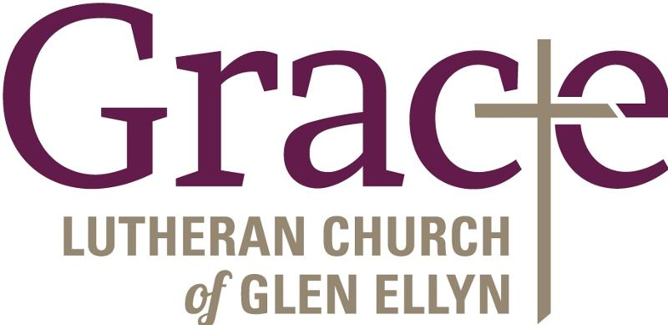

Every Member a Minister and Missionary!

Phone: 630-469-1555 Emergency Pastoral Contact: 630-674-2887
info@graceglenellyn.org www.graceglenellyn.org

Pastor
Rev. Melody Eastman office ext. 14
meastman@graceglenellyn.org

Ministry Associate
Becky Ficarella office ext. 17
bficarella@graceglenellyn.org

Office Manager office ext. 10
Barbara Sudds
bsudds@graceglenellyn.org

Minister of Music 219-718-8879
Bradford Thompson
bradfordthompson@gmail.com

