ELW Grace Lutheran Church

493 Forest Avenue, Glen Ellyn IL 630.469.1555
www.graceglenellyn.org

6th Sunday after Pentecost July 4, 2021

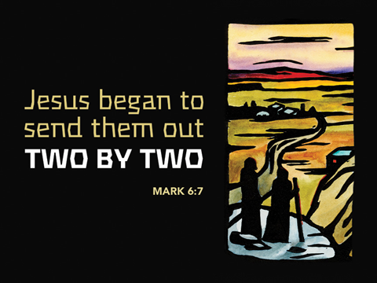

+ Proclaim Christ + Build Community +
+ Serve Our Neighbors +

Introduction
Jesus does great deeds of power and gives his disciples authority over demons. Yet none of this power is unilateral; it all must be received by faith. Jesus asks his disciples to go out without money or supplies, so that they will be dependent on how others receive them. When we are sent from the assembly to witness and to heal, we are asked to be vulnerable, to be dependent on the reception of others. The Spirit always operates in the “between”: between Jesus and his Abba, between Jesus and us, between you and me, between us and those to whom we are sent.

Gathering
The Holy Spirit calls us together as the people of God.
Welcome/Announcements
Helpful Reminders for those joining via Zoom:
- The host will mute you when you join, and you will remain muted until the end of the service.
- You are welcome to join in all congregation responses (in Bold black.) and hymns.
- At the end of the service you may unmute your mic to share greetings with your fellow worshippers. If you dialed in on the phone, press *6. Remember, your host cannot unmute you.

Helpful Reminders for those joining in person:
- Maintain 6’ distance between family groups
- Remain in your pews for communion.
- You may place your offering in the box in the narthex.

Prelude

*Please stand as you are able and turn to face the font.
*Confession and Forgiveness
All may make the sign of the cross, the sign marked at baptism, as the presiding minister begins.
Blessed be the holy Trinity,☩ one God, the God of manna, the God of miracles, the God of mercy. Amen.

Drawn to Christ and seeking God’s abundance, let us confess our sin.
Silence is kept for reflection.

God, our provider, help us. It is hard to believe there is enough to share. We question your ways when they differ from the ways of the world in which we live. We turn to our own understanding rather than trusting in you. We take offense at your teachings and your ways.
Turn us again to you. Where else can we turn? Share with us the words of eternal life and feed us for life in the world. Amen.
Beloved people of God: in Jesus, the manna from heaven, you are fed and nourished. By Jesus, the worker of miracles, there is always more than enough. Through Jesus, ☩ the bread of life, you are shown God’s mercy: you are forgiven and loved into abundant life. Amen. Be seated.

Entrance Hymn ELW #796 How Firm a Foundation
sts. 1,2,4
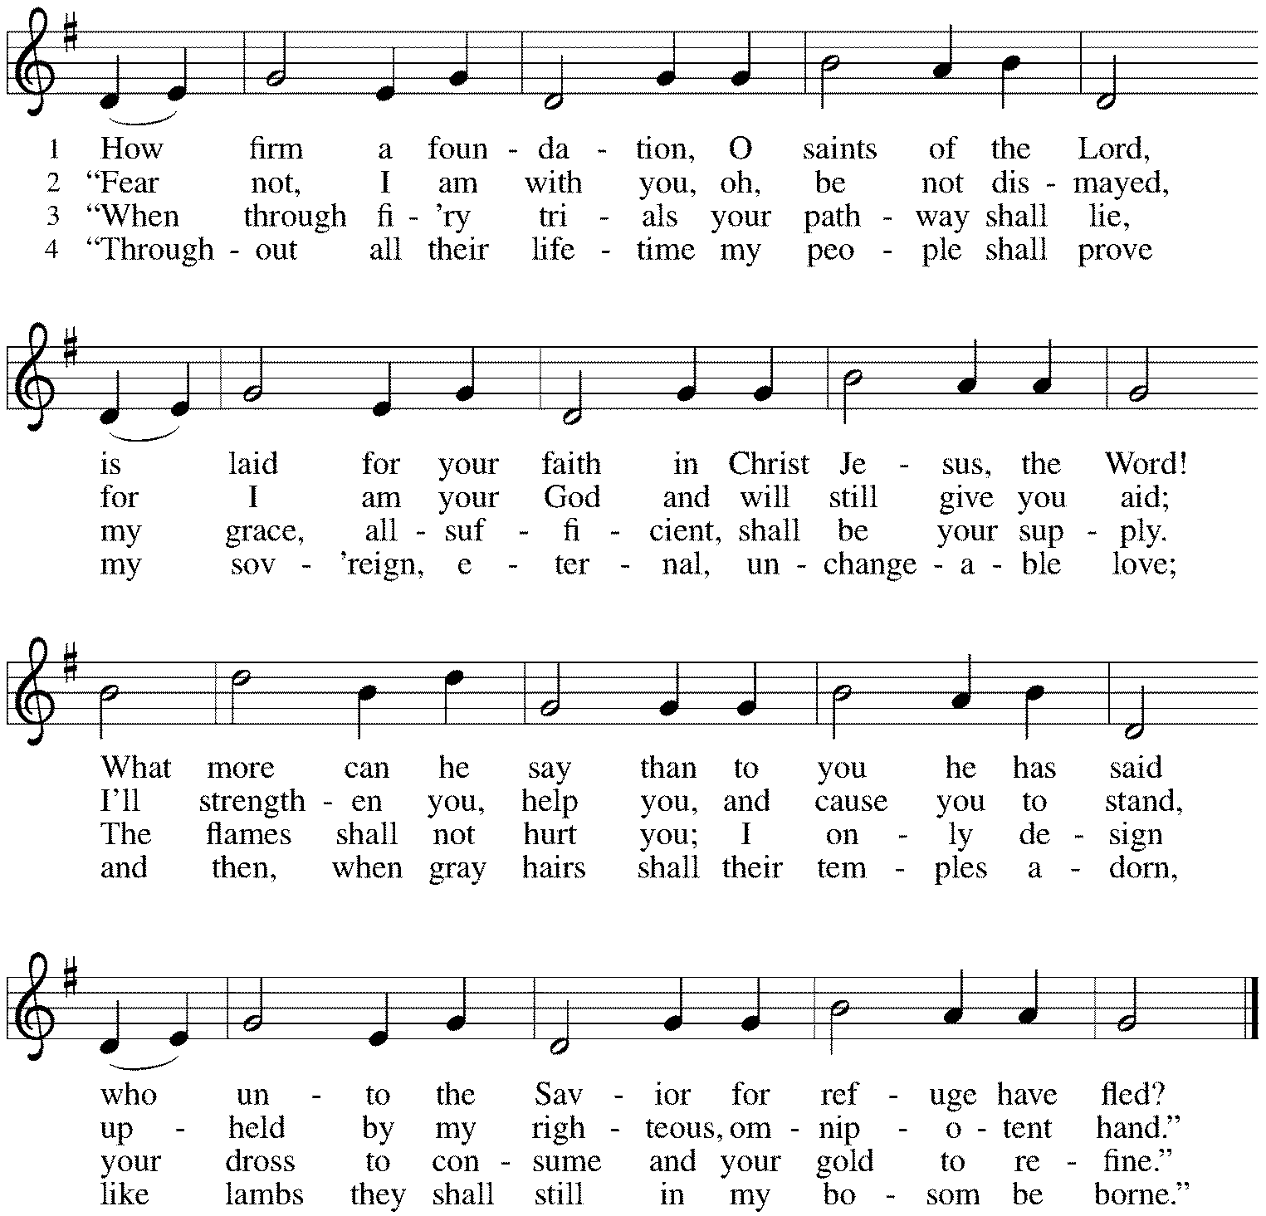

*Please stand as you are able
*Greeting
The grace of our Lord Jesus Christ, the love of God, and the communion of the Holy Spirit be with you all. And also with you.
*Hymn of Praise This is the Feast (from Mass for Immanuel, Singing in Community)
The congregation sings the refrain, the cantor sings the stanzas.
The cantor will introduce the refrain the first time through.
At the end of each stanza, the congregation repeats the “Alleluia” after the cantor.

Refrain: This is the feast of vict’ry for our God. Alleluia, alleluia.
Worthy is Christ, the Lamb who was slain,
whose blood set us free to be people of God. Alleluia. Alleluia.
Refrain
Power, riches, wisdom, and strength, and honor, blessing and glory are his. Alleluia. Alleluia.
Refrain
Sing with all the people of God, and join in the hymn of all creation. Alleluia. Alleluia.
Refrain
Blessing, honor, glory and might be to God and the Lamb forever, amen. Alleluia. Alleluia.
Refrain
For the Lamb who was slain has begun his reign. Amen. Alleluia. Alleluia!
Refrain

*Prayer of the Day
God of the covenant, in our baptism you call us to proclaim the coming of your kingdom. Give us the courage you gave the apostles, that we may faithfully witness to your love and peace in every circumstance of life, in the name of Jesus Christ, our Savior and Lord. Amen. Be seated.

Word
God speaks to us in scripture reading, preaching, and song.
First Lesson Ezekiel 2:1-5
In 597 BCE, the priest Ezekiel was removed into exile in Babylon. While there, he received a vision of God appearing majestically on a chariot throne. Today’s reading recounts God’s commissioning of Ezekiel during this vision. The prophet is to speak God’s word to a people unwilling to hear.

¹[A voice] said to me: O mortal, stand up on your feet, and I will speak with you.²And when he spoke to me, a spirit entered into me and set me on my feet; and I heard him speaking to me. ³He said to me, Mortal, I am sending you to the people of Israel, to a nation of rebels who have rebelled against me; they and their ancestors have transgressed against me to this very day. ⁴The descendants are impudent and stubborn. I am sending you to them, and you shall say to them, “Thus says the Lord God.” ⁵Whether they hear or refuse to hear (for they are a rebellious house), they shall know that there has been a prophet among them.

Word of God, Word of Life. Thanks be to God.

Psalm Psalm 123
Our eyes look to you, O God, until you show us your mercy. (Ps. 123:2)

¹To you I lift up my eyes, to you enthroned in the heavens.
²As the eyes of servants look to the hand of their masters, and the eyes of a maid to the hand of her mistress, so our eyes look to you, O Lord our God, until you show us your mercy.
³Have mercy upon us, O Lord, have mercy, for we have had more than enough of contempt,
⁴too much of the scorn of the indolent rich, and of the derision of the proud.

Second Lesson 2 Corinthians 12:2-10
Christians do not boast of their own accomplishments. Rather, Christian boasting focuses attention on how the power of Christ is present in our lives, especially in times of weakness and vulnerability. No matter what our circumstances in life, Christ’s grace is sufficient for us.

²I know a person in Christ who fourteen years ago was caught up to the third heaven—whether in the body or out of the body I do not know; God knows. ³And I know that such a person—whether in the body or out of the body I do not know; God knows—⁴was caught up into Paradise and heard things that are not to be told, that no mortal is permitted to repeat. ⁵On behalf of such a one I will boast, but on my own behalf I will not boast, except of my weaknesses. ⁶But if I wish to boast, I will not be a fool, for I will be speaking the truth. But I refrain from it, so that no one may think better of me than what is seen in me or heard from me, ⁷even considering the exceptional character of the revelations. Therefore, to keep me from being too elated, a thorn was given me in the flesh, a messenger of Satan to torment me, to keep me from being too elated. ⁸Three times I appealed to the Lord about this, that it would leave me, ⁹but he said to me, “My grace is sufficient for you, for power is made perfect in weakness.” So, I will boast all the more gladly of my weaknesses, so that the power of Christ may dwell in me. ¹⁰Therefore I am content with weaknesses, insults, hardships, persecutions, and calamities for the sake of Christ; for whenever I am weak, then I am strong.

Word of God, Word of Life. Thanks be to God.

*Please stand as you are able.
Gospel Acclamation C. Heine
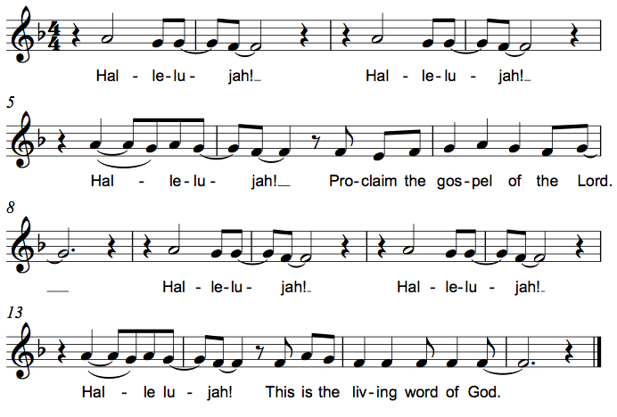

The holy Gospel according to Mark. Glory to you, O Lord.

*Gospel Mark 6:1-13
At home and abroad, Jesus and his disciples encounter resistance as they seek to proclaim God’s word and relieve affliction.

¹[Jesus] came to his hometown, and his disciples followed him.²On the sabbath he began to teach in the synagogue, and many who heard him were astounded. They said, “Where did this man get all this? What is this wisdom that has been given to him? What deeds of power are being done by his hands! ³Is not this the carpenter, the son of Mary and brother of James and Joses and Judas and Simon, and are not his sisters here with us?” And they took offense at him. ⁴Then Jesus said to them, “Prophets are not without honor, except in their hometown, and among their own kin, and in their own house.” ⁵And he could do no deed of power there, except that he laid his hands on a few sick people and cured them. ⁶And he was amazed at their unbelief.
Then he went about among the villages teaching. ⁷He called the twelve and began to send them out two by two, and gave them authority over the unclean spirits. ⁸He ordered them to take nothing for their journey except a staff; no bread, no bag, no money in their belts; ⁹but to wear sandals and not to put on two tunics. ¹⁰He said to them, “Wherever you enter a house, stay there until you leave the place. ¹¹If any place will not welcome you and they refuse to hear you, as you leave, shake off the dust that is on your feet as a testimony against them.” ¹²So they went out and proclaimed that all should repent. ¹³They cast out many demons, and anointed with oil many who were sick and cured them.

The Gospel of the Lord. Praise to you, O Christ. Be seated.

Sermon The Rev. Melody Eastman

*Please stand as you are able.
Hymn of the Day ELW #579 Lord, You Give the Great Commission
sts. 1,5
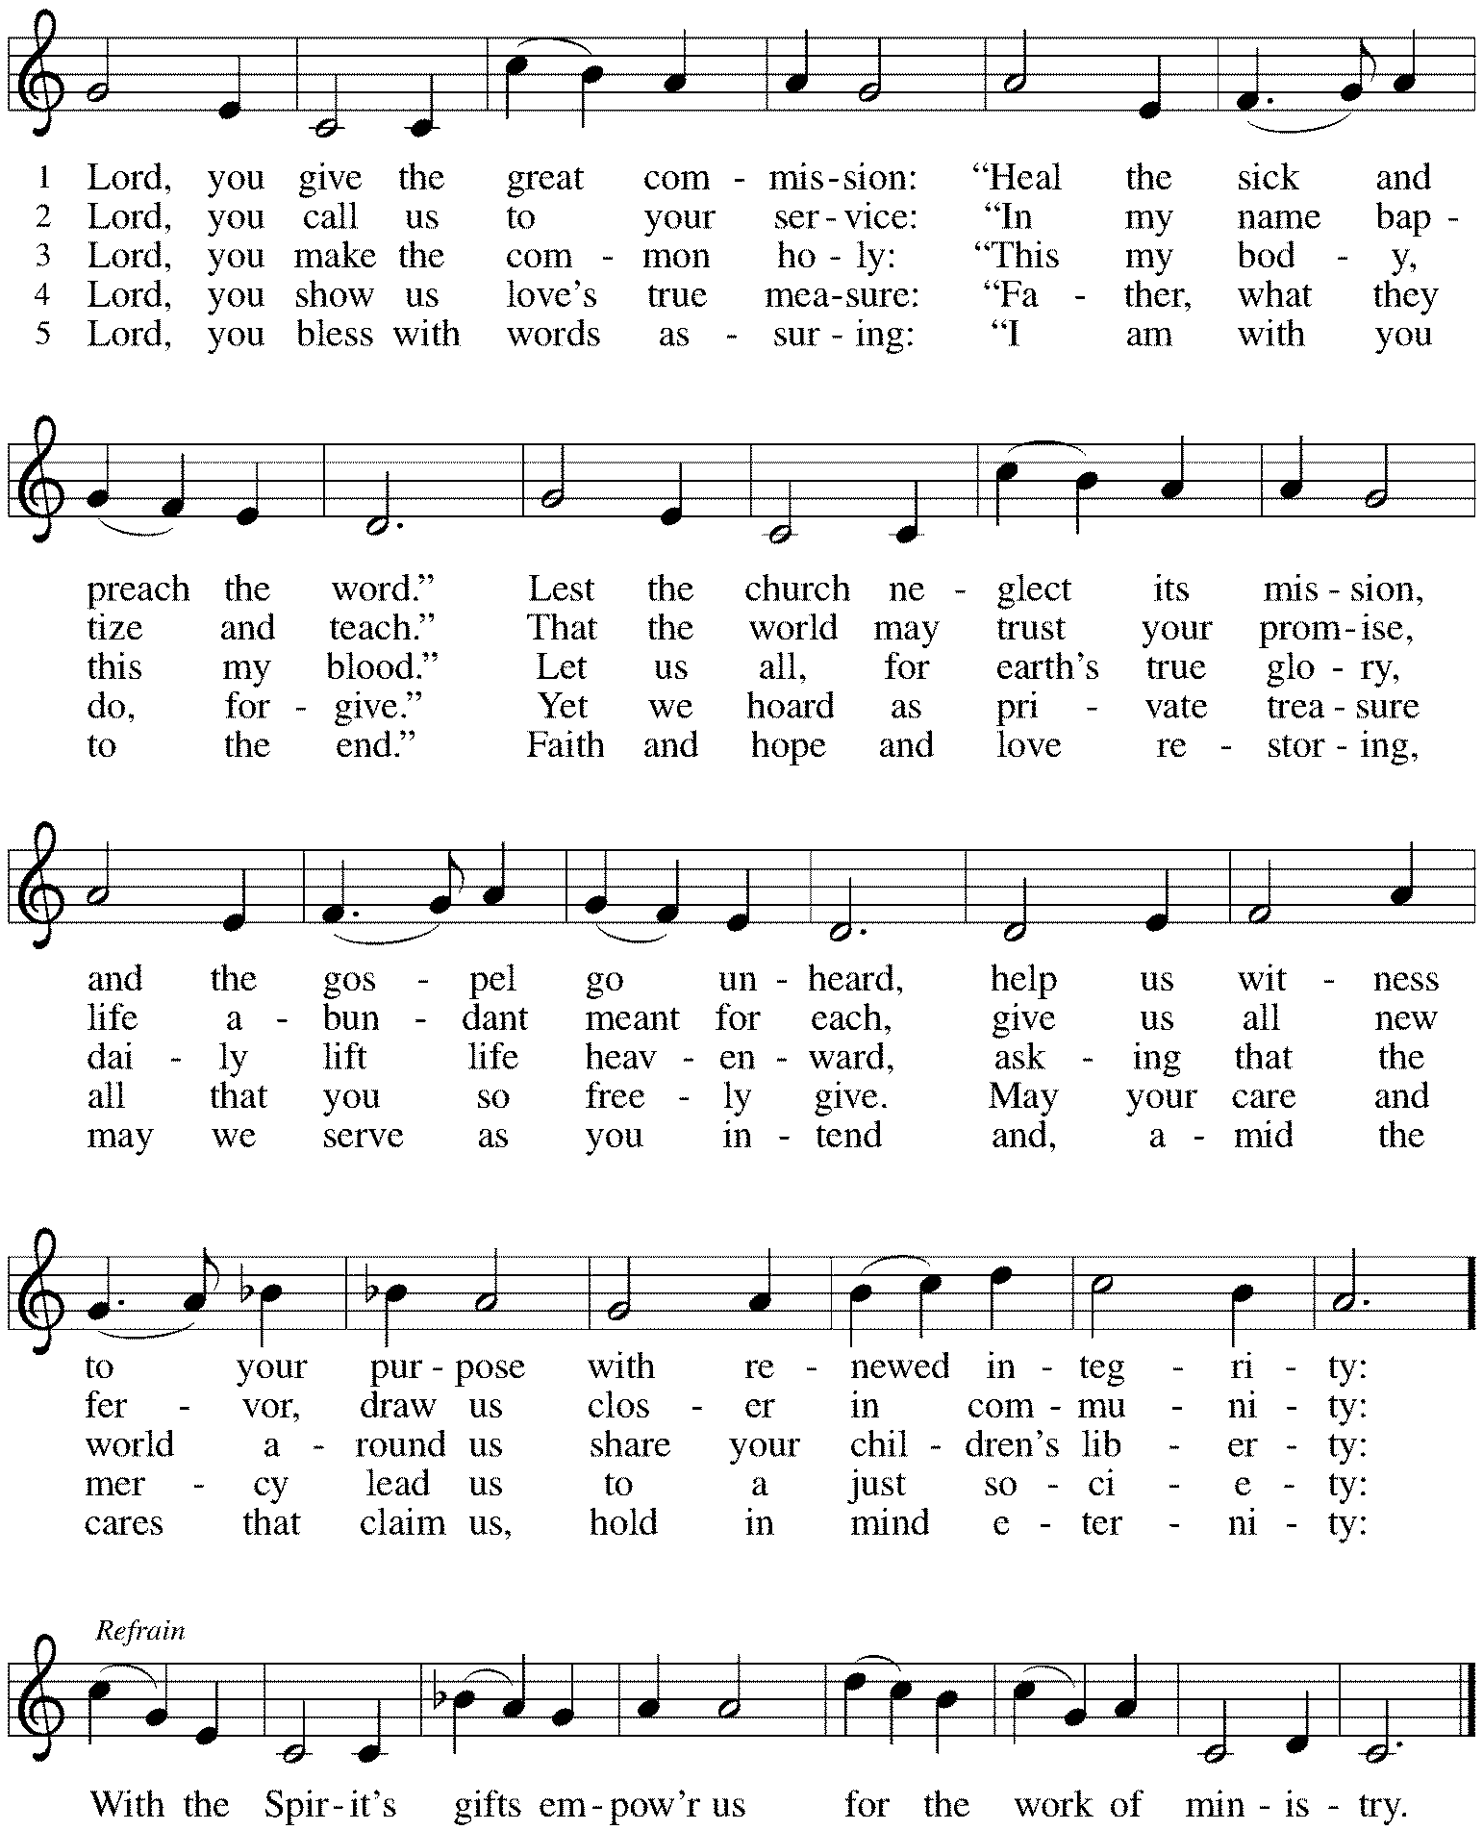
*Prayers of Intercession
Let us come before the triune God in prayer.
A brief silence.

God of all, through the waters of baptism you claim people of all races, ethnicities, and languages as your beloved children. Sustain the baptized and increase their faith, that your gospel may be proclaimed throughout the earth. Lord, in your mercy, hear our prayer.

God of the heavens, your creating Spirit animates the universe. We give you thanks for the moon and stars, for the planets and the Milky Way Galaxy, and for all of the mysteries of the cosmos that remain unknown to us. Lord, in your mercy, hear our prayer.

God of freedom, you have liberated us from sin and death and rescue us from all forms of spiritual, social, and political oppression. Defend us from tyrants in our midst and deliver us from all forms of slavery or corruption. Direct our freedom for works of liberation and wholeness. Lord, in your mercy, hear our prayer.

God of compassion, you became vulnerable in the person of Jesus Christ in solidarity with the disempowered. Strengthen those who feel faint, give courage to those who fear, and bring wholeness to those in need, especially Sandra, Cathy, Bob, Jim, Sigrid, Dorothy, Carol, Dolores, Norma, Dorothy, and those we name before you now. . . Lord, in your mercy, hear our prayer.

God of holiness, you send us out into the world to proclaim your love. We pray for our outreach ministries. Equip us as we leave this place to witness and serve our neighbors. Lord, in your mercy, hear our prayer.

As our nation celebrates our independence and freedoms, we thank you for the many gifts of this country. Help us use our freedoms well. Help us overcome polarization so that our democracy will be strong in the good work that blesses all people. Help us work together in the midst of diversity, using our differences to accomplish what you desire. Strengthen our elected leaders, and give them the vision that brings hope. Lord, in our mercy, hear our prayer.

We give you thanks that in every time and place you call forth prophets who move us towards freedom. Thank you for those who work for human rights, community organizers, and all who strive for liberty for all. Lord, in your mercy, hear our prayer.

We lift our prayers to you, O God, trusting in your abiding grace.
Amen.

*Peace
The peace of Christ be with you always. And also with you.
Please share the peace with others in your household, or by making a sign of peace to those on Zoom. Please remain standing.
Meal
God feeds us with the presence of Jesus Christ.
*Offering Prayer
Jesus, Bread of life, you have set this table with your very self,
and called us to the feast of plenty.
Gather what has been sown among us,
and strengthen us in this meal.
Make us to be what we receive here,
your body for the life of the world.
Amen.

*Great Thanksgiving
The Lord be with you.
And also with you.

Lift up your hearts.
We lift them to the Lord.

Let us give thanks to the Lord our God.
It is right to give our thanks and praise.

*Preface
It is indeed right, our duty and our joy,
that we should at all times and in all places give thanks and praise to you,
almighty and merciful God, through our Savior Jesus Christ;
who on this day overcame death and the grave,
and by his glorious resurrection opened to us the way of everlasting life.
And so, with all the choirs of angels,
with the church on earth and the hosts of heaven,
we praise your name and join their unending hymn:

*Sanctus C. Heine
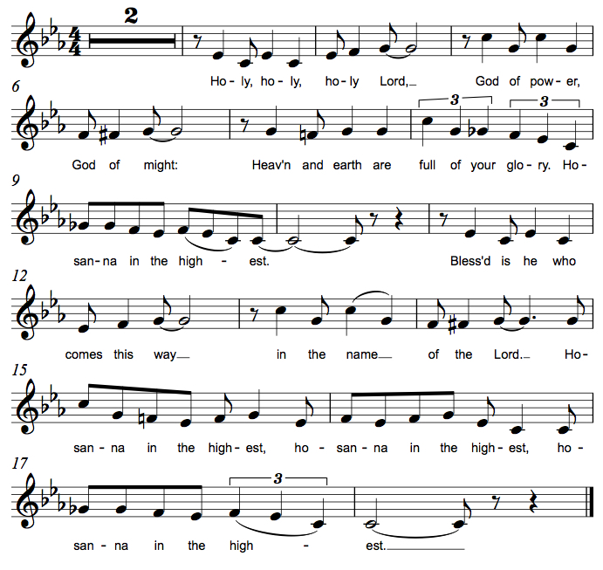

*Thanksgiving at the Table
You are indeed holy, almighty and merciful God.
You are most holy,
and great is the majesty of your glory.

You so loved the world that you gave your only Son,
so that everyone who believes in him may not perish
but have eternal life.

We give you thanks for his coming into the world
to fulfill for us your holy will
and to accomplish all things for our salvation.

In the night in which he was betrayed,
our Lord Jesus took bread, and gave thanks;
broke it, and gave it to his disciples, saying:
Take and eat; this is my body, given for you.
Do this for the remembrance of me.

Again, after supper, he took the cup, gave thanks,
and gave it for all to drink, saying:
This cup is the new covenant in my blood,
shed for you and for all people for the forgiveness of sin.
Do this for the remembrance of me.

For as often as we eat of this bread and drink from this cup,
we proclaim the Lord's death until he comes.
Christ has died. Christ is risen. Christ will come again.

You may hold up your (unopened) communion kit as you are able.

Remembering, therefore, his salutary command,
his life-giving passion and death,
his glorious resurrection and ascension,
and the promise of his coming again,
we give thanks to you, O Lord God Almighty,
not as we ought but as we are able;
we ask you mercifully to accept our praise and thanksgiving
and with your Word and Holy Spirit to bless us, your servants,
and these your own gifts of bread and wine,
so that we and all who share in the body and blood of Christ
may be filled with heavenly blessing and grace,
and, receiving the forgiveness of sin,
may be formed to live as your holy people
and be given our inheritance with all your saints.
You may lower your communion kit.

To you, O God, Father, Son, and Holy Spirit,
be all honor and glory in your holy church, now and forever.
Amen.

*The Lord’s Prayer
Gathered into one by the Holy Spirit, let us pray as Jesus taught us.
Our Father in heaven, hallowed be your name, your kingdom come, your will be done,
on earth as in heaven. Give us today our daily bread. Forgive us our sins as we forgive those who sin against us. Save us from the time of trial and deliver us from evil.
For the kingdom, the power, and the glory are yours, now and forever. Amen.

*Invitation to Communion
Christ has set the table with more than enough for all. Come! Be Seated.

If you have difficulty opening your communion, please signal an usher for assistance.

Peel up the clear top seal over the wafer, and hold the wafer up when you are ready.
This is the Body of Christ, given for you. (Eat the bread.)

Peel up the second foil seal over the juice, and hold your cup up when you are ready.
This is the blood of Christ, shed for you. (Drink the wine/juice.)
Amen.

After communion you may place the packaging in the bowl in your pew. The ushers will dispose of these following the service.

*Please stand as you are able.
*Agnus Dei M.B. Eastman
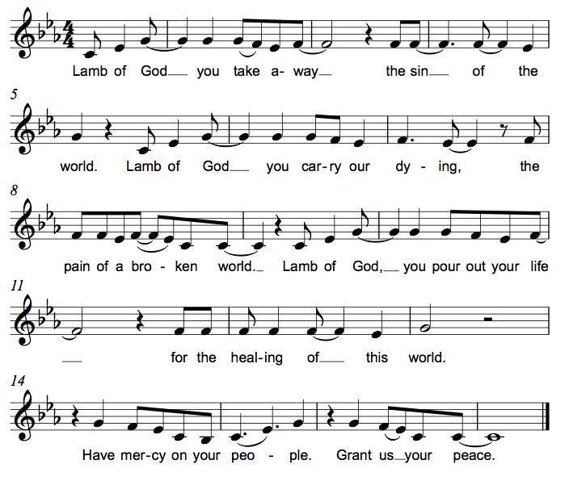

*Post-Communion Blessing
The body and blood of our Lord Jesus Christ strengthen you and keep you in his grace. Amen.

*Prayer after Communion
Jesus, Bread of life, we have received from your table more than we could ever ask. As you have nourished us in this meal, now strengthen us to love the world with your own life. In your name we pray. Amen.
Sending
God blesses us and sends us in mission to the world.
*Blessing
The blessing of God, who provides for us, feeds us, and journeys with us, ☩ be upon you now and forever. Amen.

*Sending Hymn ELW #546 To Be Your Presence
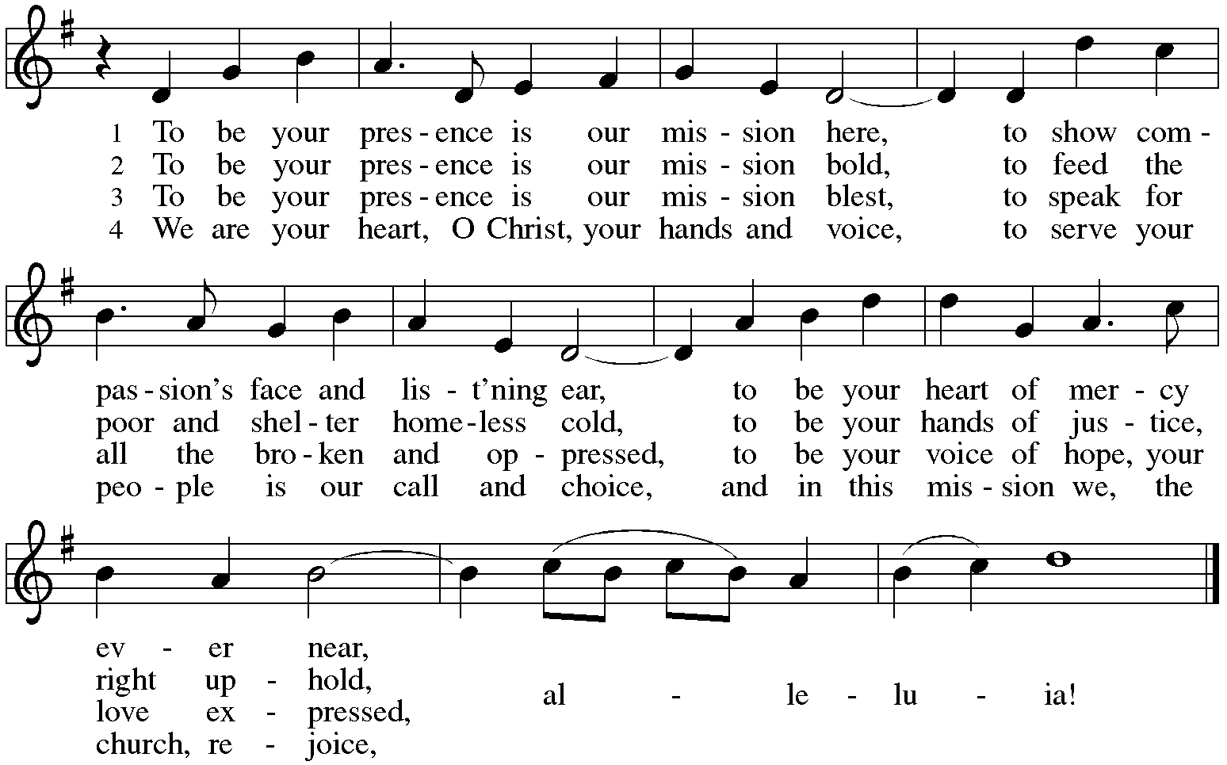

*Sent to the World
Go in peace. You are the body of Christ. Thanks be to God.

Postlude
After the postlude, those who have joined via Zoom may unmute your mics
and share a greeting with your fellow worshippers.

From Sundays and Seasons
v.20190109.1233 Copyright © 2021 Augsburg Fortress. All rights reserved.
Reprinted by permission under Augsburg Fortress Liturgies Annual License #30867.
All rights reserved. Reprinted under OneLicense.net #A-718333.

Assisting in Worship Today
Ministry Associate Becky Ficarella
Minister of Music Bradford Thompson
Lector Heather Graf
Ushers Jeff Berta, Bruce Lantz, Tim Kelly, Open
Altar Flowers

Current Prayer Requests
Please keep these people in your prayers and reach out to our sisters and brothers in Christian love. Names will be left on the list for two weeks, unless you indicate that they should remain in our prayers for a longer period.
Name Relationship Prayer For
Sandra Venturoni Member Healing & Strength
Bob Stein Member Healing & Strength
Jim Sladek Member Healing & Strength
Cathy Milleville Member Healing & Strength
Sigrid Elliott Member Healing & Strength
Dorothy Tracy Member Healing & Strength
Chris Danly Son of Mark & Pat Danly Healing & Strength
Tammy Rollo Friend of Barbara Sudds Healing & Strength
Prayers for our homebound Members
Dolores Nosal, Carol Petersen, Norma Petersen, Dorothy Stein

The church office will be closed the week of July 4.

Christ in Our Home and The Word in Season: Booklets are in the narthex on the slatwall and can be picked up at any time.

August Grace To You: Articles are due to the church office by Friday, July 9, NO EXCUSES! GTY will be sent to LPI for printing on Monday morning, July 12.

Women of Grace: We will meet outdoors at Reserve 22 on July 8 @ 7pm for drinks and dining together. We have 14 seats available for this date. Reserve in the Facebook Group page or contact Becky Ficarella.

Sr. Center Movie and Popcorn: Friday, July 9 from 10-Noon. The movie is “News of the World” with Tom Hanks. Please contact Sue Davison at 630-858-6343 to register.

Saturday Morning Meet Up is July 10 at Lake Ellyn Park 9-11am: Come join Grace families at Lake Ellyn Park for play and fellowship! Friends are always welcome!

Pool Day at Turtle Splash Water Park in West Chicago, Monday July 12, 11:30am (Rain Date July 19): Come join us for a day of pool fun! This is a newer facility that will limit the number of people able to come in each day due to COVID, so please try to arrive as close to 11:30am as possible. It is a first come basis. Admission is $15 per person for non-residents; Grace will split the cost and cover $7.50 per ticket. Please RSVP by July 9th with Becky Ficarella if you would like to attend!

Fusion High School Scavenger Hunt in Wheaton with St. Paul Lutheran Church, Wednesday, July 14, 6pm-8pm: We will meet at St. Paul Lutheran Church, 515 S. Wheaton Avenue in Wheaton. The group will split up on a scavenger hunt into town, finishing with ice cream as we walk back to St. Paul. If it rains, we will reach out with an alternate plan that day, but plan to keep the same time open.
RAMP: Our mortgage reduction campaign has been renamed “RAMP” (Reduce Another Mortgage Payment) as we continue to RAMP up to refinance our mortgage with Mission Investment Fund this Fall. We plan to make a $25,000 payment against principal in July. Thank you to all who have contributed to date. We are still hopeful we can raise another $75,000 before November. Lowering our monthly mortgage payments will free up funds that we can utilize on the ministries of Grace.

Got Capital Gains? Did you know that stock donations allow you to both claim a deduction at the appreciated value AND allow you to avoid capital gains taxes on these assets? Further, consolidating donations in a tax year could lead to increased ability to deduct charitable contributions in a given tax year. Consult your tax advisor for details, but if you’d like more information on how to go about donating stock, reach out to the church office.

COVID Restrictions at Grace: With the increase in the number of people vaccinated and the decrease in the case rate for COVID, we are lifting a few more restrictions for our worship services and building users at Grace Lutheran:
- Fully vaccinated people have the option to wear a mask or not, as you are comfortable. We ask unvaccinated people to continue to wear masks.
- We will allow singing and corporate speaking.
For the time being, we are keeping the following protocols in place for worship:
- We ask that you still sit in every other pew and practice social distancing between household groups, since we have the space.
- We will continue to use the individual communion kits, which you can pick up in the narthex with your bulletin before you enter. We will continue to receive communion in the pews.
- We will not take up the offering, but ask that you leave your offering in the offering box in the narthex.
- We will continue to offer a Zoom link for those who are continuing to participate from home. https://us02web.zoom.us/j/87240509475
Meeting ID: 872 4050 9475
One tap mobile +13126266799,,87240509475#

Circle of Care Coordinator Needed: We are seeking a new individual to fill the role of Circle of Care Coordinator. Sooz Hufnagle was fulfilling this role previously, but is no longer available to serve due to the Hufnagle's relocation to South Carolina this past week.
This role includes managing incoming requests of care from members and then finding the appropriate volunteers to help from a list of willing helpers! Examples might include rides, grocery store runs, or meal drop offs. Please contact the church office or Becky Ficarella if you are interested!

Altar Flowers for Summer Worship Services: Let's get creative and try something fun for the summer! We invite you to sign up in the narthex to provide floral bouquets that you have created. It’s okay if bouquets don’t match or we have only one bouquet on a Sunday! Share from your garden, the farmer's market, or local store and bring them with you Sunday morning! Please sign up in the Narthex, or contact the church office to reserve a date. Please only include flowers and no special decorations or messages in the bouquet. These are the available dates: July 11; July 18; July 25; August 1; August 15; August 22; September 5.

Ushers Needed: Each of our four usher teams are in need of one additional team member. Team 1 (January, May, September); Team 2 (February, June, October); Team 3 (March, July, November; Team 4 (April, August, December). Please contact the church office if you can volunteer for one of these teams or sign up in the Narthex.

In-Person Wednesday Morning 7:30am Bible Study at Grace: All are welcome to participate. Discussion centers on the Gospel for the upcoming Sunday plus other topics of interest. Tim Stephan, Jerry Miller, Sue Pagnoni, Kathy Gallian, and Tim Frakes are regulars with this group meeting in the Narthex at Grace. Please contact the church office if you have any questions.

Contributions to Grace: You may continue to mail your contributions to the church office; have your bank mail your contribution to the church office; or contribute on-line through Grace’s website. Please know, pandemic or no, our mission continues! Thank you for your continued support of our ministries at Grace Lutheran.

Bradford’s Livestream Music Session: Join Bradford for LIVE music sessions broadcast directly from Grace! Let the meditative sounds of drums, guitar, and keyboards heal your woes and soothe your souls. Wednesdays at 7:00pm. Bradford plans to change up the music and include various musicians each week. This is still a work in progress so please be patient with the format tweaks!
Just click on the link Wednesday evening at 7:00pm to join Bradford on his YouTube channel:
https://youtube.com/channel/UCbgfoPipBLAlY3hAkVKoI8Q

Chair Exercise and monthly Book Club. Registration is required as the number of attendees will be limited. The exercise class meets Mondays at 10:00am and Thursdays at 11:00am. The Book Club will meet on the third Tuesday of the month at 11:00am. Please contact Sue Davison at 630-858-6343 to register.

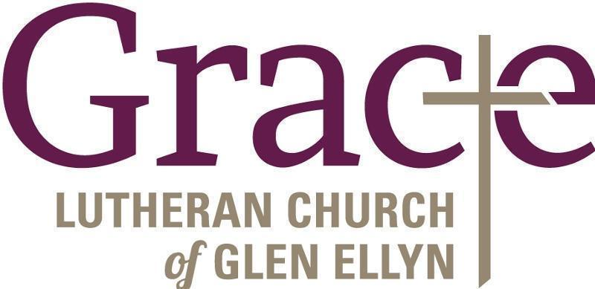

Every Member a Minister and Missionary!

Phone: 630-469-1555 Emergency Pastoral Contact: 630-674-2887
info@graceglenellyn.org www.graceglenellyn.org

Pastor
Rev. Melody Eastman office ext. 14
meastman@graceglenellyn.org

Minister of Music
Bradford Thompson 219-718-8879
bradfordmthompson@gmail.com

Ministry Associate
Becky Ficarella office ext. 17
bficarella@graceglenellyn.org

Office Manager
Barbara Sudds office ext. 10
bsudds@graceglenellyn.org

Parish Counselor
Carole LoGalbo M.S., LCPC 630-668-4594
carolelogalbo@yahoo.com

