Grace Lutheran Church

493 Forest Avenue, Glen Ellyn IL 630.469.1555
www.graceglenellyn.org

7th Sunday after Pentecost July 11, 2021

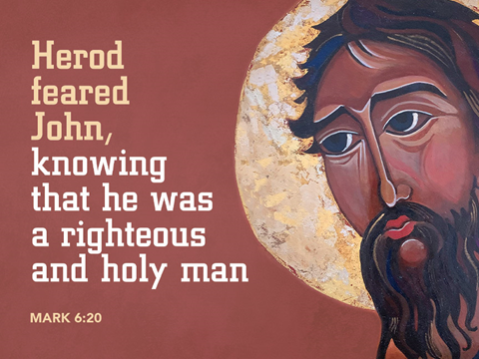

+ Proclaim Christ + Build Community +
+ Serve Our Neighbors +
Introduction
When Amos reports his vision of God judging Israel for its mistreatment of the poor, he becomes a threat to the power of the priests and the king. John the Baptist also speaks truth to power, and Herod has him killed. In Herod’s fear that Jesus is John returned from the dead, we may hear hope for the oppressed: all the prophets killed through the ages are alive in Jesus. We are called to witness to justice in company with them, and to proclaim God’s saving love.

Gathering
The Holy Spirit calls us together as the people of God.
Welcome/Announcements
Helpful Reminders for those joining via Zoom:
- The host will mute you when you join, and you will remain muted until the end of the service.
- You are welcome to join in all congregation responses (in Bold black.) and hymns.
- At the end of the service you may unmute your mic to share greetings with your fellow worshippers. If you dialed in on the phone, press *6. Remember, your host cannot unmute you.

Helpful Reminders for those joining in person:
- Maintain 6’ distance between family groups
- Remain in your pews for communion.
- You may place your offering in the box in the narthex.

Prelude

*Please stand as you are able and turn to face the font.
*Confession and Forgiveness
All may make the sign of the cross, the sign marked at baptism, as the presiding minister begins.
Blessed be the holy Trinity,☩ one God, the God of manna, the God of miracles, the God of mercy. Amen.

Drawn to Christ and seeking God’s abundance, let us confess our sin.
Silence is kept for reflection.

God, our provider, help us. It is hard to believe there is enough to share. We question your ways when they differ from the ways of the world in which we live. We turn to our own understanding rather than trusting in you. We take offense at your teachings and your ways.
Turn us again to you. Where else can we turn? Share with us the words of eternal life and feed us for life in the world. Amen.
Beloved people of God: in Jesus, the manna from heaven, you are fed and nourished. By Jesus, the worker of miracles, there is always more than enough. Through Jesus, ☩ the bread of life, you are shown God’s mercy: you are forgiven and loved into abundant life. Amen.

*Entrance Hymn ELW #697 Just a Closer Walk with Thee
sts. 1,2
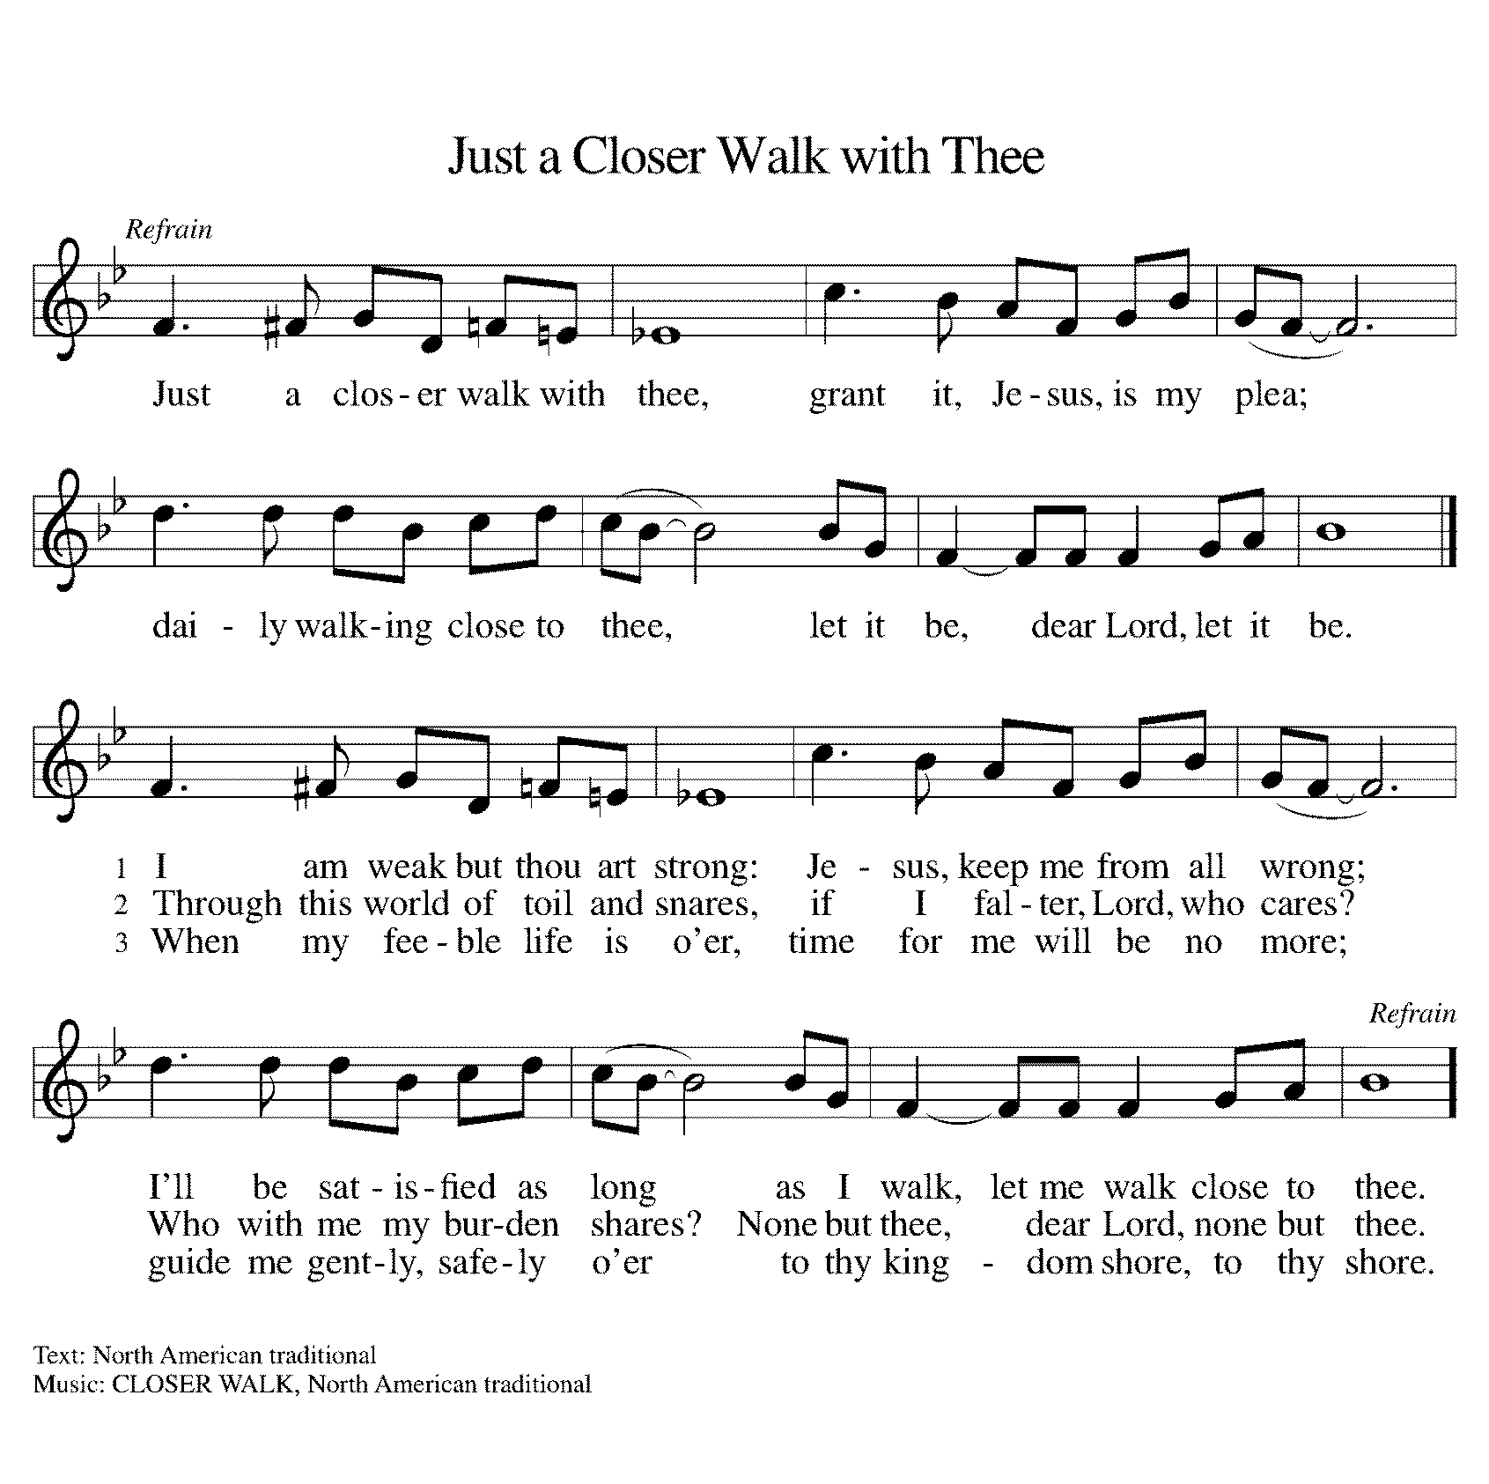

*Greeting
The grace of our Lord Jesus Christ, the love of God, and the communion of the Holy Spirit be with you all. And also with you.

*Hymn of Praise This is the Feast (from Mass for Immanuel, Singing in Community)
The congregation sings the refrain, the cantor sings the stanzas.
The cantor will introduce the refrain the first time through.
At the end of each stanza, the congregation repeats the “Alleluia” after the cantor.

Refrain: This is the feast of vict’ry for our God. Alleluia, alleluia.
Worthy is Christ, the Lamb who was slain,
whose blood set us free to be people of God. Alleluia. Alleluia.
Refrain
Power, riches, wisdom, and strength, and honor, blessing and glory are his. Alleluia. Alleluia.
Refrain
Sing with all the people of God, and join in the hymn of all creation. Alleluia. Alleluia.
Refrain
Blessing, honor, glory and might be to God and the Lamb forever, amen. Alleluia. Alleluia.
Refrain
For the Lamb who was slain has begun his reign. Amen. Alleluia. Alleluia!
Refrain

*Prayer of the Day
O God, from you come all holy desires, all good counsels, and all just works. Give to us, your servants, that peace which the world cannot give, that our hearts may be set to obey your commandments; and also that we, being defended from the fear of our enemies, may live in peace and quietness, through Jesus Christ, our Savior and Lord. Amen. Be seated.

Word
God speaks to us in scripture reading, preaching, and song.
First Lesson Amos 7:7-15
Amos is not the kind of prophet attached to temples or royal courts. Rather, he is an ordinary farmer from Judah (the southern kingdom) called by God to speak to Israel (the northern kingdom). God’s word of judgment through Amos conflicts with the king’s court prophet Amaziah, whom Amos encounters at Bethel.

⁷This is what [the Lord God] showed me: the Lord was standing beside a wall built with a plumb line, with a plumb line in his hand. ⁸And the Lord said to me, “Amos, what do you see?” And I said, “A plumb line.” Then the Lord said, “See, I am setting a plumb line in the midst of my people Israel; I will never again pass them by; ⁹the high places of Isaac shall be made desolate, and the sanctuaries of Israel shall be laid waste, and I will rise against the house of Jeroboam with the sword.” ¹⁰Then Amaziah, the priest of Bethel, sent to King Jeroboam of Israel, saying, “Amos has conspired against you in the very center of the house of Israel; the land is not able to bear all his words. ¹¹For thus Amos has said, ‘Jeroboam shall die by the sword, and Israel must go into exile away from his land.’ ”
¹²And Amaziah said to Amos, “O seer, go, flee away to the land of Judah, earn your bread there, and prophesy there; ¹³but never again prophesy at Bethel, for it is the king’s sanctuary, and it is a temple of the kingdom.”
¹⁴Then Amos answered Amaziah, “I am no prophet, nor a prophet’s son; but I am a herdsman, and a dresser of sycamore trees, ¹⁵and the Lord took me from following the flock, and the Lord said to me, ‘Go, prophesy to my people Israel.’ ”

Word of God, Word of Life. Thanks be to God.

Psalm Psalm 85:8-13
I will listen to what the Lord God is saying. (Ps. 85:8)

⁸I will listen to what the Lord God is saying; for you speak peace to your faithful people and to those who turn their hearts to you.
⁹Truly, your salvation is very near to those who fear you, that your glory may dwell in our land.
¹⁰Steadfast love and faithfulness have met together; righteousness and peace have kissed each other.
¹¹Faithfulness shall spring up from the earth, and righteousness shall look down from heaven.
¹²The Lord will indeed grant prosperity, and our land will yield its increase.
¹³Righteousness shall go before the Lord and shall prepare for God a pathway.

Second Lesson Ephesians 1:3-14
In Jesus, all of God’s plans and purposes have been made known as heaven and earth are united in Christ. Through Jesus, we have been chosen as God’s children and have been promised eternal salvation.

³Blessed be the God and Father of our Lord Jesus Christ, who has blessed us in Christ with every spiritual blessing in the heavenly places, ⁴just as he chose us in Christ before the foundation of the world to be holy and blameless before him in love. ⁵He destined us for adoption as his children through Jesus Christ, according to the good pleasure of his will, ⁶to the praise of his glorious grace that he freely bestowed on us in the Beloved. ⁷In him we have redemption through his blood, the forgiveness of our trespasses, according to the riches of his grace ⁸that he lavished on us. With all wisdom and insight ⁹he has made known to us the mystery of his will, according to his good pleasure that he set forth in Christ, ¹⁰as a plan for the fullness of time, to gather up all things in him, things in heaven and things on earth. ¹¹In Christ we have also obtained an inheritance, having been destined according to the purpose of him who accomplishes all things according to his counsel and will, ¹²so that we, who were the first to set our hope on Christ, might live for the praise of his glory. ¹³In him you also, when you had heard the word of truth, the gospel of your salvation, and had believed in him, were marked with the seal of the promised Holy Spirit; ¹⁴this is the pledge of our inheritance toward redemption as God’s own people, to the praise of his glory.

Word of God, Word of Life. Thanks be to God.

*Please stand as you are able.
*Gospel Acclamation C. Heine
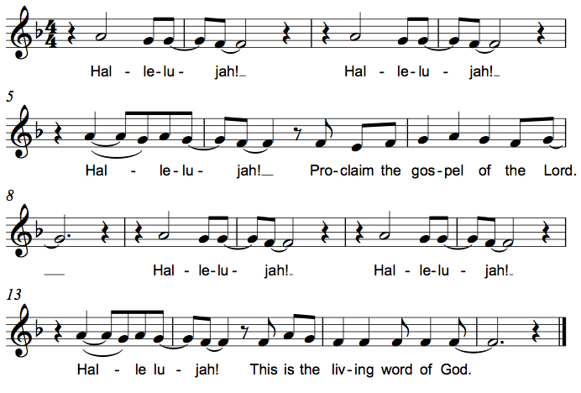

The holy Gospel according to Mark. Glory to you, O Lord.

*Gospel Mark 6:14-29
As Jesus and his disciples begin to attract attention, Mark recalls the story of John the Baptist’s martyrdom. Like John, Jesus and his disciples will also suffer at the hands of those opposed to the gospel of salvation.

¹⁴King Herod heard of [the disciples’ preaching,] for Jesus’ name had become known. Some were saying, “John the baptizer has been raised from the dead; and for this reason these powers are at work in him.” ¹⁵But others said, “It is Elijah.” And others said, “It is a prophet, like one of the prophets of old.” ¹⁶But when Herod heard of it, he said, “John, whom I beheaded, has been raised.”
¹⁷For Herod himself had sent men who arrested John, bound him, and put him in prison on account of Herodias, his brother Philip’s wife, because Herod had married her. ¹⁸For John had been telling Herod, “It is not lawful for you to have your brother’s wife.” ¹⁹And Herodias had a grudge against him, and wanted to kill him. But she could not, ²⁰for Herod feared John, knowing that he was a righteous and holy man, and he protected him. When he heard him, he was greatly perplexed; and yet he liked to listen to him. ²¹But an opportunity came when Herod on his birthday gave a banquet for his courtiers and officers and for the leaders of Galilee. ²²When his daughter Herodias came in and danced, she pleased Herod and his guests; and the king said to the girl, “Ask me for whatever you wish, and I will give it.” ²³And he solemnly swore to her, “Whatever you ask me, I will give you, even half of my kingdom.” ²⁴She went out and said to her mother, “What should I ask for?” She replied, “The head of John the baptizer.” ²⁵Immediately she rushed back to the king and requested, “I want you to give me at once the head of John the Baptist on a platter.” ²⁶The king was deeply grieved; yet out of regard for his oaths and for the guests, he did not want to refuse her. ²⁷Immediately the king sent a soldier of the guard with orders to bring John’s head. He went and beheaded him in the prison, ²⁸brought his head on a platter, and gave it to the girl. Then the girl gave it to her mother. ²⁹When his disciples heard about it, they came and took his body, and laid it in a tomb.

The Gospel of the Lord. Praise to you, O Christ. Be seated.

Sermon The Rev. Melody Eastman

*Please stand as you are able.
Hymn of the Day ELW #513 Listen, God Is Calling
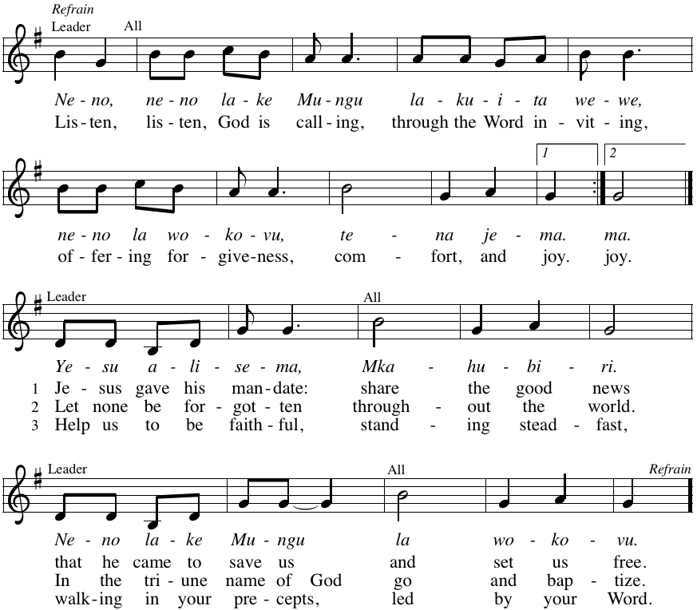

*Prayers of Intercession
Let us come before the triune God in prayer.
A brief silence.

Holy Parent, you welcome your people into one family and gather all things to yourself. Bestow your grace upon your beloved church, lavish your wisdom upon us, and redeem us from our faults, that by our witness all might praise your glory. Lord, in your mercy, hear our prayer.

Awesome Creator, you steadfastly tend to the smallest of seeds and the mightiest of sycamore trees. Spring up green growth from the earth, nourish the growth of fruit, grain, and other crops, and bless the work of farmers and laborers. Lord, in your mercy, hear our prayer.

God of the oppressed, turn the ears of those who are in power to the voices of prophets in our own day. Protect those who speak difficult truths when it is risky to do so. Lord, in your mercy, hear our prayer.

God of strength, you are near to those who endure difficulty. Comfort all who are survivors of violence, guard the refugee and the immigrant, and protect all those who are victims of prejudice and discrimination. Lord, in your mercy, hear our prayer.

God of love, we pray for this holy house and all those who worship here. We pray especially for those whose efforts behind the scenes often go unnoticed; for the custodians and maintenance workers, for our office staff, and for all of our volunteers. Lord, in your mercy,
hear our prayer.
Here other intercessions may be offered.

We thank you, God, for the saints, martyrs, and prophets who have died in the faith. We remember those in this community who have recently died. United with them as God’s children, assure us that we are yours forever. Lord, in your mercy, hear our prayer.

We lift our prayers to you, O God, trusting in your abiding grace. Amen.

*Peace
The peace of Christ be with you always. And also with you.
Please share the peace with others in your household, or by making a sign of peace to those on Zoom. Please remain standing.

Meal
God feeds us with the presence of Jesus Christ.
*Offering Prayer
Jesus, Bread of life, you have set this table with your very self, and called us to the feast of plenty. Gather what has been sown among us, and strengthen us in this meal. Make us to be what we receive here, your body for the life of the world. Amen.

*Great Thanksgiving
The Lord be with you.
And also with you.
Lift up your hearts.
We lift them to the Lord.
Let us give thanks to the Lord our God.
It is right to give our thanks and praise.

*Preface
. . . And so, with all the choirs of angels, with the church on earth and the hosts of heaven,
we praise your name and join their unending hymn:

*Sanctus C. Heine
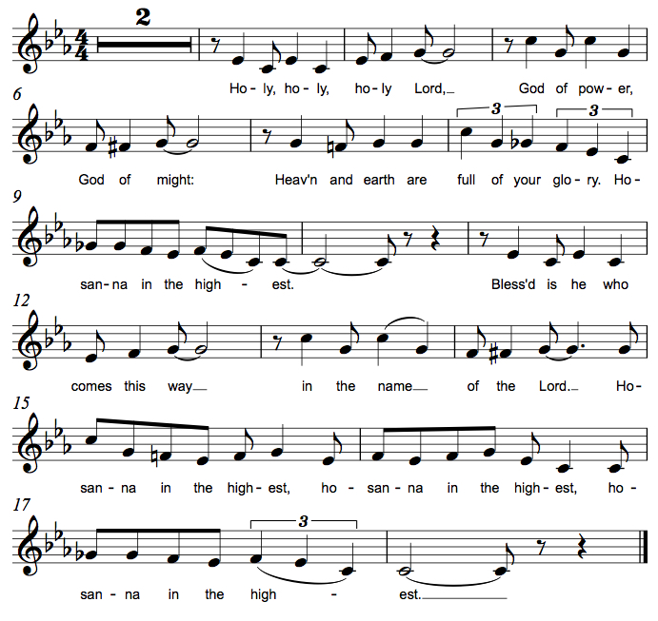

*Thanksgiving at the Table
. . . For as often as we eat of this bread and drink from this cup,
we proclaim the Lord's death until he comes.
Christ has died. Christ is risen. Christ will come again.

You may hold up your (unopened) communion kit as you are able.
Remembering, therefore, his salutary command, his life-giving passion and death, his glorious resurrection and ascension, and the promise of his coming again, we give thanks to you, O Lord God Almighty, not as we ought but as we are able; we ask you mercifully to accept our praise and thanksgiving and with your Word and Holy Spirit to bless us, your servants, and these your own gifts of bread and wine, so that we and all who share in the body and blood of Christ may be filled with heavenly blessing and grace, and, receiving the forgiveness of sin, may be formed to live as your holy people and be given our inheritance with all your saints.
You may lower your communion kit.

To you, O God, Father, Son, and Holy Spirit, be all honor and glory in your holy church, now and forever. Amen.

*The Lord’s Prayer
Gathered into one by the Holy Spirit, let us pray as Jesus taught us.
Our Father in heaven, hallowed be your name, your kingdom come, your will be done, on earth as in heaven. Give us today our daily bread. Forgive us our sins as we forgive those who sin against us. Save us from the time of trial and deliver us from evil. For the kingdom, the power, and the glory are yours, now and forever. Amen.

*Invitation to Communion
Christ has set the table with more than enough for all. Come! Be Seated.

If you have difficulty opening your communion, please signal an usher for assistance.

Peel up the clear top seal over the wafer, and hold the wafer up when you are ready.
This is the Body of Christ, given for you. (Eat the bread.)

Peel up the second foil seal over the juice, and hold your cup up when you are ready.
This is the blood of Christ, shed for you. (Drink the wine/juice.)
Amen.

Agnus Dei M.B. Eastman
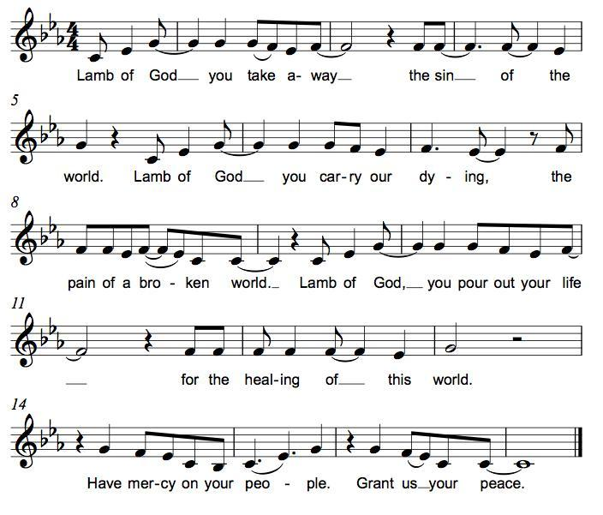

*Please stand as you are able.
*Post-Communion Blessing
The body and blood of our Lord Jesus Christ strengthen you and keep you in his grace. Amen.

*Prayer after Communion
Jesus, Bread of life, we have received from your table more than we could ever ask. As you have nourished us in this meal, now strengthen us to love the world with your own life. In your name we pray. Amen.

Sending
God blesses us and sends us in mission to the world.
*Blessing
The blessing of God, who provides for us, feeds us, and journeys with us, ☩ be upon you now and forever. Amen.

*Sending Hymn ELW #771 God, Who Stretched the Spangled Heavens
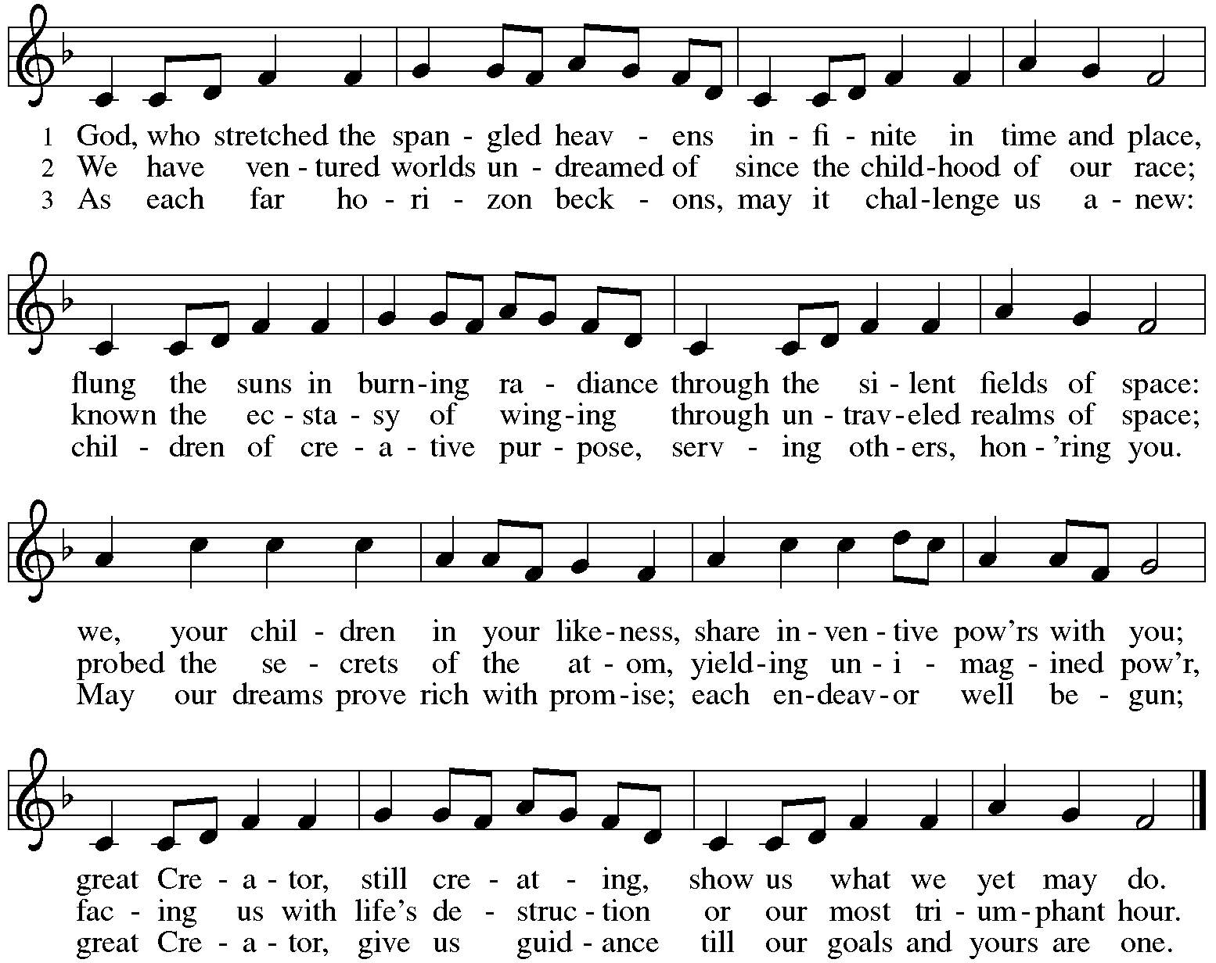

*Sent to the World
Go in peace. You are the body of Christ. Thanks be to God.

Postlude
After the postlude, those who have joined via Zoom may unmute your mics
and share a greeting with your fellow worshippers.

From Sundays and Seasons
v.20190109.1233 Copyright © 2021 Augsburg Fortress. All rights reserved.
Reprinted by permission under Augsburg Fortress Liturgies Annual License #30867.
All rights reserved. Reprinted under OneLicense.net #A-718333.

Assisting in Worship Today
Ministry Associate Becky Ficarella
Minister of Music Bradford Thompson
Lector Rob Granner
Ushers Jeff Berta, Bruce Lantz, Tim Kelly, Open
Altar Flowers

Current Prayer Requests
Name Relationship Prayer For
Sandra Venturoni Member Healing & Strength
Bob Stein Member Healing & Strength
Jim Sladek Member Healing & Strength
Cathy Milleville Member Healing & Strength
Sigrid Elliott Member Healing & Strength
Dorothy Tracy Member Healing & Strength
Chris Danly Son of Mark & Pat Danly Healing & Strength
Tammy Rollo Friend of Barbara Sudds Healing & Strength
Prayers for our homebound Members
Dolores Nosal, Carol Petersen, Norma Petersen, Dorothy Stein

The church office will be closed the week of July 18.

Christ in Our Home and The Word in Season: Booklets are in the narthex on the slatwall and can be picked up at any time.

Pool Day at Turtle Splash Water Park in West Chicago, Monday July 12, 11:30am (Rain Date July 19): Come join us for a day of pool fun! This is a newer facility that will limit the number of people able to come in each day due to COVID, so please try to arrive as close to 11:30am as possible. It is a first come basis. Admission is $15 per person for non-residents; Grace will split the cost and cover $7.50 per ticket. Please RSVP by July 9th with Becky Ficarella if you would like to attend!
Fusion High School Scavenger Hunt in Wheaton with St. Paul Lutheran Church, Wednesday, July 14, 6pm-8pm: We will meet at St. Paul Lutheran Church, 515 S. Wheaton Avenue in Wheaton. The group will split up on a scavenger hunt into town, finishing with ice cream as we walk back to St. Paul. If it rains, we will reach out with an alternate plan that day, but plan to keep the same time open.

RAMP: Our mortgage reduction campaign has been renamed “RAMP” (Reduce Another Mortgage Payment) as we continue to RAMP up to refinance our mortgage with Mission Investment Fund this Fall. We plan to make a $25,000 payment against principal in July. Thank you to all who have contributed to date. We are still hopeful we can raise another $75,000 before November. Lowering our monthly mortgage payments will free up funds that we can utilize on the ministries of Grace.

Got Capital Gains? Did you know that stock donations allow you to both claim a deduction at the appreciated value AND allow you to avoid capital gains taxes on these assets? Further, consolidating donations in a tax year could lead to increased ability to deduct charitable contributions in a given tax year. Consult your tax advisor for details, but if you’d like more information on how to go about donating stock, reach out to the church office.

COVID Restrictions at Grace: With the increase in the number of people vaccinated and the decrease in the case rate for COVID, we are lifting a few more restrictions for our worship services and building users at Grace Lutheran:
- Fully vaccinated people have the option to wear a mask or not, as you are comfortable. We ask unvaccinated people to continue to wear masks.
- We will allow singing and corporate speaking.
For the time being, we are keeping the following protocols in place for worship:
- We ask that you still sit in every other pew and practice social distancing between household groups, since we have the space.
- We will continue to use the individual communion kits, which you can pick up in the narthex with your bulletin before you enter. We will continue to receive communion in the pews.
- We will not take up the offering, but ask that you leave your offering in the offering box in the narthex.
- We will continue to offer a Zoom link for those who are continuing to participate from home. https://us02web.zoom.us/j/87240509475
Meeting ID: 872 4050 9475
One tap mobile +13126266799,,87240509475#

Circle of Care Coordinator Needed: We are seeking a new individual to fill the role of Circle of Care Coordinator. Sooz Hufnagle was fulfilling this role previously, but is no longer available to serve due to the Hufnagle's relocation to South Carolina this past week.
This role includes managing incoming requests of care from members and then finding the appropriate volunteers to help from a list of willing helpers! Examples might include rides, grocery store runs, or meal drop offs. Please contact the church office or Becky Ficarella if you are interested!

Altar Flowers for Summer Worship Services: Let's get creative and try something fun for the summer! We invite you to sign up in the narthex to provide floral bouquets that you have created. It’s okay if bouquets don’t match or we have only one bouquet on a Sunday! Share from your garden, the farmer's market, or local store and bring them with you Sunday morning! Please sign up in the Narthex, or contact the church office to reserve a date. Please only include flowers and no special decorations or messages in the bouquet. These are the available dates: July 11; July 18; July 25; August 1; August 15; August 22; September 5.

Ushers Needed: Each of our four usher teams are in need of one additional team member. Team 1 (January, May, September); Team 2 (February, June, October); Team 3 (March, July, November; Team 4 (April, August, December). Please contact the church office if you can volunteer for one of these teams or sign up in the Narthex.

In-Person Wednesday Morning 7:30am Bible Study at Grace: All are welcome to participate. Discussion centers on the Gospel for the upcoming Sunday plus other topics of interest. Tim Stephan, Jerry Miller, Sue Pagnoni, Kathy Gallian, and Tim Frakes are regulars with this group meeting in the Narthex at Grace. Please contact the church office if you have any questions.

Contributions to Grace: You may continue to mail your contributions to the church office; have your bank mail your contribution to the church office; or contribute on-line through Grace’s website. Please know, pandemic or no, our mission continues! Thank you for your continued support of our ministries at Grace Lutheran.

Bradford’s Livestream Music Session: Join Bradford for LIVE music sessions broadcast directly from Grace! Let the meditative sounds of drums, guitar, and keyboards heal your woes and soothe your souls. Wednesdays at 7:00pm. Bradford plans to change up the music and include various musicians each week. This is still a work in progress so please be patient with the format tweaks!
Just click on the link Wednesday evening at 7:00pm to join Bradford on his YouTube channel:
https://youtube.com/channel/UCbgfoPipBLAlY3hAkVKoI8Q

Every Member a Minister and Missionary!

Phone: 630-469-1555 Emergency Pastoral Contact: 630-674-2887
info@graceglenellyn.org www.graceglenellyn.org

Pastor
Rev. Melody Eastman office ext. 14
meastman@graceglenellyn.org

Minister of Music
Bradford Thompson 219-718-8879
bradfordmthompson@gmail.com

Ministry Associate
Becky Ficarella office ext. 17
bficarella@graceglenellyn.org

Office Manager
Barbara Sudds office ext. 10
bsudds@graceglenellyn.org

Parish Counselor
Carole LoGalbo M.S., LCPC 630-668-4594
carolelogalbo@yahoo.com

