Grace Lutheran Church

493 Forest Avenue, Glen Ellyn IL 630.469.1555
www.graceglenellyn.org

8th Sunday after Pentecost July 18, 2021

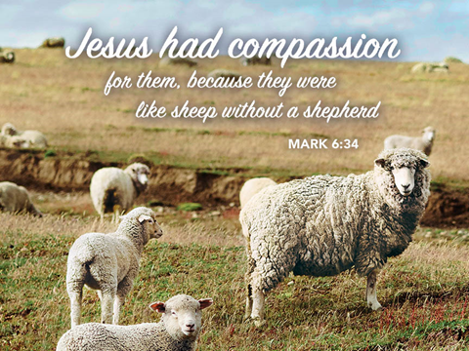

+ Proclaim Christ + Build Community +
+ Serve Our Neighbors +

Introduction
Mark’s gospel makes clear how great is the press of the crowd, with its countless needs to be met, on Jesus and his disciples. Yet in today’s gospel Jesus advises his disciples to get away and rest, to take care of themselves. Sometimes we think that when others are in great need we shouldn’t think of ourselves at all; but Jesus also honors the caregivers’ need. We are sent from Christ’s table to care for others and for ourselves.

Gathering
The Holy Spirit calls us together as the people of God.
Welcome/Announcements
Helpful Reminders for those joining via Zoom:
- The host will mute you when you join, and you will remain muted until the end of the service.
- You are welcome to join in all congregation responses (in Bold black.) and hymns.
- At the end of the service you may unmute your mic to share greetings with your fellow worshippers. If you dialed in on the phone, press *6. Remember, your host cannot unmute you.

Helpful Reminders for those joining in person:
- Maintain 6’ distance between family groups
- Remain in your pews for communion.
- You may place your offering in the box in the narthex.

Prelude

*Please stand as you are able and turn to face the font.
*Confession and Forgiveness
All may make the sign of the cross, the sign marked at baptism, as the presiding minister begins.
Blessed be the holy Trinity,☩ one God, the God of manna, the God of miracles, the God of mercy. Amen.

Drawn to Christ and seeking God’s abundance, let us confess our sin.
Silence is kept for reflection.

God, our provider, help us. It is hard to believe there is enough to share. We question your ways when they differ from the ways of the world in which we live. We turn to our own understanding rather than trusting in you. We take offense at your teachings and your ways. Turn us again to you. Where else can we turn? Share with us the words of eternal life and feed us for life in the world. Amen.

Beloved people of God: in Jesus, the manna from heaven, you are fed and nourished. By Jesus, the worker of miracles, there is always more than enough. Through Jesus, ☩ the bread of life, you are shown God’s mercy: you are forgiven and loved into abundant life. Amen.

*Entrance Hymn ELW #611 I Heard the Voice of Jesus Say

*Greeting
The grace of our Lord Jesus Christ, the love of God, and the communion of the Holy Spirit be with you all. And also with you.

*Hymn of Praise This is the Feast (from Mass for Immanuel, Singing in Community)
The congregation sings the refrain, the cantor sings the stanzas.
The cantor will introduce the refrain the first time through.
At the end of each stanza, the congregation repeats the “Alleluia” after the cantor.
Refrain: This is the feast of vict’ry for our God. Alleluia, alleluia.
Worthy is Christ, the Lamb who was slain,
whose blood set us free to be people of God. Alleluia. Alleluia.
Refrain
Power, riches, wisdom, and strength, and honor, blessing and glory are his. Alleluia. Alleluia.
Refrain
Sing with all the people of God, and join in the hymn of all creation. Alleluia. Alleluia.
Refrain
Blessing, honor, glory and might be to God and the Lamb forever, amen. Alleluia. Alleluia.
Refrain
For the Lamb who was slain has begun his reign. Amen. Alleluia. Alleluia!
Refrain
*Prayer of the Day
O God, powerful and compassionate, you shepherd your people, faithfully feeding and protecting us. Heal each of us, and make us a whole people, that we may embody the justice and peace of your Son, Jesus Christ, our Savior and Lord. Amen. Be seated.

Word
God speaks to us in scripture reading, preaching, and song.
First Lesson Jeremiah 23:1-6
Jeremiah prophesied before the exile in 587 BCE. In this passage, he uses the metaphor of a shepherd to describe the bad kings who have scattered the “flock” of Israel. God promises to gather the flock and to raise up a new king from David’s line to save Israel and Judah.

¹Woe to the shepherds who destroy and scatter the sheep of my pasture! says the Lord. ²Therefore thus says the Lord, the God of Israel, concerning the shepherds who shepherd my people: It is you who have scattered my flock, and have driven them away, and you have not attended to them. So I will attend to you for your evil doings, says the Lord. ³Then I myself will gather the remnant of my flock out of all the lands where I have driven them, and I will bring them back to their fold, and they shall be fruitful and multiply. ⁴I will raise up shepherds over them who will shepherd them, and they shall not fear any longer, or be dismayed, nor shall any be missing, says the Lord.
⁵The days are surely coming, says the Lord, when I will raise up for David a righteous Branch, and he shall reign as king and deal wisely, and shall execute justice and righteousness in the land. ⁶In his days Judah will be saved and Israel will live in safety. And this is the name by which he will be called: “The Lord is our righteousness.”

Word of God, Word of Life. Thanks be to God.

Psalm Psalm 23
The Lord is my shepherd; I shall not be in want. (Ps. 23:1)

¹The Lord is my shepherd; I shall not be in want.
²The Lord makes me lie down in green pastures and leads me beside still waters.
³You restore my soul, O Lord, and guide me along right pathways for your name’s sake.
⁴Though I walk through the valley of the shadow of death, I shall fear no evil; for you are with me; your rod and your staff, they comfort me.
⁵You prepare a table before me in the presence of my enemies; you anoint my head with oil, and my cup is running over.
⁶Surely goodness and mercy shall follow me all the days of my life, and I will dwell in the house of the Lord forever.

Second Lesson Ephesians 2:11-22
The author of this letter reminds his audience that originally they were not part of God’s chosen people. Through Jesus’ death, however, they are included in God’s household of faith, whose cornerstone is Jesus Christ.

¹¹Remember that at one time you Gentiles by birth, called “the uncircumcision” by those who are called “the circumcision”—a physical circumcision made in the flesh by human hands—¹²remember that you were at that time without Christ, being aliens from the commonwealth of Israel, and strangers to the covenants of promise, having no hope and without God in the world. ¹³But now in Christ Jesus you who once were far off have been brought near by the blood of Christ. ¹⁴For he is our peace; in his flesh he has made both groups into one and has broken down the dividing wall, that is, the hostility between us. ¹⁵He has abolished the law with its commandments and ordinances, that he might create in himself one new humanity in place of the two, thus making peace, ¹⁶and might reconcile both groups to God in one body through the cross, thus putting to death that hostility through it. ¹⁷So he came and proclaimed peace to you who were far off and peace to those who were near; ¹⁸for through him both of us have access in one Spirit to the Father. ¹⁹So then you are no longer strangers and aliens, but you are citizens with the saints and also members of the household of God, ²⁰built upon the foundation of the apostles and prophets, with Christ Jesus himself as the cornerstone. ²¹In him the whole structure is joined together and grows into a holy temple in the Lord; ²²in whom you also are built together spiritually into a dwelling place for God.

Word of God, Word of Life. Thanks be to God.

*Please stand as you are able.
*Gospel Acclamation C. Heine
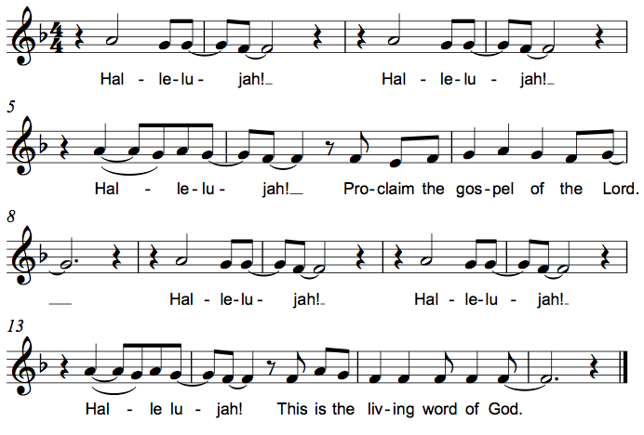

The holy Gospel according to Mark. Glory to you, O Lord.

*Gospel Mark 6:30-34, 53-56
When Jesus sends his disciples out to teach and heal, they minister among large numbers of people. Their work is motivated by Christ’s desire to be among those in need.

³⁰The apostles gathered around Jesus, and told him all that they had done and taught. ³¹He said to them, “Come away to a deserted place all by yourselves and rest a while.” For many were coming and going, and they had no leisure even to eat. ³²And they went away in the boat to a deserted place by themselves. ³³Now many saw them going and recognized them, and they hurried there on foot from all the towns and arrived ahead of them. ³⁴As he went ashore, he saw a great crowd; and he had compassion for them, because they were like sheep without a shepherd; and he began to teach them many things.
⁵³When they had crossed over, they came to land at Gennesaret and moored the boat. ⁵⁴When they got out of the boat, people at once recognized him, ⁵⁵and rushed about that whole region and began to bring the sick on mats to wherever they heard he was. ⁵⁶And wherever he went, into villages or cities or farms, they laid the sick in the marketplaces, and begged him that they might touch even the fringe of his cloak; and all who touched it were healed.

The Gospel of the Lord. Praise to you, O Christ. Be seated.

Sermon The Rev. Melody Eastman

*Please stand as you are able.
Hymn of the Day ELW #676 Lord, Speak to Us, That We May Speak
sts. 1,2,4

*Prayers of Intercession
Rooted in Christ and sustained by the Spirit, we offer our prayers for the church, the world, and all of creation.
A brief silence.

Tend your church, O God. Encourage bishops, pastors, and deacons in their proclamation of the gospel. Raise up new leaders and encourage those pursuing a call to ministry. Embolden all the baptized to embody your love and justice. Hear us, O God. Your mercy is great.

Restore your creation, O God. Sustain croplands and pastures and safeguard all farm animals and livestock. Preserve lakes, rivers, and streams that offer refreshment. Revive lands recovering from natural disasters and protect coastlands threatened by rising oceans. Hear us, O God. Your mercy is great.

Reconcile the nations, O God. Break down the dividing walls that make us strangers to one another and unite us as one human family. Equip leaders to deal wisely with conflict and guide diplomats who seek peaceful solutions. Hear us, O God. Your mercy is great.

Heal your people, O God. Look with compassion on immigrants, exiles, and all who are afraid or feel lost. Give rest to those who are weary, comfort to those who are grieving, and recovery to those who are ill especially Jim, Sandra, Sigrid, Cathy, Dorothy, Carol, Norma, Dorothy, and those we name before you now. . . Hear us, O God. Your mercy is great.

Nourish this congregation, O God. Prepare a table where we receive food for our hungering spirits. Renew our commitment to provide for one another and revitalize our ministries of feeding and nurturing hungry neighbors. Hear us, O God. Your mercy is great.
Here other intercessions may be offered.

You lead us home, O God. We give thanks for all who have died, now citizens with the saints. As you have received them into your heavenly home, so welcome all of us to dwell in your house forever. Hear us, O God. Your mercy is great.

We lift these and all our prayers to you, O God, confident in the promise of your saving love; through Jesus Christ our Lord. Amen.

*Peace
The peace of Christ be with you always. And also with you.
Please share the peace with others in your household, or by making a sign of peace to those on Zoom. Please remain standing.

Meal
God feeds us with the presence of Jesus Christ.
*Offering Prayer
Jesus, Bread of life, you have set this table with your very self, and called us to the feast of plenty. Gather what has been sown among us, and strengthen us in this meal. Make us to be what we receive here, your body for the life of the world.

*Great Thanksgiving
The Lord be with you. And also with you.

Lift up your hearts. We lift them to the Lord.

Let us give thanks to the Lord our God. It is right to give our thanks and praise.

*Preface
It is indeed right, our duty and our joy, that we should at all times and in all places give thanks and praise to you, almighty and merciful God, through our Savior Jesus Christ; who on this day overcame death and the grave, and by his glorious resurrection opened to us the way of everlasting life. And so, with all the choirs of angels, with the church on earth and the hosts of heaven, we praise your name and join their unending hymn:

*Sanctus C. Heine
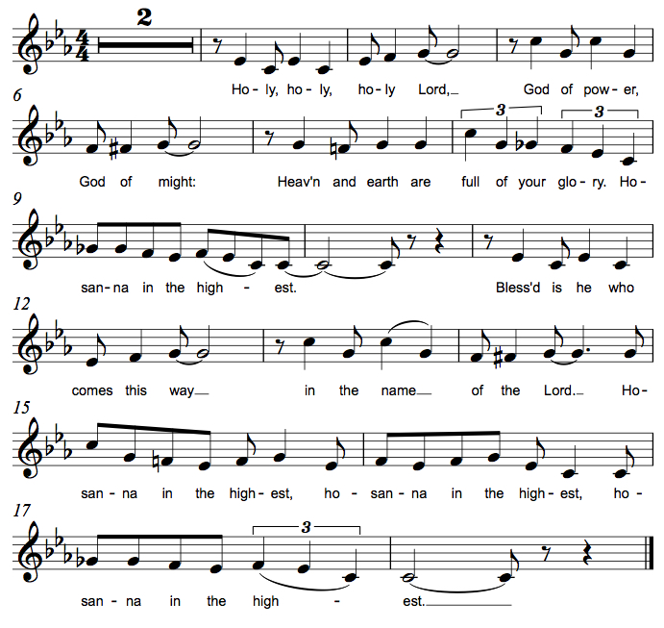

*Thanksgiving at the Table
. . . For as often as we eat of this bread and drink from this cup, we proclaim the Lord's death until he comes.
Christ has died. Christ is risen. Christ will come again.

You may hold up your (unopened) communion kit as you are able.
Remembering, therefore, his salutary command, his life-giving passion and death, his glorious resurrection and ascension, and the promise of his coming again, we give thanks to you, O Lord God Almighty, not as we ought but as we are able; we ask you mercifully to accept our praise and thanksgiving and with your Word and Holy Spirit to bless us, your servants, and these your own gifts of bread and wine, so that we and all who share in the body and blood of Christ may be filled with heavenly blessing and grace, and, receiving the forgiveness of sin, may be formed to live as your holy people and be given our inheritance with all your saints.
You may lower your communion kit.

To you, O God, Father, Son, and Holy Spirit, be all honor and glory in your holy church, now and forever.
Amen.

*The Lord’s Prayer
Gathered into one by the Holy Spirit, let us pray as Jesus taught us.
Our Father in heaven, hallowed be your name, your kingdom come, your will be done, on earth as in heaven. Give us today our daily bread. Forgive us our sins as we forgive those who sin against us. Save us from the time of trial and deliver us from evil. For the kingdom, the power, and the glory are yours, now and forever. Amen.

*Invitation to Communion
Christ has set the table with more than enough for all. Come! Be Seated.

If you have difficulty opening your communion, please signal an usher for assistance.

Peel up the clear top seal over the wafer, and hold the wafer up when you are ready.
This is the Body of Christ, given for you. (Eat the bread.)

Peel up the second foil seal over the juice, and hold your cup up when you are ready.
This is the blood of Christ, shed for you. (Drink the wine/juice.)
Amen.

After communion you may place the packaging in the bowl in your pew. The ushers will dispose of these following the service.

Agnus Dei M.B. Eastman
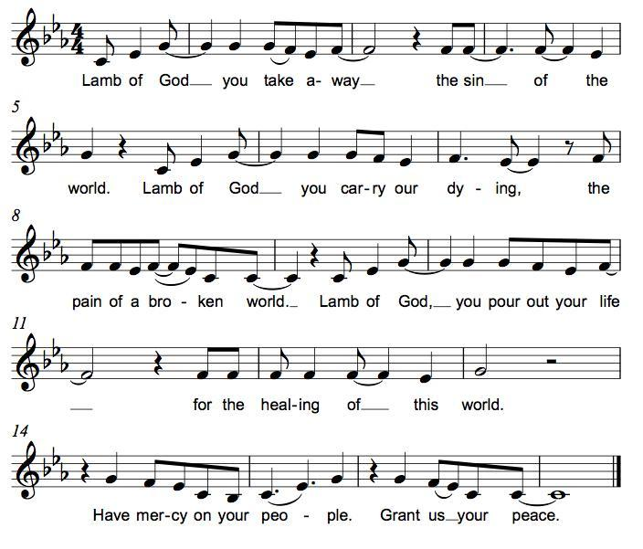

*Please stand as you are able.
*Post-Communion Blessing
The body and blood of our Lord Jesus Christ strengthen you and keep you in his grace. Amen.

*Prayer after Communion
Jesus, Bread of life, we have received from your table more than we could ever ask. As you have nourished us in this meal, now strengthen us to love the world with your own life. In your name we pray. Amen.

Sending
God blesses us and sends us in mission to the world.
*Blessing
The blessing of God, who provides for us, feeds us, and journeys with us, ☩ be upon you now and forever. Amen.

*Sending Hymn ELW #507 O God of Light
sts. 1,3,4

*Sent to the World
Go in peace. You are the body of Christ. Thanks be to God.

Postlude
After the postlude, those who have joined via Zoom may unmute your mics
and share a greeting with your fellow worshippers.

From Sundays and Seasons
v.20190109.1233 Copyright © 2021 Augsburg Fortress. All rights reserved.
Reprinted by permission under Augsburg Fortress Liturgies Annual License #30867.
All rights reserved. Reprinted under OneLicense.net #A-718333.

Assisting in Worship Today
Ministry Associate Becky Ficarella
Minister of Music Bradford Thompson
Lector Susan Jacobson
Ushers Jeff Berta, Bruce Lantz, Tim Kelly, Open
Altar Flowers

Current Prayer Requests
Please keep these people in your prayers and reach out to our sisters and brothers in Christian love. Names will be left on the list for two weeks, unless you indicate that they should remain in our prayers for a longer period.
Name Relationship Prayer For
Sandra Venturoni Member Healing & Strength
Family of Bob Stein Member Comfort in Grief
Jim Sladek Member Healing & Strength
Cathy Milleville Member Healing & Strength
Sigrid Elliott Member Healing & Strength
Dorothy Tracy Member Healing & Strength
Lori Garabrandt Relative of Chuck Miller and Lois Pertle Healing $ Strength
Chris Danly Son of Mark & Pat Danly Healing & Strength
Tammy Rollo Friend of Barbara Sudds Healing & Strength
Prayers for our homebound Members
Dolores Nosal, Carol Petersen, Norma Petersen, Dorothy Stein

The church office will be closed the weeks of July 18 and August 1.

Due to rain, the Pool Day at Turtle Splash Water Park in West Chicago has been rescheduled to Monday July 19, 11:30am: Come join us for a day of pool fun! This is a newer facility that will limit the number of people able to come in each day due to COVID, so please try to arrive as close to 11:30am as possible. It is a first come basis. Admission is $15 per person for non-residents; Grace will split the cost and cover $7.50 per ticket. Please RSVP by July 16th with Becky Ficarella if you would like to attend!

“Boundless 2022” ELCA High School Youth Gathering in Minneapolis, MN July 24-28: Open to all incoming 8th-12th grade students, the ELCA Youth Gathering will be held in Minneapolis next summer. We are planning to take students from Grace and will team up with St. Paul Lutheran Church to attend. In order for students to receive any financial assistance, I will need to know your intention of going by July 22, 2021. The registration fee for this trip will be $150 and will be due between September 22 and November 1 in order to receive early bird pricing. We will offer fundraising opportunities throughout the year to help defray the costs. We will not know our hotel assignments until late January 2022, so final costs will not be known until we have that information settled. Please reach out to Becky Ficarella with any questions.

Where Are You? We Miss You! When Grace reopened for worship on June 6 we were anticipating worship attendance of around 50 per Sunday and that number was based on the number of calls and emails we received about going back to in-person worship. Well here we are and to date, Grace has only been averaging 36 per Sunday (just a third of our attendance pre-pandemic). We have lifted some of the restrictions for worship we had in place, see blurb below, which makes our worship service almost everything it was before the pandemic. Please contact Pr. Melody or the church office if you have any questions or concerns. We look forward to seeing you!

Update on Where Are You? We Miss You! Wow, on Sunday, July 11 we had 54 in worship and that number included three new visitors (from two separate families)! We have had various visitors at several of our Sunday services to date. It is a blessing to have you back to share in our mission at Grace.

Check out Marvel's latest superhero, ELCA member Rebekah Bruesehoff, ​as the Mighty Rebekah: Rebekah is one of 20 kids Marvel selected for the Marvel Hero Project. Marvel created comics to tell the stories of heroic work everyday kids do to make the world a better place. Marvel created the character Mighty Rebekah to add her story to the Marvel universe of superheroes. You can view the story of this amazing young person on Grace’s website www.GraceGlenEllyn.org.

Circle of Care Coordinator Needed: We are seeking an individual to fill the role of Circle of Care Coordinator. Sooz Hufnagle was fulfilling this role previously, but is no longer available to serve due to the Hufnagle's relocation to South Carolina.
This role includes managing incoming requests of care from members and then finding the appropriate volunteers to help from a current list of willing helpers! Examples might include rides, grocery store runs, or meal drop offs. Please contact the church office or Becky Ficarella if you are interested!

Altar Flowers for Summer Worship Services: Let's get creative and try something fun for the summer! We invite you to sign up in the narthex to provide floral bouquets that you have created. It’s okay if bouquets don’t match or we have only one bouquet on a Sunday! Share from your garden, the farmer's market, or local store and bring them with you Sunday morning! Please sign up in the Narthex, or contact the church office to reserve a date. Please only include flowers and no special decorations or messages in the bouquet. These are the available dates: July 25; August 1; August 15; August 22; September 5.

Ushers Needed: Each of our four usher teams are in need of one additional team member. Team 1 (January, May, September); Team 2 (February, June, October); Team 3 (March, July, November; Team 4 (April, August, December). Please contact the church office if you can volunteer for one of these teams or sign up in the Narthex.

RAMP: Our mortgage reduction campaign has been renamed “RAMP” (Reduce Another Mortgage Payment) as we continue to RAMP up to refinance our mortgage with Mission Investment Fund this Fall. We plan to make a $25,000 payment against principal in July. Thank you to all who have contributed to date. We are still hopeful we can raise another $75,000 before November. Lowering our monthly mortgage payments will free up funds that we can utilize on the ministries of Grace.

Got Capital Gains? Did you know that stock donations allow you to both claim a deduction at the appreciated value AND allow you to avoid capital gains taxes on these assets? Further, consolidating donations in a tax year could lead to increased ability to deduct charitable contributions in a given tax year. Consult your tax advisor for details, but if you’d like more information on how to go about donating stock, reach out to the church office.

Contributions to Grace: You may continue to mail your contributions to the church office; have your bank mail your contribution to the church office; or contribute on-line through Grace’s website. Please know, pandemic or no, our mission continues! Thank you for your continued support of our ministries at Grace Lutheran.

Bradford’s Livestream Music Session: Join Bradford for LIVE music sessions broadcast directly from Grace! Just click on the link Wednesday evening at 7:00pm to join Bradford on his YouTube channel: https://youtube.com/channel/UCbgfoPipBLAlY3hAkVKoI8Q

Chair Exercise and monthly Book Club. Registration is required as the number of attendees will be limited. The exercise class meets Mondays at 10:00am and Thursdays at 11:00am. The Book Club will meet on the third Tuesday of the month at 11:00am. Please contact Sue Davison at 630-858-6343 to register.

Buy a Birdhouse to Benefit the Food Pantry at the Glen Ellyn Sidewalk Sale ﻿July 23-24: The Birdhouse Lady of Glen Ellyn, former Grace member Marcia Lamoureux, is donating all proceeds of the sale of her amazing creations to the Food Pantry during the Glen Ellyn Sidewalk Sale on Friday, July 23 and Saturday, July 24 from 9 a.m. – 4 p.m. A Pantry volunteer has also donated a hand-carved wooden bench which will be raffled and then customized for the winner. The Food Pantry booth will be located in the parking lot at Grace Lutheran Church.

Save the Date: August 29th Outdoor Worship & Picnic at Blackwell Forest Preserve. More details to come!

Every Member a Minister and Missionary!

Phone: 630-469-1555 Emergency Pastoral Contact: 630-674-2887
info@graceglenellyn.org www.graceglenellyn.org

Pastor
Rev. Melody Eastman office ext. 14
meastman@graceglenellyn.org

Minister of Music
Bradford Thompson 219-718-8879
bradfordmthompson@gmail.com

Ministry Associate
Becky Ficarella office ext. 17
bficarella@graceglenellyn.org

Office Manager
Barbara Sudds office ext. 10
bsudds@graceglenellyn.org

Parish Counselor
Carole LoGalbo M.S., LCPC 630-668-4594
carolelogalbo@yahoo.com

