Grace Lutheran Church

493 Forest Avenue, Glen Ellyn IL 630.469.1555
www.graceglenellyn.org

9th Sunday after Pentecost July 25, 2021

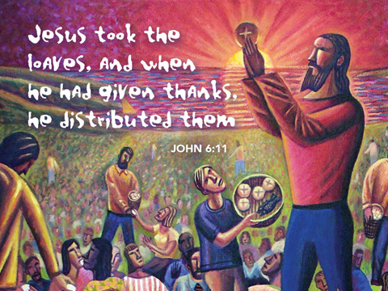

+ Proclaim Christ + Build Community +
+ Serve Our Neighbors +

Introduction
Today is the first of five Sundays with gospel readings from John 6, the first four of which focus on Jesus as bread of life. Today Jesus feeds thousands of people with five loaves and two fish. What we have, what we bring to Jesus’ table, seems like it is not nearly enough to meet all the needs we see around us. But it is not the adequacy of our supplies or our skills that finally makes the difference: it is the power of Jesus working in the littlest and least to transform this world into the world God desires, a world where all the hungry are satisfied.

Gathering
The Holy Spirit calls us together as the people of God.
Welcome/Announcements
Helpful Reminders for those joining via Zoom:
- The host will mute you when you join, and you will remain muted until the end of the service.
- You are welcome to join in all congregation responses (in Bold black.) and hymns.
- At the end of the service you may unmute your mic to share greetings with your fellow worshippers. If you dialed in on the phone, press *6. Remember, your host cannot unmute you.

Helpful Reminders for those joining in person:
- Maintain 6’ distance between family groups
- Remain in your pews for communion.
- You may place your offering in the box in the narthex.

Prelude

*Please stand as you are able and turn to face the font.
*Confession and Forgiveness
All may make the sign of the cross, the sign marked at baptism, as the presiding minister begins.
Blessed be the holy Trinity,☩ one God, the God of manna, the God of miracles, the God of mercy. Amen.

Drawn to Christ and seeking God’s abundance, let us confess our sin.
Silence is kept for reflection.

God, our provider, help us. It is hard to believe there is enough to share. We question your ways when they differ from the ways of the world in which we live. We turn to our own understanding rather than trusting in you. We take offense at your teachings and your ways. Turn us again to you. Where else can we turn? Share with us the words of eternal life and feed us for life in the world. Amen.

Beloved people of God: in Jesus, the manna from heaven, you are fed and nourished. By Jesus, the worker of miracles, there is always more than enough. Through Jesus, ☩ the bread of life, you are shown God’s mercy: you are forgiven and loved into abundant life. Amen.

*Entrance Hymn ELW #689 Praise and Thanksgiving
sts. 1,2,4
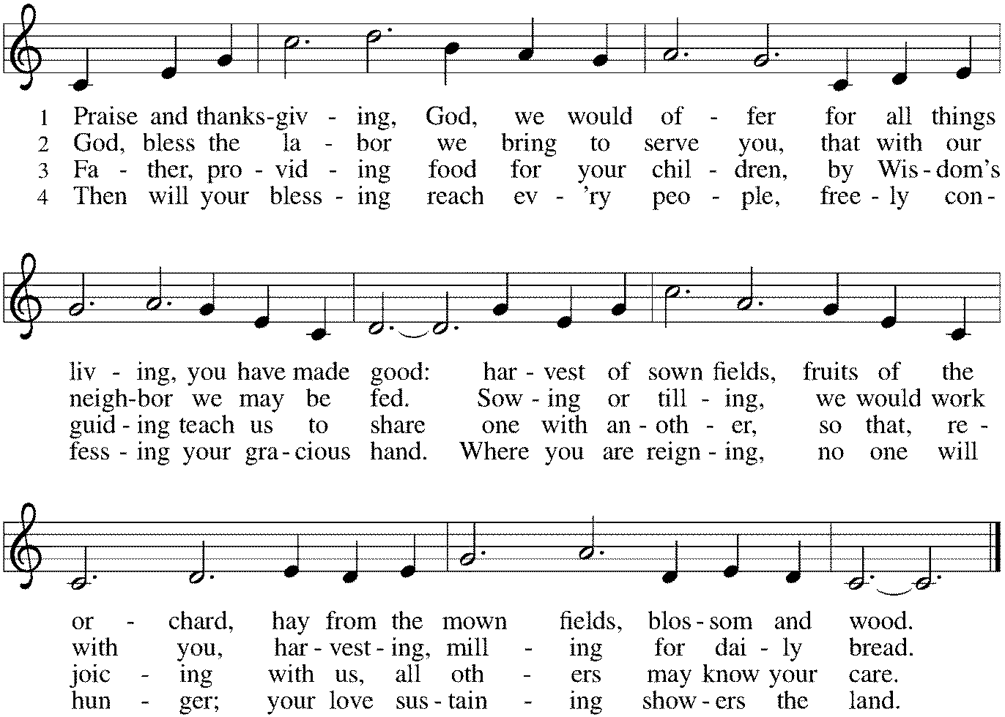

*Greeting
The grace of our Lord Jesus Christ, the love of God, and the communion of the Holy Spirit be with you all. And also with you.
*Hymn of Praise This is the Feast (from Mass for Immanuel, Singing in Community)
The congregation sings the refrain, the cantor sings the stanzas.
The cantor will introduce the refrain the first time through.
At the end of each stanza, the congregation repeats the “Alleluia” after the cantor.
Refrain: This is the feast of vict’ry for our God. Alleluia, alleluia.
Worthy is Christ, the Lamb who was slain,
whose blood set us free to be people of God. Alleluia. Alleluia.
Refrain
Power, riches, wisdom, and strength, and honor, blessing and glory are his. Alleluia. Alleluia.
Refrain
Sing with all the people of God, and join in the hymn of all creation. Alleluia. Alleluia.
Refrain
Blessing, honor, glory and might be to God and the Lamb forever, amen. Alleluia. Alleluia.
Refrain
For the Lamb who was slain has begun his reign. Amen. Alleluia. Alleluia!
Refrain

*Prayer of the Day
Gracious God, you have placed within the hearts of all your children a longing for your word and a hunger for your truth. Grant that we may know your Son to be the true bread of heaven and share this bread with all the world, through Jesus Christ, our Savior and Lord. Amen. Be seated.

Word
God speaks to us in scripture reading, preaching, and song.
First Lesson 2 Kings 4:42-44
Today’s reading is part of a larger section of 2 Kings that describes the miracles of Elisha, the successor to Elijah. Here the prophet gives food to a hungry crowd. Though there is not enough food to go around, Elisha trusts God, who provides enough and even more to satisfy the need.

⁴²A man came from Baal-shalishah, bringing food from the first fruits to [Elisha,] the man of God: twenty loaves of barley and fresh ears of grain in his sack. Elisha said, “Give it to the people and let them eat.” ⁴³But his servant said, “How can I set this before a hundred people?” So he repeated, “Give it to the people and let them eat, for thus says the Lord, ‘They shall eat and have some left.’ ” ⁴⁴He set it before them, they ate, and had some left, according to the word of the Lord.

Word of God, Word of Life. Thanks be to God.

Psalm Psalm 145:10-18
You open wide your hand and satisfy the desire of every living thing. (Ps. 145:16)

¹⁰All your works shall praise you, O Lord, and your faithful ones shall bless you.
¹¹They shall tell of the glory of your kingdom and speak of your power,
¹²that all people may know of your power and the glorious splendor of your kingdom.
¹³Your kingdom is an everlasting kingdom; your dominion endures through-out all ages. You, Lord, are faithful in all your words, and loving in all your works.
¹⁴The Lord upholds all those who fall and lifts up those who are bowed down.
¹⁵The eyes of all wait upon you, O Lord, and you give them their food in due season.
¹⁶You open wide your hand and satisfy the desire of every living thing.
¹⁷You are righteous in all your ways and loving in all your works.
¹⁸You are near to all who call upon you, to all who call upon you faithfully.

Second Lesson Ephesians 3:14-21
We have been rooted and grounded in the love of Christ, which surpasses all human knowledge. Because Christ dwells in our hearts, our lives are continuously strengthened and empowered by the ongoing presence of the Spirit.

¹⁴For this reason I bow my knees before the Father, ¹⁵from whom every family in heaven and on earth takes its name. ¹⁶I pray that, according to the riches of his glory, he may grant that you may be strengthened in your inner being with power through his Spirit, ¹⁷and that Christ may dwell in your hearts through faith, as you are being rooted and grounded in love. ¹⁸I pray that you may have the power to comprehend, with all the saints, what is the breadth and length and height and depth, ¹⁹and to know the love of Christ that surpasses knowledge, so that you may be filled with all the fullness of God.
²⁰Now to him who by the power at work within us is able to accomplish abundantly far more than all we can ask or imagine, ²¹to him be glory in the church and in Christ Jesus to all generations, forever and ever. Amen.

Word of God, Word of Life. Thanks be to God.

*Please stand as you are able.
*Gospel Acclamation C. Heine
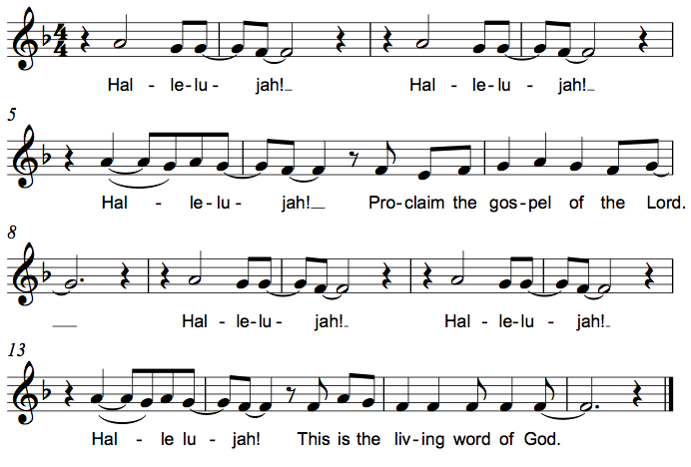

The holy Gospel according to John. Glory to you, O Lord.

*Gospel John 6:1-21
In John’s gospel, the miracles of Jesus are called “signs,” because they reveal the true character of God. As such, they remain within the mystery of God and cannot be brought under human control.

¹Jesus went to the other side of the Sea of Galilee, also called the Sea of Tiberias. ²A large crowd kept following him, because they saw the signs that he was doing for the sick. ³Jesus went up the mountain and sat down there with his disciples. ⁴Now the Passover, the festival of the Jews, was near. ⁵When he looked up and saw a large crowd coming toward him, Jesus said to Philip, “Where are we to buy bread for these people to eat?” ⁶He said this to test him, for he himself knew what he was going to do. ⁷Philip answered him, “Six months’ wages would not buy enough bread for each of them to get a little.” ⁸One of his disciples, Andrew, Simon Peter’s brother, said to him, ⁹“There is a boy here who has five barley loaves and two fish. But what are they among so many people?” ¹⁰Jesus said, “Make the people sit down.” Now there was a great deal of grass in the place; so they sat down, about five thousand in all. ¹¹Then Jesus took the loaves, and when he had given thanks, he distributed them to those who were seated; so also the fish, as much as they wanted. ¹²When they were satisfied, he told his disciples, “Gather up the fragments left over, so that nothing may be lost.” ¹³So they gathered them up, and from the fragments of the five barley loaves, left by those who had eaten, they filled twelve baskets. ¹⁴When the people saw the sign that he had done, they began to say, “This is indeed the prophet who is to come into the world.”
¹⁵When Jesus realized that they were about to come and take him by force to make him king, he withdrew again to the mountain by himself.
¹⁶When evening came, his disciples went down to the sea, ¹⁷got into a boat, and started across the sea to Capernaum. It was now dark, and Jesus had not yet come to them. ¹⁸The sea became rough because a strong wind was blowing. ¹⁹When they had rowed about three or four miles, they saw Jesus walking on the sea and coming near the boat, and they were terrified. ²⁰But he said to them, “It is I; do not be afraid.” ²¹Then they wanted to take him into the boat, and immediately the boat reached the land toward which they were going.

The Gospel of the Lord. Praise to you, O Christ. Be seated.

Sermon The Rev. Melody Eastman

*Please stand as you are able.
Hymn of the Day ELW #515 Break Now the Bread of Life
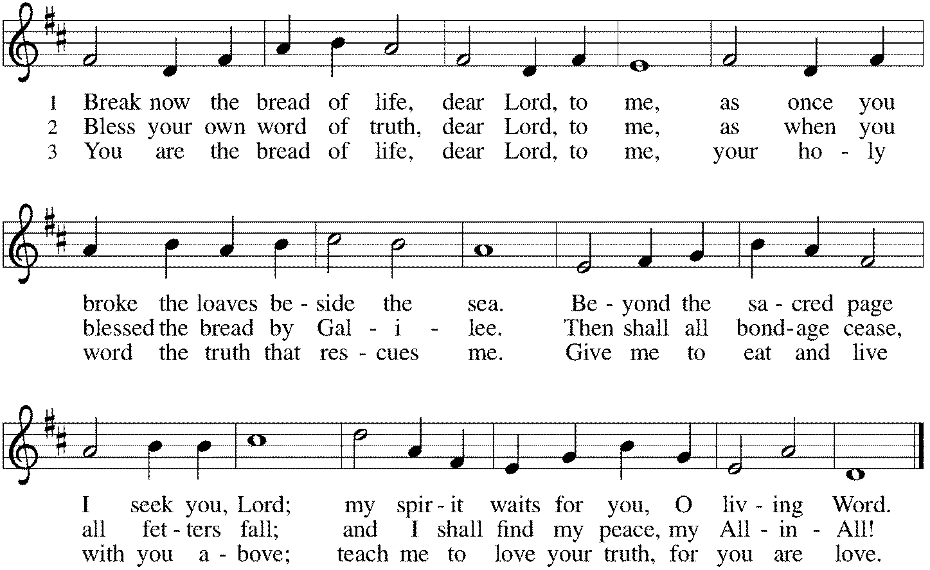

*Prayers of Intercession
Rooted in Christ and sustained by the Spirit, we offer our prayers for the church, the world, and all of creation.
A brief silence.
We pray for the church. Bless the ministries of our neighboring congregations. Empower churches throughout the world and encourage missionaries who accompany global neighbors. Kindle in us a spirit of collaboration, that all people may know your loving works. Hear us, O God. Your mercy is great.

We pray for creation. Send rain to lands experiencing drought and come to the aid of those enduring sweltering heat. Nurture wheat and barley crops grown for the nourishment of your people and conserve aquatic habitats and fish populations. Hear us, O God. Your mercy is great.

We pray for those who govern. Cast out arrogance, selfishness, and corruption and instruct those who lead to practice compassion and humility. Inspire them with a vision of the common good and a commitment to ensure that all who hunger are fed. Hear us, O God. Your mercy is great.

We pray for those bowed down by heavy burdens: those who are unemployed or underemployed, those unable to find affordable housing, and those without health insurance. Console those who grieve and hear the cries of those who call to you for healing especially Jim, Cathy, Sigrid, Dorothy, Sandra, Carol, Norma, Dorothy and those we name before you now. . . Hear us, O God. Your mercy is great.

We pray for this assembly. Deepen our resolve to use what we have to serve those in need. When we worry that we do not have enough resources for ministry, assure us of your abundance. Hear us, O God. Your mercy is great.
Here other intercessions may be offered.
We give thanks for those who have died. As you sustained them through all their days, so dwell in our hearts, that we may have the power to comprehend, with all the saints, the love of Christ that surpasses knowledge. Hear us, O God. Your mercy is great.

We lift these and all our prayers to you, O God, confident in the promise of your saving love; through Jesus Christ our Lord. Amen.
*Peace
The peace of Christ be with you always. And also with you.
Please share the peace with others in your household, or by making a sign of peace to those on Zoom. Please remain standing.

Meal
God feeds us with the presence of Jesus Christ.
*Offering Prayer
Jesus, Bread of life,
you have set this table with your very self,
and called us to the feast of plenty.
Gather what has been sown among us,
and strengthen us in this meal.
Make us to be what we receive here,
your body for the life of the world. Amen

*Great Thanksgiving
The Lord be with you. And also with you.

Lift up your hearts. We lift them to the Lord.

Let us give thanks to the Lord our God. It is right to give our thanks and praise.

*Preface
It is indeed right, our duty and our joy,
that we should at all times and in all places give thanks and praise to you,
almighty and merciful God, through our Savior Jesus Christ;
who on this day overcame death and the grave,
and by his glorious resurrection opened to us the way of everlasting life.
And so, with all the choirs of angels,
with the church on earth and the hosts of heaven,
we praise your name and join their unending hymn:

*Sanctus C. Heine
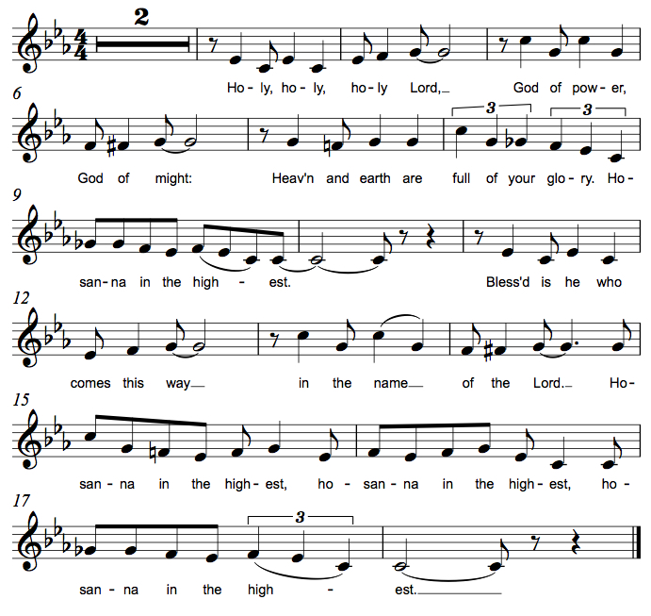

*Thanksgiving at the Table
You are indeed holy, almighty and merciful God.
You are most holy,
and great is the majesty of your glory.

You so loved the world that you gave your only Son,
so that everyone who believes in him may not perish
but have eternal life.

We give you thanks for his coming into the world
to fulfill for us your holy will
and to accomplish all things for our salvation.

In the night in which he was betrayed,
our Lord Jesus took bread, and gave thanks;
broke it, and gave it to his disciples, saying:
Take and eat; this is my body, given for you.
Do this for the remembrance of me.

Again, after supper, he took the cup, gave thanks,
and gave it for all to drink, saying:
This cup is the new covenant in my blood,
shed for you and for all people for the forgiveness of sin.
Do this for the remembrance of me.

For as often as we eat of this bread and drink from this cup,
we proclaim the Lord's death until he comes.
Christ has died. Christ is risen. Christ will come again.

You may hold up your (unopened) communion kit as you are able.
Remembering, therefore, his salutary command,
his life-giving passion and death,
his glorious resurrection and ascension,
and the promise of his coming again,
we give thanks to you, O Lord God Almighty,
not as we ought but as we are able;
we ask you mercifully to accept our praise and thanksgiving
and with your Word and Holy Spirit to bless us, your servants,
and these your own gifts of bread and wine,
so that we and all who share in the body and blood of Christ
may be filled with heavenly blessing and grace,
and, receiving the forgiveness of sin,
may be formed to live as your holy people
and be given our inheritance with all your saints.
You may lower your communion kit.

To you, O God, Father, Son, and Holy Spirit,
be all honor and glory in your holy church, now and forever.
Amen.

*The Lord’s Prayer
Gathered into one by the Holy Spirit, let us pray as Jesus taught us.
Our Father in heaven, hallowed be your name, your kingdom come, your will be done, on earth as in heaven. Give us today our daily bread. Forgive us our sins as we forgive those who sin against us. Save us from the time of trial and deliver us from evil. For the kingdom, the power, and the glory are yours, now and forever. Amen.

*Invitation to Communion
Christ has set the table with more than enough for all. Come! Be Seated.

If you have difficulty opening your communion, please signal an usher for assistance.

Peel up the clear top seal over the wafer, and hold the wafer up when you are ready.
This is the Body of Christ, given for you. (Eat the bread.)

Peel up the second foil seal over the juice, and hold your cup up when you are ready.
This is the blood of Christ, shed for you. (Drink the wine/juice.)
Amen.

After communion you may place the packaging in the bowl in your pew. The ushers will dispose of these following the service.

Agnus Dei M.B. Eastman
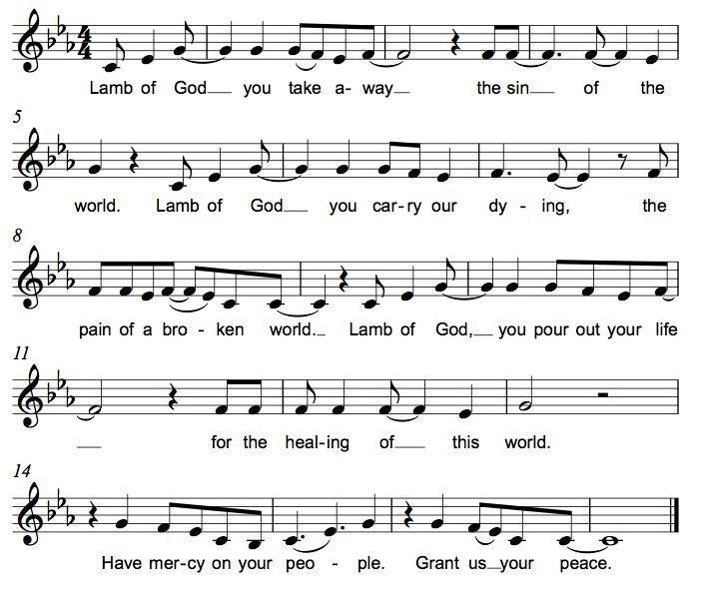
*Please stand as you are able.
*Post-Communion Blessing
The body and blood of our Lord Jesus Christ strengthen you and keep you in his grace. Amen.

*Prayer after Communion
Jesus, Bread of life, we have received from your table more than we could ever ask. As you have nourished us in this meal, now strengthen us to love the world with your own life. In your name we pray. Amen.

Sending
God blesses us and sends us in mission to the world.
*Blessing
The blessing of God, who provides for us, feeds us, and journeys with us, ☩ be upon you now and forever. Amen.

*Sending Hymn Go On Your Way in Peace, My Friend

*Sent to the World
Go in peace. You are the body of Christ. Thanks be to God.

Postlude
After the postlude, those who have joined via Zoom may unmute your mics
and share a greeting with your fellow worshippers.

From Sundays and Seasons
v.20190109.1233 Copyright © 2021 Augsburg Fortress. All rights reserved.
Reprinted by permission under Augsburg Fortress Liturgies Annual License #30867.
All rights reserved. Reprinted under OneLicense.net #A-718333.

Assisting in Worship Today
Ministry Associate Becky Ficarella
Minister of Music Bradford Thompson
Lector Jeff Nelson
Ushers Jeff Berta, Bruce Lantz, Tim Kelly, Open
Altar Flowers

Current Prayer Requests
Please keep these people in your prayers and reach out to our sisters and brothers in Christian love. Names will be left on the list for two weeks, unless you indicate that they should remain in our prayers for a longer period.
Name Relationship Prayer For
Sandra Venturoni Member Healing & Strength
Family of Bob Stein Member Comfort in Grief
Jim Sladek Member Healing & Strength
Cathy Milleville Member Healing & Strength
Sigrid Elliott Member Healing & Strength
Dorothy Tracy Member Healing & Strength
Lori Garabrandt Relative of Chuck Miller and Lois Pertle Healing $ Strength
Chris Danly Son of Mark & Pat Danly Healing & Strength
Tammy Rollo Friend of Barbara Sudds Healing & Strength
Prayers for our homebound Members
Dolores Nosal, Carol Petersen, Norma Petersen, Dorothy Stein

The church office will be closed the week of August 1.

“Boundless 2022” ELCA High School Youth Gathering in Minneapolis, MN July 24-28: Open to all incoming 8th-12th grade students, the ELCA Youth Gathering will be held in Minneapolis next summer. We are planning to take students from Grace and will team up with St. Paul Lutheran Church to attend. In order for students to receive any financial assistance, I will need to know your intention of going by July 22, 2021. The registration fee for this trip will be $150 and will be due between September 22 and November 1 in order to receive early bird pricing. We will offer fundraising opportunities throughout the year to help defray the costs. We will not know our hotel assignments until late January 2022, so final costs will not be known until we have that information settled. Please reach out to Becky Ficarella with any questions.

Circle of Care Coordinator Needed: We are seeking an individual to fill the role of Circle of Care Coordinator. Sooz Hufnagle was fulfilling this role previously, but is no longer available to serve due to the Hufnagle's relocation to South Carolina.
This role includes managing incoming requests of care from members and then finding the appropriate volunteers to help from a current list of willing helpers! Examples might include rides, grocery store runs, or meal drop offs. Please contact the church office or Becky Ficarella if you are interested!

Altar Flowers for Summer Worship Services: Let's get creative and try something fun for the summer! We invite you to sign up in the narthex to provide floral bouquets that you have created. It’s okay if bouquets don’t match or we have only one bouquet on a Sunday! Share from your garden, the farmer's market, or local store and bring them with you Sunday morning! Please sign up in the Narthex, or contact the church office to reserve a date. Please only include flowers and no special decorations or messages in the bouquet. These are the available dates: August 1; August 15; August 22; September 5.

Ushers Needed: Each of our four usher teams are in need of one additional team member. Team 1 (January, May, September); Team 2 (February, June, October); Team 3 (March, July, November; Team 4 (April, August, December). Please contact the church office if you can volunteer for one of these teams or sign up in the Narthex.

RAMP: Our mortgage reduction campaign has been renamed “RAMP” (Reduce Another Mortgage Payment) as we continue to RAMP up to refinance our mortgage with Mission Investment Fund this Fall. We plan to make a $25,000 payment against principal in July. Thank you to all who have contributed to date. We are still hopeful we can raise another $75,000 before November. Lowering our monthly mortgage payments will free up funds that we can utilize on the ministries of Grace.

Got Capital Gains? Did you know that stock donations allow you to both claim a deduction at the appreciated value AND allow you to avoid capital gains taxes on these assets? Further, consolidating donations in a tax year could lead to increased ability to deduct charitable contributions in a given tax year. Consult your tax advisor for details, but if you’d like more information on how to go about donating stock, reach out to the church office.

Contributions to Grace: You may continue to mail your contributions to the church office; have your bank mail your contribution to the church office; or contribute on-line through Grace’s website. Please know, pandemic or no, our mission continues! Thank you for your continued support of our ministries at Grace Lutheran.

Bradford’s Livestream Music Session: Join Bradford for LIVE music sessions broadcast directly from Grace! Just click on the link Wednesday evening at 7:00pm to join Bradford on his YouTube channel: https://youtube.com/channel/UCbgfoPipBLAlY3hAkVKoI8Q

Chair Exercise and monthly Book Club. Registration is required as the number of attendees will be limited. The exercise class meets Mondays at 10:00am and Thursdays at 11:00am. The Book Club will meet on the third Tuesday of the month at 11:00am. Please contact Sue Davison at 630-858-6343 to register.

Save the Date: August 29th Outdoor Worship & Picnic at Blackwell Forest Preserve. More details to come!

Every Member a Minister and Missionary!

Phone: 630-469-1555 Emergency Pastoral Contact: 630-674-2887
info@graceglenellyn.org www.graceglenellyn.org

Pastor
Rev. Melody Eastman office ext. 14
meastman@graceglenellyn.org

Minister of Music
Bradford Thompson 219-718-8879
bradfordmthompson@gmail.com

Ministry Associate
Becky Ficarella office ext. 17
bficarella@graceglenellyn.org

Office Manager
Barbara Sudds office ext. 10
bsudds@graceglenellyn.org

Parish Counselor
Carole LoGalbo M.S., LCPC 630-668-4594
carolelogalbo@yahoo.com

