Grace Lutheran Church
493 Forest Avenue, Glen Ellyn IL 630.469.1555
www.graceglenellyn.org

8th Sunday After Pentecost July 26, 2020

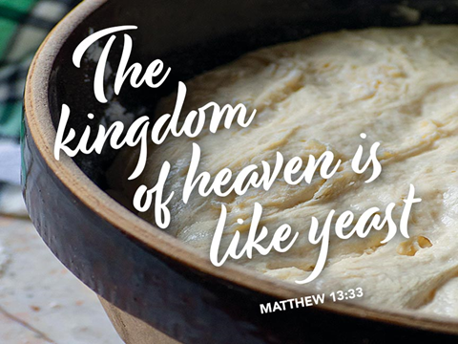

+ Proclaim Christ + Build Community +
+ Serve Our Neighbors +
Introduction
As Solomon prays for wisdom, we seek to more deeply know the treasures of faith. In today’s gospel Jesus offers everyday images that reveal to us the reign of God: a tree that becomes a sheltering home, yeast that penetrates and expands, a treasured pearl, a net that gains a great catch. Even as we seek the riches of God’s reign, the great surprise is that God’s grace finds us first!
Gathering
The Holy Spirit calls us together as the people of God.

Prelude

Confession and Forgiveness
All may make the sign of the cross, the sign marked at baptism, as the presiding minister begins.
Blessed be the holy Trinity, ☩ one God,
whose steadfast love is everlasting,
whose faithfulness endures from generation to generation.
Amen.

Trusting in the mercy of God, let us confess our sin.
Silence is kept for reflection.

Reconciling God,
we confess that we do not trust your abundance,
and we deny your presence in our lives.
We place our hope in ourselves
and rely on our own efforts.
We fail to believe that you provide enough for all.
We abuse your good creation for our own benefit.
We fear difference and do not welcome others
as you have welcomed us.
We sin in thought, word, and deed.
By your grace, forgive us;
through your love, renew us;
and in your Spirit, lead us;
so that we may live and serve you in newness of life. Amen.

Beloved of God,
by the radical abundance of divine mercy
we have peace with God through ☩ Christ Jesus,
through whom we have obtained grace upon grace.
Our sins are forgiven.
Let us live now in hope.
For hope does not disappoint,
because God’s love has been poured into our hearts
through the Holy Spirit.
Amen.

Opening Hymn ELW #781 Children of the Heavenly Father

Greeting
The grace of our Lord Jesus Christ, the love of God, and the communion of the Holy Spirit be with you all. And also with you.

Prayer of the Day
Beloved and sovereign God, through the death and resurrection of your Son you bring us into your kingdom of justice and mercy. By your Spirit, give us your wisdom, that we may treasure the life that comes from Jesus Christ, our Savior and Lord. Amen.
Word
God speaks to us in scripture reading, preaching, and song.

First Lesson 1 Kings 3:5-12
Because Solomon did not ask for long life, riches, or the defeat of his enemies, God gave him what he asked for: wisdom to govern the people well.

⁵At Gibeon the Lord appeared to Solomon in a dream by night; and God said, “Ask what I should give you.” ⁶And Solomon said, “You have shown great and steadfast love to your servant my father David, because he walked before you in faithfulness, in righteousness, and in uprightness of heart toward you; and you have kept for him this great and steadfast love, and have given him a son to sit on his throne today. ⁷And now, O Lord my God, you have made your servant king in place of my father David, although I am only a little child; I do not know how to go out or come in. ⁸And your servant is in the midst of the people whom you have chosen, a great people, so numerous they cannot be numbered or counted. ⁹Give your servant therefore an understanding mind to govern your people, able to discern between good and evil; for who can govern this your great people?”
¹⁰It pleased the Lord that Solomon had asked this. ¹¹God said to him, “Because you have asked this, and have not asked for yourself long life or riches, or for the life of your enemies, but have asked for yourself understanding to discern what is right, ¹²I now do according to your word. Indeed I give you a wise and discerning mind; no one like you has been before you and no one like you shall arise after you.”

Word of God, Word of Life. Thanks be to God.

The Psalm Psalm 119:129-136
(Read responsively by verse)
¹²⁹Your decrees are wonderful;
therefore I obey them with all my heart.
¹³⁰When your word is opened it gives light;
it gives understanding to the simple.
¹³¹I open my mouth and pant
because I long for your commandments.
¹³²Turn to me and be gracious to me,
as you always do to those who love your name.
¹³³Order my footsteps in your word;
let no iniquity have dominion over me.
¹³⁴Rescue me from those who oppress me,
and I will keep your commandments.
¹³⁵Let your face shine upon your servant
and teach me your statutes.
¹³⁶My eyes shed streams of tears,
because people do not keep your teaching.

Second Lesson Romans 8:26-39
These words celebrate the depth of God’s actions for us. Through Christ’s death for us and the activity of the Spirit praying for us, we are fused to God’s love poured out in Jesus Christ. Nothing, not even death itself, is able to separate us from such incredible divine love.

²⁶The Spirit helps us in our weakness; for we do not know how to pray as we ought, but that very Spirit intercedes with sighs too deep for words. ²⁷And God, who searches the heart, knows what is the mind of the Spirit, because the Spirit intercedes for the saints according to the will of God.
²⁸We know that all things work together for good for those who love God, who are called according to his purpose. ²⁹For those whom he foreknew he also predestined to be conformed to the image of his Son, in order that he might be the firstborn within a large family. ³⁰And those whom he predestined he also called; and those whom he called he also justified; and those whom he justified he also glorified.
³¹What then are we to say about these things? If God is for us, who is against us? ³²He who did not withhold his own Son, but gave him up for all of us, will he not with him also give us everything else? ³³Who will bring any charge against God’s elect? It is God who justifies. ³⁴Who is to condemn? It is Christ Jesus, who died, yes, who was raised, who is at the right hand of God, who indeed intercedes for us. ³⁵Who will separate us from the love of Christ? Will hardship, or distress, or persecution, or famine, or nakedness, or peril, or sword? ³⁶As it is written,
“For your sake we are being killed all day long;
we are accounted as sheep to be slaughtered.”
³⁷No, in all these things we are more than conquerors through him who loved us. ³⁸For I am convinced that neither death, nor life, nor angels, nor rulers, nor things present, nor things to come, nor powers, ³⁹nor height, nor depth, nor anything else in all creation, will be able to separate us from the love of God in Christ Jesus our Lord.

Word of God, Word of Life. Thanks be to God.

Gospel Acclamation
Alleluia, Lord, to whom shall we go? You have the words of eternal life. Alleluia.

The holy Gospel according to Matthew. Glory to you, O Lord.

Gospel Matthew 13:31-33, 44-52
Throughout Matthew’s gospel, Jesus and his disciples proclaim the good news that “the kingdom of heaven is near!” Here, Jesus offers several brief parables that explore the implications of this announcement for people’s lives.

³¹[Jesus] put before [the crowds] another parable: “The kingdom of heaven is like a mustard seed that someone took and sowed in his field;³²it is the smallest of all the seeds, but when it has grown it is the greatest of shrubs and becomes a tree, so that the birds of the air come and make nests in its branches.”
³³He told them another parable: “The kingdom of heaven is like yeast that a woman took and mixed in with three measures of flour until all of it was leavened.”
⁴⁴“The kingdom of heaven is like treasure hidden in a field, which someone found and hid; then in his joy he goes and sells all that he has and buys that field.
⁴⁵“Again, the kingdom of heaven is like a merchant in search of fine pearls; ⁴⁶on finding one pearl of great value, he went and sold all that he had and bought it.
⁴⁷“Again, the kingdom of heaven is like a net that was thrown into the sea and caught fish of every kind; ⁴⁸when it was full, they drew it ashore, sat down, and put the good into baskets but threw out the bad. ⁴⁹So it will be at the end of the age. The angels will come out and separate the evil from the righteous ⁵⁰and throw them into the furnace of fire, where there will be weeping and gnashing of teeth.
⁵¹“Have you understood all this?” They answered, “Yes.” ⁵²And he said to them, “Therefore every scribe who has been trained for the kingdom of heaven is like the master of a household who brings out of his treasure what is new and what is old.”

The Gospel of the Lord. Praise to you, O Christ.

Sermon The Rev. Melody Eastman

Apostles’ Creed

With the whole church, let us confess our faith.
I believe in God, the Father almighty, creator of heaven and earth. I believe in Jesus Christ, God's only Son, our Lord, who was conceived by the Holy Spirit, born of the virgin Mary, suffered under Pontius Pilate, was crucified, died, and was buried; he descended to the dead. On the third day he rose again; he ascended into heaven, he is seated at the right hand of the Father, and he will come to judge the living and the dead. I believe in the Holy Spirit, the holy catholic church, the communion of saints, the forgiveness of sins, the resurrection of the body, and the life everlasting. Amen.

Prayers of Intercession
Confident of your care and helped by the Holy Spirit, we pray for the church, the world, and all who are in need.
A brief silence.

Merciful God, your reign is revealed to us in common things: a mustard shrub, a woman baking bread, a fishing net. Help your church witness to the surprising yet common ways you encounter us in daily life. Lord, in your mercy,
hear our prayer.

When your word is opened, it gives light and understanding. Increase our understanding and awe of your creation; guide the work of scientists and researchers. Treasuring the earth, may we live as grateful and healing caretakers of our home. Lord, in your mercy,
hear our prayer.

As the birds of the air nest in branches of trees, gather the nations of the world into the welcoming shade of your merciful reign. Direct leaders of nations to build trust with each other and walk in the way of peace. Lord, in your mercy,
hear our prayer.

Your Spirit helps us in our weakness and intercedes for the saints according to your will. Help us when we do not know how to pray. Give comfort to the dying, refuge to the weary, justice to those who are oppressed, and healing to the sick, especially Chris, Sigrid, Dorothy, Farrel, Patricia, Anita, Bob, Evelyn, Carol, Norma, Dorothy, and those we name before you now. . . Lord, in your mercy,
hear our prayer.

You show steadfast love and direct us to ask of you what we need. Help this congregation ask boldly for what is most needed. Refresh us with new dreams of being your people in this place and time. Lord, in your mercy,
hear our prayer.
Here other intercessions may be offered.

In you our lives are never lost. Strengthen us by the inspiring witness of your people in all times and places. Embolden our witness now and one day gather us with all your saints in light. Lord, in your mercy,
hear our prayer.

In the certain hope that nothing can separate us from your love, we offer these prayers to you; through Jesus Christ our Lord. Amen.

The Lord’s Prayer (Ecumenical Version)
Gathered into one by the Holy Spirit, let us pray as Jesus taught us.

Our Father in heaven, hallowed be your name, your kingdom come, your will be done, on earth as in heaven. Give us today our daily bread. Forgive us our sins as we forgive those who sin against us. Save us from the time of trial and deliver us from evil. For the kingdom, the power and the glory are yours, now and forever. Amen.

Sending
God blesses us and sends us in mission to the world.
Blessing
Neither death, nor life, nor angels, nor rulers, nor things present, nor things to come, nor powers, nor height, nor depth, nor anything else in all creation,
will be able to separate us from the love of God in Christ Jesus. God, the creator, ☩ Jesus, the Christ, and the Holy Spirit, the comforter,
bless us and keep us in eternal love. Amen.

Sending Hymn Seek Ye First the Kingdom of God

1. Seek ye first the kingdom of God
And his righteousness,
And all these things shall be added unto you.
Allelu, alleluia.
2. Ask, and it shall be given unto you,
Seek and you shall find.
Knock, and the door shall be opened unto you.
Allelu, alleluia.
3. We do not live by bread alone,
But by ev'ry word
That proceeds from the mouth of God.
Allelu, alleluia.

Sent to the World
Go in peace. Christ is with you. Thanks be to God.

From Sundays and Seasons v.20190109.1233 Copyright © 2020 Augsburg Fortress. All rights reserved.
Reprinted by permission under Augsburg Fortress Liturgies Annual License #30867.
Reprinted under OneLicense.net #A-718333.

Current Prayer Requests
Name Relation to Grace Prayers For
Farrell Benefield
and Patricia Moore Members Healing & Strength
Chris Danly Son of Mark & Pat Danly Healing & Strength
Sigrid Elliott Friend of Grace Healing & Strength
Dorothy Tracy Member Healing & Strength
Prayers for our homebound Members
Anita Blakemore, Bob Clauss, Evelyn Elson, Carol Petersen, Norma Petersen, Dorothy Stein

Weekly Announcements

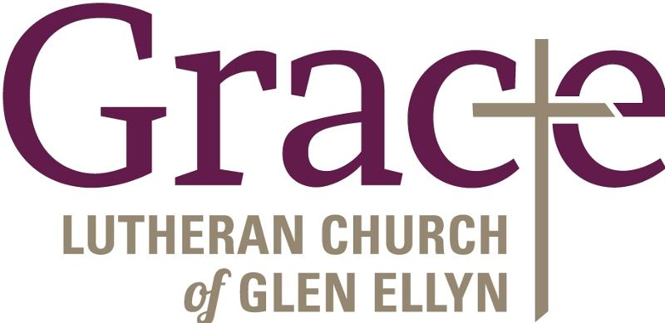

Every Member a Minister and Missionary!

Phone: 630-469-1555 Emergency Pastoral Contact: 630-674-2887
info@graceglenellyn.org www.graceglenellyn.org

Pastor
Rev. Melody Eastman office ext. 14
meastman@graceglenellyn.org

Minister of Music
Bradford Thompson 219-718-8879
bradfordmthompson@gmail.com

Ministry Associate
Becky Ficarella office ext. 17
bficarella@graceglenellyn.org

Office Manager
Barbara Sudds office ext. 10
bsudds@graceglenellyn.org

Parish Counselor
Carole LoGalbo M.S., LCPC 630-668-4594
carolelogalbo@yahoo.com

