Grace Lutheran Church

493 Forest Avenue, Glen Ellyn IL 630.469.1555
www.graceglenellyn.org

10th Sunday after Pentecost August 1, 2021

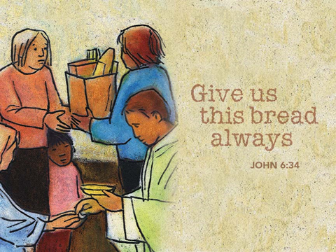

+ Proclaim Christ + Build Community +
+ Serve Our Neighbors +

Introduction
Apparently not satisfied by Jesus’ feeding of thousands, some who were there press him for a sign of his power; perhaps it is daily manna they want. As always in John’s gospel when people want a sign, Jesus offers himself. He is the bread come from heaven to give life to the world. He calls us to come to him and believe in him, and through that relationship to know the one who sent him.

Gathering
The Holy Spirit calls us together as the people of God.
Welcome/Announcements
Helpful Reminders for those joining via Zoom:
- The host will mute you when you join, and you will remain muted until the end of the service.
- You are welcome to join in all congregation responses (in Bold black.) and hymns.
- At the end of the service you may unmute your mic to share greetings with your fellow worshippers. If you dialed in on the phone, press *6. Remember, your host cannot unmute you.

Helpful Reminders for those joining in person:
- Maintain 6’ distance between family groups
- Remain in your pews for communion.
- You may place your offering in the box in the narthex.

Prelude

*Please stand as you are able and turn to face the font.
*Confession and Forgiveness
All may make the sign of the cross, the sign marked at baptism, as the presiding minister begins.
Blessed be the holy Trinity,☩ one God, the God of manna, the God of miracles, the God of mercy. Amen.

Drawn to Christ and seeking God’s abundance, let us confess our sin.
Silence is kept for reflection.

God, our provider, help us. It is hard to believe there is enough to share. We question your ways when they differ from the ways of the world in which we live. We turn to our own understanding rather than trusting in you. We take offense at your teachings and your ways. Turn us again to you. Where else can we turn? Share with us the words of eternal life and feed us for life in the world. Amen.

Beloved people of God: in Jesus, the manna from heaven, you are fed and nourished. By Jesus, the worker of miracles, there is always more than enough. Through Jesus, ☩ the bread of life, you are shown God’s mercy: you are forgiven and loved into abundant life. Amen.

*Entrance Hymn ELW #487 What Feast of Love
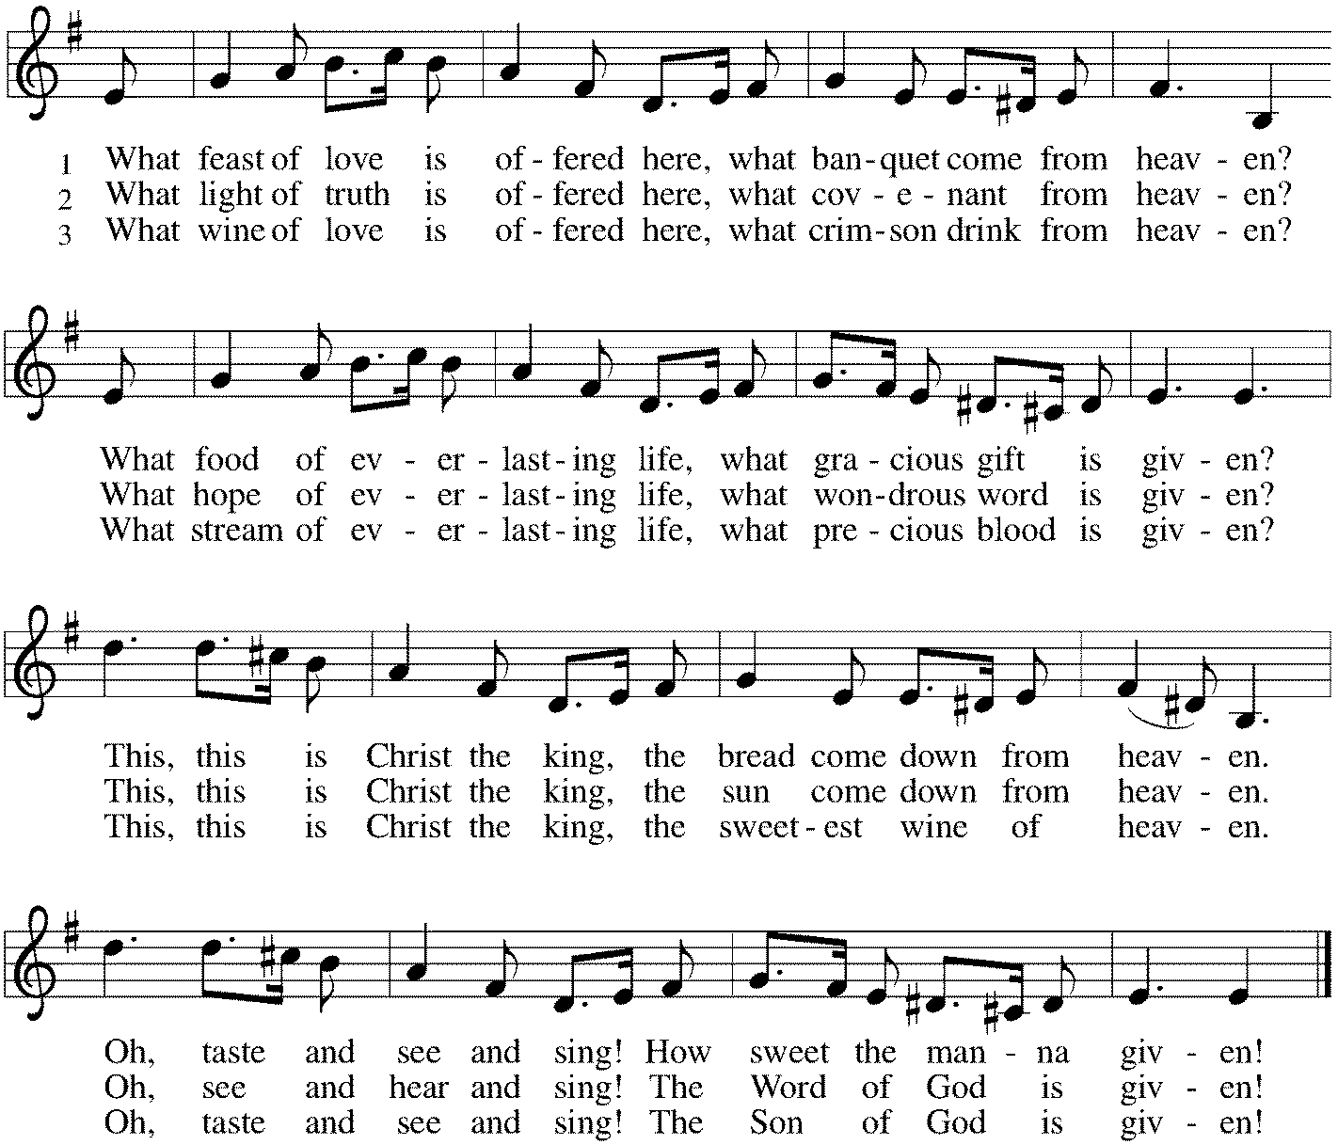

*Greeting
The grace of our Lord Jesus Christ, the love of God, and the communion of the Holy Spirit be with you all. And also with you.

*Kyrie p. 202
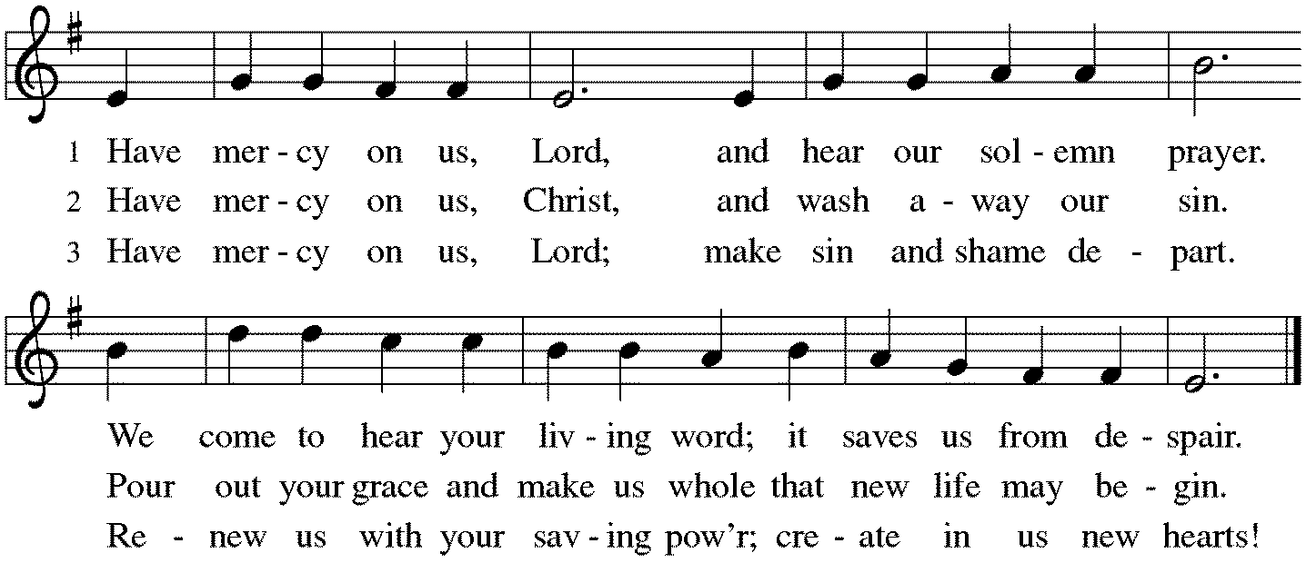

*Hymn of Praise p. 204
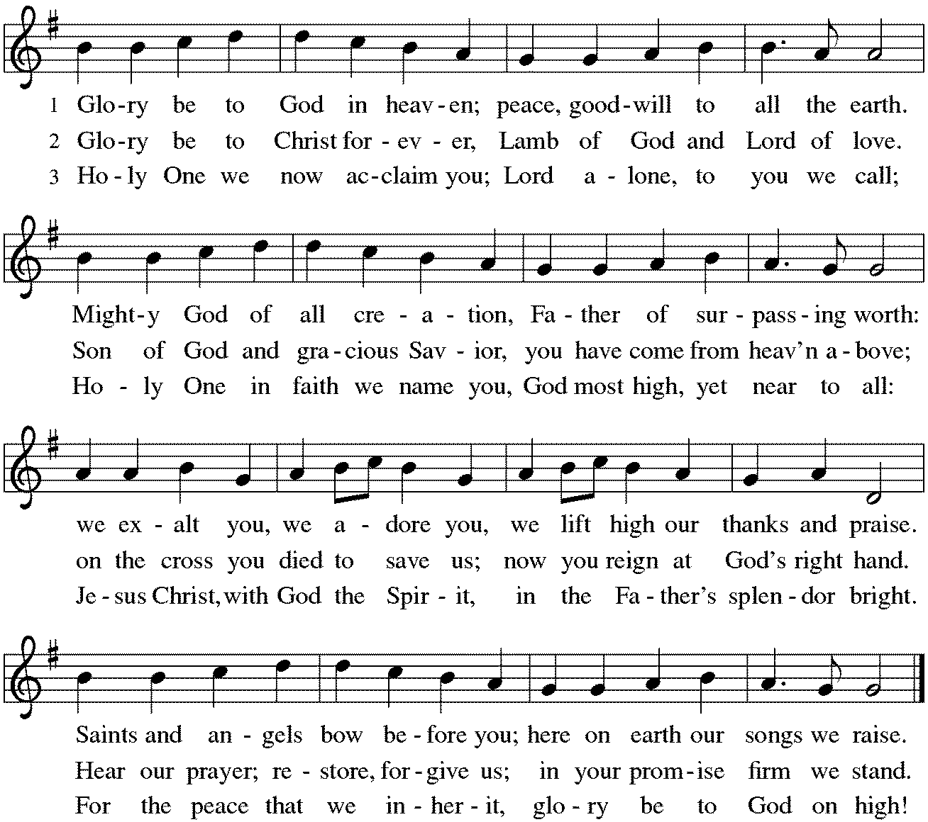
*Prayer of the Day
O God, eternal goodness, immeasurable love, you place your gifts before us; we eat and are satisfied. Fill us and this world in all its need with the life that comes only from you, through Jesus Christ, our Savior and Lord. Amen. Be seated.

Word
God speaks to us in scripture reading, preaching, and song.
First Lesson Exodus 16:2-4, 9-15
A food crisis becomes a faith crisis for the Israelites in the wilderness. The hungry people forget God’s saving work in the exodus, and they wish for the food they had in Egypt. Nevertheless, God miraculously meets their needs, with manna for bread and quail for meat.

²The whole congregation of the Israelites complained against Moses and Aaron in the wilderness. ³The Israelites said to them, “If only we had died by the hand of the Lord in the land of Egypt, when we sat by the fleshpots and ate our fill of bread; for you have brought us out into this wilderness to kill this whole assembly with hunger.”
⁴Then the Lord said to Moses, “I am going to rain bread from heaven for you, and each day the people shall go out and gather enough for that day. In that way I will test them, whether they will follow my instruction or not.”
⁹Then Moses said to Aaron, “Say to the whole congregation of the Israelites, ‘Draw near to the Lord, for he has heard your complaining.’ ” ¹⁰And as Aaron spoke to the whole congregation of the Israelites, they looked toward the wilderness, and the glory of the Lord appeared in the cloud. ¹¹The Lord spoke to Moses and said, ¹²“I have heard the complaining of the Israelites; say to them, ‘At twilight you shall eat meat, and in the morning you shall have your fill of bread; then you shall know that I am the Lord your God.’ ”
¹³In the evening quails came up and covered the camp; and in the morning there was a layer of dew around the camp. ¹⁴When the layer of dew lifted, there on the surface of the wilderness was a fine flaky substance, as fine as frost on the ground. ¹⁵When the Israelites saw it, they said to one another, “What is it?” For they did not know what it was. Moses said to them, “It is the bread that the Lord has given you to eat.”

Word of God, Word of Life. Thanks be to God.

Psalm Psalm 78:23-29
God rained down manna from heaven; so mortals ate the bread of angels. (Ps. 78:24, 25)

²³So God commanded the clouds above and opened the doors of heaven,
²⁴raining down manna upon them to eat and giving them grain from heaven.
²⁵So mortals ate the bread of angels; God provided for them food enough.
²⁶The Lord caused the east wind to blow in the heavens and powerfully led out the south wind,
²⁷raining down flesh upon them like dust and flying birds like the sand of the seas,
²⁸letting them fall in the midst of the camp and round about the dwellings.
²⁹So the people ate and were well filled, for God gave them what they craved.

Second Lesson Ephesians 4:1-16
Christians share fundamental unity and diversity. Our unity consists in the one body, one Spirit, one Lord, one faith, one baptism, and one God. Our diversity is expressed in various forms of ministry whose goal is equipping the saints and building up Christ’s one body.

¹I therefore, the prisoner in the Lord, beg you to lead a life worthy of the calling to which you have been called, ²with all humility and gentleness, with patience, bearing with one another in love, ³making every effort to maintain the unity of the Spirit in the bond of peace. ⁴There is one body and one Spirit, just as you were called to the one hope of your calling, ⁵one Lord, one faith, one baptism, ⁶one God and Father of all, who is above all and through all and in all.
⁷But each of us was given grace according to the measure of Christ’s gift. ⁸Therefore it is said,
“When he ascended on high he made captivity itself a captive;
he gave gifts to his people.”
⁹(When it says, “He ascended,” what does it mean but that he had also descended into the lower parts of the earth? ¹⁰He who descended is the same one who ascended far above all the heavens, so that he might fill all things.) ¹¹The gifts he gave were that some would be apostles, some prophets, some evangelists, some pastors and teachers, ¹²to equip the saints for the work of ministry, for building up the body of Christ, ¹³until all of us come to the unity of the faith and of the knowledge of the Son of God, to maturity, to the measure of the full stature of Christ. ¹⁴We must no longer be children, tossed to and fro and blown about by every wind of doctrine, by people’s trickery, by their craftiness in deceitful scheming. ¹⁵But speaking the truth in love, we must grow up in every way into him who is the head, into Christ, ¹⁶from whom the whole body, joined and knit together by every ligament with which it is equipped, as each part is working properly, promotes the body’s growth in building itself up in love.

Word of God, Word of Life. Thanks be to God.

*Please stand as you are able.
*Gospel Acclamation p. 205 Alleluia
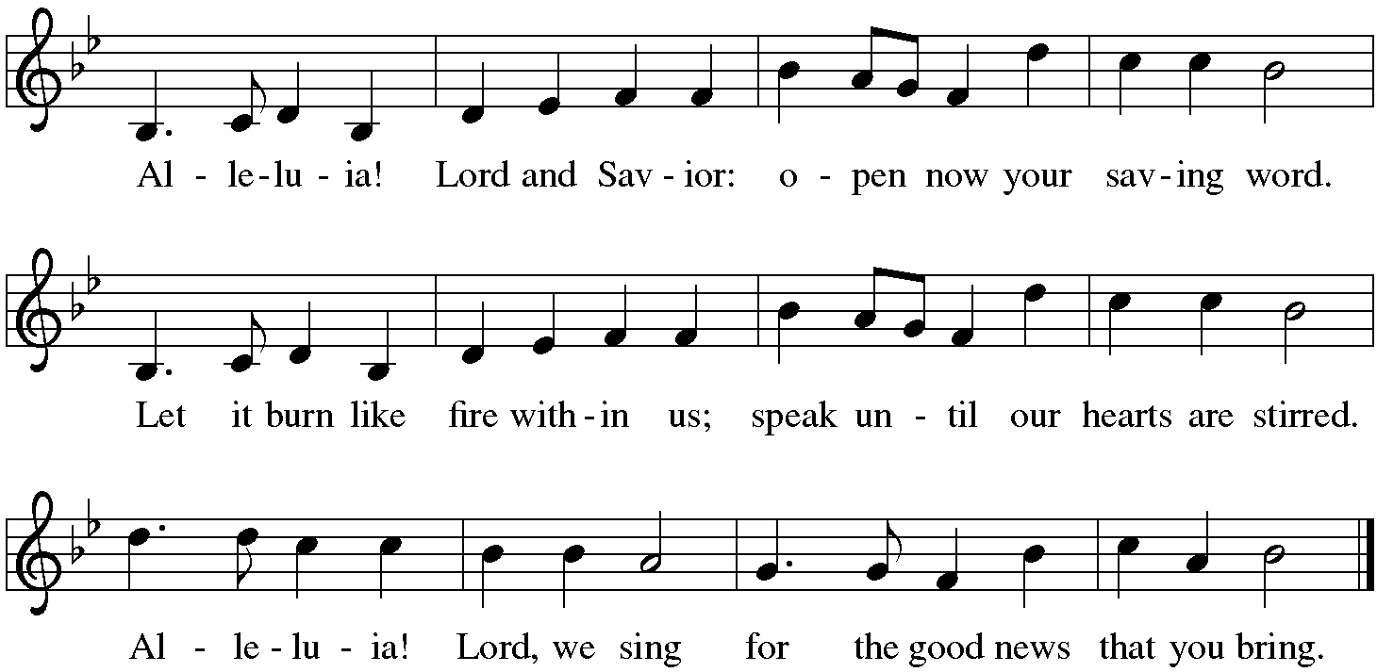

The holy Gospel according to John. Glory to you, O Lord.

*Gospel John 6:24-35
Many of the five thousand people Jesus fed in the wilderness continued to follow him throughout the countryside. Jesus challenges them to consider the real nature of their quest.

²⁴When the crowd saw that neither Jesus nor his disciples were [beside the sea,] they themselves got into the boats and went to Capernaum looking for Jesus.
²⁵When they found him on the other side of the sea, they said to him, “Rabbi, when did you come here?” ²⁶Jesus answered them, “Very truly, I tell you, you are looking for me, not because you saw signs, but because you ate your fill of the loaves. ²⁷Do not work for the food that perishes, but for the food that endures for eternal life, which the Son of Man will give you. For it is on him that God the Father has set his seal.” ²⁸Then they said to him, “What must we do to perform the works of God?” ²⁹Jesus answered them, “This is the work of God, that you believe in him whom he has sent.” ³⁰So they said to him, “What sign are you going to give us then, so that we may see it and believe you? What work are you performing? ³¹Our ancestors ate the manna in the wilderness; as it is written, ‘He gave them bread from heaven to eat.’ ” ³²Then Jesus said to them, “Very truly, I tell you, it was not Moses who gave you the bread from heaven, but it is my Father who gives you the true bread from heaven. ³³For the bread of God is that which comes down from heaven and gives life to the world.” ³⁴They said to him, “Sir, give us this bread always.”
³⁵Jesus said to them, “I am the bread of life. Whoever comes to me will never be hungry, and whoever believes in me will never be thirsty.”

The Gospel of the Lord. Praise to you, O Christ. Be seated.

Sermon The Rev. Melody Eastman

*Please stand as you are able.
*Hymn of the Day ELW #485 I Am the Bread of Life
sts. 1,2,5
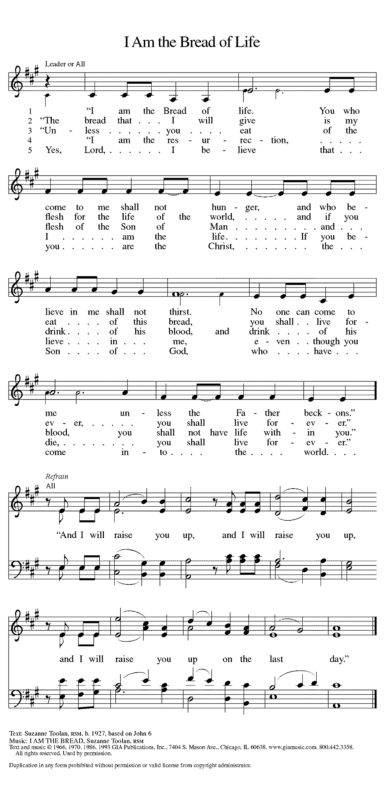

Refrain on next page

*Prayers of Intercession
Rooted in Christ and sustained by the Spirit, we offer our prayers for the church, the world, and all of creation.
A brief silence.
You call your church to be the body of Christ. Awaken all the baptized to the gifts you provide for carrying out the work of ministry. Where the church is divided, knit us together and restore the unity of the faith. Hear us, O God. Your mercy is great.

You command the clouds above and cause the wind to blow in the heavens. Watch over deserts and wilderness places. Regenerate rainforests, defend species at risk of extinction, and strengthen the work of conservation organizations. Hear us, O God. Your mercy is great.

You summon leaders to respond to the needs of your people. Instill those who govern with patience when confronted with grievances and perseverance in seeking what promotes the well-being of the community. Hear us, O God. Your mercy is great.

You draw near to those who cry out for help. Feed those who are hungry, reassure those who are despairing, and accompany those who are imprisoned. Rain down the true bread from heaven that gives life to the world. Hear us, O God. Your mercy is great.

You receive all who come seeking a sign of grace. Make this congregation a place of hospitality for those accustomed to rejection. To those who have felt excluded here or elsewhere, prepare us to welcome them in the name of Christ. To those who are ill, grant your healing Spirit; we pray especially for Keith, Lori, Jim, Cathy, Sigrid, Dorothy, Dolores, Norma, Carol, Dorothy, and those we name before you now…. Hear us, O God. Your mercy is great.
Here other intercessions may be offered.

You provide food that endures for eternal life. Sustain us each day with the bread of life until we are gathered with all the saints and feast together at your heavenly banquet. Hear us, O God. Your mercy is great.

We lift these and all our prayers to you, O God, confident in the promise of your saving love; through Jesus Christ our Lord. Amen.
*Peace
The peace of Christ be with you always. And also with you.
Please share the peace with others in your household, or by making a sign of peace to those on Zoom. Please remain standing.

Meal
God feeds us with the presence of Jesus Christ.
*Offering Prayer
Jesus, Bread of life,
you have set this table with your very self,
and called us to the feast of plenty.
Gather what has been sown among us,
and strengthen us in this meal.
Make us to be what we receive here,
your body for the life of the world. Amen

*Great Thanksgiving
The Lord be with you. And also with you.
Lift up your hearts. We lift them to the Lord.
Let us give thanks to the Lord our God. It is right to give our thanks and praise.

*Preface
It is indeed right, our duty and our joy,
that we should at all times and in all places give thanks and praise to you,
almighty and merciful God, through our Savior Jesus Christ;
who on this day overcame death and the grave,
and by his glorious resurrection opened to us the way of everlasting life.
And so, with all the choirs of angels,
with the church on earth and the hosts of heaven,
we praise your name and join their unending hymn:

*Sanctus p. 207 Holy, Holy, Holy
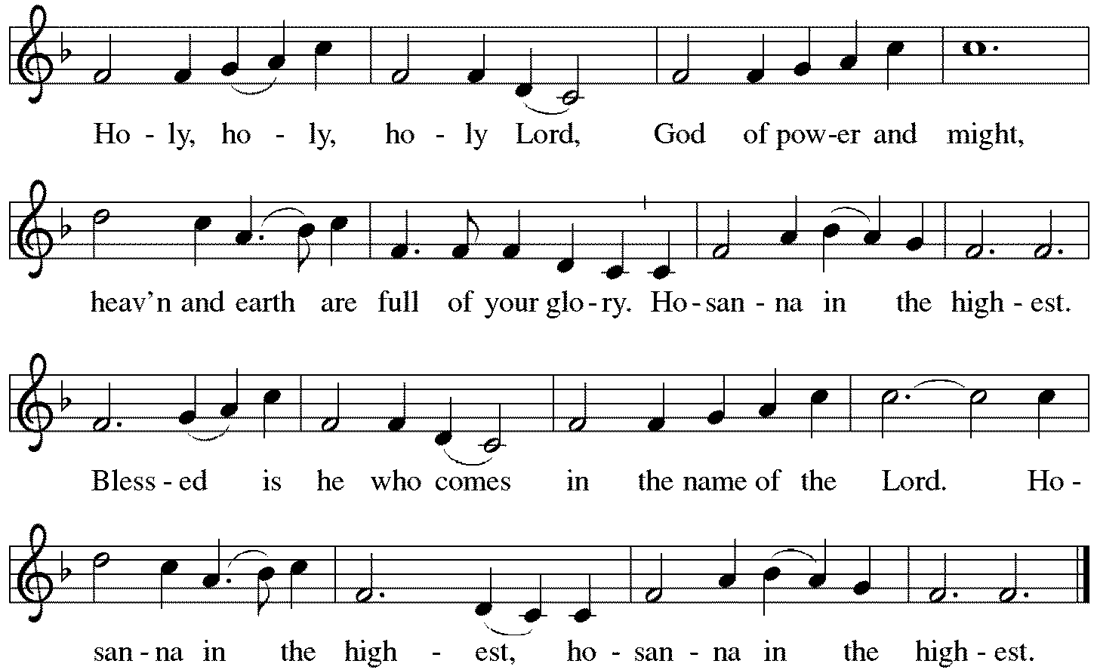

*Thanksgiving at the Table
You are indeed holy, almighty and merciful God.
You are most holy,
and great is the majesty of your glory.

You so loved the world that you gave your only Son,
so that everyone who believes in him may not perish
but have eternal life.
We give you thanks for his coming into the world
to fulfill for us your holy will
and to accomplish all things for our salvation.

In the night in which he was betrayed,
our Lord Jesus took bread, and gave thanks;
broke it, and gave it to his disciples, saying:
Take and eat; this is my body, given for you.
Do this for the remembrance of me.

Again, after supper, he took the cup, gave thanks,
and gave it for all to drink, saying:
This cup is the new covenant in my blood,
shed for you and for all people for the forgiveness of sin.
Do this for the remembrance of me.

For as often as we eat of this bread and drink from this cup,
we proclaim the Lord's death until he comes.
Christ has died. Christ is risen. Christ will come again.

You may hold up your (unopened) communion kit as you are able.
Remembering, therefore, his salutary command,
his life-giving passion and death,
his glorious resurrection and ascension,
and the promise of his coming again,
we give thanks to you, O Lord God Almighty,
not as we ought but as we are able;
we ask you mercifully to accept our praise and thanksgiving
and with your Word and Holy Spirit to bless us, your servants,
and these your own gifts of bread and wine,
so that we and all who share in the body and blood of Christ
may be filled with heavenly blessing and grace,
and, receiving the forgiveness of sin,
may be formed to live as your holy people
and be given our inheritance with all your saints.
You may lower your communion kit.

To you, O God, Father, Son, and Holy Spirit,
be all honor and glory in your holy church, now and forever.
Amen.

*The Lord’s Prayer
Gathered into one by the Holy Spirit, let us pray as Jesus taught us.
Our Father in heaven, hallowed be your name, your kingdom come, your will be done, on earth as in heaven. Give us today our daily bread. Forgive us our sins as we forgive those who sin against us. Save us from the time of trial and deliver us from evil. For the kingdom, the power, and the glory are yours, now and forever. Amen.

*Invitation to Communion
Christ has set the table with more than enough for all. Come! Be Seated.

If you have difficulty opening your communion, please signal an usher for assistance.

Peel up the clear top seal over the wafer, and hold the wafer up when you are ready.
This is the Body of Christ, given for you. (Eat the bread.)

Peel up the second foil seal over the juice, and hold your cup up when you are ready.
This is the blood of Christ, shed for you. (Drink the wine/juice.)
Amen.

After communion you may place the packaging in the bowl in your pew. The ushers will dispose of these following the service.

Agnus Dei p. 208 Lamb of God
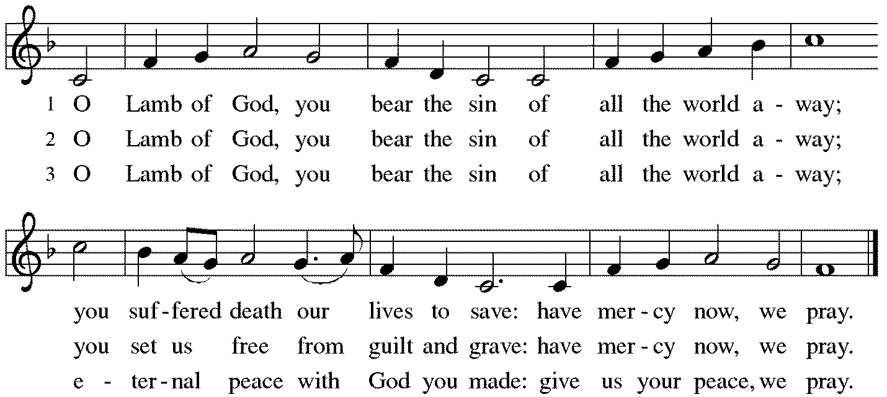

*Please stand as you are able.
*Post-Communion Blessing
The body and blood of our Lord Jesus Christ strengthen you and keep you in his grace. Amen.

*Prayer after Communion
Jesus, Bread of life, we have received from your table more than we could ever ask. As you have nourished us in this meal, now strengthen us to love the world with your own life. In your name we pray. Amen.

Sending
God blesses us and sends us in mission to the world.
*Blessing
The blessing of God, who provides for us, feeds us, and journeys with us, ☩ be upon you now and forever. Amen.

*Sending Hymn ELW#463 We Are All One in Christ!
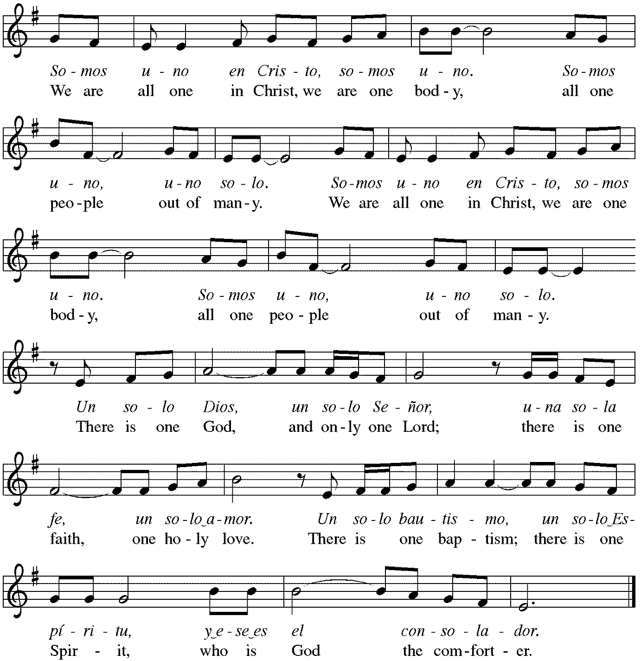

*Sent to the World
Go in peace. You are the body of Christ. Thanks be to God.

Postlude
After the postlude, those who have joined via Zoom may unmute your mics
and share a greeting with your fellow worshippers.

From Sundays and Seasons
v.20190109.1233 Copyright © 2021 Augsburg Fortress. All rights reserved.
Reprinted by permission under Augsburg Fortress Liturgies Annual License #30867.
All rights reserved. Reprinted under OneLicense.net #A-718333.

Assisting in Worship Today
Ministry Associate Becky Ficarella
Minister of Music Bradford Thompson
Lector Vince Hardt
Ushers Mario Ficarella, Chuck Miller, Bill Murdoch, Open
Altar Flowers

Current Prayer Requests
Please keep these people in your prayers and reach out to our sisters and brothers in Christian love. Names will be left on the list for two weeks, unless you indicate that they should remain in our prayers for a longer period.
Name Relationship Prayer For
Jim Sladek Member Healing & Strength
Cathy Milleville Member Healing & Strength
Sigrid Elliott Member Healing & Strength
Dorothy Tracy Member Healing & Strength
Keith Petras Brother of Dru Geraghty Healing & Strength
Family of Joanne Wenner Sandy Wenner’s mother Comfort in Grief
Lori Garabrandt Relative of Chuck Miller and Lois Pertle Healing & Strength
Chris Danly Son of Mark & Pat Danly Healing & Strength
Tammy Rollo Friend of Barbara Sudds Healing & Strength
Prayers for our homebound Members
Dolores Nosal, Carol Petersen, Norma Petersen, Dorothy Stein

The church office will be closed the week of August 1.

Articles for the September issue of Grace to You are due to the church office by Friday, August 6. The newsletter will be sent to print on Monday, August 9.

FaithTalk August 5: Join Pr. Melody on the 1st Thursday of the month from 12:30-2:00pm. If you are attending Sue Davison’s exercise class that ends at noon, bring a lunch and join us in the basement after class. Those who like can eat lunch together and we’ll begin our discussion at 12:30.

Women of Grace: We will meet for drinks and dining outdoors together on August 12, 7:00pm, at Reserve 22. Please RSVP to Becky Ficarella by phone 847-347-0928 or email bficarella@graceglenellyn.org.

High School & Confirmation Bible Study: Via Zoom Monday, August 2nd at 7:30pm with Dominic LoGalbo and Becky Ficarella.

High School Volunteer Opportunity: Saturday, August 14th at St. Andrew’s Church in West Chicago from 8am-11am we will assist with the delivery of food and baby essential items to a drive-up food pantry. This ministry serves as many as 300 cars on a given Saturday. We will team up with St. Paul Youth for this event. Please RSVP with Becky Ficarella.

Calling ALL Students and Professionals: Backpack Blessing is Sunday, August 15th at 9am! Bring your backpack/briefcase and receive a tag and blessing for the exciting year of study ahead!

Fellowship Sunday, August 15: We will offer coffee and donuts with outdoor seating following the worship service. We look forward to visiting with you!

Save the Date: August 29th Outdoor Worship & Picnic at Blackwell Forest Preserve. Join us for a special outdoor worship service at the East Picnic Shelter at Blackwell Forest Preserve on Sunday, August 29 at 9:00am. (The East Picnic Shelter is a long drive into the park—the last shelter at the end of the road, but easily accessible with a paved path from the parking lot to the shelter.) Feel free to bring camp chairs (the shelter may not hold all of us) and your own picnic brunch/lunch; we’ll enjoy fellowship, food and some kids’ games after our service. We look forward to seeing you there!

August Birthday Blessings: Beth Bruning 94 on 8/9; Shirley Sauerman 94 on 8/17; Carol Wandke 91 on 8/22; and Norma Peterson 94 on 8/26.

Lectors: If you would like to see the readings in advance of your Sunday, you can view the current week bulletin on Grace’s website.

Check out Marvel's latest superhero, ELCA member Rebekah Bruesehoff, ​as the Mighty Rebekah: Rebekah is one of 20 kids Marvel selected for the Marvel Hero Project. Marvel created comics to tell the stories of heroic work everyday kids do to make the world a better place. Marvel created the character Mighty Rebekah to add her story to the Marvel universe of superheroes. You can view the story of this amazing young person on Grace’s website www.GraceGlenEllyn.org.

Circle of Care Coordinator Needed: We are seeking an individual to fill the role of Circle of Care Coordinator. Sooz Hufnagle was fulfilling this role previously, but is no longer available to serve due to the Hufnagle's relocation to South Carolina.
This role includes managing incoming requests of care from members and then finding the appropriate volunteers to help from a current list of willing helpers! Examples might include rides, grocery store runs, or meal drop offs. Please contact the church office or Becky Ficarella if you are interested!

Altar Flowers for Summer Worship Services: Let's get creative and try something fun for the summer! We invite you to sign up in the narthex to provide floral bouquets that you have created. It’s okay if bouquets don’t match or we have only one bouquet on a Sunday! Share from your garden, the farmer's market, or local store and bring them with you Sunday morning! Please sign up in the Narthex, or contact the church office to reserve a date. Please only include flowers and no special decorations or messages in the bouquet. These are the available dates: August 15; August 22; September 5.

Ushers Needed: Each of our four usher teams are in need of one additional team member. Team 1 (January, May, September); Team 2 (February, June, October); Team 3 (March, July, November; Team 4 (April, August, December). Please contact the church office if you can volunteer for one of these teams or sign up in the Narthex.

RAMP: Our mortgage reduction campaign has been renamed “RAMP” (Reduce Another Mortgage Payment) as we continue to RAMP up to refinance our mortgage with Mission Investment Fund this Fall. We plan to make a $25,000 payment against principal in July. Thank you to all who have contributed to date. We are still hopeful we can raise another $75,000 before November. Lowering our monthly mortgage payments will free up funds that we can utilize on the ministries of Grace.

Got Capital Gains? Did you know that stock donations allow you to both claim a deduction at the appreciated value AND allow you to avoid capital gains taxes on these assets? Further, consolidating donations in a tax year could lead to increased ability to deduct charitable contributions in a given tax year. Consult your tax advisor for details, but if you’d like more information on how to go about donating stock, reach out to the church office.
Contributions to Grace: You may continue to mail your contributions to the church office; have your bank mail your contribution to the church office (this works great); or contribute on-line through Grace’s website (Grace/you pay fees). Please know, pandemic or no, our mission continues! Thank you for your continued support of our ministries at Grace Lutheran.

Bradford’s Livestream Music Session: Join Bradford for LIVE music sessions broadcast directly from Grace! Just click on the link Wednesday evening at 7:00pm to join Bradford on his YouTube channel: https://youtube.com/channel/UCbgfoPipBLAlY3hAkVKoI8Q

Chair Exercise and monthly Book Club. Registration is required as the number of attendees will be limited. The exercise class meets Mondays at 10:00am and Thursdays at 11:00am. The Book Club will meet on the third Tuesday of the month at 11:00am. Please contact Sue Davison at 630-858-6343 to register.

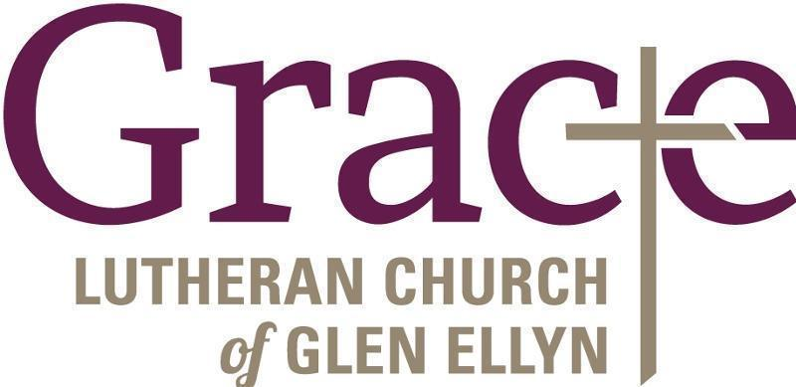

Every Member a Minister and Missionary!

Phone: 630-469-1555 Emergency Pastoral Contact: 630-674-2887
info@graceglenellyn.org www.graceglenellyn.org

Pastor
Rev. Melody Eastman office ext. 14
meastman@graceglenellyn.org

Minister of Music
Bradford Thompson 219-718-8879
bradfordmthompson@gmail.com

Ministry Associate
Becky Ficarella office ext. 17
bficarella@graceglenellyn.org

Office Manager
Barbara Sudds office ext. 10
bsudds@graceglenellyn.org

Parish Counselor
Carole LoGalbo M.S., LCPC 630-668-4594
carolelogalbo@yahoo.com

