Grace Lutheran Church

493 Forest Avenue, Glen Ellyn IL 630.469.1555
www.graceglenellyn.org

11th Sunday after Pentecost August 8, 2021

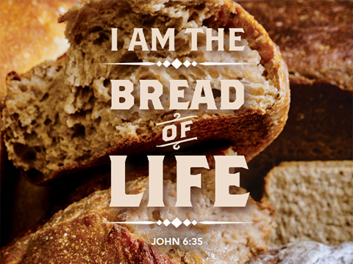

+ Proclaim Christ + Build Community +
+ Serve Our Neighbors +
Introduction
Jesus says that the bread he gives for the life of the world is his flesh, and whoever eats this bread has eternal life now and will be raised on the last day. In Ephesians Paul tells us what this life Jesus gives us looks like, this life we live as those marked with the seal of the Holy Spirit in baptism. We live in love, as Christ loved us and gave himself up for us. The whole purpose of life is giving yourself for the other.

Gathering
The Holy Spirit calls us together as the people of God.
Welcome/Announcements
Helpful Reminders for those joining via Zoom:
- The host will mute you when you join, and you will remain muted until the end of the service.
- You are welcome to join in all congregation responses (in Bold black.) and hymns.
- At the end of the service you may unmute your mic to share greetings with your fellow worshippers. If you dialed in on the phone, press *6. Remember, your host cannot unmute you.

Helpful Reminders for those joining in person:
- Maintain 6’ distance between family groups
- Remain in your pews for communion.
- You may place your offering in the box in the narthex.

Prelude

*Please stand as you are able and turn to face the font.
*Confession and Forgiveness
All may make the sign of the cross, the sign marked at baptism, as the presiding minister begins.
Blessed be the holy Trinity,☩ one God, the God of manna, the God of miracles, the God of mercy. Amen.

Drawn to Christ and seeking God’s abundance, let us confess our sin.

God, our provider, help us. It is hard to believe there is enough to share. We question your ways when they differ from the ways of the world in which we live. We turn to our own understanding rather than trusting in you. We take offense at your teachings and your ways. Turn us again to you. Where else can we turn? Share with us the words of eternal life and feed us for life in the world. Amen.

Beloved people of God: in Jesus, the manna from heaven, you are fed and nourished. By Jesus, the worker of miracles, there is always more than enough. Through Jesus, ☩ the bread of life, you are shown God’s mercy: you are forgiven and loved into abundant life. Amen.

*Entrance Hymn ELW #400 God of Tempest, God of Whirlwind
sts. 1,2,4
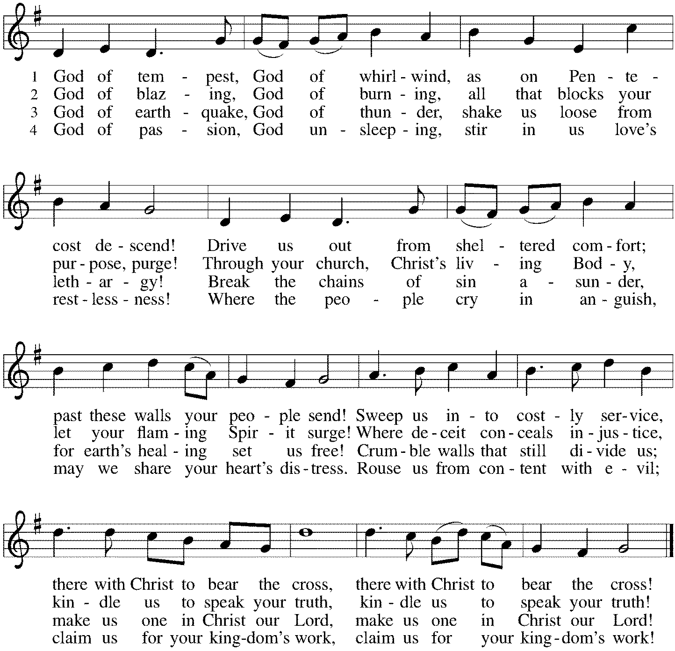

*Greeting
The grace of our Lord Jesus Christ, the love of God, and the communion of the Holy Spirit be with you all. And also with you.

*Kyrie p. 202
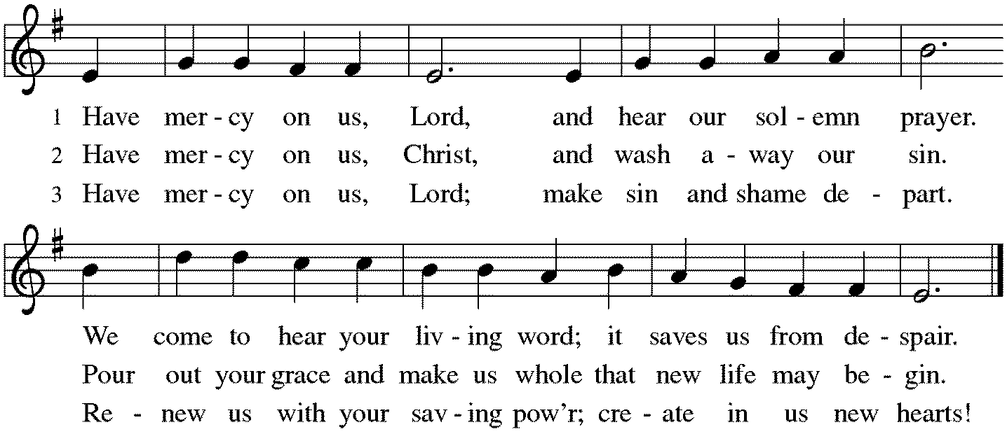

*Hymn of Praise p. 204
*Prayer of the Day
Gracious God, your blessed Son came down from heaven to be the true bread that gives life to the world. Give us this bread always, that he may live in us and we in him, and that, strengthened by this food, we may live as his body in the world, through Jesus Christ, our Savior and Lord. Amen. Be seated.

Word
God speaks to us in scripture reading, preaching, and song.
First Lesson 1 Kings 19:4-8
First Kings chapter 18 describes the contest between Elijah and the prophets of Baal. The contest proves that the Lord is God, and afterward Elijah orders the killing of the Baal prophets. Angered by the deaths of her prophets, Queen Jezebel threatens to kill Elijah. This reading finds Elijah fleeing, fatigued, and in utter despair.

⁴[Elijah] went a day’s journey into the wilderness, and came and sat down under a solitary broom tree. He asked that he might die: “It is enough; now, O Lord, take away my life, for I am no better than my ancestors.”⁵Then he lay down under the broom tree and fell asleep. Suddenly an angel touched him and said to him, “Get up and eat.” ⁶He looked, and there at his head was a cake baked on hot stones, and a jar of water. He ate and drank, and lay down again. ⁷The angel of the Lord came a second time, touched him, and said, “Get up and eat, otherwise the journey will be too much for you.” ⁸He got up, and ate and drank; then he went in the strength of that food forty days and forty nights to Horeb the mount of God.

Word of God, Word of Life. Thanks be to God.

Psalm Psalm 34:1-8
Taste and see that the Lord is good. (Ps. 34:8)

¹I will bless the Lord at all times; the praise of God shall ever be in my mouth.
²I will glory in the Lord; let the lowly hear and rejoice.
³Proclaim with me the greatness of the Lord; let us exalt God’s name together.
⁴I sought the Lord, who answered me and delivered me from all my terrors.
⁵Look upon the Lord and be radiant, and let not your faces be ashamed.
⁶I called in my affliction, and the Lord heard me and saved me from all my troubles.
⁷The angel of the Lord encamps around those who fear the Lord and delivers them.
⁸Taste and see that the Lord is good; happy are they who take refuge in God!

Second Lesson Ephesians 4:25--5:2
Christians are called to be imitators of God. This does not mean Christians are perfect. Rather, the Spirit is at work in our lives so that our actions and attitudes genuinely reflect the love and forgiveness we have received through Christ and his death.

²⁵So then, putting away falsehood, let all of us speak the truth to our neighbors, for we are members of one another. ²⁶Be angry but do not sin; do not let the sun go down on your anger, ²⁷and do not make room for the devil. ²⁸Thieves must give up stealing; rather let them labor and work honestly with their own hands, so as to have something to share with the needy. ²⁹Let no evil talk come out of your mouths, but only what is useful for building up, as there is need, so that your words may give grace to those who hear. ³⁰And do not grieve the Holy Spirit of God, with which you were marked with a seal for the day of redemption. ³¹Put away from you all bitterness and wrath and anger and wrangling and slander, together with all malice, ³²and be kind to one another, tenderhearted, forgiving one another, as God in Christ has forgiven you. ^{5:1}Therefore be imitators of God, as beloved children, ²and live in love, as Christ loved us and gave himself up for us, a fragrant offering and sacrifice to God.

Word of God, Word of Life. Thanks be to God.

*Please stand as you are able.
*Gospel Acclamation p. 205 Alleluia
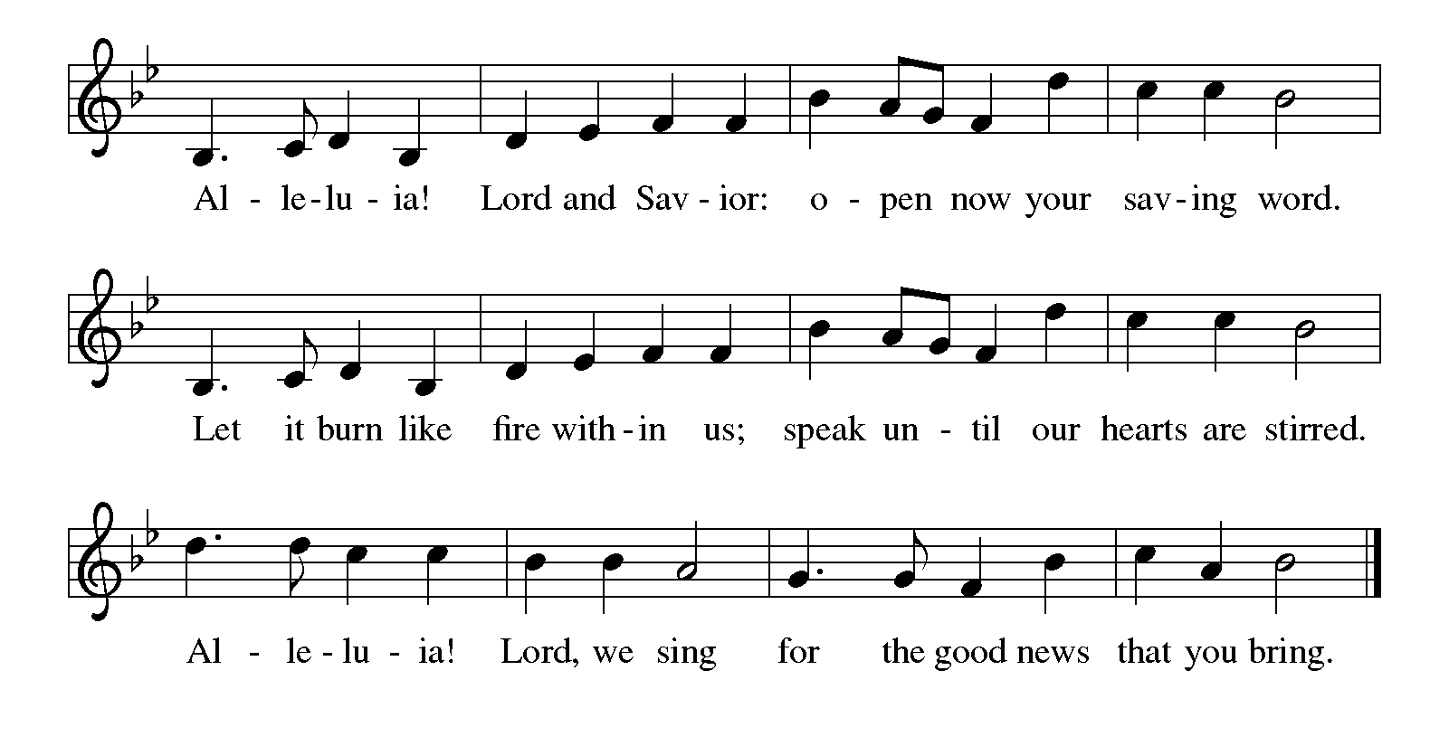

The holy Gospel according to John. Glory to you, O Lord.

*Gospel John 6:41-51
After feeding more than five thousand people in the wilderness, Jesus teaches them regarding the true significance of this remarkable sign.

³⁵Jesus said to [the crowd,] “I am the bread of life. Whoever comes to me will never be hungry, and whoever believes in me will never be thirsty. ⁴¹Then the Jews began to complain about him because he said, “I am the bread that came down from heaven.” ⁴²They were saying, “Is not this Jesus, the son of Joseph, whose father and mother we know? How can he now say, ‘I have come down from heaven’?” ⁴³Jesus answered them, “Do not complain among yourselves. ⁴⁴No one can come to me unless drawn by the Father who sent me; and I will raise that person up on the last day. ⁴⁵It is written in the prophets, ‘And they shall all be taught by God.’ Everyone who has heard and learned from the Father comes to me. ⁴⁶Not that anyone has seen the Father except the one who is from God; he has seen the Father. ⁴⁷Very truly, I tell you, whoever believes has eternal life. ⁴⁸I am the bread of life. ⁴⁹Your ancestors ate the manna in the wilderness, and they died. ⁵⁰This is the bread that comes down from heaven, so that one may eat of it and not die. ⁵¹I am the living bread that came down from heaven. Whoever eats of this bread will live forever; and the bread that I will give for the life of the world is my flesh.”

The Gospel of the Lord. Praise to you, O Christ. Be seated.

Sermon The Rev. Melody Eastman

*Please stand as you are able.
*Hymn of the Day ELW #793 Be Thou My Vision
sts. 1,2,4
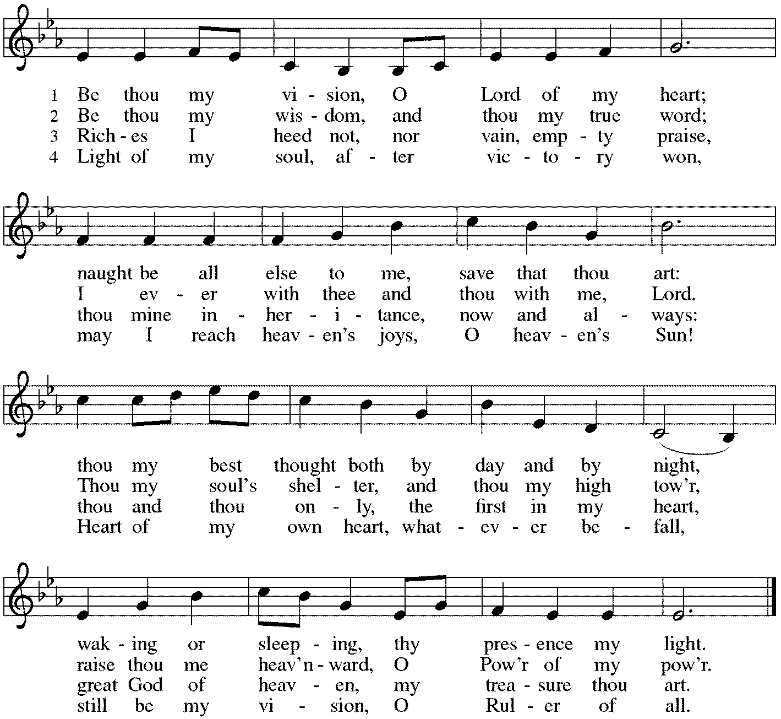

*Prayers of Intercession
Rooted in Christ and sustained by the Spirit, we offer our prayers for the church, the world, and all of creation.
A brief silence.

For the church of Christ in all its diverse forms. For mission developers, new mission starts, and all communities of faith exploring new models of ministry for the sake of the gospel. For congregations facing difficult decisions about their future. God, in your mercy, hear our prayer.

For the health and well-being of creation. For shade trees that provide refuge from the hot summer sun. For lakes, rivers, and oceans contaminated by pollution and all who lack clean water. God, in your mercy, hear our prayer.

For those called to positions of authority in our legal system, we pray. For judges, lawyers, law clerks, and court employees who ensure the fair administration of justice. For corrections officers and prison chaplains, that they would deal mercifully with those who are incarcerated. God, in your mercy, hear our prayer.

For all who cry out to you in their affliction. For exiles, refugees, and others who face long and difficult journeys, uncertain about the future. For all who mourn the death of a loved one, especially Sandy Wenner, mourning the death of her mother Joanne. For all who are sick, especially Sigrid, Jim, Cathy, Dorothy, Dolores, Carol, Norma, Dorothy, and those we name before you now. . . God, in your mercy, hear our prayer.

All honor and glory and blessing belong to you. We thank you and praise you for the faith and witness of Beth Bruning, and we ask your blessing on her as she celebrates her 94th birthday. We praise you for the faith of all the saints. Be near us as we await the day when we will feast with the risen Christ forever. God, in your mercy, hear our prayer.

For this assembly gathered around your table, we pray. For those among us who bake bread and prepare the vessels for our communion celebration. For those who bring the food from this table to those who are homebound or hospitalized. God, in your mercy, hear our prayer.

For those who have been raised to eternal life, we give thanks. With all the saints we praise you for the bread of life that keeps us in your love forever. God, in your mercy, hear our prayer.

We lift these and all our prayers to you, O God, confident in the promise of your saving love; through Jesus Christ our Lord. Amen.

*Peace
The peace of Christ be with you always. And also with you.
Please share the peace with others in your household, or by making a sign of peace to those on Zoom. Please remain standing.

Meal
God feeds us with the presence of Jesus Christ.
*Offering Prayer
Jesus, Bread of life, you have set this table with your very self, and called us to the feast of plenty. Gather what has been sown among us, and strengthen us in this meal. Make us to be what we receive here, your body for the life of the world. Amen

*Great Thanksgiving
The Lord be with you. And also with you.
Lift up your hearts. We lift them to the Lord.
Let us give thanks to the Lord our God. It is right to give our thanks and praise.

*Preface
It is indeed right, our duty and our joy, that we should at all times and in all places give thanks and praise to you, almighty and merciful God, through our Savior Jesus Christ; who on this day overcame death and the grave, and by his glorious resurrection opened to us the way of everlasting life. And so, with all the choirs of angels, with the church on earth and the hosts of heaven, we praise your name and join their unending hymn:

*Sanctus p. 207 Holy, Holy, Holy
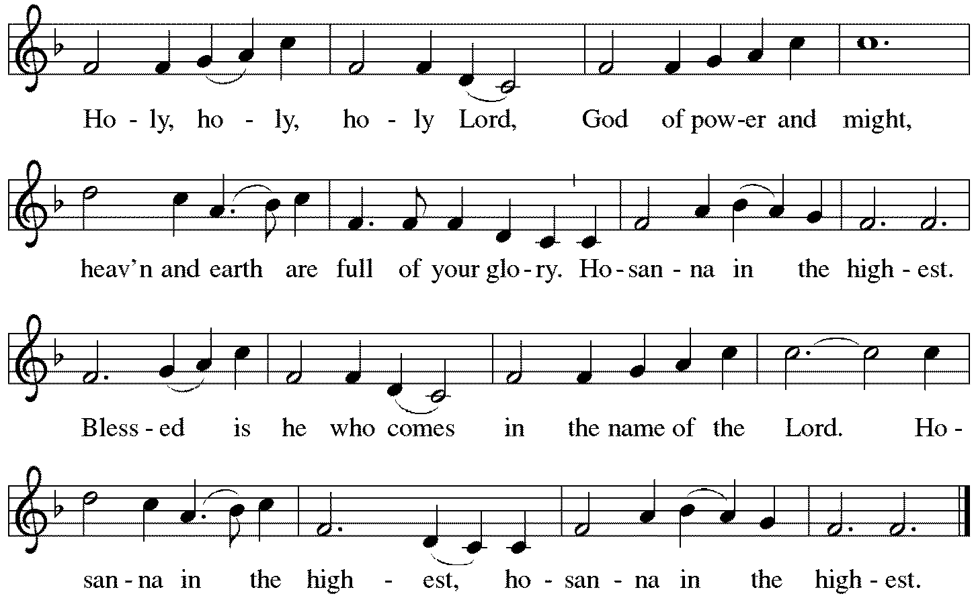

*Thanksgiving at the Table
You are indeed holy, almighty and merciful God. You are most holy, and great is the majesty of your glory.

You so loved the world that you gave your only Son, so that everyone who believes in him may not perish
but have eternal life. We give you thanks for his coming into the world to fulfill for us your holy will and to accomplish all things for our salvation.
In the night in which he was betrayed, our Lord Jesus took bread, and gave thanks; broke it, and gave it to his disciples, saying: Take and eat; this is my body, given for you. Do this for the remembrance of me.

Again, after supper, he took the cup, gave thanks, and gave it for all to drink, saying: This cup is the new covenant in my blood, shed for you and for all people for the forgiveness of sin. Do this for the remembrance of me.

For as often as we eat of this bread and drink from this cup, we proclaim the Lord's death until he comes. Christ has died. Christ is risen. Christ will come again.

You may hold up your (unopened) communion kit as you are able.
Remembering, therefore, his salutary command, his life-giving passion and death, his glorious resurrection and ascension, and the promise of his coming again, we give thanks to you, O Lord God Almighty, not as we ought but as we are able; we ask you mercifully to accept our praise and thanksgiving and with your Word and Holy Spirit to bless us, your servants, and these your own gifts of bread and wine, so that we and all who share in the body and blood of Christ may be filled with heavenly blessing and grace, and, receiving the forgiveness of sin, may be formed to live as your holy people and be given our inheritance with all your saints.
You may lower your communion kit.

To you, O God, Father, Son, and Holy Spirit, be all honor and glory in your holy church, now and forever. Amen.

*The Lord’s Prayer
Gathered into one by the Holy Spirit, let us pray as Jesus taught us.
Our Father, who art in heaven, hallowed be thy name, thy kingdom come, thy will be done, on earth as it is in heaven. Give us this day our daily bread; and forgive us our trespasses as we forgive those who trespass against us; and lead us not into temptation but deliver us from evil. For thine is the kingdom, the power, and the glory, forever and ever. Amen.

*Invitation to Communion
Christ has set the table with more than enough for all. Come! Be Seated.

If you have difficulty opening your communion, please signal an usher for assistance.

Peel up the clear top seal over the wafer, and hold the wafer up when you are ready.
This is the Body of Christ, given for you. (Eat the bread.) Amen.

Peel up the second foil seal over the juice, and hold your cup up when you are ready.
This is the blood of Christ, shed for you. (Drink the wine/juice.) Amen.

After communion you may place the packaging in the bowl in your pew. The ushers will dispose of these following the service.

Agnus Dei p. 208 Lamb of God
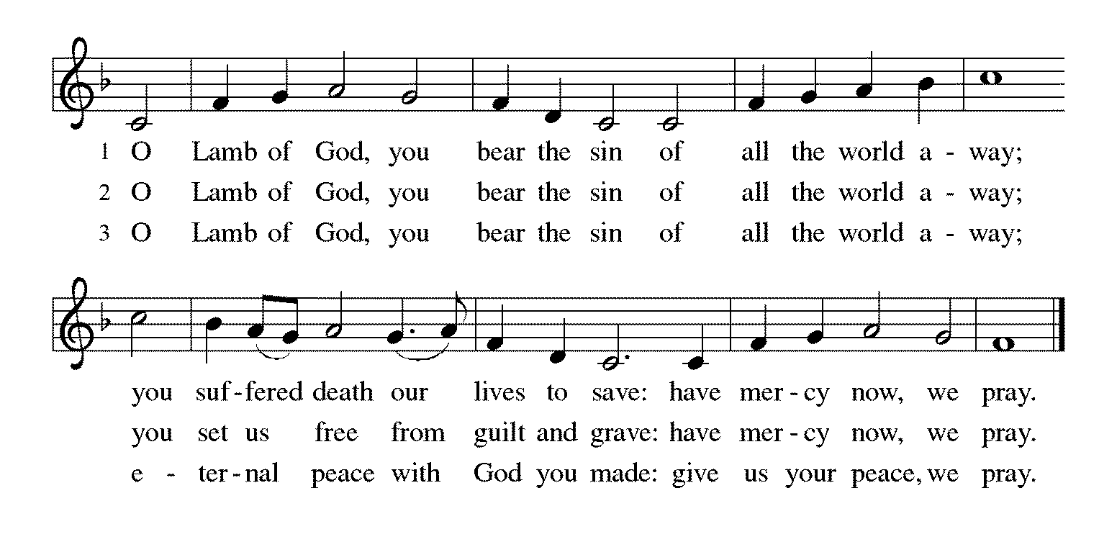

*Please stand as you are able.
*Post-Communion Blessing
The body and blood of our Lord Jesus Christ strengthen you and keep you in his grace. Amen.

*Prayer after Communion
Jesus, Bread of life, we have received from your table more than we could ever ask. As you have nourished us in this meal, now strengthen us to love the world with your own life. In your name we pray. Amen.
Sending
God blesses us and sends us in mission to the world.
*Blessing
The blessing of God, who provides for us, feeds us, and journeys with us, ☩ be upon you now and forever. Amen.

*Sending Hymn ELW#535 Hallelujah! We Sing Your Praises
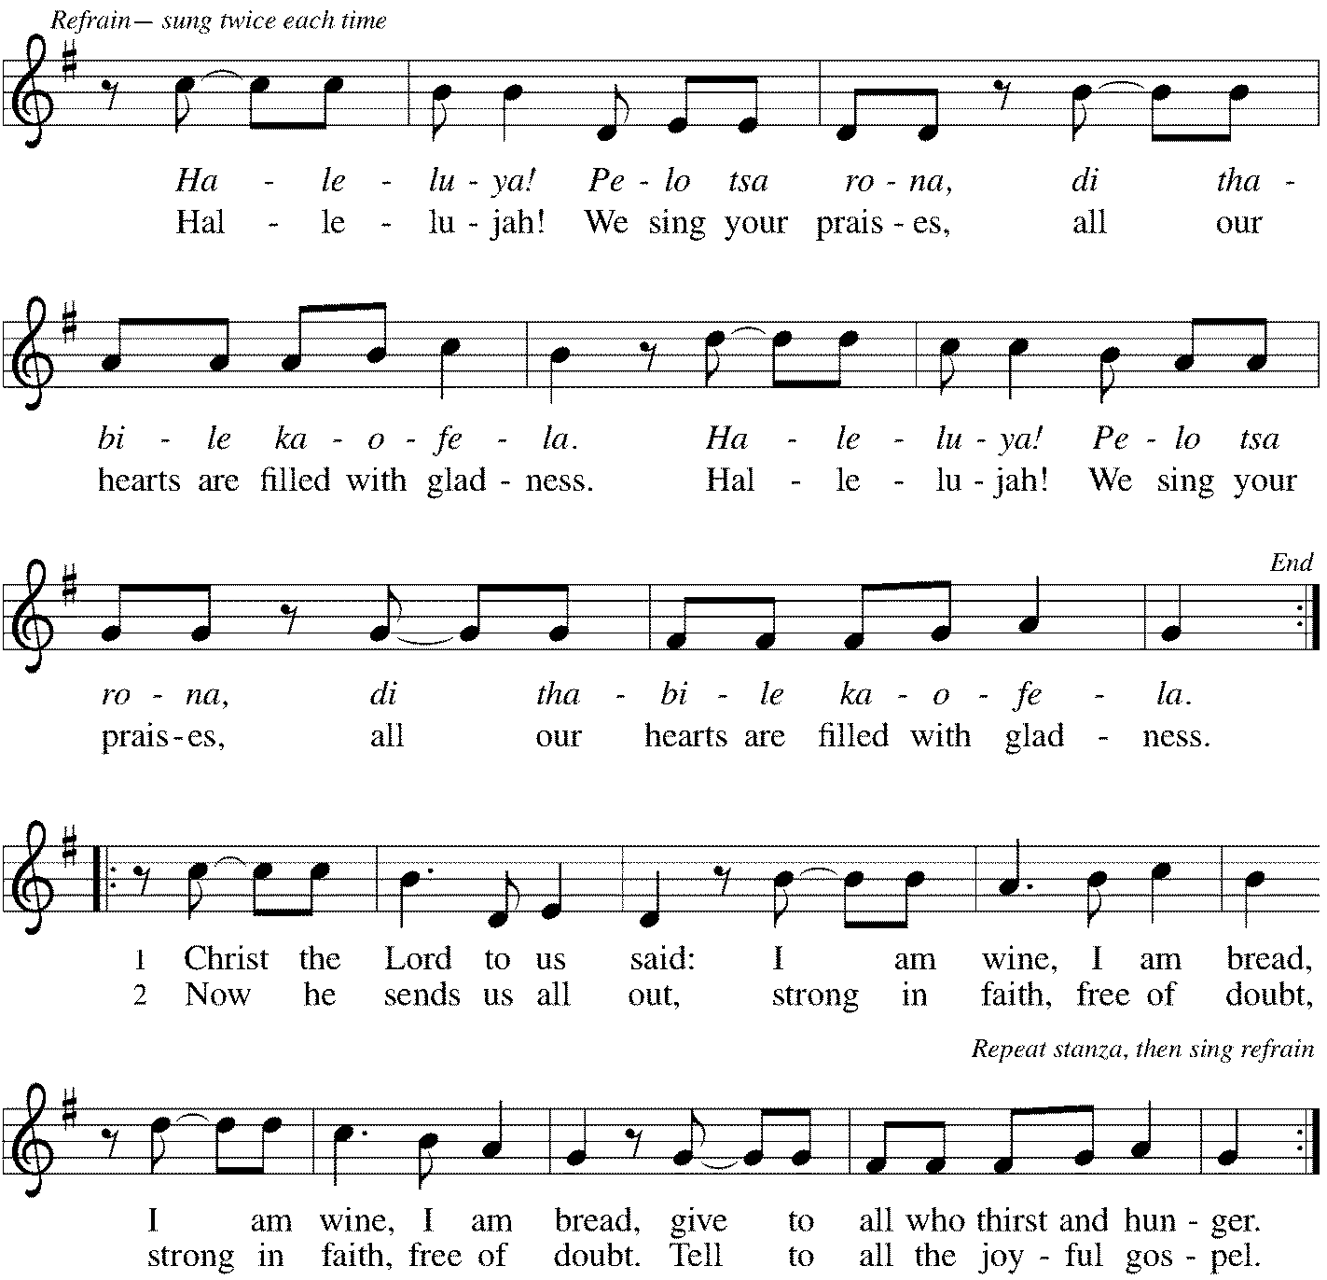

*Sent to the World
Go in peace. You are the body of Christ. Thanks be to God.

Postlude
After the postlude, those who have joined via Zoom may unmute your mics
and share a greeting with your fellow worshippers.

From Sundays and Seasons
v.20190109.1233 Copyright © 2021 Augsburg Fortress. All rights reserved.
Reprinted by permission under Augsburg Fortress Liturgies Annual License #30867.
All rights reserved. Reprinted under OneLicense.net #A-718333.
Assisting in Worship Today
Ministry Associate Becky Ficarella
Minister of Music Bradford Thompson
Lector Rob Granner
Ushers Mario Ficarella, Chuck Miller, Bill Murdoch, Open
Altar Flowers Jean Jeske in loving memory of Jerry.

Current Prayer Requests
Please keep these people in your prayers and reach out to our sisters and brothers in Christian love. Names will be left on the list for two weeks, unless you indicate that they should remain in our prayers for a longer period.
Name Relationship Prayer For
Jim Sladek Member Healing & Strength
Cathy Milleville Member Healing & Strength
Sigrid Elliott Member Healing & Strength
Dorothy Tracy Member Healing & Strength
Keith Petras Brother of Dru Geraghty Healing & Strength
Family of Joanne Wenner Mother of Sandy Wenner Comfort in Grief
Lori Garabrandt Relative of Chuck Miller and Lois Pertle Healing & Strength
Chris Danly Son of Mark & Pat Danly Healing & Strength
Tammy Rollo Friend of Barbara Sudds Healing & Strength
Prayers for our homebound Members
Dolores Nosal, Carol Petersen, Norma Petersen, Dorothy Stein

Articles for the September issue of Grace to You are due to the church office by Friday, August 6. The newsletter will be sent to print on Monday, August 9.

Women of Grace: We will meet for drinks and dining outdoors together on August 12, 7:00pm, at Reserve 22. Please RSVP to Becky Ficarella by phone 847-347-0928 or email bficarella@graceglenellyn.org.

High School Volunteer Opportunity: Saturday, August 14th at St. Andrew’s Church in West Chicago from 8am-11am we will assist with the delivery of food and baby essential items to a drive-up food pantry. This ministry serves as many as 300 cars on a given Saturday. We will team up with St. Paul Youth for this event. Please RSVP with Becky Ficarella.

Calling ALL Students and Professionals: Backpack Blessing is Sunday, August 15th at 9am! Bring your backpack/briefcase and receive a tag and blessing for the exciting year of study ahead!

Fellowship Sunday: We will offer coffee and donuts with outdoor seating following the worship service on August 15th. We look forward to visiting with you!

August Birthday Blessings: Beth Bruning 94 on 8/9; Shirley Sauerman 94 on 8/17; Carol Wandke 91 on 8/22; and Norma Peterson 94 on 8/26.

Save the Date - Outdoor Worship & Picnic at Blackwell Forest Preserve: Join us for a special outdoor worship service at the East Picnic Shelter at Blackwell Forest Preserve on Sunday, August 29th at 9:00am. (The East Picnic Shelter is a long drive into the park—the last shelter at the end of the road, but easily accessible with a paved path from the parking lot to the shelter.) Feel free to bring camp chairs (the shelter may not hold all of us) and your own picnic brunch/lunch; we’ll enjoy fellowship, food and some kids’ games after our service. We look forward to seeing you there!

Lectors: If you would like to see the readings in advance of your Sunday, you can view the current week bulletin on Grace’s website.

Check out Marvel's latest superhero, ELCA member Rebekah Bruesehoff, ​as the Mighty Rebekah: Rebekah is one of 20 kids Marvel selected for the Marvel Hero Project. Marvel created comics to tell the stories of heroic work everyday kids do to make the world a better place. Marvel created the character Mighty Rebekah to add her story to the Marvel universe of superheroes. You can view the story of this amazing young person on Grace’s website www.GraceGlenEllyn.org.

Circle of Care Coordinator Needed: We are seeking an individual to fill the role of Circle of Care Coordinator. Sooz Hufnagle was fulfilling this role previously, but is no longer available to serve due to the Hufnagle's relocation to South Carolina.
This role includes managing incoming requests of care from members and then finding the appropriate volunteers to help from a current list of willing helpers! Examples might include rides, grocery store runs, or meal drop offs. Please contact the church office or Becky Ficarella if you are interested!

Altar Flowers for Summer Worship Services: Let's get creative and try something fun for the summer! We invite you to sign up in the narthex to provide floral bouquets that you have created. It’s okay if bouquets don’t match or we have only one bouquet on a Sunday! Share from your garden, the farmer's market, or local store and bring them with you Sunday morning! Please sign up in the Narthex, or contact the church office to reserve a date. Please only include flowers and no special decorations or messages in the bouquet. These are the available dates: August 15; August 22; September 5.

Ushers Needed: Each of our four usher teams are in need of one additional team member. Team 1 (January, May, September); Team 2 (February, June, October); Team 3 (March, July, November; Team 4 (April, August, December). Please contact the church office if you can volunteer for one of these teams or sign up in the Narthex.

RAMP: Our mortgage reduction campaign has been renamed “RAMP” (Reduce Another Mortgage Payment) as we continue to RAMP up to refinance our mortgage with Mission Investment Fund this Fall. We plan to make a $25,000 payment against principal in July. Thank you to all who have contributed to date. We are still hopeful we can raise another $75,000 before November. Lowering our monthly mortgage payments will free up funds that we can utilize on the ministries of Grace.

Got Capital Gains? Did you know that stock donations allow you to both claim a deduction at the appreciated value AND allow you to avoid capital gains taxes on these assets? Further, consolidating donations in a tax year could lead to increased ability to deduct charitable contributions in a given tax year. Consult your tax advisor for details, but if you’d like more information on how to go about donating stock, reach out to the church office.
Contributions to Grace: You may continue to mail your contributions to the church office; have your bank mail your contribution to the church office (this works great); or contribute on-line through Grace’s website (Grace/you pay fees). Please know, pandemic or no, our mission continues! Thank you for your continued support of our ministries at Grace Lutheran.

Bradford’s Livestream Music Session: Join Bradford for LIVE music sessions broadcast directly from Grace! Just click on the link Wednesday evening at 7:00pm to join Bradford on his YouTube channel: https://youtube.com/channel/UCbgfoPipBLAlY3hAkVKoI8Q

Chair Exercise and monthly Book Club. Registration is required as the number of attendees will be limited. The exercise class meets Mondays at 10:00am and Thursdays at 11:00am. The Book Club will meet on the third Tuesday of the month at 11:00am. Please contact Sue Davison at 630-858-6343 to register.

Every Member a Minister and Missionary!

Phone: 630-469-1555 Emergency Pastoral Contact: 630-674-2887
info@graceglenellyn.org www.graceglenellyn.org

Pastor
Rev. Melody Eastman office ext. 14
meastman@graceglenellyn.org

Minister of Music
Bradford Thompson 219-718-8879
bradfordmthompson@gmail.com

Ministry Associate
Becky Ficarella office ext. 17
bficarella@graceglenellyn.org

Office Manager
Barbara Sudds office ext. 10
bsudds@graceglenellyn.org

Parish Counselor
Carole LoGalbo M.S., LCPC 630-668-4594
carolelogalbo@yahoo.com

