Grace Lutheran Church

493 Forest Avenue, Glen Ellyn IL 630.469.1555
www.graceglenellyn.org

12th Sunday after Pentecost August 15, 2021

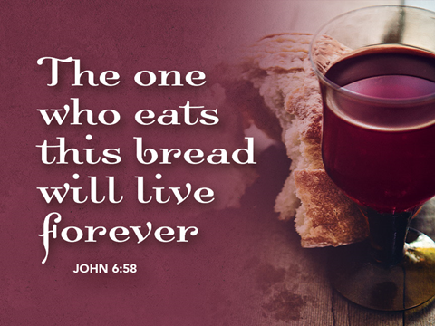

+ Proclaim Christ + Build Community +
+ Serve Our Neighbors +
Introduction
Wisdom prepares a feast, sets her table, and invites all to come and eat her bread and drink her wine. The first chapter of John’s gospel owes much to the biblical tradition that imagined Wisdom as existing before anything was created and having a role in the work of creation. Christ, the wisdom of God (1 Cor. 1:24), today invites us to eat his flesh and drink his blood. John’s gospel includes no account of the institution of the Lord’s supper, but here we can't help hearing Jesus’ words as an invitation to the meal of bread and wine we share.
Gathering
The Holy Spirit calls us together as the people of God.
Welcome/Announcements
Helpful Reminders for those joining via Zoom:
- The host will mute you when you join, and you will remain muted until the end of the service.
- You are welcome to join in all congregation responses (in Bold black.) and hymns.
- At the end of the service you may unmute your mic to share greetings with your fellow worshippers. If you dialed in on the phone, press *6. Remember, your host cannot unmute you.

Helpful Reminders for those joining in person:
- Maintain 6’ distance between family groups
- Remain in your pews for communion.
- You may place your offering in the box in the narthex.

Prelude

*Please stand as you are able and turn to face the font.
*Confession and Forgiveness
All may make the sign of the cross, the sign marked at baptism, as the presiding minister begins.
Blessed be the holy Trinity,☩ one God, the God of manna, the God of miracles, the God of mercy. Amen.

Drawn to Christ and seeking God’s abundance, let us confess our sin.

God, our provider, help us. It is hard to believe there is enough to share. We question your ways when they differ from the ways of the world in which we live. We turn to our own understanding rather than trusting in you. We take offense at your teachings and your ways. Turn us again to you. Where else can we turn? Share with us the words of eternal life and feed us for life in the world. Amen.

Beloved people of God: in Jesus, the manna from heaven, you are fed and nourished. By Jesus, the worker of miracles, there is always more than enough. Through Jesus, ☩ the bread of life, you are shown God’s mercy: you are forgiven and loved into abundant life. Amen.

*Entrance Hymn ELW #566 Morning Has Broken
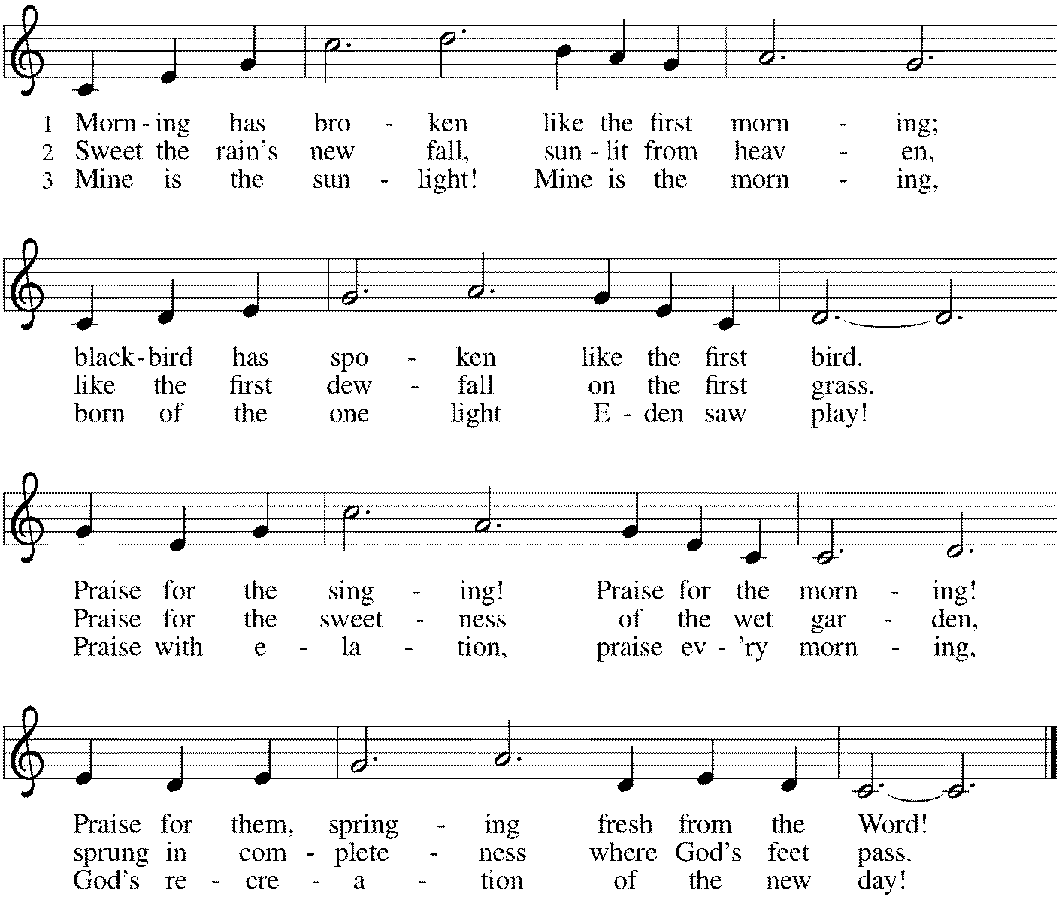

*Greeting
The grace of our Lord Jesus Christ, the love of God, and the communion of the Holy Spirit be with you all. And also with you.
*Hymn of Praise p. 204

*Prayer of the Day
Ever-loving God, your Son gives himself as living bread for the life of the world. Fill us with such a knowledge of his presence that we may be strengthened and sustained by his risen life to serve you continually, through Jesus Christ, our Savior and Lord. Amen. Be seated.
Word
God speaks to us in scripture reading, preaching, and song.
First Lesson Proverbs 9:1-6
Wisdom is portrayed as a woman who invites people to partake of her banquet. Just as ordinary food is necessary for physical life, Wisdom’s food—insight and understanding—is necessary for fullness of life with God. Partaking of Wisdom’s banquet is the way to life.

¹Wisdom has built her house, she has hewn her seven pillars. ²She has slaughtered her animals, she has mixed her wine, she has also set her table. ³She has sent out her servant-girls, she calls from the highest places in the town, ⁴“You that are simple, turn in here!” To those without sense she says, ⁵“Come, eat of my bread and drink of the wine I have mixed. ⁶Lay aside immaturity, and live, and walk in the way of insight.”

Word of God, Word of Life. Thanks be to God.

Psalm Psalm 34:9-14
Those who seek the Lord lack nothing that is good. (Ps. 34:10)

⁹Fear the Lord, you saints of the Lord, for those who fear the Lord lack nothing.
¹⁰The lions are in want and suffer hunger, but those who seek the Lord lack nothing that is good.
¹¹Come, children, and listen to me; I will teach you reverence for the Lord.
¹²Who among you takes pleasure in life and desires long life to enjoy prosperity?
¹³Keep your tongue from evil and your lips from lying words.
¹⁴Turn from evil and do good; seek peace and pursue it.

Second Lesson Ephesians 5:15-20
True wisdom integrates our new reality in Christ with our Christian fellowship and daily conduct. Because we are filled with the Spirit, Christians regularly rejoice together, give thanks to God for one another, and care for one another. In this way we revere our Lord Jesus Christ.

¹⁵Be careful then how you live, not as unwise people but as wise, ¹⁶making the most of the time, because the days are evil. ¹⁷So do not be foolish, but understand what the will of the Lord is. ¹⁸Do not get drunk with wine, for that is debauchery; but be filled with the Spirit, ¹⁹as you sing psalms and hymns and spiritual songs among yourselves, singing and making melody to the Lord in your hearts, ²⁰giving thanks to God the Father at all times and for everything in the name of our Lord Jesus Christ.

Word of God, Word of Life. Thanks be to God.

*Please stand as you are able.

*Gospel Acclamation p. 205 Alleluia
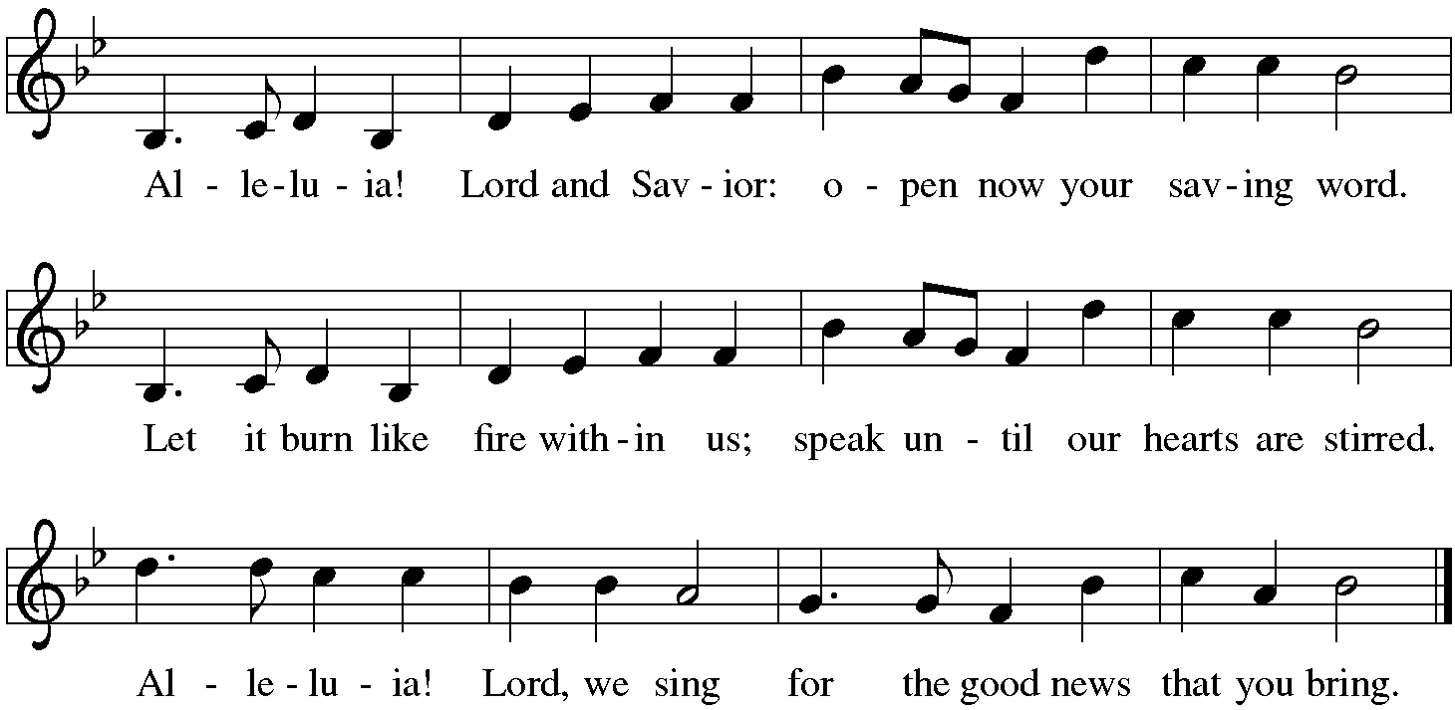

The holy Gospel according to John. Glory to you, O Lord.

*Gospel John 6:51-58
In John’s gospel, the feeding of the five thousand leads to extended teaching in which Jesus identifies himself as the true “bread of life.” Finally, in these verses, he makes a connection that would not be understood until after his death, in light of the church’s celebration of holy communion.

[Jesus said,] ⁵¹“I am the living bread that came down from heaven. Whoever eats of this bread will live forever; and the bread that I will give for the life of the world is my flesh.”
⁵²The Jews then disputed among themselves, saying, “How can this man give us his flesh to eat?” ⁵³So Jesus said to them, “Very truly, I tell you, unless you eat the flesh of the Son of Man and drink his blood, you have no life in you. ⁵⁴Those who eat my flesh and drink my blood have eternal life, and I will raise them up on the last day; ⁵⁵for my flesh is true food and my blood is true drink. ⁵⁶Those who eat my flesh and drink my blood abide in me, and I in them. ⁵⁷Just as the living Father sent me, and I live because of the Father, so whoever eats me will live because of me. ⁵⁸This is the bread that came down from heaven, not like that which your ancestors ate, and they died. But the one who eats this bread will live forever.”

The Gospel of the Lord. Praise to you, O Christ. Be seated.

Sermon The Rev. Melody Eastman

*Please stand as you are able.
*Hymn of the Day ELW #518 We Eat the Bread of Teaching
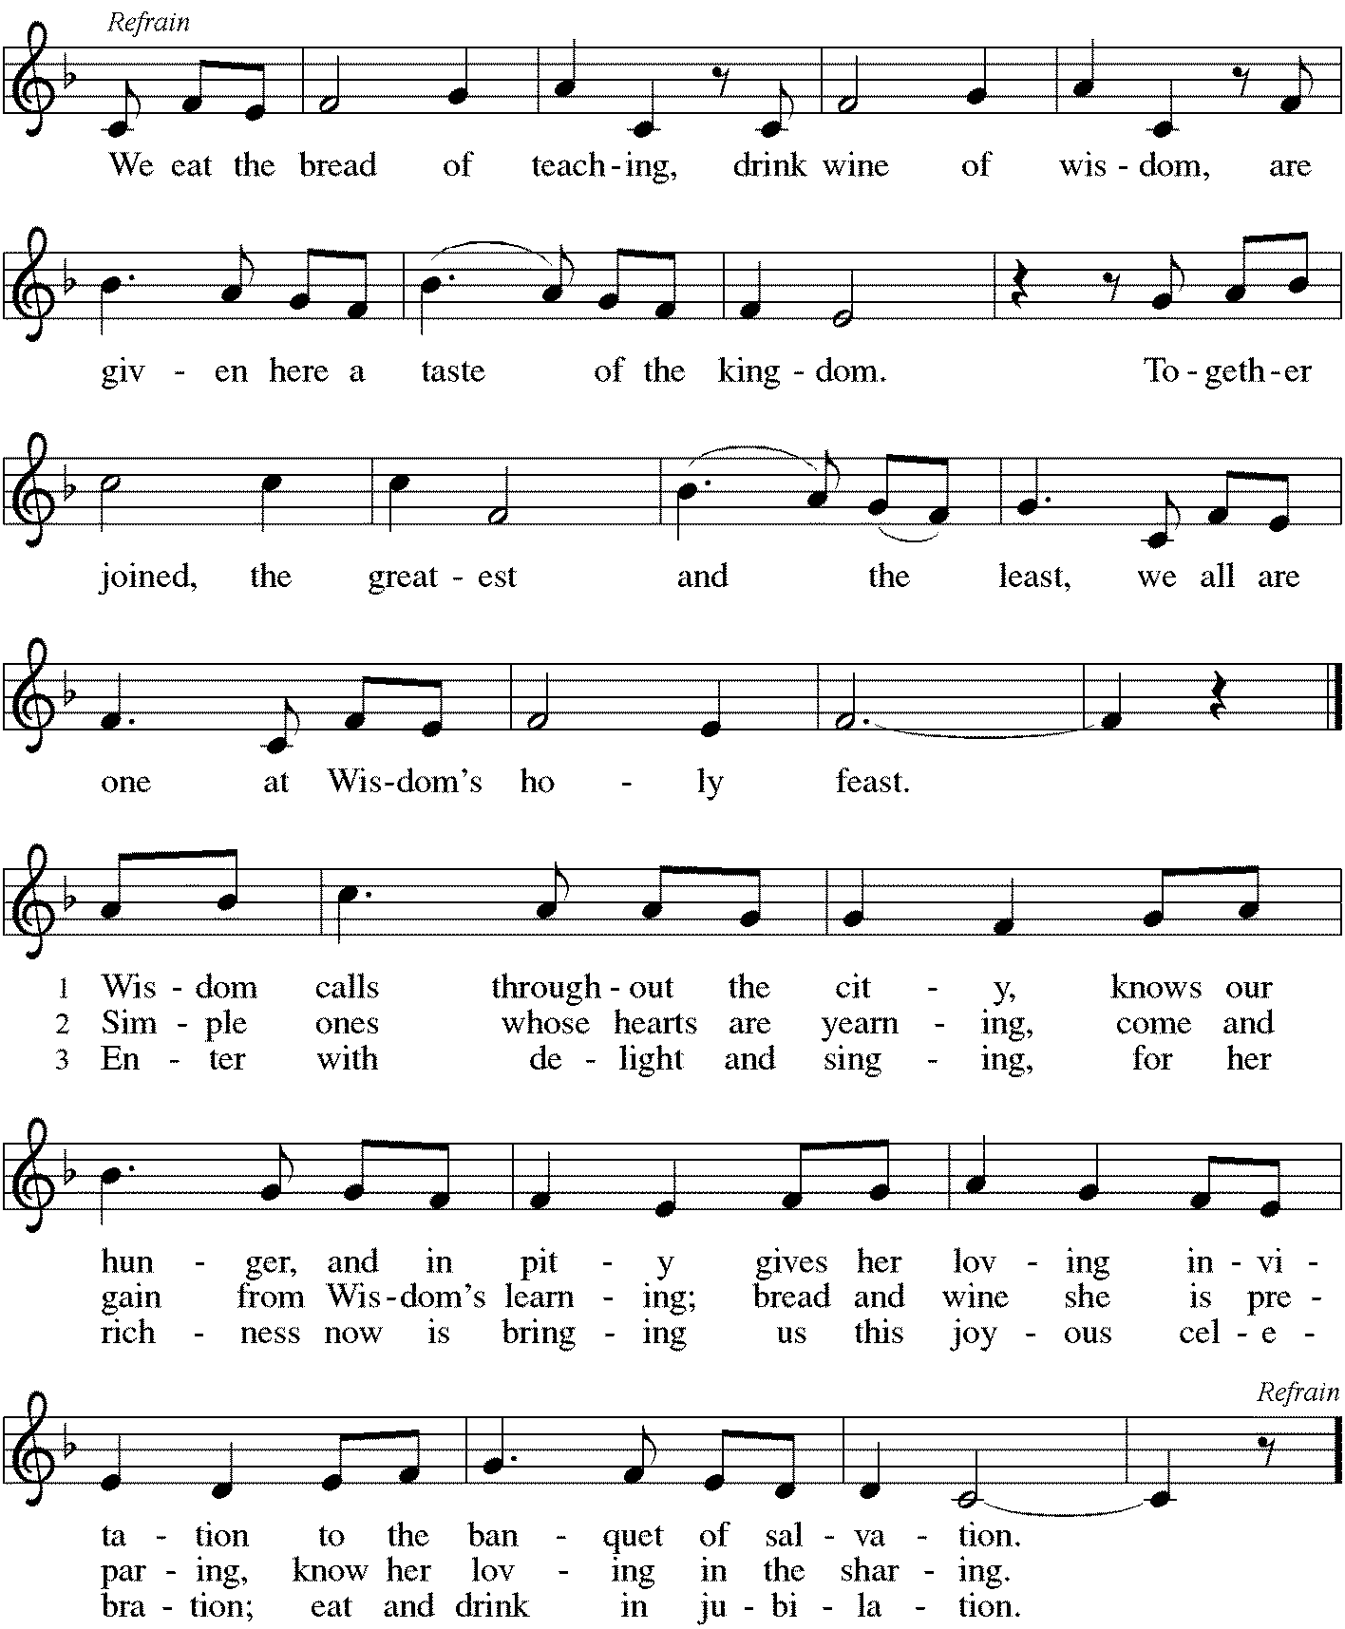

Blessing of the Backpacks
Loving God, be with these backpacks and briefcases and bags, and with those who carry them.
Be with them and help them as they begin a new year of learning, teaching, working, growing, and serving.
May their minds and their pencils be sharp; may their lunches never be forgotten at home; and may their pink pearl erasers help them to remember that mistakes are okay - and when you’re a student they are in fact the most important part of the process. Just let them make their mistakes at the right time, and not the wrong time.
God, thank you for glue sticks and homework folders and laptops and crisp new notebooks waiting to be filled; thank you for schools and libraries and teachers; for offices and co-workers and fellow learners. Thank you for the gift of curiosity and new knowledge and for your wisdom that is all around.
God of wisdom, bless these backpacks and briefcases and bags, and all those who carry them.
We pray this and everything in the name of your son, who left his parents so he could sit and learn at the feet of those rabbis in the temple.
We pray this and everything in the name of Jesus, amen.

*Prayers of Intercession
Rooted in Christ and sustained by the Spirit, we offer our prayers for the church, the world, and all of creation.
A brief silence.
God of wisdom, enlighten your church. Guide theologians, biblical scholars, authors, and seminary professors as they seek greater knowledge and invite others into deeper understanding. Teach us to ask faithful questions and open our minds to new ideas. God, in your mercy, hear our prayer.

God of creation, mend the earth. Cool warming oceans and preserve melting ice caps. Increase our awareness of changing climate patterns and reveal new approaches to the ecological challenges we face. Shield those in the path of hurricanes or tropical storms. God, in your mercy, hear our prayer.

God of all nations, direct our leaders. Grant them courage to lay aside political grudges and renew their determination to address difficult conflicts. Guide them in the work of reconciliation. God, in your mercy, hear our prayer.

God of compassion, tend to the wounded. Rescue those tormented by mental illness or mired in addiction. Ease the anxiety of those struggling with dementia. Come quickly to help all who are grieving and all those who suffer, especially Jim, Cathy, Sigrid, Dorothy, Norma, Dolores, Carol, Dorothy and those we name before you now. . . God, in your mercy, hear our prayer.

All honor and glory and blessing belong to you. We thank you and praise you for the faith and witness of Beth Bruning and Shirley Sauerman, and we ask your blessing on them as they celebrate their 94th birthday. We praise you for the faith of all the saints. Be near us as we await the day when we will feast with the risen Christ forever. God, in your mercy, hear our prayer.

God of beauty, inspire artists. Bless those whose visual and musical gifts enliven this assembly. Bless the creative work of poets, hymnwriters, composers, painters, sculptors, and others that enrich our worship and daily life. God, in your mercy, hear our prayer.

God of resurrection, bring us to new life. Give us the living bread from heaven through which we abide in your love, and on the last day raise us with all the saints to eternal life. God, in your mercy, hear our prayer.

We lift these and all our prayers to you, O God, confident in the promise of your saving love; through Jesus Christ our Lord. Amen.

*Peace
The peace of Christ be with you always. And also with you.
Please share the peace with others in your household, or by making a sign of peace to those on Zoom. Please remain standing.

Meal
God feeds us with the presence of Jesus Christ.
*Offering Prayer
Jesus, Bread of life,
you have set this table with your very self,
and called us to the feast of plenty.
Gather what has been sown among us,
and strengthen us in this meal.
Make us to be what we receive here,
your body for the life of the world. Amen

*Great Thanksgiving
The Lord be with you. And also with you.
Lift up your hearts. We lift them to the Lord.
Let us give thanks to the Lord our God. It is right to give our thanks and praise.

*Preface
It is indeed right, our duty and our joy,
that we should at all times and in all places give thanks and praise to you,
almighty and merciful God, through our Savior Jesus Christ;
who on this day overcame death and the grave,
and by his glorious resurrection opened to us the way of everlasting life.
And so, with all the choirs of angels,
with the church on earth and the hosts of heaven,
we praise your name and join their unending hymn:

*Sanctus p. 207 Holy, Holy, Holy
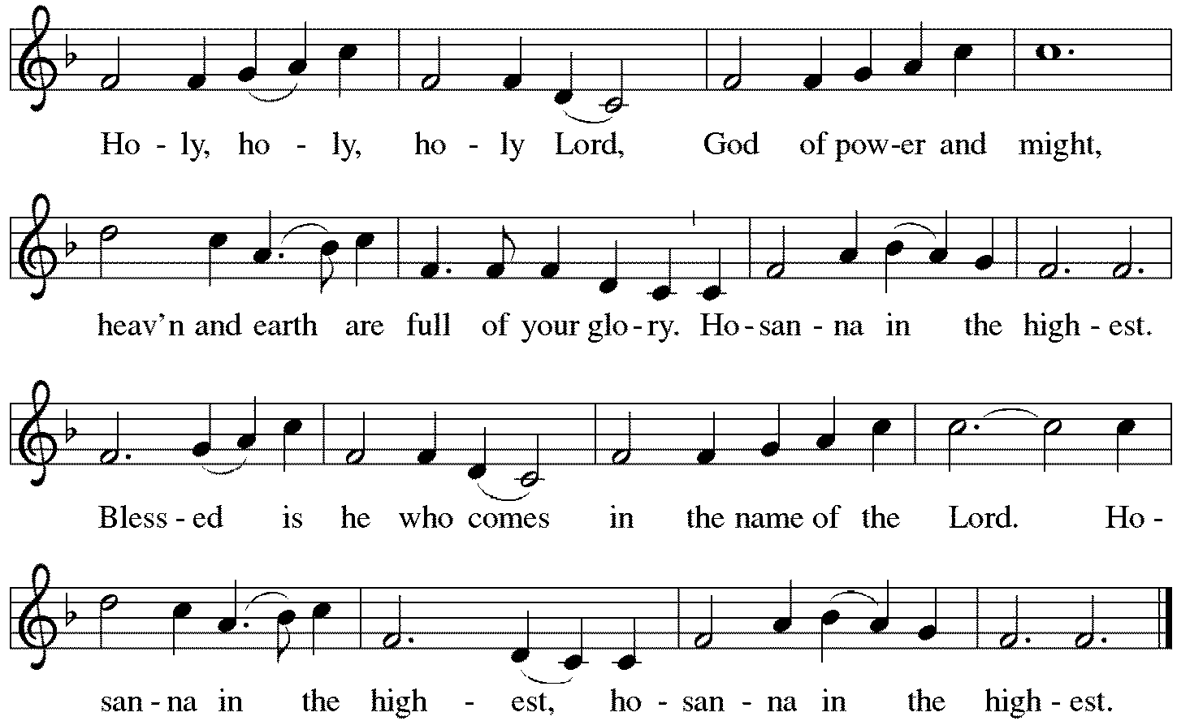

*Thanksgiving at the Table
You are indeed holy, almighty and merciful God.
You are most holy,
and great is the majesty of your glory.

You so loved the world that you gave your only Son,
so that everyone who believes in him may not perish
but have eternal life.
We give you thanks for his coming into the world
to fulfill for us your holy will
and to accomplish all things for our salvation.

In the night in which he was betrayed,
our Lord Jesus took bread, and gave thanks;
broke it, and gave it to his disciples, saying:
Take and eat; this is my body, given for you.
Do this for the remembrance of me.
Again, after supper, he took the cup, gave thanks,
and gave it for all to drink, saying:
This cup is the new covenant in my blood,
shed for you and for all people for the forgiveness of sin.
Do this for the remembrance of me.

For as often as we eat of this bread and drink from this cup,
we proclaim the Lord's death until he comes.
Christ has died. Christ is risen. Christ will come again.

You may hold up your (unopened) communion kit as you are able.
Remembering, therefore, his salutary command,
his life-giving passion and death,
his glorious resurrection and ascension,
and the promise of his coming again,
we give thanks to you, O Lord God Almighty,
not as we ought but as we are able;
we ask you mercifully to accept our praise and thanksgiving
and with your Word and Holy Spirit to bless us, your servants,
and these your own gifts of bread and wine,
so that we and all who share in the body and blood of Christ
may be filled with heavenly blessing and grace,
and, receiving the forgiveness of sin,
may be formed to live as your holy people
and be given our inheritance with all your saints.
You may lower your communion kit.

To you, O God, Father, Son, and Holy Spirit,
be all honor and glory in your holy church, now and forever.
Amen.

*The Lord’s Prayer
Gathered into one by the Holy Spirit, let us pray as Jesus taught us.
Our Father, who art in heaven, hallowed be thy name, thy kingdom come, thy will be done, on earth as it is in heaven. Give us this day our daily bread; and forgive us our trespasses as we forgive those who trespass against us; and lead us not into temptation but deliver us from evil. For thine is the kingdom, the power, and the glory, forever and ever. Amen.

*Invitation to Communion
Christ has set the table with more than enough for all. Come! Be Seated.

If you have difficulty opening your communion, please signal an usher for assistance.

Peel up the clear top seal over the wafer, and hold the wafer up when you are ready.
This is the Body of Christ, given for you. (Eat the bread.) Amen.

Peel up the second foil seal over the juice, and hold your cup up when you are ready.
This is the blood of Christ, shed for you. (Drink the wine/juice.) Amen.

After communion you may place the packaging in the bowl in your pew. The ushers will dispose of these following the service.

Agnus Dei p. 208 Lamb of God
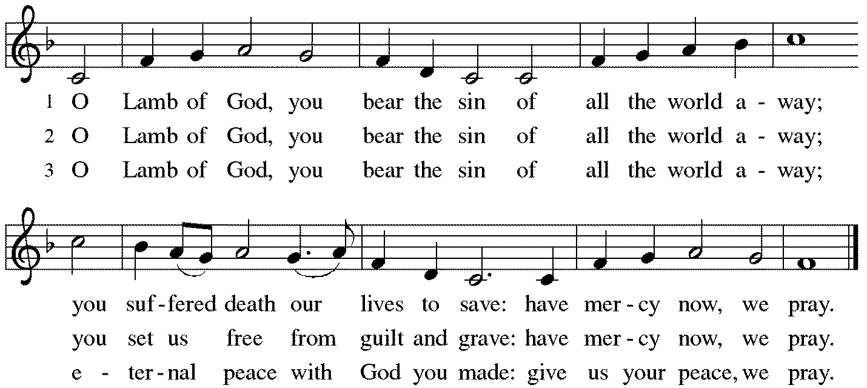

*Please stand as you are able.

*Post-Communion Blessing
The body and blood of our Lord Jesus Christ strengthen you and keep you in his grace. Amen.

*Prayer after Communion
Jesus, Bread of life, we have received from your table more than we could ever ask. As you have nourished us in this meal, now strengthen us to love the world with your own life. In your name we pray. Amen.

Sending
God blesses us and sends us in mission to the world.
*Blessing
The blessing of God, who provides for us, feeds us, and journeys with us, ☩ be upon you now and forever. Amen.

*Sending Hymn ELW#537 On Our Way Rejoicing
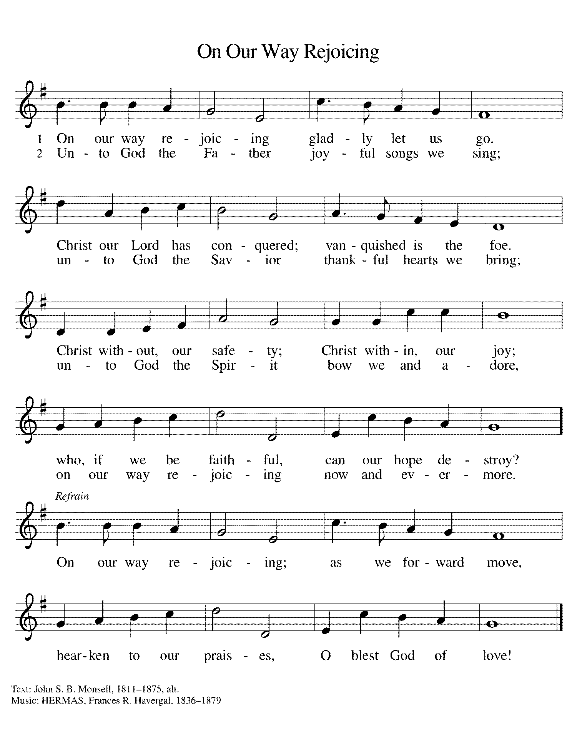
Refrain on next page

*Sent to the World
Go in peace. You are the body of Christ. Thanks be to God.

Postlude
After the postlude, those who have joined via Zoom may unmute your mics
and share a greeting with your fellow worshippers.

From Sundays and Seasons
v.20190109.1233 Copyright © 2021 Augsburg Fortress. All rights reserved.
Reprinted by permission under Augsburg Fortress Liturgies Annual License #30867.
All rights reserved. Reprinted under OneLicense.net #A-718333.

Assisting in Worship Today
Ministry Associate Becky Ficarella
Minister of Music Bradford Thompson
Lector Susan Jacobson
Ushers Mario Ficarella, Chuck Miller, Bill Murdoch, Open

Current Prayer Requests
Please keep these people in your prayers and reach out to our sisters and brothers in Christian love. Names will be left on the list for two weeks, unless you indicate that they should remain in our prayers for a longer period.
Name Relationship Prayer For
Jim Sladek Member Healing & Strength
Cathy Milleville Member Healing & Strength
Sigrid Elliott Member Healing & Strength
Dorothy Tracy Member Healing & Strength
Norma Petersen Member Healing & Strength
Keith & Rita Matthews SIL & Daughter of Norma Petersen Healing & Strength
Norma Petersen Member Healing & Strength
Keith Petras Brother of Dru Geraghty Healing & Strength
Family of Joanne Wenner Sandy Wenner’s mother Comfort in Grief
Lori Garabrandt Relative of Chuck Miller and Lois Pertle Healing & Strength
Chris Danly Son of Mark & Pat Danly Healing & Strength
Tammy Rollo Friend of Barbara Sudds Healing & Strength
Prayers for our homebound Members
Dolores Nosal, Carol Petersen, Norma Petersen, Dorothy Stein

August Birthday Blessings: Shirley Sauerman 94 on 8/17; Carol Wandke 91 on 8/22; and Norma Peterson 94 on 8/26.

Outdoor Worship & Picnic at Blackwell Forest Preserve: Join us for a special outdoor worship service at the East Picnic Shelter at Blackwell Forest Preserve on Sunday, August 29th at 9:00am. (The East Picnic Shelter is a long drive into the park—the last shelter at the end of the road, but easily accessible with a paved path from the parking lot to the shelter.) Feel free to bring camp chairs (the shelter may not hold all of us) and your own picnic brunch/lunch; we’ll enjoy fellowship, food and some kids’ games after our service. We look forward to seeing you there!

Lectors: If you would like to see the readings in advance of your Sunday, you can view the current week bulletin on Grace’s website.

Circle of Care Coordinator Needed: We are seeking an individual to fill the role of Circle of Care Coordinator. This role includes managing incoming requests of care from members and then finding the appropriate volunteers to help from a current list of willing helpers! Examples might include rides, grocery store runs, or meal drop offs. Please contact the church office or Becky Ficarella if you are interested!

Ushers Needed: Each of our four usher teams are in need of one additional team member. Team 1 (January, May, September); Team 2 (February, June, October); Team 3 (March, July, November; Team 4 (April, August, December). Please contact the church office if you can volunteer for one of these teams or sign up in the Narthex.

RAMP: Our mortgage reduction campaign has been renamed “RAMP” (Reduce Another Mortgage Payment) as we continue to RAMP up to refinance our mortgage with Mission Investment Fund this Fall. Thank you to all who have contributed to date. We are still hopeful we can raise another $75,000 before November. Lowering our monthly mortgage payments will free up funds that we can utilize on the ministries of Grace.

Got Capital Gains? Did you know that stock donations allow you to both claim a deduction at the appreciated value AND allow you to avoid capital gains taxes on these assets? Further, consolidating donations in a tax year could lead to increased ability to deduct charitable contributions in a given tax year. Consult your tax advisor for details, but if you’d like more information on how to go about donating stock, reach out to the church office.

Contributions to Grace: You may continue to mail your contributions to the church office; have your bank mail your contribution to the church office (this works great); or contribute on-line through Grace’s website (Grace/you pay fees). Please know, pandemic or no, our mission continues! Thank you for your continued support of our ministries at Grace Lutheran.

Bradford’s Livestream Music Session: Join Bradford for LIVE music sessions broadcast directly from Grace! Just click on the link Wednesday evening at 7:00pm to join Bradford on his YouTube channel: https://youtube.com/channel/UCbgfoPipBLAlY3hAkVKoI8Q

Chair Exercise and monthly Book Club. Registration is required as the number of attendees will be limited. The exercise class meets Mondays at 10:00am and Thursdays at 11:00am. The Book Club will meet on the third Tuesday of the month at 11:00am. Please contact Sue Davison at 630-858-6343 to register.

Every Member a Minister and Missionary!

Phone: 630-469-1555 Emergency Pastoral Contact: 630-674-2887
info@graceglenellyn.org www.graceglenellyn.org

Pastor
Rev. Melody Eastman office ext. 14
meastman@graceglenellyn.org

Minister of Music
Bradford Thompson 219-718-8879
bradfordmthompson@gmail.com

Ministry Associate
Becky Ficarella office ext. 17
bficarella@graceglenellyn.org

Office Manager
Barbara Sudds office ext. 10
bsudds@graceglenellyn.org

Parish Counselor
Carole LoGalbo M.S., LCPC 630-668-4594
carolelogalbo@yahoo.com

