Grace Lutheran Church

493 Forest Avenue, Glen Ellyn IL 630.469.1555
www.graceglenellyn.org

13th Sunday after Pentecost August 22, 2021

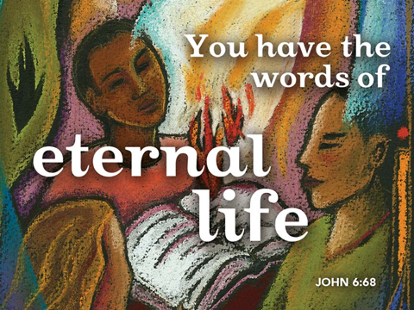

+ Proclaim Christ + Build Community +
+ Serve Our Neighbors +

Introduction
In today’s gospel many people take offense at Jesus’ invitation to eat his flesh and drink his blood; even many of Jesus’ disciples peel off. This is the backdrop in John’s gospel for Peter’s confession of faith. “To whom can we go?” asks Peter, in words we sometimes sing just before the gospel is read. “You have the words of eternal life.” In order to take such a stand, as Peter and Joshua did, Paul tells us to arm ourselves with the word of God. We pray in the Spirit that we might be bold ambassadors of the gospel.

Gathering
The Holy Spirit calls us together as the people of God.
Welcome/Announcements
Helpful Reminders for those joining via Zoom:
- The host will mute you when you join, and you will remain muted until the end of the service.
- You are welcome to join in all congregation responses (in Bold black.) and hymns.
- At the end of the service you may unmute your mic to share greetings with your fellow worshippers. If you dialed in on the phone, press *6. Remember, your host cannot unmute you.

Helpful Reminders for those joining in person:
- Maintain 6’ distance between family groups
- Remain in your pews for communion.
- You may place your offering in the box in the narthex.

Prelude

*Please stand as you are able and turn to face the font.
*Confession and Forgiveness
All may make the sign of the cross, the sign marked at baptism, as the presiding minister begins.
Blessed be the holy Trinity,☩ one God, the God of manna, the God of miracles, the God of mercy. Amen.

Drawn to Christ and seeking God’s abundance, let us confess our sin.
God, our provider, help us. It is hard to believe there is enough to share. We question your ways when they differ from the ways of the world in which we live. We turn to our own understanding rather than trusting in you. We take offense at your teachings and your ways. Turn us again to you. Where else can we turn? Share with us the words of eternal life and feed us for life in the world. Amen.
Beloved people of God: in Jesus, the manna from heaven, you are fed and nourished. By Jesus, the worker of miracles, there is always more than enough. Through Jesus, ☩ the bread of life, you are shown God’s mercy: you are forgiven and loved into abundant life. Amen.

*Entrance Hymn ELW #849 Yours, Lord, Is the Glory

*Greeting
The grace of our Lord Jesus Christ, the love of God, and the communion of the Holy Spirit be with you all. And also with you.

*Hymn of Praise p. 204

*Prayer of the Day
Holy God, your word feeds your people with life that is eternal. Direct our choices and preserve us in your truth, that, renouncing what is false and evil, we may live in you, through your Son, Jesus Christ, our Savior and Lord. Amen. Be seated.

Word
God speaks to us in scripture reading, preaching, and song.
First Lesson Joshua 24:1-2a, 14-18
In the Near East, covenant means “agreement” or “alliance.” It describes relationships and is the primary word used to characterize the relationship between God and Israel. By delivering Israel, God has already begun the relationship. Joshua calls upon the people to respond.

¹Then Joshua gathered all the tribes of Israel to Shechem, and summoned the elders, the heads, the judges, and the officers of Israel; and they presented themselves before God. ^{2a}And Joshua said to all the people, ¹⁴“Now therefore revere the Lord, and serve him in sincerity and in faithfulness; put away the gods that your ancestors served beyond the River and in Egypt, and serve the Lord. ¹⁵Now if you are unwilling to serve the Lord, choose this day whom you will serve, whether the gods your ancestors served in the region beyond the River or the gods of the Amorites in whose land you are living; but as for me and my household, we will serve the Lord.”
¹⁶Then the people answered, “Far be it from us that we should forsake the Lord to serve other gods; ¹⁷for it is the Lord our God who brought us and our ancestors up from the land of Egypt, out of the house of slavery, and who did those great signs in our sight. He protected us along all the way that we went, and among all the peoples through whom we passed; ¹⁸and the Lord drove out before us all the peoples, the Amorites who lived in the land. Therefore we also will serve the Lord, for he is our God.”

Word of God, Word of Life. Thanks be to God.

Psalm Psalm 34:15-22
The eyes of the Lord are upon the righteous. (Ps. 34:15)

¹⁵The eyes of the Lord are upon the righteous, and God’s ears are open to their cry.
¹⁶The face of the Lord is against those who do evil, to erase the remembrance of them from the earth.
¹⁷The righteous cry, and the Lord hears them and delivers them from all their troubles.
¹⁸The Lord is near to the brokenhearted and saves those whose spirits are crushed.
¹⁹Many are the troubles of the righteous, but the Lord delivers them from every one.
²⁰God will keep safe all their bones; not one of them shall be broken.
²¹Evil will bring death to the wicked and those who hate the righteous will be punished.
²²O Lord, you redeem the life of your servants, and those who put their trust in you will not be punished.

Second Lesson Ephesians 6:10-20
Like a general giving a rousing speech to troops before battle, this letter closes by calling on Christians to be equipped for spiritual warfare against evil. The full armor of God includes truth, righteousness, peace, faith, the gift of salvation, and the word of God inspired by the Spirit.

¹⁰Be strong in the Lord and in the strength of his power. ¹¹Put on the whole armor of God, so that you may be able to stand against the wiles of the devil. ¹²For our struggle is not against enemies of blood and flesh, but against the rulers, against the authorities, against the cosmic powers of this present darkness, against the spiritual forces of evil in the heavenly places. ¹³Therefore take up the whole armor of God, so that you may be able to withstand on that evil day, and having done everything, to stand firm. ¹⁴Stand therefore, and fasten the belt of truth around your waist, and put on the breastplate of righteousness. ¹⁵As shoes for your feet put on whatever will make you ready to proclaim the gospel of peace. ¹⁶With all of these, take the shield of faith, with which you will be able to quench all the flaming arrows of the evil one. ¹⁷Take the helmet of salvation, and the sword of the Spirit, which is the word of God.
¹⁸Pray in the Spirit at all times in every prayer and supplication. To that end keep alert and always persevere in supplication for all the saints. ¹⁹Pray also for me, so that when I speak, a message may be given to me to make known with boldness the mystery of the gospel, ²⁰for which I am an ambassador in chains. Pray that I may declare it boldly, as I must speak.

Word of God, Word of Life. Thanks be to God.

*Please stand as you are able.
*Gospel Acclamation p. 205 Alleluia
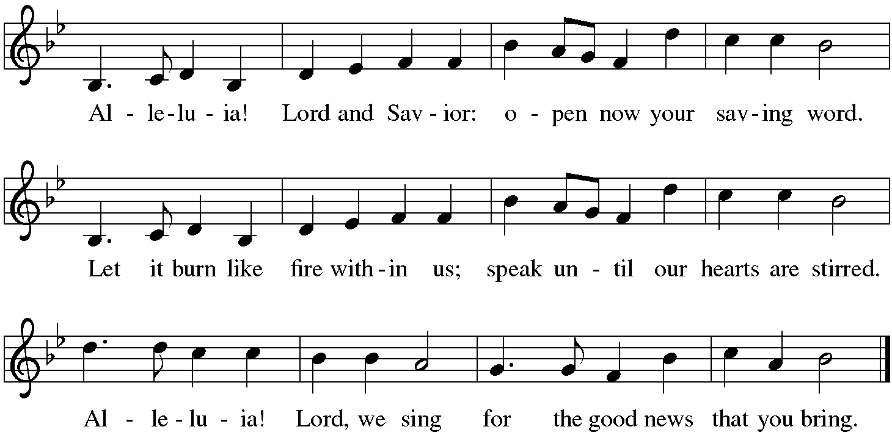

The holy Gospel according to John. Glory to you, O Lord.

*Gospel John 6:56-69
The “hard saying” that offends Jesus’ disciples is his claim that his followers must eat his flesh and drink his blood. The followers who return to their old lives know something about how odd this sounds. Simon Peter, on the other hand, knows something about the scarcity of living, gracious words. He asks the most important question: “To whom shall we go?”

[Jesus said,] ⁵⁶“Those who eat my flesh and drink my blood abide in me, and I in them. ⁵⁷Just as the living Father sent me, and I live because of the Father, so whoever eats me will live because of me. ⁵⁸This is the bread that came down from heaven, not like that which your ancestors ate, and they died. But the one who eats this bread will live forever.” ⁵⁹He said these things while he was teaching in the synagogue at Capernaum.
⁶⁰When many of his disciples heard it, they said, “This teaching is difficult; who can accept it?” ⁶¹But Jesus, being aware that his disciples were complaining about it, said to them, “Does this offend you? ⁶²Then what if you were to see the Son of Man ascending to where he was before? ⁶³It is the spirit that gives life; the flesh is useless. The words that I have spoken to you are spirit and life. ⁶⁴But among you there are some who do not believe.” For Jesus knew from the first who were the ones that did not believe, and who was the one that would betray him. ⁶⁵And he said, “For this reason I have told you that no one can come to me unless it is granted by the Father.”
⁶⁶Because of this many of his disciples turned back and no longer went about with him. ⁶⁷So Jesus asked the twelve, “Do you also wish to go away?” ⁶⁸Simon Peter answered him, “Lord, to whom can we go? You have the words of eternal life. ⁶⁹We have come to believe and know that you are the Holy One of God.”

The Gospel of the Lord. Praise to you, O Christ. Be seated.

Sermon The Rev. Melody Eastman

*Please stand as you are able.
*Hymn of the Day ELW #801 Change My Heart, O God
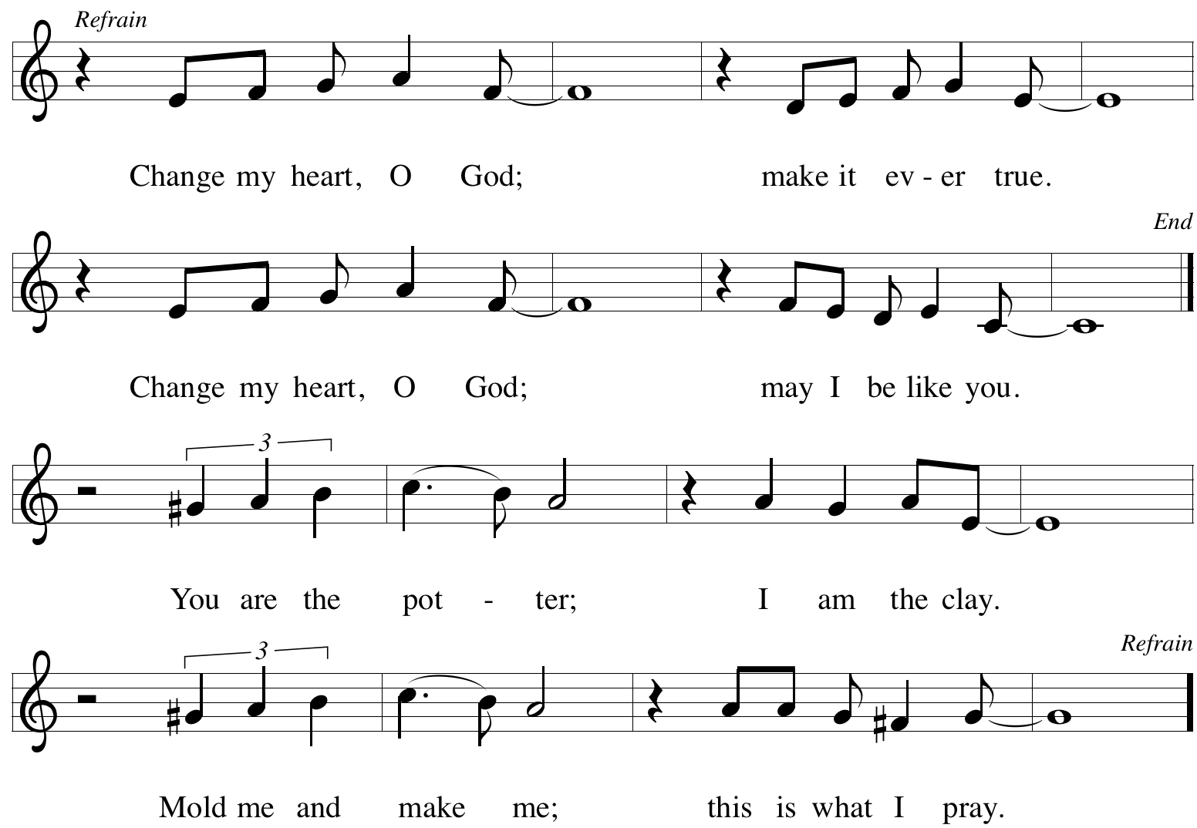

*Prayers of Intercession
Made children and heirs of God’s promise, we pray for the church, the world, and all in need.
A brief silence.

God of courage, bless all leaders of your church. Make them ready to proclaim the gospel of peace and strengthen them to preach your loving word. Lord, in your mercy, hear our prayer.

God of creation, bless fields and orchards. Protect the land from drought and bring life-giving rain to support growth. Heal the areas devastated by wildfires here in the US, in Canada, in Greece and in Siberia. Instruct your people in wise treatment of the world you have provided for all your creatures. Lord, in your mercy, hear our prayer.

God of community, bless all who seek justice between nations and peoples. Give guidance to bridge-builders, heal divisions, and inspire cooperation in times of crisis, disaster, and war. Lord, in your mercy, hear our prayer.

God of compassion, bless all who are in any need. Accompany all who are lonely and feeling abandoned and remind them of your abiding presence. Accompany all who are persecuted and exploited and open us to their cries. Sustain and protect the people in Afghanistan who suffer fear, persecution and the loss of freedom. Lord, in your mercy, hear our prayer.

God of change, bless our transitions. Guide all who are embarking on new stages in life such as a new job, new school, or new community. Sustain enduring friendships and kindle new relationships and interests. Lord, in your mercy, hear our prayer.

We ask for your healing and strength for those in our community who are ill or in need, especially Bradford, Jim, Cathy, Sigrid, Dorothy, Norma, Dolores, Carol, Dorothy, and those we name before you now…. Lord, in your mercy, hear our prayer.

All honor and glory and blessing belong to you. We thank you and praise you for the faith and witness of Carol Wandke and Norma Petersen, and we ask your blessing on them as Carol celebrates her 91st birthday and Norma celebrates her 94th. We thank you for the new life of Cate Lou Milleville, born to Ken and Elle this past week, and ask your blessing upon their family. God, in your mercy, hear our prayer.

God of comfort, bless all who mourn the deaths of their beloved ones. We give you thanks for the saints who have gone before us. Renew our confidence in your promise of resurrection and life in the world to come. Lord, in your mercy,
hear our prayer.

Receive these prayers, O God, and those in our hearts known only to you; through Jesus Christ our Lord. Amen.

*Peace
The peace of Christ be with you always. And also with you.
Please share the peace with others in your household, or by making a sign of peace to those on Zoom. Please remain standing.

Meal
God feeds us with the presence of Jesus Christ.
*Offering Prayer
Jesus, Bread of life,
you have set this table with your very self,
and called us to the feast of plenty.
Gather what has been sown among us,
and strengthen us in this meal.
Make us to be what we receive here,
your body for the life of the world. Amen

*Great Thanksgiving
The Lord be with you. And also with you.
Lift up your hearts. We lift them to the Lord.
Let us give thanks to the Lord our God. It is right to give our thanks and praise.

*Preface
It is indeed right, our duty and our joy, that we should at all times and in all places give thanks and praise to you, almighty and merciful God, through our Savior Jesus Christ; who on this day overcame death and the grave, and by his glorious resurrection opened to us the way of everlasting life. And so, with all the choirs of angels, with the church on earth and the hosts of heaven, we praise your name and join their unending hymn:
*Sanctus p. 207 Holy, Holy, Holy
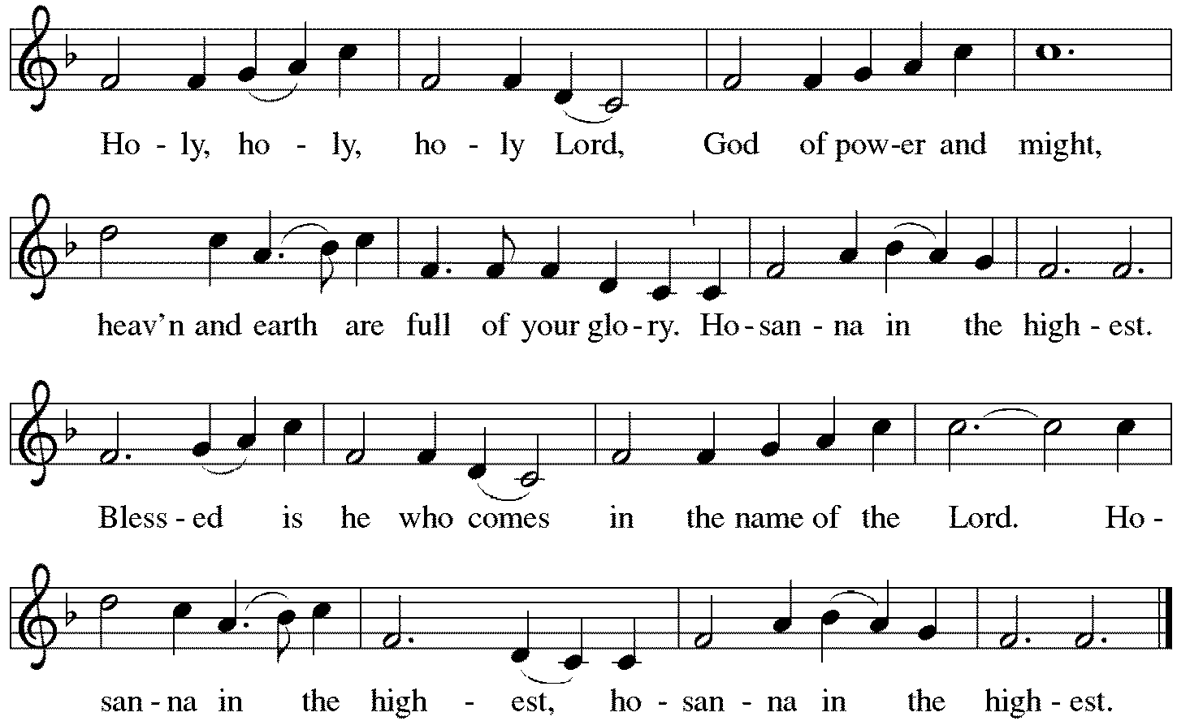

*Thanksgiving at the Table
You are indeed holy, almighty and merciful God.
You are most holy,
and great is the majesty of your glory.

You so loved the world that you gave your only Son,
so that everyone who believes in him may not perish
but have eternal life.
We give you thanks for his coming into the world
to fulfill for us your holy will
and to accomplish all things for our salvation.

In the night in which he was betrayed,
our Lord Jesus took bread, and gave thanks;
broke it, and gave it to his disciples, saying:
Take and eat; this is my body, given for you.
Do this for the remembrance of me.
Again, after supper, he took the cup, gave thanks,
and gave it for all to drink, saying:
This cup is the new covenant in my blood,
shed for you and for all people for the forgiveness of sin.
Do this for the remembrance of me.

For as often as we eat of this bread and drink from this cup,
we proclaim the Lord's death until he comes.
Christ has died. Christ is risen. Christ will come again.

You may hold up your (unopened) communion kit as you are able.
Remembering, therefore, his salutary command,
his life-giving passion and death,
his glorious resurrection and ascension,
and the promise of his coming again,
we give thanks to you, O Lord God Almighty,
not as we ought but as we are able;
we ask you mercifully to accept our praise and thanksgiving
and with your Word and Holy Spirit to bless us, your servants,
and these your own gifts of bread and wine,
so that we and all who share in the body and blood of Christ
may be filled with heavenly blessing and grace,
and, receiving the forgiveness of sin,
may be formed to live as your holy people
and be given our inheritance with all your saints.
You may lower your communion kit.

To you, O God, Father, Son, and Holy Spirit,
be all honor and glory in your holy church, now and forever.
Amen.

*The Lord’s Prayer
Gathered into one by the Holy Spirit, let us pray as Jesus taught us.
Our Father, who art in heaven, hallowed be thy name, thy kingdom come, thy will be done, on earth as it is in heaven. Give us this day our daily bread; and forgive us our trespasses as we forgive those who trespass against us; and lead us not into temptation but deliver us from evil. For thine is the kingdom, the power, and the glory, forever and ever. Amen.

*Invitation to Communion
Christ has set the table with more than enough for all. Come! Be Seated.

If you have difficulty opening your communion, please signal an usher for assistance.

Peel up the clear top seal over the wafer, and hold the wafer up when you are ready.
This is the Body of Christ, given for you. (Eat the bread.) Amen.

Peel up the second foil seal over the juice, and hold your cup up when you are ready.
This is the blood of Christ, shed for you. (Drink the wine/juice.) Amen.

After communion you may place the packaging in the bowl in your pew. The ushers will dispose of these following the service.

Agnus Dei p. 208 Lamb of God
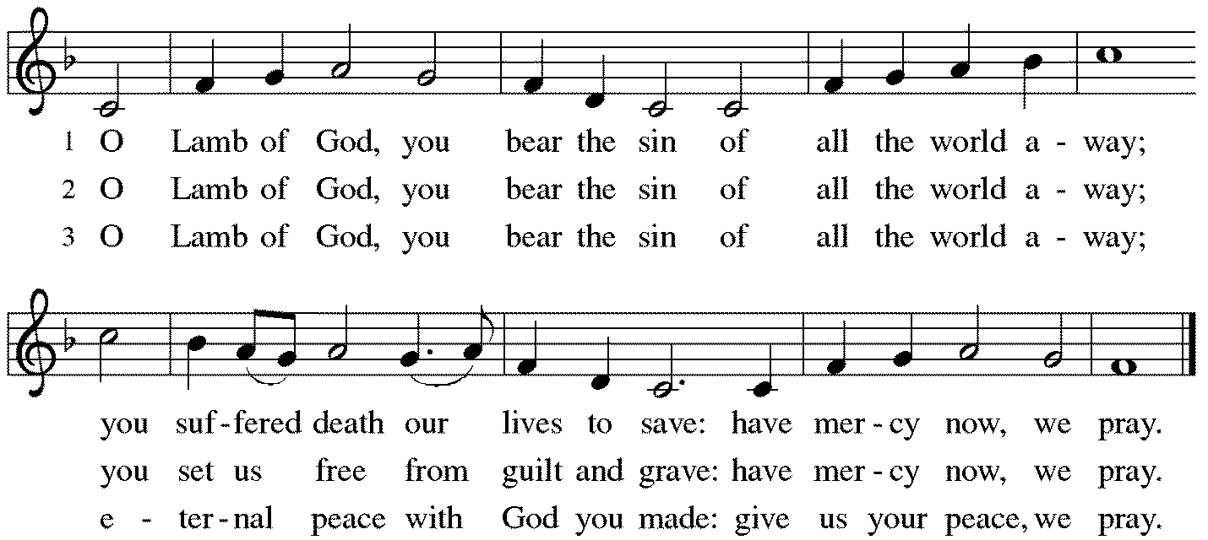

*Please stand as you are able.

*Post-Communion Blessing
The body and blood of our Lord Jesus Christ strengthen you and keep you in his grace. Amen.

*Prayer after Communion
Jesus, Bread of life, we have received from your table more than we could ever ask. As you have nourished us in this meal, now strengthen us to love the world with your own life. In your name we pray. Amen.

Sending
God blesses us and sends us in mission to the world.
*Blessing
The blessing of God, who provides for us, feeds us, and journeys with us, ☩ be upon you now and forever. Amen.

*Sending Hymn ELW#638 Blessed Assurance
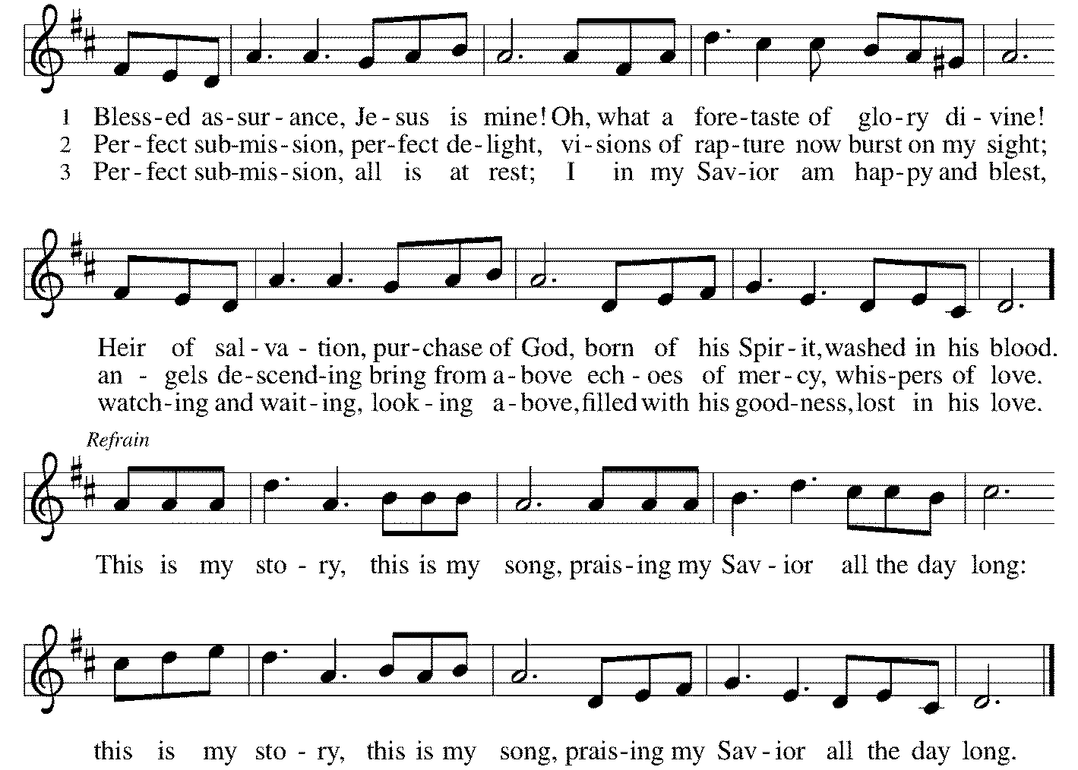
*Sent to the World
Go in peace. You are the body of Christ. Thanks be to God.

Postlude
After the postlude, those who have joined via Zoom may unmute your mics
and share a greeting with your fellow worshippers.

From Sundays and Seasons
v.20190109.1233 Copyright © 2021 Augsburg Fortress. All rights reserved.
Reprinted by permission under Augsburg Fortress Liturgies Annual License #30867.
All rights reserved. Reprinted under OneLicense.net #A-718333.

Assisting in Worship Today
Ministry Associate Becky Ficarella
Minister of Music Bradford Thompson
Lector Jason Graf
Ushers Mario Ficarella, Chuck Miller, Bill Murdoch, Open

Current Prayer Requests
Please keep these people in your prayers and reach out to our sisters and brothers in Christian love. Names will be left on the list for two weeks, unless you indicate that they should remain in our prayers for a longer period.
Name Relationship Prayer For
Bradford Thompson Grace’s Minister of Music Healing & Strength
Elle and Ken Milleville, who welcomed daughter Cate Lou Milleville on Tuesday, August 10.
Carol Wandke Member 91st Birthday (8/22)
Norma Petersen Member 94th Birthday (8/26)
Jim Sladek Member Healing & Strength
Cathy Milleville Member Healing & Strength
Sigrid Elliott Member Healing & Strength
Dorothy Tracy Member Healing & Strength
Norma Petersen Member Healing & Strength
Keith & Rita Matthews SIL & Daughter of Norma Petersen Healing & Strength
Norma Petersen Member Healing & Strength
Keith Petras Brother of Dru Geraghty Healing & Strength
Family of Joanne Wenner Sandy Wenner’s mother Comfort in Grief
Lori Garabrandt Relative of Chuck Miller and Lois Pertle Healing & Strength
Chris Danly Son of Mark & Pat Danly Healing & Strength
Prayers for our homebound Members
Dolores Nosal, Carol Petersen, Norma Petersen, Dorothy Stein

“God’s work. Our hands.” Food Drive: For “God’s work. Our hands.” on September 12, Grace has organized a Food Drive to benefit DuPage PADS and the Glen Ellyn Food Pantry. The Food Drive will run August 15 through September 12. All items received will be blessed on September 12 during the worship service and then distributed to PADS and GEFP. Items requested for PADS include bottled juice, fruit snacks/pop tarts/chewy bars, and individually package desserts. The GEFP can use everything including personal and laundry care items, and dog/cat food.

Outdoor Worship & Picnic at Blackwell Forest Preserve: Join us for a special outdoor worship service and the Blessing of the Backpacks at the East Picnic Shelter at Blackwell Forest Preserve on Sunday, August 29 at 9:00am. (The East Picnic Shelter is a long drive into the park—the last shelter at the end of the road, but easily accessible with a paved path from the parking lot to the shelter.) Feel free to bring camp chairs (the shelter may not hold all of us) and your own picnic brunch/lunch; we’ll enjoy fellowship, food and some kids’ games after our service. Bring your backpack/briefcase and receive a tag and blessing for the exciting year of study ahead! We look forward to seeing you there!

Lectors: If you would like to see the readings in advance of your Sunday, you can view the current week bulletin on Grace’s website.

Circle of Care Coordinator Needed: We are seeking an individual to fill the role of Circle of Care Coordinator. This role includes managing incoming requests of care from members and then finding the appropriate volunteers to help from a current list of willing helpers! Examples might include rides, grocery store runs, or meal drop offs. Please contact the church office or Becky Ficarella if you are interested!

Ushers Needed: Each of our four usher teams are in need of one additional team member. Team 1 (January, May, September); Team 2 (February, June, October); Team 3 (March, July, November; Team 4 (April, August, December). Please contact the church office if you can volunteer for one of these teams or sign up in the Narthex.

RAMP: Our mortgage reduction campaign has been renamed “RAMP” (Reduce Another Mortgage Payment) as we continue to RAMP up to refinance our mortgage with Mission Investment Fund this Fall. Thank you to all who have contributed to date. We are still hopeful we can raise another $75,000 before November. Lowering our monthly mortgage payments will free up funds that we can utilize on the ministries of Grace.

Got Capital Gains? Did you know that stock donations allow you to both claim a deduction at the appreciated value AND allow you to avoid capital gains taxes on these assets? Further, consolidating donations in a tax year could lead to increased ability to deduct charitable contributions in a given tax year. Consult your tax advisor for details, but if you’d like more information on how to go about donating stock, reach out to the church office.

Contributions to Grace: You may continue to mail your contributions to the church office; have your bank mail your contribution to the church office (this works great); or contribute on-line through Grace’s website (Grace/you pay fees). Please know, pandemic or no, our mission continues! Thank you for your continued support of our ministries at Grace Lutheran.

Bradford’s Livestream Music Session: Join Bradford for LIVE music sessions broadcast directly from Grace! Just click on the link Wednesday evening at 7:00pm to join Bradford on his YouTube channel: https://youtube.com/channel/UCbgfoPipBLAlY3hAkVKoI8Q

Chair Exercise and monthly Book Club. Registration is required as the number of attendees will be limited. The exercise class meets Mondays at 10:00am and Thursdays at 11:00am. The Book Club will meet on the third Tuesday of the month at 11:00am. Please contact Sue Davison at 630-858-6343 to register.

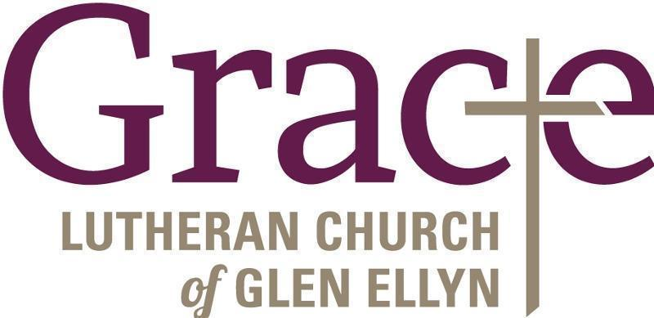

Every Member a Minister and Missionary!

Phone: 630-469-1555 Emergency Pastoral Contact: 630-674-2887
info@graceglenellyn.org www.graceglenellyn.org

Pastor
Rev. Melody Eastman office ext. 14
meastman@graceglenellyn.org

Minister of Music
Bradford Thompson 219-718-8879
bradfordmthompson@gmail.com

Ministry Associate
Becky Ficarella office ext. 17
bficarella@graceglenellyn.org

Office Manager
Barbara Sudds office ext. 10
bsudds@graceglenellyn.org

Parish Counselor
Carole LoGalbo M.S., LCPC 630-668-4594
carolelogalbo@yahoo.com

