Grace Lutheran Church

493 Forest Avenue, Glen Ellyn IL 630.469.1555
www.graceglenellyn.org

14th Sunday after Pentecost August 29, 2021

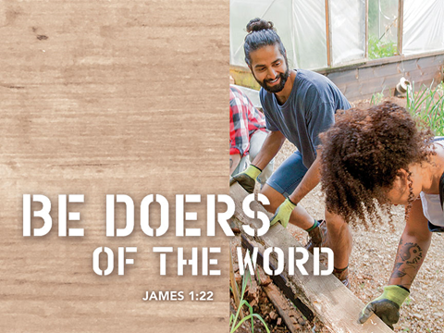

+ Proclaim Christ + Build Community +
+ Serve Our Neighbors +

Introduction
Jesus protests against human customs being given the weight of divine law, while the essence of God’s law is ignored. True uncleanness comes not from external things, but from the intentions of the human heart. Last week Jesus told us “the words that I have spoken to you are spirit and life” (John 6:63). Now James says God has given us birth by the word of truth. We who were washed in the word when we were born in the font return to it every Sunday to ask God to create in us clean hearts.

Gathering
The Holy Spirit calls us together as the people of God.
Welcome/Announcements
You are welcomed to remain seated throughout this morning’s liturgy.
Prelude

Confession and Forgiveness
All may make the sign of the cross, the sign marked at baptism, as the presiding minister begins.
Blessed be the holy Trinity,☩ one God, the God of manna, the God of miracles, the God of mercy. Amen.

Drawn to Christ and seeking God’s abundance, let us confess our sin.
God, our provider,
help us. It is hard to believe there is enough to share. We question your ways when they differ from the ways of the world in which we live. We turn to our own understanding rather than trusting in you. We take offense at your teachings and your ways. Turn us again to you. Where else can we turn? Share with us the words of eternal life and feed us for life in the world. Amen.

Beloved people of God: in Jesus, the manna from heaven, you are fed and nourished. By Jesus, the worker of miracles, there is always more than enough. Through Jesus, ☩ the bread of life, you are shown God’s mercy: you are forgiven and loved into abundant life. Amen.

Entrance Hymn ELW #824 This Is My Father’s World
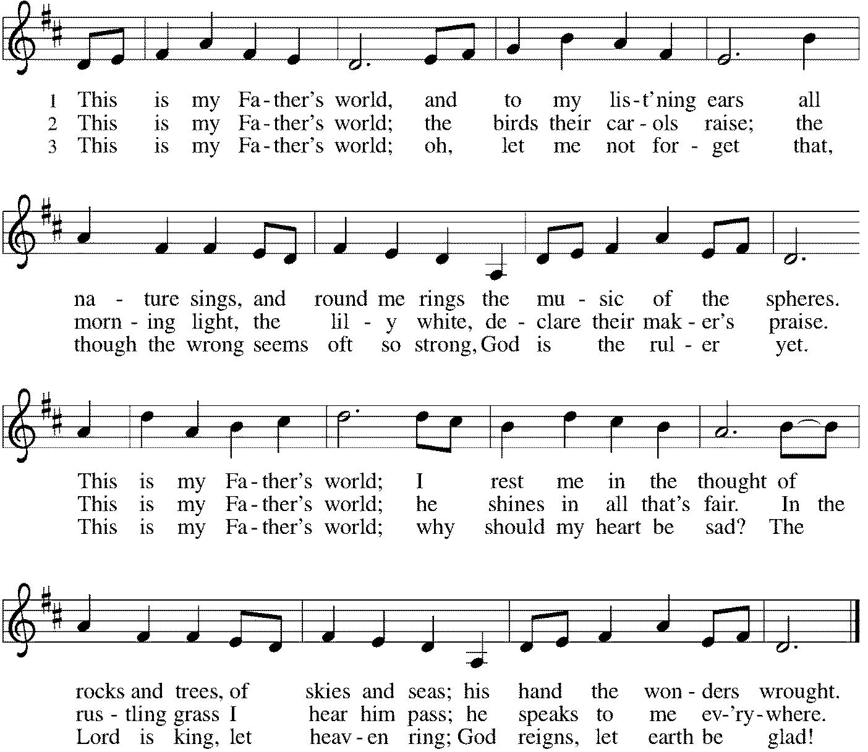

Greeting
The grace of our Lord Jesus Christ, the love of God, and the communion of the Holy Spirit be with you all. And also with you.

Hymn of Praise p. 204

Prayer of the Day
O God our strength, without you we are weak and wayward creatures. Protect us from all dangers that attack us from the outside, and cleanse us from all evil that arises from within ourselves, that we may be preserved through your Son, Jesus Christ, our Savior and Lord. Amen.
Word
God speaks to us in scripture reading, preaching, and song.
First Lesson Deuteronomy 4:1-2, 6-9
The Israelites believed the law was a divine gift that provided guidelines for living out the covenant. Moses commands the people to obey the law and to neither add to nor subtract from it. The Israelites are also to teach the law to their children and their children’s children.

¹So now, Israel, give heed to the statutes and ordinances that I am teaching you to observe, so that you may live to enter and occupy the land that the Lord, the God of your ancestors, is giving you. ²You must neither add anything to what I command you nor take away anything from it, but keep the commandments of the Lord your God with which I am charging you.
⁶You must observe them diligently, for this will show your wisdom and discernment to the peoples, who, when they hear all these statutes, will say, “Surely this great nation is a wise and discerning people!” ⁷For what other great nation has a god so near to it as the Lord our God is whenever we call to him? ⁸And what other great nation has statutes and ordinances as just as this entire law that I am setting before you today?
⁹But take care and watch yourselves closely, so as neither to forget the things that your eyes have seen nor to let them slip from your mind all the days of your life; make them known to your children and your children’s children.

Word of God, Word of Life. Thanks be to God.

Psalm Psalm 15
¹Lord, who may dwell in your tabernacle? Who may abide upon your holy hill?
²Those who lead a blameless life and do what is right, who speak the truth from their heart;
³they do not slander with the tongue, they do no evil to their friends; they do not cast discredit upon a neighbor.
⁴In their sight the wicked are rejected, but they honor those who fear the Lord. They have sworn upon their health and do not take back their word.
⁵They do not give their money in hope of gain, nor do they take bribes against the innocent. Those who do these things shall never be overthrown.

Second Lesson James 1:17-27
The letter of James was intended to provide first-century Christians with instruction in godly behavior. Here Christians are encouraged to listen carefully and to act on what they hear, especially by caring for those least able to care for themselves.

¹⁷Every generous act of giving, with every perfect gift, is from above, coming down from the Father of lights, with whom there is no variation or shadow due to change. ¹⁸In fulfillment of his own purpose he gave us birth by the word of truth, so that we would become a kind of first fruits of his creatures.
¹⁹You must understand this, my beloved: let everyone be quick to listen, slow to speak, slow to anger; ²⁰for your anger does not produce God’s righteousness. ²¹Therefore rid yourselves of all sordidness and rank growth of wickedness, and welcome with meekness the implanted word that has the power to save your souls.
²²But be doers of the word, and not merely hearers who deceive themselves. ²³For if any are hearers of the word and not doers, they are like those who look at themselves in a mirror; ²⁴for they look at themselves and, on going away, immediately forget what they were like. ²⁵But those who look into the perfect law, the law of liberty, and persevere, being not hearers who forget but doers who act—they will be blessed in their doing.
²⁶If any think they are religious, and do not bridle their tongues but deceive their hearts, their religion is worthless. ²⁷Religion that is pure and undefiled before God, the Father, is this: to care for orphans and widows in their distress, and to keep oneself unstained by the world.

Word of God, Word of Life. Thanks be to God.

Gospel Acclamation p. 205 Alleluia
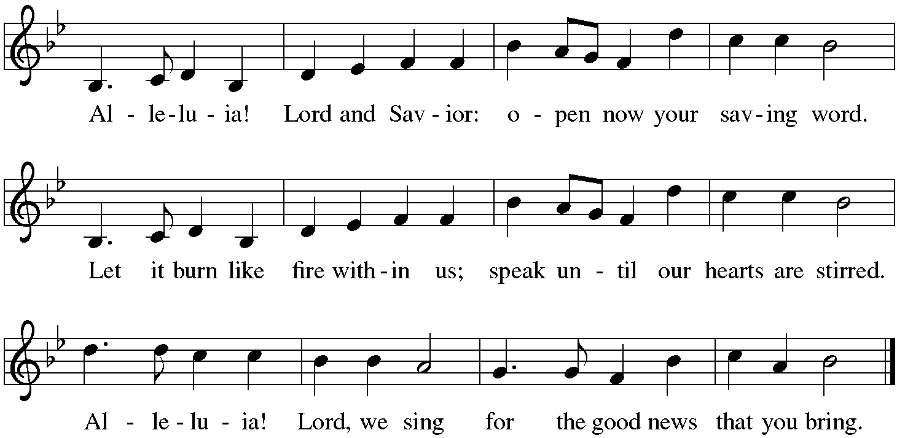

The holy Gospel according to Mark. Glory to you, O Lord.

Gospel Mark 7:1-8, 14-15, 21-23
Mark’s gospel depicts Jesus as challenging traditional ways in which religious people determine what is pure or impure. For Jesus, the observance of religious practices cannot become a substitute for godly words or deeds that spring from a faithful heart.

¹Now when the Pharisees and some of the scribes who had come from Jerusalem gathered around [Jesus], ²they noticed that some of his disciples were eating with defiled hands, that is, without washing them. ³(For the Pharisees, and all the Jews, do not eat unless they thoroughly wash their hands, thus observing the tradition of the elders; ⁴and they do not eat anything from the market unless they wash it; and there are also many other traditions that they observe, the washing of cups, pots, and bronze kettles.) ⁵So the Pharisees and the scribes asked him, “Why do your disciples not live according to the tradition of the elders, but eat with defiled hands?” ⁶He said to them, “Isaiah prophesied rightly about you hypocrites, as it is written, ‘This people honors me with their lips, but their hearts are far from me; ⁷in vain do they worship me, teaching human precepts as doctrines.’ ⁸You abandon the commandment of God and hold to human tradition.”
¹⁴Then he called the crowd again and said to them, “Listen to me, all of you, and understand: ¹⁵there is nothing outside a person that by going in can defile, but the things that come out are what defile.”
²¹For it is from within, from the human heart, that evil intentions come: fornication, theft, murder, ²²adultery, avarice, wickedness, deceit, licentiousness, envy, slander, pride, folly. ²³All these evil things come from within, and they defile a person.”

The Gospel of the Lord. Praise to you, O Christ.

Sermon The Rev. Melody Eastman

Hymn of the Day ELW #512 Lord, Let My Heart Be Good Soil
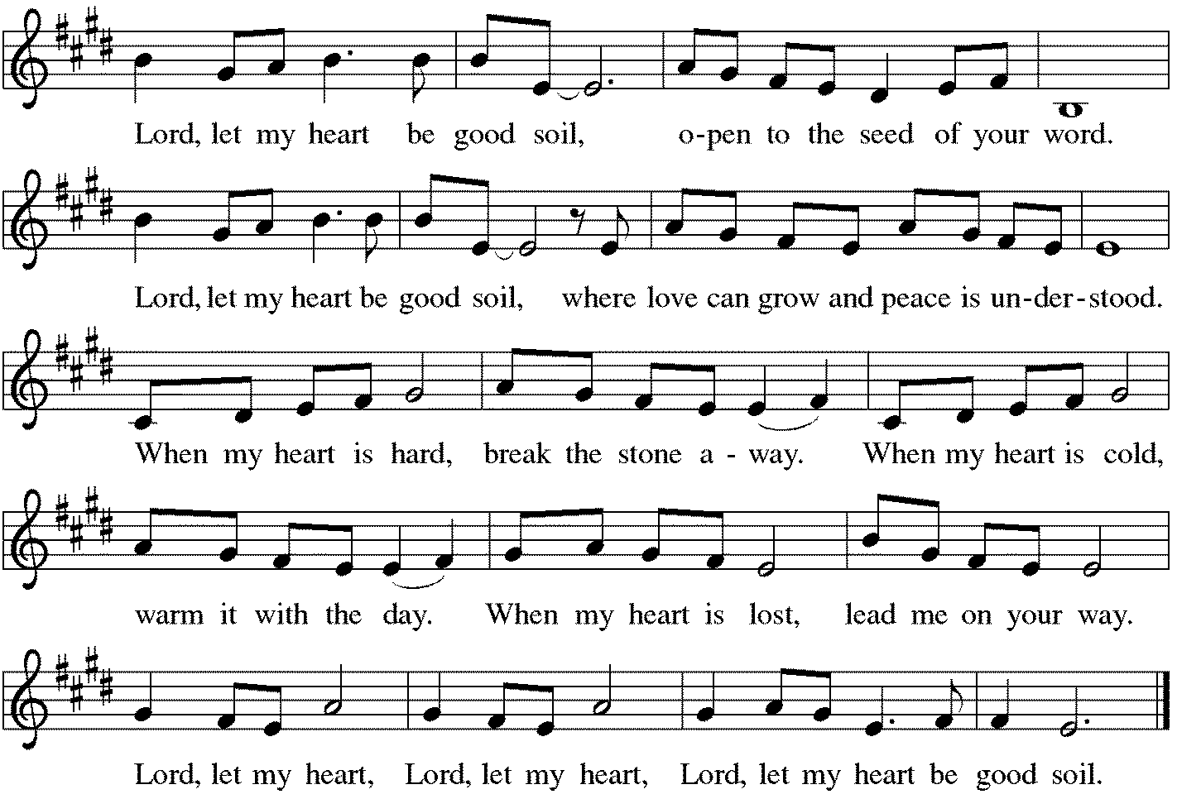
Blessing of the Backpacks
Loving God, be with these backpacks and briefcases and bags, and with those who carry them.
Be with them and help them as they begin a new year of learning, teaching, working, growing, and serving.
May their minds and their pencils be sharp; may their lunches never be forgotten at home; and may their pink pearl erasers help them to remember that mistakes are okay - and when you’re a student they are in fact the most important part of the process. Just let them make their mistakes at the right time, and not the wrong time.
God, thank you for glue sticks and homework folders and laptops and crisp new notebooks waiting to be filled; thank you for schools and libraries and teachers; for offices and co-workers and fellow learners. Thank you for the gift of curiosity and new knowledge and for your wisdom that is all around.
God of wisdom, bless these backpacks and briefcases and bags, and all those who carry them. Grant joy in learning and joy in serving.
We pray this and everything in the name of your son, who left his parents so he could sit and learn at the feet of those rabbis in the temple. We pray this and everything in the name of Jesus, amen.

Prayers of Intercession
Made children and heirs of God’s promise, we pray for the church, the world, and all in need.
A brief silence.

We pray for the church, that it is a safe haven for all who seek your presence. Fill it with pastors, deacons, and leaders who echo your expansive and generous welcome. Lord, in your mercy, hear our prayer.

We pray for the whole of creation, that plants and animals have the habitat and resources to thrive and flourish. Inspire us to protect threatened habitats and ensure a sustainable future for generations to come. Lord, in your mercy, hear our prayer.

We pray for individuals in positions of authority. Raise up wise and discerning leaders in federal, state, and local governments and guide them to seek the benefit of every person. Lord, in your mercy, hear our prayer.

We pray for all who are in need. Support and encourage those who are unemployed, underemployed, or experiencing poverty. Bring food, shelter, clothes, and stability for daily life. Be with all who are ill, especially Bradford, Jim, Cathy, Sigrid, Dorothy, Norma, Dolores, Carol, Dorothy, and those we name before you now…. Lord, in your mercy, hear our prayer.

We pray for this congregation, especially those beginning a new school year. Empower teachers and school administrators. Guide students in their learning and development. Accompany parents, foster parents, and caregivers who provide encouragement and love. Lord, in your mercy, hear our prayer.

We give thanks for the faithful departed who showed us how to honor God with our heart. Inspire us by their example and renew our faith, trusting that we will be united with them in glory. Lord, in your mercy, hear our prayer.

Receive these prayers, O God, and those in our hearts known only to you; through Jesus Christ our Lord. Amen.

Peace
The peace of Christ be with you always. And also with you.

Meal
God feeds us with the presence of Jesus Christ.
Offering Prayer
Jesus, Bread of life,
you have set this table with your very self,
and called us to the feast of plenty.
Gather what has been sown among us,
and strengthen us in this meal.
Make us to be what we receive here,
your body for the life of the world. Amen

Great Thanksgiving
The Lord be with you. And also with you.
Lift up your hearts. We lift them to the Lord.
Let us give thanks to the Lord our God. It is right to give our thanks and praise.

Preface
It is indeed right, our duty and our joy, that we should at all times and in all places give thanks and praise to you, almighty and merciful God, through our Savior Jesus Christ; who on this day overcame death and the grave, and by his glorious resurrection opened to us the way of everlasting life. And so, with all the choirs of angels, with the church on earth and the hosts of heaven, we praise your name and join their unending hymn:

Sanctus p. 207 Holy, Holy, Holy
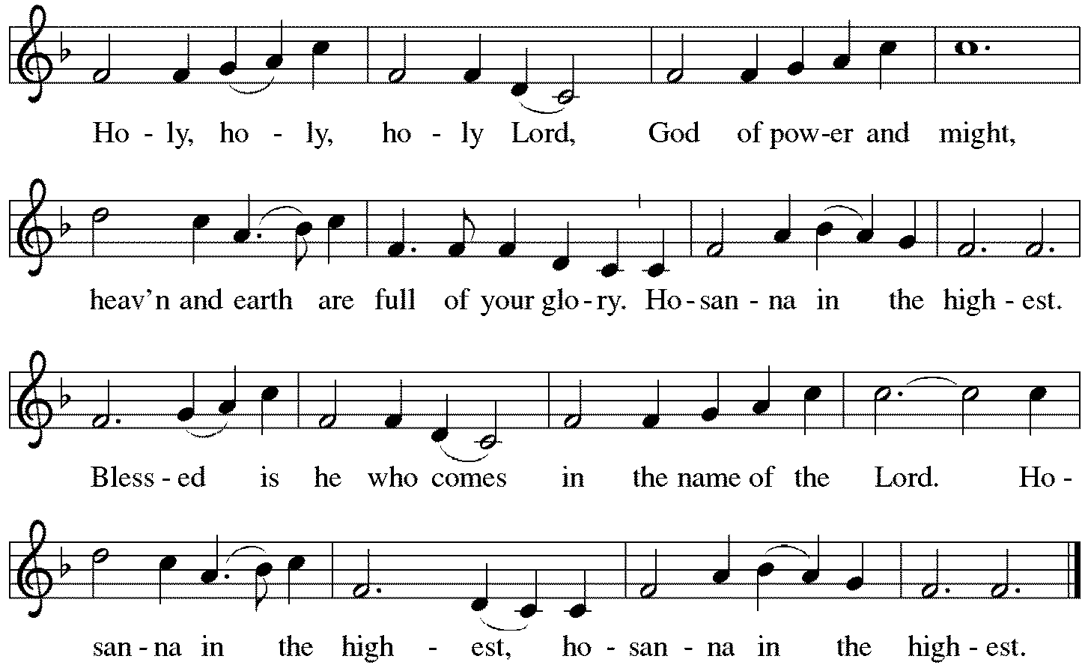

*Thanksgiving at the Table
You are indeed holy, almighty and merciful God.
You are most holy, and great is the majesty of your glory.

You so loved the world that you gave your only Son,
so that everyone who believes in him may not perish
but have eternal life.
We give you thanks for his coming into the world
to fulfill for us your holy will
and to accomplish all things for our salvation.

In the night in which he was betrayed,
our Lord Jesus took bread, and gave thanks;
broke it, and gave it to his disciples, saying:
Take and eat; this is my body, given for you.
Do this for the remembrance of me.

Again, after supper, he took the cup, gave thanks,
and gave it for all to drink, saying:
This cup is the new covenant in my blood,
shed for you and for all people for the forgiveness of sin.
Do this for the remembrance of me.

For as often as we eat of this bread and drink from this cup,
we proclaim the Lord's death until he comes.
Christ has died. Christ is risen. Christ will come again.

You may hold up your (unopened) communion kit as you are able.
Remembering, therefore, his salutary command,
his life-giving passion and death,
his glorious resurrection and ascension,
and the promise of his coming again,
we give thanks to you, O Lord God Almighty,
not as we ought but as we are able;
we ask you mercifully to accept our praise and thanksgiving
and with your Word and Holy Spirit to bless us, your servants,
and these your own gifts of bread and wine,
so that we and all who share in the body and blood of Christ
may be filled with heavenly blessing and grace,
and, receiving the forgiveness of sin,
may be formed to live as your holy people
and be given our inheritance with all your saints.
You may lower your communion kit.

To you, O God, Father, Son, and Holy Spirit,
be all honor and glory in your holy church, now and forever.
Amen.

The Lord’s Prayer
Gathered into one by the Holy Spirit, let us pray as Jesus taught us.
Our Father, who art in heaven, hallowed be thy name, thy kingdom come, thy will be done, on earth as it is in heaven. Give us this day our daily bread; and forgive us our trespasses as we forgive those who trespass against us; and lead us not into temptation but deliver us from evil. For thine is the kingdom, the power, and the glory, forever and ever. Amen.

Invitation to Communion
Christ has set the table with more than enough for all. Come!

If you have difficulty opening your communion, please signal for assistance.

Peel up the clear top seal over the wafer, and hold the wafer up when you are ready.
This is the Body of Christ, given for you. (Eat the bread.) Amen.

Peel up the second foil seal over the juice, and hold your cup up when you are ready.
This is the blood of Christ, shed for you. (Drink the wine/juice.) Amen.

Agnus Dei p. 208 Lamb of God
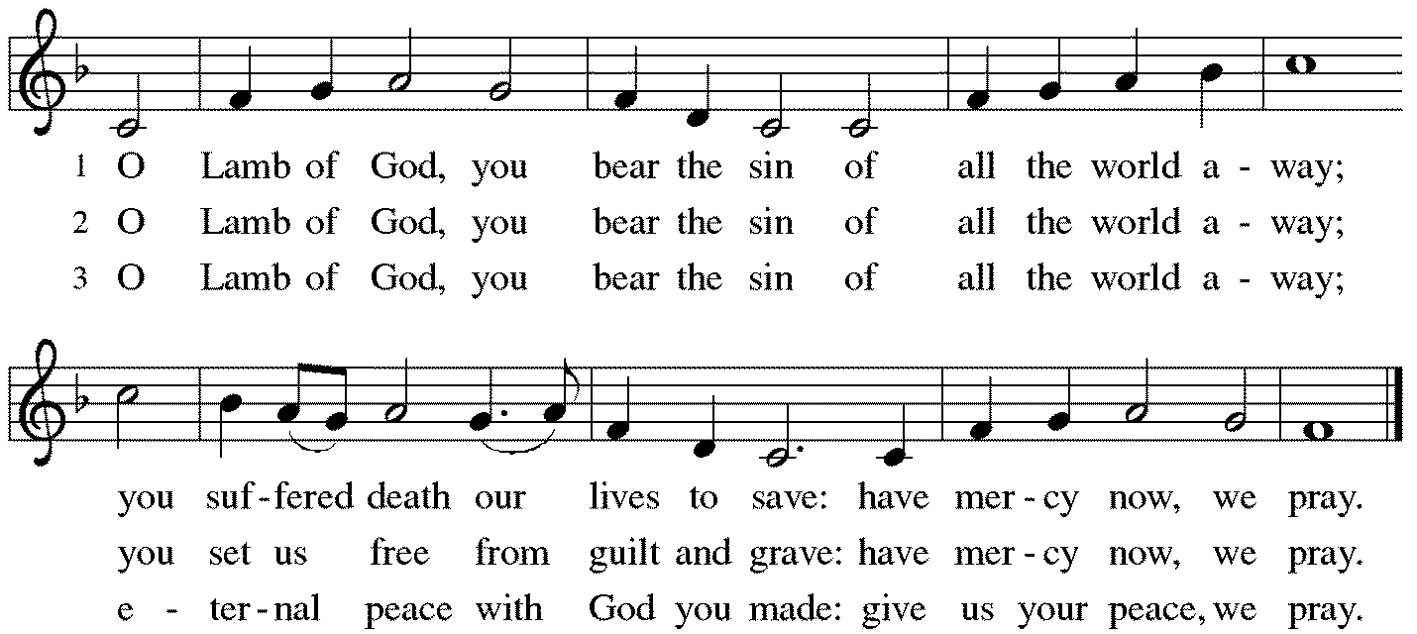

Post-Communion Blessing
The body and blood of our Lord Jesus Christ strengthen you and keep you in his grace. Amen.

Prayer after Communion
Jesus, Bread of life, we have received from your table more than we could ever ask. As you have nourished us in this meal, now strengthen us to love the world with your own life. In your name we pray. Amen.

Sending
God blesses us and sends us in mission to the world.
Blessing
The blessing of God, who provides for us, feeds us, and journeys with us, ☩ be upon you now and forever. Amen.

Sending Hymn ACS #987 Guide My Feet

Guide my feet, while I run this race. (3 times)
For I don’t want to run this race in vain.

Hold my hand, while I run this race….

Stand by me, while I run this race….

I’m your child, while I run this race….

Search my heart, while I run this race….

Sent to the World
Go in peace. You are the body of Christ. Thanks be to God.

Postlude
Thanks to Marty Eastman for leading the music this morning.

From Sundays and Seasons
v.20190109.1233 Copyright © 2021 Augsburg Fortress. All rights reserved.
Reprinted by permission under Augsburg Fortress Liturgies Annual License #30867.
All rights reserved. Reprinted under OneLicense.net #A-718333.

Assisting in Worship Today
Ministry Associate Becky Ficarella
Minister of Music Bradford Thompson
Lector Jeff Nelson
Ushers Mario Ficarella, Chuck Miller, Bill Murdoch, Open

Current Prayer Requests
Please keep these people in your prayers and reach out to our sisters and brothers in Christian love. Names will be left on the list for two weeks, unless you indicate that they should remain in our prayers for a longer period.
Name Relationship Prayer For
Bradford Thompson Grace’s Minister of Music Healing & Strength
Family of Robert LoGalbo Member Comfort in Grief
Elle and Ken Milleville, who welcomed daughter Cate Lou Milleville on Tuesday, August 10.
Jim Sladek Member Healing & Strength
Cathy Milleville Member Healing & Strength
Sigrid Elliott Member Healing & Strength
Dorothy Tracy Member Healing & Strength
Keith & Rita Matthews SIL & Daughter of Norma Petersen Healing & Strength
Keith Petras Brother of Dru Geraghty Healing & Strength
Lori Garabrandt Relative of Chuck Miller and Lois Pertle Healing & Strength
Chris Danly Son of Mark & Pat Danly Healing & Strength
Prayers for our homebound Members
Dolores Nosal, Carol Petersen, Norma Petersen, Dorothy Stein

God’s work. Our hands. Food Drive: For “God’s work. Our hands.” on September 12, Grace has organized a Food Drive to benefit DuPage PADS and the Glen Ellyn Food Pantry. The Food Drive will run through September 12. All items received will be blessed on September 12 during the worship service and then distributed to PADS and GEFP. Items requested for PADS include: individually packaged chips, pretzels, trail mix, nuts, fruit juices, fruit cups, fruit sticks, and snacks; individually wrapped cookies, pies, cakes, and candy; steamable small packages of frozen vegetables; and frozen meals for adults and kids. Items requested for the GEFP include: paper towels; oatmeal (canisters or packets); salad dressing; canned sloppy joes; canned chili; ketchup/mustard/relish/mayo; pancake mix and syrup; boxed pasta and jarred pasta sauce; any canned fruit; fresh potatoes; toothpaste and toothbrushes.

RAMP (Reduce Another Mortgage Payment): As we continue to RAMP up to refinance our mortgage with Mission Investment Fund in October, we wish to thank you all who have contributed to date. We are still hopeful we can raise an additional $75,000 before October 5. Our monthly mortgage payment is a big ticket item in our budget at $6,777 monthly ($81,324 annually) and lowering that amount by an additional $1,000 or more per month will greatly help our annual budget and free up funds that we can utilize on the ministries of Grace. Please give any amount you can between now and October 5. Indicate your contribution is for the Mortgage Reduction Fund.

Circle of Care Coordinator Needed: We are seeking an individual to fill the role of Circle of Care Coordinator. This role includes managing incoming requests of care from members and then finding the appropriate volunteers to help from a current list of willing helpers! Examples might include rides, grocery store runs, or meal drop offs. Please contact the church office or Becky Ficarella if you are interested!

Ushers Needed: Each of our four usher teams are in need of one additional team member. Team 1 (January, May, September); Team 2 (February, June, October); Team 3 (March, July, November; Team 4 (April, August, December). Please contact the church office if you can volunteer for one of these teams or sign up in the Narthex.

Got Capital Gains? Did you know that stock donations allow you to both claim a deduction at the appreciated value AND allow you to avoid capital gains taxes on these assets? Further, consolidating donations in a tax year could lead to increased ability to deduct charitable contributions in a given tax year. Consult your tax advisor for details, but if you’d like more information on how to go about donating stock, reach out to the church office.

Contributions to Grace: You may continue to mail your contributions for the General Fund and Mortgage Reduction Fund to the church office; have your bank mail your contribution to the church office (this works great); or contribute on-line through Grace’s website (Grace/you pay fees). Please know, pandemic or no, our mission continues! Thank you for your continued support of our ministries at Grace Lutheran.

Date Added for Sr. Center Chair Exercise. The exercise class meets Mondays at 10:00am, Tuesdays at 11:30am, and Thursdays at 11:00am. Registration is required as the number of attendees will be limited. Please contact Sue Davison at 630-858-6343 to register.

Sr. Center Book Club: The Book Club will meet on the third Tuesday of the month at 11:00am. Please contact Sue Davison at 630-858-6343 to register.

A Celebration of Life for Joan Frank: Thursday, September 2, in the Arbor Room at the Morton Arboretum, followed by a Funeral Service Friday, September 3, at Grace Lutheran Church in Glen Ellyn.

Every Member a Minister and Missionary!

Phone: 630-469-1555 Emergency Pastoral Contact: 630-674-2887
info@graceglenellyn.org www.graceglenellyn.org

Pastor
Rev. Melody Eastman office ext. 14
meastman@graceglenellyn.org

Minister of Music
Bradford Thompson 219-718-8879
bradfordmthompson@gmail.com

Ministry Associate
Becky Ficarella office ext. 17
bficarella@graceglenellyn.org

Office Manager
Barbara Sudds office ext. 10
bsudds@graceglenellyn.org

Parish Counselor
Carole LoGalbo M.S., LCPC 630-668-4594
carolelogalbo@yahoo.com

