Grace Lutheran Church

493 Forest Avenue, Glen Ellyn IL 630.469.1555
www.graceglenellyn.org

15th Sunday after Pentecost September 5, 2021

+ Proclaim Christ + Build Community +
+ Serve Our Neighbors +

Introduction
James tells us to stop showing favoritism in the assembly, treating the rich visitor with more honor than the poor one. Jesus himself seems to show partiality in his first response to the Syrophoenician woman in today’s gospel. Was he testing her faith in saying Gentiles don’t deserve the goods meant for God’s children? Or was he speaking out of his human worldview, but transcended those limits when she took him by surprise with her reply? Either way, the story tells us that God shows no partiality. Everyone who brings a need to Jesus is received with equal honor as a child and heir.

Gathering
The Holy Spirit calls us together as the people of God.
Welcome/Announcements
Helpful Reminders for those joining via Zoom:
- The host will mute you when you join, and you will remain muted until the end of the service.
- You are welcome to join in all congregation responses (in Bold black.) and hymns.
- At the end of the service you may unmute your mic to share greetings with your fellow worshippers. If you dialed in on the phone, press *6. Remember, your host cannot unmute you.
Helpful Reminders for those joining in person:
- Maintain 6’ distance between family groups
- You may place your offering in the box in the narthex.

Prelude

*Please stand as you are able and turn to face the font.
*Confession and Forgiveness
All may make the sign of the cross, the sign marked at baptism, as the presiding minister begins.
Blessed be the holy Trinity, ☩ one God, whose teaching is life, whose presence is sure, and whose love is endless. Amen.

Let us confess our sins to the one who welcomes us with an open heart.
Silence is kept for reflection.

God our comforter: like lost sheep, we have gone astray. We gaze upon abundance and see scarcity. We turn our faces away from injustice and oppression. We exploit the earth with our apathy and greed. Free us from our sin, gracious God. Listen when we call out to you for help. Lead us by your love to love our neighbors as ourselves. Amen.

All have sinned and fall short of the glory of God. By the gift of grace in ☩ Christ Jesus, God makes us righteous. We receive with glad hearts the forgiveness of all our sins. Amen.

*Entrance Hymn ELW #519 Open Your Ears, O Faithful People
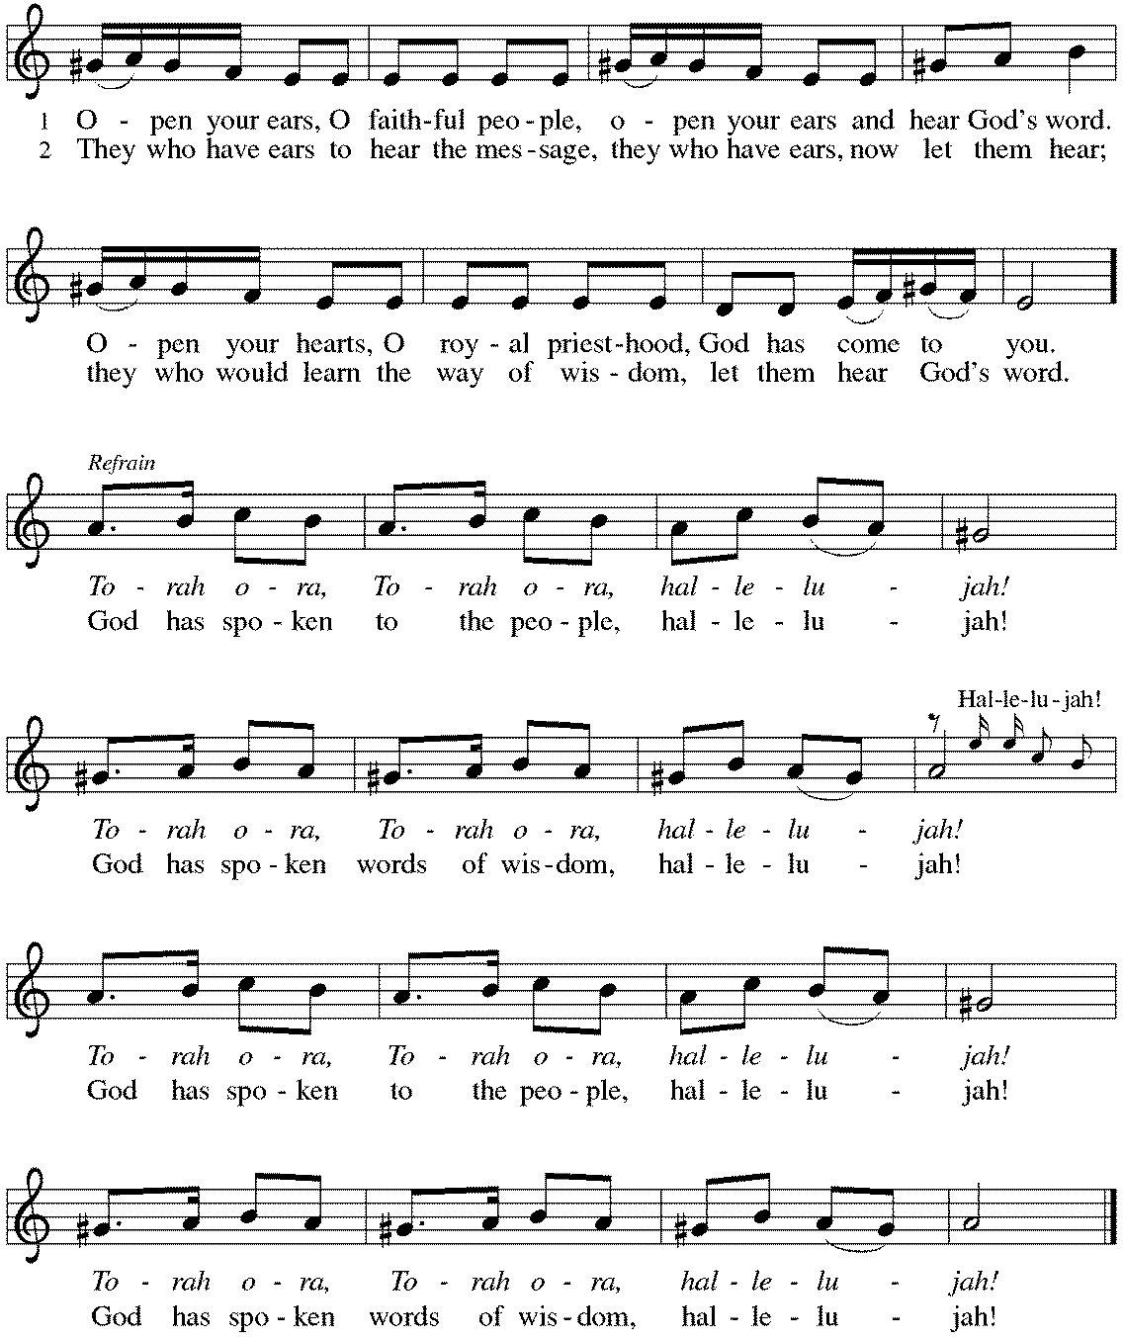

*Greeting
The grace of our Lord Jesus Christ, the love of God, and the communion of the Holy Spirit be with you all. And also with you.
*Kyrie p. 184
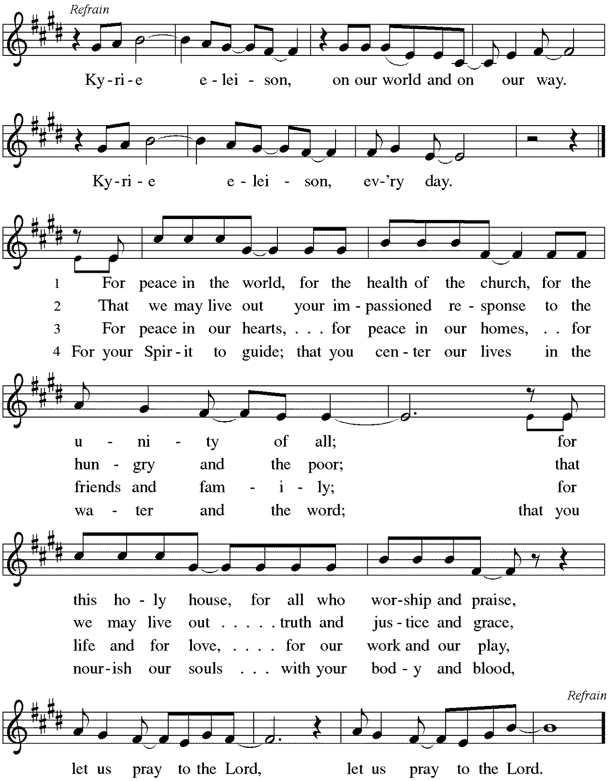
*Prayer of the Day
Gracious God, throughout the ages you transform sickness into health and death into life. Open us to the power of your presence, and make us a people ready to proclaim your promises to the whole world, through Jesus Christ, our healer and Lord. Amen. Be seated.

Word
God speaks to us in scripture reading, preaching, and song.
First Lesson Isaiah 35:4-7a
These verses are a word of hope to the exiles in Babylon. Isaiah 34 portrays God’s vengeance on Edom, Israel’s age-old enemy, which makes the path from Babylon to Zion safe for the exiles’ return. The desert itself will flow with water to give drink to the returning exiles.

⁴Say to those who are of a fearful heart, “Be strong, do not fear! Here is your God. He will come with vengeance, with terrible recompense. He will come and save you.”
⁵Then the eyes of the blind shall be opened, and the ears of the deaf unstopped; ⁶then the lame shall leap like a deer, and the tongue of the speechless sing for joy. For waters shall break forth in the wilderness, and streams in the desert; ^{7a}the burning sand shall become a pool, and the thirsty ground springs of water.

Word of God, Word of Life. Thanks be to God.

Psalm Psalm 146
I will praise the Lord as long as I live. (Ps. 146:2)

¹Hallelujah! Praise the Lord, O my soul!
²I will praise the Lord as long as I live; I will sing praises to my God while I have my being.
³Put not your trust in rulers, in mortals in whom there is no help.
⁴When they breathe their last, they return to earth, and in that day their thoughts perish.
⁵Happy are they who have the God of Jacob for their help, whose hope is in the Lord their God;
⁶who made heaven and earth, the seas, and all that is in them; who keeps promises forever;
⁷who gives justice to those who are oppressed, and food to those who hunger. The Lord sets the captive free.
⁸The Lord opens the eyes of the blind; the Lord lifts up those who are bowed down; the Lord loves the righteous.
⁹The Lord cares for the stranger; the Lord sustains the orphan and widow, but frustrates the way of the wicked.
¹⁰The Lord shall reign forever, your God, O Zion, throughout all generations. Hallelujah!

Second Lesson James 2:1-17
Faithful Christians do not show partiality to the rich and powerful of the world, especially at the expense of the poor and weak. Likewise, faith does not pay mere lip service to God’s will. Instead, a living Christian faith expresses itself in acts of compassion and mercy for those in need.

¹My brothers and sisters, do you with your acts of favoritism really believe in our glorious Lord Jesus Christ? ²For if a person with gold rings and in fine clothes comes into your assembly, and if a poor person in dirty clothes also comes in, ³and if you take notice of the one wearing the fine clothes and say, “Have a seat here, please,” while to the one who is poor you say, “Stand there,” or, “Sit at my feet,” ⁴have you not made distinctions among yourselves, and become judges with evil thoughts? ⁵Listen, my beloved brothers and sisters. Has not God chosen the poor in the world to be rich in faith and to be heirs of the kingdom that he has promised to those who love him? ⁶But you have dishonored the poor. Is it not the rich who oppress you? Is it not they who drag you into court? ⁷Is it not they who blaspheme the excellent name that was invoked over you?
⁸You do well if you really fulfill the royal law according to the scripture, “You shall love your neighbor as yourself.” ⁹But if you show partiality, you commit sin and are convicted by the law as transgressors. ¹⁰For whoever keeps the whole law but fails in one point has become accountable for all of it. ¹¹For the one who said, “You shall not commit adultery,” also said, “You shall not murder.” Now if you do not commit adultery but if you murder, you have become a transgressor of the law. ¹²So speak and so act as those who are to be judged by the law of liberty. ¹³For judgment will be without mercy to anyone who has shown no mercy; mercy triumphs over judgment.
¹⁴What good is it, my brothers and sisters, if you say you have faith but do not have works? Can faith save you? ¹⁵If a brother or sister is naked and lacks daily food, ¹⁶and one of you says to them, “Go in peace; keep warm and eat your fill,” and yet you do not supply their bodily needs, what is the good of that? ¹⁷So faith by itself, if it has no works, is dead.

Word of God, Word of Life. Thanks be to God.

*Please stand as you are able.
*Gospel Acclamation p. 188 Alleluia
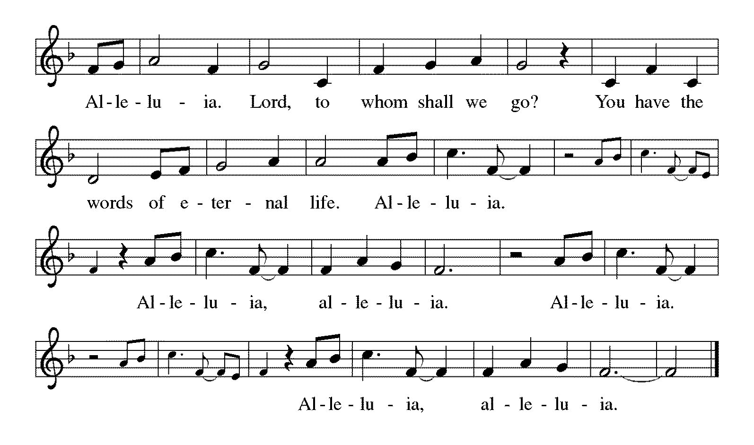

The holy Gospel according to Mark. Glory to you, O Lord.

*Gospel Mark 7:24-37
In Mark’s gospel, encounters with women usually signify turning points in Jesus’ ministry. Here, a conversation with a Syrophoenician woman marks the beginning of his mission to the Gentiles.

²⁴[Jesus] set out and went away to the region of Tyre. He entered a house and did not want anyone to know he was there. Yet he could not escape notice,²⁵but a woman whose little daughter had an unclean spirit immediately heard about him, and she came and bowed down at his feet. ²⁶Now the woman was a Gentile, of Syrophoenician origin. She begged him to cast the demon out of her daughter. ²⁷He said to her, “Let the children be fed first, for it is not fair to take the children’s food and throw it to the dogs.” ²⁸But she answered him, “Sir, even the dogs under the table eat the children’s crumbs.” ²⁹Then he said to her, “For saying that, you may go—the demon has left your daughter.” ³⁰So she went home, found the child lying on the bed, and the demon gone.
³¹Then he returned from the region of Tyre, and went by way of Sidon towards the Sea of Galilee, in the region of the Decapolis. ³²They brought to him a deaf man who had an impediment in his speech; and they begged him to lay his hand on him. ³³He took him aside in private, away from the crowd, and put his fingers into his ears, and he spat and touched his tongue. ³⁴Then looking up to heaven, he sighed and said to him, “Ephphatha,” that is, “Be opened.” ³⁵And immediately his ears were opened, his tongue was released, and he spoke plainly. ³⁶Then Jesus ordered them to tell no one; but the more he ordered them, the more zealously they proclaimed it. ³⁷They were astounded beyond measure, saying, “He has done everything well; he even makes the deaf to hear and the mute to speak.”

The Gospel of the Lord. Praise to you, O Christ. Be seated.

Hymn Sing

*Please stand as you are able.
*Hymn of the Day ELW #612 Healer of Our Every Ill
sts. 1,2,4
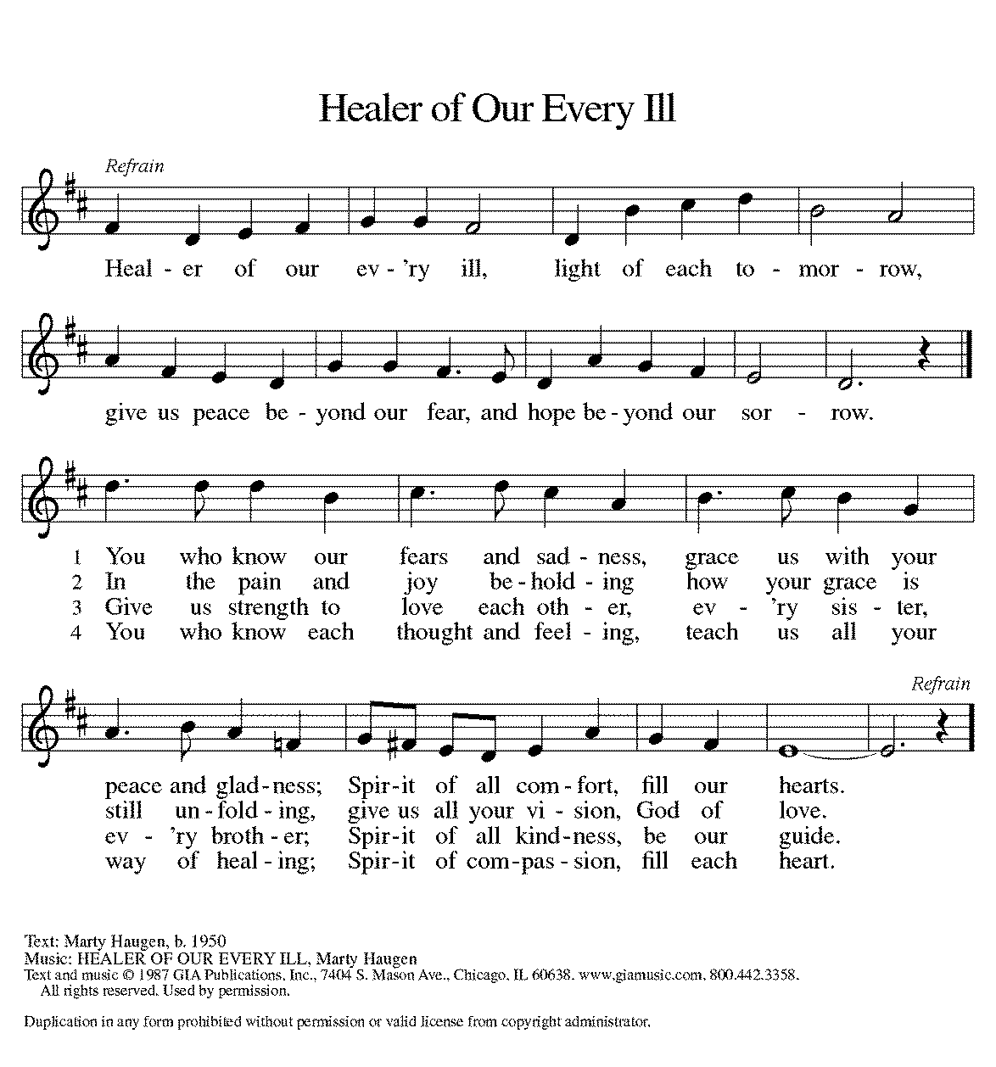
Be seated.
*Prayers of Intercession
Made children and heirs of God’s promise, we pray for the church, the world, and all in need.
A brief silence.

Holy One, you bring your people together in worship. Enliven your church. Guide all evangelists, preachers, prophets, and missionaries who seek to share your love through word and deed. Lord, in your mercy, hear our prayer.

You provide water for thirsty ground and sunshine to feed hungry plants. Bless all who advocate for healthy forests, unpolluted air, and clean waterways. Inspire all people to show care for the world you have made. Lord, in your mercy, hear our prayer.

You show no partiality. Increase justice in all nations. Encourage leaders and governments to work with one another for the good of our common world. Unite us in seeking the health, safety, and dignity of all. Lord, in your mercy, hear our prayer.

You accompany those who are most in need. Shelter all fleeing violence or persecution, protect any who are in danger, and sustain them through uncertain and unstable times. Lord, in your mercy, hear our prayer.

Sustain those who continue to battle wildfires and those who have lost homes and income. Sustain those who struggle to bring relief to those suffering from the effects of Hurricane Ida, and to those who have lost loved ones, shelter, and employment. Lord, in your mercy, hear our prayer.

Be with all who are ill or in any need, especially Bradford, Jim, Cathy, Sigrid, Dorothy, Norma, Dolores, Carol, Dorothy, and those we name before you now….Lord, in your mercy, hear our prayer.

You support the work of your disciples. Continue to nurture the leadership and ministries of this congregation. Lord, in your mercy, hear our prayer.

Be with all who celebrate and increase their joy, especially Paul and JoAnn Griffin as they celebrate their 61st wedding anniversary. Lord, in your mercy, hear our prayer.

You embrace all who have died in the faith and brought them into your glorious presence. We thank you for their example and rejoice in their lives. Lord, in your mercy, hear our prayer.

Receive these prayers, O God, and those in our hearts known only to you; through Jesus Christ our Lord. Amen.

*Peace
The peace of Christ be with you always. And also with you.
Please share the peace with others in your household, or by making a sign of peace to those on Zoom. Please remain standing.

*The Lord’s Prayer Ecumenical Version
Gathered into one by the Holy Spirit, let us pray as Jesus taught us.
Our Father in heaven, hallowed be your name, your kingdom come, your will be done, on earth as in heaven. Give us today our daily bread. Forgive us our sins as we forgive those who sin against us. Save us from the time of trial and deliver us from evil. For the kingdom, the power and the glory are yours, now and forever. Amen.

Sending
God blesses us and sends us in mission to the world.
*Blessing
People of God, we are Christ’s body, bringing new life to a suffering world. The holy Trinity, ☩ one God, bless us now and forever. Amen.

*Sending Hymn ELW#722 O Christ, Your Heart, Compassionate
sts. 1,2,4
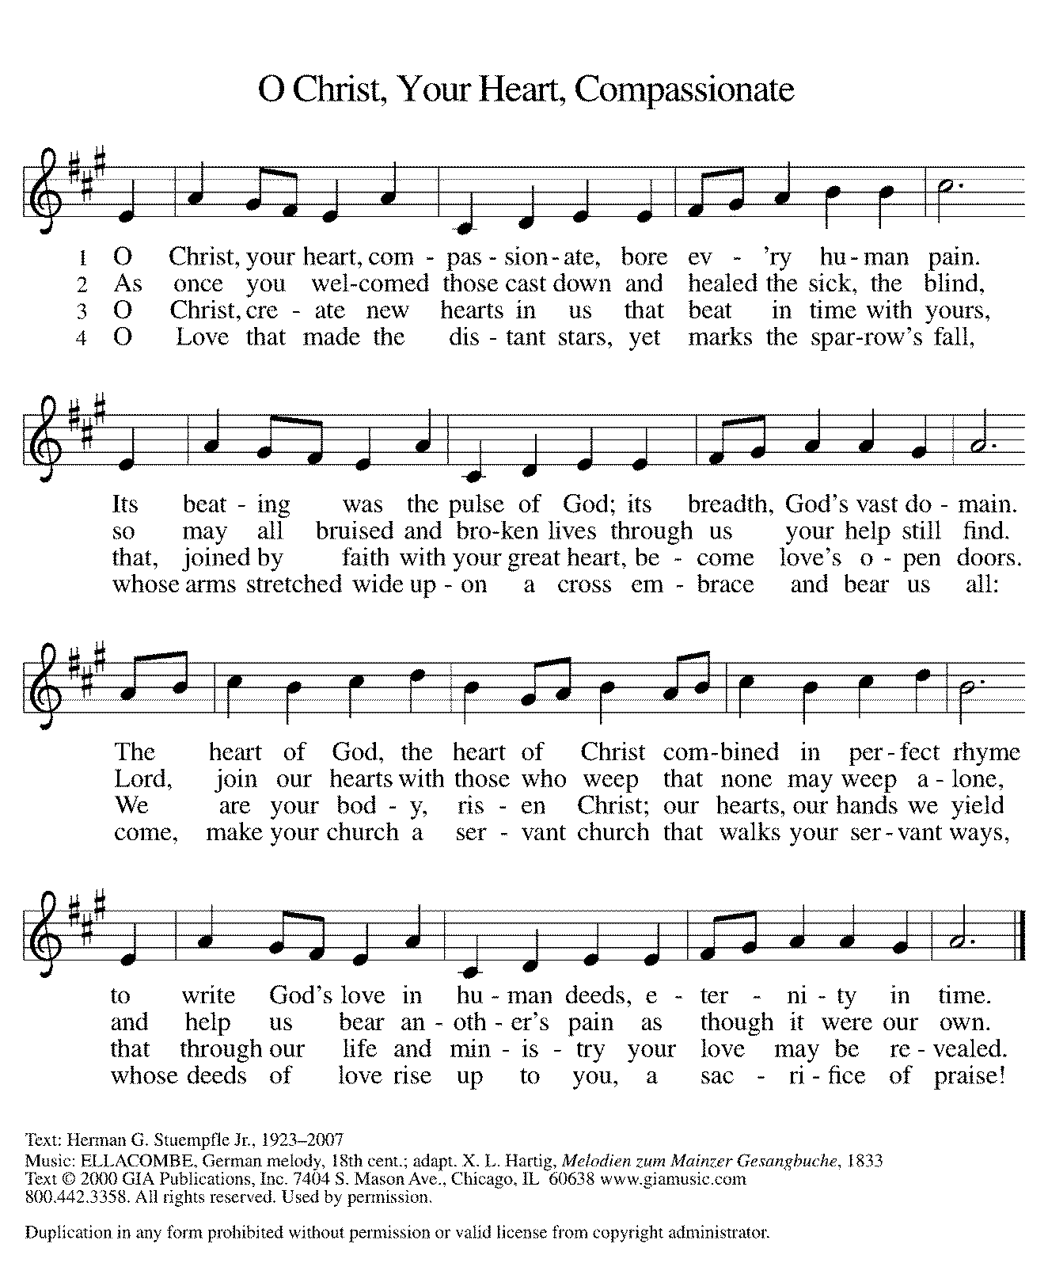

*Sent to the World
Go in peace. The living Word dwells in you. Thanks be to God.

Postlude

Thank you to Becky Ficarella for leading us in worship today.

After the postlude, those who have joined via Zoom may unmute your mics
and share a greeting with your fellow worshippers.

From Sundays and Seasons
v.20190109.1233 Copyright © 2021 Augsburg Fortress. All rights reserved.
Reprinted by permission under Augsburg Fortress Liturgies Annual License #30867.
All rights reserved. Reprinted under OneLicense.net #A-718333.

Assisting in Worship Today
Ministry Associate Becky Ficarella
Minister of Music Bradford Thompson
Lector Vince Hardt
Ushers Mark Drager, John Jokela, Rich Pasbrig, Open

Current Prayer Requests
Please keep these people in your prayers and reach out to our sisters and brothers in Christian love. Names will be left on the list for two weeks, unless you indicate that they should remain in our prayers for a longer period.
Name Relationship Prayer For
Paul and JoAnn Griffin Members 61st Anniversary (9/4)
Jim Sladek Member Healing & Strength
Cathy Milleville Member Healing & Strength
Sigrid Elliott Member Healing & Strength
Dorothy Tracy Member Healing & Strength
Norma Petersen Member Healing & Strength
Keith Petras Brother of Dru Geraghty Healing & Strength
Lori Garabrandt Relative of Chuck Miller and Lois Pertle Healing & Strength
Chris Danly Son of Mark & Pat Danly Healing & Strength
Prayers for our homebound Members
Dolores Nosal, Carol Petersen, Norma Petersen, Dorothy Stein

RAMP (Reduce Another Mortgage Payment): As we continue to RAMP up to refinance our mortgage with Mission Investment Fund in October, we wish to thank you all who have contributed to date. We are still hopeful we can raise an additional $75,000 before October 5. Our monthly mortgage payment is a big ticket item in our budget at $6,777 monthly ($81,324 annually) and lowering that amount by an additional $1,000 or more (yes please) per month will greatly help our annual budget and free up funds that we can utilize on the ministries of Grace. Please give any amount you can between now and October 5. Indicate your contribution is for the Mortgage Reduction Fund.

Got Capital Gains? Did you know that stock donations allow you to both claim a deduction at the appreciated value AND allow you to avoid capital gains taxes on these assets? Further, consolidating donations in a tax year could lead to increased ability to deduct charitable contributions in a given tax year. Consult your tax advisor for details, but if you’d like more information on how to go about donating stock, reach out to the church office.

Contributions to Grace: You may continue to mail your contributions for the General Fund and the Mortgage Reduction Fund to the church office; have your bank mail your contribution to the church office (this works great); or contribute on-line through Grace’s website (Grace/you pay fees). Please know, pandemic or no, our mission continues! Thank you for your continued support of our ministries at Grace Lutheran.

Choir rehearsal resume Wednesday, September 8th, at 7pm! Come join us for an hour of fun, super low-pressure music-making! Not free on Wednesday evenings? You’re still welcome to join us on Sunday mornings at 8:40! Don’t feel good about your voice/singing? We can work on that, too! No matter your voice type or skill level, there’s room for you! Get excited, my friends! The fun starts now :)

Wednesday Night Ignite (Confirmation) begins September 8th, 7-8:30pm, at Faith Lutheran for 7th and 8th Grade students: Lessons led by Grace Ministry Associate Becky Ficarella and Faith Lutheran’s Pastor Joe Yucha. Games, small group scripture and study discussion time, and large group Big Topic discussion time! We move around a lot! Get ready for a season of fun! Schedule is as follows: 9/8 Session 1; 9/15 Session 2; 9/22 Feed My Starving Children Event; 9/29 Session 3.

Women of Grace: We will meet for drinks and dining outdoors together on Thursday, September 9, 7:00pm, at Reserve 22. Due to COVID and the Delta variant we are only able to reserve two tables for six people at each table. Please RSVP to Becky Ficarella at 847-347-0928 or bficarella@graceglenellyn.org.

Blessing moved to September 19 - God’s work. Our hands. Food Drive: For “God’s work. Our hands.” on September 12, Grace has organized a Food Drive to benefit DuPage PADS and the Glen Ellyn Food Pantry. The Food Drive will now run through September 19. All items received will be blessed on September 19 during the worship service and then distributed to PADS and GEFP. Items requested for PADS include: individually packaged chips, pretzels, trail mix, nuts, fruit juices, fruit cups, fruit sticks, and snacks; individually wrapped cookies, pies, cakes, and candy; steamable small packages of frozen vegetables; and frozen meals for adults and kids. Items requested for the GEFP include: paper towels; oatmeal (canisters or packets); salad dressing; canned sloppy joes; canned chili; ketchup/mustard/relish/mayo; pancake mix and syrup; boxed pasta and jarred pasta sauce; any canned fruit; fresh potatoes; toothpaste and toothbrushes.

Pill Bottle Project: Calling all volunteers! After being shut down for over a year, we will meet weekly beginning Tuesday, September 14 from 6-7:30pm in the upstairs kitchen next to the gym. We need to work through our backlog of pill bottles. If you would like to volunteer, just show up! Please note: at this time we are not accepting any pill bottles as it will take some time to get through the current inventory we have. If you have any questions, please contact Mark Hamilton at (630) 841-2941 / mark.hamilton@ifs.com

Former Faith & Friendship Now Grace Fellowship Luncheon: This monthly luncheon is open to the entire congregation regardless of age! Join us on Wednesday, September 15 for worship with communion at 11am followed by a soup and sandwich meal in the Narthex at 11:45am. This group meets on the third Wednesday of the month. We are looking for volunteers to help with this monthly event, please let Becky Ficarella know if you are available!

Generations Choir Wednesday, September 15, 6:00pm: Grace’s all ages choir has returned! We will meet on the third Wednesday of the month at 6:00pm for a simple soup meal and then rehearse our music from 6:45-7:15pm. We will sing on the following Sunday, September 19 at the beginning of the worship service! We can't wait to raise praise with you in fellowship and song! All questions about the meal should be directed to Becky Ficarella, and questions regarding the music should be directed to Bradford Thompson!

Circle of Care Coordinator Needed: We are seeking an individual to fill the role of Circle of Care Coordinator. This role includes managing incoming requests of care from members and then finding the appropriate volunteers to help from a current list of willing helpers! Examples might include rides, grocery store runs, or meal drop offs. Please contact the church office or Becky Ficarella if you are interested!

Date Added for Sr. Center Chair Exercise: The exercise class meets Mondays at 10:00am, Tuesdays at 11:30am, and Thursdays at 11:00am. Registration is required as the number of attendees will be limited. Please contact Sue Davison at 630-858-6343 to register.

Sr. Center Book Club: The Book Club meets on the third Tuesday of the month at 11:00am. Please contact Sue Davison at 630-858-6343 to register.

Every Member a Minister and Missionary!

Phone: 630-469-1555 Emergency Pastoral Contact: 630-674-2887
info@graceglenellyn.org www.graceglenellyn.org

Pastor
Rev. Melody Eastman office ext. 14
meastman@graceglenellyn.org

Minister of Music
Bradford Thompson 219-718-8879
bradfordmthompson@gmail.com

Ministry Associate
Becky Ficarella office ext. 17
bficarella@graceglenellyn.org

Office Manager
Barbara Sudds office ext. 10
bsudds@graceglenellyn.org

Parish Counselor
Carole LoGalbo M.S., LCPC 630-668-4594
carolelogalbo@yahoo.com

