Grace Lutheran Church
493 Forest Avenue, Glen Ellyn IL 630.469.1555
www.graceglenellyn.org

14th Sunday after Pentecost September 6, 2020

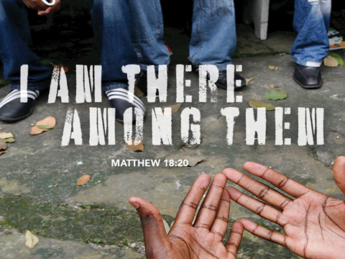

+ Proclaim Christ + Build Community +
+ Serve Our Neighbors +
Introduction
Conflict is a part of relationships and life in community. Jesus’ words in today's gospel are often used in situations having to do with church discipline. The prophet Ezekiel tells of warning the wicked to turn from their ways, and Paul reminds us that love is the fulfilling of the law. We gather in the name of Christ, assured that he is present among us with gifts of peace and reconciliation.

Gathering
The Holy Spirit calls us together as the people of God.

Prelude

Confession and Forgiveness
All may make the sign of the cross, the sign marked at baptism,
as the worship leader begins.

Blessed be the holy Trinity, ☩ one God, who creates, redeems, and
sustains us and all of creation. Amen.

Let us confess our sin in the presence of God and of one another.
Silence is kept for reflection.

Faithful God,
have mercy on us. We confess that we are captive to sin
and cannot free ourselves.
We turn from your loving embrace and go our own ways.
We pass judgment on one another before examining ourselves.
We place our own needs before those of our neighbors.
We keep your gift of salvation to ourselves.
Make us humble, cast away our transgressions,
and turn us again to life in you
through Jesus Christ, our Savior and Lord. Amen.

God hears the cries of all who call out in need, and through his death and resurrection, Christ has made us his own. Hear the truth that God proclaims: Our sins are forgiven in the name of ☩ Jesus Christ. Led by the Holy Spirit, let us live in freedom and newness to do God’s work in the world. Amen.

Opening ELW# 772 Oh, that the Lord Would Guide My Ways

Greeting
The grace of our Lord Jesus Christ, the love of God, and the communion of the Holy Spirit be with you all. And also with you.

Prayer of the Day
O Lord God, enliven and preserve your church with your perpetual mercy. Without your help, we mortals will fail; remove far from us everything that is harmful, and lead us toward all that gives life and salvation, through Jesus Christ, our Savior and Lord. Amen.

Word
God speaks to us in scripture reading, preaching, and song.

First Lesson Ezekiel 33:7-11
God appointed Ezekiel as a sentinel for the house of Israel. Ezekiel must faithfully convey God’s warnings to the people. Remarkably, God—who is about to attack Jerusalem—gives a warning with the hope that repentance will make the attack unnecessary.

⁷So you, mortal, I have made a sentinel for the house of Israel; whenever you hear a word from my mouth, you shall give them warning from me. ⁸If I say to the wicked, “O wicked ones, you shall surely die,” and you do not speak to warn the wicked to turn from their ways, the wicked shall die in their iniquity, but their blood I will require at your hand. ⁹But if you warn the wicked to turn from their ways, and they do not turn from their ways, the wicked shall die in their iniquity, but you will have saved your life.
¹⁰Now you, mortal, say to the house of Israel, Thus you have said: “Our transgressions and our sins weigh upon us, and we waste away because of them; how then can we live?” ¹¹Say to them, As I live, says the Lord God, I have no pleasure in the death of the wicked, but that the wicked turn from their ways and live; turn back, turn back from your evil ways; for why will you die, O house of Israel?

Word of God, Word of Life. Thanks be to God.

The Psalm Read responsively by verse Psalm 119:33-40
I desire the path of your commandments. (Ps. 119:35)

³³Teach me, O Lord, the way of your statutes,
and I shall keep it to the end.
³⁴Give me understanding, and I shall keep your teaching;
I shall keep it with all my heart.
³⁵Lead me in the path of your commandments,
for that is my desire.
³⁶Incline my heart to your decrees
and not to unjust gain.
³⁷Turn my eyes from beholding falsehood;
give me life in your way.
³⁸Fulfill your promise to your servant,
which is for those who fear you.
³⁹Turn away the reproach that I dread,
because your judgments are good.
⁴⁰Behold, I long for your commandments;
by your righteousness enliven me.

Second Lesson Romans 13:8-14
The obligation of Christians is to love one another and so fulfill the heart and goal of the law. Clothes make the person as we “put on the Lord Jesus Christ” and live today in light of the future God has in store for us.

⁸Owe no one anything, except to love one another; for the one who loves another has fulfilled the law. ⁹The commandments, “You shall not commit adultery; You shall not murder; You shall not steal; You shall not covet”; and any other commandment, are summed up in this word, “Love your neighbor as yourself.” ¹⁰Love does no wrong to a neighbor; therefore, love is the fulfilling of the law.
¹¹Besides this, you know what time it is, how it is now the moment for you to wake from sleep. For salvation is nearer to us now than when we became believers; ¹²the night is far gone, the day is near. Let us then lay aside the works of darkness and put on the armor of light; ¹³let us live honorably as in the day, not in reveling and drunkenness, not in debauchery and licentiousness, not in quarreling and jealousy. ¹⁴Instead, put on the Lord Jesus Christ, and make no provision for the flesh, to gratify its desires.

Word of God, Word of Life. Thanks be to God.

Gospel Acclamation
Alleluia, Lord, to whom shall we go? You have the words of eternal life. Alleluia.

The holy Gospel according to Matthew. Glory to you, O Lord.

Gospel Matthew 18:15-20
Jesus offers practical advice to his disciples on how individuals—and the church as a whole—should go about restoring relationships when one member has sinned against another.

[Jesus said to the disciples:] ¹⁵“If another member of the church sins against you, go and point out the fault when the two of you are alone. If the member listens to you, you have regained that one. ¹⁶But if you are not listened to, take one or two others along with you, so that every word may be confirmed by the evidence of two or three witnesses. ¹⁷If the member refuses to listen to them, tell it to the church; and if the offender refuses to listen even to the church, let such a one be to you as a Gentile and a tax collector. ¹⁸Truly I tell you, whatever you bind on earth will be bound in heaven, and whatever you loose on earth will be loosed in heaven. ¹⁹Again, truly I tell you, if two of you agree on earth about anything you ask, it will be done for you by my Father in heaven. ²⁰For where two or three are gathered in my name, I am there among them.”

The Gospel of the Lord. Praise to you, O Christ.

Sermon The Rev. Melody Eastman

Apostles’ Creed

With the whole church, let us confess our faith.
I believe in God, the Father almighty, creator of heaven and earth. I believe in Jesus Christ, God's only Son, our Lord, who was conceived by the Holy Spirit, born of the virgin Mary, suffered under Pontius Pilate, was crucified, died, and was buried; he descended to the dead. On the third day he rose again; he ascended into heaven, he is seated at the right hand of the Father, and he will come to judge the living and the dead. I believe in the Holy Spirit, the holy catholic church, the communion of saints, the forgiveness of sins, the resurrection of the body, and the life everlasting. Amen.

Prayers of Intercession
Drawn together in the compassion of God, we pray for the church, the world, and all those in need.
A brief silence.

Unite your church, O God. Grant us the gifts of repentance and reconciliation. Bless the cooperative work of churches in this community. Strengthen ecumenical partnerships; guide the work of the Lutheran World Federation and the World Council of Churches. Lord, in your mercy, hear our prayer.

Protect your creation, O God. Teach us ways that do not harm what you have entrusted to our care. Renew and enliven places suffering from drought, flood, storms, or pollution. Lord, in your mercy, hear our prayer.

Turn nations and leaders from ways that lead to death. Shape new paths toward peace and cooperation, teaching us to recognize one another as neighbors. Guide legislators, civil servants, judges, and police toward laws that protect the well-being of all. Lord, in your mercy,
hear our prayer.

Tend to all in need of your compassion. Hear the cries of those awaiting justice and those yearning for forgiveness. Give community to the lonely and neighbors to the outcast. Shelter all who are vulnerable in body, mind, or spirit, especially Marilyn, Dorothy, Sigrid, Chris, Anita, Evelyn, Carol, Norma, Dorothy and those we name before you now . . . Lord, in your mercy,
hear our prayer.

Sustain us in our work, O God, and give work to those who need it. Shape societies to ensure fair treatment for all who labor. Help us to love our neighbors in and through our work. Lord, in your mercy, hear our prayer.
Here other intercessions may be offered.

We remember with thanksgiving those who have died in faith, especially Norm Wandke. Comfort Carol and all who mourn his death. As you equipped all who have died in you, equip us with your protection and power, until with them we see your salvation. Lord, in your mercy,
hear our prayer.

All these things and whatever else you see that we need, we entrust to your mercy; through Christ our Lord. Amen.

(If your House Church is celebrating Communion, refer to that liturgy here.)

The Lord’s Prayer
Gathered into one by the Holy Spirit, let us pray as Jesus taught us.
Our Father, who art in heaven, hallowed be thy name, thy kingdom come, thy will be done on earth as it is in heaven. Give us this day our daily bread; and forgive us our trespasses, as we forgive those who trespass against us; and lead us not into temptation, but deliver us from evil. For thine is the kingdom, and the power, and the glory, forever and ever. Amen.

Sending
God blesses us and sends us in mission to the world.
Blessing
Mothering God, Father, ☩ Son, and Holy Spirit, bless us and lead us into the way of truth and life. Amen.

Sending Hymn ELW # 836 Joyful, Joyful, We Adore Thee

Sent to the World
Go in peace. Remember the poor. Thanks be to God.

From Sundays and Seasons v.20190109.1233 Copyright © 2020 Augsburg Fortress. All rights reserved.
Reprinted by permission under Augsburg Fortress Liturgies Annual License #30867.
Reprinted under OneLicense.net #A-718333.

GOSPEL MESSAGE
September 6, 2020
LECTIONARY 23
Restoring Right Relationships
In today’s gospel reading, Jesus turns his attention to the community of believers. Matthew is the only gospel in which Jesus explicitly speaks about the church and therefore addresses some concerns of communal living. This week, Matthew provides a framework for responding to sin and conflict for the sake of restoration within a community.
It is inevitable that in a relationship, a time comes when someone lets you down. They may disappoint you, fail to meet your expectations, hurt your feelings, disagree with you, misspeak, or break your trust. This happens in all relationships and in all places—the church is no exception. Although these actions can be unintentional, occasionally relationships are scarred by purposeful acts of betrayal, abuse, deception, and malice. In all cases, Jesus’ way acknowledges the reality of broken people and relationships, and recommends a path forward.
It is common to seek revenge or try to get even with those who have hurt us. We expect them to be punished for the wrong they have done. What Jesus proposes here is a system not of retributive justice but of restorative justice. Instead of demanding vengeance, we can engage the other person in order to heal and repair the relationship and community. We are to try multiple times, involving the community as needed, to make amends. We are not to give up on the ones who do harm, but to offer opportunities for dialogue and healing.
Jesus does not abandon sinners or the church filled with conflicted believers. He comes among them as they listen to each other and works to restore their relationships. We practice the work of restoration every week by sharing a sign of peace with one another. In each exchange of peace, Jesus comes among us to offer grace and forgiveness.

Current Prayer Requests
Name Relation to Grace Prayers For
Paul & JoAnne Griffin Members 60th Anniversary (9/4)
Family of Albert Wilhelm Helen Sladek’s Brother Comfort in Grief
Family of Norm Wandke Carol Wandke’s Husband Comfort in Grief
Marilyn Goodrich Member Healing & Strength
Chris Danly Son of Mark & Pat Danly Healing & Strength
Sigrid Elliott Friend of Grace Healing & Strength
Dorothy Tracy Member Healing & Strength
Prayers for our homebound Members
Anita Blakemore, Evelyn Elson, Carol Petersen, Norma Petersen, Dorothy Stein

Weekly Announcements

House Church Worship via phone or internet every Sunday morning at 9:30am! We will have 3-4 “House Churches” of worshipping members (each House Church consisting of 6-8 members/families meeting via Zoom or calling in by phone.) Those of us that have experienced House Church have found this to be a very sacred experience. Pastor Melody will join one House Church each week on a rotating basis to celebrate communion. If you are unsure how to sign on, go ahead and register and let us know you need some help; we’ll walk you through it! We would be so blessed to have you join us. And the best part!? Inviting friends to join us is always welcomed!
Register online for a House Church at graceglenellyn.org (on the main page Announcements) or contact Becky Ficarella directly at 847-347-0928 or bficarella@graceglenellyn.org.

Tuesday Evening House Church begins September 8th @ 7pm: Are Sunday mornings at 9:30am not a convenient time for you to worship? Come join Becky Ficarella for an Evening Worship opportunity on Tuesdays at 7pm. Please register on the Grace Website or contact Becky and let her know that you would like to be a part of the Tuesday Night House Church.

High School and Confirmation Sunday Morning Gospel Study via Zoom, Sunday,
September 13 at 11am: We have had great participation and success with our bi-weekly Sunday Morning Virtual Gospel Study with Dominic LoGalbo. This is open to all Middle and High School students to attend. A zoom link will be emailed to you for participation. This is a great group to invite a friend to join too!

Monday Evening Bible Class: Beginning on September 14, 2020, 7:00pm, we will study the book What We Believe and Why by the Rev. Dr. George Byron Koch. The author is local, pastor of New Jerusalem House of Prayer in West Chicago. He entered theological study after the study of physics and information technology. While dealing with theology, the book is written in plain language. The goal is for us to think rigorously, recognize the Jewish roots of Christianity, understand the teachings of various Christian denominations in a respectful way, and how to live and love as Jesus taught. The goal of the book is to both sharpen the Christian mind and strengthen the Christian heart.

We will start into the book and determine the correct pace for ourselves. The book has 24 chapters of uneven length. The early chapters must be taken slowly as they introduce the key concepts of the study. Most likely, we will meet online rather than in person until we are certain that it is safe to meet together in the church building.

The Monday night group has become cohesive over the years, sharing treats and conversation as well as our Bible study. Still, there is always room for more, and we will make you feel welcome. Contact Mark Hamilton at mark.hamilton@ifsworld.com or Vince Hardt at vvince2001@hotmail.com if you have not participated before and wish to join us now so that we can obtain a book for you.

Women of Grace Virtual Zoom, 7pm Thursday, September 17: We will meet via Zoom for fellowship this month! Pull up a chair with your beverage and snack and join the other Women of Grace for online fun. The Zoom link will be posted in the Facebook Women of Grace group and will be sent out in an E-blast as well. Hope to see you there!

Due to the use of the gym by the Food Pantry for food sorting and storage, the gym will not be available to any groups until September of 2021.

First Congregational Church of Glen Ellyn is holding "Rally Days" from Thursday, September 10 through Sunday, September 13. They will give a Rally Day goodie bag to those that bring in food donations for the Glen Ellyn Food Pantry.

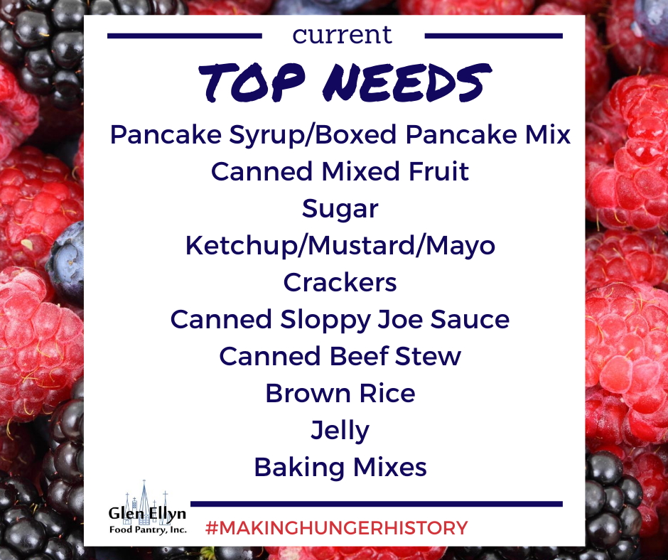

Mums Will Be Blooming at the Glen Ellyn History Center: From Wednesday, September 9 through Saturday, September 12, 10am to 5pm, the Glen Ellyn Historical Society is presenting their annual Mum Sale. Everyone come and purchase these beautiful fall flowers. The sale location is 800 N. Main Street. The price is $15 for each mum plant or three plants for $40.

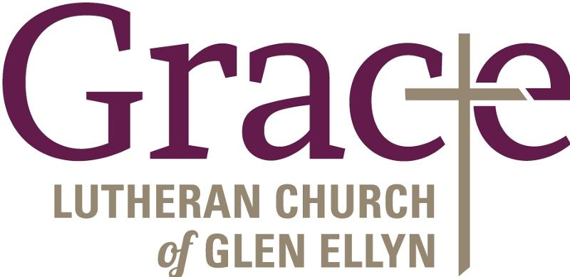

Every Member a Minister and Missionary!

Phone: 630-469-1555 Emergency Pastoral Contact: 630-674-2887
info@graceglenellyn.org www.graceglenellyn.org

Pastor
Rev. Melody Eastman office ext. 14
meastman@graceglenellyn.org

Minister of Music
Bradford Thompson 219-718-8879
bradfordmthompson@gmail.com

Ministry Associate
Becky Ficarella office ext. 17
bficarella@graceglenellyn.org

Office Manager
Barbara Sudds office ext. 10
bsudds@graceglenellyn.org

Parish Counselor
Carole LoGalbo M.S., LCPC 630-668-4594
carolelogalbo@yahoo.com

