Grace Lutheran Church

493 Forest Avenue, Glen Ellyn IL 630.469.1555
www.graceglenellyn.org

16th Sunday after Pentecost September 12, 2021

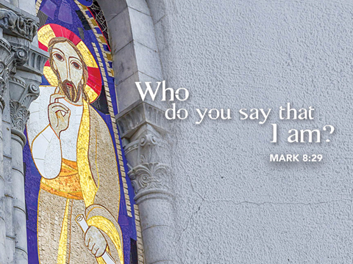

+ Proclaim Christ + Build Community +
+ Serve Our Neighbors +

Introduction
Three weeks ago we heard Peter’s confession of faith as told in John’s gospel. This week we hear Mark’s version, when Peter says, “You are the Messiah.” In John, the stumbling block is Jesus’ invitation to eat his flesh, given for the life of the world. In Mark too the scandal has to do with Jesus’ words about his own coming death, and here Peter himself stumbles over Jesus’ words. But Jesus is anointed (the meaning of messiah) in Mark only on the way to the cross (14:3); so we are anointed in baptism with the sign of the cross.

Gathering
The Holy Spirit calls us together as the people of God.
Welcome/Announcements
Helpful Reminders for those joining via Zoom:
- The host will mute you when you join, and you will remain muted until the end of the service.
- You are welcome to join in all congregation responses (in Bold black.) and hymns.
- At the end of the service you may unmute your mic to share greetings with your fellow worshippers. If you dialed in on the phone, press *6. Remember, your host cannot unmute you.

Helpful Reminders for those joining in person:
- Maintain 6’ distance between family groups
- Remain in your pews for communion.
- You may place your offering in the box in the narthex.

Prelude

*Please stand as you are able and turn to face the font.
*Confession and Forgiveness
All may make the sign of the cross, the sign marked at baptism, as the presiding minister begins.
Blessed be the holy Trinity, ☩ one God, whose teaching is life, whose presence is sure, and whose love is endless. Amen.

Let us confess our sins to the one who welcomes us with an open heart.
Silence is kept for reflection.
God our comforter: like lost sheep, we have gone astray. We gaze upon abundance and see scarcity. We turn our faces away from injustice and oppression. We exploit the earth with our apathy and greed. Free us from our sin, gracious God. Listen when we call out to you for help. Lead us by your love to love our neighbors as ourselves. Amen.

All have sinned and fall short of the glory of God. By the gift of grace in ☩ Christ Jesus, God makes you righteous. Receive with glad hearts the forgiveness of all your sins. Amen.

*Entrance Hymn ELW #808 Lord Jesus, You Shall Be My Song
sts. 1-3
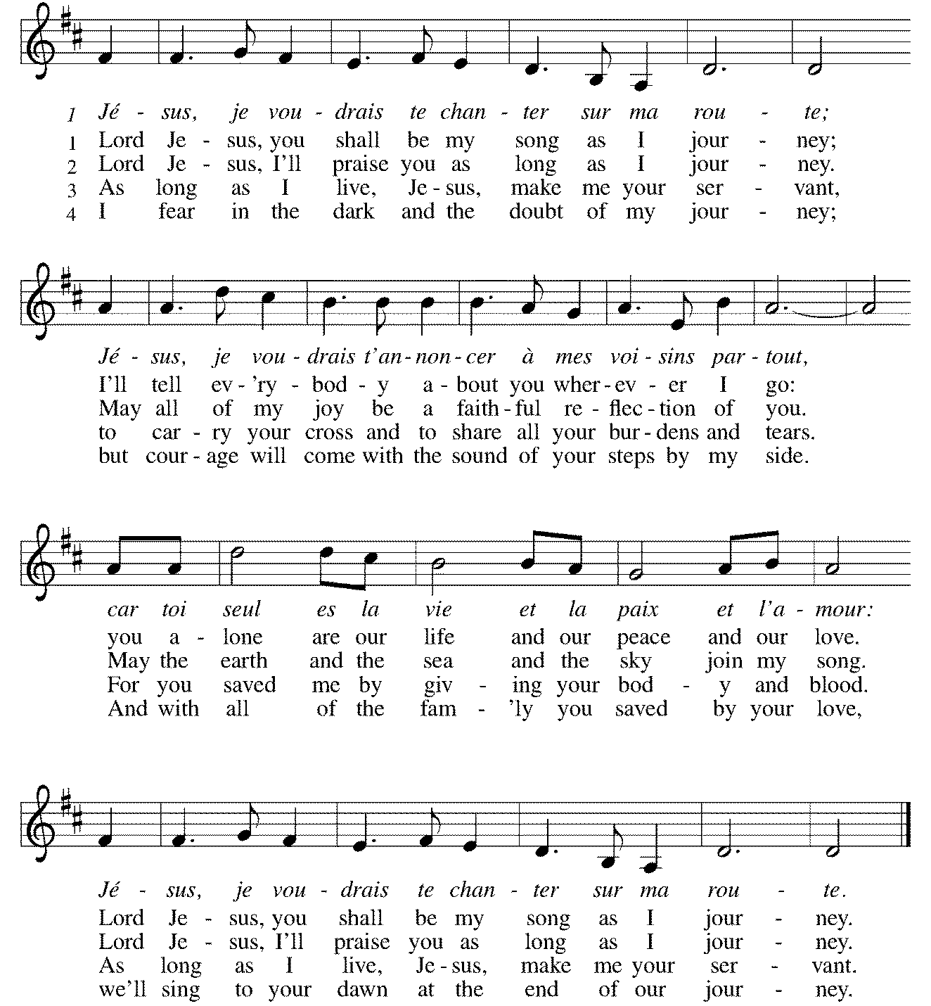

*Greeting
The grace of our Lord Jesus Christ, the love of God, and the communion of the Holy Spirit be with you all. And also with you.

*Kyrie p. 184
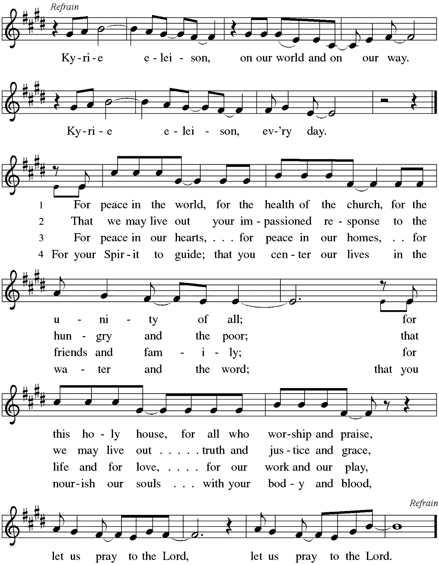
*Prayer of the Day
O God, through suffering and rejection you bring forth our salvation, and by the glory of the cross you transform our lives. Grant that for the sake of the gospel we may turn from the lure of evil, take up our cross, and follow your Son, Jesus Christ, our Savior and Lord. Amen. Be seated.

Word
God speaks to us in scripture reading, preaching, and song.
First Lesson Isaiah 50:4-9a
The image of the servant of the Lord is one of the notable motifs in the book of Isaiah. Today’s reading describes the mission of the servant, whom early Christians associated with Jesus. Like Jesus, the servant does not strike back at his detractors but trusts in God’s steadfast love.

⁴The Lord God has given me the tongue of a teacher, that I may know how to sustain the weary with a word. Morning by morning he wakens— wakens my ear to listen as those who are taught. ⁵The Lord God has opened my ear, and I was not rebellious, I did not turn backward. ⁶I gave my back to those who struck me, and my cheeks to those who pulled out the beard; I did not hide my face from insult and spitting.
⁷The Lord God helps me; therefore I have not been disgraced; therefore I have set my face like flint, and I know that I shall not be put to shame; ⁸he who vindicates me is near. Who will contend with me? Let us stand up together. Who are my adversaries? Let them confront me. ^{9a}It is the Lord God who helps me; who will declare me guilty?

Word of God, Word of Life. Thanks be to God.

Psalm Psalm 116:1-9
I will walk in the presence of the Lord. (Ps. 116:9)

¹I love the Lord, who has heard my voice, and listened to my supplication,
²for the Lord has given ear to me whenever I called.
³The cords of death entangled me; the anguish of the grave came upon me; I came to grief and sorrow.
⁴Then I called upon the name of the Lord: “O Lord, I pray you, save my life.”
⁵Gracious is the Lord and righteous; our God is full of compassion.
⁶The Lord watches over the innocent; I was brought low, and God saved me.
⁷Turn again to your rest, O my soul, for the Lord has dealt well with you.
⁸For you have rescued my life from death, my eyes from tears, and my feet from stumbling;
⁹I will walk in the presence of the Lord in the land | of the living.

Second Lesson James 3:1-12
This text uses various images to illustrate how damaging and hurtful the way we speak to and about others can be. Not only are we to control our speech, but what we say and how we say it are to reflect our faith.

¹Not many of you should become teachers, my brothers and sisters, for you know that we who teach will be judged with greater strictness. ²For all of us make many mistakes. Anyone who makes no mistakes in speaking is perfect, able to keep the whole body in check with a bridle. ³If we put bits into the mouths of horses to make them obey us, we guide their whole bodies. ⁴Or look at ships: though they are so large that it takes strong winds to drive them, yet they are guided by a very small rudder wherever the will of the pilot directs. ⁵So also the tongue is a small member, yet it boasts of great exploits.
How great a forest is set ablaze by a small fire! ⁶And the tongue is a fire. The tongue is placed among our members as a world of iniquity; it stains the whole body, sets on fire the cycle of nature, and is itself set on fire by hell. ⁷For every species of beast and bird, of reptile and sea creature, can be tamed and has been tamed by the human species, ⁸but no one can tame the tongue—a restless evil, full of deadly poison. ⁹With it we bless the Lord and Father, and with it we curse those who are made in the likeness of God. ¹⁰From the same mouth come blessing and cursing. My brothers and sisters, this ought not to be so. ¹¹Does a spring pour forth from the same opening both fresh and brackish water? ¹²Can a fig tree, my brothers and sisters, yield olives, or a grapevine figs? No more can salt water yield fresh.

Word of God, Word of Life. Thanks be to God.

*Please stand as you are able.
*Gospel Acclamation p. 188 Alleluia
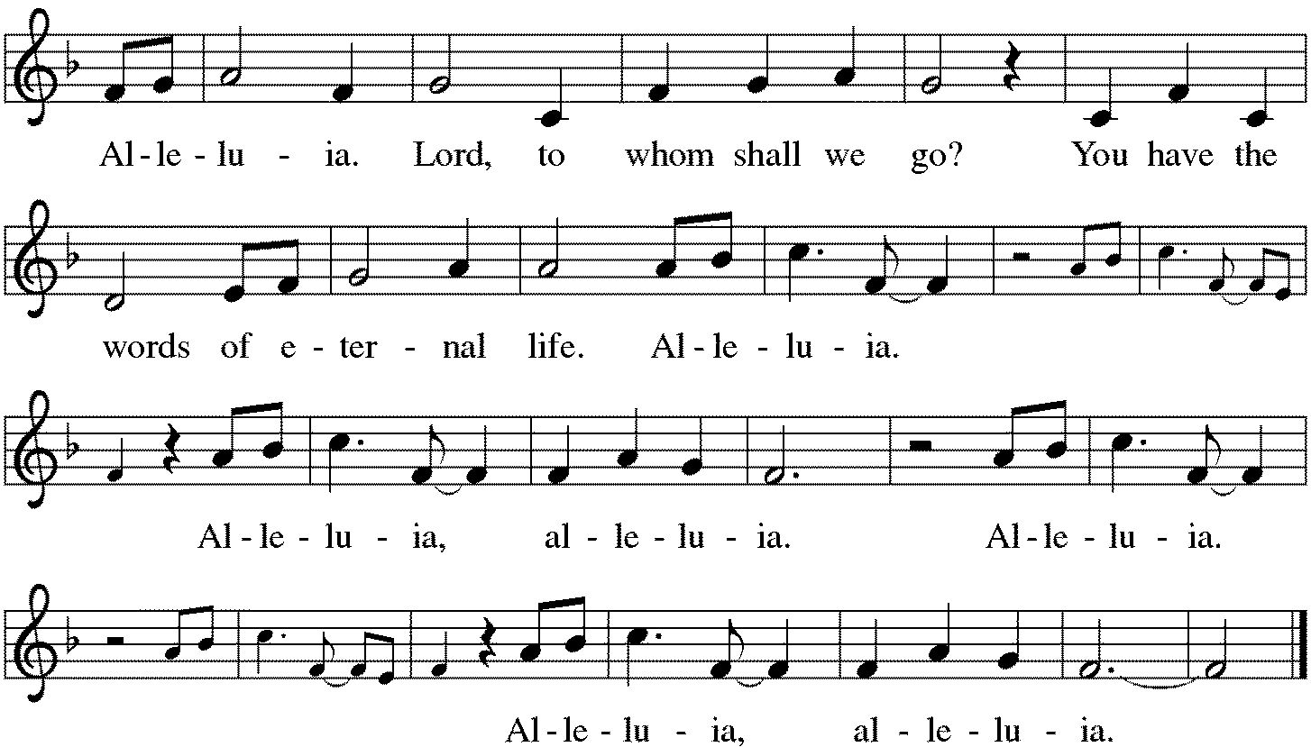

The holy Gospel according to Mark. Glory to you, O Lord.

*Gospel Mark 8:27-38
This story provides the turning point in Mark’s gospel. Peter is the first human being in the narrative to acknowledge Jesus as the Messiah, but he cannot accept that as the Messiah Jesus will have to suffer. Moreover, Jesus issues a strong challenge to all by connecting discipleship and the cross.

²⁷Jesus went on with his disciples to the villages of Caesarea Philippi; and on the way he asked his disciples, “Who do people say that I am?” ²⁸And they answered him, “John the Baptist; and others, Elijah; and still others, one of the prophets.” ²⁹He asked them, “But who do you say that I am?” Peter answered him, “You are the Messiah.” ³⁰And he sternly ordered them not to tell anyone about him.
³¹Then he began to teach them that the Son of Man must undergo great suffering, and be rejected by the elders, the chief priests, and the scribes, and be killed, and after three days rise again. ³²He said all this quite openly. And Peter took him aside and began to rebuke him. ³³But turning and looking at his disciples, he rebuked Peter and said, “Get behind me, Satan! For you are setting your mind not on divine things but on human things.”
³⁴He called the crowd with his disciples, and said to them, “If any want to become my followers, let them deny themselves and take up their cross and follow me. ³⁵For those who want to save their life will lose it, and those who lose their life for my sake, and for the sake of the gospel, will save it. ³⁶For what will it profit them to gain the whole world and forfeit their life? ³⁷Indeed, what can they give in return for their life? ³⁸Those who are ashamed of me and of my words in this adulterous and sinful generation, of them the Son of Man will also be ashamed when he comes in the glory of his Father with the holy angels.”

The Gospel of the Lord. Praise to you, O Christ. Be seated.

Sermon The Rev. Rebecca Templeton

*Please stand as you are able.
*Hymn of the Day ELW #798 Will You Come and Follow Me
sts. 1, 4, 5
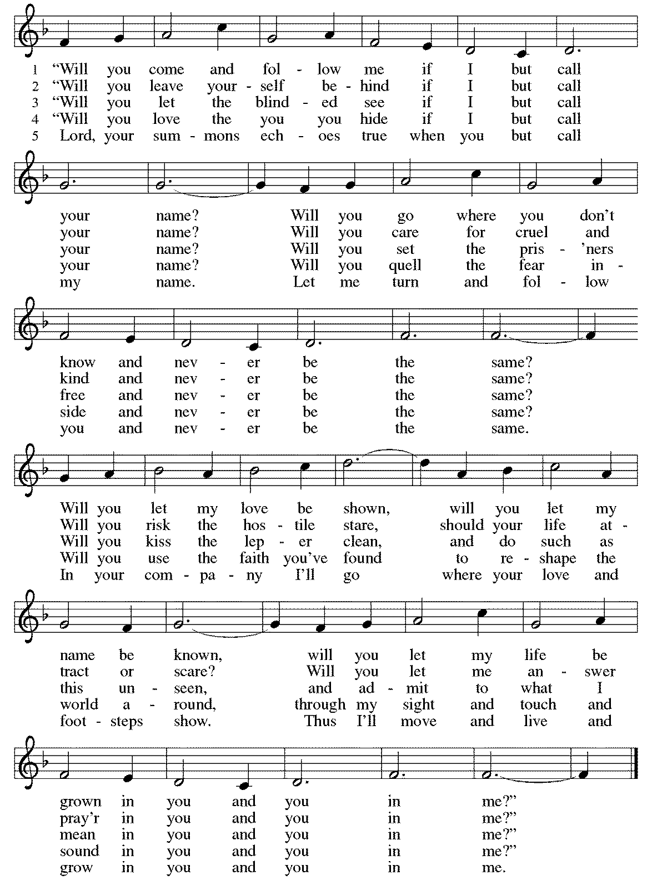
*Prayers of Intercession
Made children and heirs of God’s promise, we pray for the church, the world, and all in need.
A brief silence.

Revealing God, you have made yourself known through bread and wine, water and word. Continue to nurture your church, that it is a place where your presence is experienced and shared. Lord, in your mercy, hear our prayer.

Creating God, you brought life into being and called it good. Bring new creation to lands devastated by tornadoes, hurricanes, floods, fires, and other disasters. Restore forests and curb overflowing waters. Lord, in your mercy, hear our prayer.

Protecting God, you desire all people to live in peace and safety. Provide for all who are in danger. Strengthen first responders to help meet the complex needs of others. Provide care and compassion as they face trauma themselves. Lord, in your mercy, hear our prayer.

Transforming God, you announce release to the captives and freedom to the oppressed. Break chains of discrimination and injustice. Amplify voices that go unheard and inspire us to advocate for those who are overlooked. Lord, in your mercy, hear our prayer.

Forming God, you gather this community together. Shape our communal life, that in our prayer, praise, and worship, we honor you and encourage one another. Keep our disagreements civil and increase our joy in working together. Lord, in your mercy, hear our prayer.
Here other intercessions may be offered.

Redeeming God, you accompany your people through every stage of life. We give you thanks for the saints who now rest in your embrace. Lord, in your mercy, hear our prayer.

Receive these prayers, O God, and those in our hearts known only to you; through Jesus Christ our Lord. Amen.

*Peace
The peace of Christ be with you always. And also with you.
Please share the peace with others in your household, or by making a sign of peace to those on Zoom. Please remain standing.

Meal
God feeds us with the presence of Jesus Christ.
*Offering Prayer
God of abundance,
you cause streams to break forth in the desert
and manna to rain from the heavens.
Accept the gifts you have first given us.
Unite them with the offering of our lives
to nourish the world you love so dearly;
through Jesus Christ, our Savior and Lord. Amen

*Great Thanksgiving
The Lord be with you. And also with you.
Lift up your hearts. We lift them to the Lord.
Let us give thanks to the Lord our God. It is right to give our thanks and praise.

*Preface
It is indeed right, our duty and our joy, that we should at all times and in all places give thanks and praise to you, almighty and merciful God, through our Savior Jesus Christ; who on this day overcame death and the grave, and by his glorious resurrection opened to us the way of everlasting life. And so, with all the choirs of angels, with the church on earth and the hosts of heaven, we praise your name and join their unending hymn:

*Sanctus p. 190 Holy, Holy, Holy
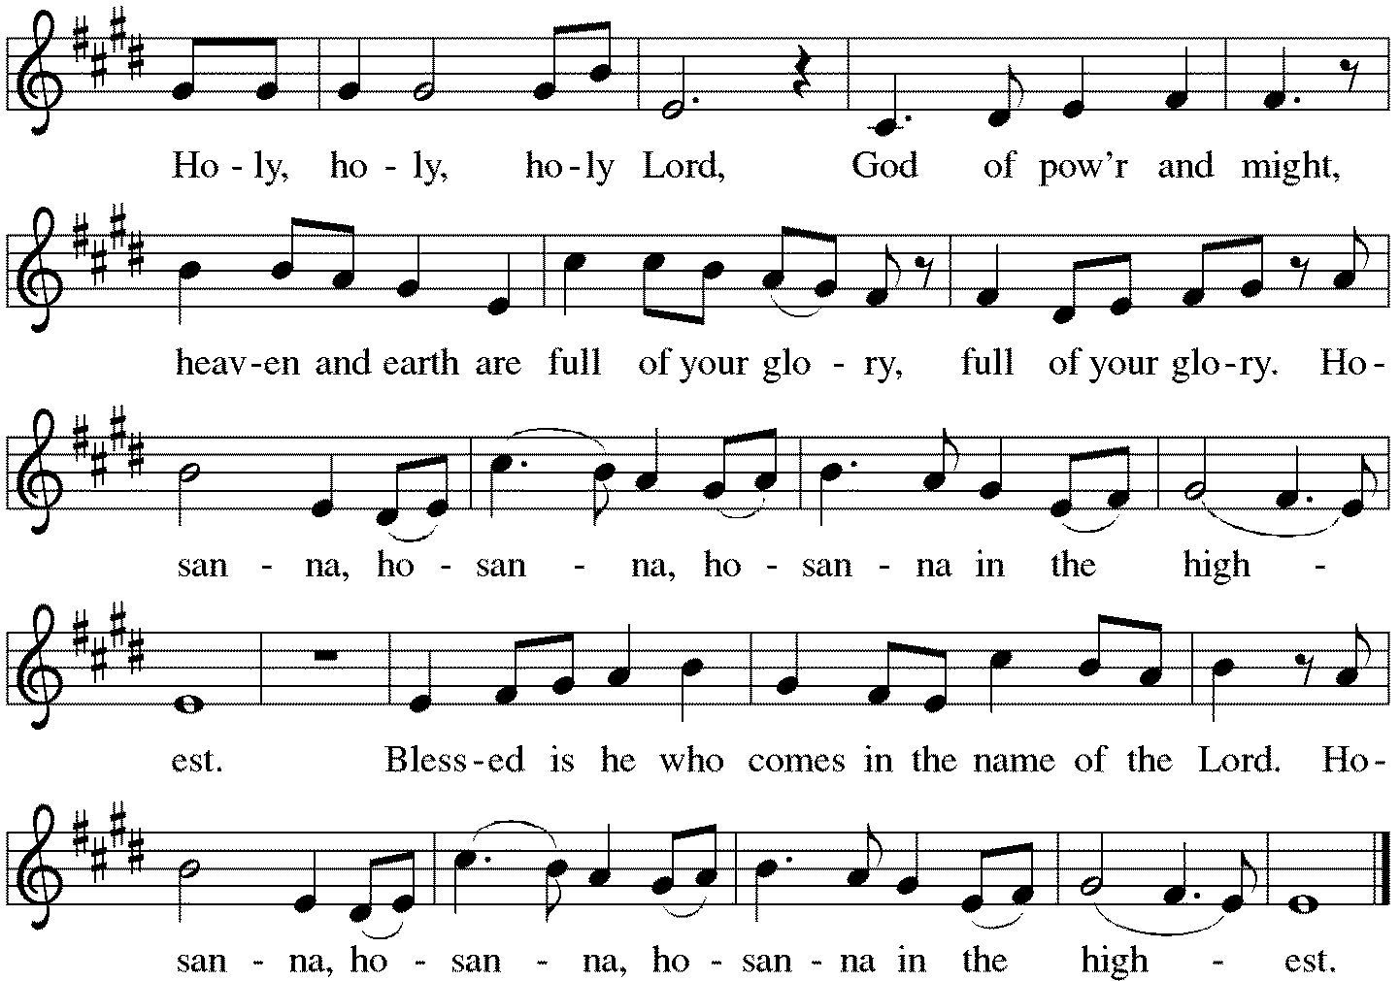

*Thanksgiving at the Table
Holy God,
holy and mighty,
holy and immortal:
you we praise and glorify,
you we worship and adore.

You formed the earth from chaos;
you encircled the globe with air;
you created fire for warmth and light;
you nourish the lands with water.
You molded us in your image,
and with mercy higher than the mountains,
with grace deeper than the seas,
you blessed the Israelites and cherished them as your own.

That also we, estranged and dying,
might be adopted to live in your Spirit,
you called to us through the life and death of Jesus.

In the night in which he was betrayed,
our Lord Jesus took bread, and gave thanks;
broke it, and gave it to his disciples, saying:
Take and eat; this is my body, given for you.
Do this for the remembrance of me.

Again, after supper, he took the cup, gave thanks,
and gave it for all to drink, saying:
This cup is the new covenant in my blood,
shed for you and for all people for the forgiveness of sin.
Do this for the remembrance of me.

Together as the body of Christ,
we proclaim the Lord's death until he comes.
Christ has died. Christ is risen. Christ will come again.
With this bread and cup we remember your Son,
the first-born of your new creation.
We remember his life lived for others,
and his death and resurrection, which renews the face of the earth.
We await his coming,
when, with the world made perfect through your wisdom,
all our sins and sorrows will be no more.
Amen. Come, Lord Jesus.

You may hold up your (unopened) communion kit as you are able.
Holy God,
holy and merciful,
holy and compassionate,
send upon us and this meal your Holy Spirit,
whose breath revives us for life,
whose fire rouses us to love.
Enfold in your arms all who share this holy food.
Nurture in us the fruits of the Spirit,
that we may be a living tree, sharing your bounty with all the world.
Amen. Come, Holy Spirit.
You may lower your communion kit.

Holy and benevolent God,
receive our praise and petitions,
as Jesus received the cry of the needy,
and fill us with your blessing,
until, needy no longer and bound to you in love,
we feast forever in the triumph of the Lamb:
through whom all glory and honor is yours, O God, O Living One,
with the Holy Spirit, in your holy church, now and forever.
Amen.

*The Lord’s Prayer
Gathered into one by the Holy Spirit, let us pray as Jesus taught us.
Our Father in heaven, hallowed be your name, your kingdom come, your will be done, on earth as in heaven. Give us today our daily bread. Forgive us our sins as we forgive those who sin against us. Save us from the time of trial and deliver us from evil. For the kingdom, the power, and the glory are yours, now and forever. Amen.

*Invitation to Communion
All who hunger and thirst, come. The table is ready. Be Seated.

If you have difficulty opening your communion, please signal an usher for assistance.

Peel up the clear top seal over the wafer, and hold the wafer up when you are ready.
This is the Body of Christ, given for you. (Eat the bread.) Amen.

Peel up the second foil seal over the juice, and hold your cup up when you are ready.
This is the blood of Christ, shed for you. (Drink the wine/juice.) Amen.

After communion you may place the packaging in the bowl in your pew. The ushers will dispose of these following the service.

Agnus Dei p. 191 Lamb of God
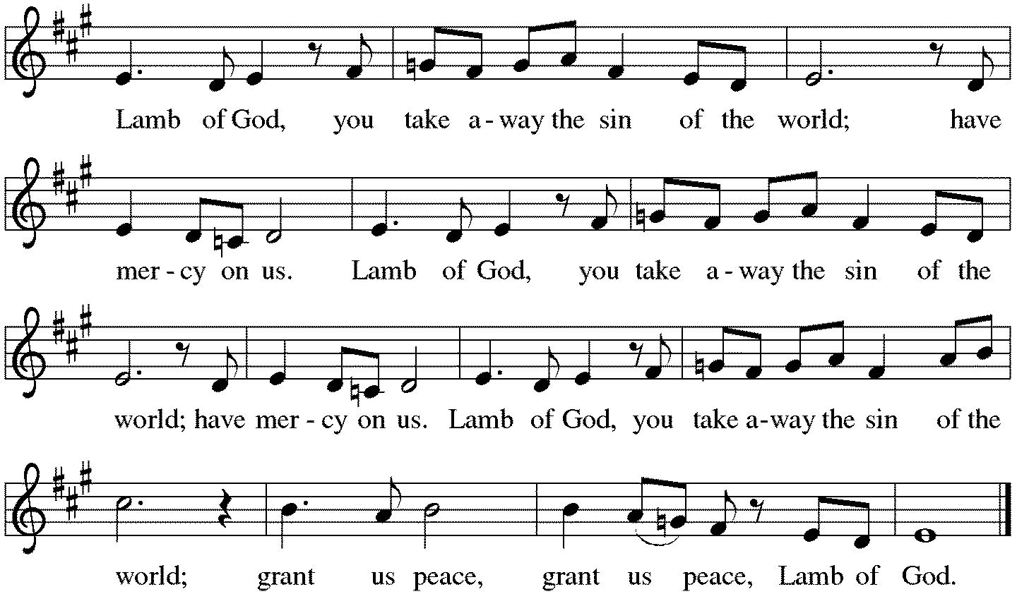

*Please stand as you are able.
*Post-Communion Blessing
The body and blood of our Lord Jesus Christ strengthen you and keep you in his grace. Amen.

*Prayer after Communion
Lord of life,
in the gift of your body and blood
you turn the crumbs of our faith into a feast of salvation.
Send us forth into the world with shouts of joy,
bearing witness to the abundance of your love
in Jesus Christ, our Savior and Lord.
Amen.
Sending
God blesses us and sends us in mission to the world.
*Blessing
People of God, you are Christ’s body,
bringing new life to a suffering world.
The holy Trinity, ☩ one God, bless you now and forever. Amen.
*Sending Hymn ELW#733 Great Is Thy Faithfulness
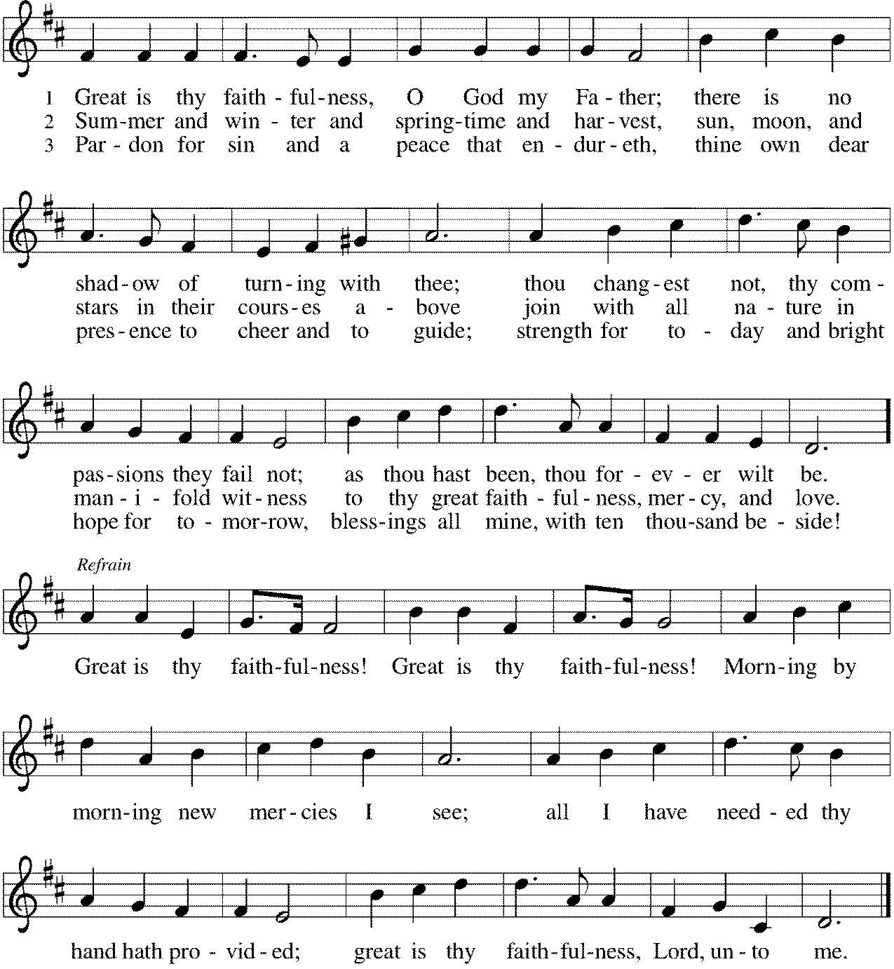

*Sent to the World
Go in peace. The living Word dwells in you. Thanks be to God.

Postlude

Thank you to Rev. Rebecca Templeton for leading us in worship today.
After the postlude, those who have joined via Zoom may unmute your mics
and share a greeting with your fellow worshippers.

From Sundays and Seasons
v.20190109.1233 Copyright © 2021 Augsburg Fortress. All rights reserved.
Reprinted by permission under Augsburg Fortress Liturgies Annual License #30867.
All rights reserved. Reprinted under OneLicense.net #A-718333.

Assisting in Worship Today
Ministry Associate Becky Ficarella
Minister of Music Bradford Thompson
Lector Heather Graf
Ushers Mark Drager, John Jokela, Rich Pasbrig, Open

Current Prayer Requests
Please keep these people in your prayers and reach out to our sisters and brothers in Christian love. Names will be left on the list for two weeks, unless you indicate that they should remain in our prayers for a longer period.
Name Relationship Prayer For
Jim Sladek Member Healing & Strength
Cathy Milleville Member Healing & Strength
Sigrid Elliott Member Healing & Strength
Dorothy Tracy Member Healing & Strength
Norma Petersen Member Healing & Strength
Keith & Rita Matthews SIL & Daughter of Norma Petersen Healing & Strength
Norma Petersen Member Healing & Strength
Keith Petras Brother of Dru Geraghty Healing & Strength
Lori Garabrandt Relative of Chuck Miller and Lois Pertle Healing & Strength
Chris Danly Son of Mark & Pat Danly Healing & Strength
Prayers for our homebound Members
Dolores Nosal, Carol Petersen, Norma Petersen, Dorothy Stein

Pastor Melody will be on vacation following through Saturday, September 18. Becky Ficarella will lead us in worship on September 5 with a hymn sing during the sermon time, there will not be communion. The Rev. Rebecca Templeton will be with us for worship on September 12.

RAMP (Reduce Another Mortgage Payment): As we continue to RAMP up to refinance our mortgage with Mission Investment Fund in October, we wish to thank you all who have contributed to date. We are still hopeful we can raise an additional $75,000 before October 5. Our monthly mortgage payment is a big ticket item in our budget at $6,777 monthly ($81,324 annually) and lowering that amount by an additional $1,000 or more (yes please) per month will greatly help our annual budget and free up funds that we can utilize on the ministries of Grace. Please give any amount you can between now and October 5. Indicate your contribution is for the Mortgage Reduction Fund.

Got Capital Gains? Did you know that stock donations allow you to both claim a deduction at the appreciated value AND allow you to avoid capital gains taxes on these assets? Further, consolidating donations in a tax year could lead to increased ability to deduct charitable contributions in a given tax year. Consult your tax advisor for details, but if you’d like more information on how to go about donating stock, reach out to the church office.

Contributions to Grace: You may continue to mail your contributions for the General Fund and the Mortgage Reduction Fund to the church office; have your bank mail your contribution to the church office (this works great); or contribute on-line through Grace’s website (Grace/you pay fees). Please know, pandemic or no, our mission continues! Thank you for your continued support of our ministries at Grace Lutheran.

Choir rehearsal Wednesdays at 7pm! Come join us for an hour of fun, super low-pressure music-making! Not free on Wednesday evenings? You’re still welcome to join us on Sunday mornings at 8:40! Don’t feel good about your voice/singing? We can work on that, too! No matter your voice type or skill level, there’s room for you! Get excited, my friends! The fun starts now :)

Wednesday Night Ignite (Confirmation), 7-8:30pm, at Faith Lutheran for 7th and 8th Grade students: Lessons led by Grace Ministry Associate Becky Ficarella and Faith Lutheran’s Pastor Joe Yucha. Games, small group scripture and study discussion time, and large group Big Topic discussion time! We move around a lot! Get ready for a season of fun! Schedule is as follows: 9/15 Session 2; 9/22 Feed My Starving Children Event; 9/29 Session 3.

Pill Bottle Project: Calling all volunteers! After being shut down for over a year, we will meet weekly beginning Tuesday, September 14th from 6-7:30pm in the upstairs kitchen next to the gym. We need to work through our backlog of pill bottles. If you would like to volunteer, just show up! Please note: at this time we are not accepting any pill bottles as it will take some time to get through the current inventory we have. If you have any questions, please contact Mark Hamilton at (630) 841-2941 / mark.hamilton@ifs.com

Former Faith & Friendship Now Grace Fellowship Luncheon: This monthly luncheon is open to the entire congregation regardless of age! Join us on Wednesday, September 15 for worship with communion at 11am followed by a soup and sandwich meal in the Narthex at 11:45am. This group meets on the third Wednesday of the month. We are looking for volunteers to help with this monthly event, please let Becky Ficarella know if you are available!

Generations Choir Wednesday, September 15, 6:00pm: Grace’s all ages choir has returned! We will meet on the third Wednesday of the month at 6:00pm for a simple soup meal and then rehearse our music from 6:45-7:15pm. We will sing on the following Sunday, September 19 at the beginning of the worship service! We can't wait to raise praise with you in fellowship and song! All questions about the meal should be directed to Becky Ficarella, and questions regarding the music should be directed to Bradford Thompson!

Men of Grace: Thursday, September 16 at 7:00pm. Contact Jeff Nelson for details.

Blessing moved to September 19 - God’s work. Our hands. Food Drive: For “God’s work. Our hands.” on September 12, Grace has organized a Food Drive to benefit DuPage PADS and the Glen Ellyn Food Pantry. The Food Drive will run through September 19. All items received will be blessed on September 19 during the worship service and then distributed to PADS and GEFP. Items requested for PADS include: individually packaged chips, pretzels, trail mix, nuts, fruit juices, fruit cups, fruit sticks, and snacks; individually wrapped cookies, pies, cakes, and candy; steamable small packages of frozen vegetables; and frozen meals for adults and kids. Items requested for the GEFP include: paper towels; oatmeal (canisters or packets); salad dressing; canned sloppy joes; canned chili; ketchup/mustard/relish/mayo; pancake mix and syrup; boxed pasta and jarred pasta sauce; any canned fruit; fresh potatoes; toothpaste and toothbrushes.

Circle of Care Coordinator Needed: We are seeking an individual to fill the role of Circle of Care Coordinator. This role includes managing incoming requests of care from members and then finding the appropriate volunteers to help from a current list of willing helpers! Examples might include rides, grocery store runs, or meal drop offs. Please contact the church office or Becky Ficarella if you are interested!

Sr. Center Chair Exercise: The exercise class meets Mondays at 10:00am, Tuesdays at 11:30am, and Thursdays at 11:00am. Registration is required as the number of attendees will be limited. Please contact Sue Davison at 630-858-6343 to register.

Sr. Center Book Club: The Book Club meets on the third Tuesday of the month at 11:00am. Please contact Sue Davison at 630-858-6343 to register.

Every Member a Minister and Missionary!

Phone: 630-469-1555 Emergency Pastoral Contact: 630-674-2887
info@graceglenellyn.org www.graceglenellyn.org

Pastor
Rev. Melody Eastman office ext. 14
meastman@graceglenellyn.org

Minister of Music
Bradford Thompson 219-718-8879
bradfordmthompson@gmail.com

Ministry Associate
Becky Ficarella office ext. 17
bficarella@graceglenellyn.org

Office Manager
Barbara Sudds office ext. 10
bsudds@graceglenellyn.org

Parish Counselor
Carole LoGalbo M.S., LCPC 630-668-4594
carolelogalbo@yahoo.com

