Grace Lutheran Church

493 Forest Avenue, Glen Ellyn IL 630.469.1555
www.graceglenellyn.org

17th Sunday after Pentecost September 19, 2021

+ Proclaim Christ + Build Community +
+ Serve Our Neighbors +

Introduction
Today we hear James warn against selfish ambition, while the disciples quarrel over which one of them is the greatest. Jesus tells them the way to be great is to serve. Then, to make it concrete, he puts in front of them a flesh-and-blood child. We are called to welcome the children God puts in front of us, to make room for them in daily interaction, and to give them a place of honor in the assembly.

Gathering
The Holy Spirit calls us together as the people of God.
Welcome/Announcements
Helpful Reminders for those joining via Zoom:
- The host will mute you when you join, and you will remain muted until the end of the service.
- You are welcome to join in all congregation responses (in Bold black.) and hymns.
- At the end of the service you may unmute your mic to share greetings with your fellow worshippers. If you dialed in on the phone, press *6. Remember, your host cannot unmute you.

Helpful Reminders for those joining in person:
- Maintain 6’ distance between family groups
- Remain in your pews for communion.
- You may place your offering in the box in the narthex.

Prelude

*Please stand as you are able and turn to face the font.
*Confession and Forgiveness
All may make the sign of the cross, the sign marked at baptism, as the presiding minister begins.
Blessed be the holy Trinity, ☩ one God, whose teaching is life, whose presence is sure, and whose love is endless. Amen.

Let us confess our sins to the one who welcomes us with an open heart.
Silence is kept for reflection.

God our comforter: like lost sheep, we have gone astray. We gaze upon abundance and see scarcity. We turn our faces away from injustice and oppression. We exploit the earth with our apathy and greed. Free us from our sin, gracious God. Listen when we call out to you for help. Lead us by your love to love our neighbors as ourselves. Amen.

All have sinned and fall short of the glory of God. By the gift of grace in ☩ Christ Jesus, God makes you righteous. Receive with glad hearts the forgiveness of all your sins. Amen.

*Entrance Hymn ACS #978 God Welcomes All
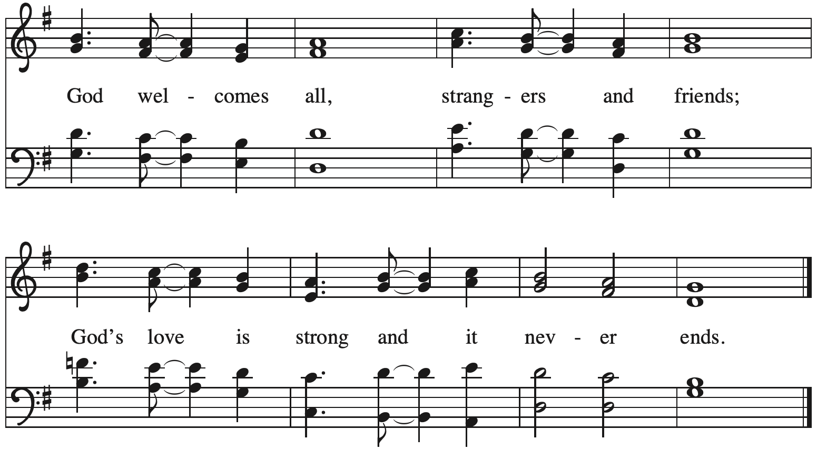

*Greeting
The grace of our Lord Jesus Christ, the love of God, and the communion of the Holy Spirit be with you all. And also with you.

*Kyrie p. 184
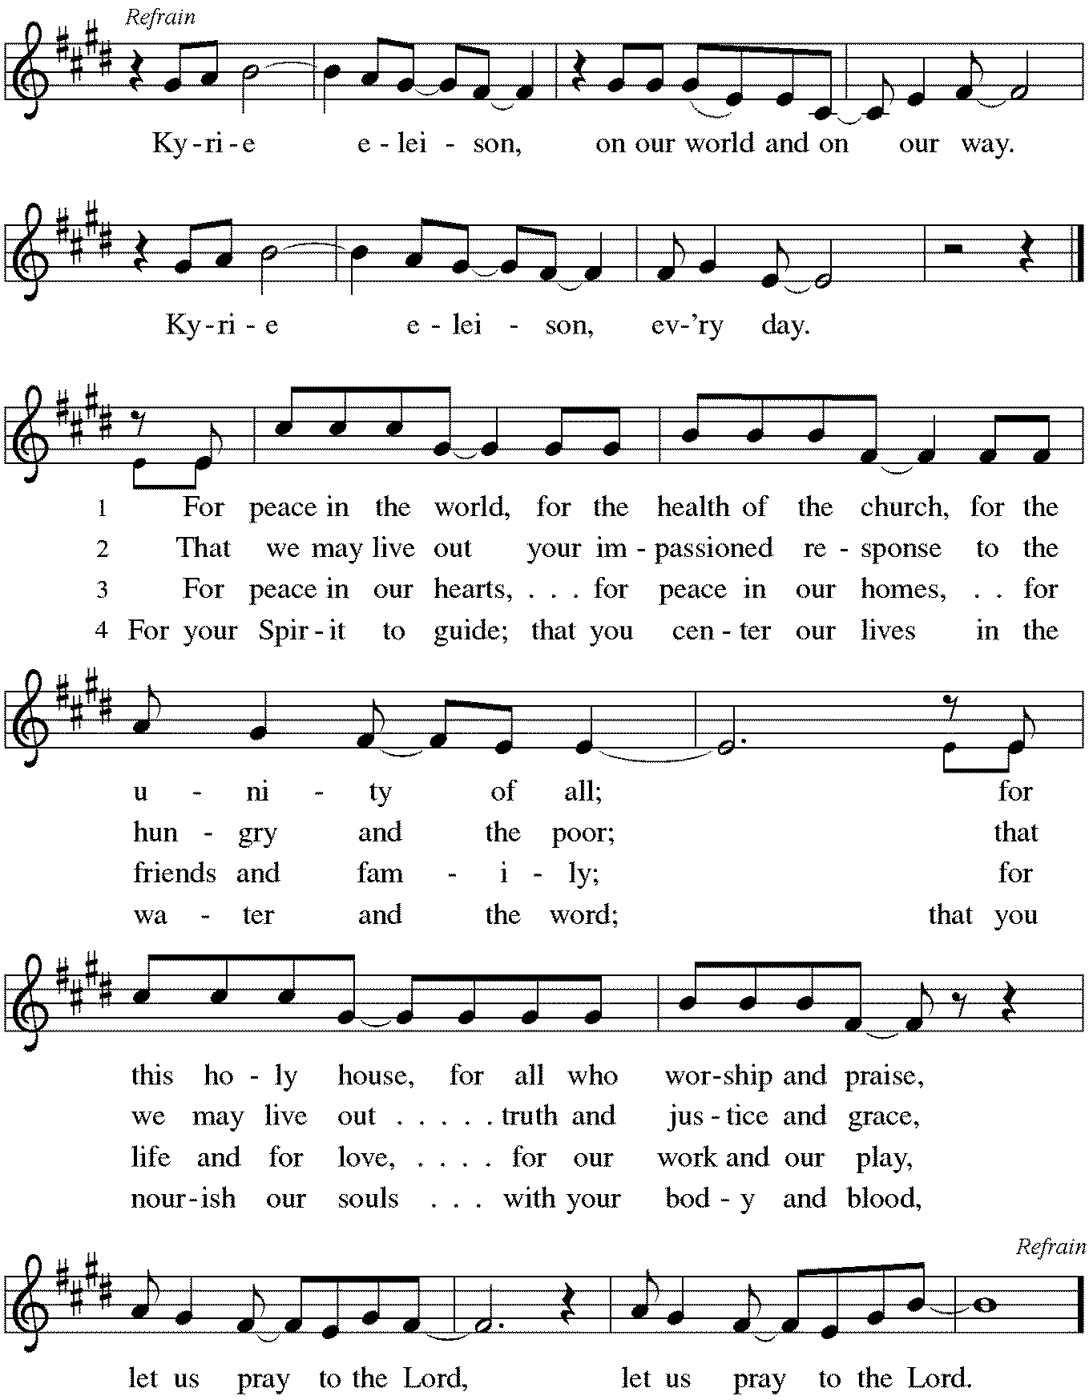

*Prayer of the Day
O God, our teacher and guide, you draw us to yourself and welcome us as beloved children. Help us to lay aside all envy and selfish ambition, that we may walk in your ways of wisdom and understanding as servants of your Son, Jesus Christ, our Savior and Lord. Amen. Be seated.

Word
God speaks to us in scripture reading, preaching, and song.
First Lesson Jeremiah 11:18-20
Today’s reading tells of the suffering of the prophet Jeremiah, who announced God’s word to Judah but was met with intense opposition and persecution. Jeremiah continues to trust in God in the midst of his suffering.

¹⁸It was the Lord who made it known to me, and I knew; then you showed me their evil deeds. ¹⁹But I was like a gentle lamb led to the slaughter. And I did not know it was against me that they devised schemes, saying, “Let us destroy the tree with its fruit, let us cut him off from the land of the living, so that his name will no longer be remembered!” ²⁰But you, O Lord of hosts, who judge righteously, who try the heart and the mind, let me see your retribution upon them, for to you I have committed my cause.

Word of God, Word of Life. Thanks be to God.

Psalm Psalm 54
God is my helper; it is the Lord who sustains my life. (Ps. 54:4)

¹Save me, O God, by your name; in your might, defend my cause.
²Hear my prayer, O God; give ear to the words of my mouth.
³For strangers have risen up against me, and the ruthless have sought my life, those who have no regard for God.
⁴Behold, God is my helper; it is the Lord who sustains my life.
⁵Render evil to those who spy on me; in your faithfulness, destroy them.
⁶I will offer you a freewill sacrifice and praise your name, O Lord, for it is good.
⁷For you have rescued me from every trouble, and my eye looks down on my enemies.

Second Lesson James 3:13--4:3, 7-8a
The wisdom God gives unites our hearts and minds. Instead of living to satisfy our own wants and desires, we manifest this wisdom in peace, gentleness, mercy, and impartiality toward others.

¹³Who is wise and understanding among you? Show by your good life that your works are done with gentleness born of wisdom. ¹⁴But if you have bitter envy and selfish ambition in your hearts, do not be boastful and false to the truth. ¹⁵Such wisdom does not come down from above, but is earthly, unspiritual, devilish. ¹⁶For where there is envy and selfish ambition, there will also be disorder and wickedness of every kind. ¹⁷But the wisdom from above is first pure, then peaceable, gentle, willing to yield, full of mercy and good fruits, without a trace of partiality or hypocrisy. ¹⁸And a harvest of righteousness is sown in peace for those who make peace.^{4:}
¹Those conflicts and disputes among you, where do they come from? Do they not come from your cravings that are at war within you? ²You want something and do not have it; so you commit murder. And you covet something and cannot obtain it; so you engage in disputes and conflicts. You do not have, because you do not ask. ³You ask and do not receive, because you ask wrongly, in order to spend what you get on your pleasures. ⁷Submit yourselves therefore to God. Resist the devil, and he will flee from you. ^{8a}Draw near to God, and he will draw near to you.

Word of God, Word of Life. Thanks be to God.

*Please stand as you are able.
*Gospel Acclamation p. 188 Alleluia
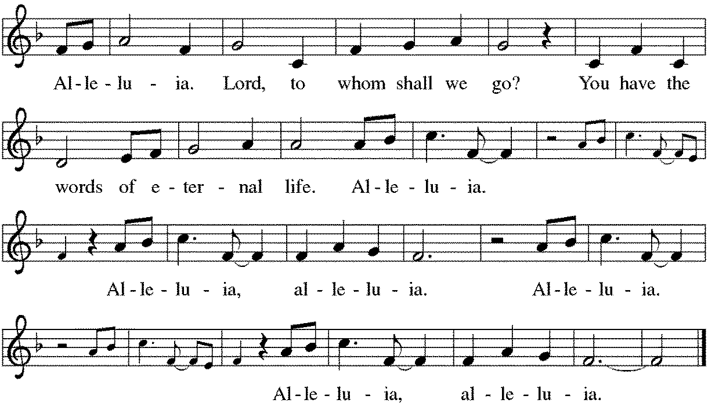

The holy Gospel according to Mark. Glory to you, O Lord.

*Gospel Mark 9:30-37
Jesus’ teaching and action in this text are directed to the church whenever it is seduced by the world’s definition of greatness: prestige, power, influence, and money. The antidote to such a concern for greatness is servanthood.
³⁰[Jesus and the disciples went on] and passed through Galilee. He did not want anyone to know it; ³¹for he was teaching his disciples, saying to them, “The Son of Man is to be betrayed into human hands, and they will kill him, and three days after being killed, he will rise again.” ³²But they did not understand what he was saying and were afraid to ask him.
³³Then they came to Capernaum; and when he was in the house he asked them, “What were you arguing about on the way?” ³⁴But they were silent, for on the way they had argued with one another who was the greatest. ³⁵He sat down, called the twelve, and said to them, “Whoever wants to be first must be last of all and servant of all.” ³⁶Then he took a little child and put it among them; and taking it in his arms, he said to them, ³⁷“Whoever welcomes one such child in my name welcomes me, and whoever welcomes me welcomes not me but the one who sent me.”

The Gospel of the Lord. Praise to you, O Christ. Be seated.

Sermon The Rev. Melody Eastman

*Please stand as you are able.
*Hymn of the Day ELW #397 Loving Spirit
sts. 1-4
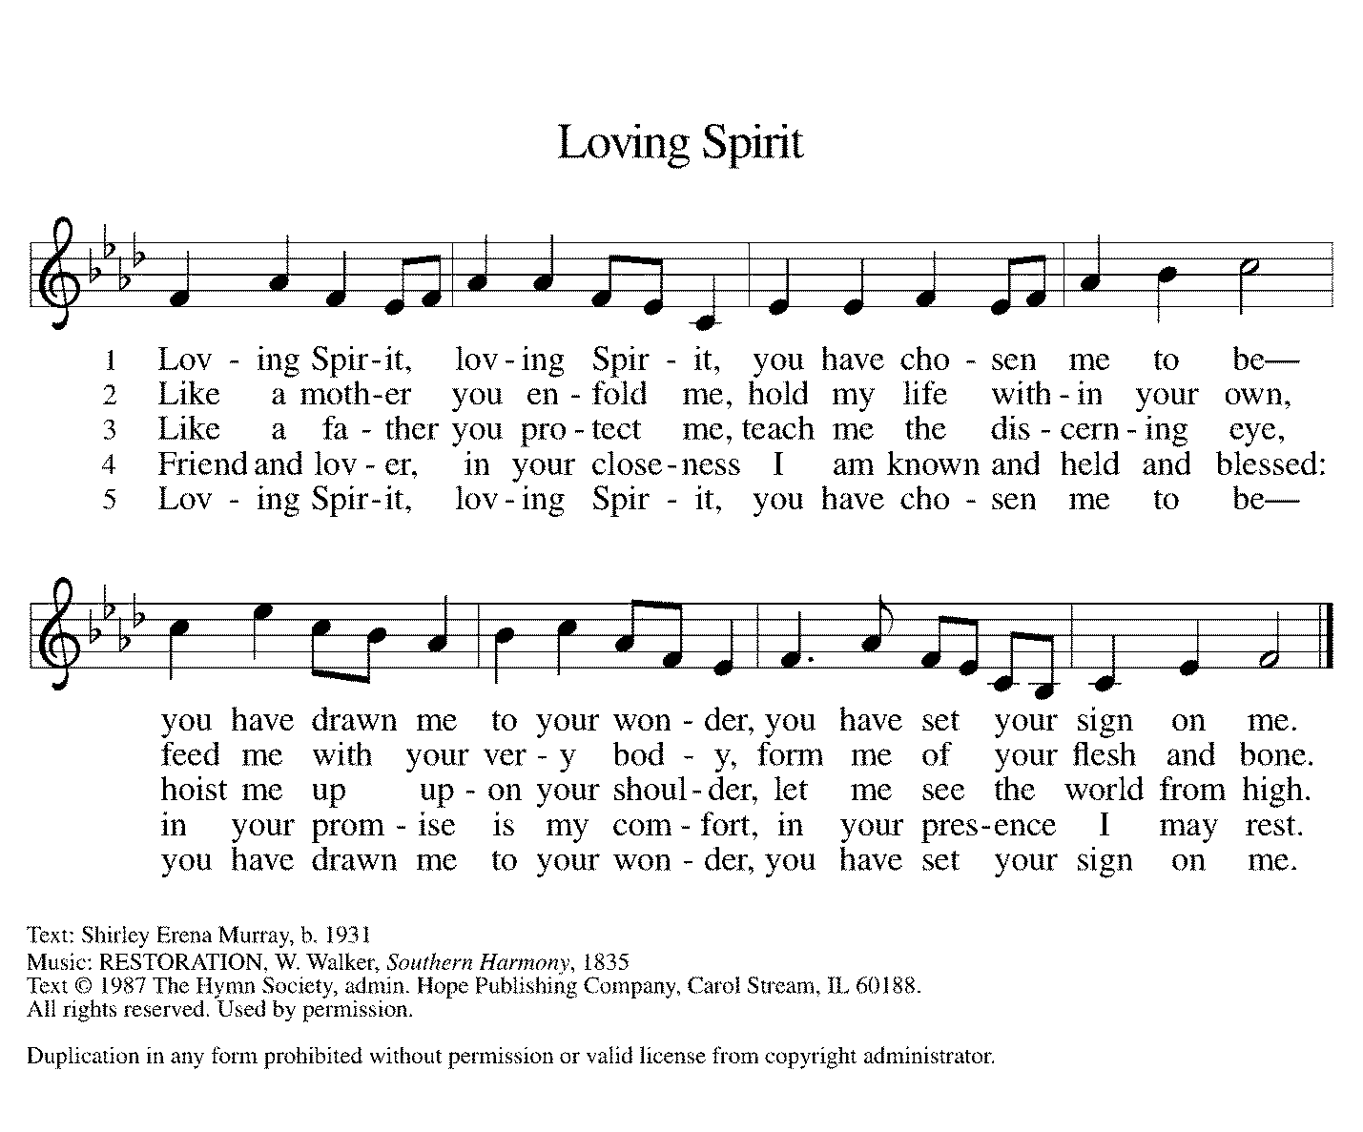

*The Creed
With the whole church, let us confess our faith.

I believe in God, the Father almighty, creator of heaven and earth.

I believe in Jesus Christ, God's only Son, our Lord, who was conceived by the Holy Spirit, born of the virgin Mary, suffered under Pontius Pilate, was crucified, died, and was buried; he descended to the dead. On the third day he rose again;
he ascended into heaven, he is seated at the right hand of the Father, and he will come to judge the living and the dead.

I believe in the Holy Spirit, the holy catholic church, the communion of saints,
the forgiveness of sins, the resurrection of the body, and the life everlasting. Amen.

*The Blessing of Gifts
Holy God, you have created and equipped us to be a people of compassion and justice. We bring these gifts to you for the sake of your children who are in need today. We thank you for the ministry of those who work directly with the people who will receive these gifts through PADS and the Glen Ellyn Food Pantry. We ask that you strengthen and encourage them as they work in what seems like an endless and often painful task. We pray that you bless the ones who will receive these items, and fill them with courage and hope. We ask that these gifts be accompanied by shelter for those people who are homeless, by adequate employment and just wages for those without enough work, and by support and companionship for those who are lonely or isolated. May your holy reign break into our world and bring hope, in Jesus’ name. Amen.

*Prayers of Intercession
Made children and heirs of God’s promise, we pray for the church, the world, and all in need.
A brief silence.

God of community, we pray for the church around the world. Unite us in our love for you. Help us overcome our divisions, that we are encouraged to work together for your sake. Lord, in your mercy, hear our prayer.

God of creation, we pray for this hurting earth. Awaken in us a new desire to care for this world and empower us to support agencies, organizations, and individual efforts to heal our environment. Lord, in your mercy, hear our prayer.

God of cooperation, we pray for nations of the world embroiled in conflict. Inspire leaders to listen to each other and work towards peaceful solutions to disagreements. Protect the vulnerable, especially children, who cannot find safety in their home or country. Lord, in your mercy, hear our prayer.

God of comfort, we pray for all who live with mental or physical illness. Help them find appropriate care. Bring healing and wholeness when the path forward seems bleak. Lord, in your mercy, hear our prayer.

God of compassion, we pray for the young people of this congregation. Renew in us your call to welcome the children in our midst. As they grow, strengthen their faith and our commitment to them. Lord, in your mercy, hear our prayer.
Here other intercessions may be offered.

All honor and glory and blessing belong to you. We thank you and praise you for the faith and witness of Jim Sladek, and we ask your blessing on him as he celebrates his 90th birthday. We praise you for the faith of all the saints. Be near us as we await the day when we will feast with the risen Christ forever. Hear us, O God. Your mercy is great.

God of consolation, we give you thanks for our loved ones who have died and pray for all who grieve today. Shine your grace on all your saints. Lord, in your mercy, hear our prayer.

Receive these prayers, O God, and those in our hearts known only to you; through
Jesus Christ our Lord. Amen.

*Peace
The peace of Christ be with you always. And also with you.
Please share the peace with others in your household, or by making a sign of peace to those on Zoom. Please remain standing.

Meal
God feeds us with the presence of Jesus Christ.
*Offering Prayer
God of abundance, you cause streams to break forth in the desert and manna to rain from the heavens. Accept the gifts you have first given us. Unite them with the offering of our lives to nourish the world you love so dearly; through Jesus Christ, our Savior and Lord. Amen

*Great Thanksgiving
The Lord be with you. And also with you.
Lift up your hearts. We lift them to the Lord.
Let us give thanks to the Lord our God. It is right to give our thanks and praise.

*Preface
It is indeed right, our duty and our joy, that we should at all times and in all places give thanks and praise to you, almighty and merciful God, through our Savior Jesus Christ; who on this day overcame death and the grave, and by his glorious resurrection opened to us the way of everlasting life. And so, with all the choirs of angels, with the church on earth and the hosts of heaven, we praise your name and join their unending hymn:

*Sanctus p. 190 Holy, Holy, Holy
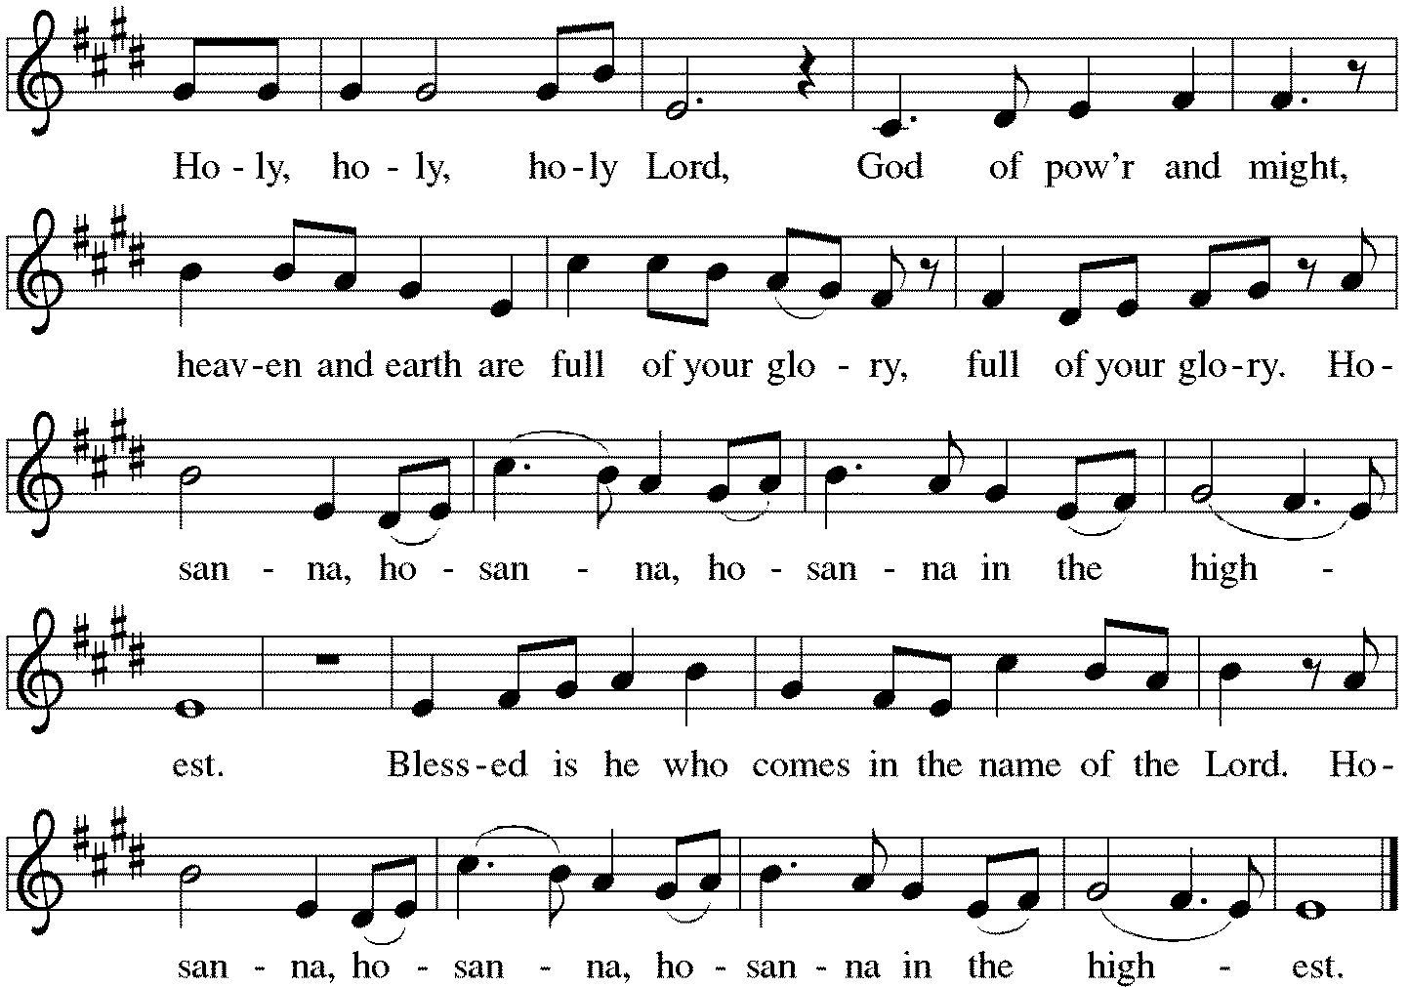

*Thanksgiving at the Table
Holy God, holy and mighty, holy and immortal: you we praise and glorify, you we worship and adore.

You formed the earth from chaos; you encircled the globe with air; you created fire for warmth and light; you nourish the lands with water. You molded us in your image, and with mercy higher than the mountains, with grace deeper than the seas, you blessed the Israelites and cherished them as your own.

That also we, estranged and dying, might be adopted to live in your Spirit, you called to us through the life and death of Jesus.
In the night in which he was betrayed, our Lord Jesus took bread, and gave thanks; broke it, and gave it to his disciples, saying: Take and eat; this is my body, given for you. Do this for the remembrance of me.

Again, after supper, he took the cup, gave thanks, and gave it for all to drink, saying: This cup is the new covenant in my blood, shed for you and for all people for the forgiveness of sin.
Do this for the remembrance of me.

Together as the body of Christ, we proclaim the Lord's death until he comes. Christ has died. Christ is risen. Christ will come again.

With this bread and cup we remember your Son, the first-born of your new creation. We remember his life lived for others, and his death and resurrection, which renews the face of the earth. We await his coming, when, with the world made perfect through your wisdom,
all our sins and sorrows will be no more. Amen. Come, Lord Jesus.

You may hold up your (unopened) communion kit as you are able.
Holy God, holy and merciful, holy and compassionate, send upon us and this meal your Holy Spirit,
whose breath revives us for life, whose fire rouses us to love. Enfold in your arms all who share this holy food. Nurture in us the fruits of the Spirit, that we may be a living tree, sharing your bounty with all the world.Amen. Come, Holy Spirit.
You may lower your communion kit.

Holy and benevolent God, receive our praise and petitions, as Jesus received the cry of the needy, and fill us with your blessing, until, needy no longer and bound to you in love,
we feast forever in the triumph of the Lamb: through whom all glory and honor is yours, O God, O Living One, with the Holy Spirit, in your holy church, now and forever. Amen.

*The Lord’s Prayer
Gathered into one by the Holy Spirit, let us pray as Jesus taught us.
Our Father in heaven, hallowed be your name, your kingdom come, your will be done, on earth as in heaven. Give us today our daily bread. Forgive us our sins as we forgive those who sin against us. Save us from the time of trial and deliver us from evil. For the kingdom, the power, and the glory are yours, now and forever. Amen.

*Invitation to Communion
All who hunger and thirst, come. The table is ready. Be Seated.

If you have difficulty opening your communion, please signal an usher for assistance.

Peel up the clear top seal over the wafer, and hold the wafer up when you are ready.
This is the Body of Christ, given for you. (Eat the bread.) Amen.

Peel up the second foil seal over the juice, and hold your cup up when you are ready.
This is the blood of Christ, shed for you. (Drink the wine/juice.) Amen.

After communion you may place the packaging in the bowl in your pew. The ushers will dispose of these following the service.

Agnus Dei p. 191 Lamb of God
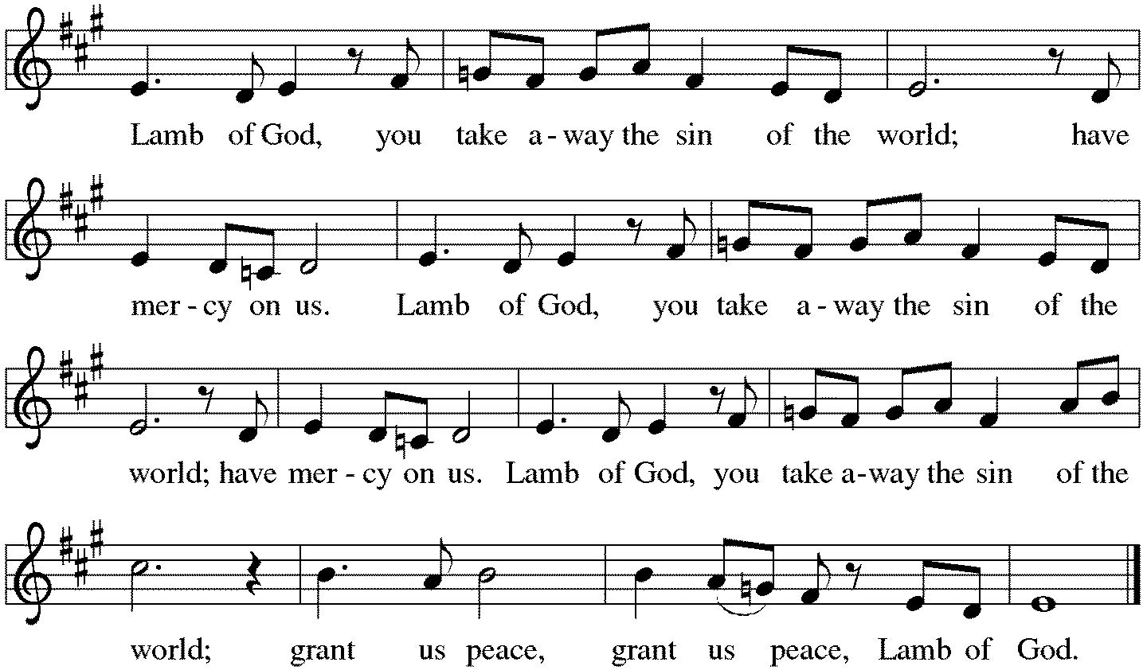

*Please stand as you are able.
*Post-Communion Blessing
The body and blood of our Lord Jesus Christ strengthen you and keep you in his grace. Amen.

*Prayer after Communion
Lord of life, in the gift of your body and blood you turn the crumbs of our faith into a feast of salvation. Send us forth into the world with shouts of joy, bearing witness to the abundance of your love in Jesus Christ, our Savior and Lord. Amen.

Sending
God blesses us and sends us in mission to the world.
*Blessing
People of God, you are Christ’s body, bringing new life to a suffering world. The holy Trinity, ☩ one God, bless you now and forever. Amen.

*Sending Hymn ELW#538 The Lord Now Sends Us Forth
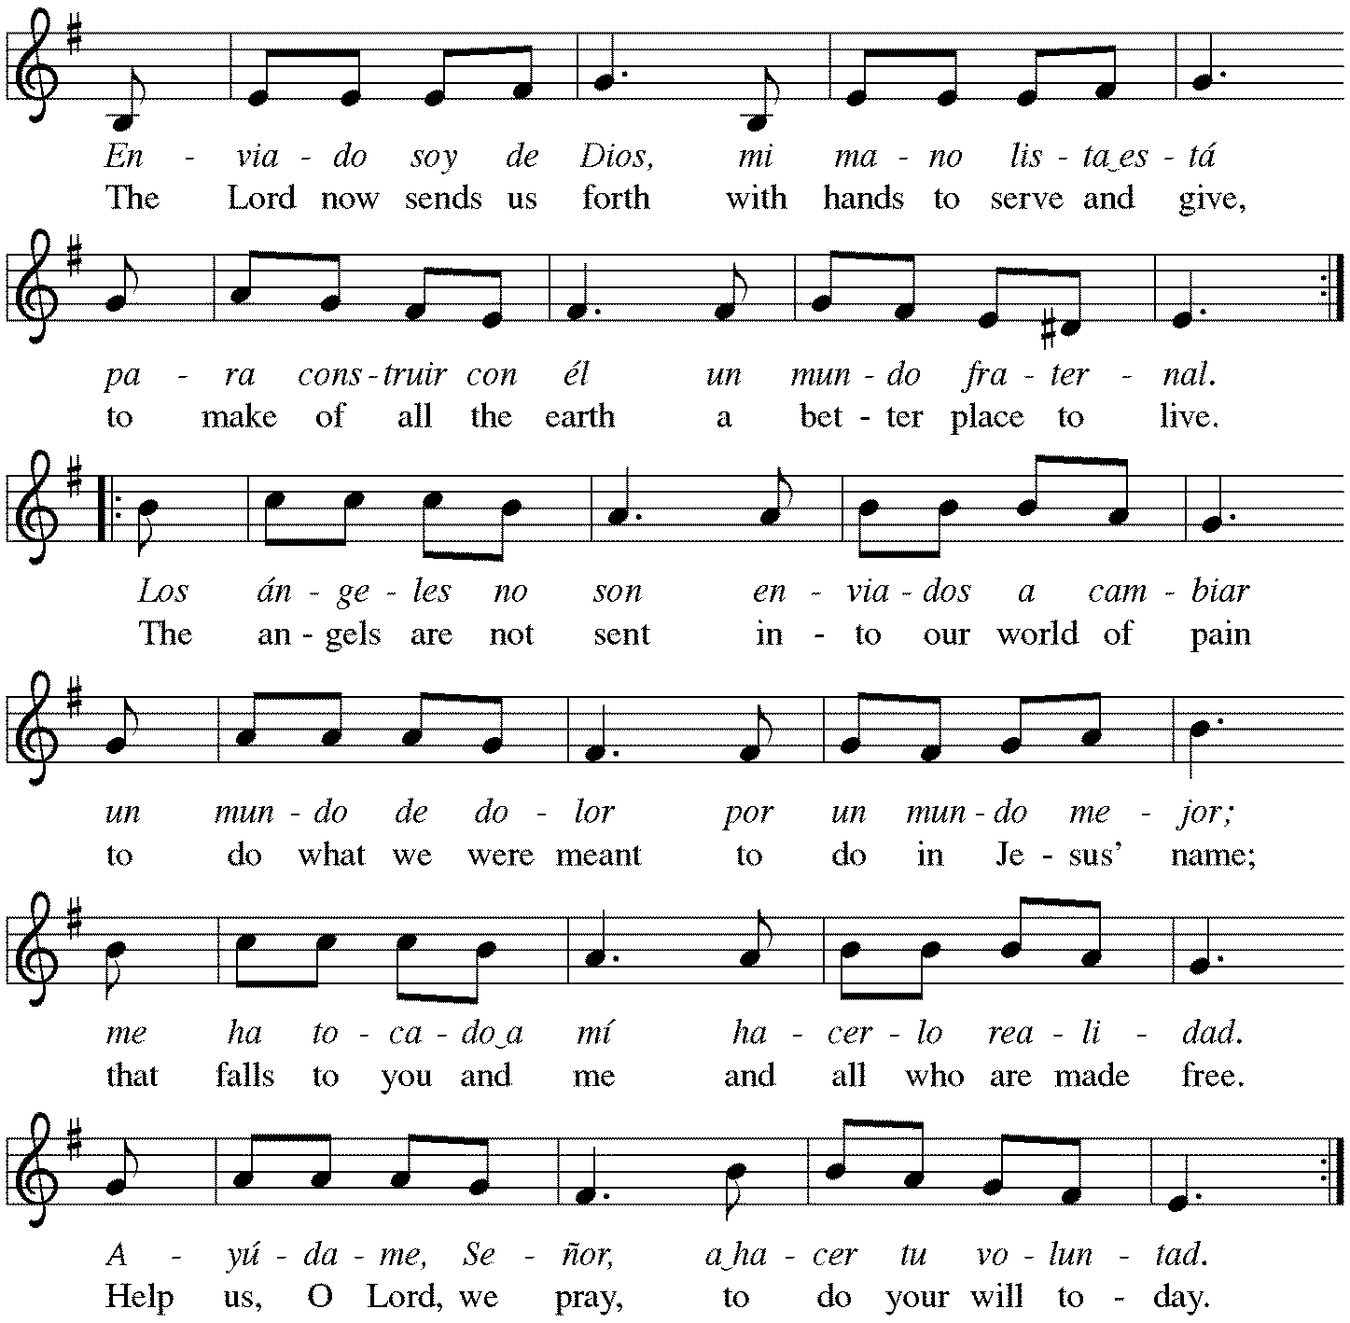

*Sent to the World
Go in peace. The living Word dwells in you. Thanks be to God.

Postlude
After the postlude, those who have joined via Zoom may unmute your mics
and share a greeting with your fellow worshippers.

From Sundays and Seasons
v.20190109.1233 Copyright © 2021 Augsburg Fortress. All rights reserved.
Reprinted by permission under Augsburg Fortress Liturgies Annual License #30867.
All rights reserved. Reprinted under OneLicense.net #A-718333.

Assisting in Worship Today
Ministry Associate Becky Ficarella
Minister of Music Bradford Thompson
Lector Rob Granner
Ushers Mark Drager, John Jokela, Rich Pasbrig, Open

Current Prayer Requests
Please keep these people in your prayers and reach out to our sisters and brothers in Christian love. Names will be left on the list for two weeks, unless you indicate that they should remain in our prayers for a longer period.
Name Relationship Prayer For
Jim Sladek Member Birthday 9/25 (90)
Cathy Milleville Member Healing & Strength
Sigrid Elliott Member Healing & Strength
Dorothy Tracy Member Healing & Strength
Norma Petersen Member Healing & Strength
Keith & Rita Matthews SIL & Daughter of Norma Petersen Healing & Strength
Norma Petersen Member Healing & Strength
Keith Petras Brother of Dru Geraghty Healing & Strength
Lori Garabrandt Relative of Chuck Miller and Lois Pertle Healing & Strength
Chris Danly Son of Mark & Pat Danly Healing & Strength
Prayers for our homebound Members
Dolores Nosal, Carol Petersen, Norma Petersen, Dorothy Stein

RAMP (Reduce Another Mortgage Payment): As we continue to RAMP up to refinance our mortgage with Mission Investment Fund in October, we wish to thank you all who have contributed to date. We are still hopeful we can raise an additional $75,000 before October 5. Our monthly mortgage payment is a big ticket item in our budget at $6,777 monthly ($81,324 annually) and lowering that amount by an additional $1,000 or more (yes please) per month will greatly help our annual budget and free up funds that we can utilize on the ministries of Grace. Please give any amount you can between now and October 5. Indicate your contribution is for the Mortgage Reduction Fund.

Got Capital Gains? Did you know that stock donations allow you to both claim a deduction at the appreciated value AND allow you to avoid capital gains taxes on these assets? Further, consolidating donations in a tax year could lead to increased ability to deduct charitable contributions in a given tax year. Consult your tax advisor for details, but if you’d like more information on how to go about donating stock, reach out to the church office.

Contributions to Grace: You may continue to mail your contributions for the General Fund and the Mortgage Reduction Fund to the church office; have your bank mail your contribution to the church office (this works great); or contribute on-line through Grace’s website (Grace/you pay fees). Please know, pandemic or no, our mission continues! Thank you for your continued support of our ministries at Grace Lutheran.

Choir rehearsal Wednesdays at 7pm! Come join us for an hour of fun, super low-pressure music-making! Not free on Wednesday evenings? You’re still welcome to join us on Sunday mornings at 8:40! Don’t feel good about your voice/singing? We can work on that, too! No matter your voice type or skill level, there’s room for you! Get excited, my friends! The fun starts now :)

Pill Bottle Project: Calling all volunteers! After being shut down for over a year, we will meet weekly on Tuesdays from 6-7:30pm in the upstairs kitchen next to the gym. We need to work through our backlog of pill bottles. If you would like to volunteer, just show up! Please note: at this time we are not accepting any pill bottles as it will take some time to get through the current inventory we have. If you have any questions, please contact Mark Hamilton at (630) 841-2941 / mark.hamilton@ifs.com

Sr. Center Chair Exercise: The exercise class meets Mondays at 10:00am, Tuesdays at 11:30am, and Thursdays at 11:00am. Registration is required as the number of attendees will be limited. Please contact Sue Davison at 630-858-6343 to register.

Sr. Center Book Club: The Book Club meets on the third Tuesday of the month at 11:00am. Please contact Sue Davison at 630-858-6343 to register.

Every Member a Minister and Missionary!

Phone: 630-469-1555 Emergency Pastoral Contact: 630-674-2887
info@graceglenellyn.org www.graceglenellyn.org

Pastor
Rev. Melody Eastman office ext. 14
meastman@graceglenellyn.org

Minister of Music
Bradford Thompson 219-718-8879
bradfordmthompson@gmail.com

Ministry Associate
Becky Ficarella office ext. 17
bficarella@graceglenellyn.org

Office Manager
Barbara Sudds office ext. 10
bsudds@graceglenellyn.org

Parish Counselor
Carole LoGalbo M.S., LCPC 630-668-4594
carolelogalbo@yahoo.com

