Grace Lutheran Church

493 Forest Avenue, Glen Ellyn IL 630.469.1555
www.graceglenellyn.org

18th Sunday after Pentecost September 26, 2021

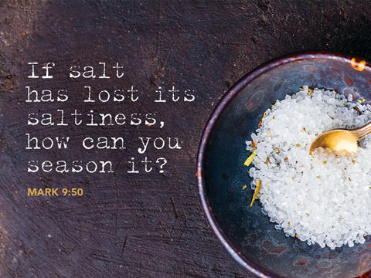

+ Proclaim Christ + Build Community +
+ Serve Our Neighbors +

Introduction
Someone who isn’t part of Jesus’ own circle is casting out demons in Jesus’ name, and the disciples want him stopped. They appeal to Jesus, as Joshua did to Moses about the elders who prophesied without official authorization. Like Moses, Jesus refuses to see this as a threat. Jesus welcomes good being done in his name, even when it is not under his control. The circle we form around Jesus’ word must be able to value good being done in ways we wouldn’t do it, by people we can’t keep tabs on.

Gathering
The Holy Spirit calls us together as the people of God.
Welcome/Announcements
Helpful Reminders for those joining via Zoom:
- The host will mute you when you join, and you will remain muted until the end of the service.
- You are welcome to join in all congregation responses (in Bold black.) and hymns.
- At the end of the service you may unmute your mic to share greetings with your fellow worshippers. If you dialed in on the phone, press *6. Remember, your host cannot unmute you.

Helpful Reminders for those joining in person:
- Maintain 6’ distance between family groups
- Remain in your pews for communion.
- You may place your offering in the box in the narthex.

Prelude

*Please stand as you are able and turn to face the font.
*Confession and Forgiveness
All may make the sign of the cross, the sign marked at baptism, as the presiding minister begins.
Blessed be the holy Trinity, ☩ one God, whose teaching is life, whose presence is sure, and whose love is endless. Amen.

Let us confess our sins to the one who welcomes us with an open heart.
Silence is kept for reflection.
God our comforter: like lost sheep, we have gone astray. We gaze upon abundance and see scarcity. We turn our faces away from injustice and oppression. We exploit the earth with our apathy and greed. Free us from our sin, gracious God. Listen when we call out to you for help. Lead us by your love to love our neighbors as ourselves. Amen.

All have sinned and fall short of the glory of God. By the gift of grace in ☩ Christ Jesus, God makes you righteous. Receive with glad hearts the forgiveness of all your sins. Amen.

*Entrance Hymn ELW#822 Oh, Sing to the Lord
sts. 1,2,4,5
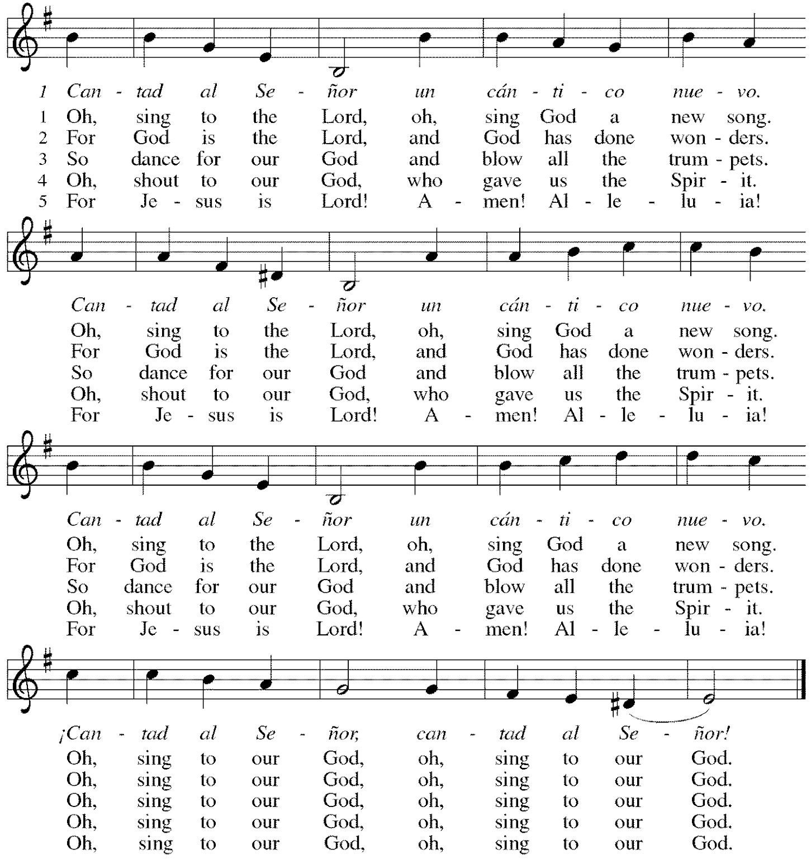
*Greeting
The grace of our Lord Jesus Christ, the love of God, and the communion of the Holy Spirit be with you all. And also with you.

*Kyrie p. 184 Bradford sings the verses, Congregation sings the refrain.
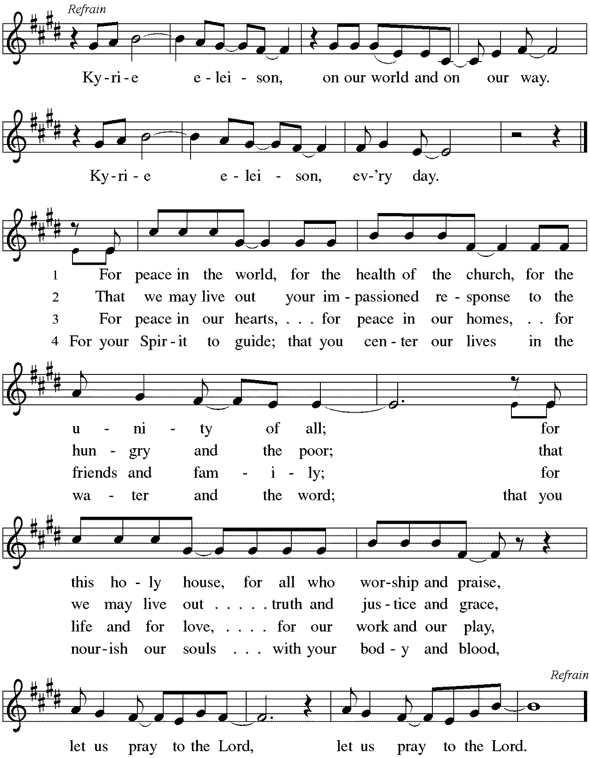
*Prayer of the Day
Generous God, your Son gave his life that we might come to peace with you. Give us a share of your Spirit, and in all we do empower us to bear the name of Jesus Christ, our Savior and Lord. Amen. Be seated.

Word
God speaks to us in scripture reading, preaching, and song.
First Lesson Numbers 11:4-6, 10-16, 24-29
What constitutes legitimate need and legitimate leadership is the focus of this reading. God provides manna in the wilderness, yet the people crave meat. What is truly needful? God bestows the spirit on seventy elders, yet two men not designated as leaders prophesy in the power of God’s spirit. What constitutes real leadership?

⁴The rabble among them had a strong craving; and the Israelites also wept again, and said, “If only we had meat to eat! ⁵We remember the fish we used to eat in Egypt for nothing, the cucumbers, the melons, the leeks, the onions, and the garlic; ⁶but now our strength is dried up, and there is nothing at all but this manna to look at.”
¹⁰Moses heard the people weeping throughout their families, all at the entrances of their tents. Then the Lord became very angry, and Moses was displeased. ¹¹So Moses said to the Lord, “Why have you treated your servant so badly? Why have I not found favor in your sight, that you lay the burden of all this people on me? ¹²Did I conceive all this people? Did I give birth to them, that you should say to me, ‘Carry them in your bosom, as a nurse carries a sucking child, to the land that you promised on oath to their ancestors’? ¹³Where am I to get meat to give to all this people? For they come weeping to me and say, ‘Give us meat to eat!’ ¹⁴I am not able to carry all this people alone, for they are too heavy for me. ¹⁵If this is the way you are going to treat me, put me to death at once—if I have found favor in your sight—and do not let me see my misery.”
¹⁶So the Lord said to Moses, “Gather for me seventy of the elders of Israel, whom you know to be the elders of the people and officers over them; bring them to the tent of meeting, and have them take their place there with you.”
²⁴So Moses went out and told the people the words of the Lord; and he gathered seventy elders of the people, and placed them all around the tent. ²⁵Then the Lord came down in the cloud and spoke to him, and took some of the spirit that was on him and put it on the seventy elders; and when the spirit rested upon them, they prophesied. But they did not do so again.
²⁶Two men remained in the camp, one named Eldad, and the other named Medad, and the spirit rested on them; they were among those registered, but they had not gone out to the tent, and so they prophesied in the camp. ²⁷And a young man ran and told Moses, “Eldad and Medad are prophesying in the camp.” ²⁸And Joshua son of Nun, the assistant of Moses, one of his chosen men, said, “My lord Moses, stop them!” ²⁹But Moses said to him, “Are you jealous for my sake? Would that all the Lord‘s people were prophets, and that the Lord would put his spirit on them!”
Word of God, Word of Life. Thanks be to God.

Psalm Psalm 19:7-14
The commandment of the Lord gives light to the eyes. (Ps. 19:8)

⁷The teaching of the Lord is perfect and revives the soul; the testimony of the Lord is sure and gives wisdom to the simple.
⁸The statutes of the Lord are just and rejoice the heart; the commandment of the Lord is clear and gives light to the eyes.
⁹The fear of the Lord is clean and endures forever; the judgments of the Lord are true and righteous altogether.
¹⁰More to be desired are they than gold, more than much fine gold, sweeter far than honey, than honey in the comb.
¹¹By them also is your servant enlightened, and in keeping them there is great reward.
¹²Who can detect one’s own offenses? Cleanse me from my secret faults.
¹³Above all, keep your servant from presumptuous sins; let them not get dominion over me; then shall I be whole and sound, and innocent of a great offense.
¹⁴Let the words of my mouth and the meditation of my heart be acceptable in your sight, O Lord, my strength and my redeemer.

Second Lesson James 5:13-20
Marks of the Christian community include praying for those who are sick and in need, celebrating with those in good health, restoring those who have strayed, confessing sins to one another, and offering forgiveness to each other.

¹³Are any among you suffering? They should pray. Are any cheerful? They should sing songs of praise. ¹⁴Are any among you sick? They should call for the elders of the church and have them pray over them, anointing them with oil in the name of the Lord. ¹⁵The prayer of faith will save the sick, and the Lord will raise them up; and anyone who has committed sins will be forgiven. ¹⁶Therefore confess your sins to one another, and pray for one another, so that you may be healed. The prayer of the righteous is powerful and effective. ¹⁷Elijah was a human being like us, and he prayed fervently that it might not rain, and for three years and six months it did not rain on the earth. ¹⁸Then he prayed again, and the heaven gave rain and the earth yielded its harvest.
¹⁹My brothers and sisters, if anyone among you wanders from the truth and is brought back by another, ²⁰you should know that whoever brings back a sinner from wandering will save the sinner’s soul from death and will cover a multitude of sins.

Word of God, Word of Life. Thanks be to God.

*Please stand as you are able.
*Gospel Acclamation p. 188 Alleluia
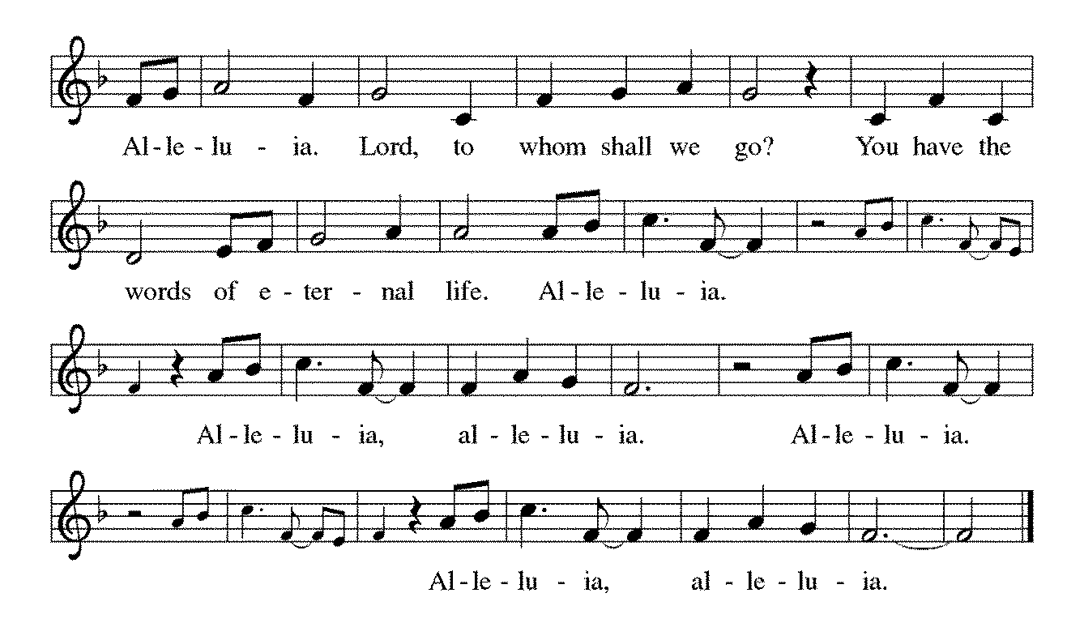

The holy Gospel according to Mark. Glory to you, O Lord.

*Gospel Mark 9:38-50
On the way to Jerusalem, Jesus teaches his disciples about ministry that involves service and sacrifice. His disciples are slow to realize that these words apply to them as well as to others.

³⁸John said to [Jesus,] “Teacher, we saw someone casting out demons in your name, and we tried to stop him, because he was not following us.” ³⁹But Jesus said, “Do not stop him; for no one who does a deed of power in my name will be able soon afterward to speak evil of me. ⁴⁰Whoever is not against us is for us. ⁴¹For truly I tell you, whoever gives you a cup of water to drink because you bear the name of Christ will by no means lose the reward.
⁴²“If any of you put a stumbling block before one of these little ones who believe in me, it would be better for you if a great millstone were hung around your neck and you were thrown into the sea. ⁴³If your hand causes you to stumble, cut it off; it is better for you to enter life maimed than to have two hands and to go to hell, to the unquenchable fire. ⁴⁵And if your foot causes you to stumble, cut it off; it is better for you to enter life lame than to have two feet and to be thrown into hell. ⁴⁷And if your eye causes you to stumble, tear it out; it is better for you to enter the kingdom of God with one eye than to have two eyes and to be thrown into hell, ⁴⁸where their worm never dies, and the fire is never quenched.
⁴⁹“For everyone will be salted with fire. ⁵⁰Salt is good; but if salt has lost its saltiness, how can you season it? Have salt in yourselves, and be at peace with one another.”

The Gospel of the Lord. Praise to you, O Christ. Be seated.

Sermon The Rev. Melody Eastman

*Please stand as you are able.
*Hymn of the Day ELW #636 How Small Our Span of Life
sts. 1-3
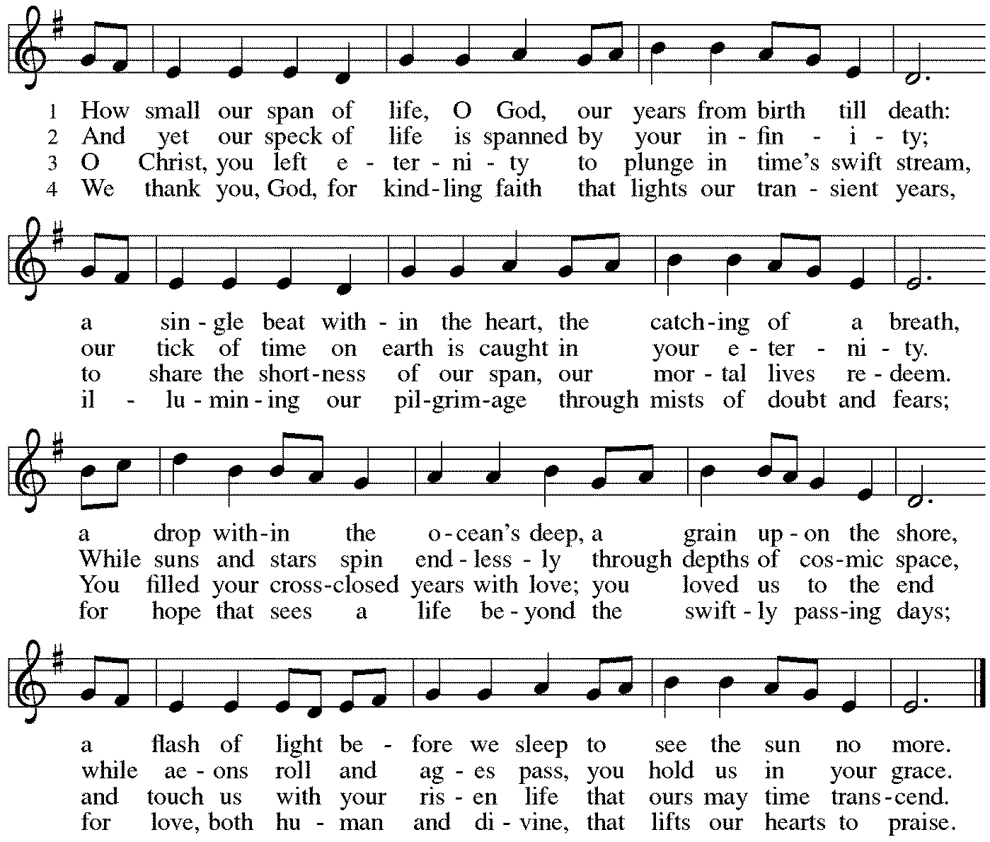

*Please turn to face the baptismal font
*Holy Baptism of Emelyn Irene Creager Parents: Sara Creager
Charles Creager

Sponsors: Melissa Haas
Dan Haas

God, who is rich in mercy and love, gives us a new birth into a living hope through the sacrament of baptism. By water and the Word God delivers us from sin and death and raises us to new life in Jesus Christ. We are united with all the baptized in the one body of Christ, anointed with the gift of the Holy Spirit, and joined in God’s mission for the life of the world.
Sponsors We present Emelyn Irene Creager for baptism.

Called by the Holy Spirit, trusting in the grace and love of God, do you desire to have Emelyn baptized into Christ?
Parents We do.

As you bring your child to receive the gift of baptism, you are entrusted with responsibilities: To live with her among God’s faithful people, to bring her to hear the word of God and to the holy supper, to teach her the Lord’s Prayer, the Creed and the Ten Commandments, to place in her hands the holy scriptures and nurture her in faith and prayer so that she may learn to trust God, proclaim Christ through word and deed, care for others and the world God made, and work for justice and peace.

Do you promise to help Emelyn to grow in the Christian faith and life?
Parents We do.

Sponsors, do you promise to nurture Emelyn in the Christian faith as you are empowered by God’s Spirit, and to help her live in the covenant of baptism and in communion with the church?
Sponsors We do.

People of God, do you promise to support Emelyn and pray for her in her new life in Christ?
Congregation We do.
*Profession of Faith
I ask you to profess your faith in Christ Jesus, reject sin, and confess the faith of the church.

Do you renounce the devil and all the forces that defy God?
Parents/Sponsors I renounce them.

Do you renounce the powers of this world that rebel against God?
Parents/Sponsors I renounce them.

Do you renounce the ways of sin that draw you from God?
Parents/Sponsors I renounce them.

The congregation joins in the profession of faith.
Do you believe in God the Father?
I believe in God, the Father almighty, creator of heaven and earth.

Do you believe in Jesus Christ, the Son of God?
I believe in Jesus Christ, God's only Son, our Lord, who was conceived by the Holy Spirit, born of the virgin Mary, suffered under Pontius Pilate, was crucified, died, and was buried; he descended to the dead. On the third day he rose again; he ascended into heaven, he is seated at the right hand of the Father, and he will come to judge the living and the dead.

Do you believe in God the Holy Spirit?
I believe in the Holy Spirit, the holy catholic church, the communion of saints, the forgiveness of sins, the resurrection of the body, and the life everlasting.

*Thanksgiving at the Font
The Lord be with you.
And also with you.

Let us give thanks to the Lord our God.
It is right to give our thanks and praise.

We give you thanks, O God, for in the beginning your Spirit moved over the waters and by your Word you created the world, calling forth life in which you took delight. Through the waters of the flood you delivered Noah and his family, and through the sea you led your people Israel from slavery into freedom. At the river your Son was baptized by John and anointed with the Holy Spirit. By the baptism of Jesus' death and resurrection you set us free from the power of sin and death and raise us up to live in you. Pour out your Holy Spirit, the power of your living Word, that those who are washed in the waters of baptism may be given new life. To you be given honor and praise through Jesus Christ our Lord, in the unity of the Holy Spirit, now and forever. Amen.

*Baptism
Emelyn Irene Creager, I baptize you in the name of the Father, and of the Son, and of the Holy Spirit.
Amen. You belong to Christ, in whom you have been baptized.

Let us pray. We give you thanks, O God, that through water and the Holy Spirit you give your beloved children new birth, cleanse them from sin, and raise them to eternal life. Sustain Emelyn Irene with the gift of your Holy Spirit: the spirit of wisdom and understanding, the spirit of counsel and might, the spirit of knowledge and the fear of the Lord, the spirit of joy in your presence, both now and forever.
Amen.

Emelyn Irene, child of God, you have been sealed by the Holy Spirit and marked with the cross of Christ forever. Amen.

*Welcome
Let your light so shine before others that they may see your good works and glorify your Father in heaven.

Let us welcome the newly baptized.
We welcome you into the body of Christ and into the mission we share: join us in giving thanks and praise to God and bearing God's creative and redeeming word to all the world.

*Affirmation of Baptism/Reception into Membership: Sara Creager, Chuck Creager
Dear friends, we give thanks to God for the gift of baptism for Emelyn and also for her parents, Sara and Chuck, one with us in the body of Christ, who are making public affirmation of their baptism and joining us in mission here at Grace.

Let us pray.
Merciful God,
we thank you for Sara and Chuck, whom you have made your own
by water and the Word in baptism.
You have called them to yourself,
enlightened them with the gifts of your Spirit,
and nourished them in the community of faith.
Uphold your servants in the gifts and promises of baptism,
and unite the hearts of all whom you have brought to new birth.
We ask this in the name of Christ.
Amen.

You have made public profession of your faith.
Do you intend to continue in the covenant
God made with you in holy baptism:
to live among God's faithful people,
to hear the word of God and share in the Lord's supper,
to proclaim the good news of God in Christ through word and deed,
to serve all people, following the example of Jesus,
and to strive for justice and peace in all the earth?

Each person responds: I do, and I ask God to help and guide me.

People of God,
do you promise to support Chuck and Sara
and pray for them in their life in Christ?
We do, and we ask God to help and guide us.

Let us pray.
We give you thanks, O God, that through water and the Holy Spirit
you give us new birth, cleanse us from sin, and raise us to eternal life.

Father in heaven, for Jesus' sake,
stir up in Sara/Chuck the gift of your Holy Spirit;
confirm her/his faith,
guide her/his life,
empower her/him in her/his serving,
give her/him patience in suffering,
and bring her/him to everlasting life.
Amen.

Let us rejoice with these sisters and brothers in Christ.
We rejoice with you in the life of baptism.
Together we will give thanks and praise to God
and proclaim the good news to all the world.
*Prayers of Intercession
Made children and heirs of God’s promise, we pray for the church, the world, and all in need.
A brief silence.

We pray for the church and its ministry. Bless the newly baptized and encourage them in their journey of faith. Sustain all members of the body of Christ in lives of prayer, service, and worship. Lord, in your mercy, hear our prayer.

We pray for natural wonders of your creation. Restore damaged forests, waterways and natural habitats and lead us to be good stewards of what you have provided. Lord, in your mercy, hear our prayer.

We pray for those in authority. Give them wise minds and compassionate hearts. Strengthen in them a desire to protect the vulnerable and care for those underserved. Lord, in your mercy, hear our prayer.

We pray for those who are struggling with cancer, dementia, or any other disease. We pray for those who need your strength, especially Cathy, Sigrid, Dorothy, Dolores, Carol and Norma. Provide them with peace and resilience for the days ahead. Sustain caregivers with energy and patience. Lord, in your mercy, hear our prayer.

We pray for the worship leaders of this congregation: musicians, readers, acolytes, and ushers. Bless us through their ministry and grant them the passion to continue in their service. Lord, in your mercy, hear our prayer.

We thank you for the witness of Jim Sladek, and ask your blessing on him as he celebrates his 90th birthday. Grant him joy in the love of family and friends. Lord, in your mercy, hear our prayer.

We give thanks for all your saints, those we have loved and known and those from every time and place. Continue to guide us by their example and reassure us of your promised salvation. Lord, in your mercy, hear our prayer.

Receive these prayers, O God, and those in our hearts known only to you; through Jesus Christ our Lord. Amen.
*Peace
The peace of Christ be with you always. And also with you.
Please share the peace with others in your household, or by making a sign of peace to those on Zoom. Please remain standing.
Meal
God feeds us with the presence of Jesus Christ.
*Offering Prayer
God of abundance,
you cause streams to break forth in the desert
and manna to rain from the heavens.
Accept the gifts you have first given us.
Unite them with the offering of our lives
to nourish the world you love so dearly;
through Jesus Christ, our Savior and Lord. Amen

*Great Thanksgiving
The Lord be with you. And also with you.
Lift up your hearts. We lift them to the Lord.
Let us give thanks to the Lord our God. It is right to give our thanks and praise.

*Preface
It is indeed right, our duty and our joy, that we should at all times and in all places give thanks and praise to you, almighty and merciful God, through our Savior Jesus Christ; who on this day overcame death and the grave, and by his glorious resurrection opened to us the way of everlasting life. And so, with all the choirs of angels, with the church on earth and the hosts of heaven, we praise your name and join their unending hymn:

*Sanctus p. 190 Holy, Holy, Holy
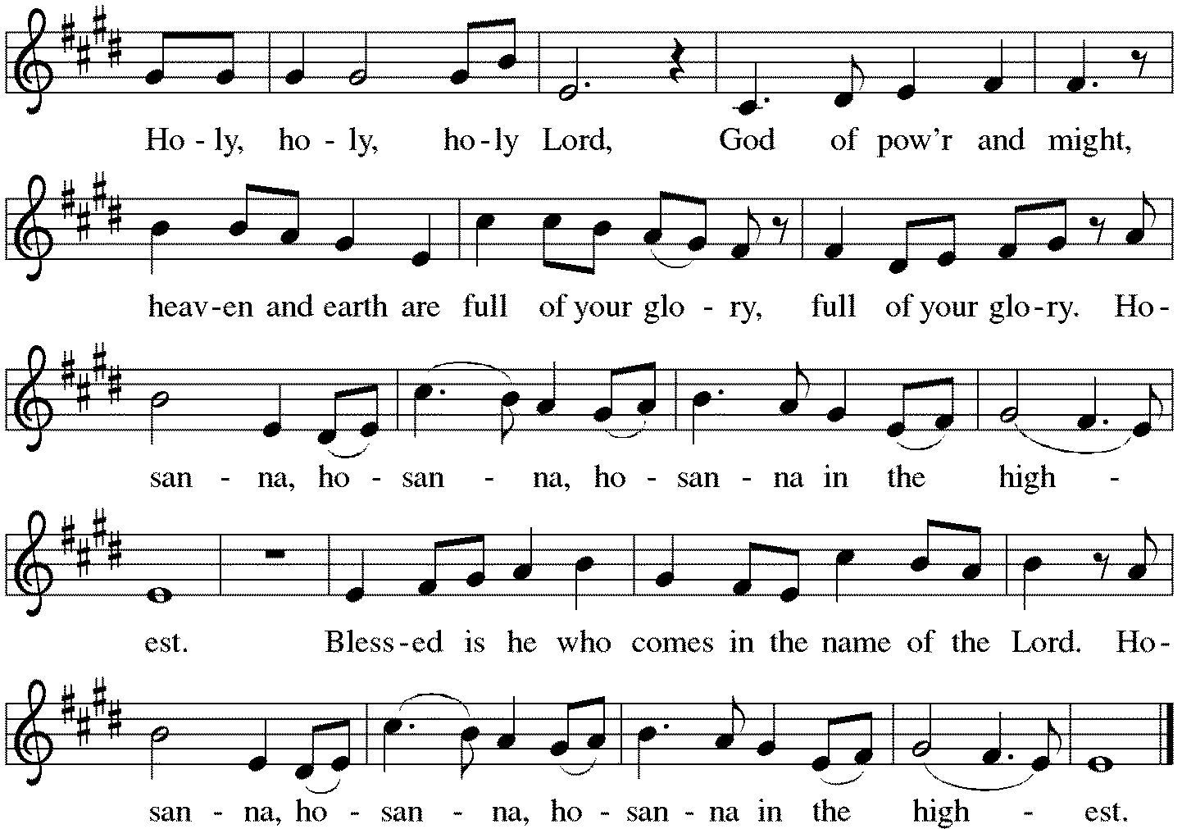

*Thanksgiving at the Table
Holy God,
holy and mighty,
holy and immortal:
you we praise and glorify,
you we worship and adore.

You formed the earth from chaos;
you encircled the globe with air;
you created fire for warmth and light;
you nourish the lands with water.
You molded us in your image,
and with mercy higher than the mountains,
with grace deeper than the seas,
you blessed the Israelites and cherished them as your own.

That also we, estranged and dying,
might be adopted to live in your Spirit,
you called to us through the life and death of Jesus.

In the night in which he was betrayed,
our Lord Jesus took bread, and gave thanks;
broke it, and gave it to his disciples, saying:
Take and eat; this is my body, given for you.
Do this for the remembrance of me.

Again, after supper, he took the cup, gave thanks,
and gave it for all to drink, saying:
This cup is the new covenant in my blood,
shed for you and for all people for the forgiveness of sin.
Do this for the remembrance of me.

Together as the body of Christ,
we proclaim the Lord's death until he comes.
Christ has died. Christ is risen. Christ will come again.

With this bread and cup we remember your Son,
the first-born of your new creation.
We remember his life lived for others,
and his death and resurrection, which renews the face of the earth.
We await his coming,
when, with the world made perfect through your wisdom,
all our sins and sorrows will be no more.
Amen. Come, Lord Jesus.

You may hold up your (unopened) communion kit as you are able.
Holy God,
holy and merciful,
holy and compassionate,
send upon us and this meal your Holy Spirit,
whose breath revives us for life,
whose fire rouses us to love.
Enfold in your arms all who share this holy food.
Nurture in us the fruits of the Spirit,
that we may be a living tree, sharing your bounty with all the world.
Amen. Come, Holy Spirit.
You may lower your communion kit.

Holy and benevolent God,
receive our praise and petitions,
as Jesus received the cry of the needy,
and fill us with your blessing,
until, needy no longer and bound to you in love,
we feast forever in the triumph of the Lamb:
through whom all glory and honor is yours, O God, O Living One,
with the Holy Spirit, in your holy church, now and forever.
Amen.

*The Lord’s Prayer
Gathered into one by the Holy Spirit, let us pray as Jesus taught us.
Our Father in heaven, hallowed be your name, your kingdom come, your will be done, on earth as in heaven. Give us today our daily bread. Forgive us our sins as we forgive those who sin against us. Save us from the time of trial and deliver us from evil. For the kingdom, the power, and the glory are yours, now and forever. Amen.

*Invitation to Communion
All who hunger and thirst, come. The table is ready. Be Seated.

If you have difficulty opening your communion, please signal an usher for assistance.

Peel up the clear top seal over the wafer, and hold the wafer up when you are ready.
This is the Body of Christ, given for you. (Eat the bread.) Amen.

Peel up the second foil seal over the juice, and hold your cup up when you are ready.
This is the blood of Christ, shed for you. (Drink the wine/juice.) Amen.

After communion you may place the packaging in the bowl in your pew. The ushers will dispose of these following the service.

Agnus Dei p. 191 Lamb of God
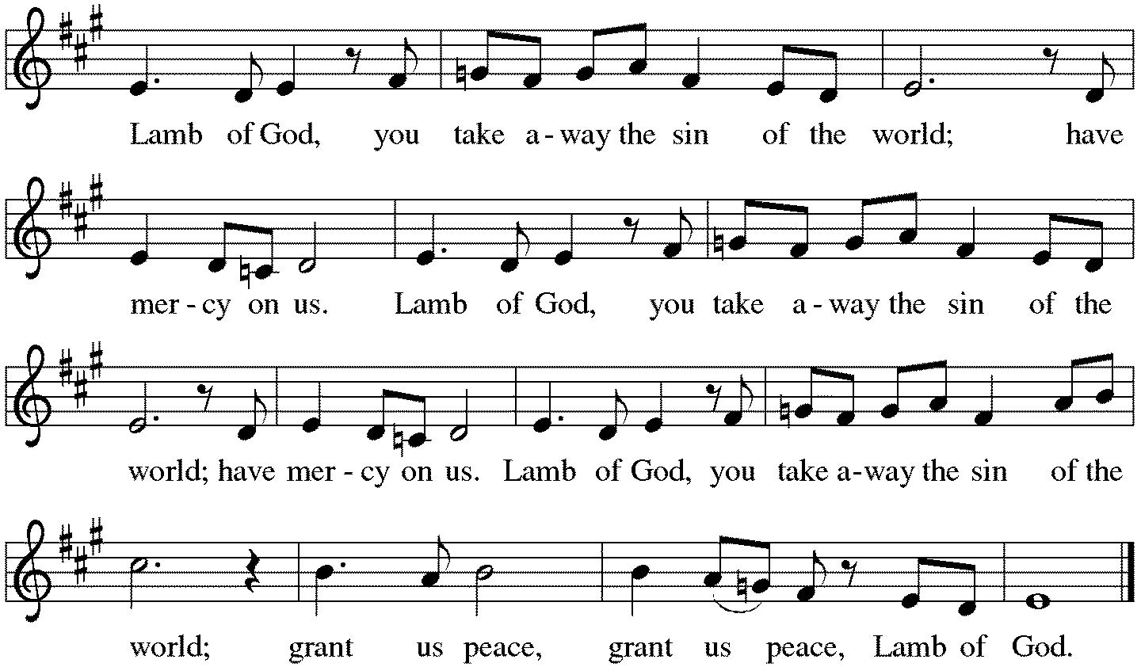

*Please stand as you are able.
*Post-Communion Blessing
The body and blood of our Lord Jesus Christ strengthen you and keep you in his grace. Amen.

*Prayer after Communion
Lord of life,
in the gift of your body and blood
you turn the crumbs of our faith into a feast of salvation.
Send us forth into the world with shouts of joy,
bearing witness to the abundance of your love
in Jesus Christ, our Savior and Lord. Amen.
Sending
God blesses us and sends us in mission to the world.
*Blessing
People of God,
you are Christ’s body,
bringing new life to a suffering world.
The holy Trinity, ☩ one God,
bless you now and forever. Amen.

*Sending Hymn ACS#942 Every Time I Feel the Spirit
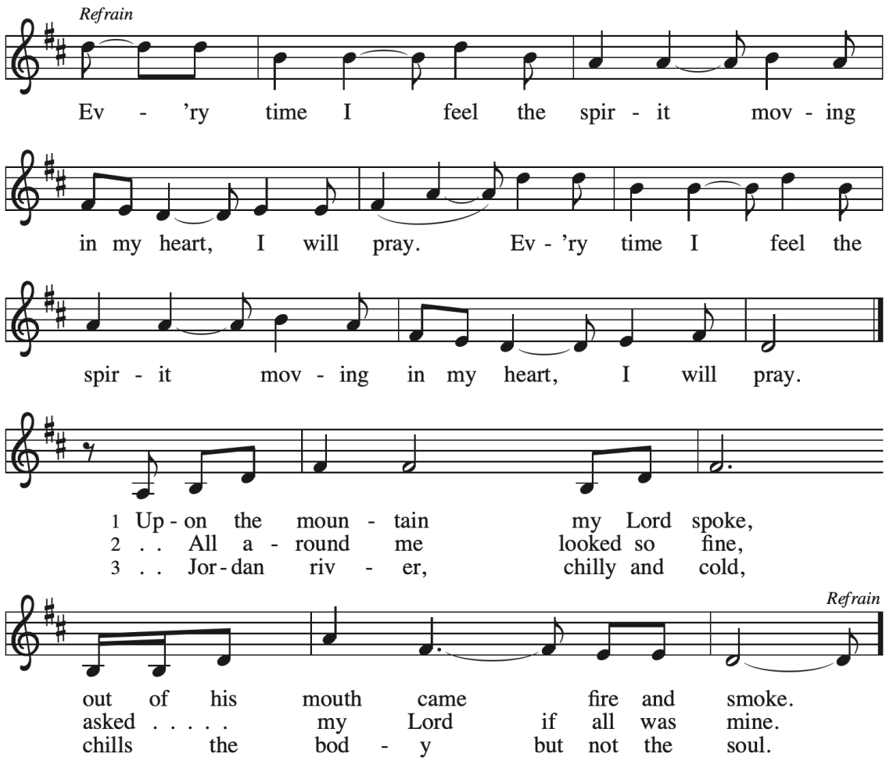

*Sent to the World
Go in peace. The living Word dwells in you. Thanks be to God.

Postlude

After the postlude, those who have joined via Zoom may unmute your mics
and share a greeting with your fellow worshippers.

From Sundays and Seasons
v.20190109.1233 Copyright © 2021 Augsburg Fortress. All rights reserved.
Reprinted by permission under Augsburg Fortress Liturgies Annual License #30867.
All rights reserved. Reprinted under OneLicense.net #A-718333.

Assisting in Worship Today
Ministry Associate Becky Ficarella
Minister of Music Bradford Thompson
Lector Susan Jacobson
Ushers Mark Drager, John Jokela, Rich Pasbrig, Open
Zoom Mark Hamilton, Jon & Cathy Milleville

Current Prayer Requests
Please keep these people in your prayers and reach out to our sisters and brothers in Christian love. Names will be left on the list for two weeks, unless you indicate that they should remain in our prayers for a longer period.
Name Relationship Prayer For
Jim Sladek Member Birthday 9/25 (90)
Family of Dorothy Stein Member Comfort in Grief
Cathy Milleville Member Healing & Strength
Sigrid Elliott Member Healing & Strength
Dorothy Tracy Member Healing & Strength
Keith Petras Brother of Dru Geraghty Healing & Strength
Lori Garabrandt Relative of Chuck Miller and Lois Pertle Healing & Strength
Chris Danly Son of Mark & Pat Danly Healing & Strength
Prayers for our homebound Members
Dolores Nosal, Carol Petersen, Norma Petersen

Faith Formation begins this Sunday: Worship at 9am, Fellowship at 9:45am; Faith Formation (all ages) at 10:20am. Sunday school will meet in the Sanctuary with Becky. Adult Faith Formation in the Fellowship Room with Pr. Melody. Sunday will be an introduction and exploring of topics for upcoming Sundays.

Join us on October 3 for the baptism of Audrey Yount.

Save the Date: Blood Drive to take place at Grace on Thursday, November 4 from 2:30-7pm. Sign up information will be forthcoming.

One Week to Go! RAMP (Reduce Another Mortgage Payment): As we continue to RAMP up to refinance our mortgage with Mission Investment Fund in October, we wish to thank you all who have contributed to date. We are still hopeful we can raise an additional $75,000 before October 5. Our monthly mortgage payment is a big ticket item in our budget at $6,777 monthly ($81,324 annually) and lowering that amount by an additional $1,000 or more (yes please) per month will greatly help our annual budget and free up funds that we can utilize on the ministries of Grace. The current principal balance on our mortgage is $889,079. Earlier this year we removed the comma, and then some! How low can we get this principal balance to go? Can we get out of $800K and into a $700K number?) Please give any amount you can between now and October 5. Indicate your contribution is for the Mortgage Reduction Fund. Envelopes are on the table in the Narthex.

Got Capital Gains? Did you know that stock donations allow you to both claim a deduction at the appreciated value AND allow you to avoid capital gains taxes on these assets? Further, consolidating donations in a tax year could lead to increased ability to deduct charitable contributions in a given tax year. Consult your tax advisor for details, but if you’d like more information on how to go about donating stock, reach out to the church office.

Contributions to Grace: You may continue to mail your contributions for the General Fund and the Mortgage Reduction Fund to the church office; have your bank mail your contribution to the church office (this works great); or contribute on-line through Grace’s website (Grace/you pay fees). Please know, pandemic or no, our mission continues! Thank you for your continued support of our ministries at Grace Lutheran.

Choir rehearsal Wednesdays at 7pm! Come join us for an hour of fun, super low-pressure music-making! Not free on Wednesday evenings? You’re still welcome to join us on Sunday mornings at 8:40! Don’t feel good about your voice/singing? We can work on that, too! No matter your voice type or skill level, there’s room for you! Get excited, my friends! The fun starts now :)

Monday Evening Bible Study: Mondays at 7:00pm, the group will begin review of a new, as yet unpublished, book from Dr. George Byron Koch. The topic is the Jewish roots of Christianity. We hope to meet live in the Great Room, subject to revision based upon the progress in eradicating COVID-19 from our community. In any event, if we meet live, we will provide a Zoom option for those who prefer to participate that way. The Monday night group has become cohesive over the years, sharing treats and conversation as well as our Bible study. Still, there is always room for more, and we will make you feel welcome. Kindly contact Mark Hamilton or Vince Hardt if you have not participated before so that we may add you to our Email list.

Pill Bottle Project: Calling all volunteers! After being shut down for over a year, we will meet weekly on Tuesdays from 6-7:30pm in the upstairs kitchen next to the gym. We need to work through our backlog of pill bottles. If you would like to volunteer, just show up! Please note: at this time we are not accepting any pill bottles as it will take some time to get through the current inventory we have. If you have any questions, please contact Mark Hamilton at (630) 841-2941 / mark.hamilton@ifs.com

Quilting Ministry September 28: This ministry will meet on the 2nd and 4th Tuesday of the month from 9:00-10:00am. Even if you can’t sew but can cut fabric into a 9” square we need you! We have 10⁺ bins of fabric waiting to be cut. After quilting you are invited to stay and attend the chair exercise class at 10:00am and if you like to knit hats, scarves, and gloves you can join the Wooly Knitters at 1pm! Everyone is welcome, bring a friend!

Sr. Center Chair Exercise: The exercise class meets Mondays at 10:00am, Tuesdays at 10:00am, and Thursdays at 11:00am. Registration is required as the number of attendees will be limited. Please contact Sue Davison at 630-858-6343 to register.

Sr. Center Book Club: The Book Club meets on the third Tuesday of the month at 11:00am. Please contact Sue Davison at 630-858-6343 to register.

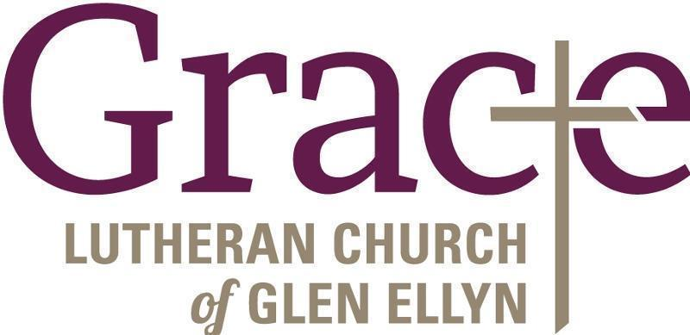

Every Member a Minister and Missionary!

Phone: 630-469-1555 Emergency Pastoral Contact: 630-674-2887
info@graceglenellyn.org www.graceglenellyn.org

Pastor
Rev. Melody Eastman office ext. 14
meastman@graceglenellyn.org

Minister of Music
Bradford Thompson 219-718-8879
bradfordmthompson@gmail.com

Ministry Associate
Becky Ficarella office ext. 17
bficarella@graceglenellyn.org

Office Manager
Barbara Sudds office ext. 10
bsudds@graceglenellyn.org

Parish Counselor
Carole LoGalbo M.S., LCPC 630-668-4594
carolelogalbo@yahoo.com

