Grace Lutheran Church

493 Forest Avenue, Glen Ellyn IL 630.469.1555
www.graceglenellyn.org

17th Sunday after Pentecost October 2, 2022

+ Proclaim Christ + Build Community +
+ Serve Our Neighbors +
Especially For Our Guests

Welcome to Grace!
If you are a guest, we’re thankful you’re here today. We hope you will feel welcomed and spiritually nourished. If you would like to speak to the pastor about the congregation, please let her know directly or call the church office. To enhance your worship experience, you may want to know the following:
· Please join us after service for some great refreshments and Christian Fellowship.
· Parts of the liturgy (worship service) not printed in this bulletin are in the red hymnal (ELW). Page numbers in the hymnal are at the bottom of the page; hymn numbers are the large numbers at the top in the back half of the book.
· All baptized people are welcome at communion. If you would like to come forward for a blessing without taking communion, you can do that too. If you have difficulty walking, feel free to let the usher know and we’ll bring communion to you.
· If you find yourself confused about where we are, ask a neighbor!
· Young children are welcome in worship! Parents, you can bring your little ones up front to the PrayGround, a space with tables, chairs and quiet activities to keep our younger members engaged during services. Please sit near your little ones and help them use the space quietly as well as participate with you in worship. If you prefer, there is also a nursery space for you to use with infants or younger toddlers in the overflow room at the rear of the sanctuary. (But we really do like having children up front, if possible!)
· Please take your bulletin home with you. It contains the weekly calendar of events at Grace plus upcoming announcements.

Introduction
A little faith goes a long way is Jesus’ point in the gospel. A mustard seed’s-worth of faith has miraculous potential. The patience, tenacity, and endurance required for the life of faith are the blessings received in holy baptism, holy communion, and the word read and proclaimed in this assembly. Anticipate them. Receive them with thanksgiving.

An asterisk (*) indicates that you should stand for that portion of the service. If standing is difficult, please remain seated. Congregation responses are in bold print.
Gathering
The Holy Spirit calls us together as the people of God.
Welcome/Announcements

Prelude

*Please stand as you are able and turn to face the font.
Confession and Forgiveness
All may make the sign of the cross, the sign that is marked at baptism, as the presiding minister begins.
Blessed be the holy Trinity, ☩ one God,
who is eager to forgive
and who loves us beyond our days.
Amen.

Dear friends, together let us acknowledge
our failure to love this world as Jesus does.
Silence is kept for reflection.
God of mercy and forgiveness,
we confess that sin still has a hold on us.
We have harmed your good creation.
We have failed to do justice,
love kindness,
and walk humbly with you.
Turn us in a new direction.
Show us the path that leads to life.
Be our refuge and strength on the journey,
through Jesus Christ, our redeemer and friend. Amen.
Beloved of God:
your sins are forgiven ☩ and you are made whole.
God points the way to new life in Christ,
who meets us on the road.
Journey now in God’s abiding love
through the power of the Holy Spirit.
Amen.

*Entrance Hymn ACS #1043 Spirit, Open My Heart
*Greeting
The grace of our Lord Jesus Christ, the love of God, and the communion of the Holy Spirit be with you all. And also with you.

*Kyrie Cantor sings Stanzas, Congregation joins on Refrain C. Heine
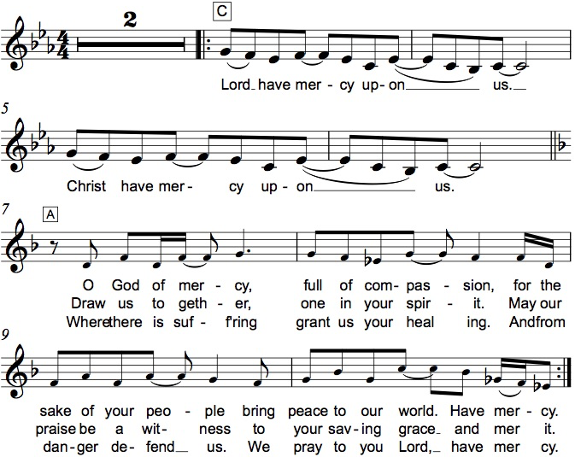

*Prayer of the Day
O God, rich in mercy, you look with compassion on this troubled world. Feed us with your grace, and grant us the treasure that comes only from you, through Jesus Christ, our Savior and Lord. Amen. Be seated.

Word
God speaks to us in scripture reading.
First Lesson Habakkuk 1:1-4; 2:1-4
Injustice and violence in the time leading up to the Babylonian exile move this prophet to lament: How can a good and all-powerful God see evil in the world and seemingly remain indifferent? God answers by proclaiming that the righteous will live by faith.

¹The oracle that the prophet Habakkuk saw. ²O Lord, how long shall I cry for help, and you will not listen? Or cry to you “Violence!” and you will not save? ³Why do you make me see wrongdoing and look at trouble? Destruction and violence are before me; strife and contention arise. ⁴So the law becomes slack and justice never prevails. The wicked surround the righteous— therefore judgment comes forth perverted.
^{2:1}I will stand at my watchpost, and station myself on the rampart; I will keep watch to see what he will say to me, and what he will answer concerning my complaint. ²Then the Lord answered me and said: Write the vision; make it plain on tablets, so that a runner may read it. ³For there is still a vision for the appointed time; it speaks of the end, and does not lie. If it seems to tarry, wait for it; it will surely come, it will not delay. ⁴Look at the proud! Their spirit is not right in them, but the righteous live by their faith.

Word of God, Word of Life. Thanks be to God.

Psalm Psalm 37:1-9
¹Do not be provoked by evildoers; do not be jealous of those who do wrong.
²For they shall soon wither like the grass, and like the green grass fade away.
³Put your trust in the Lord and do good; dwell in the land and find safe pasture.
⁴Take delight in the Lord, who shall give you your heart’s desire.
⁵Commit your way to the Lord; put your trust in the Lord, and see what God will do.
⁶The Lord will make your vindication as clear as the light and the justice of your case like the noonday sun.
⁷Be still before the Lord and wait patiently. Do not be provoked by the one who prospers, the one who succeeds in evil schemes.
⁸Refrain from anger, leave rage alone; do not be provoked; it leads only to evil.
⁹For evildoers shall be cut off, but those who hope in the Lord shall possess the land.
Second Lesson 2 Timothy 1:1-14
This letter written to Timothy is a personal message of encouragement. In the face of hardship and persecution, Timothy is reminded that his faith is a gift of God. He is encouraged to exercise that faith with the help of the Holy Spirit.

¹Paul, an apostle of Christ Jesus by the will of God, for the sake of the promise of life that is in Christ Jesus, ²To Timothy, my beloved child: Grace, mercy, and peace from God the Father and Christ Jesus our Lord.
³I am grateful to God—whom I worship with a clear conscience, as my ancestors did—when I remember you constantly in my prayers night and day. ⁴Recalling your tears, I long to see you so that I may be filled with joy. ⁵I am reminded of your sincere faith, a faith that lived first in your grandmother Lois and your mother Eunice and now, I am sure, lives in you. ⁶For this reason I remind you to rekindle the gift of God that is within you through the laying on of my hands; ⁷for God did not give us a spirit of cowardice, but rather a spirit of power and of love and of self-discipline.
⁸Do not be ashamed, then, of the testimony about our Lord or of me his prisoner, but join with me in suffering for the gospel, relying on the power of God, ⁹who saved us and called us with a holy calling, not according to our works but according to his own purpose and grace. This grace was given to us in Christ Jesus before the ages began, ¹⁰but it has now been revealed through the appearing of our Savior Christ Jesus, who abolished death and brought life and immortality to light through the gospel. ¹¹For this gospel I was appointed a herald and an apostle and a teacher, ¹²and for this reason I suffer as I do. But I am not ashamed, for I know the one in whom I have put my trust, and I am sure that he is able to guard until that day what I have entrusted to him. ¹³Hold to the standard of sound teaching that you have heard from me, in the faith and love that are in Christ Jesus. ¹⁴Guard the good treasure entrusted to you, with the help of the Holy Spirit living in us.

Word of God, Word of Life. Thanks be to God.

*Please stand as you are able.

*Gospel Acclamation Hallelujah!

The holy Gospel according to Luke. Glory to you, O Lord.
*Gospel Luke 17:5-10
On the way to Jerusalem, Jesus instructs his followers about the power of faith and the duties of discipleship. He calls his disciples to adopt the attitude of servants whose actions are responses to their identity rather than works seeking reward.

⁵The apostles said to the Lord, “Increase our faith!” ⁶The Lord replied, “If you had faith the size of a mustard seed, you could say to this mulberry tree, ‘Be uprooted and planted in the sea,’ and it would obey you.
⁷“Who among you would say to your slave who has just come in from plowing or tending sheep in the field, ‘Come here at once and take your place at the table’? ⁸Would you not rather say to him, ‘Prepare supper for me, put on your apron and serve me while I eat and drink; later you may eat and drink’? ⁹Do you thank the slave for doing what was commanded? ¹⁰So you also, when you have done all that you were ordered to do, say, ‘We are worthless slaves; we have done only what we ought to have done!’ ”

The Gospel of the Lord. Praise to you, O Christ. Be seated.

Sermon The Rev. Melody Eastman

*Please stand as you are able.
*Hymn of the Day ELW #759 My Faith Looks Up to Thee

*The Apostles’ Creed
Together with the whole Church, let us confess our faith.
I believe in God, the Father almighty, creator of heaven and earth.

I believe in Jesus Christ, God's only Son, our Lord,
who was conceived by the Holy Spirit, born of the virgin Mary,
suffered under Pontius Pilate, was crucified, died, and was buried;
he descended to the dead. On the third day he rose again;
he ascended into heaven, he is seated at the right hand of the Father,
and he will come to judge the living and the dead.

I believe in the Holy Spirit, the holy catholic church, the communion of saints,
the forgiveness of sins, the resurrection of the body, and the life everlasting. Amen.

*Prayers of Intercession
As scattered grains of wheat are gathered together into one bread, so let us gather our prayers for the church, those in need, and all of God’s good creation.
A brief silence.

We pray for your holy church in every place and for those who serve following the example of Christ. Help them to live by faith and walk by the light of your gospel. God of grace, hear our prayer.

For parts of the world ravaged by natural disaster: relieve those affected by floods, wildfires, droughts, earthquakes, tornadoes, and hurricanes. God of grace,
hear our prayer.

For every nation and for those entrusted with authority: grant our leaders self-discipline in all things, and inspire them with love for your people. God of grace, hear our prayer.

For victims of violence, abuse, and neglect: heal those who have been harmed and protect those who are vulnerable. For all who are sick especially Rich, Dorothy, Norma, Brittany, Susan, and those we name before you now. . . God of grace, hear our prayer.

For this and every congregation: rekindle your gifts within your people, and inspire councils, committees, and individuals to plan and work together that all may know your love. God of grace, hear our prayer.
Here other intercessions may be offered.

In thanksgiving that you have abolished death, and for the saints who have died. Bring us all to eternal life with you. God of grace, hear our prayer.

Gathered together in the sweet communion of the Holy Spirit, gracious God, we offer these and all our prayers to you; through Jesus Christ, our Savior. Amen.

*Peace
The peace of Christ be with you always. And also with you.
Please share the peace with others in your household, or by making a sign of peace to those on Zoom and then you may be seated as the table is prepared.
Meal
God feeds us with the presence of Jesus Christ.
Gathering of Gifts
We gather gifts for those in need and for the church’s mission.

Music During Offering

*Please stand as you are able. The gifts are brought forward while the congregation sings:
*Offertory Response C. Heine
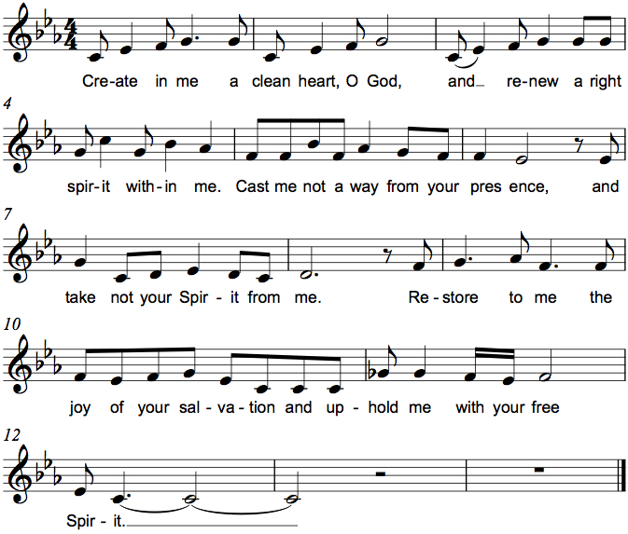

*Offering Prayer
Gracious God,
in your great love you richly provide for our needs.
Make of these gifts a banquet of blessing,
and make us ready to share with all in need;
through Jesus Christ, who sets a table for all.
Amen.

*Great Thanksgiving C. Heine
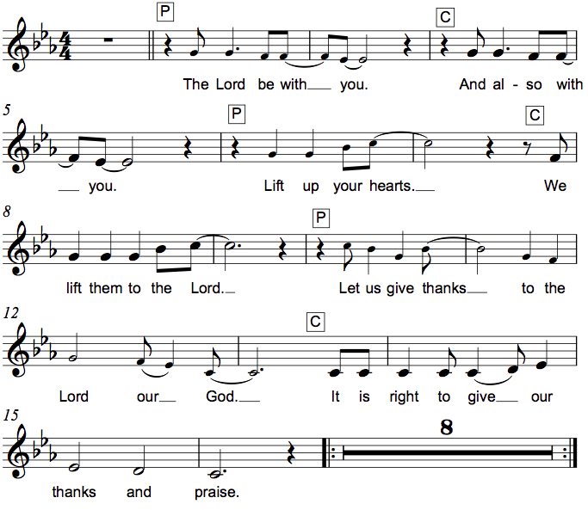

*Preface
It is indeed right, our duty and our joy,
that we should at all times and in all places give thanks and praise to you,
almighty and merciful God, through our Savior Jesus Christ;
who on this day overcame death and the grave,
and by his glorious resurrection opened to us the way of everlasting life.
And so, with all the choirs of angels,
with the church on earth and the hosts of heaven,
we praise your name and join their unending hymn:

*Sanctus Holy, Holy, Holy C. Heine
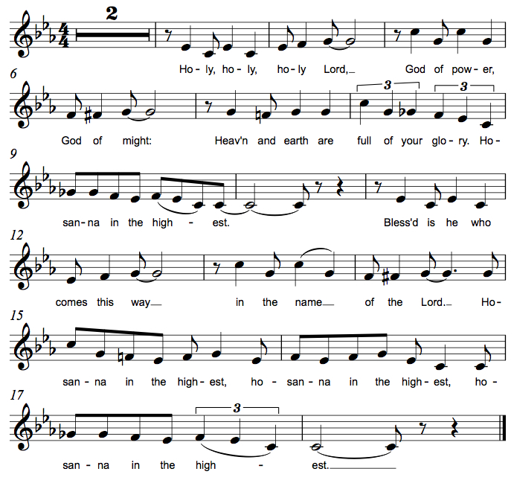
*Thanksgiving at the Table
Holy God, you alone are holy, you alone are God.
The universe declares your praise:
beyond the stars; beneath the sea; within each cell; with every breath.
We praise you, O God.

Generations bless your faithfulness:
through the water; by night and day; across the wilderness;
out of exile; into the future.
We bless you, O God.

We give you thanks for your dear Son:
at the heart of human life; near to those who suffer; beside the sinner;
among the poor; with us now.
We thank you, O God.

In the night in which he was betrayed,
our Lord Jesus took bread, and gave thanks;
broke it, and gave it to his disciples, saying:
Take and eat; this is my body, given for you.
Do this for the remembrance of me.

Again, after supper, he took the cup, gave thanks,
and gave it for all to drink, saying:
This cup is the new covenant in my blood,
shed for you and for all people for the forgiveness of sin.
Do this for the remembrance of me.

Remembering his love for us
on the way, at the table,
and to the end,
we proclaim the mystery of faith:
Christ has died. Christ is risen. Christ will come again.
We pray for the gift of your Spirit:
in our gathering; within this meal;
among your people; throughout the world.
Blessing, praise, and thanks to you,
holy God, through Christ Jesus,
by your Spirit, in your church, without end.
Amen.

*The Lord’s Prayer
Gathered into one by the Holy Spirit, let us pray as Jesus taught us.
Our Father, who art in heaven, hallowed be thy name, thy kingdom come, thy will be done on earth as it is in heaven. Give us this day our daily bread; and forgive us our trespasses, as we forgive those who trespass against us; and lead us not into temptation, but deliver us from evil. For thine is the kingdom, and the power, and the glory, forever and ever. Amen.

*Invitation to Communion
Christ invites you to this table. Come, taste and see. Be seated.

Communion
For those receiving communion from home:
This is the body of Christ, given for you. Amen (Eat the bread.)
This is the blood of Christ, shed for you. Amen (Drink the juice.)

Those who wish to come to the rail for communion or a blessing may do so at the ushers’ direction. You may return to your seat by the side aisles after you have received the bread and wine.

Agnus Dei Lamb of God M.B. Eastman
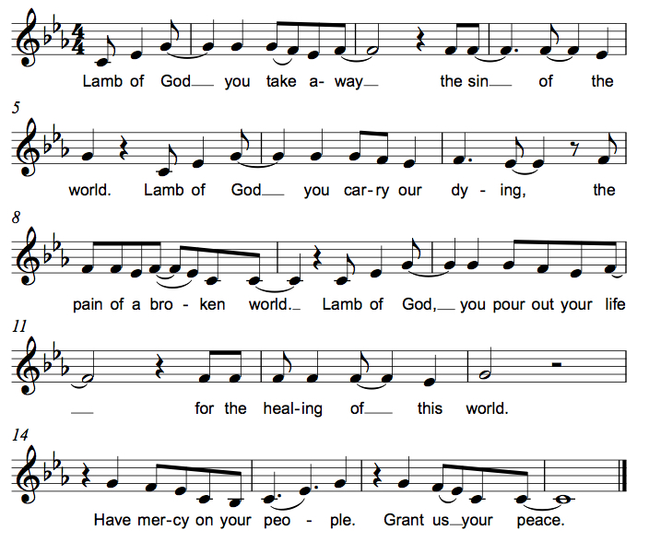

*Please stand as you are able.
*Post Communion Blessing
May the body and blood of our Lord Jesus Christ
strengthen you and keep you in his grace. Amen.

*Post Communion Prayer
God of the abundant table,
you have refreshed our hearts in this meal with bread for the journey.
Give us your grace on the road
that we might serve our neighbors with joy;
for the sake of Jesus Christ, our Lord. Amen.
Sending
God blesses us and sends us in mission to the world.
*Blessing
God, who gives life to all things and frees us from despair,
bless you with truth and peace. And may the holy Trinity, ☩ one God,
guide you always in faith, hope, and love. Amen.

*Sending Hymn ELW #635 We Walk by Faith

*Sent to the World
Go in peace, with Christ beside you. Thanks be to God.

Postlude

From Sundays and Seasons v.20190109.1233 Copyright © 2022 Augsburg Fortress. All rights reserved.
Reprinted by permission under Augsburg Fortress Liturgies Annual License #30867.
All rights reserved. Reprinted under OneLicense.net #A-718333.
Assisting in Worship Today
Pastor Rev. Melody Eastman
Minister of Music Bradford Thompson
Ministry Associate Becky Ficarella
Altar Care Sue Davison
Crucifer
Lector Susan Jacobson
Ushers Jeff Nelson, Open
Zoom Mark Hamilton, Jon & Cathy Milleville
Fellowship Hour Linda Berta

Current Prayer Requests
Name Relationship Prayer For
Ray & Bette Dieter Members 61st Anniversary 9/29
Tim & Jean Derrico Members 50th Anniversary 9/30
Susan Yerger Cousin of Bette Dieter Healing & Strength
Rich Davison Member Healing & Strength
Dorothy Derrico Member Healing & Strength
Brittany Huizenga Cousin of Cheryl Huizenga Healing & Strength
Dorothy Tracy Member Healing & Strength
Norma Petersen Member Healing & Strength
Prayers for our homebound Members
Carol Petersen, Norma Petersen

Weekly Announcements
Faith Formation:
Adult Faith 9:00-9:45: We will start out the year with an opportunity to study/review/discuss one of our nation’s hottest current topics: abortion. Over the first few weeks we’ll take a look at scripture passages relevant to the topic, the history of the Church’s stance on abortion, and the ELCA’s conversation and Social Statement. Depending on the interest of the group, we will follow this series with a look at the ELCA position on medical ethics.
Children: Ages 2 up to 6th Grade
9:00-9:15am: Gathering and fellowship time in the Great Room on 2nd Floor with crafts and toys. Coffee and healthy morning snacks available for families as they drop off their students.
9:20am: Group Prayer and Sending Song
9:20-9:45am: Spark Preschool-Kindergarten Class stays with Mrs. Graf in the Great Room
Shine 1st-6th Grade Class with Mrs. Drager in gym for Faith Formation and Bradford Thompson for Hand Chime Rehearsal
We NEED parent, guardian, and member support of these students for each of these classes. We need at least one other adult to assist each class, each week. Please let Becky Ficarella know if you can help!

The Community VBS Team sponsors “Soup-Tober” Food Drive for PADS in October! Our children learned all about Compassion for others during our fun week at Vacation Bible School this summer. To continue that important message, we plan to collect microwavable soups and Hormel microwave meals for our neighbors in PADS during the month of October. Please bring them to the display in the Narthex. Let’s show our kids how compassionate we can all be when we all come together to help!

PADS: Tuesday, October 4, 5:15pm at the Interim Housing Center. Contact Joe or Donna Jacobo for more information.

GraceGives goes to Panera in Wheaton on October 4
Come support Grace Gives from 4p-8p at the Panera located at 167 Danada Square East in Wheaton on Tuesday, October 4th. Just be sure to mention Grace Gives and we will receive 20% back in contributions. Thanks for your support!

Blood Drive: Thursday, October 13, 2:30-7:00pm. Sign up at Versiti Blood Center of Illinois - Donor Portal

Worship Leader Training: On Sunday, October 9 and 16 Grace will offer Worship Leader Training for Acolytes, Altar Care, and Lectors during Faith Formation at 9am.

People of Grace meets Tuesday, October 18
Come join us at Reserve 22 for fellowship and food! Members and friends of Grace are always welcome. Please RSVP with Jeff Nelson.

Worship Assistants: We are in need of people willing to serve as zoom tech, lector, cross-bearer, and communion assistant. We also need a minimum of two ushers for each week as we return to passing the offering plate in the pews. If you are able to help with carrying the cross and/or assisting with communion, please contact Susan Jacobson or the church office. Mark Drager schedules the ushers. Mark Hamilton works with the zoom techs. Thank you!

Altar Flowers: Would you like to place flowers on the altar to celebrate an event, or to honor and remember someone special, or just to make the altar look pretty? Sign up chart is in the Fellowship Room. They are $20 each (note new price) and can be ordered on the chart or by emailing or calling the church office. You may state the reason you are ordering them, which can be put in the bulletin. You can pay for the flowers along with your regular offering, just make a note indicating the Sunday you ordered them for.

Every Member a Minister and Missionary!

Phone: 630-469-1555 Emergency Pastoral Contact: 630-674-2887
info@graceglenellyn.org www.graceglenellyn.org

Pastor
Rev. Melody Eastman office ext. 14
meastman@graceglenellyn.org

Minister of Music
Bradford Thompson 219-718-8879
bradfordmthompson@gmail.com

Ministry Associate
Becky Ficarella office ext. 17
bficarella@graceglenellyn.org

Office Manager
Barbara Sudds office ext. 10
bsudds@graceglenellyn.org

Parish Counselor
Carole LoGalbo M.S., LCPC 630-668-4594
carolelogalbo@yahoo.com

